
CS 319 - Object-Oriented Software Engineering
Analysis Report
Break It!
Group 11
Nazlı Abaz
Caner Sezginer
Usama Moin

1.Introduction 2
2.Overview 2
2.1.Gameplay 2
2.2.Levelling 3
2.3.Bird 3
2.4.Column Types 4
2.5.Power-ups 4
3.Requirement Specification 6
3.1.Functional Requirements 6
3.1.1.Play Game 6
3.1.2.Change Settings 6
3.1.3.View Help 7
3.1.4.Train Margaret 7
3.2.Non-Functional Requirements 7
3.2.1.Game Performance 7
3.2.2.Supportability 7
3.3.Constraints 7
4.System Model 8
4.1.Use Case Model 8
4.1.1.Play Game 8
4.1.2.Change Settings 9
4.1.3.View Help 10
4.2.Dynamic Models 13
4.3. Objects and Class Models 20
5. User Interface 22
5.1.Play Game 23
5.2.Change Settings 24
5.3.View Help 25
5.4.Train Margaret 27
6.References 28

Introduction
Break It! is a fun and entertaining game that any person of any age can easily play. The game will be developed with Java. The main purpose of the game is to move the bird through columns and enemies to safely reach its nest. Even though, it may seem similar to other popular games, Break It! combines lots of different features to make it more fun and a challenging experience for the player.

The player will move the bird forward and backwards to escape the enemy and shoots the columns to create a pathway to move forward. Passing each column will enable the player to play the next level. The game will be a desktop application and will be controlled with the keyboard.

Overview

Gameplay
At the beginning of the game, the player will control a bird which moves on x-axis. While the bird is moving, columns and enemies of various sizes, materials and numbers will appear. Enemies will try to shoot the bird. Throughout the game the bird will try to survive by shooting and escaping the enemies and will move forward through creating pathways by shooting the columns. Each column indicates a new level for the bird to play. When the enemy shots the bird and bird’s health drops to zero, bird changes into a child bird which means there are two lives in this game.
The game will be controlled by the keyboard. The forward and backwards motion will be done with the left and right arrows. The bird will aim to shoot by using up and down arrows and the shot will be fired with the space button. The weapon that the player will choose will be controlled by pressing the “0” button. The special feature that the bird will have which will enable it to be imperishable for a few seconds will be chosen by pressing the control button.

Levelling
There are 5 different levels in the Break It!. Each level will have a different difficulty level. Therefore after the player passes through a column, the game will come up with different formation of enemies and a harder column to break through. The stronger enemies will come up in later levels rather than the first one. The breakability of each column will be indicated by the material it is made by which are wood and stone. Having different levels will make it easier to add new levels later on and take out the faulty ones.

Bird
The main bird which will be called Margaret has a health score that decreases anytime she is shot and increases every time she eats a meal or a mushroom. When her health score decreases to zero, she gives birth to her child version which has lesser health score than the main bird, if the child bird which is called Abraham increases his health score to match Margaret’s full health score, he can evolve to the main bird once again. On the other hand, if his health score decreases to zero the game ends. This transformation makes the game more durable for the player.
The game will start with Margaret. Margaret’s health score will be 200 points and Abraham’s will be 100 points. For Abraham to evolve into Margaret the health score needs to be 200 points. Margaret has faster shooting abilities than Abraham which will make the player choose Margaret to increase the chances of winning the game.

This is Margaret.
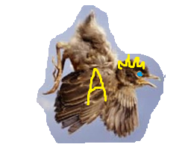This is Abraham.

Column Types
There are 2 types of columns in game which are wood and stone. The wooden column is easier for the bird to breakthrough. However, the wooden column will only appear in the first 2 levels. Also, the wooden column will need 3 blasts to the same location to break whereas the stone one needs 5 blasts.

Power-ups
    - Score Increasers
Meals: These will be prepositioned. They will be permanently stationary until the bird shoots it to gain its score. The bird’s health score will increase 25 points.
Mushrooms: These will be appearing in an instant. They will disappear if the bird does not reach them in 4 seconds. The mushrooms will appear on the bird’s path. The bird’s health will increase 50 points.
Levels: Each time the bird passes through a column which is an indicator of a next level, the bird will receive a health score of 100 points.
    - Temporary Immortality
There will be a chance for the bird to be imperishable for 5 seconds, however it has a cool down period of 60 seconds.

  - Enemies
There will be two different enemies which are cats and humans. The humans are the stronger enemy; however they will appear on the later levels. The bird can shoot or evade the enemies. The enemies can evade the bird’s shot by moving or stay at the same spot and get killed, this will be randomized.

    - Cats
The cats will be the weaker of the enemies. They will decrease the bird’s health score by 25 points if they can shoot the bird. Only 1 good-aimed shot is needed to kill one of them.

    - Humans
The humans are the stronger enemies. They will decrease the bird’s health score by 45 points if they can shoot the bird. 3 good-aimed shots are needed to kill one of them.

  - Weapons
The bird will need to shoot enemies or evade them to get through. Therefore there will be 2 different weapons with different features to kill them.

    - Small Blast
This weapon will have a smaller impact area. The upside is that the blast will move faster.

    - Big Blast
This weapon will have a larger impact area. The downside is that the blast will move slower.

Requirement Specification

Functional Requirements

Play Game
Break It! is a game that will be developed with Java. The main purpose of the game is to move the bird through columns and enemies to safely reach its nest. The game will be played with the keyboard and there will be 5 levels, 2 types of columns, 2 types of enemies, 2 types of weapons and 2 lives for the bird. The player will be moving through the game while evading or killing the enemies and shooting the columns. The bird’s health score can decrease with every shot it takes and can increase through power-ups.

Change Settings
Even though there are not many in game settings to be changed that will affect the game, there will be some settings that can be changed prior to playing the game which will be depending on the player’s preference. These are;
- Sound on/off: This will turn off the music of the game and the sound effects of the blasts.
- Hair color: Margaret’s hair color can be changed either to blonde or brunette.
- Glasses: Abraham can have a sunglass depending on the player’s preference.
- Background: There will be 2 backgrounds, one is night and the other one is morning. The default will be morning.
- Button Change: The player can change which buttons to use.

View Help
The instructions with pictures to help the player can be looked at prior to the game.

Train Margaret
This is a mini-game that will help the player improve their shooting skills. The player will control Margaret. Margaret will stay stationary and will shoot the oncoming enemies.

Non-Functional Requirements

Game Performance
Break It! Is a game that depends on timing and speed so for the game to work properly there has to be no delay while playing the game.

Supportability
The game has to be upgradable, this will be mainly done by having
different levels.
    - Usability
The game needs to have a friendly user interface. Menu and the
different choices made during the game need to be understandable.

Constraints
- Break It! will be developed with Java.
- The language of the game will be only in English.
- Size of the game will be at most 30 MBs.
- Game graphics will be done with JPanel.

System Model

Use Case Model
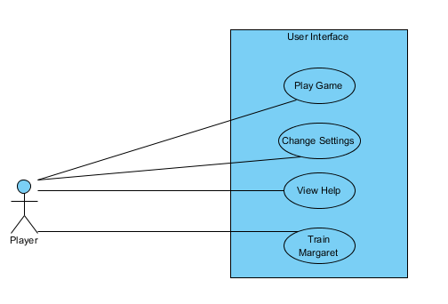

Figure 4.1 – Illustrates the use case model of Break It!

Play Game

Use Case Name: Play Game
Primary Actor: Player
Entry Condition: Player selects “Play Game” from menu.
Exit Condition: Player selects “Exit” from game screen.

Success Scenario Event Flow:
- Game is started.
- Player moves the bird through enemies.
- Player breaks the column, therefore moves on to the next level.
- Player repeats 2 and 3 until the game ends.
Alternative Flows:
If player wants to exit the game;
- Player selects “Exit” button to return to menu.
- Player presses the “x” button at the right top to exit the program.

Change Settings
Use Case Name: Change Settings
Primary Actor: Player
Pre-condition: If the player does not change the settings, the game will be uploaded as default.
Post-condition: Game settings are changed.

Entry Condition: Player selects “Change Settings” button from menu.
Exit Condition: Player selects “Back” to return to menu or selects “Play game” to play the game.
Success Scenario Event Flow:
- Player presses “Change Settings” button to change settings.
- Different options are displayed.
- Player changes the settings to their preference.
- System changes game settings.

Alternative Flows:
A. If Player wants to use the default settings
- Player does not change the settings.

View Help
Use Case Name: View Help
Primary Actor: Player
Pre-conditions: Player should be in menu.
Post-condition: -
Entry Condition: Player selects “View Help” from menu.
Exit Condition: Player selects “Back” to return previous menu.
Success Scenario:
- Player selects “View Help” from menu.
- Instructions with pictures to help understand game will be displayed to the player.

Alternative Flows:
A. If player requests to return to menu at any time;
- Player selects “Back” button.
- Player returns to menu.
B. If player wants to play the game;
- Player selects “Play Game” button.
- Player plays the game.

    - Train Margaret
Use Case Name: Train Margaret
Primary Actor: Player

Entry Condition: Player selects “Train Margaret” from menu.
Exit Condition: Player selects “Back” to return to menu or selects “Play Game” to play the game.
Success Scenario:
1.Player selects “Train Margaret” from menu.
2. Player trains Margaret until they are satisfied.
Alternative Flows:
A. If player requests to return previous menu at any time;
- Player selects “Back” button.
- Player returns to menu.
B. If player wants to play the game;
- Player selects “Play Game” button.
- Player plays the game.

Dynamic Models

Activity Diagram
The diagram in Figure 10 shows the general logic and progress of the game. Player can start to play the game by selecting "Start Game" button. After initializing the game, game loop will start. During the game, game engine check is the bird reach column position in each time unit. If player does not reach the column or the user has no life game will be over. After this step, game direct the player to the main menu. If bird does not reach the column and the game is not over yet, player continues to destroy enemies, destroy the columns or collecting bonuses. These events are all decided with checkShoots step. According to the this step, game map is updated by the acts of player and game. After player reach the column and also if player has live, the loop breaks and the game checks that is column destroyed or not. If it is not, game will be over again. Otherwise game loops back to initialize game step and next game will be harder. In any stage, if our bird loses all of lives, game will be over instantly.
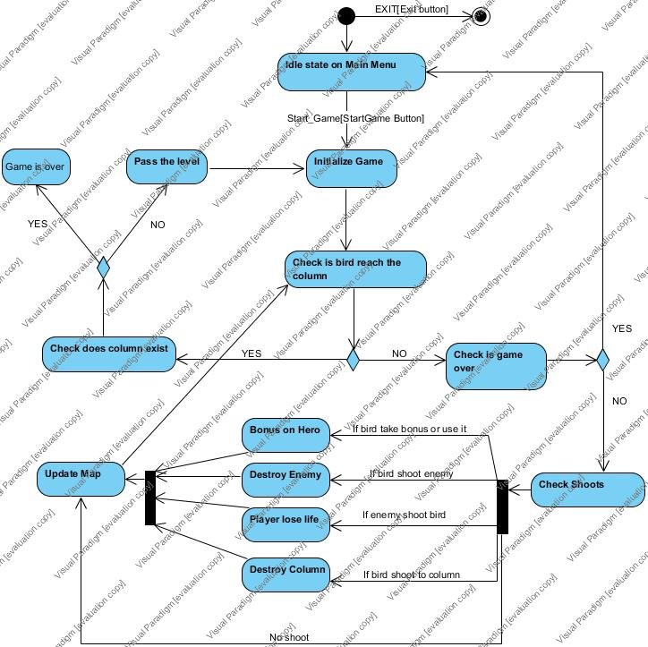
Activity diagram for the game is as the following:
Figure 10: Activity Diagram for the Game Flow

Diagram 1: Start Game
Figure 11 explains logic when the player starts a game. Player chooses the "Start Game" button from the MainMenu and GamePanel run the 'createGame()' method for GameEngine. Therefore, GameEngine creates ScreenManager and GameMap. GameEngine then runs the 'getLevel()' method of GameMap to decide which map will upload by depending result. GameMap creates Player, Column, Enemies, Bonus. Also, GameEngine creates DestroyManager to destroy enemies and columns. GameEngine has 'startGameLoop' loop of itself.

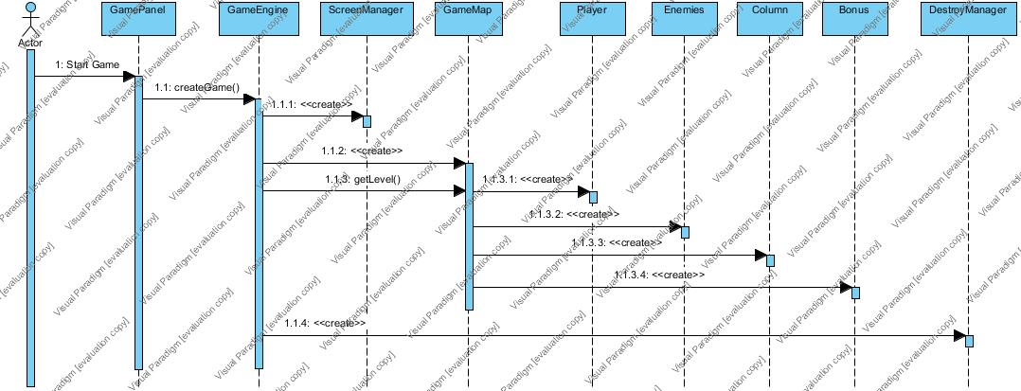
Figure 11: Sequence diagram of starting a game scenario

Diagram 2: Shoot
Figure 12 explains the logic of a shooting and destroys enemies and columns. Play moves cursor by pressing a specific buttons from the keyboard and ‘Shoot()' method of GameEngine is called by the GamePanel. This method gets the location of cursor and enemies then GameEngine trigger a shoot which means calling the method ‘checkShoot()' method of GameMap class for that specific aim. If that process is successful then GameEngine runs the 'destroyEnemy' method. This method destroy enemies from the GameMap.
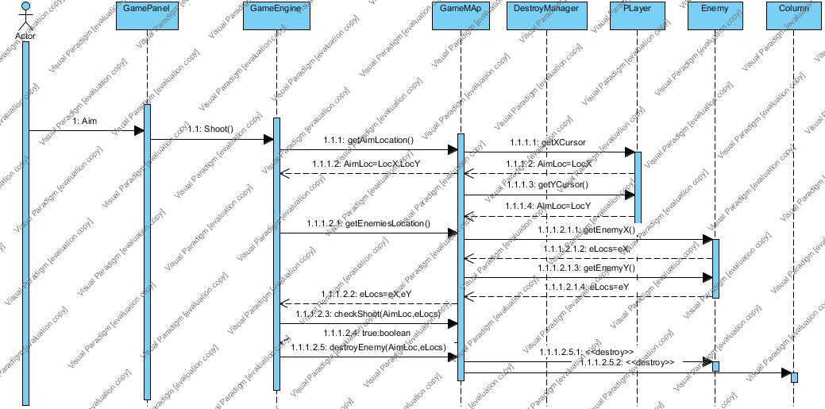
Figure 12: Sequence diagram of shooting scenario

Diagram 3: Change Settings
Figure 13 explains a logic which allow the player mute the music of the game from the settings. Player select the 'Options' button from the main menu and GamePanel runs the 'options' method of GameEngine. GameEngine run 'options' method for MenuPanel. Player is able to chooses "Mute/Unmute" from Options and GamePanel runs 'swapSound' method of SoundManager. Normally the SoundManager returns 'true' since the music is playing. Also there is another feature which is called as "Change Image". If player wants to change the icon of bird it can be done from here. Player select whatever he wants and click ok button. When 'ok' button pressed GamePAnel runs 'changeImage' method of ImageManager. Default image is Margaret's image. Player chooses "Back" from Options menu and GamePanel runs 'back' method of GameEngine. GameEngine triggers 'back' method of MenuPanel. Actor chooses "Back" from PauseMenu and GamePanel triggers 'back' method of GameEngine. GameEngine triggers 'back' method of MenuPanel. In the end, player return main menu.
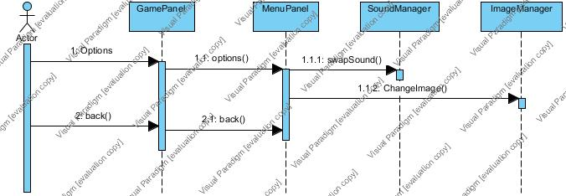
Figure 13: Sequence diagram of change settings scenario

Diagram 4: Take Bonus
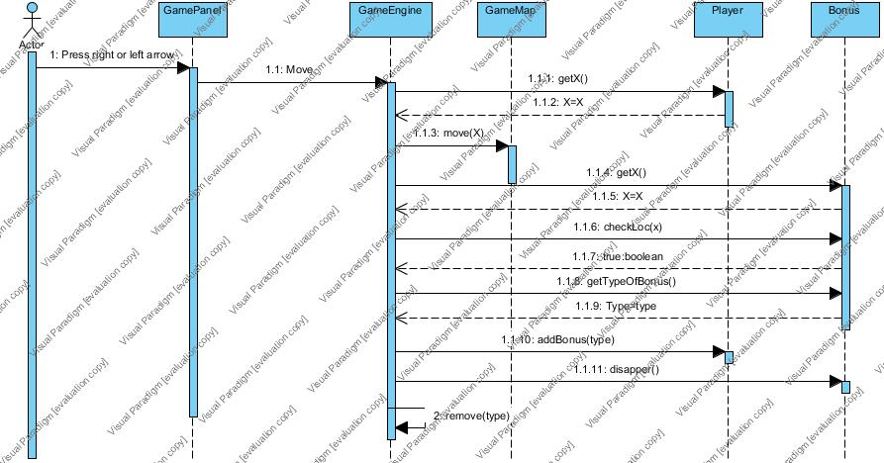
Figure 14 shows that how to get bonus. GamePanel receives the key action and delivered to GameEngine. GameEngine run the Move() method and it makes our player move. Then GameEngine use getX method from Player to clarify Player's location on x coordinate system. So it can compare bonus location and player location. GameMap runs move(X) method of Player by depending X value. GameEngine also get locations of bonus with getX(). After that, GameEngine use checkLoc(x,bx) to get bonus if it is correct the next step will be declaring type of bonus. GameEngine does that by using getTypeOfBonus() method. Therefore, we add that bonus on our bird with using addBonus(type) and disappear the bonus from the map instantly with disappear() method.Lastly, we have a remove method aswell which deletes bonus effects on our bird in time.

Figure 14: Sequence diagram of take bonus scenario

Diagram 5: Train Margaret
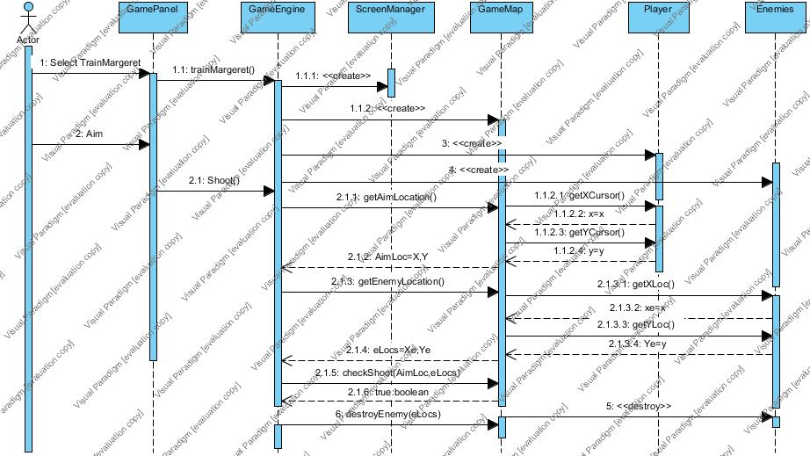
Figure 15 explains the logic of train Margaret version. Players might want to improve their shooting skill before the game to be more successful. To do that Player select TrainMargeret button on main menu. GamePanel runs trainMargeret() method from GameEngine and it runs create() method for ScreenManaget ,GameMap, Player, Enemies. Then Player moves cursor by pressing a specific buttons from the keyboard and ‘Shoot()' method of GameEngine is called by the GamePanel. This method gets the location of cursor and enemies by using some methods. After that GameEngine trigger a shoot which means calling the method ‘checkShoot()' method of GameMap class for that specific aim. If that process is successful then GameEngine runs the 'destroyEnemy' method. This method destroy enemies from the GameMap.

Figure 15: Sequence diagram of train Margaret scenario

  - Object and Class Model
The class diagram of Break It! is depicted below.
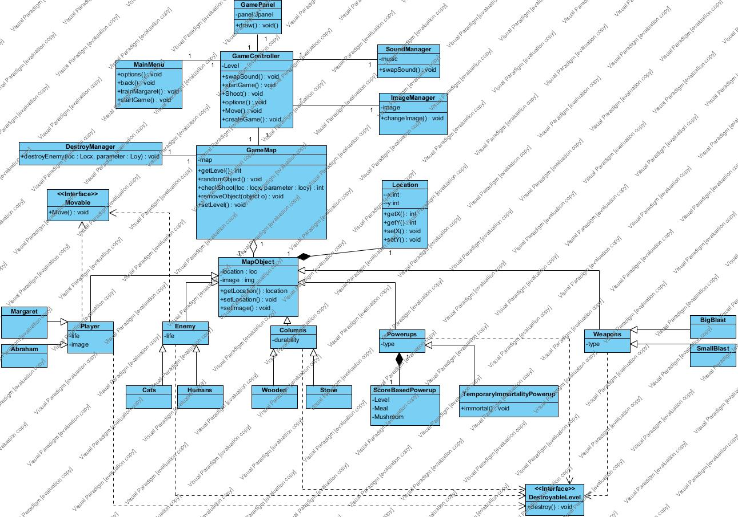

- GameController: This class manages whether the game is started or not, options are changed and if the game is started as default.

- MainMenu: This class will be the first thing that welcomes the user. Options such as the start of the game, training Margaret and optional changes will be managed with this class.

- DestroyManager: This class handles the destruction of the enemies; cats and humans.

- MapObject: This class locates and gives the locations of every objects. This class will heavily use Location class, as Location class actually gives the x and y coordinates seperately.

- GameMap: This class overviews the whole game. Game levels, objects that are in the game at the moment and the shot objects are managed through this class.

- SoundManager and Image Manager: These classes respectively manage sound and image.

- Movable: This is an interface that adds the feature of movability to the various objects.

- Enemy: This class is the parent class of the enemies which will be of two kinds; cats and humans, they have the same names for their classes respectively.

- Player: This class is the bird that the player will move through the game. It has two subclasses; Margaret and Abraham. Margaret is the class of the main bird and Abraham is the child bird.

- Columns: This class has two subclasses which are the different types of columns the game has. Wooden and Stone are the subclasses.
- Powerups: This class is the parent class of different power up types. ScoreBasedPowerUp has different power up functions within it. TemporaryImmortalityPowerUp is the class that makes Margaret undefeatable for a few seconds.
- Weapons: This class is the parent class of BigBlast and SmallBlast, which are different impact weapons the player will use.
- DestroyableLevel: This is the interface that manages all the destruction of the objects whether they are the player's object or the game generates.

- User Interface
  - Main Menu
As the application is executed, the first screen that would be displayed would be that of main menu. This screen gives user multiple options to choose from, the options include Play Game, Change Settings, View Help and Train Margaret.
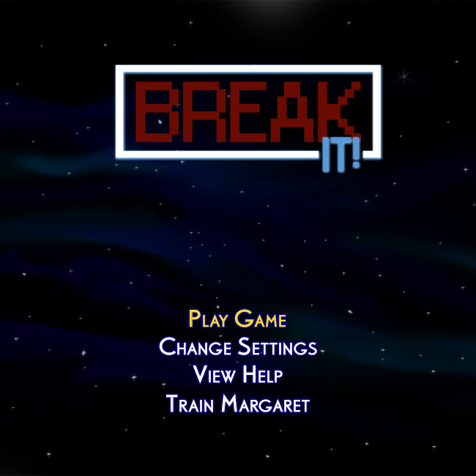

  - Play Game
If the player selects play game option the game with start with the settings currently stored in the system. The following screenshot shows what the game screen looks like.

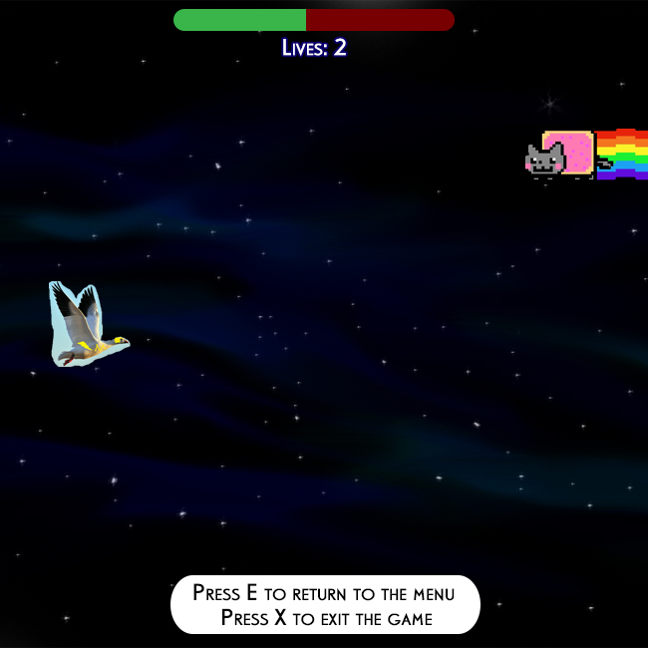

  - Change Settings
The Change Settings option comes up with number of options which can be altered as per the user’s wish, they include options to manipulate with Margaret’s and Abraham’s appearance, changing the background, configuring the keys and going back to default settings.

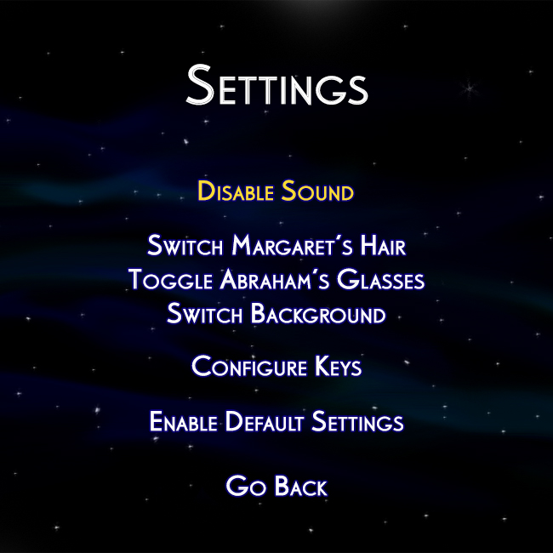

  - View Help
On choosing the view help option, player would we be displayed the details regarding all the characters as well as instruction on how to play the game etc.

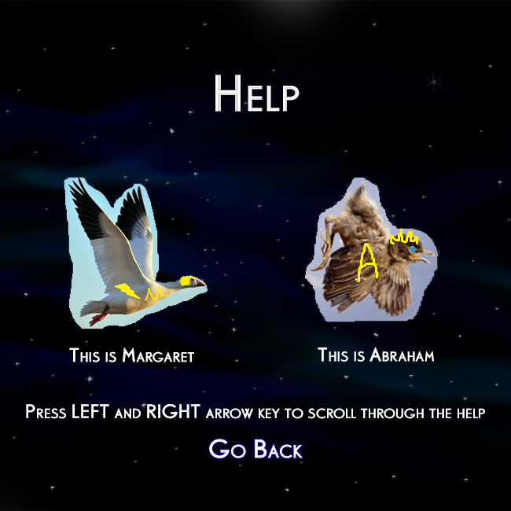

5.5. Train Margaret
By selecting the train Margaret option user can start a mini game , the target of this game is to help user improve their shooting skills.
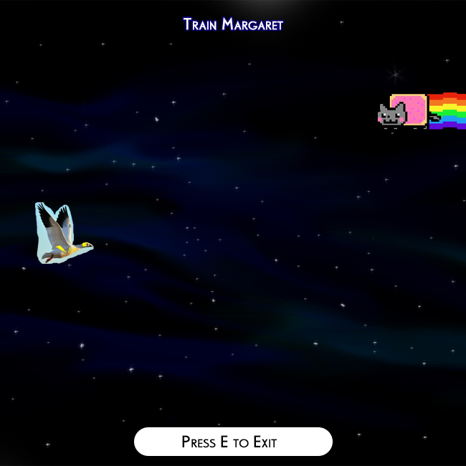

6. References
The games we were inspired by;
- http://flappybird.io/
- https://www.angrybirds.com/

