Bilkent University

Object Oriented Software Engineering

CS319 Project: Break It!

Final Report

Caner Sezginer, Güneş Batmaz, Nazlı Abaz, Usama Moin

Course Instructor: Bora Güngören

Final Report

December 24, 2016

Table of Contents

1.Exposed Documentation………………………………………………..……………………3

1.1. Introduction 3

1.1.1. System Requirements 3

1.1.2. Installation Information 4

1.2 Playing the Game 4

1.2.1. Game Overview 4

1.2.2. Game Objects 5

1.2.3. Controller Settings 7

1.4. Game Screenshots 8

1.4.1. Main Menu 8

1.4.2. Play 9

1.4.3. Change Settings 10

1.4.4. Train Margaret 11

1.4.4.View Help 12

2. Differences in Implementation………………………………..……………………………13

3. Incompleted Parts………………………………..……………………………...................13

4.Class Diagram………………………………………………………………………………14

5.Use Case Model…………………………………………………………….………………15

# 1. Exposed Documentation

# 1.1 Introduction

Break It! is a single-player game that entertains the player by hardening the game through different levels. Our aim while creating this game was to give people a moment to clear their brain through a repetitive and yet engaging gaming experience. That is achieved by having similar but a bit more difficult consecutive levels.

## System Requirements

The Standard Java Runtime Environment (JRE) is required in order in order to play games. The game can be installed and played by the CDs.

**Minimum System Requirements:**

* Windows 2000/XP
* 128 mb RAM
* Screen resolution: 800*600

**Recommended System Requirements:**

* Intel Core i5 or equivalent processor (Athlon/Duron/Celeron)
* 512 MB of RAM or higher
* Screen resolution: 1920*1080

## Installation Information

Unzip the archive file which is named breakit.zip to a directory on your computer. To run the game you have two options:

1. Run by double clicking the imprisonment.jar file to execute the game. This is recommended.
2. If you have a little bit knowledge about java programming and using Java IDE as compile and run code in java. You can open in any Java IDE, compile code and run the main method. Then the console open and the game start.

# Playing the Game

## Game Overview

In this game, the player moves the main character which is a bird called Margaret, vertically while killing the enemies which are cats and humans and breaking through the columns. Throughout the game there will be power-ups that pop up and then disappear either through gaining them or reaching their limited time. The player will gain scores through these power-ups and loses them when the bird gets shot by the enemies. While the game is not based on time, speed is critical as the bird might get shot by the enemies if it does not move. The primary goal of the game is to reach the end level, to reach the next level the player needs to break the column through shooting through it. When the bird passes the column, the next level starts. If the score drops to a critical level, then the bird will downgrade to a lower level bird called Abraham. If the score reaches critical again after being downgraded then the game is over.

## 

## Game Objects

## 1.2.2.1 Bird

The main bird which will be called Margaret has a health score that decreases anytime she is shot and increases every time she eats a meal or a mushroom. When her health score decreases to zero, she gives birth to her child version which has lesser health score than the main bird, if the child bird which is called Abraham increases his health score to match Margaret’s full health score, he can evolve to the main bird once again. On the other hand, if his health score decreases to zero the game ends. This transformation makes the game more durable for the player.

The game will start with Margaret. Margaret’s health score will be 200 points and Abraham’s will be 100 points. For Abraham to evolve into Margaret the health score needs to be 200 points. Margaret has faster shooting abilities than Abraham which will make the player choose Margaret to increase the chances of winning the game.

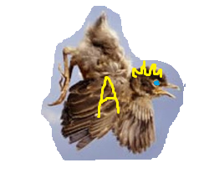

Margaret Abraham

## 1.2.2.2 Enemies

## There will be two different enemies which are cats and humans. The humans are the stronger enemy; however they will appear on the later levels. The bird can shoot or evade the enemies. The enemies can evade the bird’s shot by moving or stay at the same spot and get killed, this will be randomized.

## The cats will be the weaker of the enemies. They will decrease the bird’s health score by 25 points if they can shoot the bird. Only 1 good-aimed shot is needed to kill one of them.

## The humans are the stronger enemies. They will decrease the bird’s health score by 45 points if they can shoot the bird. 3 good-aimed shots are needed to kill one of them.

## 1.2.2.3 Power-ups

## Meals: These will be prepositioned. They will be permanently stationary until the bird shoots it to gain its score. The bird’s health score will increase 25 points.

## Mushrooms: These will be appearing in an instant. They will disappear if the bird does not reach them in 4 seconds. The mushrooms will appear on the bird’s path. The bird’s health will increase 50 points.

## Levels: Each time the bird passes through a column which is an indicator of a next level, the bird will receive a health score of 100 points.

## Temporary Immortality: There will be a chance for the bird to be imperishable for 5 seconds, however it has a cool down period of 60 seconds.

## 1.2.2.4 Column

There are 2 types of columns in game which are wood and stone. The wooden column is easier for the bird to breakthrough. However, the wooden column will only appear in the first 2 levels. Also, the wooden column will need 3 blasts to the same location to break whereas the stone one needs 5 blasts.

## 1.2.2.5 Weapons

## The bird will need to shoot enemies or evade them to get through. Therefore there will be 2 different weapons with different features to kill them.

## Small Blast: This weapon will have a smaller impact area. The upside is that the blast will move faster.

## Big Blast: This weapon will have a larger impact area. The downside is that the blast will move slower.

## Controller Settings

Player controls the character with keyboard’s direction keys.

# Game Screenshots

## Main Menu

IAs the application is executed, the first screen that would be displayed would be that of main menu. This screen gives user multiple options to choose from, the options include Play Game, Change Settings, View Help and Train Margaret.

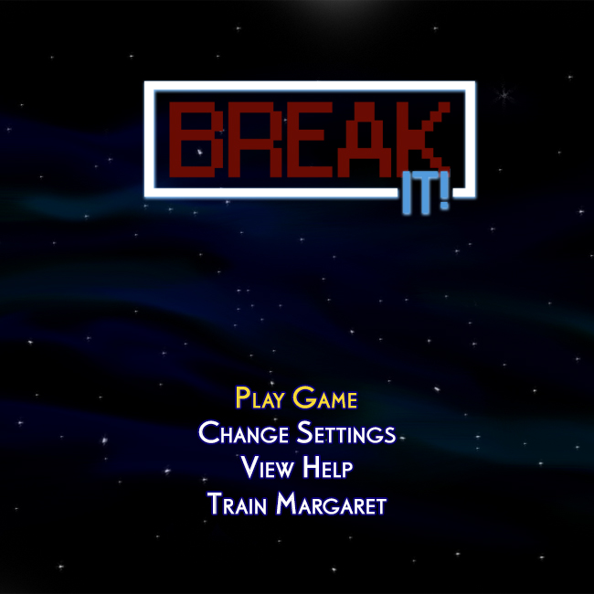

Figure 1

## Play

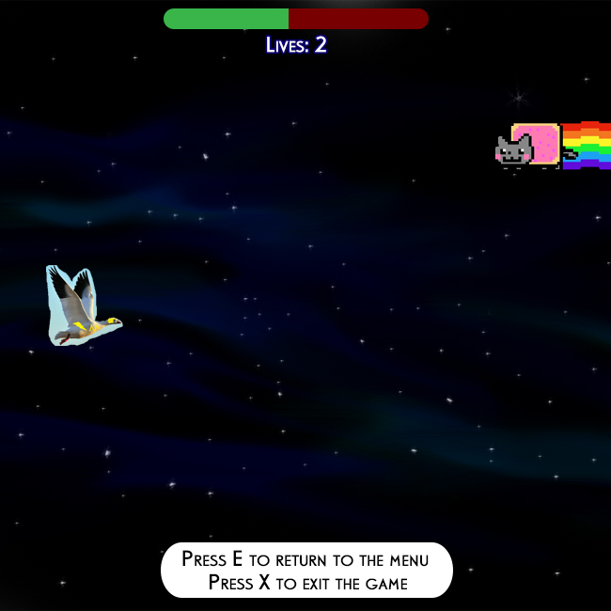 If the player selects play game option the game with start with the settings currently stored in the system. The following screenshot shows what the game screen looks like.

Figure 2

## Change Settings

The Change Settings option comes up with number of options which can be altered as per the user’s wish, they include options to manipulate with Margaret’s and Abraham’s appearance, changing the background, configuring the keys and going back to default settings.

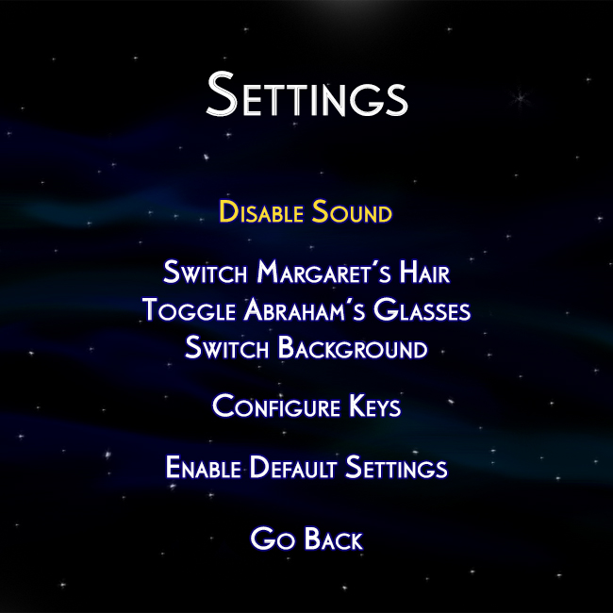

Figure 3

## Train Margaret

By selecting the train Margaret option user can start a mini game , the target of this game is to help user improve their shooting skills.

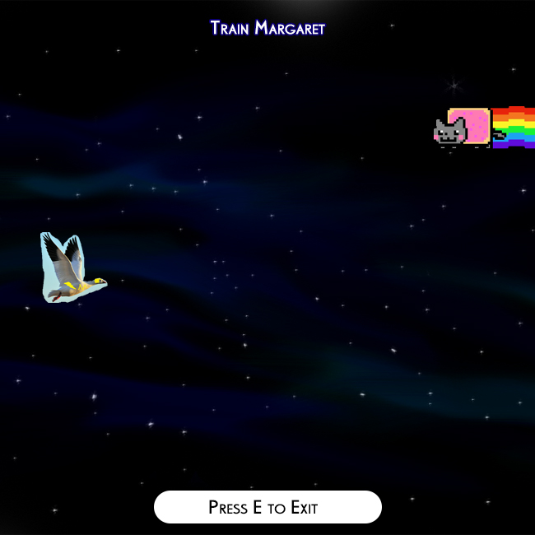

## View Help

On choosing the view help option, player would we be displayed the details regarding all the characters as well as instruction on how to play the game etc.

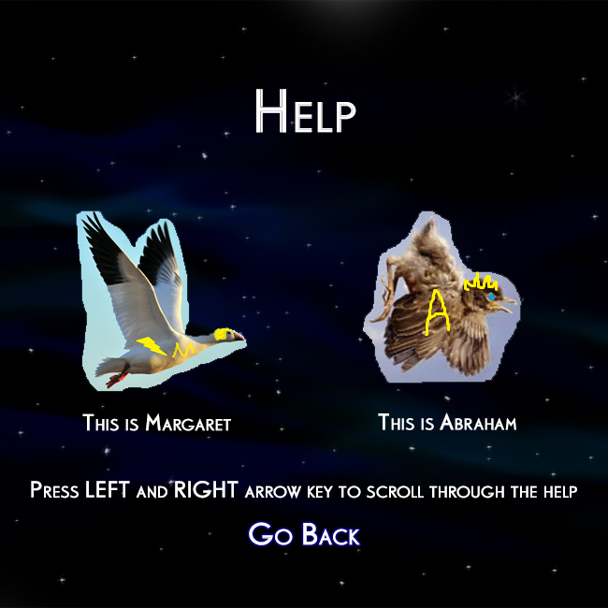

1. **Differences in Implementation**

The only big changes is about the movement direction. Before our bird was able to move only x-axis, however, when we are implementing it we face some contradictions. For example birds and other object can be same position at the same time. To prevent this and to implement it easier we decide to change x-axis to the y-axis.

Other's will be same.

1. **Incompleted Parts**

We have not started yet Enemies and Weapon classes.

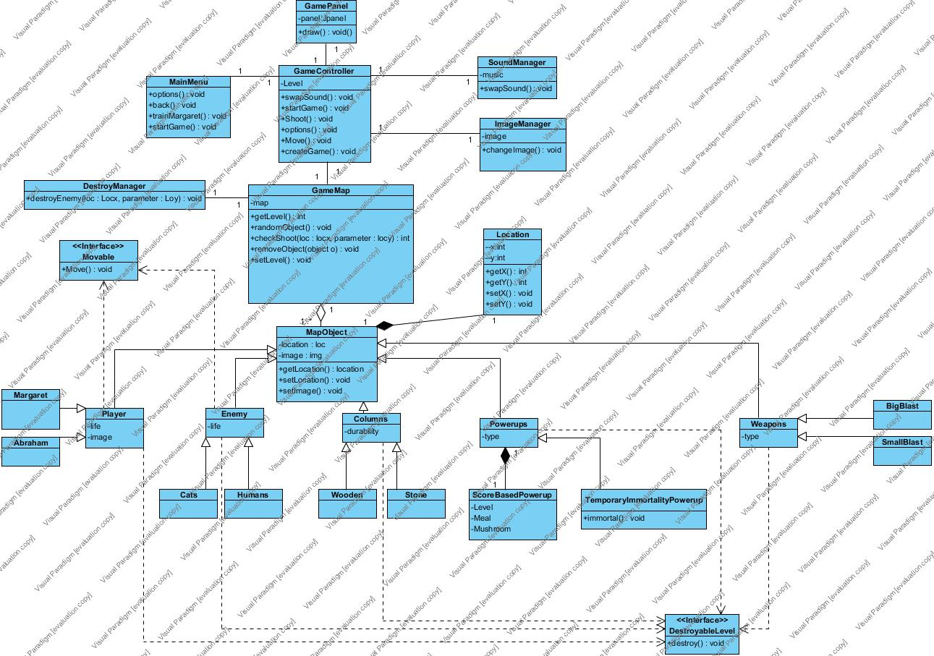**4. Class Diagram**

**5.Use Case Diagram**

