SUPERVISOR BRIEF
Experiment Completion Brief
Inductive lncRNA–disease prediction: completed scope, key results, and remaining extensions
Prepared for: Felipe Kenji
Prepared by: Nazli Hosseinipour
Date: 30 July 2026
Evidence package: https://drive.google.com/drive/folders/1_AfKjHizBvB-pZtAr9IBubi0c5Tg3fGc?usp=sharing
Status: 234/234 canonical experiment cells complete and revalidated

Verified status: The downloaded July 23 server package contains all 234 requested canonical cells: 234 valid, 0 missing, and 0 invalid. This completion statement applies to the RF/RFLDA/IPCARF suite described below; it does not include LDA-SABC.

Completed experiment suite
Experiment family | Design | Complete | Status
Within-version | True all-safe structured output | 6 / 6 | Complete
Cross-version transfer | Strict V1→V2 and V2→V1 | 114 / 114 | Complete
Pairwise binary | Fixed threshold 0.5 | 114 / 114 | Complete
Total | RF, RFLDA, IPCARF | 234 / 234 | Complete
Evidence: final_expected_vs_actual_matrix.csv, final_comparison.csv, and CODEX_ALL_EXPERIMENTS_COMPLETION_STATUS.md.

What “non-binary” and “binary” mean here
The non-binary phase contains 120 structured-output cells: 6 within-version all-safe runs and 114 strict transfer runs. Each model predicts a disease-label vector for an RNA.
The binary phase contains 114 pairwise cells. Each RNA–disease pair is treated as one association decision, while the train/test separation remains inductive by RNA.

Why the canonical outputs are suitable for reporting
- Leakage control. Features derived from the association target matrix were excluded.
- Threshold control. Clean F1 is reported only at the prespecified threshold 0.5; legacy test-fitted Youden F1 is excluded.
- Fold and protocol control. Each cell requires folds 1–10 exactly once, and all transfer/binary sidecars were checked.
- Independent recalculation. The verifier reconstructed labels and rescored persisted predictions, returning 234 complete, 0 failed, and 0 remaining.

Headline results
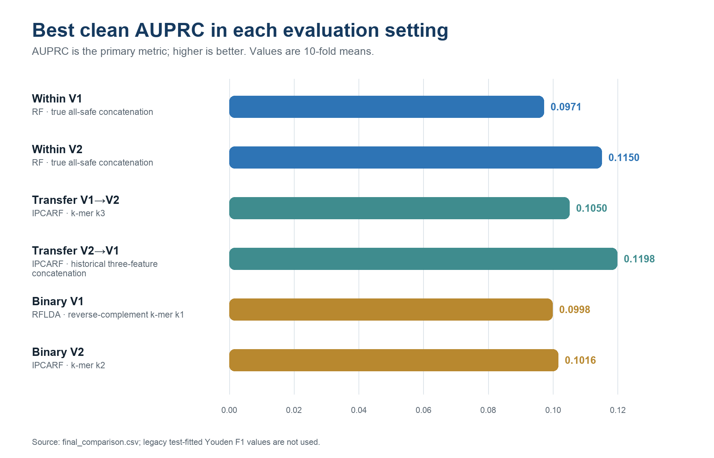
Figure 1. Best clean AUPRC in each evaluation setting.
Evaluation | Model | Feature representation | AUPRC
Within V1 | RF | true all-safe concatenation | 0.0971
Within V2 | RF | true all-safe concatenation | 0.1150
Transfer V1→V2 | IPCARF | k-mer k3 | 0.1050
Transfer V2→V1 | IPCARF | historical three-feature concatenation | 0.1198
Binary V1 | RFLDA | reverse-complement k-mer k1 | 0.0998
Binary V2 | IPCARF | k-mer k2 | 0.1016
Source: final_comparison.csv. AUPRC is primary; AUROC is secondary; threshold-dependent F1 is valid only at fixed 0.5.

Completed versus next
Completed and verified | Not yet part of the completed suite
RF, RFLDA, and IPCARF across within-version, strict transfer, and binary formulations | Run the recent LDA-SABC method under the same V1/V2 and fixed-threshold protocol
Canonical aggregation, tables, figures, protocol sidecars, and prediction-level verification | Complete the literature search for additional recent methods and select justified extensions
Interpretation: The results support a transparent meeting update now. They should still be interpreted as cross-validation estimates under severe class imbalance, not as proof of universal generalization.

