TECHNICAL REPORT
Methods, Results & Validation
Canonical RF, RFLDA, and IPCARF experiments for inductive lncRNA–disease prediction
Prepared for: Felipe Kenji
Prepared by: Nazli Hosseinipour
Date: 30 July 2026
Evidence package: https://drive.google.com/drive/folders/1_AfKjHizBvB-pZtAr9IBubi0c5Tg3fGc?usp=sharing
Status: Final verifier: 234 complete, 0 failed, 0 remaining

234/234  canonical cells | 0  missing | 0  invalid | 10  folds per cell

Executive summary
This report documents the final reconciled experiment package downloaded from the server on 23 July 2026. The canonical result set contains 234 complete cells: 6 within-version all-safe structured-output cells, 114 strict cross-version transfer cells, and 114 fixed-threshold pairwise binary cells. The final completion audit contains no missing or invalid cells.
AUPRC is treated as the principal result because the association matrices are highly imbalanced. AUROC is secondary. F1 is included only when it was calculated at the prespecified 0.5 threshold; older F1 values obtained by fitting a Youden threshold on the same test fold are explicitly excluded from clean conclusions.
The strongest AUPRC depends on the evaluation setting rather than one model dominating everywhere. RF leads the two within-version all-safe settings, IPCARF leads both transfer directions and binary V2, and RFLDA leads binary V1. These are cross-validation estimates and should be read with the limitations in Section 9.

Key messages
- The requested RF/RFLDA/IPCARF suite is complete and internally revalidated.
- The corrected workflow excludes target-derived features, uses fixed-threshold F1, and removes exact target-RNA overlap in transfer.
- All 114 transfer and 114 binary protocol sidecars satisfy the recorded threshold and fold requirements.
- LDA-SABC and the search for additional recent methods remain extensions; they are not included in the 234 completed cells.

1. Experiment design and datasets
Two dataset versions were evaluated under inductive splitting, meaning that held-out RNAs were not used for model fitting. V2 is substantially larger in both samples and disease labels.
Dataset | lncRNAs | Disease labels | Binary feature spaces | Role
V1 | 353 | 45 | 20 | Within, source/target transfer, binary
V2 | 4,114 | 124 | 18 | Within, source/target transfer, binary
Source: feature_eligibility_audit.csv, final_comparison.csv, and binary protocol sidecars.

Evaluation formulations
- Structured-output (“non-binary”). A model receives one RNA representation and predicts the full disease-label vector. This includes within-version all-safe evaluation and strict cross-version transfer.
- Pairwise binary. RNA × disease pairs are converted into association decisions, with disease similarity included by the project converter and train/test separation performed by RNA fold.

Canonical experiment matrix
Family | Feature sets | Models | Directions / versions | Cells
Within all-safe | 1 per version | 3 | V1 and V2 | 6
Strict transfer | 19 | 3 | V1→V2 and V2→V1 | 114
Pairwise binary | 20 V1; 18 V2 | 3 | V1 and V2 | 114
Total | — | RF / RFLDA / IPCARF | — | 234

Metrics
Metric | Use in this report | Reason
AUPRC | Primary | Sensitive to ranking quality under strong class imbalance
AUROC | Secondary | Useful complementary ranking measure
F1 | Fixed threshold 0.5 only | Avoids using the test labels to choose a favorable threshold

2. Models and feature spaces
The report preserves the model names used by the repository. Each model was run through the same experiment drivers, fold conventions, prediction persistence, and final scoring rules.
Model | Implementation role | Key project behavior
RF | Random-forest baseline | Uses the full compatible feature representation without the RFLDA feature-selection stage
RFLDA | Repository-native feature-ranked RF method | Ranks inputs by RF importance and selects a feature count inside its model workflow
IPCARF | Incremental-PCA-to-RF pipeline | Selects a component count and fits a random forest on the reduced representation
Implementation references: lncRNA_CIBCB2025-main/RF/rf.py, RFLDA/rflda.py, and IPCARF/ipcarf.py.

Feature-space organization
Group | Included representations | Where used
Shared sequence features | 18 compatible sequence descriptors: composition, k-mer, reverse-complement k-mer, gapped, covariance, PseDNC, and Z-curve families | Transfer and binary V2; also part of V1
Additional V1 spaces | MP sequence and MP sequence (chunked) | Binary V1 only
Historical concatenation | k-mer k4 + reverse-complement k-mer k4 + PseDNC | Included as the 19th strict-transfer feature set; explicitly labelled historical
True all-safe concatenation | All sample-compatible leakage-free features accepted by the manifest | Final within-version structured-output category
Target-derived features—including GIP, SVD, and label-feature-selection representations derived from the association matrix—were not eligible for clean inductive comparisons.

Split and protocol constants
- Ten folds per canonical cell, with folds 1 through 10 required exactly once.
- Random state 0 recorded in the transfer and binary protocol sidecars.
- Strict transfer restricted to the 11 authoritative shared diseases and identical compatible feature columns/order.
- Binary evaluation used RNA-fold inductive separation, not random pair splitting.

3. Audit, reconciliation, and execution workflow
The final package was produced through an evidence-first workflow. Existing valid results were reused, while missing or invalid cells were rerun through resumable server scripts.
- Inventory and hash audit. Enumerated candidate results, duplicates, conflicting copies, logs, predictions, and performance files across the prior result locations.
- Canonical reconciliation. Selected complete ten-fold evidence by scientific validity rather than timestamp alone; original evidence was preserved.
- Feature eligibility audit. Classified representations by availability, sample compatibility, transfer compatibility, and target leakage risk.
- Disease harmonization. Aligned disease names through a canonical list and alias mapping, then used the executed 11-disease protocol for strict transfer.
- Protocol repairs. Removed exact target-RNA overlaps, regenerated valid folds after filtering, and replaced test-fitted Youden thresholding with fixed 0.5 scoring.
- Selective resumable reruns. Reused valid completed cells, resumed prediction folds when possible, and reran only cells requiring fresh computation.
- Canonical aggregation. Rebuilt final_comparison.csv, publication tables, and figures after completion checks.
- Independent prediction-level verification. Reconstructed labels and recomputed required metrics from persisted predictions before issuing completion markers.
Provenance rule: No stale “run finished with missing cells” marker is treated as current. The final completion audit and July 23 status document supersede those historical runtime records.

4. Corrections to the evaluation protocol
Issue found | Risk | Correction in the canonical workflow
Target-derived features were present in the broader inventory | Association labels could leak into predictors | Excluded GIP, SVD, and label-derived feature-selection representations from clean inputs
Legacy F1 used a Youden threshold fitted on the same test fold | Optimistic threshold-dependent metrics | Rescored saved predictions at 0.5 or reran; legacy Youden F1 is excluded
Transfer initially retained exact source/target RNA overlap | Target examples could be seen during source training | Removed exact target IDs before fitting and recorded removals in every transfer sidecar
Old disease audit text listed 12 shared diseases | Documentation could disagree with executed runs | Treat the executed 11-disease sidecars and matching package-level list/hash as authoritative
Low-dimensional / unstable model paths could fail | Incomplete cells and non-resumable sweeps | Added bounded RFLDA feature counts and a robust IPCARF PCA fallback while preserving the intended pipeline
Evidence: code_fixes.md, feature_eligibility_audit.csv, threshold_audit.csv, model source files, and protocol sidecars.

Interpretation of the threshold repair
Ranking metrics such as AUPRC and AUROC do not depend on a single classification threshold. They remain the principal basis for comparison. F1, precision, recall, and accuracy are threshold dependent; therefore, only values produced under the fixed 0.5 rule are called clean in this report.
Important distinction: A legacy row can still contain a valid ranking score while its test-fitted threshold-dependent metrics are invalid. The final 234-row comparison avoids presenting those legacy F1 values as clean.

Strict-transfer disease protocol
The 114 executed transfer sidecars consistently contain 11 diseases, ten splits, fixed threshold mode, exact target-overlap removal, and the same canonical-list SHA-256. This repeated executed metadata is stronger evidence of what ran than the stale 12-disease audit copy.

5. Overall and within-version results
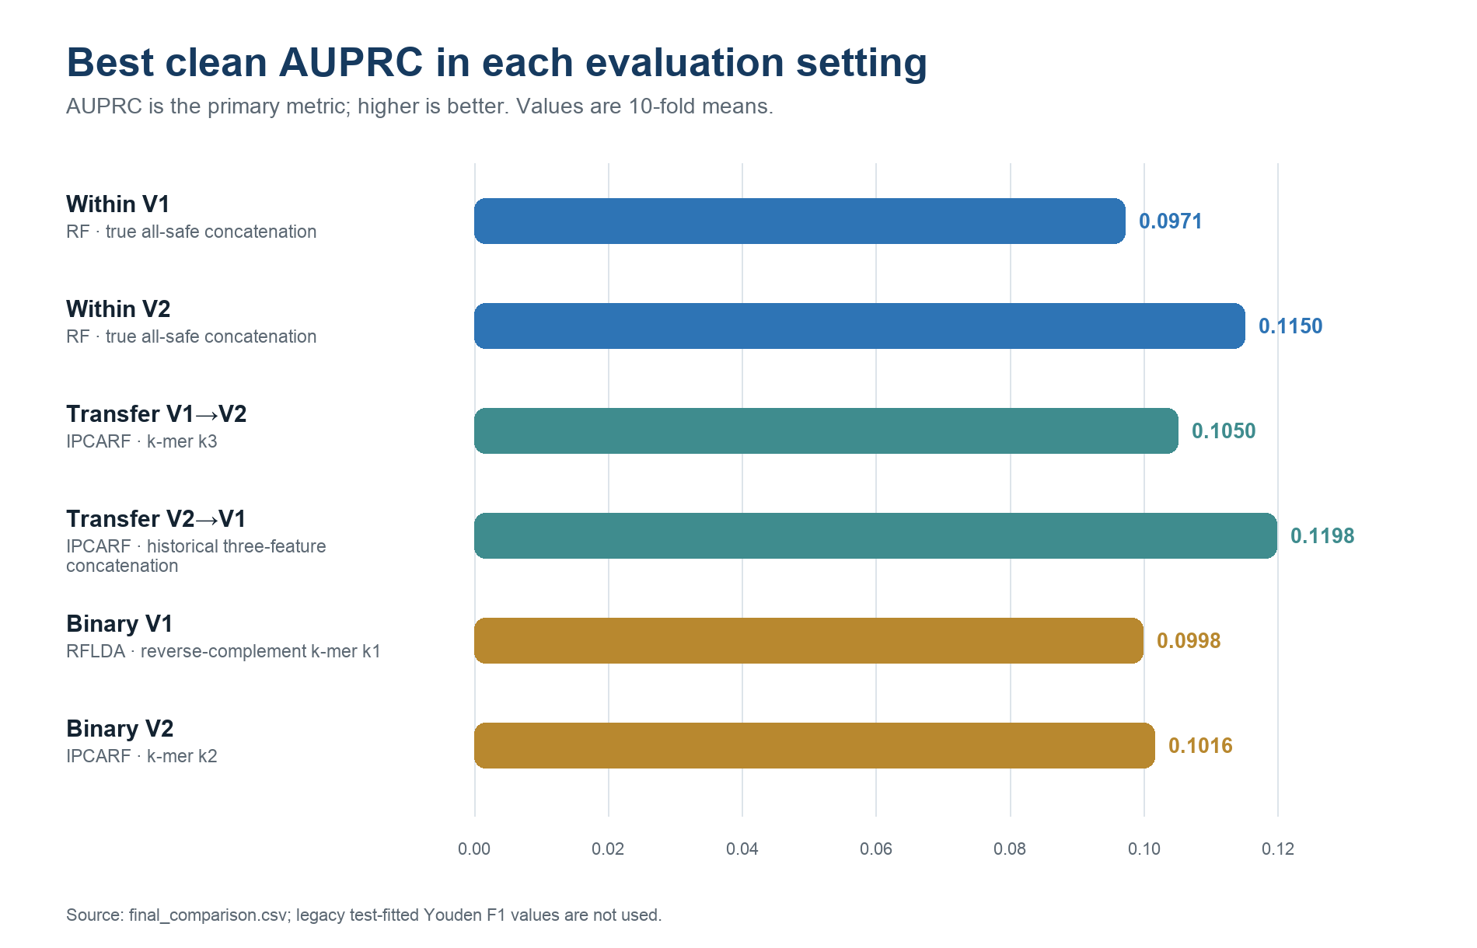
Figure 2. Best clean AUPRC by evaluation setting.
Dataset | Model | AUPRC | AUROC | F1 @ 0.5
V1 | IPCARF | 0.0904 | 0.6470 | 0.0154
V1 | RF | 0.0971 | 0.6484 | 0.0303
V1 | RFLDA | 0.0942 | 0.6635 | 0.0141
V2 | IPCARF | 0.1112 | 0.8276 | 0.0413
V2 | RF | 0.1150 | 0.8190 | 0.0605
V2 | RFLDA | 0.1072 | 0.8083 | 0.0631
Source: six true all-safe rows in final_comparison.csv.
RF gives the best within-version AUPRC for both V1 (0.0971) and V2 (0.1150). The larger V2 dataset also produces the strongest within-version AUROC among these RF rows (0.8190). The absolute AUPRC values remain modest, which is expected under sparse positive associations and argues for cautious, ranking-focused interpretation.
Terminology: “All-safe” refers to the verified leakage-free concatenation. It is not the older three-feature concatenation used as a historical transfer comparator.

6. Strict cross-version transfer results
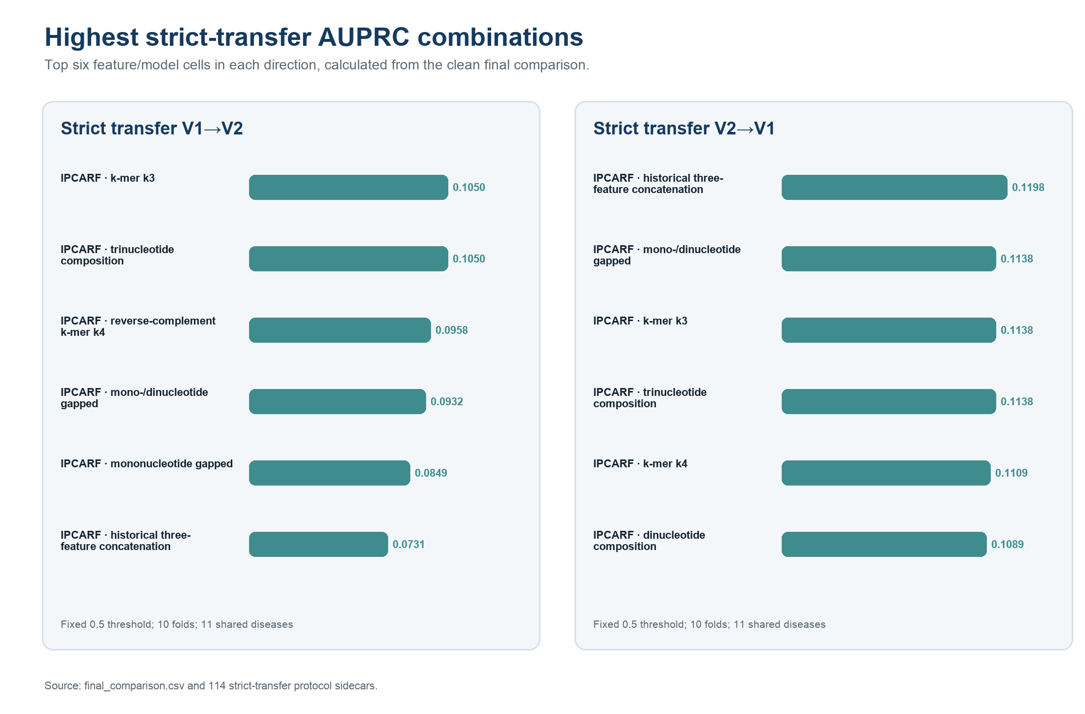
Figure 3. Highest strict-transfer AUPRC combinations in each direction.
Direction | Model | Feature | AUPRC | AUROC | F1 @ 0.5
V1→V2 | IPCARF | k-mer k3 | 0.1050 | 0.6525 | 0.1914
V2→V1 | IPCARF | historical three-feature concatenation | 0.1198 | 0.6225 | 0.0488
Source: final_comparison.csv and 114 executed transfer protocol sidecars.
IPCARF leads both directions by AUPRC: k-mer k3 for V1→V2 (0.1050) and the historical three-feature concatenation for V2→V1 (0.1198). Directional asymmetry is plausible because V1 and V2 differ greatly in sample size and label space.
12-versus-11 reconciliation: The older audit document saying “12 diseases” is stale. All 114 executed transfer sidecars and the final rows use the corrected 11-disease list with SHA-256 cb4961b6…cab2; those executed records are authoritative.

7. Pairwise binary results — V1
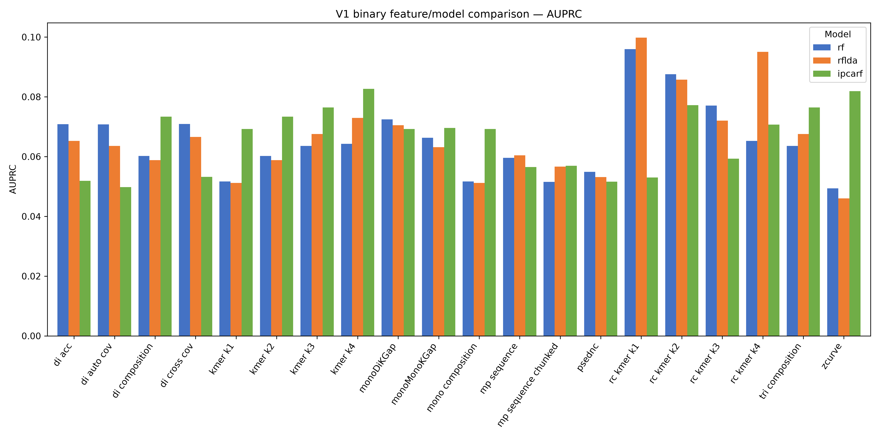
Figure 4. Binary V1 AUPRC by feature representation and model.
Rank | Model | Feature | AUPRC | AUROC | F1 @ 0.5
1 | RFLDA | reverse-complement k-mer k1 | 0.0998 | 0.5737 | 0.0038
2 | RF | reverse-complement k-mer k1 | 0.0960 | 0.5711 | 0.0038
3 | RFLDA | reverse-complement k-mer k4 | 0.0951 | 0.5501 | 0.0000
4 | RF | reverse-complement k-mer k2 | 0.0876 | 0.6004 | 0.0101
5 | RFLDA | reverse-complement k-mer k2 | 0.0858 | 0.5951 | 0.0038
Source: final_comparison.csv; the figure is the final fixed-threshold publication graphic from the July 23 package.
RFLDA with reverse-complement k-mer k1 is the best V1 binary cell by AUPRC (0.0998). Model ranking varies across feature spaces, so the best single cell should not be interpreted as uniform dominance.

8. Pairwise binary results — V2
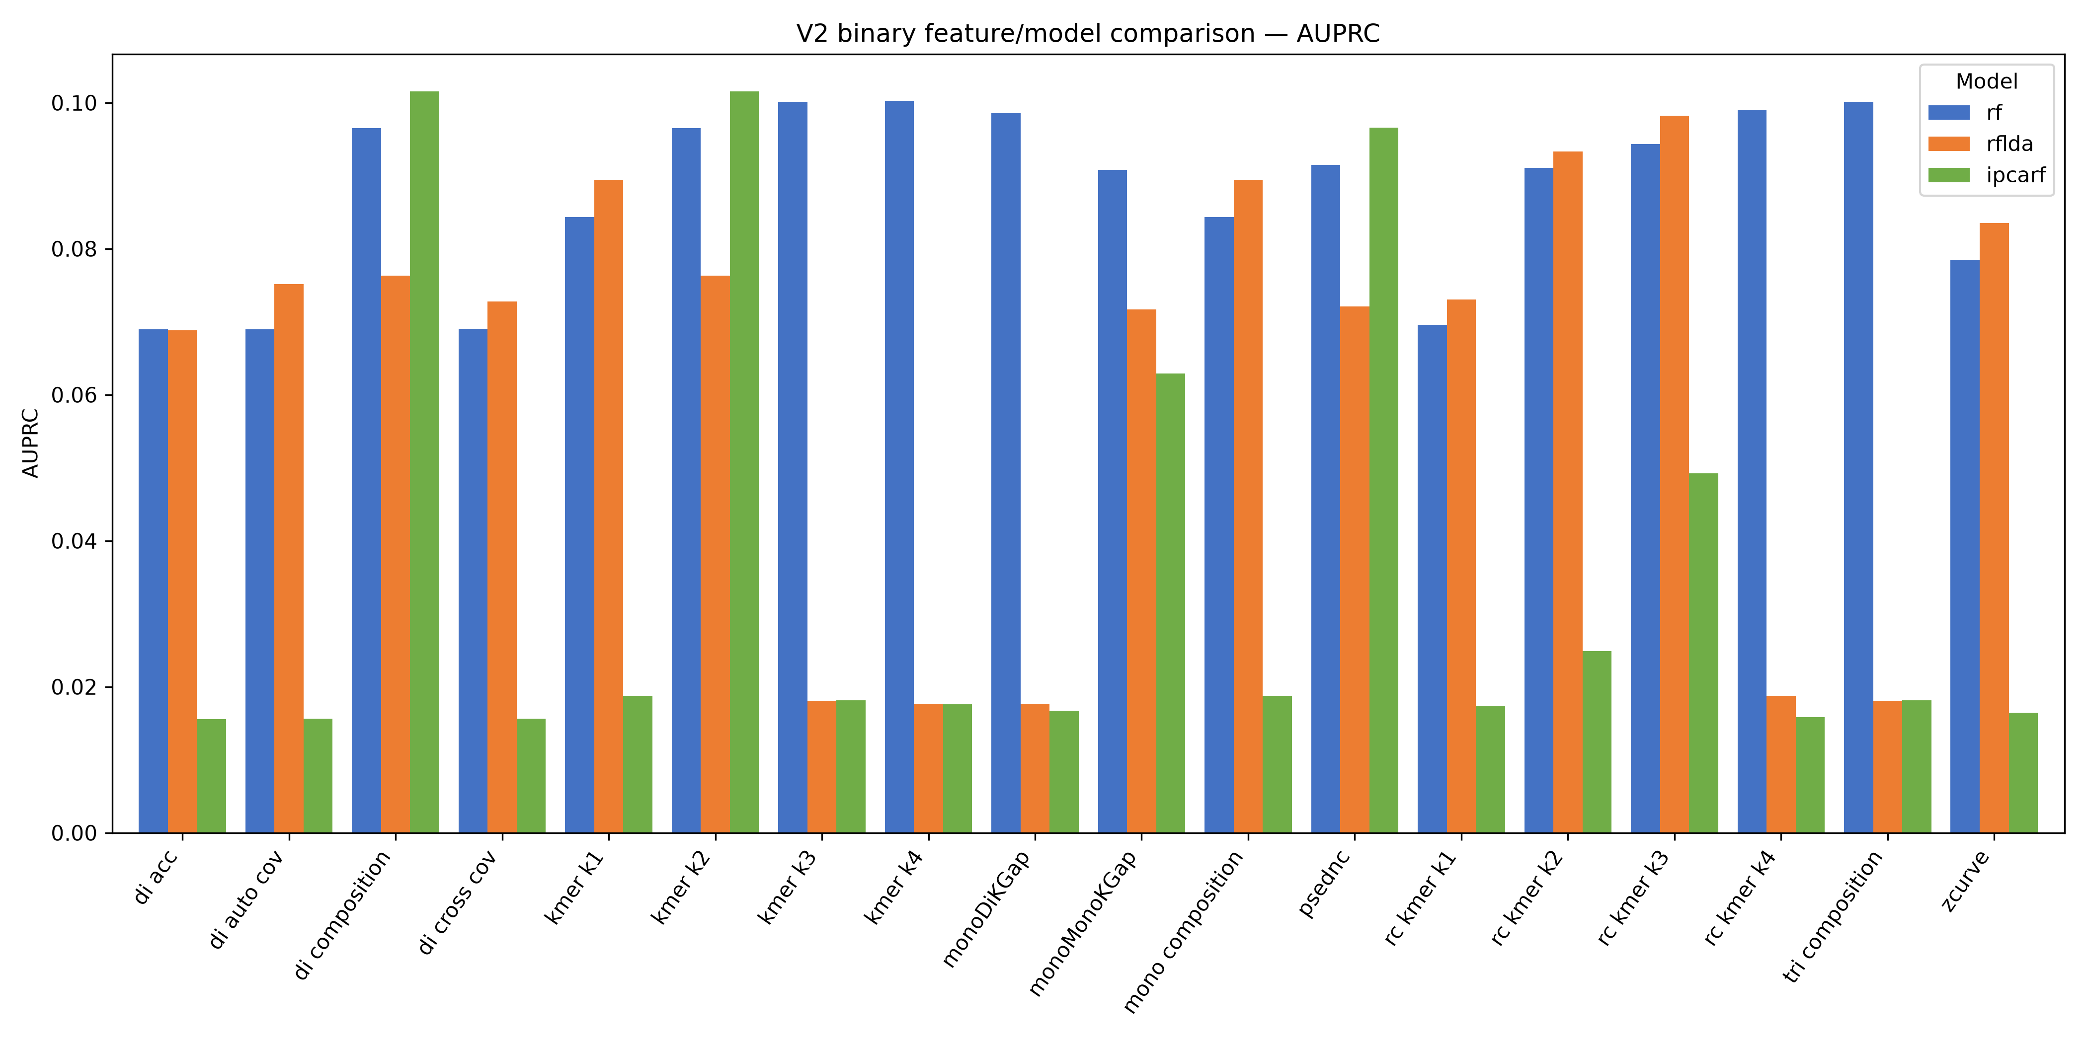
Figure 5. Binary V2 AUPRC by feature representation and model.
Rank | Model | Feature | AUPRC | AUROC | F1 @ 0.5
1 | IPCARF | k-mer k2 | 0.1016 | 0.7946 | 0.0579
2 | IPCARF | dinucleotide composition | 0.1016 | 0.7946 | 0.0579
3 | RF | k-mer k4 | 0.1002 | 0.7923 | 0.0550
4 | RF | trinucleotide composition | 0.1002 | 0.7934 | 0.0665
5 | RF | k-mer k3 | 0.1002 | 0.7934 | 0.0665
Source: final_comparison.csv; the figure is the final fixed-threshold publication graphic from the July 23 package.
IPCARF with k-mer k2 is the best V2 binary cell by AUPRC (0.1016). RF has the strongest average AUPRC across V2 binary feature spaces, whereas IPCARF supplies the best individual V2 binary cell.

9. Validation evidence and limitations
The completion claim rests on multiple layers of evidence rather than file presence alone.
Validation layer | Test performed | Observed result
Completion matrix | Matched expected cells to canonical outputs | 234 VALID_COMPLETE; 0 missing; 0 invalid
Canonical folds | Checked referenced performance files | Folds 1–10 present exactly once in all 234 cells
Transfer sidecars | Threshold, strict overlap, split count, disease list/hash | 114/114 satisfy requirements
Binary sidecars | Threshold value, split count, folds run, RNA-fold separation | 114/114 satisfy requirements
Prediction rescoring | Reconstructed labels and recomputed metrics | 234 complete; 0 failed; 0 remaining
Aggregation | Counted final comparison and publication outputs | 234 final rows; required tables and figures present
Protocol tests | Focused transfer-protocol tests | 3 passed
Evidence: E1–E7 in the appendix. “Independent” here means a separate automated verification calculation, not external peer review.

Limitations
- Cross-validation uncertainty. Reported values are fold means; differences close in magnitude may not be statistically decisive without paired uncertainty analysis.
- Severe imbalance. Low AUPRC and fixed-threshold F1 values reflect sparse positive associations; accuracy is not a headline measure.
- Cross-version domain shift. V1 and V2 differ in RNA count and disease label space; transfer is restricted to 11 shared diseases.
- Model scope. The completed matrix covers RF, RFLDA, and IPCARF only; LDA-SABC is not yet evaluated.
- Literature scope. The planned search for additional recent methods is not yet complete.
Trust statement: The package provides strong evidence that the requested experiments completed under the recorded protocol. It does not justify claiming absolute correctness, external replication, or clinical validity.

10. Completed work, next steps, and evidence index
Status | Item | Recommended action
Completed | RF/RFLDA/IPCARF: 234-cell within, transfer, and binary suite | Use canonical results for supervisor discussion and manuscript planning
Completed | Fixed-threshold rescoring, protocol sidecars, aggregation, tables, figures, verification | Preserve the July 23 package as an immutable evidence snapshot
Next | LDA-SABC recent binary method | Implement and run under the same V1/V2 RNA-fold and fixed-0.5 protocol
Next | Literature search for additional recent approaches | Create explicit inclusion criteria, shortlist methods, and estimate compute cost before expansion

Completion snapshot
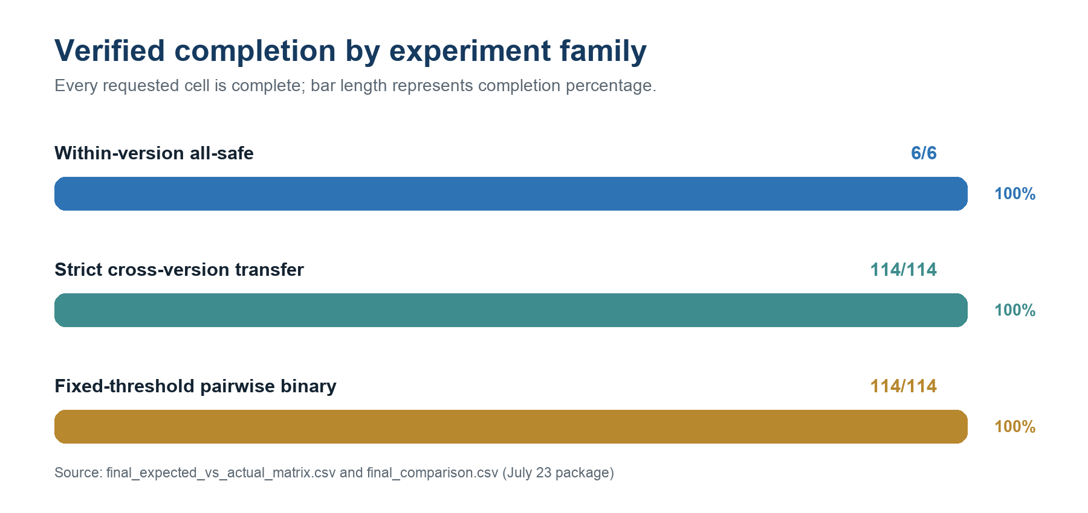
Figure 6. Verified completion by experiment family.

Compact evidence index
ID | Relative path inside July 23 package | Purpose
E1 | results/final_comparison.csv | Canonical 234-row metrics
E2 | results/audit/completion/final_expected_vs_actual_matrix.csv | Expected-versus-actual completion
E3 | results/audit/completion/final_missing_experiments.csv and final_invalid_experiments.csv | Empty missing/invalid tables
E4 | results/logs/CODEX_ALL_EXPERIMENTS_COMPLETION_STATUS.md | Final verifier output and deliverable counts
E5 | results/transfer_v1_to_v2/*.protocol.json and transfer_v2_to_v1/*.protocol.json | 114 strict-transfer sidecars
E6 | results/binary_comparison/performance/*.protocol.json | 114 binary fixed-threshold sidecars
E7 | results/audit/leakage/feature_eligibility_audit.csv and audit/threshold_protocol/threshold_audit.csv | Leakage and threshold decisions
E8 | config/canonical_shared_disease_list.csv | Authoritative 11-disease package-level list
Package root: fromserver/lncrna_disease_final_results_2026-07-23/. Authoritative transfer disease-list SHA-256: cb4961b6e488f199c6e194ebf303ba041bed0d5f03ffeb8961628af3b160cab2.
Conclusion. The canonical RF/RFLDA/IPCARF result suite is complete, internally consistent under the corrected protocol, and traceable to persisted fold-level evidence. The next scientific additions are LDA-SABC and a documented literature-driven method shortlist.

