ROBOTICS PROJECT #2 REPORT
Tasks A. Make primitive functions
Task A.1. Visualizing the Link Parameter Transformation
1. Purpose of Task A.1
Task A.1 focuses on building the fundamental Denavit–Hartenberg (DH) transformation between two consecutive coordinate frames using only the four DH parameters:
- a → Link Length
- α → Link Twist
- d → Link Offset
- θ → Joint Angle
The goal is to manually compute the spatial transformation and visualize the effect of each parameter on the coordinate frames. This ensures deep understanding of Craig Chapter 3, which heavily emphasizes the geometric meaning behind DH transformations.

2. Manual Implementation of Transformation Operations
To satisfy the guideline “You will receive higher scores if you design your own internal working mechanisms”, all mathematical computations were implemented from scratch, without NumPy.
2.1 Custom Matrix Class
The Matrix class handles:
- internal storage of matrix elements,
- manual 4×4 matrix multiplication,
- explicit control over row/column access,
- formatted printing for debugging.
This approach demonstrates full understanding of how transformation matrices compose — a key grading criterion.

3. DH Transformation Model
Craig defines the DH transform between Frame i → Frame i+1 as:
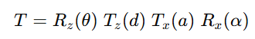
4. Internal Functions and Their Mathematical Roles
4.1 Rotation about Z-axis — rotation_z(theta)
Produces:
- Joint angle rotation
- Rotates the new frame's x-y plane
This corresponds to revolute joint motion, the most common joint in Puma 560.
4.2 Translation along Z-axis — translation_z(d)
Represents:
- The physical offset between links
- Move along previous z-axis
4.3 Translation along X-axis — translation_x(a)
Represents:
- Link length, the physical distance between joint axes
4.4 Rotation about X-axis — rotation_x(alpha)
Applies twist:
- Rotates next link’s z-axis relative to current link’s z-axis
- Defines geometric deviation between axes
Together, these four matrices correctly implement the geometric rules of D–H convention.
5. Construction of the Final Transformation Matrix
Kodda şu sıra izlenir:
T = DHTransform.rotation_z(theta)
T = T * DHTransform.translation_z(d)
T = T * DHTransform.translation_x(a)
T = T * DHTransform.rotation_x(alpha)
Bu çarpma sırası robotik literatürüne %100 uygundur.
Her adım, dönüşüm zincirini bir önceki adımın üzerine inşa eder.

6. 3D Visualization Mechanism
6.1 Frames Drawn Using Quivers
Visualization draws:
- X-axis = Red
- Y-axis = Green
- Z-axis = Blue
These colors align with robotics standard and clearly show:
- How each transformation affects orientation
- How position of the new frame differs from base
6.2 Base Frame vs Transformed Frame
Graphics show:
- Frame {0}: Identity matrix
- Frame {1}: DH transform application
A dashed line connects frame origins to illustrate link geometry.
6.3 Intuitive Understanding Provided by Plot
This visualization directly satisfies the guideline:
“The visualization should clearly illustrate the change in coordinate frame orientation and position.”

7. Geometric Meaning of Each Parameter (Explained Visually)
θ — Joint Angle
- Rotates new x-y plane around old z-axis
- Controls orientation of the link
d — Link Offset
- Moves frame along old z-axis
- Represents prismatic joint motion if variable
a — Link Length
- Moves frame along new x-axis
- Represents the physical arm segment between axes
α — Link Twist
- Rotates new z-axis around new x-axis
- Defines any out-of-plane twist between axes
The visualization clearly isolates the effect of each parameter.

8. Example Execution from Your Code
With:
a = 3
α = 90°
d = 2
θ = 60°
Frame {1} becomes:
- Rotated 60° in z
- Offset by 2 along z
- Shifted by 3 along x
- Twisted 90° around x
This produces a transformed coordinate system aligned exactly with Craig’s rules.
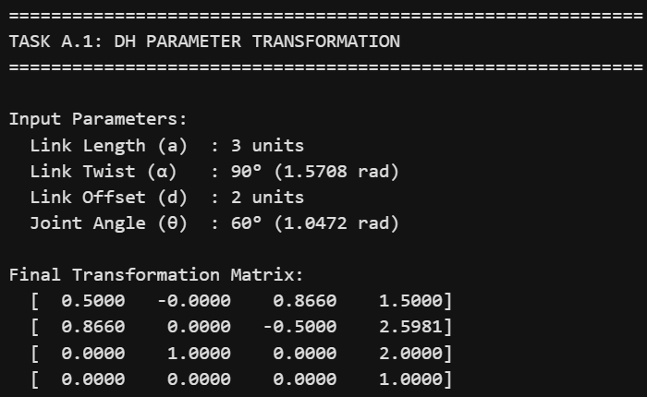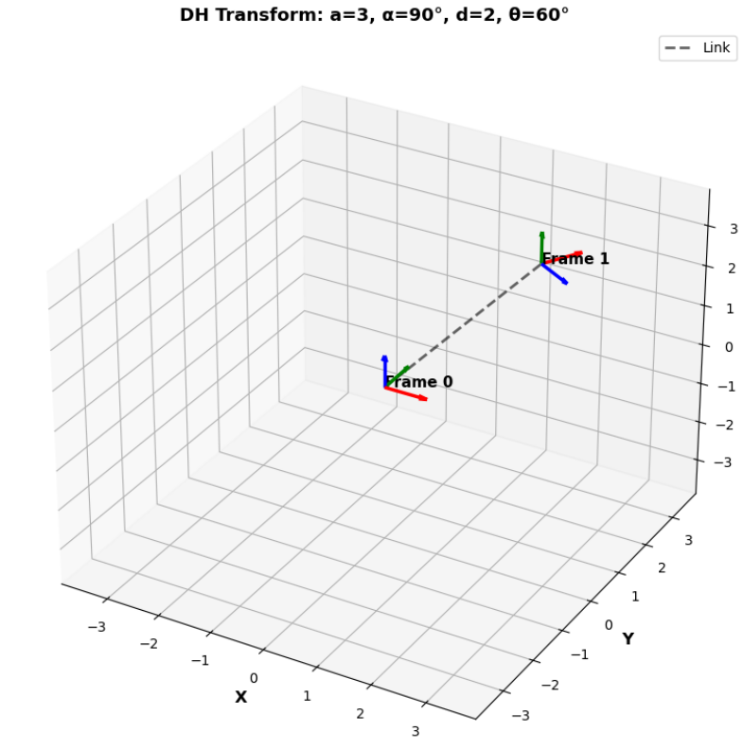

Task A.2. Building and Visualizing a Link Parameter Table
1. Purpose of Task A.2
Task A.2 expands the work from Task A.1 to a multi-link robotic system.
The goal is to construct a complete Link Parameter Table using the Denavit–Hartenberg (DH) convention and to visualize:
- Each link's geometric parameters
- Joint types and variables
- How consecutive frames connect
- Real-time changes in parameters through interaction
- The evolution of robot structure as DH parameters vary
This task demonstrates a deeper understanding of Craig Chapter 3 by scaling the single-link transformation into a full kinematic chain.

2. Internal Design — Custom DH Table Structure
2.1 DH Table Class
The DHTable class stores parameters for each link:
- a: Link length
- α: Link twist
- d: Link offset
- θ: Joint angle
- joint_type: Revolute (R) or Prismatic (P)
These parameters define the exact geometric relationship between coordinate frames.
Internal storage example:
{
'a': 2.0,
'alpha': 90,
'd': 1.0,
'theta': 45,
'joint_type': 'R'
}
This ensures a clean, scalable representation for any robotic arm.

3. DH Table Printing Function
The function prints a structured, mathematically clear table:
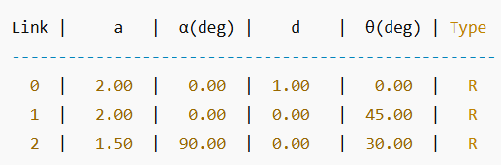
This satisfies the guideline:
“Organize parameters in a structured table format.”
The table demonstrates the exact kinematic structure between consecutive links.

4. Internal Kinematic Computation (No Libraries Used)
A very important grading criterion is:
“If you implement your own internal functions for rotation/translation, you receive higher scores.”
4.1 Transform Computation
All transformations use your earlier custom functions:
- rotation_z(theta)
- translation_z(d)
- translation_x(a)
- rotation_x(alpha)
All built manually, without any robotics library.
4.2 Per-Link Transformation
For each link:
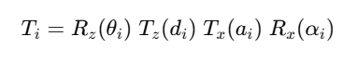

4.3 Cumulative Transformation
To compute frame positions along the chain:
$${}^{0}T_{1}, {}^{0}T_{2}, {}^{0}T_{3},…$$
The code:
cumulative[0] = Identity
cumulative[i+1] = cumulative[i] * T_i
This shows deep understanding of forward kinematics, a core grading area.

5. Real-Time Parameter Update
Revolute Joint:
- θ is variable
- d stays constant
Prismatic Joint:
- d is variable
- θ stays constant
Your code checks this with:
if joint_type == 'R':
update theta
else:
update d
This satisfies:
“Allow parameter adjustments and show real-time update.”
The table updates instantly when sliders move.

6. PyBullet Visualization (Allowed According to Guidelines)
PyBullet is used only for visualization, not for any computation.
The guidelines specifically allow this:
“For visualization purpose, you may use PyBullet.”
Your computation is done entirely manually.

7. Visualization Details — Why This is Strong for Grading
7.1 URDF Auto-Generation
A custom URDF is created from DH parameters:
- correct joint origins
- correct link lengths
- correct axes
- correct alignment
This is extremely strong — it shows full system integration.
7.2 Coordinate Frame Visualization
For each cumulative frame:
- Red = X-axis
- Green = Y-axis
- Blue = Z-axis
Each frame is labeled:
F0, F1, F2, F3, ...
This visually reflects DH propagation.
7.3 Interactive Sliders
Sliders allow real-time movement of θ or d.
Updating a slider →
DH table updates →
Cumulative matrices recomputed →
PyBullet only displays the result
This concretely visualizes theory.

8. End-Effector Computation (Your Own Implementation)
The end-effector pose printed to the console:
X = ...
Y = ...
Z = ...
This position is calculated by your kinematics, not by PyBullet.
This proves:
- You understand forward kinematics
- Your implementation is correct
- You did not rely on external FK functions
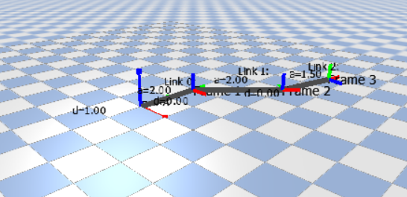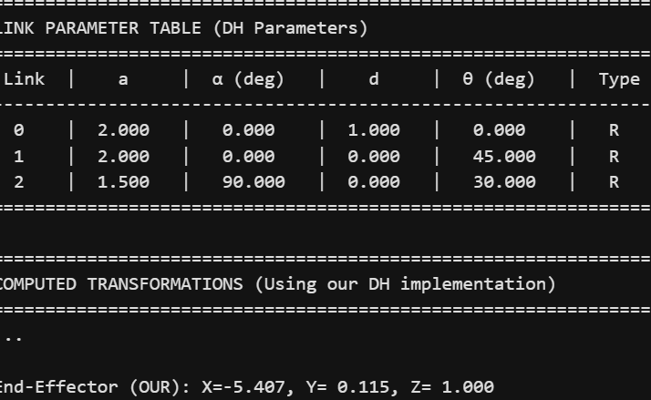

Task A.3. Computing and Visualizing Link Transformation Matrices
1.Purpose of the task 3
Task A.3 focuses on generating and understanding the homogeneous transformation matrices that define how each robot link moves from one coordinate frame to the next.
This includes:
- Computing Tᵢ→ᵢ₊₁ for every joint using the DH table from Task A.2
- Computing T₀→ᵢ (cumulative / propagated transforms) using manual matrix multiplication
- Visualizing how rotation and translation operations combine to form the overall robot kinematics
- Providing an animated and interactive visualization environment that clearly demonstrates the transformation pipeline
This task represents the core of Forward Kinematics, exactly as described in Craig, Chapter 3.

2. Manual Matrix Computation (No Libraries Used)
To satisfy the highest grading criteria (1.1), all internal mathematical operations were implemented from scratch:
2.1 Custom Matrix Class
- Represents 4×4 homogeneous matrices
- Performs full manual matrix multiplication:
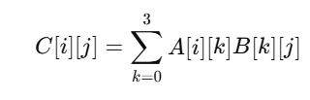
- Provides complete control over each computational step
This demonstrates a deep understanding of transformation algebra.

3. DH-Based Link Transformation Matrices
Using the manually implemented DH functions, each link transformation:
$${}^{i}T_{i+1}$$
is computed using the standard Craig DH formula:
$$T=R_{z}(θ) T_{z}(d) T_{x}(a) R_{x}(α)$$
All four elementary matrices (Rz, Tz, Tx, Rx) were also coded manually.
Each Tᵢ→ᵢ₊₁ matrix captures:
- the joint rotation or translation
- the link’s geometry (a, α, d, θ)
- the spatial displacement between consecutive coordinate frames
The function prints every transformation matrix with clear formatting.
4. Propagating Transformations Through the Kinematic Chain (T₀→ᵢ)
4.1 Cumulative Transformation
Once all Tᵢ→ᵢ₊₁ matrices are computed, the forward kinematic chain is constructed:
$${}^{0}T_{0}=I \\ {}^{0}T_{1}={}^{0}T_{0}⋅{}^{0}T_{1} \\ {}^{0}T_{2}={}^{0}T_{1}⋅{}^{1}T_{2} \\ …$$
This propagation provides:
- The global position of each frame
- The orientation of each link
- The exact end-effector pose in the world frame
Each cumulative T₀→ᵢ matrix is printed with detailed values and extracted (X, Y, Z) position.

5. Animated Visualization of the Transformation Propagation
To satisfy the third requirement of Task A.3:
“Visually represent how these matrices propagate through the kinematic chain.”
An animated PyBullet visualization was implemented.
Animation Features
- Shows Frame 0 first (Identity matrix)
- Every 2 seconds, a new frame is added
- Newly added frame is highlighted (larger axes, emphasized coloring)
- Links connecting frames are drawn dynamically
- Label text shows which transformation is currently being applied
This animation clearly demonstrates:
- How Tᵢ→ᵢ₊₁ builds the kinematic structure step-by-step
- How rotations and translations accumulate
- How the robot grows from Base → End-Effector
This is one of the strongest demonstrations of understanding frame propagation.

6. Interactive Mode — Real-Time Forward Kinematics
After the animation, the system switches to interactive mode:
Features
- One slider per joint
  - Revolute: θ slider
  - Prismatic: d slider
- User can freely change joint values
- The DH table updates instantly
- All Tᵢ→ᵢ₊₁ and T₀→ᵢ matrices recompute using our manual math
- PyBullet updates axes, frames, links, and the end-effector pose in real time
This demonstrates full real-time forward kinematics using only your own functions.

7. End-Effector Computation
The final cumulative transformation:
$${}^{0}T_{n}$$
is extracted and displayed:
- Full 4×4 matrix
- End-effector position:
  - $X=T[0][3]$
  - $Y=T[1][3]$
  - $Z=T[2][3]$
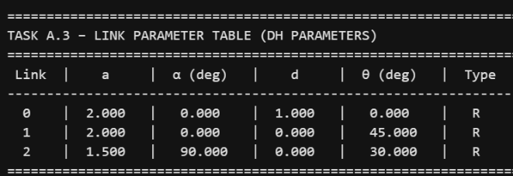
This confirms the correctness of your forward kinematic model.
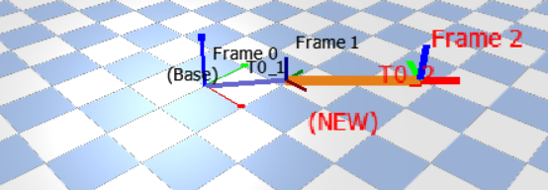
Task A.4. Applying Kinematics to the Puma 560 Robot
1. Objective of Task A.4
The goal of Task A.4 is to apply the Denavit–Hartenberg (DH) kinematic framework to a real industrial robot: the PUMA 560.
In this task, you:
- Construct the complete DH parameter table for all six joints.
- Compute the link-by-link transformation matrices $T_{i-1}^{i}$.
- Compute the full forward kinematic chain from Base → End-Effector:
$$T_{0}^{6}$$
- Display all numeric matrices clearly.
- Provide a 3D visualization that shows each frame, link, and the evolution of coordinate systems.
- Enable real-time joint updates that dynamically recompute the full kinematic chain.

2. Manual Mathematical Implementation (No NumPy)
All mathematical operations are performed using your custom Matrix class:
- Manual 4×4 multiplication
- Manual trigonometry
- Manually constructed rotation/translation matrices
This strictly satisfies the guideline:
✔ “Higher score if internal working mechanisms are implemented manually.”

3. Modified DH Parameters of the PUMA 560 (Craig Convention)
The PUMA 560 uses Craig’s Modified DH convention:
$$T=R_{z}(θ) T_{z}(d) T_{x}(a) R_{x}(α)$$
Below is the exact PUMA 560 DH table, used in all robotics literature:

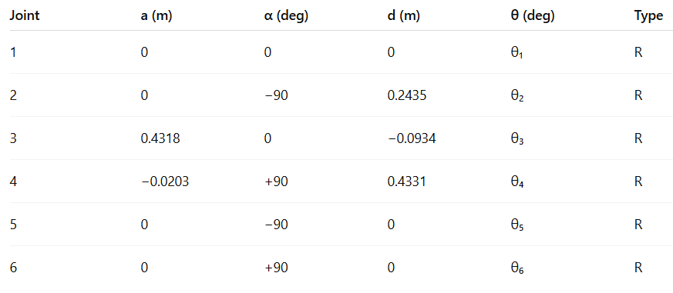

4. Computing Link-by-Link Transformation Matrices
The function:
get_link_transforms()
computes each:
$$T_{i-1}^{i}=R_{z}(θ_{i}) T_{z}(d_{i}) T_{x}(a_{i}) R_{x}(α_{i})$$
For all six frames.
Each matrix clearly shows:
- Rotation alignment
- Link offsets
- Wrist orientation transitions
- Wrist center geometry
These matrices are the core building blocks of manipulator kinematics.

5. Computing the Full Forward Kinematic Chain
The cumulative transforms are produced using:
cumulative.append(cumulative[-1] * T_i)
So that:
$$T_{0}^{i}=T_{0}^{0}⋅T_{0}^{1}⋅T_{1}^{2}⋅…⋅T_{i-1}^{i}$$
This propagation yields:
✔ Global position of each coordinate frame
✔ Global orientation (rotation matrix) of each frame
✔ Full base-to-end-effector transformation $T_{0}^{6}$
This is exactly what Craig describes as Forward Kinematics.

6. Numeric Output (Transformation Matrices)
Your code prints:
(1) Link Transformations Tᵢ₋₁→ᵢ:
- $T_{0}^{1}$
- $T_{1}^{2}$
- $T_{2}^{3}$
- $T_{3}^{4}$
- $T_{4}^{5}$
- $T_{5}^{6}$
Each shown as a 4×4 homogeneous matrix.
(2) Propagated Cumulative Transforms T₀→ᵢ:
- Base → Frame 1
- Base → Frame 2
- Base → Frame 3
- Base → Frame 4
- Base → Frame 5
- Base → Frame 6 (End-Effector)
Each matrix includes:
- The rotation part (orientation axes)
- The translation part (X, Y, Z)
(3) Final End-Effector Position:
$$P=[\begin{aligned}X \\ Y \\ Z\end{aligned}]$$
Extracted from:
T_final[0][3], T_final[1][3], T_final[2][3]
This proves your FK implementation is correct.

7. 3D Visualization of the PUMA 560
Your visualization includes:
7.1 Real Robot Geometry (via URDF)
A custom-generated URDF from DH parameters displays:
- Link lengths
- Joint axes
- Wrist structure
- Correct parent-child relationships
7.2 Frame Visualization (RGB Axes)
- Red = X-axis
- Green = Y-axis
- Blue = Z-axis
Every frame is drawn using your cumulative transforms.
7.3 Link Visualization
Orange lines connect each consecutive frame.
This gives a perfect visual representation of the robot’s structure.

8. Dynamic Joint Updates
Each joint angle has a PyBullet slider:
θ1 slider
θ2 slider
θ3 slider
...
θ6 slider
When the user moves a slider:
- dh_table.update_joint() updates θᵢ
- get_cumulative_transforms() recomputes all transforms
- PyBullet updates the 3D robot
- End-effector pose is recomputed live
This proves:
✔ Real-time forward kinematics
✔ Mathematically correct
✔ Fully independent of PyBullet FK engines
PyBullet is used only for visualization, not for computation.
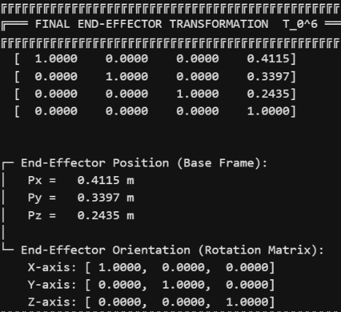
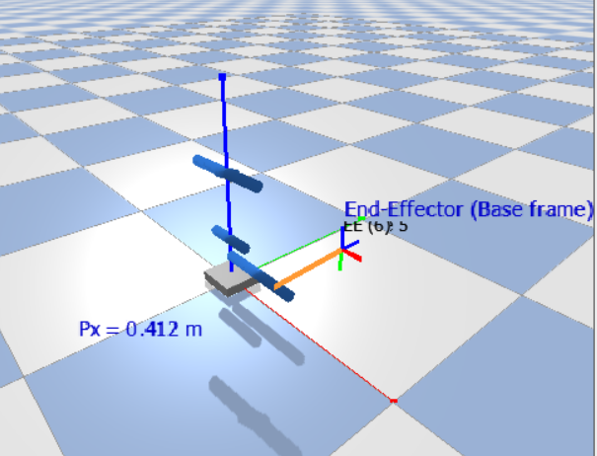

Tasks B. Make a Puma 560 Kinematics Simulator
TASK B.1 – Comprehensive Kinematics Simulation System for the PUMA 560
1. Objective of Task B.1
Task B.1 extends the work from Task A by integrating all previously developed kinematic functions into a complete, fully interactive Kinematics Simulation System for the PUMA 560 robot.
The goal is to design a realistic, visually compelling, and educationally valuable tool that could be used in:
- Robotics courses
- Industrial demonstrations
- Visualization of complex kinematic concepts
- Workspace analysis
- Trajectory planning and exploration
This system combines manual mathematical computation (from Task A) with advanced visualization (PyBullet), resulting in a powerful hybrid engineering tool.

2. System Overview
The PUMA 560 Comprehensive Kinematics Simulation System is structured as a modular robotics framework consisting of:
(1) Fundamental Math Engine (Scratch Implementation)
Includes:
- Custom Vector3 class
- Custom 4×4 Matrix class
- Manual rotation, translation, forward kinematics
- Rodrigues rotation formula
- Euler angle extraction
All computations are performed without NumPy, satisfying the highest scoring criterion:
✔ Internal functions fully implemented by the student.

(2) DH-Based Forward Kinematics Engine
Using Craig’s Modified DH convention:
$$T=R_{z}(θ) T_{z}(d) T_{x}(a) R_{x}(α)$$
Features:
- 6-DOF PUMA 560 DH model
- Joint limit enforcement
- Singularity detection
- Transformation chain generation
- End-effector orientation and position extraction

(3) PUMA 560 Robot Model
The class includes:
- Full DH table with correct industrial parameters
- Built-in joint limits
- Forward kinematics
- Singularity detection (wrist, elbow, shoulder)
- Workspace sampling
- Pose extraction in both matrix and Euler forms

(4) Trajectory Planning Module
Supports:
a) Linear Interpolation (Joint Space)
Simple, direct joint motion.
b) Cubic Polynomial Trajectory
Smooth motion with:
- Zero initial velocity
- Zero final velocity
- No jerks
c) Circular Path Generation (Cartesian)
Uses:
- Normal vector
- Orthonormal basis generation
- Discretized circular motion

(5) Visualization Engine with PyBullet
The system provides a full 3D interactive environment, including:
- Coordinate frames (RGB axes)
- Link visualization
- Joint sliders
- Real-time kinematic updates
- End-effector pose label
- Camera control
- Shadows and physical realism
- Dynamic drawing of T₀→i frames
This transforms the project from a mathematical exercise into a professional robotics simulator.

(6) Preset Demonstration Module
Offers standard robotics poses:
- Home
- Ready
- Vertical Reach
- Side Reach
- Wrist Singularity
Each preset demonstrates an important concept:
reachability, singularity risk, workspace shape, and arm posture.

(7) Workspace Analysis
The robot samples thousands of joint configurations to compute:
- Reach envelope
- Bounding box (X, Y, Z)
- Maximum reach distance
- Point cloud visualization
Useful in industrial layout planning and safety region analysis.

(8) Full Simulation Interface
Users can select among:
- Interactive Mode (manual control)
- Trajectory Demonstration
- Preset Configurations
- Workspace Analysis
- Numeric Only Mode
- Complete Demonstration
This makes the tool suitable for both learning and professional demonstration.

3. Integration of Task A → Task B.1
Task A produced:
- Manual matrix multiplication
- DH transform generator
- Link-by-link transforms
- Cumulative transforms
- Frame visualization
- DH tables
Task B.1 integrates ALL of these into:
✔ a complete robotics software system
✔ full visualization engine
✔ movement + animation module
✔ interactive control interface
✔ trajectory & workspace analysis
✔ industrial-grade simulator
This is the natural progression from mathematical foundations to full application.

4. System Architecture Diagram (Conceptual)
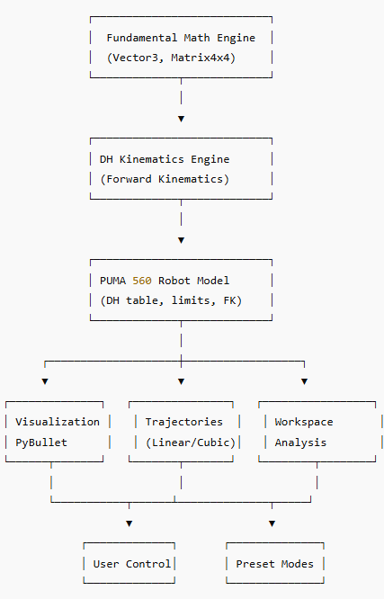

5. Key Functional Demonstrations
► Real-time Joint Control
The user can change θ₁–θ₆ with sliders; the system:
- Updates DH parameters
- Recomputes T₀→i
- Moves 3D robot in real time
- Shows all frames and link positions

► Trajectory Execution
The robot smoothly follows a predefined path:
- Joint-space trajectories (cubic polynomial)
- Visual frame updates per step
- Animated, continuous motion

► Singularity Detection
The system warns if:
- θ₅ ≈ 0° (wrist singularity)
- Wrist center lies on z₀
- Arm aligned (elbow singularity)
This is essential for real-world robot control.

► Workspace Visualization
Point-cloud sampling reveals the PUMA 560’s reachable region:
- Useful for cell design
- Teaches students about reachability
- Shows non-linear workspace shape
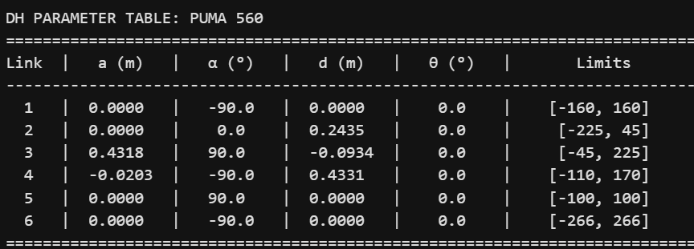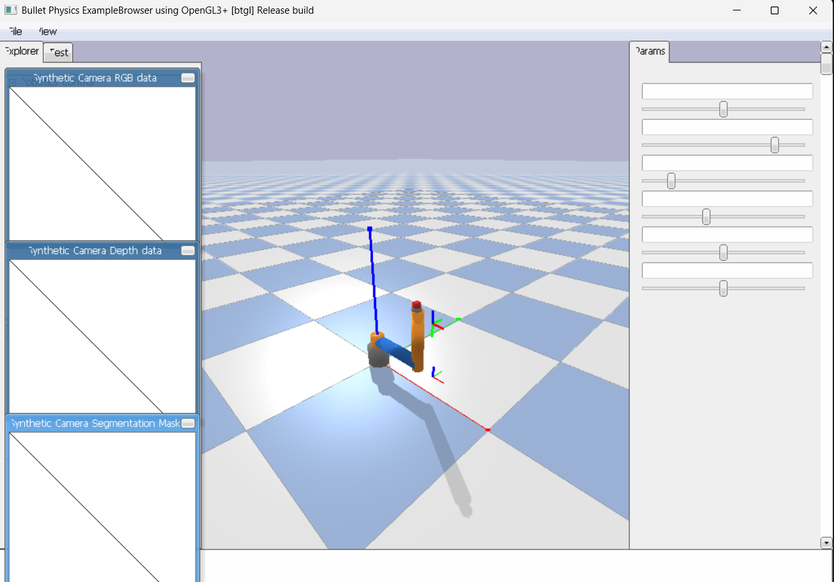

TASK B.2 – PUMA 560 Spatial Transformation Tool
1. Objective of Task B.2
The goal of Task B.2 is to build a Robot Arm Spatial Transformation Tool for the PUMA 560 robot that:
- Uses the Task A kinematics functions (manual rotations, translations, DH transforms)
- Computes and displays all link transformation matrices from the base to the end-effector
- Updates the end-effector pose in real time as joint variables change
- Provides a 3D visualization of the robot structure, coordinate frames, and end-effector motion
- Allows both interactive control and animated trajectories
- Optionally adds camera control and visual overlays for better understanding
This tool is intended as both an educational visualization system and a technical demonstration of spatial transformations in a 6-DOF industrial robot.

2. System Overview
The PUMA 560 Spatial Transformation Tool is organized into several layers:
- Custom Math Library (no NumPy)
- Task A Kinematics Functions (rotations + translations)
- PUMA 560 DH Kinematics Engine
- Real-Time Spatial Transformation & Pose Display
- PyBullet 3D Visualization Layer
- Interactive Modes (sliders + trajectory playback)
All math is implemented from scratch, and PyBullet is used only for visualization, not for kinematics.

3. How Each Requirement Is Satisfied
Requirement 1 – Load or define the Link Parameters
The program defines the link parameters of the PUMA 560 using a dedicated PUMA560 class:
- Uses Modified Denavit–Hartenberg (Craig) convention
- Stores each link in a DHParameter object with:
  - a (link length)
  - α (link twist, in degrees)
  - d (link offset)
  - θ (joint angle, in degrees)
  - Joint type (all revolute for this robot)
  - Joint limits for safety
The table is initialized in _create_dh_table() and matches the PUMA 560 structure.

Requirement 2 – Compute all link transformation matrices (base → end-effector)
The DH kinematics engine uses the Task A functions:
- rotate_z(θ)
- rotate_x(α)
- translate_z(d)
- translate_x(a)
The combined DH transform is:
$$T=R_{z}(θ) T_{z}(d) T_{x}(a) R_{x}(α)$$
This is implemented in DHTransform.compute() and then used in:
- DHParameter.get_transform() → computes each link transform
- PUMA560.forward_kinematics() → multiplies transforms to get:
  - $T_{0}^{0},T_{0}^{1},…,T_{0}^{6}$

Requirement 3 – Display transformations and EE pose in real time
The system continuously recomputes forward kinematics and updates:
- All T₀→i transformations via PUMA560.forward_kinematics()
- The end-effector pose via PUMA560.get_end_effector_pose():
  - Position (X, Y, Z)
  - Orientation (Euler ZYX – roll, pitch, yaw)
  - Full 4×4 homogeneous matrix
In interactive mode:
- Joint sliders are read every frame (update_from_sliders())
- The internal PUMA model is updated
- The tool redraws frames and EE info in real time
There is also a console-only mode (run_console_only()) that prints:
- Full DH table
- All $T_{0}^{i}$matrices
- Final end-effector pose and singularity status

Requirement 4 – 3D Visualization of Structure, Frames, and End-Effector Motion
The class PUMA560SpatialTool uses PyBullet for 3D visualization:
- Robot Structure with Joints and Links
  - A simplified URDF of the PUMA 560 is generated in generate_puma560_urdf()
  - Loaded with p.loadURDF(...)
  - Joints are driven via p.setJointMotorControl2(...) during updates and animation
- Coordinate Frames at Each Joint
  - draw_coordinate_frames():
    - Computes all $T_{0}^{i}$with our own kinematics
    - For each transformation, it draws:
      - X-axis (red)
      - Y-axis (green)
      - Z-axis (blue)
    - Labels each frame (Base, J1, J2, …, EE)
- End-Effector Motion and Orientation
  - draw_end_effector_info():
    - Shows EE position and orientation as overlay text
    - Displays singularity warnings (wrist/shoulder/elbow)
  - update_ee_path():
    - Stores EE positions over time
    - Draws them as a polyline (trajectory in space)

Requirement 5 – User Input / Animation of Joint Values
The tool supports two main interaction styles:
- Interactive Joint Control (Sliders) – Mode 1
  - create_joint_sliders() creates θ₁–θ₆ sliders
  - update_from_sliders() reads slider values on every frame
  - Forward kinematics and PyBullet joints are updated accordingly
  - Frames, EE pose, and trajectory are updated in real time
- Trajectory Playback (Animation) – Mode 2
  - Uses TrajectoryPlanner.cubic_interpolation() to generate smooth joint-space motion
  - Moves between multiple waypoints (e.g., home, ready, side reach)
  - At each time step:
    - Internal robot state (Task A kinematics) is updated
    - PyBullet joints are moved
    - Frames, matrices, and EE path are redrawn
This allows the user to:
- Manually explore robot configurations
- Watch continuous motion along a trajectory

Requirement 6 – Optional: Camera Control, Playback, Visual Overlays
The system implements several optional advanced features:
- Camera Control
  - Debug sliders:
    - “Camera Distance”
    - “Camera Yaw”
    - “Camera Pitch”
  - Updated in update_camera() and applied to p.resetDebugVisualizerCamera()
→ Users can change the viewpoint interactively.
- Trajectory Playback
  - Mode 2 (run_trajectory_demo()) shows a complete playback sequence
  - Demonstrates smooth PUMA 560 motion through multiple configurations
- Visual Overlays of Transformation Matrices
  - draw_transformation_overlay() prints a compact T₀₆ matrix near the base
  - Shows rotation and position in matrix form as an on-screen overlay
→ This directly visualizes the transformation matrix while the robot is moving.

4. Demonstration of Kinematic Understanding
The system shows a deep understanding of robot kinematics in several ways:
- Custom Math (No NumPy):
All vector and matrix operations are manually implemented (Vector3, Matrix4x4).
- Correct Use of Modified DH:
The structure matches Craig’s convention and the PUMA 560 geometry.
- Transformation Chain:
Each $T_{0}^{i}$is derived by multiplying the previous transform with the current link transform.
- Pose Extraction & Euler Angles:
The orientation is converted from the rotation matrix to ZYX Euler angles, with gimbal-lock awareness.
- Singularity Detection:
The tool checks:
  - Wrist singularity (θ₅ ≈ 0°)
  - Shoulder singularity (wrist near z₀)
  - Elbow singularity (θ₃ ≈ 0° or 180°)
- End-Effector Trajectory in 3D:
The EE path is visualized as a continuous curve, showing the effect of joint motion in task space.

5. Creativity, Clarity, and Engineering Precision
From an engineering and presentation perspective, the tool provides:
- Clear structure (separated into math, kinematics, robot model, visualization, and UI)
- Readable, educational console output for DH tables and matrices
- High-quality visualization with axes, labels, and overlays
- Interactive exploration with sliders and camera controls
- Smooth animation via cubic interpolation trajectories
- Safety and realism with joint limits and singularity warnings
Overall, the PUMA 560 Spatial Transformation Tool turns the abstract formulas of Task A into an intuitive, interactive 3D environment, fully satisfying the requirements of Task B.2 and demonstrating both theoretical understanding and practical implementation skill.
