Project Development Phase
Model Performance Test

Date | 21 February 2025
Team ID | LTVIP2025TMID25057
Project Name | CRM Application For Management
Maximum Marks

Model Performance Testing:
Project team shall fill the following information in the model performance testing template.

S.NO | Parameter | Values | Screenshot
1 | Model Summary | Salesforce automation setup for Data management using Object, Fields and Reports.  Note: Import Records if data Match Correctly then Records will Created or Else it will Show Error | 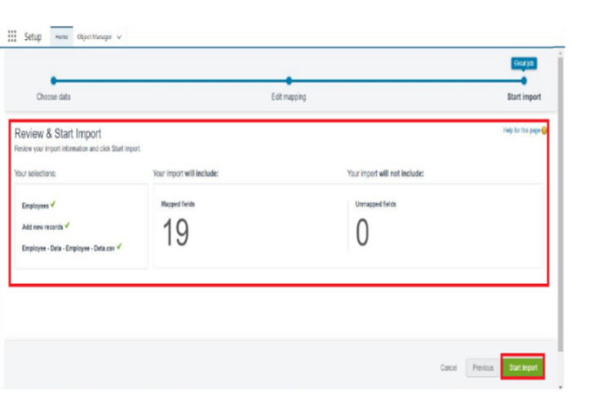
2 | Accuracy | Training Accuracy - 98%  Validation Accuracy - 98% | 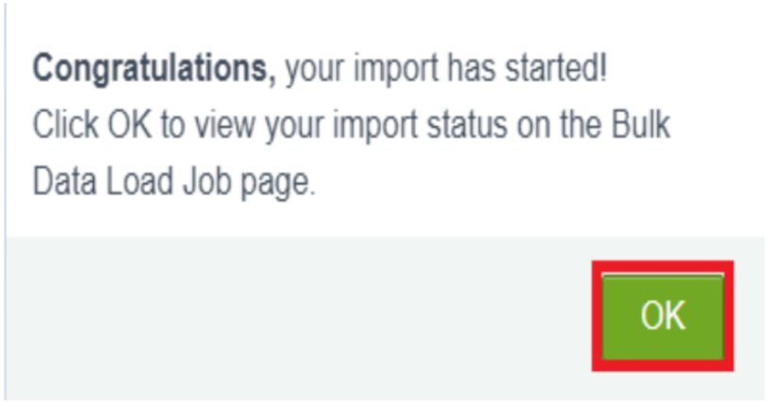
3 | Confidence Score (Only Yolo Projects) | Class Detected - If detecting Object and fields name if wrong and other activity  Confidence Score - If the model is 92% sure the object is correctly detected | 