ASSIGNMENT 1
CO1: Apply object-oriented programming principles and C++ constructs such as data types, operators and control structures to design and write structured OOP-based programs – the object-oriented
paradigm and its basic principles, tokens, keywords, identifiers, constants, data types, type compatibility, variables, operators, implicit conversions, operator precedence and control structures.

Assignment Title: Design, Implement and Validate the Fare Logic of a City Metro Smart-Card System (Total Marks - 50)
Nature of Assignment: Individual Duration: 1 Week
Submission Date: 4-11-2026
Bloom’s Levels Assessed: K5 – Evaluate (every task in this assignment is at K5 level) Mandatory Execution and GitHub Submission
- Every student must individually execute every task in this assignment, including all “Complete the Code” programs.
- Create a GitHub repository named DSA01-<RegisterNumber>-Assignment1 and share it with the course faculty (public, or private with the faculty added as a collaborator).
- Keep one folder for each task (for example: Task01, Task02 … or Q1, Q2 …), containing the C++ source files, input files and output screenshots.
- Include a README.md with your name, register number, compiler and version (for example g++ 13), the exact g++ command used to compile (for example g++ -std=c++17 -Wall -Wextra), the steps to run each program, and a short note of the result of each task.
- Commit your work progressively – at least one commit for each task. The commit history will be checked; a single upload of all files on the last day will not be accepted.
- Submit the GitHub link below and on the cover page of your report. An assignment submitted without a working GitHub link will not be evaluated.

GitHub Repository Link: https://github.com/nazma824/DSA0117
How to Answer the Additional Questions
Complete the Code: Copy the given code into your repository, replace every TODO with working code without changing the rest of the program, execute it and compare your output with the expected output.
Predict the Output: Write the exact output of the given program before running it. Then run it and explain every difference between your prediction and the actual output, using the C++ rules involved. Predictions written after running the program will not be credited.
Alternative Concept and Complexity Analysis: Describe how the solution would change if the alternative concept were used, with code or pseudocode, and analyse and compare the time

complexity and space complexity of both solutions using Big-O notation, supported by your own measurements wherever possible.

Scenario — Namma Metro Smart-Card Fare System
A city metro rail divides its network into three zones – Inner, Middle and Outer. The fare is Rs 10, Rs 20 or Rs 30 according to the farthest zone travelled, with a 20% surcharge during peak hours (8–10 AM and 5–8 PM). Passengers use a stored-value smart card, and a journey is allowed only if at least Rs 50 remains on the card after the fare is deducted. Students and senior citizens receive a
concession.
The first version of the gate software was written in a hurry. Some fares are off by a paisa, the peak check accepts 10 AM as peak and 8 PM as off-peak inconsistently, a negative balance once appeared on a card, and the fare values are typed in several places.
The number of journeys processed may grow:
1 station (20,000 journeys a day) → 1 line (500,000 a day) → whole network (3,000,000 a day)
You are required to analyse the problem, identify its objects, choose suitable C++ data types, constants, operators and control structures, implement the fare logic and validate it, so that every fare and balance is exact.
Design Challenge:
The metro is adding a fourth zone, a weekend discount and monthly passes.
Re-evaluate your original design and determine whether it should be retained, modified or redesigned.

TASK 1 – Understand the Problem and Identify the Objects 4 Marks Bloom’s Level: K5 – Evaluate
Analyse the fare problem from the object-oriented point of view. Discuss:
- The objects in the problem (card, passenger, journey, zone, fare table) and the data and behaviour of each
- How the same problem would be written in a procedural style, and what changes in an object-oriented style
- The basic principles of OOP – encapsulation, abstraction, inheritance and polymorphism – and where each could appear in this system
- The rules every correct journey must satisfy (for example: balance never below Rs 50 after a journey)

You are expected to justify each object and rule, not merely list names. Alternative Concept and Complexity Analysis
If the fare system were written in a purely procedural style (global variables and free functions) instead of SmartCard, Journey and FareTable classes, what would the solution be? Analyse whether the time per journey or the memory per card changes (both are O(1)), and compare how much code must be changed when one fare rule changes.
Evidence Expected
A clear object-oriented analysis with objects, their data and behaviour, rules and stated assumptions.

TASK 2 – Use Tokens, Keywords, Identifiers and Constants Correctly 3 Marks Bloom’s Level: K5 – Evaluate
Define the fares, surcharge and limits so that a revision is made in one place only. Discuss:
- The five kinds of tokens in your program (keywords, identifiers, constants, operators, punctuators) with examples
- #define, const and constexpr constants, and why constexpr is preferred for the fare table
- enum and enum class for zones, and why enum class is safer
- Naming rules and conventions for identifiers

Alternative Concept and Complexity Analysis
If the fares were written with #define macros instead of constexpr constants and an enum class, what would change? Compare type checking and scope, and analyse the memory used (a macro occupies no storage; a constexpr value usually does not either) and whether the running time is affected.
Evidence Expected
A single, well-named set of constants with a justified choice between #define, const, constexpr and enum class.

TASK 3 – Choose Data Types and Check Type Compatibility 4 Marks Bloom’s Level: K5 – Evaluate
Select a C++ data type for every value in the system. Discuss:
- The type chosen (bool, char, int, long long, unsigned, float, double, auto) for fares, balances, times, zone numbers and journey counts, with sizeof on your system

- Why money should be stored in integer paise and not as double rupees
- Type compatibility rules, and what the compiler does with int, double and bool values in the same expression
- The ranges from <climits> and whether int is enough for a day’s collection across the network

Alternative Concept and Complexity Analysis
If money were stored as double rupees instead of long long paise, what would the solution be?
Analyse the time per addition (O(1) in both), the space per value (8 bytes in both), and measure how the rounding error grows when n fares are added.
Evidence Expected
A justified data-type table with sizes and ranges, and evidence of one precision or overflow problem with its resolution.

TASK 4 – Control Implicit Conversions 4 Marks Bloom’s Level: K5 – Evaluate
Identify every place in the program where C++ converts a value from one type to another without being told.
Discuss:
- Integer division and integer-to-double conversion
- Comparison of signed and unsigned values, and the compiler warning it produces
- Narrowing conversions, and how brace initialisation (int x{3.7};) prevents them
- static_cast and when an explicit cast is needed

Predict the Output
Write the exact output of the program below BEFORE running it. Then compile and run it, and explain every difference between your prediction and the actual output.
#include <iostream>

int main()
{
int a = 7, b = 2; double c = a / b;

double d = static_cast<double>(a) / b; std::cout << c << ' ' << d << '\n';

char ch = 'A' + 2;
std::cout << ch << ' ' << ch + 1 << '\n';

bool flag = 5;
std::cout << flag << ' ' << std::boolalpha << flag << '\n';

unsigned int u = 1; int s = -1;
std::cout << (s < u ? "s < u" : "s >= u") << '\n';
}

My predicted output (write before running):

Explain each line of the actual output, naming the conversion that took place (integer division, char to int promotion, int to bool, signed to unsigned).
Alternative Concept and Complexity Analysis
If every conversion in the program were written explicitly with static_cast (and brace initialisation were used everywhere), instead of relying on implicit conversions, what would the solution be?
Analyse whether the running time or memory changes, and which errors are caught at compile time instead of at run time.
Evidence Expected
Identified conversion points with demonstrated surprises, and corrected code using brace initialisation or static_cast.

TASK 5 – Write Correct Expressions with the Right Precedence 4 Marks Bloom’s Level: K5 – Evaluate

Write the expressions for the peak check, the surcharge and the concession. Discuss:
- Operator precedence and associativity in each expression, including the conditional operator
?: and compound assignment
- The difference between x++ and ++x, and why i = i++ is a mistake
- The result of / and % with negative operands
- Why (hour >= 8 && hour < 10) || (hour >= 17 && hour < 20) is correct and hour >= 8 && hour < 10 || hour >= 17 && hour < 20 is equivalent but harder to read

Predict the Output
Write the exact output of the program below BEFORE running it. Then compile and run it, and explain every difference between your prediction and the actual output.
#include <iostream>

int main()
{
int x = 5, y = 3;
std::cout << x + y * 2 << ' ' << (x + y) * 2 << '\n';

int z = x++ + ++y;
std::cout << z << ' ' << x << ' ' << y << '\n';

std::cout << (x > y ? x : y) << ' ' << x % 4 * 2 << '\n';
std::cout << 10 / 3 << ' ' << 10 % 3 << ' ' << -10 / 3 << ' ' << -10 % 3 << '\n';

int k = 0;
for (int i = 0; i < 10; i += 3) k += i; std::cout << k << '\n';
}

My predicted output (write before running):

For every line, name the operators involved and the order in which precedence and associativity apply them.
Alternative Concept and Complexity Analysis
If the peak-hour check were done with a lookup table bool peak[24] indexed by the hour, instead of a combined && / || expression, what would the solution be? Analyse the time per check (O(1) in both, but fewer comparisons with the table) and the extra space of 24 bytes.
Evidence Expected
Correct, readable expressions with an operator-by-operator explanation.

TASK 6 – Design the Control Structures 4 Marks Bloom’s Level: K5 – Evaluate
Design the decision and looping logic for computing a fare and processing a day’s journeys. Discuss:
- When to use if–else, a switch on the zone, and the conditional operator
- How a for loop, a range-based for loop and a while loop could process the journeys, and which is best
- Where break and continue are needed (for example, skipping an invalid journey)
- What happens when no case of a switch matches

Write pseudocode for the fare computation following the SIMATS Engineering – Standard for Algorithmic Pseudocode before writing C++ code.
Complete the Code
Complete TODO 1 and TODO 2 below using a switch statement and integer paise, and execute the program.
#include <iomanip> #include <iostream>

enum class Zone { Inner, Middle, Outer };

constexpr int BASE_PAISE[] = {1000, 2000, 3000}; // Rs 10, Rs 20, Rs 30 constexpr int PEAK_SURCHARGE_PERCENT = 20;
constexpr long long MIN_BALANCE_PAISE = 5000; // Rs 50 must remain on the card

long long fare(Zone z, bool peak)
{
// TODO 1: Use a switch on z to pick the base fare from BASE_PAISE, then add
// PEAK_SURCHARGE_PERCENT % in peak hours using integer arithmetic only

}

bool canTravel(long long balance, long long f)
{
// TODO 2: Return true only if the balance left after paying the fare is at least
// MIN_BALANCE_PAISE

}

int main()
{
long long balance = 10000; // Rs 100.00 in paise struct Trip { Zone zone; bool peak; };
Trip trips[] = {{Zone::Inner, false}, {Zone::Outer, true}, {Zone::Middle, false}}; for (const Trip& t : trips) {
long long f = fare(t.zone, t.peak); if (canTravel(balance, f)) {
balance -= f;
std::cout << "Fare Rs " << f / 100 << '.' << std::setw(2)
<< std::setfill('0') << f % 100 << std::setfill(' ');
} else {
std::cout << "Denied (low balance)";

}
std::cout << " balance Rs " << balance / 100 << '\n';
}
}

Expected output:
Fare Rs 10.00 balance Rs 90
Fare Rs 36.00 balance Rs 54
Denied (low balance) balance Rs 54

Add a journey at exactly 10 AM and at exactly 8 PM and check that your peak rule treats them correctly.
Alternative Concept and Complexity Analysis
If the base fare were looked up from an array indexed by the zone (constexpr long long FARE[] =
{1000, 2000, 3000}) instead of a switch, what would the solution be? Analyse the time per lookup (O(1) in both; the switch may become a jump table), the space of the array, and how each design copes with a fourth zone.
Evidence Expected
Pseudocode and C++ control structures for the fare computation, with justified choices.

TASK 7 – From Procedural to Object-Oriented 4 Marks Bloom’s Level: K5 – Evaluate
Rewrite the fare logic in two styles. Discuss:
- A procedural version with separate variables and free functions
- An object-oriented version with a SmartCard class that keeps its balance private and offers deduct() and canTravel()
- How the class prevents a negative balance
- Which version is easier to change when the minimum balance changes

Alternative Concept and Complexity Analysis

If the balance were kept in a public data member instead of a private member with deduct() and canTravel(), what would the solution be? Analyse whether time or space changes (they do not), and explain which rule of the system can then be broken by any part of the program.
Evidence Expected
Two working versions and a reasoned comparison of the procedural and object-oriented designs.

TASK 8 – Read and Print Data Safely 4 Marks Bloom’s Level: K5 – Evaluate
Design the input and output of the gate program. Discuss:
- Reading values with cin and checking cin.fail() when the operator types letters instead of numbers
- Clearing the error state with cin.clear() and discarding the bad input
- Formatting money with <iomanip> (setw, setfill, fixed, setprecision)
- Printing a neat journey report

Alternative Concept and Complexity Analysis
If each input line were read with std::getline() and converted with std::stoi() inside try/catch, instead of reading numbers directly with cin >>, what would the solution be? Analyse the time to process a
line of length L (O(L) in both) and the buffer space needed, and compare how each recovers from invalid input.
Evidence Expected
Safe input handling with demonstrated recovery from invalid input, and correctly formatted output.

TASK 9 – Implement and Test the Fare Logic 4 Marks Bloom’s Level: K5 – Evaluate
Implement the complete fare logic and test it. Test:
- Normal journeys in each zone, peak and off-peak
- Boundary cases: exactly 8:00, 10:00, 17:00 and 20:00; a balance that leaves exactly Rs 50
- Invalid cases: an unknown zone, a negative recharge, letters typed for the hour
- A small set of 5 journeys whose total you calculate by hand

Alternative Concept and Complexity Analysis
If each journey were tested against a table of test cases (inputs and expected fares) in a loop, instead of separate hand-written checks, what would the solution be? Analyse the time for t tests (O(t)) and the space of the table, and how easily a new boundary case can be added.
Evidence Expected
Working source code and a test table with expected and actual results for every case.

TASK 10 – Compare Expectations with Execution 4 Marks Bloom’s Level: K5 – Evaluate
Compare what you expected with what actually happened. Discuss:
- Whether the double and integer-paise totals for 20,000, 500,000 and 3,000,000 journeys agree, and by how much they differ
- Whether int overflows for the network total
- The compiler warnings you received with -Wall -Wextra and what each meant
- Reasons for any difference

Alternative Concept and Complexity Analysis
If the network total were accumulated in an int, a long long or a double, what would happen at
3,000,000 journeys? Analyse when each type fails (overflow versus loss of precision), and compare the time per addition and the space per variable.
Evidence Expected
A reasoned comparison of expected and observed behaviour, supported by measured totals.

TASK 11 – Recommend and Defend the Final Design 4 Marks Bloom’s Level: K5 – Evaluate
Recommend the final design for the metro. Discuss:
- The types, constants and classes you recommend and why
- How a fare revision will be carried out
- The limitations of your design
- Whether the design remains correct for the whole network

Your recommendation must be based on evidence from your own experiments. Alternative Concept and Complexity Analysis
If the fare table were read from a configuration file when the gate starts, instead of being compiled into the program, what would the solution be? Analyse the extra start-up time to read z fare values and the space they occupy, against the cost of recompiling and redeploying after every revision.
Evidence Expected
A technically justified recommendation supported by your tests and measurements.

DAY-4 DESIGN CHALLENGE
TASK 12 – Re-evaluate and Adapt the Design 8 Marks Bloom’s Level: K5 – Evaluate
Changed Requirement
The metro adds a fourth zone (Airport, Rs 60), a 10% weekend discount that does not combine with the peak surcharge, and a monthly pass that allows unlimited journeys in two chosen zones.
Re-evaluate your original design. You may RETAIN → MODIFY → or REDESIGN your original solution.
- Impact Analysis – 2 Marks
Identify which constants, enum values, expressions, switch statements and classes are affected. Evidence Expected
A clear analysis of how the changed requirements affect the original design.
- Evaluation of the Original Design – 2 Marks
Evaluate whether the switch-based fare logic and the SmartCard class can absorb the changes, using worked examples.
Evidence Expected
A technically supported evaluation of the original design.
- Adaptation or Redesign – 2 Marks
Describe and implement the revised design (for example: a fare table indexed by zone, a separate discount rule, a Pass class).
Evidence Expected
An appropriate design response with working code.
- Evidence-Based Defence – 2 Marks
Defend your decision using test results and the trade-offs involved. Evidence Expected
A well-supported final decision integrating tests and the changed requirements.

MARK DISTRIBUTION
Task Bloom’s Level Marks
Task 1 – Object-Oriented Analysis K5 – Evaluate 4 Task 2 – Tokens and Constants K5 – Evaluate 3
Task 3 – Data Types and Compatibility K5 – Evaluate 4 Task 4 – Implicit Conversions K5 – Evaluate 4
Task 5 – Operators and Precedence K5 – Evaluate 4 Task 6 – Control Structures K5 – Evaluate 4
Task 7 – Procedural vs Object-Oriented K5 – Evaluate 4 Task 8 – Input and Output K5 – Evaluate 4
Task 9 – Implementation & Testing | K5 – Evaluate | 4
Task 10 – Expectation vs Execution | K5 – Evaluate | 4
Task 11 – Final Recommendation | K5 – Evaluate | 4
Subtotal 42
Task 12 – Day-4 Design Challenge | K5 – Evaluate | 8
TOTAL 50

Submission Requirements
- GitHub repository link (mandatory) containing the executed code for every task, including every completed “Complete the Code” program, with input files, output screenshots and a README.md.
- Your assignment report containing the required evidence for Tasks 1–12, including UML diagrams, pseudocode, test tables and complexity analyses.

Assessment Verification
Students may be asked to explain, execute or modify any part of their code during a brief verification discussion/viva. The student should be able to explain and defend the work submitted as their own.

Scenario – Namma Metro Smart-Card Fare System
A city metro rail divides its network into three zones:
- Inner Zone – Rs. 10
- Middle Zone – Rs. 20
- Outer Zone – Rs. 30
A 20% surcharge applies during peak hours:
- Morning: 8 AM to 10 AM
- Evening: 5 PM to 8 PM
Passengers use a stored-value smart card. A journey is allowed only if at least Rs. 50 remains on the card after the fare is deducted.
Students and senior citizens receive a concession.
The system must calculate fares accurately, prevent negative balances and handle millions of journeys.
Assumptions used in this assignment:
- Peak hours are 8:00–9:59 AM and 5:00–7:59 PM.
- Therefore, exactly 8 AM and 5 PM are peak hours, while exactly 10 AM and 8 PM are off-peak.
- The assignment does not specify the concession percentage. A 10% concession is used in the examples below as an assumption. Confirm the actual percentage with your faculty.
- Money is stored in integer paise to avoid floating-point rounding errors.
TASK 1 – Understand the Problem and Identify the Objects
1.1 Identify the objects in the system
Object-oriented programming represents a real-world system using objects. Each object contains data and behavior.
Object | Data | Behaviour
SmartCard | Card ID, balance | Checks balance, deducts fare and recharges
Passenger | Passenger ID, passenger type | Stores passenger category
Journey | Zone, hour, journey details | Represents a passenger's trip
Zone | Inner, Middle, Outer | Identifies the travel zone
FareTable | Base fares, surcharge | Calculates the correct fare
Explanation:
- SmartCard: Stores the passenger's available balance and ensures that the balance does not fall below Rs. 50 after a journey.
- Passenger: Stores passenger details and identifies whether the passenger is a regular passenger, student or senior citizen.
- Journey: Stores the details of a particular trip, such as the zone and time.
- Zone: Represents the different metro zones and their fare values.
- FareTable: Stores the fare details in one place so that changes can be made easily.
1.2 Procedural programming and object-oriented programming
Procedural programming:
In procedural programming, the system uses separate variables and functions to calculate fares and update balances.
Example functions:
- calculateFare()
- canTravel()
- deductFare()
Object-oriented programming:
In object-oriented programming, data and functions are grouped into classes.
For example, the SmartCard class stores the balance and provides functions to check and deduct the fare.
OOP is easier to maintain because each class has a separate responsibility.
1.3 Four basic principles of OOP
- Encapsulation: Combining data and functions inside a class. The SmartCard class keeps the balance private.
- Abstraction: Hiding internal implementation details and showing only necessary functions such as canTravel().
- Inheritance: StudentPassenger and SeniorPassenger can inherit common details from a Passenger class.
- Polymorphism: Different passenger types can have different concession rates using a common function.
1.4 Rules of a correct journey
- The passenger must select a valid zone.
- The hour must be between 0 and 23.
- The fare must not be negative.
- The balance after fare deduction must be at least Rs. 50.
- The card balance must never become negative.
- Fare values should be stored centrally.
Alternative Concept and Complexity Analysis
If the system uses procedural programming, it will use global variables and separate functions.
Both procedural and object-oriented implementations take O(1) time for one journey and O(1) memory for one card.
However, when fare rules change, procedural programming may require changes in multiple functions. In OOP, the changes can be made mainly inside the FareTable class.
TASK 2 – Use Tokens, Keywords, Identifiers and Constants Correctly
2.1 Five kinds of C++ tokens
Tokens are the smallest meaningful elements of a C++ program.
Token | Examples
Keywords | class, int, if, return, public
Identifiers | SmartCard, balancePaise, calculateFare
Constants | 5000, 20, true
Operators | +, -, *, /, ==, &&
Punctuators | ;, (), , []
2.2 Difference between #define, const and constexpr
- #define: Used for textual substitution. It does not provide normal type checking.
- const: Creates a read-only variable.
- constexpr: Allows values to be evaluated at compile time when possible.
constexpr is preferred for fixed fare values because it is type-safe and can be checked by the compiler.
Example:
C++
enum class Zone {
Inner,
Middle,
Outer
};

constexpr long long MIN_BALANCE_PAISE = 5000;
constexpr int PEAK_SURCHARGE_PERCENT = 20;

constexpr long long BASE_FARE_PAISE[] = {
1000, 2000, 3000
};

2.3 enum and enum class
An enum represents a group of named constant values.
An enum class is safer because its values are scoped.
Example:
C++
enum class Zone {
Inner,
Middle,
Outer
};
We access the values using:
C++
Zone::Inner
Zone::Middle
Zone::Outer
2.4 Naming rules
- Variable names should be meaningful.
- Names should not begin with a number.
- Keywords cannot be used as identifiers.
- Variables and functions can use camelCase.
- Constants can use uppercase letters.
Alternative Concept and Complexity Analysis
If macros were used instead of constexpr, type checking and scope safety would be weaker.
Both usually have no significant runtime difference because the compiler can optimise constant values.

TASK 3 – Choose Data Types and Check Type Compatibility
3.1 Data types used in the system
Value | Data type | Reason
Fare | long long | Stores fare in paise
Balance | long long | Stores large money values
Hour | int | Stores values from 0 to 23
Zone | enum class | Represents valid zones
Peak hour | bool | Stores true or false
Passenger ID | string | Stores passenger identification
Journey count | long long | Supports large journey counts
Character | char | Stores a single character
3.2 Why money should be stored in integer paise
Money should be stored as integer paise instead of double rupees because floating-point values may produce rounding errors.
For example:
C++
double amount = 0.1 + 0.2;
The result may not be represented exactly as 0.30.
Instead, store money in paise:
C++
long long amount = 10 + 20;
The result is exactly 30 paise.

3.3 Type compatibility
When different data types are used in one expression, C++ may automatically convert one type into another.
Example:
C++
int a = 10;
double b = 2.5;
double result = a + b;
Here, the integer value is converted to double.
A bool value can also convert into an integer:
- true becomes 1
- false becomes 0
3.4 Size of data types
The following code displays the sizes on the computer being used.
C++
#include <iostream>
#include <climits>
using namespace std;
int main() {
cout << "int: " << sizeof(int) << endl;
cout << "long long: " << sizeof(long long) << endl;
cout << "double: " << sizeof(double) << endl;
cout << "bool: " << sizeof(bool) << endl;
cout << "char: " << sizeof(char) << endl;
cout << "INT_MAX: " << INT_MAX << endl;
cout << "LLONG_MAX: " << LLONG_MAX << endl;
return 0;
}
Common sizes are:
Data type | Common size
int | 4 bytes
long long | 8 bytes
double | 8 bytes
bool | 1 byte
char | 1 byte
Actual sizes should be recorded from the compiler used.
Alternative Concept and Complexity Analysis
Both double and long long commonly use 8 bytes and perform addition in O(1) time.
However, long long stores integer paise exactly, whereas double may introduce rounding errors.
If 3,000,000 journeys each cost Rs. 36, the total is Rs. 108,000,000 or 10,800,000,000 paise. This exceeds the usual maximum value of a 32-bit signed int when stored in paise. Therefore, long long is safer.
TASK 4 – Control Implicit Conversions
4.1 Meaning of implicit conversion
Implicit conversion happens when C++ automatically changes one data type into another.
Examples include:
- Integer to double conversion.
- Integer to bool conversion.
- Character to integer promotion.
- Signed to unsigned conversion.

The given program is:
C++
#include <iostream>
using namespace std;
int main() {
int a = 7, b = 2;
double c = a / b;
double d = static_cast<double>(a) / b;
cout << c << ' ' << d << '\n';
char ch = 'A' + 2;
cout << ch << ' ' << ch + 1 << '\n';
bool flag = 5;
cout << flag << ' '
<< boolalpha << flag << '\n';
unsigned int u = 1;
int s = -1;
cout << (s < u ? "s < u" : "s >= u") << '\n';
}

output:
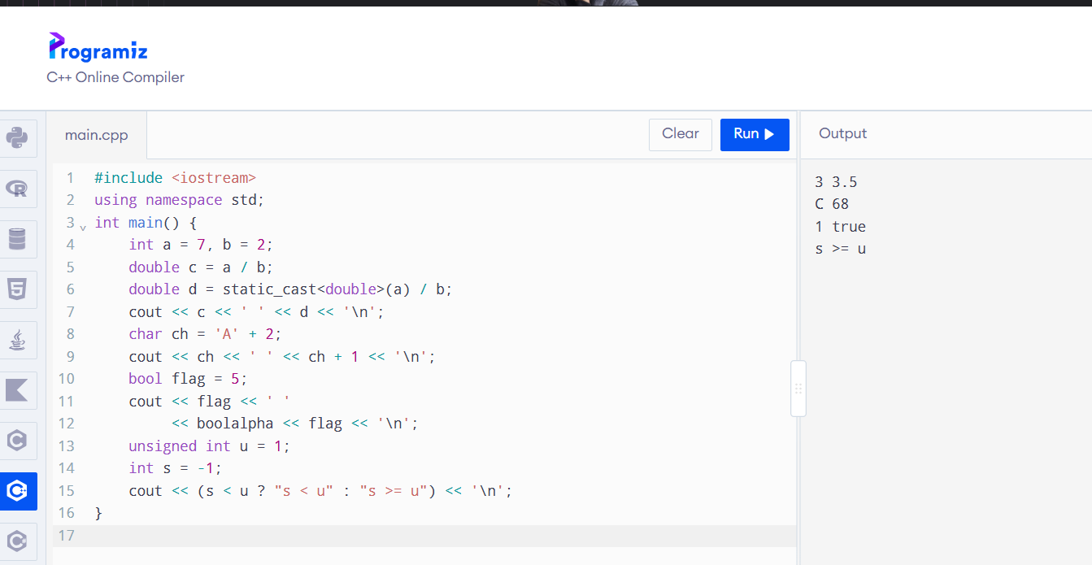4.3 Explanation
- a / b performs integer division. Therefore, 7 / 2 gives 3. The second expression converts 7 into double before division, giving 3.5.
- Character arithmetic promotes char to int. Therefore, 'A' + 2 produces C. In ch + 1, the character is promoted to an integer, giving 68.
- The integer 5 converts to bool true. By default, true is printed as 1. After boolalpha, it is printed as true.
- When comparing signed and unsigned integers, -1 is converted to an unsigned value. Therefore, the condition s < u is false.
Alternative Concept and Complexity Analysis
Explicit conversions can be written using static_cast.
Brace initialisation can prevent narrowing conversions.
Example:
C++
int x{3.7};
This produces a compilation error because converting 3.7 into an integer would lose information.
Explicit conversions improve code clarity but generally do not change runtime complexity.
TASK 5 – Write Correct Expressions with the Right Precedence (4 Marks)
5.1 Peak-hour expression
The correct peak-hour condition is:
C++
bool peak =
(hour >= 8 && hour < 10) ||
(hour >= 17 && hour < 20);
This checks two time periods:
- Morning: 8 AM to before 10 AM.
- Evening: 5 PM to before 8 PM.
5.2 Surcharge calculation
C++
long long surcharge = (baseFare * 20 + 50) / 100;

long long finalFare = baseFare + surcharge;
This calculates the 20% surcharge using integer arithmetic and rounds to the nearest paise.
5.3 Difference between x++ and ++x
- x++ returns the old value and then increments.
- ++x increments first and then returns the new value.
Example:
C++
int x = 5;

cout << x++;
Output:
Plain text
5
After execution, x becomes 6.
5.4 Predict the output
The given program is:
C++
#include <iostream>
using namespace std;
int main() {
int x = 5, y = 3;
cout << x + y * 2 << ' '
<< (x + y) * 2 << '\n';
int z = x++ + ++y;
cout << z << ' ' << x << ' ' << y << '\n';
cout << (x > y ? x : y) << ' '
<< x % 4 * 2 << '\n';
cout << 10 / 3 << ' '
<< 10 % 3 << ' '
<< -10 / 3 << ' '
<< -10 % 3 << '\n';
int k = 0;
for (int i = 0; i < 10; i += 3)
k += i;
cout << k << '\n';
}

Predicted output:
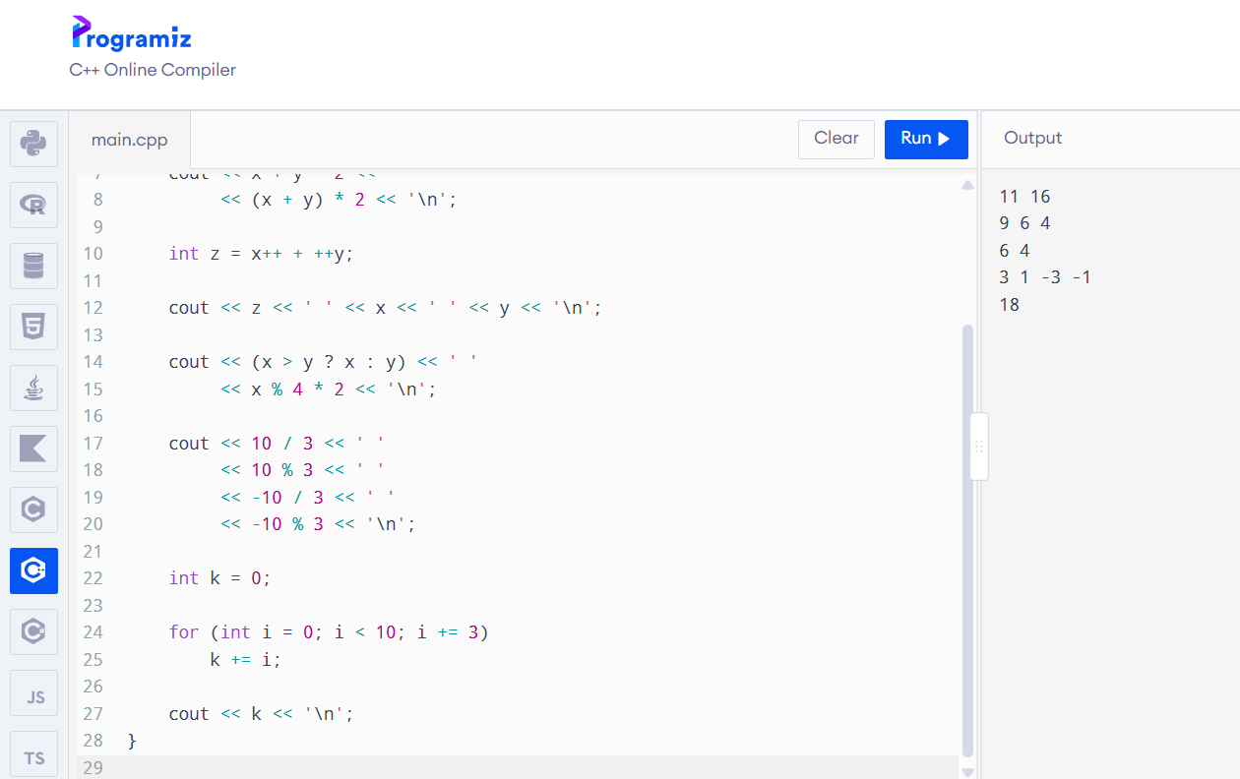
Explanation
- Multiplication has higher precedence than addition.
- x++ uses the old value of x and then increments it.
- ++y increments y before using its value.
- The conditional operator selects the larger value.
- The remainder operator % returns the remainder.
- The loop adds 0, 3, 6 and 9, producing 18.
Alternative Concept and Complexity Analysis
A lookup table can be used instead of a combined logical expression:
C++
bool peak[24];
The lookup operation takes O(1) time and uses approximately 24 bytes if bool occupies one byte. It may reduce comparisons, but the table must be initialised correctly.

TASK 6 – Design the Control Structures (4 Marks)
6.1 Control structures used
if–else: Used to check whether the passenger has enough balance.
switch: Used to select the fare based on the zone.
for loop: Used to process a known number of journeys.
while loop: Used when input continues until a condition is met.
break: Used to exit a switch case or loop.
continue: Used to skip an invalid journey and process the next one.
6.2 Pseudocode
- START.
- Read the zone, hour and card balance.
- Validate the zone and hour.
- Select the base fare.
- Check whether the journey occurs during peak hours.
- If peak, calculate the surcharge.
- Calculate the final fare.
- Check whether the remaining balance is at least Rs. 50.
- If sufficient, deduct the fare.
- Otherwise, deny the journey.
- Display the final balance.
- STOP.
6.3 Completed C++ program
C++
#include <iomanip>
#include <iostream>
using namespace std;
enum class Zone {
Inner,
Middle,
Outer
};
constexpr long long BASE_PAISE[] = {
1000, 2000, 3000
};
constexpr int PEAK_SURCHARGE_PERCENT = 20;
constexpr long long MIN_BALANCE_PAISE = 5000;
long long fare(Zone z, bool peak) {
long long base = 0;
switch (z) {
case Zone::Inner:
base = BASE_PAISE[0];
break;
case Zone::Middle:
base = BASE_PAISE[1];
break;
case Zone::Outer:
base = BASE_PAISE[2];
break;
default:
return -1;
}
if (peak) {
base += (base * PEAK_SURCHARGE_PERCENT + 50) / 100;
}
return base;
}
bool canTravel(long long balance, long long f) {
return f >= 0 &&
balance - f >= MIN_BALANCE_PAISE;
}
int main() {
long long balance = 10000;
struct Trip {
Zone zone;
bool peak;
};
Trip trips[] = {
{Zone::Inner, false},
{Zone::Outer, true},
{Zone::Middle, false}
};
for (const Trip& t : trips) {
long long f = fare(t.zone, t.peak);
if (canTravel(balance, f)) {
balance -= f;
cout << "Fare Rs "
<< f / 100 << '.'
<< setw(2) << setfill('0')
<< f % 100 << setfill(' ');
}
else {
cout << "Denied (low balance)";
}

cout << " balance Rs "
<< balance / 100 << '\n';
}
}
output
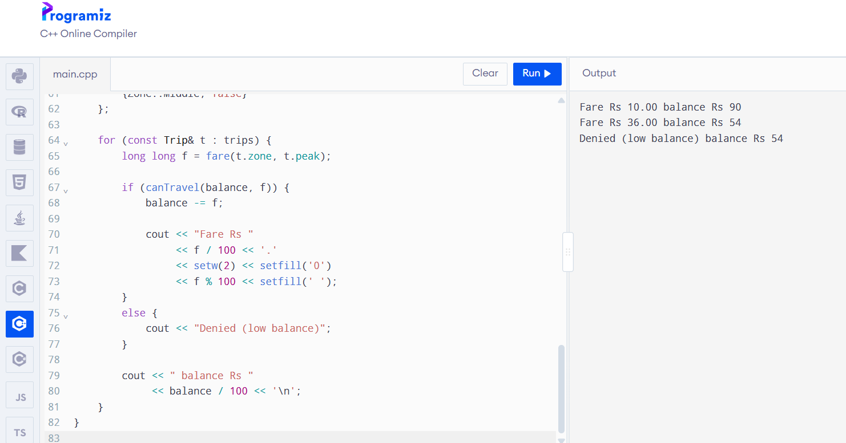Explanation
The starting balance is Rs. 100.
- First journey: Rs. 10 is deducted. Remaining balance = Rs. 90.
- Second journey: Rs. 30 + 20% surcharge = Rs. 36. Remaining balance = Rs. 54.
- Third journey: Rs. 20 cannot be deducted because the remaining balance would become Rs. 34, which is below Rs. 50. Therefore, the journey is denied.
Alternative Concept and Complexity Analysis
An array can be used instead of switch to select the fare.
Both approaches take O(1) time. An array makes it easier to add new zones by adding another fare entry.
TASK 7 – From Procedural to Object-Oriented Programming

7.1 Procedural programming
Procedural programming uses separate variables and functions.
Example:
C++
long long balance = 10000;
bool canTravel(long long balance, long long fare) {
return balance - fare >= 5000;
}

void deductFare(long long &balance, long long fare) {
if (canTravel(balance, fare)) {
balance -= fare;
}
}
7.2 Object-oriented programming
Object-oriented programming uses classes and objects.
Example:
C++
class SmartCard {
private:
long long balancePaise;
static constexpr long long MIN_BALANCE = 5000;
public:
explicit SmartCard(long long initial)
: balancePaise(initial) {}

bool canTravel(long long fare) const {
return fare >= 0 &&
balancePaise - fare >= MIN_BALANCE;
}
bool deduct(long long fare) {
if (!canTravel(fare)) {
return false;
}
balancePaise -= fare;
return true;
}
long long balance() const {
return balancePaise;
}
};
7.3 Comparison
Procedural programming | Object-oriented programming
Uses separate variables | Uses classes and objects
Uses free functions | Uses member functions
Data may be accessed directly | Private data is protected
Harder to manage large systems | Easier to maintain large systems
Both approaches take O(1) time per journey and O(1) memory per card.

Alternative Concept and Complexity Analysis
If balance were public, any part of the program could change it directly. This could produce a negative balance or violate the Rs. 50 minimum balance rule.
Private data members protect the balance and make the system safer.
TASK 8 – Read and Print Data Safely
8.1 Reading input using cin
The cin statement reads input from the user.
If the user enters letters instead of a number, the input operation fails.
We can check this using cin.fail().
8.2 Handling invalid input
C++
#include <iostream>
#include <limits>
using namespace std;
int main() {
int hour;
cout << "Enter hour (0-23): ";
while (!(cin >> hour) ||
hour < 0 || hour > 23) {
cout << "Invalid hour. Enter again: ";
cin.clear();
cin.ignore(
numeric_limits<streamsize>::max(),
'\n'
);
}
cout << "Accepted hour: " << hour << endl;

return 0;
}
8.3 Formatting output
The <iomanip> header provides formatting functions:
- setw() sets the width.
- setfill() fills empty spaces.
- fixed displays fixed decimal notation.
- setprecision() controls decimal places.
Alternative Concept and Complexity Analysis
Another method is to use getline() to read a complete line and stoi() to convert it into an integer.
Both approaches take O(L) time to process a line of length L.
getline() provides more control over complete input lines, while cin is convenient for formatted input.

TASK 9 – Implement and Test the Fare Logic
9.1 Test cases
Test | Input / Condition | Expected Result
1 | Inner zone, off-peak | Rs. 10
2 | Middle zone, off-peak | Rs. 20
3 | Outer zone, off-peak | Rs. 30
4 | Outer zone, peak | Rs. 36
5 | Exactly 8:00 AM | Peak
6 | Exactly 10:00 AM | Off-peak
7 | Exactly 5:00 PM | Peak
8 | Exactly 8:00 PM | Off-peak
9 | Remaining balance exactly Rs. 50 | Journey accepted
10 | Remaining balance Rs. 49.99 | Journey denied
11 | Invalid zone | Input rejected
12 | Letters entered for hour | Input rejected and reprompted
9.2 Five-journey hand calculation
Assume the starting balance is Rs. 200.
Journey | Fare
Inner off-peak | Rs. 10
Middle peak | Rs. 24
Outer off-peak | Rs. 30
Inner peak | Rs. 12
Middle off-peak | Rs. 20
Total | Rs. 96
Final balance:
Rs. 200 − Rs. 96 = Rs. 104
Alternative Concept and Complexity Analysis
A table of test cases can be used to check all inputs and expected results.
For t test cases, the time complexity is O(t), and the test table requires O(t) space.
TASK 10 – Compare Expectations with Execution
10.1 Calculate total fares
Assume every journey costs Rs. 36 for this comparison.
Number of journeys | Total in rupees | Total in paise
20,000 | Rs. 720,000 | 72,000,000
500,000 | Rs. 18,000,000 | 1,800,000,000
3,000,000 | Rs. 108,000,000 | 10,800,000,000
These are theoretical totals, not measured system results.
10.2 Integer overflow
An int commonly has a maximum value of 2,147,483,647.
The total of 10,800,000,000 paise exceeds this value.
Therefore, int may overflow when storing the total.
The long long data type is recommended because it can store much larger integer values.
10.3 Comparison of data types
Data type | Advantage | Limitation
int | Uses less memory | May overflow
long long | Stores large integer values | Uses more memory than int
double | Supports decimal values | May produce rounding errors
10.4 Compiler warnings
Compile using:
Bash
g++ -std=c++17 -Wall -Wextra filename.cpp -o program
Common warnings include:
- Signed and unsigned comparison.
- Unused variables.
- Narrowing conversions.
- Missing return statements.
Record the actual warnings shown by your compiler.
Alternative Concept and Complexity Analysis
All three data types perform addition in O(1) time.
However, int can overflow at large totals, double can introduce precision errors, and long long is suitable for large integer-paise totals.
TASK 11 – Recommend and Defend the Final Design
11.1 Recommended design
The following design is recommended for the metro smart-card system:
- Use enum class Zone to represent zones.
- Use constexpr to define fixed fare values.
- Store money using long long integer paise.
- Use a SmartCard class to manage card balance.
- Use a FareTable component to calculate fares.
- Validate user input before processing journeys.
- Use long long for large journey totals.
11.2 Advantages
- Prevents negative balances.
- Avoids floating-point money errors.
- Makes fare changes easier.
- Supports large numbers of journeys.
- Improves code organisation.
- Makes testing easier.
11.3 Limitations
The original design supports only three zones.
If the metro changes its fares, the program must be updated and recompiled when fares are stored as compile-time constants.
Alternative Concept and Complexity Analysis
Fare values can also be stored in a configuration file.
Reading z fares from a file takes O(z) time at startup and requires O(z) storage.
This allows fare changes without recompiling the entire program, but the file must be validated carefully.
TASK 12 – Day-4 Design Challenge: Re-evaluate and Adapt the Design
Changed requirements
The metro introduces:
- A fourth zone called Airport with a fare of Rs. 60.
- A 10% weekend discount.
- The weekend discount cannot be combined with the peak surcharge.
- A monthly pass that allows unlimited journeys in two selected zones.
A. Impact Analysis (2 Marks)
The following changes are required:
- Add Airport to the Zone enum.
- Add Rs. 60 to the fare table.
- Modify the fare calculation function.
- Add a weekend condition.
- Add a Pass class.
- Update the test cases.
The original SmartCard class can still be used for stored-value journeys.
B. Evaluation of the Original Design (2 Marks)
The original switch statement can be modified to support the fourth zone.
However, if more zones are added in the future, the switch statement will require additional cases.
A fare table is easier to extend because a new fare can be added to the table.
The SmartCard class can remain unchanged because its responsibility is to manage the card balance.
A separate Pass class should manage monthly-pass eligibility.
Worked examples:
- Weekday peak Inner fare = Rs. 10 + 20% = Rs. 12.
- Weekend Inner fare = Rs. 10 − 10% = Rs. 9.
- Airport off-peak fare = Rs. 60.
The weekend discount takes priority over the peak surcharge.
C. Adaptation and Revised C++ Code
C++
#include <iostream>
#include <array>
using namespace std;

enum class Zone {
Inner,
Middle,
Outer,
Airport
};

constexpr array<long long, 4> FARE = {
1000, 2000, 3000, 6000
};

long long calculateFare(
Zone z,
int hour,
bool weekend
) {
int i = static_cast<int>(z);

if (i < 0 || i >= 4 ||
hour < 0 || hour > 23) {
return -1;
}

long long f = FARE[i];

if (weekend) {
f = (f * 90 + 50) / 100;
}
else {
bool peak =
(hour >= 8 && hour < 10) ||
(hour >= 17 && hour < 20);

if (peak) {
f += (f * 20 + 50) / 100;
}
}

return f;
}

class Pass {
private:
Zone first;
Zone second;

public:
Pass(Zone a, Zone b)
: first(a), second(b) {}

bool covers(Zone z) const {
return z == first || z == second;
}
};

int main() {
Pass monthly(
Zone::Inner,
Zone::Middle
);

cout << calculateFare(
Zone::Inner, 8, false
) << " paise\n";

cout << calculateFare(
Zone::Inner, 8, true
) << " paise\n";

cout << calculateFare(
Zone::Airport, 12, false
) << " paise\n";

cout << (monthly.covers(Zone::Inner)
? "yes" : "no") << '\n';

cout << (monthly.covers(Zone::Airport)
? "yes" : "no") << '\n';

return 0;
}

output:
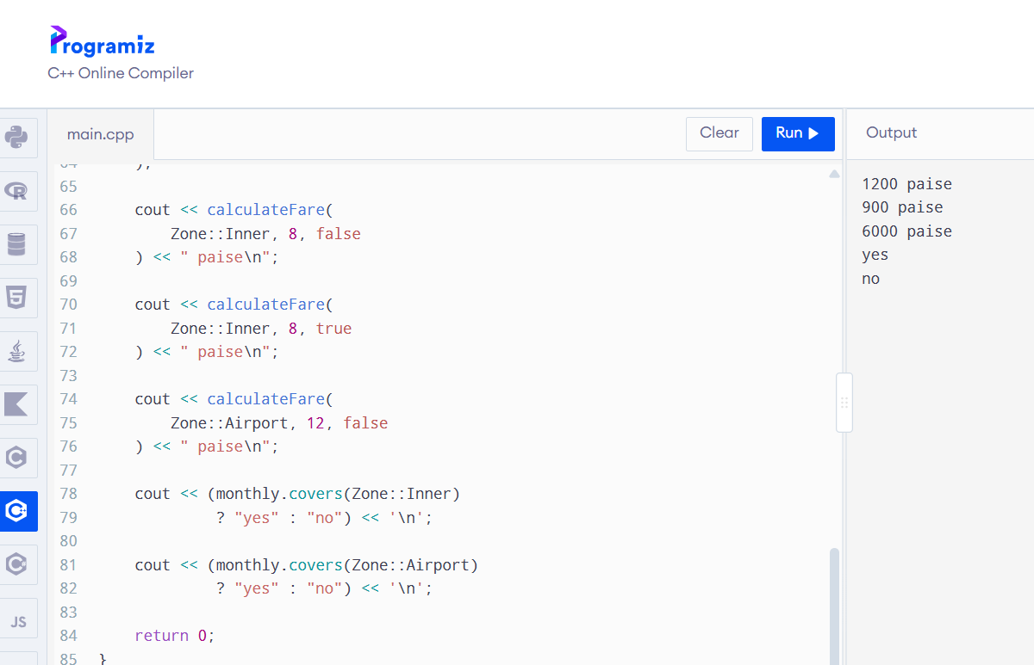D. Evidence-Based Defence (2 Marks)
The recommended decision is to modify the original design.
The SmartCard class can be retained because it manages the balance and fare deduction.
The three-zone fare selection should be changed into a four-zone fare table.
The weekend discount should be implemented as a separate condition so that it does not combine with the peak surcharge.
A separate Pass class should manage the two zones covered by a monthly pass.
The fare lookup and pass-coverage check take O(1) time.
The revised design is easier to maintain and extend when new requirements are introduced.
A real metro system would also need to handle pass expiry dates, passenger identification and route validation.

Conclusion
The Namma Metro Smart-Card Fare System demonstrates how C++ programming concepts can be applied to a real-world transportation system.
The assignment uses object-oriented programming, data types, constants, operators, control structures and input validation to calculate fares accurately.
Storing money as integer paise avoids floating-point rounding problems. Using long long prevents overflow for large network totals. Encapsulation protects the smart-card balance from invalid changes.
The revised design supports the Airport zone, weekend discounts and monthly passes. Therefore, modifying the original design with a fare table and a separate Pass class provides a flexible and maintainable solution.

