Cisco Networking Academy Program

**Course summary:**

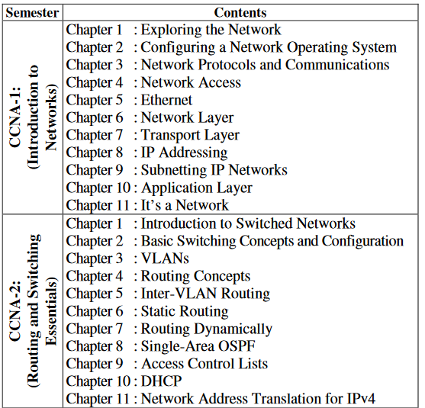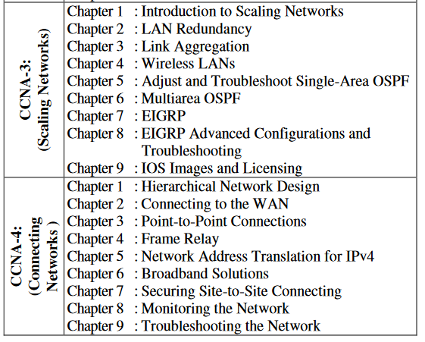

*Khulna University of Engineering & Technology*

*Department of Computer Science and Engineering*