Goochland

Which land use categories are considered rural?

Which crops will be in the categories that you make? (see table below)

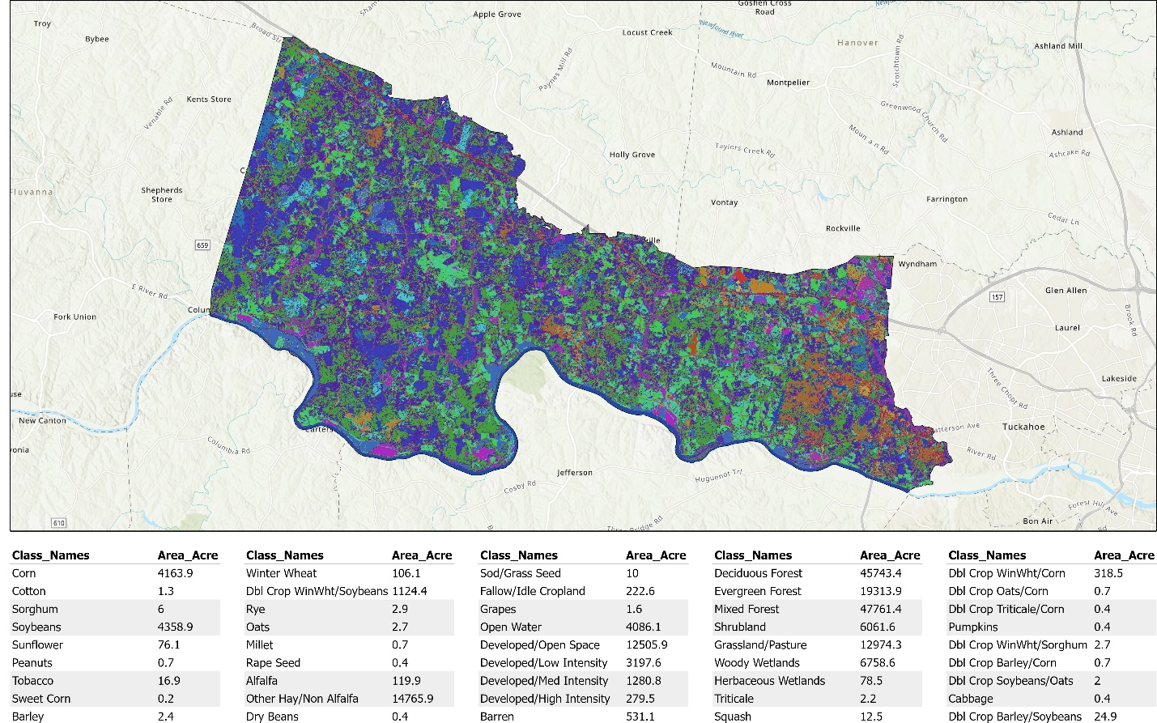

Powhatan

Is the parcel data from 2014 correct?