**Southeast University**

# **Department of Computer Science & Engineering (CSE)**



**Project proposal on**

**Daily Task Management**

SUBMITTED BY

Name: Ornab Biswas

Id:2020000000095

Name: [Nazmul Hasan](mailto:2020000000099@seu.edu.bd)

Id:2020000000099

SUBMITTED TO

MD. MIJANUR RAHMAN

Assistant Professor

Department of Computer Science and Engineer

Southeast University

**Project Objective:**

The objective of this project is to create a comprehensive Daily Task Management System that helps individuals and teams efficiently organize, track, and complete their daily tasks and responsibilities. The system aims to improve productivity, time management, and overall task management by providing a user-friendly interface and robust features.

**Introduction:**

Effective task management is essential for personal and professional success. With the increasing demands on our time and attention, having a reliable tool to manage daily tasks can make a significant difference in productivity and organization. This project seeks to develop a Daily Task Management System that caters to the needs of individuals and teams across various domains.

**Features of the Project:**

The Daily Task Management System will include the following key features:

1. User Registration and Authentication: Users will be able to create accounts and log in securely to access their task lists.

2. Task Creation and Organization: Users can create tasks, assign due dates, set priorities, and categorize tasks into different lists or projects.

3. Task Tracking and Status Updates: Users can update task statuses (e.g., in progress, completed) and add comments or notes to tasks for better tracking.

4. Notification and Reminders: The system will send notifications and reminders for upcoming tasks and deadlines.

5. Task Sharing and Collaboration: Users can share tasks and collaborate with others on shared projects or lists.

6. Search and Filter: The system will provide powerful search and filtering options to easily locate specific tasks or projects.

7. Calendar Integration: Users can sync their task lists with their calendar apps for better time management.

8. Data Backup and Restore: Automatic data backup and restore functionality to prevent data loss.

9. Analytics and Reports: Users can generate reports and view analytics on their task completion rates and productivity.

10. Mobile and Web Accessibility: The system will be accessible on both web and mobile platforms for convenience.

**Flowchart:**

**Log Out**

**Delete Task**

**Task Details**

Yes

Task Completed

Task Completed?

NO

**Edit Task**

**Task List**

**User Registration?**

**Create Task**

**Main Menu**

**User Registration**

NO

Yes

**User Login**

**Use Case Diagram:**



**GUI:**

**Login Page:**

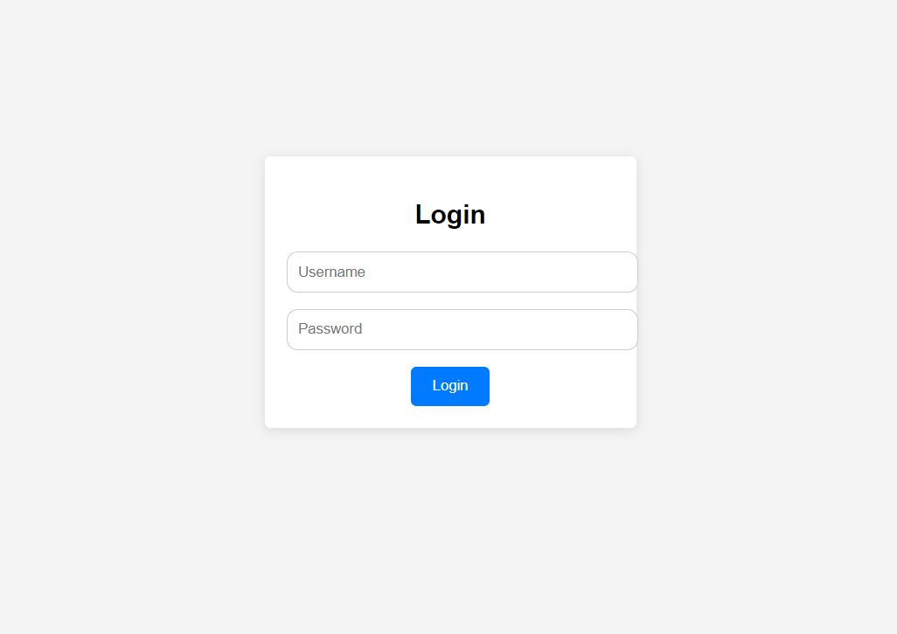

**Registration Page:**

