**ROTARACT CLUB OF COMILLA SOUTH**

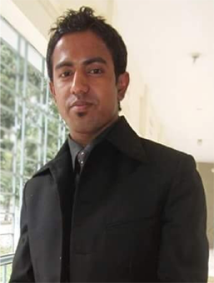





CTC:081,SRC-Rotary Club of Comilla South; DOI:27 June 2008. DOC-16 Feb. 2009; CP:Ex-Rtr. Abdus Salam Ahmed; CS: Ex-Rtr. Md. Mohiuddin Moin; Total Member: 22, TM: 1st & 3rd Friday 3:30 PM, MV: GLOVAL AVEATION, PADUAR BAZAR, BISWAROAD, SADAR SOUTH, COMILLA.

**SECRETARY**

**PRESIDENT**

**RCC**

**ROTARACT COMMITTEE CHAIRMAN**

Rtn. Anwar Hossain Majumder

Paduar Bazar, Biswaroad,

Sadar South

Comilla.

Mob:01711177004

**OFFICE BEARERS (2017-18)**

P: Rtr. Md. Mehedi Hasan; IPP: Rtr. Md. Elius Sunny; VP: Rtr. Md. Tofajjal Hossain.; VP: Rtr. SM Giasuddin; HS: Rtr. A B Faruk Chy; JS: Rtr. Rafsan Jani; JS: Rtr. Mahmudul Hasan; Tre: Rtr. Shekh Nazmul Islam; D: Rtr. S M Mamun (Club); Rtr. Shakawat Hossain (Comm.); Rtr. Md. Wahid (Int’l); Rtr. Saidul Hasan (Fin.); Rtr. Bikash Devnath (Prof.); E: Rtr. Fakhrul Hasan; Chief Sgt: Rtr.Md. Rabiul Hasan Sumon;. Sgt: Rtr.Md. Al-amin.



**RTR. Md. IMAM HOSSAIN Mz. RAJU**. MA: S/O Late Ismail Hossain Mz, Vill: Bijoypur, PO: Noabazar, PS: Choddagram, Comilla. Mob: 01819043778, BD:07/02/1988. O/P: Job, H: Sports, HD:Comilla, HPC: President, HPD: DDRR.



**RTR. Md. SAJJAD HOSSAIN FARHAD**. MA: S/O Md. Jashim Uddin, Vill: Durgapur, PO: Ahmed Nagor, PS: Sadar South, Comilla-3500. Mob: 01935456707, BD:23/07/1992. O/P: Service, BG: A+, H: Sports, HD:Comilla, HPC: President, HPD: RR.



**RTR. S M SHOHEB KIBRIA**. MA: S/O Md. Abdul Momin, Vill: Gabtoli, PO: Elahipur, PS: Sadar South, Comilla. Mob: 01813398580, BD:06/09/1987. O/P: Job, BG: O+, H: Sports, HD:Comilla, HPC: President,



**RTR. Md. FAYSAL AHAMMED**. MA: S/O Abul Kashem, Vill: Dyara, PO: Ahmed Nagor, PS: Sadar South, Comilla-3500. Mob: 01911854797, BD:23/10/1991. O/P: Business, BG: B+, H: Slepping, HD:Comilla, HPC: President, HPD: JS.



**RTR. Md. MEHEDI HASAN**. MA: S/O Hazi Sultan Ahmed, Vill: Sreeballavepur, PO: Ahmed Nagor, PS: Sadar South, Comilla-3500. Mob: 01735119605, BD:29/12/1989. O/P: Job, BG: B+, H: Travelling, HD:Comilla, HPC: President.



**RTR. Md. TOFAJJAL HOSSAIN**. MA: S/O: Late Mohammad Ali, Vill: Shoarkhill, PO: Miabazar, PS: Choddagram, Comilla. Mob: 01681989304, BD:25/06/1992. O/P: Business, BG: B+, H: Travelling, HD:Comilla, HPC: VP.



**RTR. ELIUS SUNNY**. MA: S/O: Noor Ahmed , Vill: Motua Hazi bari, PO: Heshakhal Bazar, PS: Nangalkot, Comilla. Mob: 01812338322, 01521408971, BD:31/01/1989; O/P: Teacher, BG: O+, H: Travelling, HD:Comilla, HPC: President,



**RTR. Md. A B FARUK CHOWDURY**. MA: S/O Nowab Ali, Vill: Hirapur, PO: Ahmed Nagor, PS: Sadar South, Comilla-3500. Mob: 01730999409, BD:05/06/1992. O/P: Job, BG: B+, H: Travelling, HD:Comilla, HPC: Secretary.



**RTR. S M GIASUDDIN** . MA: S/O Shirazul Islam, Vill: Salmanpur, PO: Elahipur, PS: Sadar South, Comilla. Mob: 01711062083, BD:01/06/1988. O/P: Business, BG: A+, H: Sports, HD:Comilla, HPC: VP



**RTR. RAFSAN JANI**. MA: S/O Shamsul Hoqe, Vill: Sreeballavepur, PO: Ahmed Nagor, PS: Sadar South, Comilla-3500. Mob: 01855755242, BD:07/08/1995. O/P: Business, BG: A+, H: Travelling, HD:Comilla, HPC: Joint-Secretary.



**RTR. MAHMUDUL HASAN**. MA: S/O Abdul Mannan, Vill: Dutiapur, PO: North Bagmara, PS: Lalmai, Comilla. Mob: 01827928600, BD:08/10/1994. O/P: Student, BG: A+, H: Sports, HD:Comilla, HPC: Joint-Secretary.



**RTR. SHAKH NAZMUL ISLAM**. MA: S/O Omer Faruk Shekh, Vill: Norkhali, PO: Hularhat, PS: Sadar, Pirojpur. Mob: 01982222020, BD:18/02/1994. O/P: Student, BG: O+, H: Sports, Live:Comilla, HPC: Treasurer .



**RTR. S M S MAMUN**. MA: S/O: Md. Nowsher Ali, Vill:+PO:+PS: Laxmipur Sadar, Laxmipur. Mob: 01988456739, BD:23/05/1993. O/P: Student, BG: A+, H: Sports, Live:Comilla, HPC: Club Service Director.



**RTR. FAKHRUL HASAN Mz.**. MA: S/O Late Nazir Ahmed, Vill: Hirapur , PO: Ahmed Nagor, PS: Sadar South, Comilla-3500. Mob: 01913623395, BD:28/06/1986. O/P: Job, BG: AB+, H: Writing, HD:Comilla, HPC: Editor.

.



**RTR. Md. WAHID Mz**. MA: S/O: Moktul Hossain , Vill:Baropara , PO:Bijoypur, PS: Sadar South, Comilla-3500. Mob: 01934269935, BD:01/07/1988. O/P: Job, BG: O+, H: Travelling, HD:Comilla, HPC: International Service Director.

.



**RTR. SAIDUL HASAN** **BAPPI**. MA: S/O Abdul Haque, Vill: Dyara , PO: Ahmed Nagor, PS: Sadar South, Comilla-3500. Mob: Mob: 01940410091, BD:22/01/1996. O/P: Student, BG: AB+, H: Travelling, HD:Comilla, HPC: Finance Service Director.

.

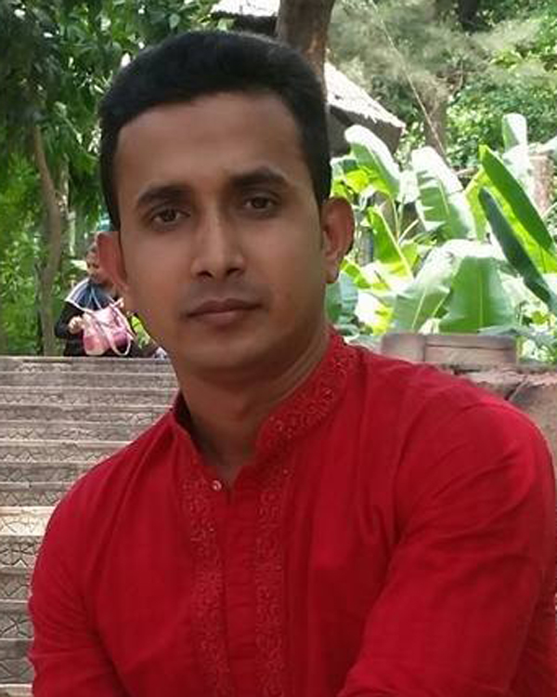

**RTR. SHAKHAWAT HOSSAIN**. MA: S/O Hazi Momtaj Uddin, Vill: King Bamisha , PO: Bamisha Bazar, PS: Sadar South, Comilla-3500. Mob: 01822811046, BD:17/10/1989. O/P: Business, BG: AB+, H: Travelling, HD:Comilla, HPC: Community Service Director.

.

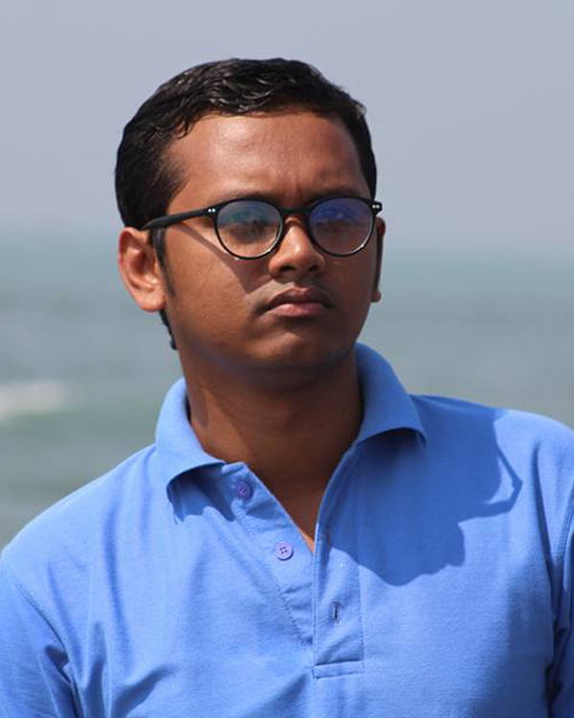

**RTR. BIKASH DEVNATH**. MA: S/O HoreKrishno Devnath, Vill: Sreeballavepur, PO: Ahmed Nagor, PS: Sadar South, Comilla-3500. Mob: 017922216052, BD:03/10/1989. O/P: Job, BG: B+, H: Travelling, HD:Comilla, HPC: Professional Service Director.

.



**RTR. RABIUL HASAN SUMON**. MA: S/O: Md. Jakir Hossain , Vill: South Bagmara, PO: Kotbari, PS: Sadar South, Comilla. Mob: 01917225146, BD:30/11/1992. O/P: Business, BG: A+, H: Sports, HD:Comilla, HPC: Chief Sgt-at-Arms.



**RTR. MONSUR AHMED**. MA: S/O:, Vill:Meghua , PO:Dhalowa , PS: Nangalkot, Comilla. Mob: 01813572467, BD:30/11/1992. O/P: Student, BG: O+, H: Sports, HD:Comilla, HPC: Member



**RTR. Md. Al-AMIN**. MA: S/O: Md. Nurul Islam , Vill: Kaduty, PO: Kaduty Bazar, PS: Chandina, Comilla. Mob: 01736111869, BD:21/11/1995. O/P: Student, BG: B+, H: Sports, HD:Comilla, HPC: Sgt-at-Arms.



**RTR. ABU NAEM TOHIN**. MA: S/O: Doc. Delwar Hossain , Vill: Sreenibash, PO: Bijoypur, PS: Sadar South, Comilla. Mob: 01956743425, BD:12/06/1996. O/P: Student, BG: B+, H: Sports, HD:Comilla, HPC: Member