INDEX
- Rules for Writing Clean Code……………………………………...………….2
- Three core Concepts of Programming………………………………….…4
- Bugs…………………………………………………………………..………..……..…4
- Reduce Code……………………………………………………………………..…..4
- Think in Systems (not in components)…………………………………….5
- Pointers……………………………………………………………………..…..……..5
- Avoid Hybrid Classes (OOP)…………………………………………………….6
- Dynamic Programming…………………………………………………..........9
- If condition inversing……………………………..……………..……………..10
- Garbage Collection………………………………….………..……………..11
- SaaS, PaaS & IaaS……………………………………………….…………….14
- SSH (Secure Shell)…………………………………………….………………15
- Mono-repo (Monolithic Repository)…………………………….....20
- MCP (Model Context Protocol)…………………………………………24
- SOLID Principles……………………………………………………………….24
- Bash (Command Language Interpreter)………………..............30
- Async, Call Stack, Event Loop and Isolate………………………..…31
- Debounce and Throttle in Programming……………………………31
- Schema (JSON, DB, API)……………………………………………………33

Rules for Writing Clean Code:
# Follow these always:
- Centralization:
# Instead of writing the same thing multiple times, write once in a separate place and use it anywhere. Like one central static variable for magic strings (“Hi, ...”) or storing KEYs of a Map to prevent typing mistakes in future (One less risk, enum is used too). So, changing it only in one central point instead of everywhere. This is centralized control

- Reusability:
# If same code, same logic, same variable, and same widget is used multiple times or duplicated. Then make it reusable using a function or method, Class, and extracting widget etc. So, we have centralized control, prevented duplication and reduced extra boilerplate code or spaghetti. Use state hoisting, constructor parameters, a bool value to ensure reusability

- Readability:
# Don’t overengineer things. If something can be done using a simple approach then do it simply, don’t add complexity. Make sure other developers can read the code and understand it easily. But if the simple approach makes it harder to understand then drop it. The number one priority is Readability because after six months the next developer who reads the codebase might be you! Use proper yet short comments, ensure Reusability and Breaking into Small Chunks approach

- Break into Small Chunks:
# Even if code, variables, Class, function, and widgets are not reusable, but still Break it into Smaller Chunks. Like custom widgets or splitting build methods. This keeps the Widget Tree small, increasing code Readability and better understanding

- Reduce Code:
# More code = More Liability, leading more time for debugging. Number of lines of code doesn’t mean good code, it just means more to read for debugging. Try to implement logic or do something by writing as few lines of code as possible. But don’t make it too complicated so it loses Readability. Maintain Readability while writing less code

- Backtracking Flow for Debugging:
# Software engineer thinks in inverse (what to do when opposite of the condition is true) or in reverse. Like thinking the opposite or inverse of the condition and what to do (if(!codition) return)) this ensures less code, less if-else nesting and increases Readability. Same approach is for Backtracking, if we face bug instead of debugging from where the Code Flow is starting, debug from where the Code Flow ends with result and go in reverse. This way we can spot bugs more easily.

Break

Three core concepts of Programming:
Bugs:
# Everything is a State machine. Bugs are not random. Every Bug is just an unexpected State. The program is always in some State:
- User logged in
- User logged out
- Loading, error and success
# And Bugs happen when we end up in a State we didn’t plan for.
# For, debugging instead of using console logs everywhere just map out the States:
- What States this thing can be in?
- Which transitions are possible?
- Where did we end up where we didn’t expect?
# Always try to think in states

Reduce Code:
# Our code is a liability not an asset. More do not mean more value. Because every line of code we write we have to:
- Read
- Maintain
- Debug and Delete
# More code = more bug possibilities. Don’t feel it’s a failure when we delete or reduce code on the other hand its productive. Before we write anything ask:
- Do we actually need this?
- Can we solve this with less?
- Can we delete something instead of adding?

Think in Systems Not Components:
# Nothing in programming exist in isolation. Our function just doesn’t run it calls something and that calls other things. Find out how the functions are talking to each other (the Code Flow) and track them for debugging.

Break

Pointers:
# A pointer is a variable that holds address of another variable.
# Everything in memory is just memory addresses. When we declare a variable, the computer allocates memory and gives us address
# A pointer (&a 1000) is just us directly working with that address instead or pretending it doesn’t exist. Variables = Labels.
# Variables are just convenient labels for memory locations
# This clears the concept of pass by reference vs pass by value. When you write code think “What’s happening in memory”.
Variable
Name:
Memory:
a q y m c p r z
1000 1004 1008 1012 1016 1020 1024 1028
Memory
Address:
&a 100 &q 1004 &m 1012

Break

Avoid Hybrid Classes (OOP):
# Some classes refuse to pick a side; they expose their data through getters and setters but they also have methods that do real work.
# Like this Product class, it lets anyone read and write the price but it also calculates discounts. So, when a Subscription comes along with different pricing the discount logic is trapped inside this class
# And when we need new behavior (methods) like calculating total price (according to quantity) or tax the data is already leaked because we have to use the getters everywhere
# It becomes half data structure and half object. This called a hybrid which is the worst of both worlds.
class Product:
__name = ''
__price = 0.0
def get_name(self):
return self.__name
def get_price(self):
return self.__price
def set_name(self, price):
self.__price = price
def apply_discount(self, pct):
return self.__price * (1 - pct/100)

class Subscription:
__monthly = 0.0
__months = 0
def apply_discount(self):
if self.__months > 12:
return self.__monthly * 0.8
return self.__monthly

p = Product()
qty = 10
rate = 0.2
total = p.get_price() * qty # Data leaked
tax = p.get_price() * rate
# A pure Data Structure doesn’t have this problem. We have to put the business logic somewhere else like another class specifically for business logic or behavior.
# Remember Objects hide data and expose behavior where Data Structure expose data and skip behavior
class Product:
__name = ''
__price = 0.0
def get_name(self):
return self.__name
def get_price(self):
return self.__price
def set_name(self, price):
self.__price = price
def apply_discount(self, pct):
return self.__price * (1 - pct/100)

class ProductPricing:
def apply_discount(self, product = Product(), pct = 0.0):
return product.get_price() * (1 - pct/100)

Break

Dynamic Programming:
# Dynamic programming is an approach to write algorithms that avoids wasting work.
# To use Dynamic Programming on a problem, that problem needs to have two things:
- Overlapping subproblems
- Optimal substructure
# Dynamic Programming algorithms keep track of subproblems and then use the optimal solutions to those subproblems to solve the larger problem.

Approaches for Dynamic Programming:
# There are two types of approaches for writing a Dynamic Programming algorithm:
- Memorization (or top down): Think of it like caching. Write the algorithm as usual but instead of recalculating the results of every subproblems every time, we store the results in some sort of cache. For example, a simple nested dictionary or map (in case of grid).
- Tabulation (or bottom up): Instead of solving the problem recursively with a cache, we build a table of known results iteratively. We actually build out every single result to all of the subproblems, filling in every result as we go.

Use Case:
# If all the subproblems in a larger problem need to be solved to get the right solution, then Tabulation is more efficient because we can pre-allocate memory and fill out all the answers to all the sub-problems as we go.
# But if we need only some of the subproblems need to be solved to solve the overall problem, then Memorization is usually better because we only need to store what we actually need in sort of lazy loaded fashion.

Break

IF Condition Inversing:
# Using if block with the condition normally looks like this:
void onTap () {
if (isSuccess) {
// do something
}
}
# But if we use the inverse condition or not (!) then the code becomes
void onTap () {
if (!isSuccess) return;
// do something
}
# The code becomes shorter and more readable because if block is now single line.
# So, prefer conditions with not (!) when using if block, if it’s possible

Break

Garbage Collection:
# Memory allocation is what happens every time our app needs space like:
- Opening a photo
- Building a list
- Storing a user object
# The runtime reaches into RAM and carves out a chunk. Garbage collection (GC) is the automated system that gets those chunks back when our code no longer needs them.
# In low-level languages like C, we own that responsibility ourself where we allocate, we free. Forget to free and that chunk sits in RAM forever, owned by no one, usable by nothing. That's a memory leak.
# Java, Python, Dart and JavaScript handles this automatically in runtime. GC runs in the background and reclaims what we've abandoned.
# The key insight is garbage = anything our code can no longer reach. GC hunts unreachable chunks, frees them, and repeats.
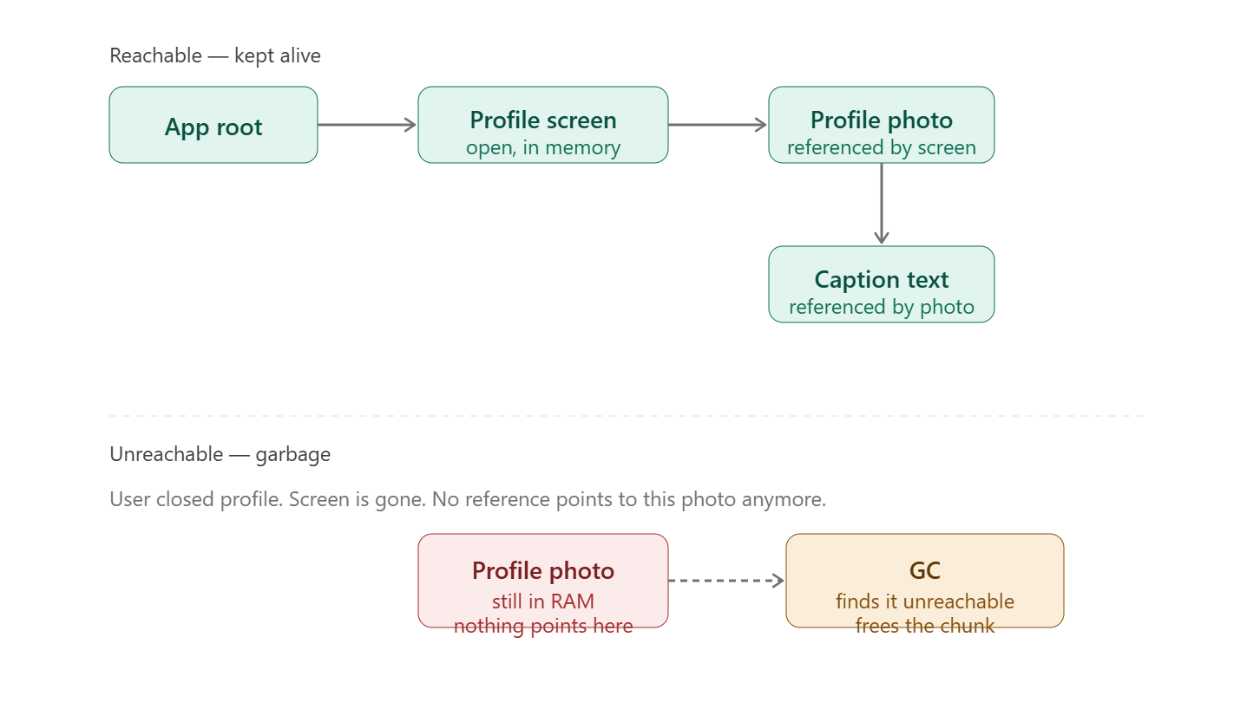
The GC algorithm in one sentence:
# Start from every known root (our running code, global variables). Trace every reference. Anything we couldn't reach during that trace is garbage, free it.
# The moment the profile screen closes, the chain breaks. The photo still occupies RAM, but no root can reach it. GC marks it, sweeps it, done.

What GC does NOT save us from:
# GC only collects what's unreachable. If our code holds a reference, it never uses like:
- A list that keeps growing
- An event listener never removed
- A cache that never evicts that object is technically reachable.
# GC won't touch it. That's still a memory leak, just one the language won't catch for us. This is the gotcha in Flutter/Dart too like StreamSubscription objects held in controllers that never .cancel() are a classic one.

GC in Dart:
# The Dart VM (Virtual Machine, a runtime environment and compilation engine for executing Dart code) handles memory management using a highly optimized generational garbage collector designed specifically to keep UI-heavy apps running smoothly.
# Dart's garbage collection is broken down into two main phases:
- Young Space (Nursery): Newly created objects (like temporary widgets) are stored here. It is collected very quickly using a fast, stop-the-world process called a scavenger.
- Old Space: Objects that survive a few collection cycles are moved here. This area handles longer-lived objects and is collected concurrently using mark-and-sweep or compacting algorithms so it doesn't freeze our app.

Break

SaaS, PaaS & IaaS:
# These are 3 cloud models serving different purposes:

- SaaS (Software as a Service):
# Ready-to-use software accessed over the internet or website. “Just use the software”
# Best for End Users, they consume the software without worrying about the backend
# Examples:
- Canva
- Shopify
- Zoom

- PaaS (Platform as a Service):
# A platform for developers to build, test and deploy applications. “Build the software”
# Best for Developers, focused on building apps while the platform handles deployment, scaling and infrastructure
# Examples:
- Firebase
- Vercel
- heroku

- IaaS (Infrastructure as a Service):
# Virtualized infrastructure resources over the internet or web. “Manage the infrastructure”
# Best for IT Teams / Businesses, full control over infrastructure, customization and security
- AWS
- Google Cloud
- Microsoft Azure

Break

SSH (Secure Shell):
# SSH is an essential tool for managing remote servers. Used for:
- Remote command-line access
- File transfers
- Tunneling traffic
# SSH has two keys:
- Public Key
- Can be shared with everyone.
- Used to encrypt or verify signatures.
- Private Key
- Secret.
- Never leaves our machine.
- Used to decrypt or create signatures.

The SSH Connection Flow:
# When we initiate a SSH connection or run this command:
ssh user@server.com
# Then:
Client (Your Laptop)
|
|
Internet
|
|
Server (VPS)

Step-1, Server Provides Its Identity:
# Server sends its public host key.
Server
|
|-----> Public Host Key
|
Client
# The first time we connect, SSH says “The authenticity of host can't be established. Are you sure you want to continue?”
# Because our laptop has never seen this server before. After we accept using:
~/.ssh/known_hosts
# Stores the server's public key fingerprint. Next time:
- Server sends key
- Client compares with stored key
# If different “WARNING: REMOTE HOST IDENTIFICATION HAS CHANGED!”. This protects against a fake server pretending to be ours.

Step-2, Secure Key Exchange:
# SSH does not encrypt all traffic using public/private keys. That would be too slow.
# Instead SSH creates a temporary secret key called a Session Key using algorithms like:
- Diffie-Hellman
- ECDH
- Curve25519
# The client and server mathematically agree on the same secret key without ever sending that secret across the network.
Client ------------ Server
\ /
\ /
Shared Secret
# An attacker can see all exchanged messages but cannot calculate the secret.

Step-3, Server Authenticates You:
# Now the server must know "Are you really Nazmul?". Suppose you generated:
ssh-keygen
# We get:
id_rsa.pub -> Public Key
id_rsa -> Private Key
# We copy id_rsa.pub and send to the server:
~/.ssh/authorized_keys
# Server stores our public key. Authentication Process:
- Server sends a challenge to prove we own the private key.
- Our laptop signs the challenge:
Challenge + Private Key
↓
Digital Signature
- Then sends Signature to the server.
- Server verifies it using our public key:
Public Key + Signature
↓
Valid?
# If valid access Granted. If not access Denied.
# The private key stays in our local machine:
Your Laptop
|
| Private Key
|
# The server never receives it. The server only receives the Signature which proves we own the private key. So even if someone compromises the server, they still don't get our private key.

Prevents Man-in-the-Middle Attack:
# Suppose an attacker sits between us and the server.
You <---> Hacker <---> Server
# Without verification Hacker sends fake public key, we trust it. SSH prevents this because our laptop remembers the server's public host key.
known_hosts
# Next connection:
Expected Key = ABC123
Received Key = XYZ999
# Mismatch “WARNING! Connection is rejected”. This is the main defense against man-in-the-middle attacks.

Final Mental Model:
Think of SSH in three phases:
1. Verify Server
↓
2. Create Shared Secret Session Key
↓
3. Authenticate User
↓
4. Encrypted Communication

Break

Mono-repo (Monolithic Repository):
# A Mono-repo (Monolithic Repository) is a single Git (.git) repository that contains multiple projects, apps, packages, or services together.

Normal Repository:
# In normal Repository (Poly-repo), we might have one Flutter app and one Git repository
movie_app/
# Where each project has its own Git repository
movie_app/ -> Repo 1
movie_api/ -> Repo 2
shared_package/ -> Repo 3

Mono-Repo:
# HERE, everything lives in a one repository. That one Git repository contains:
- Multiple Flutter apps
- Shared Dart packages
- Backend Services
- Internal tools
my_company/
├── apps/
│ ├── movie_app/
│ ├── admin_app/
│ └── web_dashboard/
│
├── packages/
│ ├── ui_kit/
│ ├── auth_package/
│ └── networking/
│
└── backend/
├── api/
└── worker/

Importance of Mono-repo’s:
# Suppose we have:
- Customer Flutter App
- Admin Flutter App
- Shared UI package
customer_app_repo
admin_app_repo
ui_package_repo
# Updating the UI package means:
- Change UI package
- Publish package
- Update dependency in customer app
- Update dependency in admin app
# With a Mono-repo all code is together:
repo/
├── customer_app
├── admin_app
└── ui_package
# We can modify ui_package and both apps immediately see the changes

Flutter Example:
# A common Flutter mono-repo is:
flutter_workspace/
├── apps/
│ ├── customer_app/
│ └── admin_app/
│
└── packages/
├── design_system/
├── network_client/
└── auth/
# Many teams use tools like Melos and Very Good CLI to manage these repositories.

Break

MCP with Flutter, Dart Firebase & GitHub:
# See p5 AI usage and mental model’s doc

Break

SOLID Principles:
# SOLID is an acronym for five object-oriented design principles that serve as guidelines for writing clean, maintainable, and scalable code. Introduced by Robert C. Martin in 2000

- Single Responsibility Principle (SRP):
# A class should have only one reason to change, ensuring it has a single job.
# Like imagine the WeatherScreen widget inside it we:
- Fetch API
- Parse JSON
- Store data
- Manage loading
- Show UI
- Handle errors
- Cache data
# One class doing everything. If the API, UI or caching changes then the widget changes too. One class has many reasons to change
class WeatherScreen extends StatefulWidget {…}
# Good design is split responsibilities:
- WeatherScreen only shows UI
- WeatherController controls and manages state of UI
- WeatherRepository only gets weather
- WeatherAPI only talks to HTTP
# Each has one job only
WeatherScreen
│
WeatherController
│
WeatherRepository
│
WeatherApi
# SRP in widgets like instead of 500-line widget in one file create reusable smaller widgets or split build methods
HomeScreen
├── Header
├── SearchBar
├── ProductGrid
└── BottomBar

- Open/Closed Principle (OCP):
# Software entities should be open for extension but closed for modification. Meaning don’t keep editing existing code every time we add something new
# Imagine payment method where every new payment requires editing this file (BAD)
if (payment == "Bkash") {}
if (payment == "Nagad") {}
if (payment == "Card") {}
# Better approach would be implementing the interface class so adding a payment means creating a new class instead of modifying old logic
abstract class PaymentMethod {
Future<void> pay();
}
class BkashPayment implement PaymentMethod {…}
class NagadPayment implement PaymentMethod {…}
# Flutter example, instead of editing NotificationService class every time we support another notification provider
PushNotificationService
LocalNotificationService
LocalNotificationService

- Liskov Substitution Principle (LSP):
# A subclass should behave exactly like its parent promises. Bad Example:
abstract class FileStorage {
Future save();
}
# Good implementations, here all save data and code shouldn’t care which one
LocalStorage
CloudStorage
HiveStorage
# Flutter example. Repository:
abstract class AuthRepository {}
# Implementation:
FirebaseAuthRepository
MockAuthRepository
ApiAuthRepository
# Anywhere expecting AuthRepository should work with any implementation. That's LSP.

- Interface Segregation Principle (ISP):
# Clients should not be forced to depend on interfaces they do not use.
# Bad:
abstract class UserRepository {
login();
logout();
uploadPhoto();
deleteAccount();
sendOTP();
refreshToken();
}
# But Imagine our screen only needs login() so why should that screen depend on everything else?
# Better:
LoginRepository
PhotoRepository
ProfileRepository
# Small focused interfaces. Flutter packages do this constantly. Instead of one giant service, they expose multiple smaller APIs.

- Dependency Inversion Principle (DIP):
# High-level modules should not depend on low-level modules; both should depend on abstractions.
# Bad, controller directly creates service. Now our controller is permanently tied to WeatherApi.
class WeatherController extends ChangeNotifier {
final api = WeatherApi();
…
}
# Better. Controller now depends on WeatherRepository not WeatherApi
abstract class WeatherRepository {}
# Then inject these to the controller:
ApiRepository implements WeatherRepository {}
MockRepository implements WeatherRepository {}
CachedRepository implements WeatherRepository {}
# This is exactly what we've already learned with Riverpod and get_it. The UI only knows about WeatherRepository. Tomorrow, we can replace it with a mock or cached implementation without changing the UI.
# For example:
final repoProvider = Provider<WeatherRepository>((ref) {
return ApiWeatherRepository();
});

How SOLID Fits into a Flutter App:
UI
│
▼
Controller / ViewModel
│
▼
Repository
│
▼
API

Break

Bash (Command Language Interpreter):
# Used for interacting with a computer from the command line. It’s also called a shell because it surrounds the operating system kernel to hide its complexity while allowing us access data and write files
# The terminal of a Unix machine like MacOS and Linux (Not Windows), default shell is usually a Bash (Borne Again Shell)
# Bash provides a prompt where we can type a command which will be then interpreted by the Shell and executed on the OS
# Bash is also a programming language that allows us to write scripts
NOTE: For implementation of Bash see implementation of programming mental model’s doc

Break

Async, Call Stack, Event Loop and Isolate:
# The core principles for non-blocking UI codes and performing asynchronous background work. For more info see d2 dart asynchronous await and future doc’s last part

Break

Debounce and Throttle in Programming:
# Debounce means wait until events stop for a certain time, then execute for once.
# For example, user is typing and when user stops typing then after 500ms execute the task or call API once. But if the user types again before 500ms then reset the timer and wait for 500ms again before executing
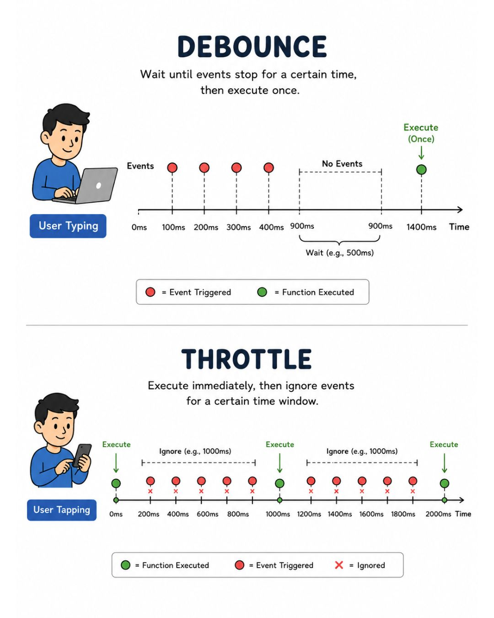

Throttle:
# Throttle says execute immediately, then ignore events for a certain time window
# Example, user taps then execute immediately after that for 1000ms ignore all user taps. Then again after 1000ms if user taps then execute once and ignore the later taps until 1000ms is finished again

Usage:
# These two techniques can help us:
- Reduce unnecessary API calls
- Improve app responsiveness
- Reduce backend load

Break

Schema in JSON, DB & API:
# A schema is a description of how something is supposed to be structured (like fields, their types and constraints). Like:
User
id → integer
name → string
email → string
age → integer
# This isn't actual user data. It's a description of what user data should look like. Actual data would be:
{
"id": 10,
"name": "Nazmul",
"email": "nazmul@example.com",
"age": 24
}
# So:
Schema Data
────────────── ───────────────
id → integer id → 10
name → string name → "Nazmul"
email → string email → "nazmul@example.com"
age → integer age → 24
# Schema ≠ actual data. Schema → describes the data while Data → follows that description

JSON Schema:
# JSON Schema is a standard way to describe and validate the structure and constraints of JSON data. For example:
{
"type": "object",
"properties": {
"id": {
"type": "integer"
},
"name": {
"type": "string"
},
"age": {
"type": "integer"
}
},
"required": ["id", "name"]
}
# This is not user data. It is a schema describing user data. It says:
The JSON must be an object.

It can have:
id → integer
name → string
age → integer

id and name are required.
# Then this is valid JSON data where required fields are given and also matches the data type:
{
"id": 10,
"name": "Nazmul",
"age": 24
}
# But this is invalid because id was supposed to be an integer and name is required. So, JSON schema is used for VALIDATION in the backend
{
"id": "hello",
}
# That's the major purpose of JSON Schema:
JSON data
↓
JSON Schema
↓
"Does this data follow the rules?"
# JSON Schema can describe much more than types too like required properties, minimum/maximum values, string patterns, array rules, nested objects, etc.

API Schema:
# API Schema describes what an API expects and returns. For example, imagine our FastAPI backend has:
GET /users/10
# And it returns:
{
"id": 10,
"name": "Nazmul",
"email": "nazmul@example.com"
}
# The API schema can describe:
GET /users/{id}

Response:
{
id: integer
name: string
email: string
}
# It can also describe things like:

- Endpoint, HTTP method, Parameters
- Request body, Response body
- Data types, Required fields
- Possible responses
- Authentication requirements
# This is why we encounter OpenAPI schemas when working with FastAPI. OpenAPI is a specification for describing HTTP APIs, and its official specification is maintained by the OpenAPI Initiative. For example, conceptually API schema looks like this:
/users/{id}:
get:
parameters:
- name: id
type: integer

responses:
200:
content:
application/json:
schema:
type: object
properties:
id:
type: integer
name:
type: string
# JSON Schema describes how a JSON object looks like. So, an API schema may contain JSON schemas inside it.
API
│
├── GET /users
│ │
│ └── Response Schema
│ └── User JSON structure
│
├── POST /users
│ │
│ ├── Request Schema
│ │
│ └── Response Schema
│
└── DELETE /users/{id}

Database Schema:
# Database Schema is different it’s the structure/organization of the database (table’s column/row data types, constraints etc.). Like:
Users table

id INTEGER
name VARCHAR
email VARCHAR
age INTEGER
# Which we might create it with:
CREATE TABLE users (
id INTEGER PRIMARY KEY,
name VARCHAR(100) NOT NULL,
email VARCHAR(255) NOT NULL,
age INTEGER
);
# This defines the structure of the table.
Database
│
├── users
│ ├── id
│ ├── name
│ ├── email
│ └── age
│
├── posts
│ ├── id
│ ├── title
│ └── user_id
│
└── comments
├── id
├── body
└── user_id
# That overall structure can be called the database schema. It describes things such as:
- Tables, columns, data types
- primary keys, foreign keys
- constraints, relationships
- indexes, views, etc.
# So:
Database Schema
↓
"What does this database look like?"

PostgreSQL Exception SCHEMA:
# In PostgreSQL, schema also has a more specific meaning. For example:
CREATE SCHEMA auth;
# Then:
database
│
├── auth
│ ├── users
│ └── sessions
│
└── public
├── products
└── orders
# Here auth itself is a namespace/container for database objects. We could have:
auth.users
public.users
# Both can exist because they're in different schemas. PostgreSQL explicitly describes a schema as a namespace containing objects such as tables, data types, functions, and operators. So don't confuse these two meanings:
"Database schema"
↓
The structure/design of the database

PostgreSQL SCHEMA
↓
A namespace/container inside a database
# The terminology is unfortunately overloaded

