INDEX
- Dart Synchronous………………………………………….………………..……….….2
- .timeOut() method in Future……………………..………………………..……...5
- Future.wait(…) method for Parallel……………………………..……………….6
- Future.any(…) method………………………………………………..…………….10
- Future.delayed(…) method…………………………………………………….….12
- Future.microtask(…) method……………….………………………….………..13
- Future.error() method…………………………………………………………..18
- FutureBuilder Widget…………………………………….……….…………….21
- Getting Value from a Future async Function…………………..……….25
- Mounted………………………………………………………………………..……..26
- Completer<T>() class with Future<T>…………………………………….28
- Debounce/Timer in Dart………………………………………………………..34
- async Constructors and async in Class……………………………….……46
- Async, Call Stack, Microtask Queue & Isolates……………….……….46
- Call Stack in Event Loop………………………………………………………….50
- Microtask Queue………………………………………………………………..….53
- Isolate……………………………………………………………………………………57

Dart Synchronous:
# In Dart, by default everything is synchronous. Synchronous blocks other operations from executing until its complete. So, operation3 can’t be printed before executing example() function.
example () {
print(‘Operation2’);
}
void main () {
print(‘Operation1’);
example();
print(‘Operation3’);
}
Output: Opertaion1
Operation2
Operation3

Dart Asynchronous Future:
# Future is like a promise that it will return something.
# It has two states completed and uncompleted. Asynchronous allows other operations to execute before it completes. By delayed() function or method we can delay the printing time. So operation1 prints first then operation3 then after 3 second operation prints.
Future example () async {
await Future.delayed(Duration(second: 3));
print(‘Operation2’);
}
void main () {
print(‘Operation1’);
example();
print(‘Operation3);
}
# Output:
Operation1
Operation3
Operation2
NOTE: For more in-depth clarification see last in the doc

Dart Asynchronous Await:
# await can only be used in an asynchronous function. It tells the compiler to wait until that asynchronous operation is complete.
# Basically, turns an async to sync. Here operation1 prints first then waits 3 seconds prints operation2 and 12 then prints operation3.
Future example () async {
await Future.delayed(Duration(second: 3));
print(‘Operation2’);
return 12;
}
void main () async {
print(‘Operation1);
int res = await example();
print(res);
print(Operation3);
}
Output: Operation1
Operation2
12
Operation3

Future vs async vs await:
Future | async | await
It’s the promise meaning the result isn’t available yet but it’s on its way. Don't stand frozen at the counter waiting for order. Do other things. When the food is ready, it's brought to our table. | It marks the function as one that performs asynchronous work. Once added Dart automatically makes the function return a Future<T> | It pauses only that functions code until the Future completes meanwhile, the rest of our app continues running smoothly

Break

.timeOut() method in Future:
# Every Future<T> method or class has .timeOut() method property in them.
# We can use it to set a time out so users don’t have to wait for a long time if API response or Future result is taking more time than it should (Best Practice for Future’s)
# .timeOut() method takes two parameters:
- const Duration() to specify the duration for time out
- onTimeout: void callback method is triggered when time runs out and Future still doesn’t give any result
Future<void> timer() async {
await Future.delayed(const Duration(seconds: 3));
print('Done');
}
void main () async {
timer().timeout(
const Duration(seconds: 2),
onTimeout: () {
print('timed out'); // shows timed out
}
);
}

Break

Future.wait:
# Future.wait() runs multiple futures (asynchronous) in parallel and waits for all of them to complete. It completes only when every Future<T> in the list finishes or fails if any one throws an error.
# Here’s what happens:
- All three futures start running at the same time.
- Dart waits until all are done before continuing.
- The await returns a list of results if the futures return values.
await Future.wait<void>([
fetchWeather(),
getUserProfile(),
loadSettings(),
]);
NOTE: If we use Future.wait() in initState() we do not need to use await or convert the function to async

Use Case:
# Its really useful when we are calling more than one Future<T> or async method and awaiting them using await.
# Instead of writing one after another meaning after completing one Future starts another, we run all of them parallelly (Best Practice)
Future<void> _getData () async {
await fetchWeather(), // runs first
await getUserProfile(), // runs after the first one finishes
}
/// With Future.wait(…)
Future<void> _getData () async {
await Future.wait<void>([
fetchWeather(), // both runs parallelly at the same time
getUserProfile(), // doesn’t wait for the first one
]);
}
# But this pattern only works if our second Future<T> method is not dependent on the first one otherwise second Future<T> will run alongside the first one with no value and showing error
Future<void> _getData () async {
final cityName = await fetchCity(),
await getWeather(city: cityName), // dependent on the first one, Future.wait(…) will cause error
}

With Return Values:
# By default, Future.wait() expects to return a value or List of values or results of Future’s
# Here, both async’s run parallelly and total wait time is 2 seconds not 3 seconds.
# We can also get the values of a Future<T> function directly without using a global variable outside the function and set it in setState.
Future<String> fetchWeather() async {
await Future.delayed(Duration(seconds: 2));
return "☀️ Sunny";
}
Future<String> fetchTemperature() async {
await Future.delayed(Duration(seconds: 1));
return "27°C";
}
void main() async {
final results = await Future.wait([
fetchWeather(),
fetchTemperature(),
]);
print(results); // ["☀️ Sunny", "27°C"]
}

With no return values:
# In order to tell Dart that Future.wait() does not return a value just calls the functions parallelly we have to add <void> like this Future.wait<void>(). This pattern is perfect for initState() in Flutter apps. We can’t directly return from the Future function we have to use the global variable in this way.
Future<void> loadAppData() async {
await Future.wait<void>([
initializeDatabase(),
preloadImages(),
checkUserLogin(),
]);
print("✅ All setup done!");
}

Break

Future.any:
# Future.any<void>() runs multiple futures in parallel, but returns as soon as one of them completes (successfully or with an error). Think of it like whichever finishes first, give me that result. It’s useful when:
- We have backup APIs or redundant sources, and we want to use whichever responds first.
- Or we want to timeout a slow operation combined with Future.delayed().
# We can also return values or just call the function just like Future.wait(). No return values.
await Future.any([
fetchFromServerA(),
fetchFromServerB(),
fetchFromServerC(),
]);
NOTE: If we use Future.any() in initState() we do not need to use await or convert the function to async.

With return values:
# Shows B finished it is the fastest one.
Future<String> serverA() async {
await Future.delayed(Duration(seconds: 3));
return "A finished";
}
Future<String> serverB() async {
await Future.delayed(Duration(seconds: 1));
return "B finished";
}
Future<String> serverC() async {
await Future.delayed(Duration(seconds: 2));
return "C finished";
}
void main() async {
final result = await Future.any([serverA(), serverB(), serverC()]);
print(result);
}

Break

Future.delayed:
# Future.delayed() runs a callback after a specified delay like a timer. It’s just a Future that completes after some time.
# It takes a const Duration() and a lambda function as void call back that runs after that time. Make sure to await it
Future.delayed(const Duration(seconds: 2), () {
print("Executed after 2 seconds");
});
# We can also do this
await Future.delayed(Duration(seconds: 3));
print("Executed after 3 seconds");

Common uses:
# Show splash screen delay. Waits 3 second then navigates to home screen.
Future.delayed(Duration(seconds: 3), () {
Navigator.pushReplacementNamed(context, '/home');
});

# Simulate network delay in testing
Future<String> fakeApi() async {
await Future.delayed(Duration(seconds: 2));
return "Fetched Data";
}

# Combine with Future.any for timeout. If fetchWeather() is slow, after 3 seconds we’ll get "⚠️ Timeout"
final result = await Future.any([
fetchWeather(),
Future.delayed(Duration(seconds: 3), () => "⚠️ Timeout"),
]);
print(result);
NOTE: But use http.get().timeout() method for this which is better

Break

Future.microtask(…):
# It schedules a function to run very soon, but NOT immediately. Specifically, it runs after the current synchronous code finishes (until Call Stack is empty) but before normal Future events like Future.delayed

Event Loop (Must Understand):
# Dart has two queues:
- Microtask Queue (HIGH priority)
- Future.microtask
- scheduleMicrotask
- Event Queue (LOW priority)
- Future()
- Future.delayed
- UI events, I/O
# Execution order:
print('A');
Future.microtask(() => print('B'));
Future(() => print('C'));
print('D');
# Output:
A
D
B // microtask runs first
C // then normal future
NOTE: For more detailed flow see last of the doc

Why use it in initState:
# Instead of using helper methods or functions we can use Future.microtask().
# We cannot safely use context immediately in initState for some operations. Because widget tree is not fully built yet and dependencies might not be ready.
# Solution, use helper methods or Future.microtask()
# Step-by-step:
- initState() runs (sync)
- Widget is inserted into tree
- Our microtask is queued
- Sync code finishes
- Microtask runs → NOW context is safe
@override
void initState() {
super.initState();
Future.microtask(() {
context.read<MyProvider>().fetchData();
});
}

Real Use Cases (Production Level):
# Case-1, Provider/ Riverpod calls
@override
void initState() {
super.initState();
Future.microtask(() {
context.read<UserProvider>().loadUser();
});
}
# Case-2, navigation after screen loads
Future.microtask(() {
Navigator.push(context, MaterialPageRoute(
builder: (_) => HomeScreen(),
));
});
# Case-3, showing dialog / snackbar
Future.microtask(() {
showDialog(
context: context,
builder: (_) => AlertDialog(title: Text('Hello')),
);
});

Common Mistakes (Pay Attention):
# Mistake-1, thinking it’s a delay. It’s not a delay and it runs almost immediately
# Mistake-2, Using it everywhere. Don’t blindly wrap everything in microtask. Use it only when we need context and we need to defer execution slightly
# Mistake-3, confusing with Future().
Future(() {}); // event queue (slower)
Future.microtask(() {}); // microtask queue (faster)

Microtask vs Future vs addPostFrameCallback:
# This is where most Flutter developers get confused.
# Future.microtask:
- Runs ASAP after sync code
- BEFORE UI frame completes
# Future(() {}):
- Runs later (event queue)
- AFTER microtasks
# WidgetsBinding.instance.addPostFrameCallback:
WidgetsBinding.instance.addPostFrameCallback((_) {
// runs AFTER first frame is rendered
});
# This runs AFTER UI is fully drawn.
Situation | Use
Need context safely in initState | Future.microtask()
Need UI rendered first | addPostFrameCallback
General async work | Future()

Break

Future.error(…):
# In Dart, Future.error(…) creates a Future that immediately completes with an error instead of a value. Think of it as the opposite of Future.value(‘Success’)
# Mental Model (IMPORTANT). A Future has only 3 states:
- ⏳ Pending (Future.loading())
- ✅ Completed with value (Future.value())
- ❌ Completed with error (Future.error())
# Future.error() directly jumps to state error

Basic Example:
# Future.error() behaves like throwing an error inside async code. We use it for simulating API failures.
Future<String> getData() async {
return Future.error('Something went wrong');
}
// Usage
try {
final data = await getData();
print(data);
} catch (e) {
print(e); // ✅ catches the error
}

Difference with throw Exception:
# throw is used inside async functions and synchronous style error
# Future.error() explicitly creates a failed future and works even outside async
# Future.error = manual future failure and throw = language-level exception
Future<String> test() async {
throw 'Error';
}
Future<String> test() {
return Future.error('Error');
}

Real Flutter Use Case:
# API failure simulation.
Future<String> fetchUser() {
bool hasError = true;
if (hasError) {
return Future.error('API failed');
}
return Future.value('User Data');
}

Use Cases:
# Case-1, Repository Layer (Clean Architecture)
Future<User> getUser() {
if (networkFail) {
return Future.error(Exception('No internet'));
}
return api.getUser();
}
# Case-2, Form validation with async
Future<void> submit() {
if (email.isEmpty) {
return Future.error('Email required');
}
return Future.value();
}
# Case-3, Testing (VERY COMMON)
when(mockRepo.getUser())
.thenAnswer((_) => Future.error('Failed'));

Break

FutureBuilder:
# In Flutter:
- API calls
- Database reads
- SharedPreferences reads
- File loading
# All of these return a Future and UI cannot wait synchronously. FutureBuilder listens to a Future and rebuilds the UI automatically when the Future’s state changes.
# It takes a type to know the return type.
# future: takes Future function (Or async computation) like API call or async calls it can be null
# snapshot represents the current state of the Future.
- snapshot.connectionState loading / done
- snapshot.data result (if success)
- snapshot.error error (if failed)
- snapshot.hasData data exists
- snapshot.hasError error exists
# snapshot.connectionState possible values:
- none Future is null
- waiting Future is running
- active (mostly streams)
- done Future completed
# For FutureBuilder, we mostly use waiting and done
FutureBuilder<Weather>(
future: weatherService.getWeather(),
builder: (context, snapshot) {
if (snapshot.connectionState == ConnectionState.waiting) {
return const CircularProgressIndicator();
}
if (snapshot.hasError) {
return Text('Error: ${snapshot.error}');
}
if (!snapshot.hasData) {
return const Text('No data');
}
final weather = snapshot.data!;
return Text('${weather.temperature}');
},
)
NOTE: There’s also initialData: the data that will be used to create the snapshots provided until a non-null future has completed

Where to create the Future:
# Don’t assign the Future API call directly because it will call the API every time when it gets built instead define a late Future function type variable. This way we can prevent multiple API calls.
late Future<Weather> weatherFuture;
@override
void initState() {
super.initState();
weatherFuture = getWeather();
}
FutureBuilder(
future: weatherFuture,
)

Important:
# FutureBuilder vs initState + setState. Using FutureBuilder when:
- Simple one-time load
- UI directly depends on Future
- No complex State Management
# Using initState + setState when:
- Multiple async calls
- Manual control
- Complex logic
- Caching

Refreshing a FutureBuilder:
# Just call the Future API caller again in the late variable in setState and we can wrap inside RefreshIndicator’s onRefresh callback if we want to
setState(() {
weatherFuture = getWeather();
});

Handling empty & error UI cleanly:
if (snapshot.hasError) {
return ErrorWidget(snapshot.error!);
}
if (!snapshot.hasData) {
return const Text('Nothing found');
}

Common mistakes (avoid these):
- Calling Future inside build
- Ignoring snapshot.hasError
- Not handling loading state
- Multiple API calls unintentionally
- Using setState with FutureBuilder data

Break

Getting Value from a Future async Function:
# Future<T> type functions can’t return a variable. They return an instance of Future if we don’t await it
# To solve this, define a variable outside the Future function and then initialize it in the function lastly use setState in the function when variable is assigned with value to update the UI with new value.
String? cityName;
getCityName() async {
final String cityName2 = await _weatherService.getCurrentCityName();
setState(() {
cityName = cityName2;
});
}
NOTE: Use mounted after any async operation if there is setState and anything widget related.

Break

Mounted:
# In Flutter, every State object (like our _WeatherPageState) has a built-in boolean property called mounted. It tells whether the State object is still attached to the widget tree.
- mounted == true → The widget is still active in the UI (visible or in memory).
- mounted == false → The widget has been disposed (removed from the tree).

bool get mounted
# When we call an asynchronous function (like await), Flutter might rebuild or dispose of the widget before the function finishes. If our widget was navigated away or disposed while waiting, calling setState() or showing a SnackBar() widget using context will show an error.
# We can safely guard against this by checking if the widget is still mounted after any async gap:
_fetchWeather() async {
String cityName = await _weatherService.getCurrentCity();
if (!mounted) return; // Stop if widget is no longer in tree
try {
final weather = await _weatherService.getWeather(cityName);
if (!mounted) return; // again safe check before setState()
setState(() {
_weather = weather;
});
} catch (e) {
if (!mounted) return;
ScaffoldMessenger.of(context).showSnackBar(
SnackBar(content: Text(e.toString())),
);
}
}

When to use mounted:
# Always check mounted after any await when we plan to:
- Use setState()
- Use BuildContext (for navigation, SnackBar(), dialogs, etc.)
- Access inherited widgets or theme data

context.mounted:
# We can also use context.mounted to check if the context is active/alive, or if it’s not before using context to show a scaffold message or something like that. We can stop that function if context is not active using return
if(!context.mounted) return;
Navigator.pop(context); ScaffoldMessenger.of(context).showSnackBar(SnackBar(content: Text(…),));
# Or we can store the context in a variable ctx before await or async call then use that variable. This ensures safe capture before await
Future<void> _moveToNextScreen() async {
final ctx = context;
await Future.delayed(const Duration(seconds: 2));
if (!mounted) return;
Navigator.pushReplacementNamed(ctx, '/home');
}

Break

Completer<T>() class with Future<T>:
# Completer<T>() is a way to control Future<T> objects and to complete them later with a value or error. Think of Completer as a remote control and Future is like a TV. A Completer gives us the remote control to decide when the Future finishes (or returns)

The Problem Completer Solves:
# Normally, an async function finishes when it reaches its end. Like:
Call getName()
↓
wait 2 sec
↓
return "Nazmul"
# The function itself knows when it is finished
Future<String> getName() async {
await Future.delayed(Duration(seconds: 2));
return "Nazmul";
}
# But what if the function doesn't know when it will finish. Example:
Show Dialog
↓
User thinks...
↓
User clicks OK
↓
Return result
# The function has no idea whether the user will click in 2 seconds, 20 seconds or 2 hours. The completion depends on someone else. That's exactly what Completer<T>() is for. (It can also solve API calling and awaiting problem in Stream.listen())
NOTE: Basically, solves async race conditions

Basic Usage:
# Here, the Future<String> (future()) is read only, the Completer controls it. First create an object of Completer<T>() using OOP
# And return _completer.future in the method (future) that we want to control. Value of that future method will be returned by _completer.complete(…) method when called
# Also check _comleter.isCompleted to see if future is already completed or not. We can also complete with error instead of value using _completer.completeError(‘…’)
class User {
final Completer<String> _completer = Completer<String>();
Future<String> future() async {
return _completer.future;
}
void complete(String value) {
if(_completer.isCompleted == false) {
_completer.complete(value);
}
}
void completeWithError() {
if(_completer.isCompleted == false) {
_completer.completeError('Error');
}
}
}
# In the UI, await future() returns ‘Hello’ when complete(‘Hello’) is called
user.complete(‘Hello’)
…
final value = await user.future() // returns hello

Use Case:
# Use a Completer<T>() whenever the completion of a Future<T> depends on an external event (like API call in Stream), not on the normal flow of the current function
# Solving async race conditions. For example, API calling in Stream.listen() method and the Future<T> that started the Stream will only finish API calling is finished in another method. See dart3 streams doc for this

Nullable Completer for Fresh Completer Per Method Call (In State Management):
# If we directly initialize or create the Completer like this:
final Completer<bool> _authCompleter = Completer<bool>();
…
Future<void> startAuth() async {
…
return _authCompleter.future;
}
# Then we’re creating the Completer once and the Notifier (state management) get one Completer for its entire lifetime. And it creates this problem:
- First Login, everything works:
_authCompleter created User logs in _authCompleter.complete(true)
- Second Login:
startAuth() return _authCompleter.future
# But _authCompleter.future is already completed from the First Login. So, await startAuth() returns immediately without waiting for the new authentication
# The Correct Approach, The Completer<bool>? should be null and only initialized when the startAuth() method is called. So, it represents one authentication attempt, not the lifetime of the Notifier. And every Login gets a fresh Completer
class AuthNotifier extends Notifier<bool> {
Completer<bool>? _authCompleter;
…
Future<void> startAuth() async {
_authCompleter = Completer<bool>();
…
return _authCompleter!.future;
}
…
void complete(String value) {
if(!(_completer.isCompleted ?? true)) {
_completer.complete(value);
}
}
void completeWithError() {
if(!(_completer.isCompleted ?? true)) {
_completer.completeError('Error');
}
}
…
}

Break

Debounce/Timer in Dart:
What Happens Internally:
# Timer registers callback in Dart event loop. After duration:
- Callback is pushed into event queue
- Event loop executes it
- UI thread remains non-blocking
# That’s why Flutter doesn’t freeze.

Timer:
# Timer comes from:
import 'dart:async';
# It schedules code to run in the future. There are two types:
- A) One-shot Timer:
# Runs once after a delay.
Timer(Duration(seconds: 2), () {
print("Runs after 2 seconds");
});

- B) Periodic Timer:
# Runs repeatedly at fixed intervals.
Timer.periodic(Duration(seconds: 1), (timer) {
print("Runs every 1 second");
});

Debounce:
# Debounce means: “Wait until the user stops doing something before running a task.” Example:
- User types in search field
- Instead of calling API every keystroke
- We wait 500ms after they stop typing
- Then call API once
It prevents:
- Unnecessary database writes
- Too many API calls
- Performance issues
# Think of it like this, user toggles checkbox quickly:
Tap Tap Tap Tap Tap
# Without debounce:
DB update DB update DB update DB update DB update
# With debounce:
(wait 500ms)
DB update only once
# That’s the idea.

Database/API Debounce:
# For DB or API Debounce use one-shot timer Timer((…), () {}) that runs once after a delay. If user taps multiple times instead of updating DB or calling API multiple times, we use debounce (wait until user is done then do it)
# Instead of calling API every keystroke or user tap. We wait 500ms after they stop typing. Then call API or update DB once
# First create an object (_debounce) of Timer class which can be nullable
# Then initialize it in the method we are updating data in the List to save in the database
# Make sure to cancel any previous debounce if any was running (this resets the debounce to 500 milliseconds every time user taps) using .cancel() method. This is the heart of debounce. We are basically saying: “Forget the previous delayed call. Start fresh.” Now only the LAST user action survives.
# Then before database update or write we are using debounce. Timer(…) takes a Duration(…) to run the code or logic after that specified time or delay (like after 500 milliseconds do this)
# In Timer(…), the second parameter is a callback method that takes a lambda function (){} and the code written here like database update happens after the delay
Timer? _debounce;
void checkBoxChanged(bool? value, int index) {
setState(() {
db.toDoList[index][1] = value;
});
// Cancel previous timer
_debounce?.cancel();
// Start new timer
_debounce = Timer(const Duration(milliseconds: 500), () {
db.updateData();
});
}

OTP Timer or Periodic Timer:
# For OTP timer or to set any timer we use periodic timer Timer.periodic((…), (timer){…}) that runs repeatedly at fixed intervals
# This means, every 1 second, run this callback (second parameter of Timer()).
# What’s happening logically:
- Every second → decrease time
- When reaches 0 → stop timer
- Show button again
# This is CORRECT usage of periodic timer.
# First create an object(_resendOTPTimer) of Timer(…) class it can be late or nullable
# Then we assign it using Timer.periodic(…). Timer.periodic() takes a Duration(…) as the first parameter which is the specified fixed interval after which the callback (the second parameter) runs. The callback gives us timer internally from Flutter so we can cancel it using timer.cancel()
# We also define an integer (_startTime) for countdown (and UI display) which decreases at fixed interval when callback runs. If it reaches zero then stops timer
# Very IMPOTANT, Make sure to .cancel() timer (_resendOTPTimer) in dispose() method. Because:
- Timer keeps running in background.
- If screen is destroyed and timer continues → memory leak.
# Always cancel:
- Timers
- Streams
- Controllers
# If we don’t → our app becomes unstable.
# When using Provider SM use helper methods like stopTimer() to cancel the timer. Don’t call the Provider dispose() method in UI (Worst Practice), Provider will automatically handle it but then we need to inject the Provider in that screen using ChangeNotifierProvider.value(…) not in the main.dart
int _startTime = 30;
int get startTime => _startTime;
late Timer _resendOTPTimer;
bool _showResetOTPButton = true;
bool get showResetOTPButton => _showResetOTPButton;
void startTimer () {
_startTime = 30;
_showResetOTPButton = false;
_resendOTPTimer = Timer.periodic(const Duration(seconds: 1), (timer) {
if (_startTime == 0) {
timer.cancel();
_showResetOTPButton = true;
} else {
_startTime--;
}
notifyListeners();
});
}
void stopTimer(){
_resendOTPTimer.cancel();
}
@override
void dispose() {
_resendOTPTimer.cancel();
super.dispose();
}

Deep Understanding, Debounce vs Throttle:
# Most juniors confuse these.
# Debounce Wait until user stops. Example:
Typing search.
# Throttle Allow action only once every X time. Example:
Prevent double click on login button.
# Different behavior.

Clean Debounce Utility (Professional Pattern):
Instead of manually writing timer everywhere, create reusable class / service
# Now our code is clean and scalable. This is how experienced developers write it. Or we can write this logic directly in the Provider, GetX state management controller class.
class Debouncer {
final Duration delay;
Timer? _timer;

Debouncer({required this.delay});
void run(VoidCallback action) {
_timer?.cancel();
_timer = Timer(delay, action);
}
void dispose() {
_timer?.cancel();
}
}
# Usage:
final _debouncer = Debouncer(delay: Duration(milliseconds: 500));
void checkBoxChanged(bool? value, int index) {
setState(() {
db.toDoList[index][1] = value;
});
_debouncer.run(() {
db.updateData();
});
}

Advanced Tip (Production Apps):
# If we’re using:
- Riverpod
- Bloc
- RxDart
# They have built-in debounce operators. Much cleaner for large apps. Example in streams:
stream.debounceTime(Duration(milliseconds: 500))

Final Mental Model:
# Think like this:
Feature | Purpose | Use Case
Timer | Run code later | Delay execution
Timer.periodic | Run repeatedly | Countdown
Debounce | Wait for silence | Search, DB update
Throttle | Limit frequency | Button spam

Riverpod Debounce:
# For Riverpod, async notifier, here:
- AutoDisposeAsyncNotifier automatically disposes when screen leaves. Professional habit.
- state = AsyncLoading() Riverpod async state has 3 states: Loading, Data and Error. We manually control them.
- _debounce?.cancel() real debounce logic.
# UI layer:
class SearchScreen extends ConsumerWidget {
const SearchScreen({super.key});
@override
Widget build(BuildContext context, WidgetRef ref) {
final searchState = ref.watch(searchProvider);
return Scaffold(
appBar: AppBar(title: const Text("Riverpod Debounce Search")),
body: Column(
children: [
Padding(
padding: const EdgeInsets.all(16),
child: TextField(
onChanged: (value) {
ref.read(searchProvider.notifier).search(value);
},
decoration: const InputDecoration(
hintText: "Search...",
border: OutlineInputBorder(),
…
),
Expanded(
child: searchState.when(
loading: () =>
const Center(child: CircularProgressIndicator()),
error: (e, _) =>
Center(child: Text("Error: $e")),
data: (results) {
if (results.isEmpty) {
return const Center(child: Text("No Results"));
}
return ListView.builder(
itemCount: results.length,
itemBuilder: (context, index) {
return ListTile(
title: Text(results[index]),
…
}
# Internal flow for this:
User types →
search() called →
Timer waits 500ms →
If user types again → previous timer cancelled →
After 500ms idle → API called →
state updated →
UI rebuilds automatically
# This is production level debounce. Riverpod Notifier keeps Business logic separated, UI clean, AutoDispose handles memory and Testable

RxDart Debounce:
# True Reactive Debounce (RxDart Style). If we want real stream operator. Add:
dependencies:
rxdart: ^0.27.7
# Then:
import 'package:rxdart/rxdart.dart';
final _queryController = PublishSubject<String>();
_queryController
.debounceTime(const Duration(milliseconds: 500))
.listen((query) {
// call API here
});
# That’s using RxDart operator. But for most Flutter apps, Riverpod + Timer is enough.

Break

Async Constructors and Async in Class:
# See d5 part2 of dart OOP doc

Break

Async, Call Stack, Microtask Queue & Isolates:
# async is Single Thread meaning uses the Event Loop to handle tasks without blocking the main thread. Code flow:
# Step-1, here main thread starts fetchUser() method, in that method:
- await registers the timer or continuation Callback and pauses the fetchUser() method until the continuation Callback returns completed result
- Only after that it resumes (so thread is free after registering the Callback). So, await does not stop the thread, it only pauses the current async function (fetchUser()). It basically says "Okay, resume this function later. I'm going to continue executing other available work now."
# Step-2, then immediately Dart runtime & Event Loop, runs:
- fetchPosts() method until await Future.delayed()
- Pauses and registers continuation callback, thread is free again
# Step-3, prints ‘End’ and this is why ‘End’ is printed first than the first two methods
# Mental Model:
main()
├─ fetchUser()
│ └─ await ...
│ ↳ pause function
│ ↳ register continuation callback
├─ fetchPosts()
│ └─ await ...
│ ↳ pause function
│ ↳ register continuation callback
└─ print("End")
Output:
End
At this point:
fetchUser() -> paused
fetchPosts() -> paused
main() -> finished
# Then the flow in Callback queue becomes:
Timer/Network completes // awaited operation completes
↓
Callback placed in queue // Continuation callback added to queue
↓
Event loop picks it up // Event Loop picks callback & resumes it
↓
Resume fetchPosts() // async function resumes after await
# Think of await as “Pause me here. Event Loop Call me back when the result is ready. Meanwhile, continue with other work”. It’s like we don’t order the food & wait for it, we simply do other work and when the food is ready, it’s served
# The Event Loop takes the continuation Callback results from a queue (line) so the first completed result gets executed first.
NOTE: VERY IMPORTANT, Event Loop only takes the next task when the Call Stack is empty (see below)
# Code:
void main() {
fetchUser();
fetchPosts();
print("End");
}
Future<void> fetchUser() async {
await Future.delayed(Duration(seconds: 5));
print("User");
}
Future<void> fetchPosts() async {
await Future.delayed(Duration(seconds: 1));
print("Posts");
}
# Final output:
End
Posts
User
# Mental image:
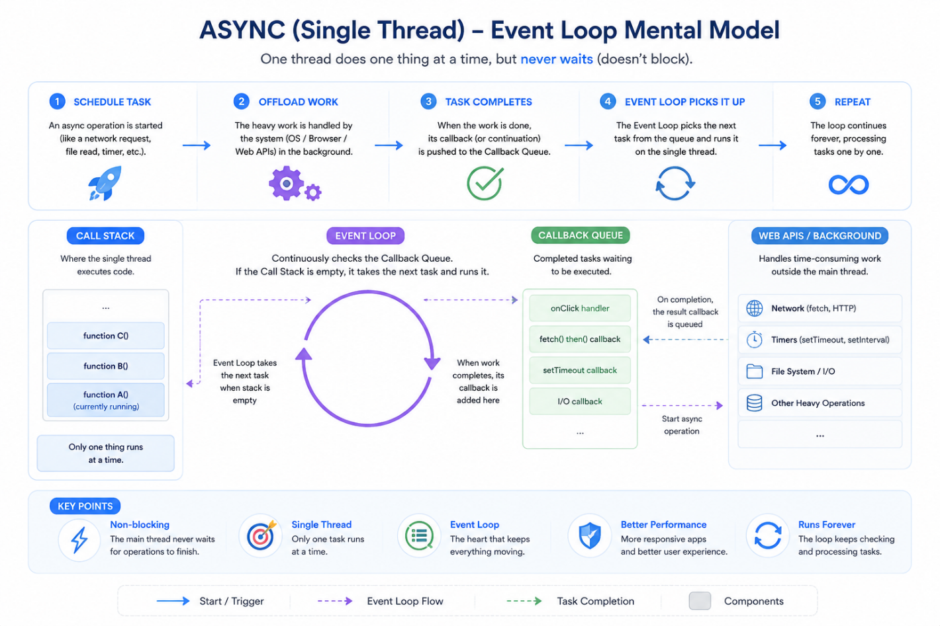

Call Stack in Event Loop:
# The Call Stack is not a to-do list but its “The chain of functions or nested functions currently being executed”.
# Event loop generally runs one thing at a time using a Call Stack, it means:
- Step-1, main() starts so Call Stack is:
┌──────┐
│ main │
└──────┘
- Step-2, main() calls functionA() and notice main() is not finished, waiting for functionA(). So, Call Stack now:
┌───────────┐
│ functionA │
├──────────┤
│ main │
└────────── ┘
- Step-3, functionA() calls functionB(). Now functionB() is on top and The CPU always executes the top frame like a Stack. The Call Stack:
┌───────────┐
│ functionB │
├──────────┤
│ functionA │
├──────── ─┤
│ main │
└──────────┘
- Step-4, functionB() executes and finishes. Pop stack:
┌───────────┐
│ functionA │
├──────────┤
│ main │
└───────── ─┘
- Step-5, functionA() finishes. Pop:
┌──────┐
│ main │
└──────┘
- Step-6, main() finishes. Stack:
(empty)
# This is why its LIFO (Last in First Out), think of function calls like this:
main
└─ functionA
└─ functionB currently running
# Before functionA can continue, functionB must finish. Before main can continue, functionA must finish. So, the most recently called function is always the one currently executing (Stack works perfectly for this)

Relation to Event loop:
# When an async function reaches:
await Future.delayed(...);
# Something special happens. Before await Call Stack:
┌───────────┐
│ fetchUser │
├───────── ─┤
│ main │
└───────────┘
# With it, at await:
- Register continuation callback.
- Pause the function.
- Remove fetchUser() from stack.
# Call Stack becomes:
┌──────┐
│ main │
└──────┘
# Later when main() finishes Call Stack:
(empty)
# The Event Loop now waits (after doing other work like finishing main()).REMEMBER, Event Loop only takes the next Callback or task from the queue only when the Call Stack is empty. Now, when the Future completes:
Callback Queue // Call Stack empty
↓
Event Loop
↓
Resume fetchUser
# The runtime pushes the continuation Callback from the queue to the Call Stack:
┌───────────┐
│ fetchUser │
└───────────┘
# and execution continues after the await part in that function. This is how Call Stack, Event Loop, Microtask Queue, Continuation Callback queue interacts and await just marks it.

Microtask Queue:
# Dart’s Event Loop has two queues to pick from:
- Microtask Queue High priority
- Event Queue Low priority
# Event is basically Future(), Future.delayed() without async/await

Microtask Impact:
# Without Microtasks imagine only one queue (Event queue) where Event Loop takes first event and executes it.
# With Microtasks Dart does this:
Microtask Queue
---------------
M1
M2
Event Queue
-----------
E1
E2
E3
# Event Loop rule, so Microtasks always run before normal events (continuation Callbacks):
1. Execute current stack // Callback Stack empty?
2. Empty ALL microtasks
3. Execute ONE event // Future() or .delayed() without async/await
4. Empty ALL microtasks
5. Execute ONE event
6. Repeat
# Then Full Mental Model:
Single Thread
│
▼
Call Stack
│
▼
Stack Empty?
│
▼
┌─────────────────┐
│ Microtask Queue │ ← highest priority
└─────────────────┘
│
▼
┌─────────────┐
│ Event Queue │ ← Future(), timers, Future.delayed() I/O, UI events
└─────────────┘
│
▼
Event Loop

Code Example:
# Step-1, print(“Main”) runs because its synchronous and in the Call Stack which is must be empty before Event Loop picks tasks from other two queues
# Step-2, after printing main, Call Stack becomes empty and Event Loop has two queues to pick from:
Microtask Queue
---------------
Microtask
Event Queue
-----------
Future
# Step-3, Event Loop checks any Microtasks? If yes then run them all before Event or continuation Callback queue. So, prints microtask
# Step-4, finally Microtask queue is empty. Now run one event or continuation Callback from the queue. So, prints future
void main () async {
Future(() => print("future"));
scheduleMicrotask(() {
print("microtask");
});
print("main");
# Output:
main
microtask
future

async/await Continuation Callback with Microtask:
# This is the interesting part. When a Future or continuation Callback completes or returns a result:
await something();
# The continuation or resuming after the await is typically scheduled as a microtask. Conceptually:
await fetch();
print("Done");
# Becomes something like the below, and that continuation or resuming gets very high priority:
fetch().then((_) {
print("Done");
});
# That's one reason async code often resumes before timers and other events.
NOTE: JavaScript or TypeScript also has these Call Stack, Microtask queue, Event queue

Isolate:
# Unlike async which gives 1 thread, 1 Event loop, Isolates give multiple threads, multiple Event loops for true parallel execution

The Problem:
# Imagine this:
void processImage() {
// 5 seconds of CPU work
}
# In Flutter, the UI freezes if we do the this:
onPressed() {
processImage();
}
# Because the main isolate is busy and the Event loop cannot process taps, animations or rendering until the CPU work finishes.
Main Isolate
├─ UI Rendering
├─ Event Loop
└─ processImage()

Solution:
# Spawn another Isolate:
Main Isolate
├─ UI
└─ Event Loop
Worker Isolate
└─ Image Processing
# Now both can run simultaneously or parallelly:
Core 1 → Main Isolate
Core 2 → Worker Isolate

The Most Important Rule:
# Isolates do not share memory. In Java threads:
Thread A
Thread B
same memory
# This causes:
- race conditions
- locks
- deadlocks
- synchronization headaches
# Dart avoids this and data is copied and passed through messages. Like:
Main Isolate
│
▼
Message
│
▼
Worker Isolate

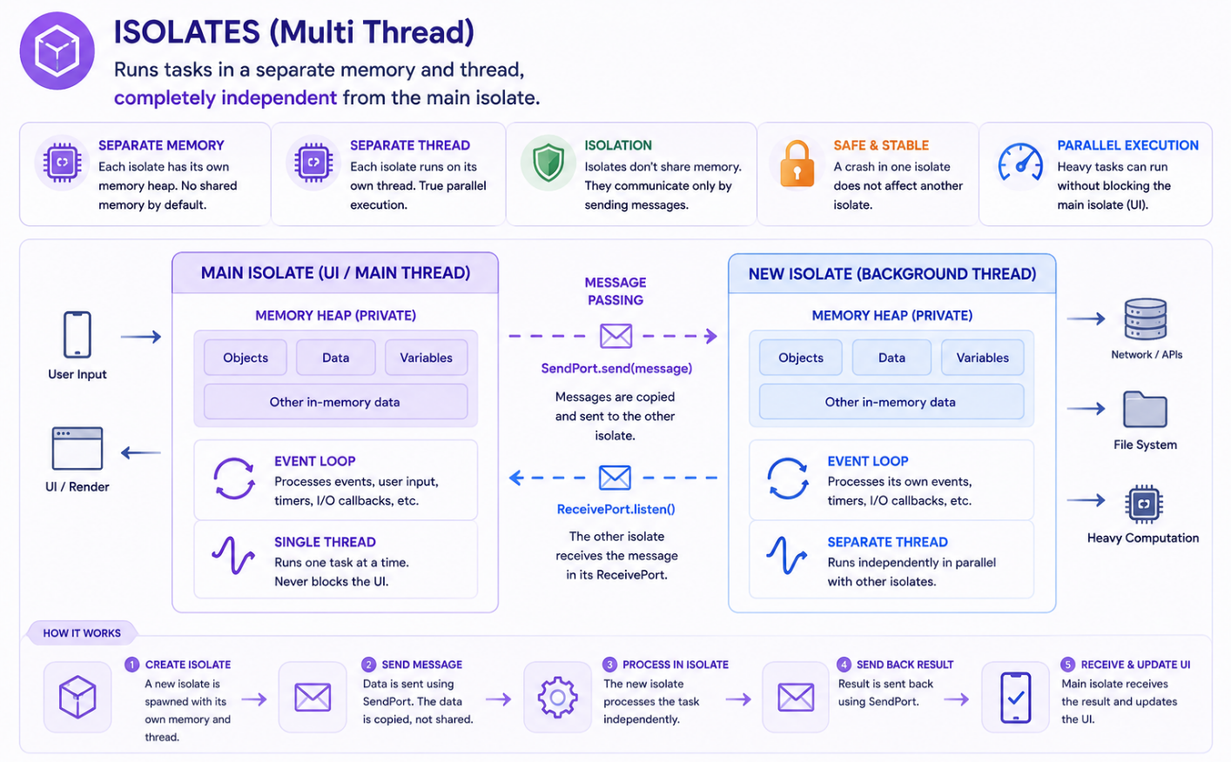

Async vs Isolate:
# The Mental Model to Remember:
// async / await
Main Isolate
├─ Event Loop
├─ Call Stack
└─ Async Tasks
# async/ await helps one Isolate handle many waiting operations efficiently.
// Isolate
Main Isolate
Worker Isolate
Worker Isolate

 | async/await | Isolate
Concept | One worker,  Many tasks,  Switches between tasks | Multiple workers,  Each worker has own queue,  Each worker has own Event Loop,
Example | One waiter:  Take order  Take order  Take order  Serve ready order first | Like parallel work:  Waiter A  Waiter B  Waiter C
Usage | For:  HTTP request & APIs,  Database queries  File reading & timers,  WebSocket’s | For:  Image & video processing,  Large JSON parsing,  Encryption / decryption,  Compression,  Heavy algorithms,  Machine learning inference,  Anything CPU-heavy

NOTE: In Python, Future is Coroutine/Task and everything is same but there’s no Isolate because it uses shared memory for threads just like Java

Break

