Index
- Creating Window…………………………………………………2
- Adding Widget…………………………………………………….2
- Common Widgets List………………………………………….3
- Label Widget………………………………………………………4
- Controlling foreground & background color……………..4
- Controlling Height & Width……………………………………5
- Button Widget…………………………………………………….5
- Entry Widget……………………………………………………….6
- Retrieving text with .get()………………………………………8
- Deleting text with .delete()………………………………..9
- Inserting text with .insert()………………………………..11
- Multiline Input with Text Widgets .get()……………….13
- Deleting text from text widget with .delete()………..15
- Inserting Text in Text Widget with .insert()……………17
- Frame Widgets……………………………………………….18
- Adjusting Frame Appearance With Reliefs…………..20
- Best Widget Naming Practices…………………………..21
- Controlling Layout with Geometry Managers……….22
- tk.X……………………………………………………………….22
- Side Keyword Argument……………………………………23
- tk.Y………………………………………………………………..23
- tk.BOTH…………………………………………………………24
- The .place() Geometry Manager…………………………25
- The .grid() Geometry Manager……………………………26
- External and Internal Padding……………………………28
- Column and Row Configure………………………………29
- Sticky Parameter……………………………………………..31
- Events and Events Handlers………………………………34
- Using Bind & Command…………………………….………34 & 36
- Opening and saving files in tkinter & Additionals..….38 & 39
Creating Window:
import tkinter as tk
window = tk.Tk()
window.mainloop()
# import tkinter basically imports tkinter gui and as a class which is tk. Then, .Tk() class creates a root window and .mainloop() runs the code for this gui.

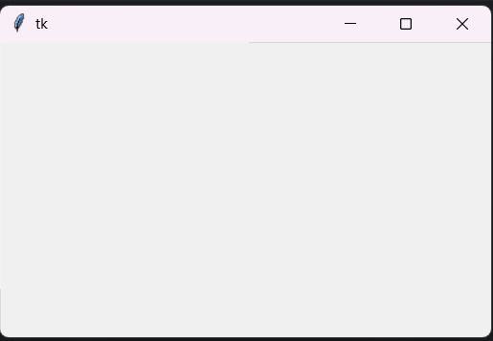
Output:

Note: Using .geometry(width*height) method we can set the initial size of our root window.
window.geometry("600x400")
Adding Widget:
import tkinter as tk
window = tk.Tk()
greetings = tk.Label(text ='Hello, Tkinter')
greetings.pack()
window.mainloop()
# .Label() is a widget that displays static text or image. And, .pack() is used to place the widget in the window. Moreover, .pack() stacks widget left to right or top to bottom, .grid() to place widgets in row/column table and .place() using exact coordinates.
Output:
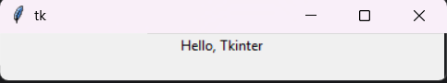

Common Widgets List:
Class | Description
Label | A widget used to display text or static image on the screen.
Button | A button that can contain text and can perform an action when clicked.
Entry | A text entry widget that allows only a single line of text.
Text | A text entry widget that allows multiline text entry.
Frame | A rectangular region used to group related widgets or provide padding between widgets

These are classic widgets which are available in tkinter package but there are themed widgets too, those are available in the ttk submodule, for example tkinter.ttk.Label
Label Widget:
Controlling foreground and background color:
import tkinter as tk
window = tk.Tk()
label = tk.Label(
text ='Hello, Tkinter',
fg= 'white',
bg= 'black'
)
label.pack()
window.mainloop()
# fg and bg are shorthand parameters for foreground and background. And, fg sets the color of the text while bg sets the color of the background. You can also use hexadecimal RGB values to set the color.
Output:
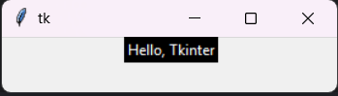

Controlling height and width:
import tkinter as tk
window = tk.Tk()
label = tk.Label(
text ='Hello, Tkinter',
fg= 'white',
bg= 'black',
width= 10,
height= 10
)
label.pack()
window.mainloop()
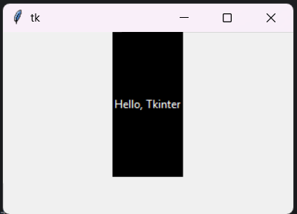
# width and height just sets the widget size.
Output:

Button Widgets:
import tkinter as tk
window = tk.Tk()
button = tk.Button(
text="Click me!",
width=25,
height=5,
bg="blue",
fg="yellow",
)
button.pack()
window.mainloop()
# tk.Button() is a clickable button widget which can be configured to call a function whenever they’re clicked.
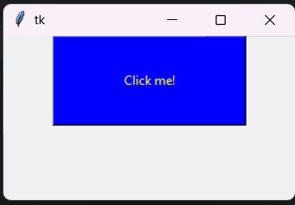
Output:

Entry Widgets:
import tkinter as tk
window = tk.Tk()
label = tk.Label(
text ='Name',
fg= 'white',
bg= 'black',
)
entry = tk.Entry(
fg="yellow",
bg="blue",
width=50
)
label.pack()
entry.pack()
window.mainloop()
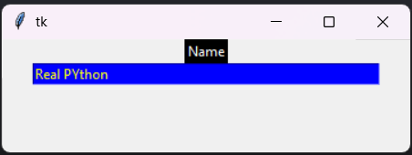
# tk.Entry() widget will display a small text box that the user can type some text into. Creating and styling an Entry widget works pretty much exactly like with Label and Button widgets.
Outputs:

Note: There is font=(‘font_name’, font_size) parameter in the entry/text widget while creating it to adjust font size and make text field taller.
Retrieving text with .get():
import tkinter as tk
def print_name():
name = entry.get()
print(name)
window = tk.Tk()
label = tk.Label(
text ='Name',
fg= 'white',
bg= 'black',
)
entry = tk.Entry(
fg="yellow",
bg="blue",
width=50
)
button = tk.Button(
text="Entry",
command= print_name,
)
label.pack() # to place the widget in the window.
entry.pack()
button.pack()
window.mainloop()
# .get() stores the user input in a variable which can be used later. print_name() method displays the entered text in the widget in console. Command calls the function on clicked.
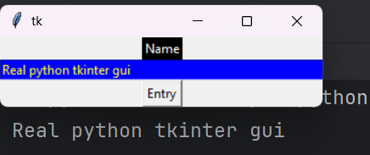
Output:

Deleting text with .delete():
import tkinter as tk
def print_name():
name = entry.get()
print(name)
def delete_name():
entry.delete(0, tk.END)
window = tk.Tk()
label = tk.Label(
text ='Name',
fg= 'white',
bg= 'black',
)
entry = tk.Entry(
fg="yellow",
bg="blue",
width=50
)
button = tk.Button(
text="Entry",
command= print_name,
)
button2 = tk.Button(
text="Delete",
command= delete_name,
)
label.pack()
entry.pack()
button.pack()
button2.pack()
window.mainloop()
# delete_name() to delete the entered text in the widget. .delete(0,4) works like string slicing will delete everything from 0 index to 4 index and tk.END is the last index of the string.
Output:

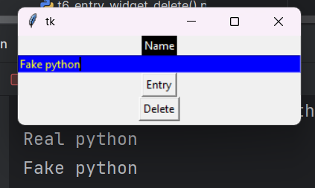

Inserting text with .insert():
import tkinter as tk
def print_name():
name = entry.get()
print(name)
window = tk.Tk()
label = tk.Label(
text ='Name',
fg= 'white',
bg= 'black',
)
entry = tk.Entry(
fg="yellow",
bg="blue",
width=50
)
entry.insert(0, "Real Python")
button = tk.Button(
text="Entry",
command= print_name,
)
label.pack()
entry.pack()
button.pack()
window.mainloop()
# Here, .insert() method preloads the widget with text “Real Python” and if entry already contains some text, then it will insert the new text at the specified index and shift all existing text to the right.
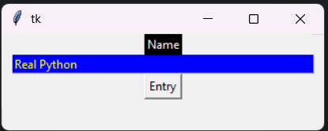
Output:

Multiline Input with Text Widgets .get():
import tkinter as tk
def print_name():
name = text.get("1.0", tk.END)
print(name)
window = tk.Tk()
label = tk.Label(
text ='Multiline Input',
fg= 'white',
bg= 'black',
)
text = tk.Text()
button = tk.Button(
text="Entry",
command= print_name,
)
label.pack()
text.pack()
button.pack()
window.mainloop()
# tk.Text() creates a text widget where any text can be typed. Here, it is used for taking multiline inputs. And text.get("1.0", tk.END) stores the user input in a variable. The syntax is text.get("line_number.index", "line_number.index") like ("1.0", "2.3") it works like string slicing. Note, /n is included too in the variable
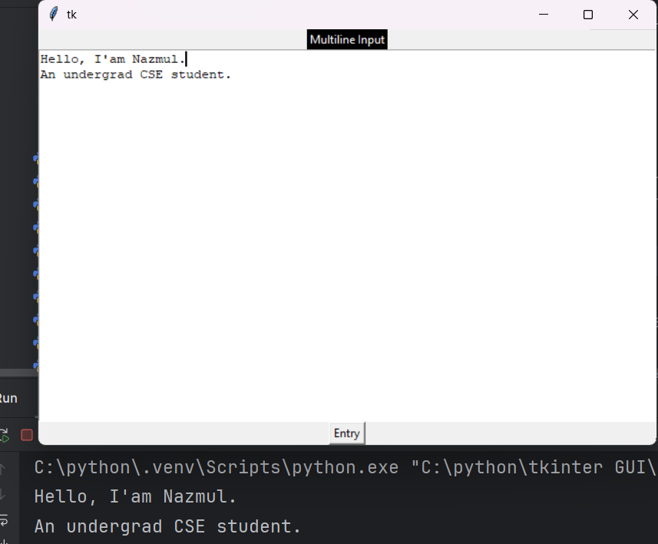
# It also has parameters like height= , width= , fg= , bg= and font= (‘Arial’, 20)
Output:

Deleting text from text widget with .delete():
import tkinter as tk
def print_name():
name = text.get("1.0", tk.END)
print(name)
def delete_name():
text.delete("1.0", tk.END)
window = tk.Tk()
label = tk.Label(
text ='Multiline Input',
fg= 'white',
bg= 'black',
)
text = tk.Text()
button = tk.Button(
text="Entry",
command= print_name,
)
button2 = tk.Button(
text="Delete",
command= delete_name,
)
label.pack() # to place the widget in the window.
text.pack()
button.pack()
button2.pack()
window.mainloop()
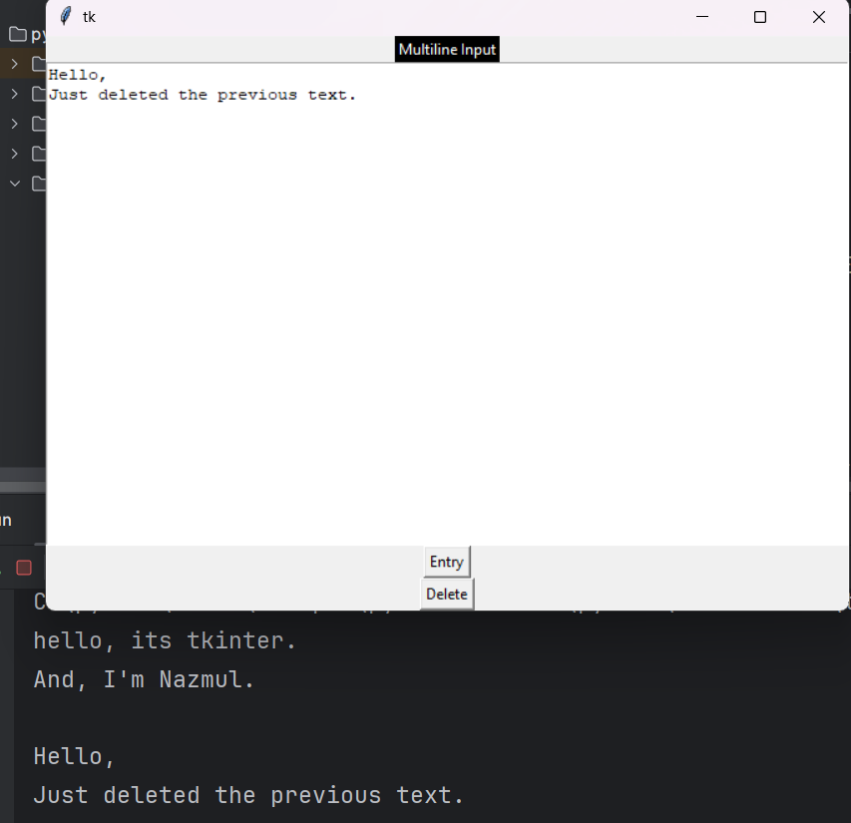
# delete_name() method to delete the entered text in the text widget. And, .delete() is also similar to get syntax it works like string slicing. Note /n can be deleted too, making the second line into first line.
Output:

Inserting Text in Text Widget with .insert():
import tkinter as tk
def print_name():
name = text.get("1.0", tk.END)
print(name)
window = tk.Tk()
label = tk.Label(
text ='Multiline Input',
fg= 'white',
bg= 'black',
)
text = tk.Text()
text.insert(tk.END,"Hello")
text.insert(tk.END,"\nNazmul")
button = tk.Button(
text="Entry",
command= print_name,
)
label.pack()
text.pack()
button.pack()
window.mainloop()
# Text widget comes with prefilled text. And, .insert() will insert text at the specified position if there’s already text at or after that position. Or, append text to the specified line if the character number is greater than the index of the last character in the text box. Also, tk.END is used to automatically append any text at the last and \n is used to add a new line.
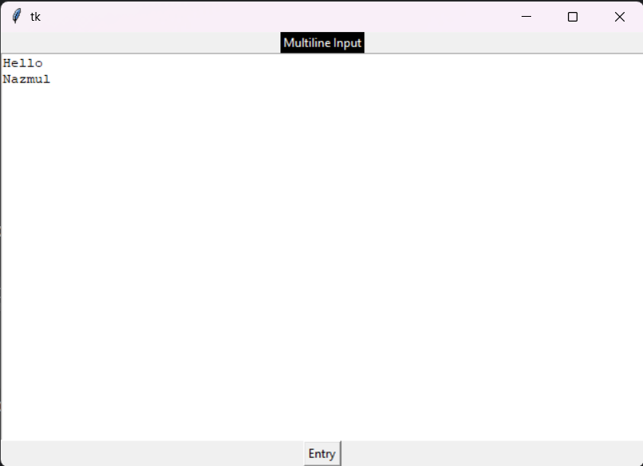
Output:

Frame Widgets:
import tkinter as tk
window = tk.Tk()
frame_a = tk.Frame()
frame_b = tk.Frame()
label_a = tk.Label(master=frame_a, text="I'm in Frame A")
label_b = tk.Label(master=frame_b, text="I'm in Frame B")
label_a.pack()
label_b.pack()
frame_a.pack()
frame_b.pack()
window.mainloop()
# tk.Frame() creates a frame widget. Frames are like containers for other widgets. A widget can be assigned to a frame by setting the widget’s master attribute. And, frame_a, frame_b contains a label with the text "I'm in Frame A", "I'm in Frame B". By swapping a and b the order is changed too
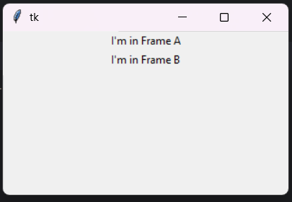
Output:

Adjusting Frame Appearance With Reliefs:
import tkinter as tk
border_effects = {
"flat": tk.FLAT,
"sunken": tk.SUNKEN,
"raised": tk.RAISED,
"groove": tk.GROOVE,
"ridge": tk.RIDGE,
}
window = tk.Tk()
for relief_name, relief in border_effects.items():
frame = tk.Frame(master=window, relief=relief, borderwidth=5)
frame.pack(side=tk.LEFT)
label = tk.Label(master=frame, text=relief_name)
label.pack()
window.mainloop()
# Using .items() takes the key and value of the dictionary for each iteration. Then, declares parent container, relief sets the border style and sets the borderwidth to 5 pixels. Using tk.LEFT the pack geometry manager, left-to-right stacking. Created a label widget which shows relief name.
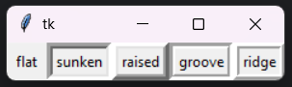
Output:

The following relief effects:
- tk.FLAT ("flat"): creates a frame that appears to be flat.
- tk.SUNKEN ("sunken"): adds a border that gives the frame the appearance of being sunken into the window.
- tk.RAISED ("raised"): gives the frame a border that makes it appear to stick out from the screen.
- tk.GROOVE ("groove"): adds a border that appears as a sunken groove around an otherwise flat frame.
- tk.RIDGE ("ridge"): gives the appearance of a raised lip around the edge of the frame.
Best Widget Naming Practices:
Widget Class | Variable Name Prefix | Example
Label | lbl | lbl_name
Button | btn | btn_submit
Entry | ent | ent_age
Text | txt | txt_notes
Frame | frm | frm_address

Controlling Layout with Geometry Managers:
Tk.X:
import tkinter as tk
window = tk.Tk()
frame1 = tk.Frame(master=window, height=100, bg="red")
frame2 = tk.Frame(master=window, height=50, bg="yellow")
frame3 = tk.Frame(master=window, height=25, bg="blue")
frame1.pack(fill=tk.X)
frame2.pack(fill=tk.X)
frame3.pack(fill=tk.X)
window.mainloop()
# tk.X to fill in the horizontal direction and stack the three frames so that each one fills the whole window horizontally, which can expanded horizontally.
Output:

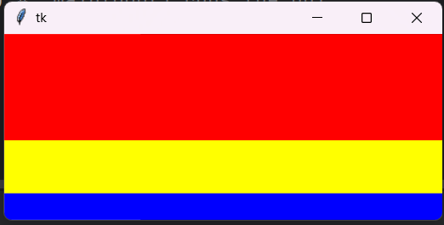

Side Keyword Argument:
By default its set to tk.TOP and other options are:
- tk.TOP ("top")
- tk.BOTTOM ("bottom")
- tk.LEFT ("left")
- tk.RIGHT ("right")
Tk.Y:
import tkinter as tk
window = tk.Tk()
frame1 = tk.Frame(master=window, width=200, height=100, bg="red")
frame2 = tk.Frame(master=window, width=100, bg="yellow")
frame3 = tk.Frame(master=window, width=50, bg="blue")
frame1.pack(fill=tk.Y, side=tk.LEFT)
frame2.pack(fill=tk.Y, side=tk.LEFT)
frame3.pack(fill=tk.Y, side=tk.LEFT)
window.mainloop()
# At least one frame should have height argument to force the window to have some height. fill=tk.Y to make the frames responsive when you resize the window vertically and side=tk.LEFT to stack the frames or widgets at left side.
Output:

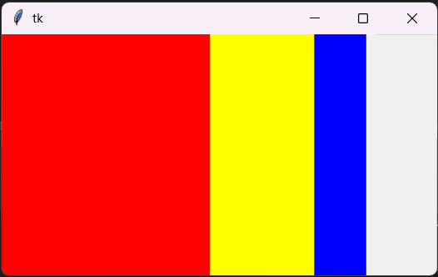

Tk.BOTH:
import tkinter as tk
window = tk.Tk()
frame1 = tk.Frame(master=window, width=200, height=100, bg="red")
frame2 = tk.Frame(master=window, width=100, bg="yellow")
frame3 = tk.Frame(master=window, width=50, bg="blue")
frame1.pack(fill=tk.BOTH, side=tk.LEFT, expand=True)
frame2.pack(fill=tk.BOTH, side=tk.LEFT, expand=True)
frame3.pack(fill=tk.BOTH, side=tk.LEFT, expand=True)
window.mainloop()
# fill=tk.BOTH to make the frames responsive when you resize the window both vertically and horizontally, and side=tk.LEFT to stack the frames or widgets at left side. Also, expand is used to expand the widget to fill any extra unused space in the parent window.
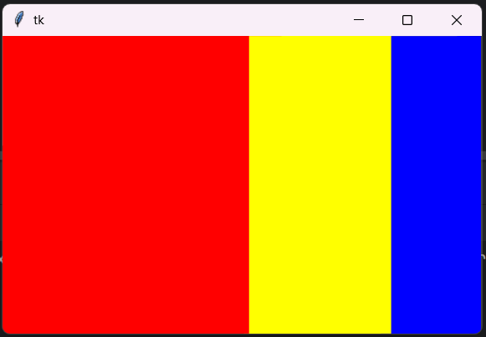
Output:

The .place() Geometry Manager:
import tkinter as tk
window = tk.Tk()
frame = tk.Frame(master=window, width=150, height=150)
frame.pack()
label1 = tk.Label(master=frame, text="I'm at (0, 0)", bg="red")
label2 = tk.Label(master=frame, text="I'm at (75, 75)", bg="yellow")
label1.place(x=0, y=0)
label2.place(x=75, y=75)
window.mainloop()
# .place() is used to place it in frame at position (0, 0) and (75, 75).
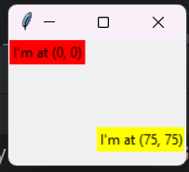
Output:

Note: .place() is a poor choice for making responsive and cross-platform layouts because they don’t change as the window is resized.
The .grid() Geometry Manager:
import tkinter as tk
window = tk.Tk()
for i in range(3):
for j in range(3):
frame = tk.Frame(
master=window,
relief=tk.RAISED,
borderwidth=1
)
frame.grid(row=i, column=j)
label = tk.Label(master=frame, text=f"Row {i}\nColumn {j}")
label.pack()
window.mainloop()
# The nested loop for taking i as row number and j as column number. tk.RAISED, gives the frame a border that makes it appear to stick out from the screen. Then, .grid(row=i, column=j) Creates the grid iteratively according to i and j.
Output:

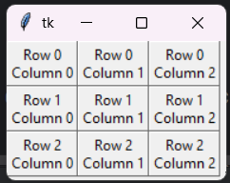

External and Internal Padding:
- padx adds padding in the horizontal direction.
- Pady adds padding in the vertical direction.
import tkinter as tk
window = tk.Tk()
for i in range(3):
for j in range(3):
frame = tk.Frame(
master=window,
relief=tk.RAISED,
borderwidth=1
)
frame.grid(row=i, column=j, padx= 5, pady=5)
label = tk.Label(master=frame, text=f"Row {i}\nColumn {j}")
label.pack(padx= 5, pady= 5)
window.mainloop()
# Padding is just some blank space that surrounds a widget and visually sets its content apart. Here, padx and pady adds 5 pixel padding both horizontally and vertically. Also, .pack() also has padx and pady parameters to give a lil bit of space between label widget and frame border.
Note: You can also add space at specific direction using padx= (0, 10) or pady= (0, 10)
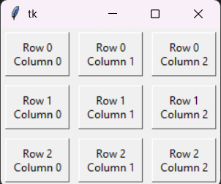
Output:

Column and Row Configure:
Both .columnconfigure() and .rowconfigure() take three essential arguments:
- Index: The index of the grid column or row that you want to configure or a list of indices to configure multiple rows or columns at the same time.
- Weight: A keyword argument called weight that determines how the column or row should respond to window resizing, relative to the other columns and rows.
- Minimum Size: A keyword argument called minsize that sets the minimum size of the row height or column width in pixels.
import tkinter as tk
window = tk.Tk()
for i in range(3):
window.columnconfigure(i, weight= 1, minsize= 75)
window.rowconfigure(i, weight= 1, minsize= 50)
for j in range(3):
frame = tk.Frame(
master=window,
relief=tk.RAISED,
borderwidth=1
)
frame.grid(row=i, column=j, padx= 5, pady=5)
label = tk.Label(master=frame, text=f"Row {i}\nColumn {j}")
label.pack(padx= 5, pady= 5)
window.mainloop()
# columnconfigure() and rowconfigure() control how space is allocated in a grid. The index of the row/column that needs to be configured. And, weight decides how much a row/column should expand proportionally when the window resizes. Moreover, minsize sets a minimum size so things don’t collapse when too small.
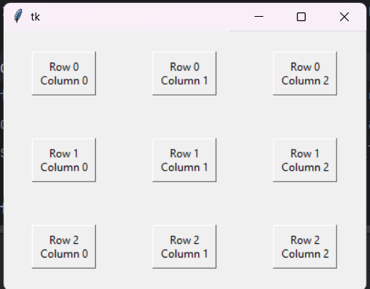
Output:

Sticky Parameter:
Changing the location of each label inside of the grid cell using the sticky parameter, which accepts a string containing one or more of the following letters:
- "n" or "N" to align to the top-center part of the cell.
- "e" or "E" to align to the right-center side of the cell.
- "s" or "S" to align to the bottom-center part of the cell.
- "w" or "W" to align to the left-center side of the cell.
Combining them:
- “ne” to place top right corner of the cell.
- “sw” to place bottom left corner of the cell.
import tkinter as tk
window = tk.Tk()
window.columnconfigure(0, minsize=250)
window.rowconfigure([0, 1], minsize=100)
label1 = tk.Label(text="A")
label2 = tk.Label(text="B")
label1.grid(row=0, column=0, sticky="ne")
label2.grid(row=1, column=0, sticky="sw")
window.mainloop()
# As written above two labels are accordingly in their cell.
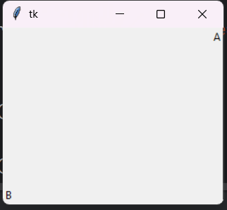
Ouput:

More on Sticky Parameter:
import tkinter as tk
window = tk.Tk()
window.rowconfigure(0, weight= 1, minsize=50)
window.columnconfigure([0, 1, 2, 3], weight= 1, minsize=50)
label1 = tk.Label(text="1", bg="black", fg="white")
label2 = tk.Label(text="2", bg="black", fg="white")
label3 = tk.Label(text="3", bg="black", fg="white")
label4 = tk.Label(text="4", bg="black", fg="white")
label1.grid(row=0, column=0)
label2.grid(row=0, column=1, sticky="ew")
label3.grid(row=0, column=2, sticky="ns")
label4.grid(row=0, column=3, sticky="nsew")
window.mainloop()
# Creates a 1 row and 4 column grid. Here, ns is like pack geometries fill=tk.Y, ew is like pack geometries fill=tk.X, and nsew is like pack geometries fill= tk.BOTH.
Output:

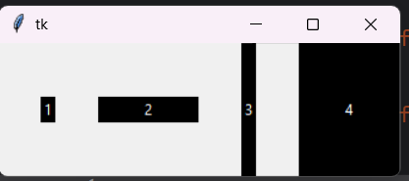

.grid() | .pack()
sticky="ns" | fill=tk.Y
sticky="ew" | fill=tk.X
sticky="nsew" | fill=tk.BOTH

Events and Events Handlers:
.bind():
import tkinter as tk
window = tk.Tk()
def handle_click(event):
print("The button was clicked!")
button = tk.Button(text="Click me!")
button.bind("<Button-1>", handle_click)
button.pack()
window.mainloop()
# tkinter automatically passes an event object to the function when something happens. The function prints the button was clicked. Binding connects a specific event to a function called an event handler. When the user left-clicks on this button, calls the function handle_click. "<Button-2>" for middle mouse button, "<Button-3>" for right mouse button.
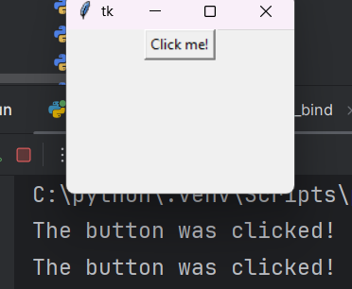
Output:

Note: We can also use bind to check what entry widget was last edited by using event.widget (event parameter is needed to use this) that returns the widget that is edited which can be stored in a variable for use. Here, global keyword is used to use the var in the function without creating a local one for the function. Read page 44 for more
last_edited = None
def set_last_edited(event):
global last_edited
last_edited = event.widget
Binds the widgets to event function. <Key> keyboard sensor: goes off whenever we type something inside the widget and <FocusIn> attention sensor: goes off when the widget gains the user’s focus (clicked or tabbed into) & lastly it calls the event function which updates the last_edited
entry.bind("<Key>", set_last_edited)
entry_c.bind("<Key>", set_last_edited)
entry.bind("<FocusIn>", set_last_edited)
entry_c.bind("<FocusIn>", set_last_edited)
Using Command:
import tkinter as tk
def increase():
value = int(lbl_value["text"])
lbl_value["text"] = str(value + 1)
def decrease():
value = int(lbl_value["text"])
lbl_value["text"] = str(value – 1)
window = tk.Tk()
window.rowconfigure(0, minsize=50, weight=1)
window.columnconfigure([0, 1, 2], minsize=50, weight=1)
btn_decrease = tk.Button(master=window, text="-", command=decrease)
lbl_value = tk.Label(master=window, text="0")
btn_increase = tk.Button(master=window, text="+", command=increase)
btn_decrease.grid(row=0, column=0, sticky="nsew")
lbl_value.grid(row=0, column=1)
btn_increase.grid(row=0, column=2, sticky="nsew")
window.mainloop()
# By writing label["text"] accesses the label widgets value and converts it to int. Then, increases the value by 1 and converts it back to string and updates it. Same process for decrease function except it decreases value by 1. Assigns window as parent container (every widget must have a parent) and command attribute calls the increase function when button is tapped.
Output:
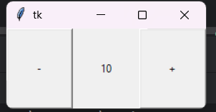

Opening and Saving Files in tkinter:
# filedialog is a submodule in Tkinter that provides ready-made dialog windows for opening and saving files. askopenfilename method opens a file chooser dialog for selecting an existing file and asksaveasfilename method opens a save dialog where we can type a new file name or select an existing file to overwrite. Lastly, returns the full path of the file we select as a string.
# If the user cancels the file explorer dialog if condition stops the function.
# File handling opens the file in utf-8 encoding it ensures can read text in standard encoding. And, .read method reads the file stores the texts as string in a variable. Also, .insert(tk.END, text) method inserts the texts from the text file in the text widget.
# File handling opens the file and writes it in utf-8 encoding it ensures can read text in standard encoding. And, .get("1.0", tk.END) method gets the texts from the text widget and stores them in a variable. Lastly, .write(text) method writes the texts in a new file or saves it in an existing file.
# Changing the window title to show the file location
from tkinter.filedialog import askopenfilename, asksaveasfilename
def open_file():
"""Open a file for editing."""
filepath = askopenfilename(
filetypes=[("Text Files", "*.txt"), ("All Files", "*.*")]
)
if not filepath:
return
txt_edit.delete("1.0", tk.END)
with open(filepath, mode="r", encoding="utf-8") as input_file:
text = input_file.read()
txt_edit.insert(tk.END, text)
window.title(f"Simple Text Editor - {filepath}")
def save_file():
"""Save the current file as a new file."""
filepath = asksaveasfilename(
defaultextension=".txt",
filetypes=[("Text Files", "*.txt"), ("All Files", "*.*")],
)
if not filepath:
return
with open(filepath, mode="w", encoding="utf-8") as output_file:
text = txt_edit.get("1.0", tk.END)
output_file.write(text)
window.title(f"Simple Text Editor - {filepath}")
Note: For more methods read submodule documentation of python
Additional:
Entry Widget Textvariable:
# textvariable links the Entry widget where the user types text to a Tkinter variable object like StringVar(), IntVar(), DoubleVar(), or BooleanVar(). Whatever the user types in the entry box it is automatically stored in that variable. We can access it using .get() method or write in it with .insert() method.
data = tk.StringVar()
entry = tk.Entry(master= window, textvariable=data, width=30)
data_var = data.get().strip()
Opening New Window and more:
# tk.Tk() class creates the main/root window. And, tk.Toplevel() class creates new windows (children of the main one).
top = tk.Toplevel(master= window)
# tk.destroy() closes a window.
# tk.withdraw() hides a window.
# tk.deiconify() shows a hidden window again.
# tk.resizable(False, False) prevents resizing.
# tk.protocol("WM_DELETE_WINDOW", callback) custom close button handler.
Label Widget Config and Image:
# image= parameter tells the label to display a picture instead of text.
label = tk.Label(top, image = qr_tk)
# But we need to reference it like this or garbage collection delete the image and the label will be blank
label.image = qr_tk
Config:
# label.config() method is used to update the text or foreground back ground or any parameter when the program is still running.
lbl_save.config(text= f"✅ Saved at {filepath}", fg="green")

Index2

Canvas Widget:
# Canvas is a special widget that lets us draw shapes, images, and text. bg="white" sets background color. width, height sets the size of the widget. .pack() places it inside the window.
canvas = tk.Canvas(master= window, bg="white", width=600, height=400)
canvas.pack()
# Here, .create_line() draws a line from (50, 50) to (200, 200).
# capstyle= controls the shape of the line’s ends which are the “caps” at the tips of the line. Available options are:
- "butt" for flat edge (default).
- "round" for rounded edge (smooth circular ends).
- "projecting" for squared-off edge that projects slightly beyond the end
# smooth= this tells Tkinter whether to smooth the line using curves (splines). smooth=False (default) means each new line segment is a straight line between two points. smooth=True means Tkinter uses Bezier curves to smooth the connected line segments, giving a flowing, natural “pen” effect.
canvas.create_line(50, 50, 200, 200, fill="blue", width=3, capstyle="round", smooth=True)
# Here, .create_rectangle() draws a rectangle between (100,100) and (200,200)
canvas.create_rectangle(100, 100, 200, 200, fill="yellow", outline="black")
# .create_oval() draws an oval inside the bounding box. (If square, it becomes a circle.)
canvas.create_oval(250, 100, 350, 200, fill="red")
# .create_text() enters text
canvas.create_text(300, 300, text="Hello!", font=("Arial", 16), fill="green")
Event Binding:
Canvas becomes interactive when we bind events (mouse, keyboard key press, etc).
# "<Button-1>" is for single left click.
# "<B1-Motion>" is for left button + move
# "<ButtonRelease-1>" is for releasing left button
canvas.bind("<Button-1>", left_click)
canvas.bind("<B1-Motion>", drag)
canvas.bind("<ButtonRelease-1>", release)
# event.x and event.y is for mouse coordinates and every drag event gives us new coordinates.
def left_click(event):
print("Clicked at:", event.x, event.y)
# Tkinter automatically creates an event object and passes it into our function. This event object contains information about what just happened, such as:
- event.x → X coordinate of the mouse (relative to the widget that triggered the event).
- event.y → Y coordinate of the mouse (relative to the widget).
- event.x_root, event.y_root → absolute screen coordinates of the mouse.
- event.type → type of event (like ButtonPress, Motion).
- event.widget → the widget that triggered the event
Color:
# Color picker this gives us a color chooser dialog. .askcolor() method opens a GUI color picker dialog and returns a tuple of two elements first is rgb value and second is hex value.By default it returns rgb code but if res[1] is used it returns a hex color code instead of rgb. Which is stored in a variable.
# We need to import askcolor first form tkinter.colorchooser
# brush_color is the variable which chooses the default color.
from tkinter.colorchooser import askcolor
brush_color = "#000000"
def pick_color():
global brush_color
res = askcolor(title="Pick brush color") # returns ( (r,g,b), "#rrggbb" ) or (None, None)
if res and res[1]:
brush_color = res[1]
Brush Size:
# We need a tk.scale() a slider widget to adjust the brush size. Here, from_=, to= parameters are the number range to adjust the value of the brush size. And, orient= parameter is used to define if the slider will be horizontal or vertical. variable= parameter is used to get the adjusted value from the slider widget using .get() method.
# The variable(size_var) has to be a tk.IntVar(value= 4) type. We can also set default value like 4.
# But we can also use size_slider.get() directly without a variable if we prefer.
# Be cautions we need to get the value from the slider widget inside a event function otherwise it won’t update.
size_var = tk.IntVar(value=4)
size_slider = tk.Scale(root, from_=1, to=60, orient="horizontal", variable=size_var, label="Brush size")
size_slider.pack()
brush_size = size_var.get()
Clear and Eraser:
# canvas.delete("all") method removes all canvas items.
# canvas.delete(tag_or_id) method deletes or removes all items with that tag if a tag name is passed; removes a single item if an item id (int) is passed as parameter.
# canvas.cget("bg") or canvas['bg'] method get the canvas background color and drawing with that color simulates an eraser.
# But we might face problems erasing with the background color if the background is a gradient or image. Solution is maintaining a backing image.
canvas.delete("all")
canvas.delete("stroke")
eraser_width = 30
canvas.create_line(x1, y1, x2, y2, fill=canvas.cget("bg"), width=eraser_width, capstyle=tk.ROUND)
Saving the canvas with ImageGrab:
# First import ImageGrab from PIL (pillow) library.
# window.update() method flushes pending UI drawing so capture reflects the latest strokes.
# winfo_rootx() / winfo_rooty() method means top-left position of the window on the screen.
# canvas.winfo_x() / winfo_y() method means position of canvas inside the window.
# canvas.winfo_width() method returns the current width of the canvas in pixels. Unlike winfo_x(), this is the size, not the position. canvas.winfo_height() does the same as above, but for height. These give us the dimensions of the canvas. Putting it all together:
x1 = x + canvas.winfo_width()
y1 = y + canvas.winfo_height()
So now we have a bounding box. Top-left corner: (x, y) and Bottom-right corner: (x1, y1). This is exactly the rectangle we pass to ImageGrab.grab(bbox=(x, y, x1, y1)) so it captures only the canvas, not the whole screen.
# ImageGrab.grab(bbox=()) method returns a PIL Image of that rectangle. And, .save() writes to file.
# ImageGrab.grab(bbox=(left, top, right, bottom))
# We need to pair it with filedialog library to save it in our machine.
from PIL import ImageGrab
def save_canvas_image(filename="drawing.png"):
root.update() # ensure latest drawing is rendered
x = root.winfo_rootx() + canvas.winfo_x()
y = root.winfo_rooty() + canvas.winfo_y()
x1 = x + canvas.winfo_width()
y1 = y + canvas.winfo_height()
ImageGrab.grab(bbox=(x, y, x1, y1)).save(filename)
Note: It may face some issues on some linux set ups

