INDEX
- GetX State Management……………………………………………..…..3
- Pillar-1 Reactive State Manager (Obx / GetX widget)……………..4
- Pillar2- Simple State Manager (GetBuilder)……………………….11
- Reactive vs Simple State Manager…………………………………….13
- GetX DI (Dependency Injection)……………………………………….16
- The 4 Registration Methods……………………………………………..17
- Get.find(), Retrieve from anywhere…………………………………..22
- Bindings (The Production Pattern)……………………………………23
- Smart Management (Disposable Engine of GetX)………………..30
- A Real-World Architecture Pattern………………………………..31
- Instant Replacement (For Testing)………………………………..34
- Shared Controller Problem (in Two Pages)……………………..37
- GetX Service…………..………………………………………………..42
- GetConnect (GetX’s built-in HTTP client)……………………...51
- GetView and GetWidget (Useful widgets)……………………..54
- ValueBuilder and ObxValue (local ephemeral state)…….…56
- Encapsulation in GetX………………………………………………..85
- Stream & StreamSubscription in GetX…….…………………..87
- Repository Pattern with GetX……………………………………….90
- BottomNavigationBar Widget with GetX…………………….100
- The Full Architecture…………………………………………………ss102

INDEX-2
- GetX Routing………………………………………………………………..61
- Part-1, Navigation Methods (No Named routes)………………….62
- Part-2, Named Routes + GetPage……………………..……………..64
- Part-3, Passing Data Through Named Routes……………………..66
- Part-4, Middleware (GetX equivalent of route guards)………….68
- Part-5, Our onGenerateRoute: pattern in GetX………………….71
- GetX Context-Free UI (SnackBars, dialogs)…….………..……....79
- Global Settings (Useful APIs of GetX)………………………………..82

GetX State Management:
# GetX does not use Streams or ChangeNotifier like other state managers. The creator wrote his own primitives called GetValue and GetStream which are low-latency and lightweight replacements.
# GetX can be so performant because it skips Flutter's notification pipeline entirely and uses its own surgical update system.
# So, the comparison table:
Library | Built on
Provider | ChangeNotifier (Flutter's own)
Riverpod | ChangeNotifier + its own providers
BLoC | Dart Stream / StreamController
GetX | Custom GetValue + GetStream (no external dependencies)

Installation:
# Run this command in the terminal
flutter pub add get
# Or manually add the dependencies
dependencies:
get: ^4.7.3
# Then import it
import 'package:get/get.dart';
NOTE: GetX doesn’t work with material_ui standalone package after Flutter 3.47. Use FVM version manager and version 3.44.9 and stick to build in Material library

GetX State Managers:
# GetX state management has two pillar model
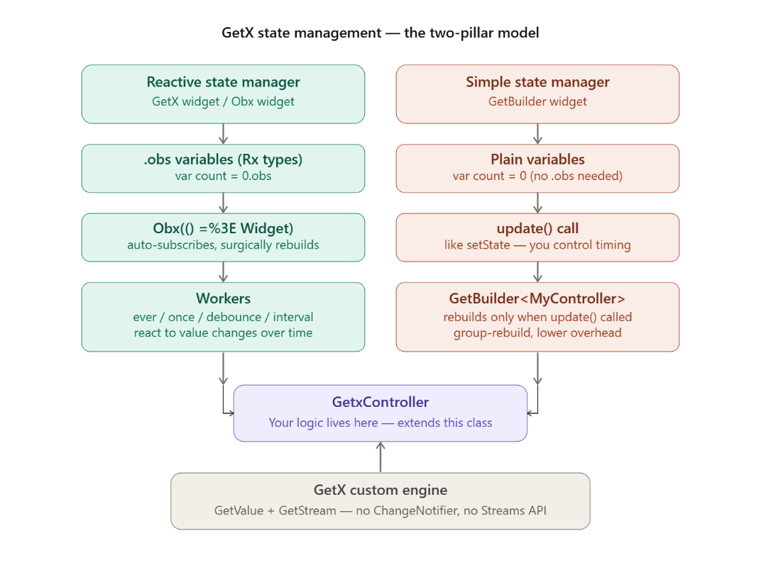

Pillar-1 Reactive State Manager (Obx / GetX widget):
# This is the ‘hot path’ variables that automatically push UI updates

Step-1, The Controller:
# Our business logic like API calling lives in a class that extends GetxController
# .obs under the hood, it creates a Stream of the type, assigns the initial value, and notifies all widgets that use it that they "belong" to this variable when the Rx value changes, they will have to change as well
# .obs is syntactic sugar. 0.obs is actually RxInt(0). Three ways to declare reactive variables:
- Way-1, Typed Rx class (most explicit). There’s also RxnBool or RxnInt for nullable types
final count = RxInt(0);
final count2 = RxnInt();
final name = RxString('');
final flag = RxBool(false);
final myList = RxList([…]);
- Way-2, Generic Rx<Type> (useful for custom classes). There’s also Rxn<Type>() for nullable Rx
final user = Rx<User>(User());
final user2 = Rxn<User>();
- Way-3, .obs short hand (preferred and most readable)
final count = 0.obs;
final name = ''.obs;
final items = <String>[].obs; // reactive list!
final movies = <MovieModel>[].obs
# Final controller would look like this:
import 'package:get/get.dart';
class CounterController extends GetxController {
// .obs makes this variable "observable" (Rx type)
var count = 0.obs;
void increment() => count.value++;
void decrement() => count.value--;
}
NOTE: GetxController class has lifecycles like onInit() (for workers), onReady() and onClose().

Step-2, Register the controller with Get.put():
# Get.put() registers the controller in GetX's internal dependency container. Any widget can now find it via Get.find<CounterController>(). Think of it like a global singleton that GetX manages for us. There’s also Get.lazyPut() for better performance and error prevention
# In our widget's build method (or via Bindings in GetMaterialApp())
final controller = Get.put(CounterController());

Step-2, Use in UI, wrap reactive zones int Obx:
# The key mental model, Obx((){…}) is a surgical scalpel, not a sledgehammer. Only the widget inside the Obx rebuilds, not the whole page. We can and should have many small Obx wrappers per screen.
# Get.find<…>() method retrieves the already-registered controller
class CounterPage extends StatelessWidget {
final controller = Get.find<CounterController>();
@override
Widget build(BuildContext context) {
return Scaffold(
appBar: AppBar(
// Obx wraps ONLY the widget that needs to rebuild
title: Obx(() => Text('Count: ${controller.count.value}')),
),
body: Center(
// This text rebuilds independently from the AppBar title
child: Obx(() => Text(
'${controller.count}',
style: TextStyle(fontSize: 48),
)),
),
floatingActionButton: FloatingActionButton(
// This button does NOT rebuild — no Obx needed here
onPressed: controller.increment,
child: Icon(Icons.add),
…
}
NOTE: If there is no controller in Obx(() {}) then it will show error

# If we have Obx watching our ListView, and another Obx watching a checkbox inside the ListView, when changing the checkbox value, only it will be updated and when changing the list value, only the ListView will be updated (no Provider or Riverpods selector or select needed). Like this, when isChecked changes → only the inner Obx rebuilds. When tasks changes → only the outer Obx rebuilds. Zero unnecessary rebuilds. One Obx only watches one reactive state remember that
Obx(() => ListView.builder(
itemCount: controller.tasks.length,
itemBuilder: (_, index) => Obx(() => CheckboxListTile(
value: controller.isChecked.value,
onChanged: (val) => controller.isChecked.value = val!,
title: Text(controller.tasks[index]),
…
)
NOTE: If we do wrap it with only one outside Obx() then outer Obx() won’t react to isChecked changing inside task for that we need to call controller.tasks.refresh() method to force outer Obx() to rebuild. But this is messy approach and it forces full list rebuild even when only one checkbox changed. Avoid this and use per-Item RxBool with inner Obx instead
# Another amazing thing, if controller.name is "John" and we change it to "John" ( name.value = "John" ), as it's the same value as before, nothing will change on the screen, and Obx , to save resources, will simply ignore the new value and not rebuild the Widget
NOTE-2: There’ also GetX<CountController> widget but Obx is preferred because it doesn’t require specifying a type

Step-4, Workers that React to Value Changes Overtime:
# Workers are like event listeners on our .obs variables. Always declare them in onInit() method of GetxController.
# ever() fires every time count changes, once() fires only the FIRST time count changes
# debounce() fires 1 second AFTER the user stops changing count. Perfect for search bars / API calls. debounce() is our best friend for search inputs.
# interval() fires at most once per second, even if changed 100 times. interval() is our best friend for preventing abuse like spam clicks on a “Buy” button
class CounterController extends GetxController {
var count = 0.obs;
@override
void onInit() {
super.onInit();
// Fires every time count changes
ever(count, (value) => print('Count is now: $value'));

// Fires only the FIRST time count changes
once(count, (value) => print('First change: $value'));
// Fires 1 second AFTER the user stops changing count
// Perfect for search bars / API calls
debounce(count, (value) => fetchData(value),
time: Duration(seconds: 1));
// Fires at most once per second, even if changed 100 times
interval(count, (value) => print('Throttled: $value'),
time: Duration(seconds: 1));
}
Future<void> fetchData(int val) async {
// imagine API call here
}
}
NOTE: GetxController class also has lifecycle methods like:
- onInit() (for workers) run when controller is first created
- onReady() runs when controller is ready
- And onClose() runs when controller is disposed or closed.

Pillar2- Simple State Manager (GetBuilder):
# This is the "manual mode" we control exactly when to rebuild. No .obs just plain variable
# But we must call update() method (like Providers notifyListeners()) because nothing rebuilds automatically. update() method triggers all GetBuilder widgets listening to this controller
class CartController extends GetxController {
// No .obs just plain variable
int itemCount = 0;
double totalPrice = 0.0;
void addItem(double price) {
itemCount++;
totalPrice += price;
// We MUST call update(), nothing rebuilds automatically
update();
}
void removeItem(double price) {
if (itemCount > 0) {
itemCount--;
totalPrice -= price;
update(); // triggers all GetBuilder widgets listening to this controller
}
}
}

Usage in UI:
# We use GetBuilder(), here init: property takes the CartController() and registers the controller if not already registered. And the entire builder: runs on every update() call
class CartPage extends StatelessWidget {
@override
Widget build(BuildContext context) {
return GetBuilder<CartController>(
init: CartController(), // registers if not already registered
builder: (controller) {
// This entire builder runs on every update() call
return Column(
children: [
Text('Items: ${controller.itemCount}'),
Text('Total: \$${controller.totalPrice.toStringAsFixed(2)}'),
ElevatedButton(
onPressed: () => controller.addItem(9.99),
child: Text('Add Item'),
…
}
NOTE: It also has child: property for optimization like ValueNotifier<T>

Reactive vs Simple State Manager:
# GetX is aimed at granular control over what's being updated. GetBuilder is aimed at multiple state control, imagine we added 30 products to a cart, we click delete one, and at the same time the list is updated, the price is updated, and the badge in the shopping cart is updated to a smaller number. This type of approach makes GetBuilder super useful, because it groups states and changes them all at once.
 | Reactive (Obx) | Simple (GetBuilder)
Variable syntax | var x = 0.obs | var x = 0
Trigger rebuild | Automatic on value change | Manual update() call
Rebuild scope | Per-variable, surgical | Whole builder, grouped
Performance | Best for fine-grained UI | Best for batch updates
Use case | Counters, flags, input fields | Cart, form with many fields
Boilerplate | Very low | Low

# A golden rule, use Reactive when one variable = one UI element. Use Simple when one action = many UI elements update together.

Common Mistakes:
# Mistake-1, Using .value on lists when not needed
// Wrong — lists don't need .value in the view
Text('${controller.items.value.length}')
// Correct — lists are directly accessible
Text('${controller.items.length}')
# Mistake-2, putting a non-observable in Obx because it will never rebuild, count is not .obs
var count = 0;
Obx(() => Text('$count')) // dead widget
# Mistake-3, Calling update() in Reactive mode or vice versa. If we used .obs, don't call update(), it's redundant but If we used GetBuilder, don't forget update(), nothing triggers otherwise
# Mistake 4, Forgetting to call super.onInit()
@override
void onInit() {
super.onInit(); // ALWAYS call this first
ever(count, (_) => doSomething());
}
# Mistake-5, Declaring Workers outside onInit(). Workers started in build() will be re-created on every rebuild and we'll end up with dozens of identical listeners. Always declare them in onInit.

Industry Practices & Advanced Usage:
- In production apps, controllers are almost never registered with Get.put() directly in the view. Instead, Bindings (like in GetMaterialApp()) are used to separate controller registration from views entirely.
- Large apps use GetxService (not GetxController) for truly global things like auth state or a network client so services are never destroyed.
- The ever worker is commonly used for navigation side effects like in auth controller
ever(isAuthenticated, (val) => val ? Get.offAll(HomeScreen()) : Get.offAll(LoginScreen())).
- Obx is preferred over the GetX<Controller> widget in modern GetX usage because it's cleaner and doesn't require specifying a type. We generally inherit it using extends GetX<Controller> when creating reusable widgets
NOTE: There’s also things like StateMixing which is declared using GetControlller with StateMixing<T>{} and gives RxStaus (RxStatus.loading(), .success(), .empty() and .error(…))

Break

GetX DI (Dependency Injection):
# GetX DI is a global type-keyed map. When we call Get.put(MyController()), GetX stores that instance in an internal map using the type MyController as the key. When we call Get.find<MyController>(), it looks up that key and hands it back from anywhere in the app, no context, no Provider, no InheritedWidget.
# Think of it like a warehouse. put/lazyPut/create = putting a box in the warehouse and find = fetching that box by its label. Bindings = an employee who automatically puts and removes boxes when a truck (route) arrives or leaves.

The GetX DI Container Model:
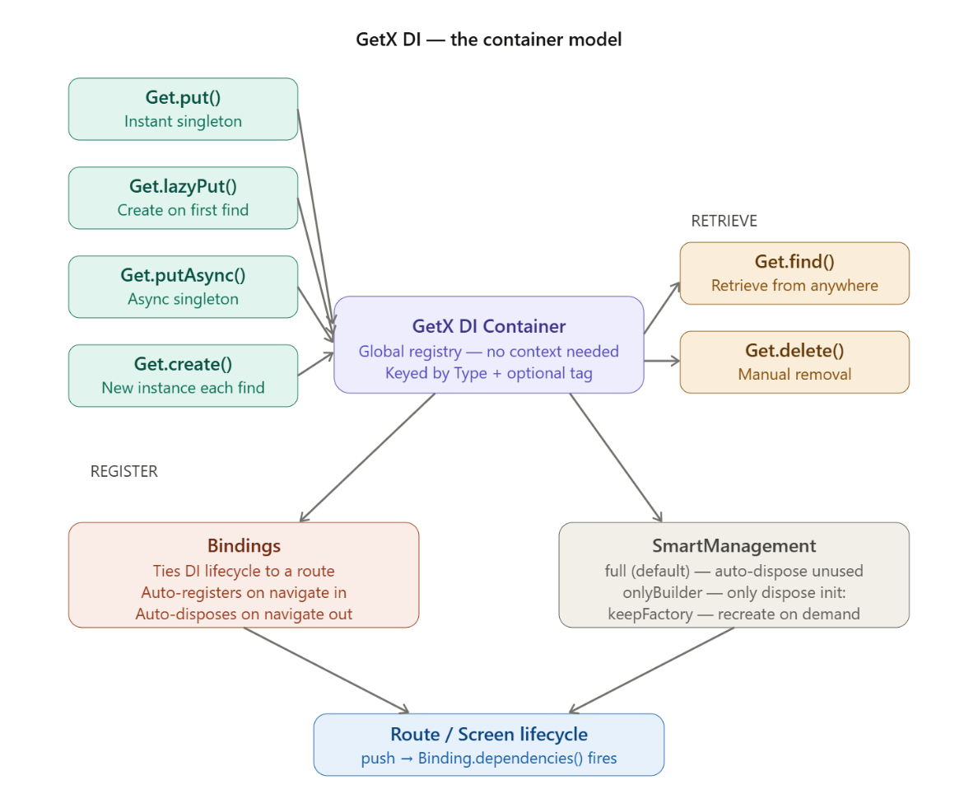

The 4 Registration Methods:
1. Get.put(), Immediate Singleton:
# Creates and stores the instance right now. The return value is the instance, so we can use controller directly. No need to call Get.find() right after Get.put(). But may cause error like it may work before flutters first frame is drawn
# Set the permanent: property to true so controller is never auto-disposed. Useful for services that live for the whole app (like auth controller, API caller)
# Use tag: property for multiple instances of the same type. Useful when we need the same CartController but for two different screens for separate purposes.
final controller = Get.put(HomeController());
// permanent
Get.put(AuthService(), permanent: true);
// tag
Get.put(CartController(), tag: 'guest-cart');
Get.put(CartController(), tag: 'user-cart');

2. Get.lazyPut(), Deferred singleton:
# It Registers a factory function but creates nothing yet. The instance is built only on the first Get.find<T>() call. lazyPut is what we almost always use inside Bindings. It's memory-efficient and only allocates when actually needed.
# fenix: true (by default its false) means "rise from ashes" like if the instance gets disposed, it can be RECREATED on next Get.find()
// Nothing created here just stores the factory
Get.lazyPut<ApiService>(() => ApiService());
// fenix: true = "rise from ashes"
Get.lazyPut<ProfileController>(
() => ProfileController(),
fenix: true,
);
# fenix: true vs permanent: true, the critical difference:
 | permanent: true | fenix: true
Instance lives | Forever, never disposed | Disposed when not used
On next find after disposal | — (never disposed) | Recreated from factory
Memory | Always occupied | Freed when not in use
Use for | Auth, DB, SharedPrefs | Feature controllers we might need again

3. Get.putAsync(), Async Singleton:
# For dependencies that require async initialization (SharedPreferences, databases, tokens).
// Awaits the async factory before the instance is available
await Get.putAsync<SharedPreferences>(() async {
return await SharedPreferences.getInstance();
});
# A realistic example, initializing a database (AppDataBase). Using an Future<…> init() method that will initialize late SharedPrefernces and other database things. Then in putAsync(() async => StorageService.init())
class AppDataBase {
late SharedPreferences _prefs;
// Services can have async init() method, using putAsync
Future<StorageService> init() async {
_prefs = await SharedPreferences.getInstance();
// migration login, opening connections
}
await Get.putAsync<AppDatabase>(() async {
final db = AppDatabase();
await db.init(); // await migrations, open connections, etc.
return db;
});
# We typically call or register these in main() before runApp(), or in an initialBinding: property of GetMaterialApp(). If we register it in main() method then we have to await Get.putAsync<…>(…) before runApp()
void main() async {
WidgetsFlutterBinding.ensureInitialized();
await Get.putAsync<SharedPreferences>(() async =>
await SharedPreferences.getInstance());
await Get.wait(); // (Optional) Or use this, to be safe
runApp(MyApp());
}
# IMPORTANT, but not every async dependency should delay application startup. Some things should be lazily initialized only when a feature actually needs them.
# For example, if the service isn’t immediately needed the don’t await it, just simply start async initialization in Get.putAsync(…) and immediately continue to runApp()
…
Get.putAsync<MyService>(
() async => MyService().init(),
);
runApp(const MyApp());

4. Get.create(), New instance every time:
# Every Get.find() call returns a brand-new instance. This is the odd one but it is NOT a singleton.
// Each Get.find<ItemController>() creates a fresh controller
Get.create<ItemController>(() => ItemController());
# Use this when a ListView where each list item needs its own independent controller. Combined with extends GetWidget<T> (not StatelessWidget) and GetX will give each widget its own instance and cache it to that widget's lifecycle.
// GetWidget caches ONE instance per widget identity
class TodoItem extends GetWidget<TodoItemController> {
@override
Widget build(BuildContext context) {
return Text(controller.title); // each item has its own controller
}
}

Get.find(), Retrieve from anywhere:
# This is the killer feature of GetX DI. No BuildContext, no widget tree traversal just calls Get.find() from a controller, a service, a repository, anywhere.
# We can also use tag: property to get multiple instances of same type when we registered
// Basic retrieval — type is inferred
final auth = Get.find<AuthService>();
// With tag
final guestCart = Get.find<CartController>(tag: 'guest-cart');
final userCart = Get.find<CartController>(tag: 'user-cart');
// Using in a controller (no context needed!)
class OrderController extends GetxController {
// We can inject another controller directly
final cart = Get.find<CartController>();
final auth = Get.find<AuthService>();
void placeOrder() {
if (auth.isLoggedIn) {
// use cart data...
}
}
}
NOTE: There’s also Get.replace<T>(…) for instant replacement for testing, Get.reset() or Get.delete<T>(force: true) for removing a GetxService or GetxController

Bindings (The Production Pattern):
# Raw Get.put() in a widget's build method works but it's messy. Bindings are the professional way; they tie controller lifecycle precisely to route lifecycle.
# Bindings ensure that Controller (HomeController) is created and initialized when user navigates to ‘/home’ route. And the Controller stays alive until the ‘/home’ is removed from the navigation stack (if route is removed from navigation stack then the onDelete() method of Controller runs and Controller is deleted from memory)

Step-1, Create a Binding Class:
# Just implement it using implements on Bindings and override dependencies() method
class HomeBinding implements Bindings {
@override
void dependencies() {
// lazyPut is preferred here — only creates when first accessed
Get.lazyPut<HomeController>(() => HomeController());
Get.lazyPut<ProductRepository>(() => ProductRepository());
}
}
…
class ProfileBinding implements Bindings {
@override
void dependencies() {
Get.lazyPut<ProfileController>(() => ProfileController());
}
}

Step-2, Attach Binding to a route:
# Go to root of our app and replace MaterialApp() with GetMaterialApp() which has all the things of MaterialApp() with Getx attached to it
# Then in the GetMaterialApp(), getPages: property takes a list of GetPage() classes instance. In the GetPage() class we specify:
- The name of the route (named route) using name: property
- The page or screen to build or show using page: () =>
- And the binding for that page to register the controller needed for that screen or page using binding:
# Now when the user navigates to ‘/profile’ the ProfileBinding.dependencies() fires → registers ProfileController and when User navigates away → GetX auto-disposes ProfileController. No memory leaks. No manual cleanup. Zero effort.
// In our GetMaterialApp routes list:
GetMaterialApp(
initialRoute: '/home',
getPages: [
GetPage(
name: '/home',
page: () => HomeView(),
binding: HomeBinding(), // fires when /home is pushed to route
),
GetPage(
name: '/profile',
page: () => ProfileView(),
binding: ProfileBinding(), // fires when /profile is pushed to route
),
],
)

Alternative, BindingsBuilder (Inline, no class needed):
# For simple screens where creating a full class feels like overkill then use BindingsBuilder(…)
…
GetPage(
name: '/settings',
page: () => SettingsView(),
binding: BindingsBuilder(() {
Get.lazyPut<SettingsController>(() => SettingsController());
}),
),

initialBinding: App-Wide Registration:
# In GetMaterialApp(), we have initialBinding: property for app-level eager binding injection before first frame is drawn. Use it when we skip named routing (we have only one screen to show so bind only one) or need global controllers ready immediately.
# In large apps, a common pattern is an AppBinding passed to GetMaterialApp's initialBinding:, it registers all permanent services (auth, network, analytics) at startup. Route-specific bindings handle the rest.
# Permanent services live forever whereas Route controllers are born and die with their screen. Think of it as two layers of DI:
App starts
└── initialBinding (AppBinding) fires ONCE
├── AuthService (permanent)
├── ApiClient (permanent)
└── AnalyticsService (permanent)

User navigates to /home
└── HomeBinding fires
└── HomeController (disposed when user leaves /home)
# So, AppBinding runs once at app start, before any screen renders. Route bindings run on demand. We have to worry about "is AuthService available yet?", it always is.
# lib/app/bindings/app_binding.dart
class AppBinding implements Bindings {
@override
void dependencies() {
// These are permanent and never disposed, available everywhere
Get.put(ApiClient(), permanent: true);
Get.put(AuthService(), permanent: true);
Get.put(AnalyticsService(), permanent: true);
// Async service — db, shared prefs, etc.
Get.putAsync<LocalStorage>(
() async => await LocalStorage.init(),
permanent: true,
);
}
}
# In main.dart
void main() {
runApp(
GetMaterialApp(
initialBinding: AppBinding(), // fires before any route loads
initialRoute: '/home',
getPages: [
GetPage(
name: '/home',
page: () => HomeView(),
binding: HomeBinding(), // HomeController — route-scoped
),
GetPage(
name: '/profile',
page: () => ProfileView(),
binding: ProfileBinding(), // ProfileController — route-scoped
…
}
# In any controller can now pull permanent services freely
class HomeController extends GetxController {
final api = Get.find<ApiClient>(); // registered by AppBinding
final auth = Get.find<AuthService>(); // registered by AppBinding
final analytics = Get.find<AnalyticsService>(); // registered by AppBinding
}

Smart Management (Controlling Disposable Engine of GetX):
# GetX by default disposes unused controllers from memory, even if a failure occurs and a widget that uses it is not properly disposed. This is what is called the full mode of dependency management
GetMaterialApp(
smartManagement: SmartManagement.full, // default, change it only if we know why
home: Home(),
)
# There are three modes:
The three modes:
- SmartManagement.full (default):
Auto-disposes anything not in use and not marked permanent. Best for most apps — trust it.
- SmartManagement.onlyBuilder:
Only disposes controllers registered via init: in GetBuilder or lazyPut in a Binding. Controllers registered with Get.put() are immune. Use this when we want predictable, explicit disposal.
- SmartManagement.keepFactory:
Like full, but retains the factory function even after disposal. So, the controller can be recreated if needed again. Similar effect to fenix: true.
# In 95% of apps, leave it as full and use Bindings. That combination is industry-standard GetX.

A Real-World Architecture Pattern:
# Here's how a production GetX app wires this all together:
// main.dart
void main() async {
WidgetsFlutterBinding.ensureInitialized();
// Services that live for the entire app lifecycle
await Get.putAsync<SharedPreferences>(
() async => await SharedPreferences.getInstance());
Get.put(AuthService(), permanent: true);
Get.put(ApiClient(), permanent: true);
runApp(MyApp());
}

// app.dart
class MyApp extends StatelessWidget {
@override
Widget build(BuildContext context) {
return GetMaterialApp(
initialRoute: '/home',
getPages: [
GetPage(name: '/home', page: () => HomeView(), binding: HomeBinding()),
GetPage(name: '/cart', page: () => CartView(), binding: CartBinding()),
GetPage(name: '/profile', page: () => ProfileView(), binding: ProfileBinding()),
…
}

// bindings/home_binding.dart
class HomeBinding implements Bindings {
@override
void dependencies() {
Get.lazyPut<HomeController>(() => HomeController());
}
}

// controllers/home_controller.dart
class HomeController extends GetxController {
// Gets services from the container — no constructor injection mess
final auth = Get.find<AuthService>();
final api = Get.find<ApiClient>();
var products = <Product>[].obs;
@override
void onInit() {
super.onInit();
fetchProducts();
}
Future<void> fetchProducts() async {
final data = await api.getProducts();
products.assignAll(data);
}
}

// views/home_view.dart
class HomeView extends StatelessWidget {
// Controller already registered by HomeBinding
final c = Get.find<HomeController>();
@override
Widget build(BuildContext context) {
return Scaffold(
body: Obx(() => ListView.builder(
itemCount: c.products.length,
itemBuilder: (_, i) => Text(c.products[i].name),
…
}

Instant Replacement (For Testing):
# This is how GetX enables dependency inversion / testability without any third-party mocking library.
# Create an abstract class for interface like AuthRepository and implement it then just override the method in abstract class and then register using Get.put<…>() method and switch it up with Get.replace<…>() method
abstract interface class AuthRepository {
Future<User> login(String email, String pass);
}
class RealAuthRepository implements AuthRepository {
@override
Future<User> login(String email, String pass) => api.login(email, pass);
}
class MockAuthRepository implements AuthRepository {
@override
Future<User> login(String e, String p) async => User(name: 'Test');
}
// In production
Get.put<AuthRepository>(RealAuthRepository());
// In tests — replace without touching the rest of the app
Get.replace<AuthRepository>(MockAuthRepository());

Common Mistakes:
# Mistake-1, Calling Get.find() before Get.put(). It will crash
// CRASH — nothing registered yet
final c = Get.find<HomeController>();
// Correct — register first
Get.put(HomeController());
final c = Get.find<HomeController>();
# Mistake-2, Double-registering without permanent. Second Get.put() will throw if instance already exists
Get.put(HomeController());
Get.put(HomeController()); // Error in debug mode!
// Use replace() if we intentionally want to swap
Get.replace(HomeController());
# Mistake-3, Get.put() inside build() on a non-permanent service then every rebuild re-registers and this is wrong
Widget build(context) {
Get.put(SomeController()); // BAD, use Bindings or put once in initState
}
# Mistake-4, Forgetting permanent: true for app-wide services. AuthService disposed when screen pops which is very bad
Get.put(AuthService()); // missing permanent: true!
// Correct
Get.put(AuthService(), permanent: true);

# Mistake-5, Using Get.create() expecting a singleton (same instance)
Get.create<Controller>(() => Controller());
Get.find<Controller>() == Get.find<Controller>(); // FALSE, two different instances!

Break

Same Controller Used in Two Pages (Shared Controller Problem):
# If one controller is needed or shared for two pages like cart and product screen then a problem occurs like GetX route-based controller dispose system will dispose that controller even if its still being used in product screen
# Mental Model:
App Memory
│
├── ProductScreen opens
│ └── ProductBinding fires → CartController.lazyPut() registered
│
├── CartScreen opens
│ └── CartBinding fires → CartController.lazyPut() → SAME instance reused ✅
│
├── CartScreen closes
│ └── GetX tries to delete CartController...
│ but ProductScreen still needs it! 💀 ← THIS is the problem

Solution-1, lazyPut with fenix: true:
# When Cart Screen closes → controller deleted and when Product Screen tries to access Cart Controller → GetX sees fenix: true → recreates it
# But here’s the catch state is lost on recreation. If cart had items and controller was deleted then new instance = empty cart. Bad for cart specifically. So, if we want to preserve the cart item use Solution-2
// CartBinding
class CartBinding extends Bindings {
@override
void dependencies() {
Get.lazyPut(() => CartController(), fenix: true); // auto-recreates if deleted
}
}
// ProductBinding
class ProductBinding extends Bindings {
@override
void dependencies() {
Get.lazyPut(() => CartController(), fenix: true); // same tag, reuses instance
}
}
# Then in GetMaterialApp()
// GetPage routing
GetPage(name: '/cart', page: () => CartScreen(), binding: CartBinding()),
GetPage(name: '/product', page: () => ProductScreen(), binding: ProductBinding()),

Solution-2, Get.put() with permanent: true in a Parent / App-Level Binding (Best for Cart):
# Register the cart controller as permanent and product controller stays in its own binding (its screen specific)
# No binding is needed for cart controller in GetPage() of cart screen cause its already banded in initialBinding:
// AppBinding, registered in initialBinding
class AppBinding extends Bindings {
@override
void dependencies() {
Get.put(CartController(), permanent: true); // never deleted
// ProductController stays in its own binding — it's screen-specific
}
}
# In get material app
GetMaterialApp(
initialBinding: AppBinding(), // CartController lives here
getPages: [
GetPage(name: '/product', page: () => ProductScreen(), binding: ProductBinding()),
GetPage(name: '/cart', page: () => CartScreen()), // no binding needed
],
)
# Product binding
// ProductBinding — only product-specific stuff
class ProductBinding extends Bindings {
@override
void dependencies() {
Get.lazyPut(() => ProductController());
// CartController already in memory from AppBinding
}
}

Decision Tree for this pattern:
# See this mental model before this approach.
Is the controller's data needed across the whole app lifetime?
(cart, auth, theme, user session)
│
YES → Get.put(permanent: true) in initialBinding/AppBinding
│ OR use Repository Data cache pattern
NO
│
▼
Is it shared between 2-3 specific screens temporarily?
│
YES → lazyPut(fenix: true) in both bindings
│
NO
│
▼
Single screen only → lazyPut() in that screen's binding only
NOTE: Duplicating controller logic into two separate controllers just to avoid sharing defeats the whole point. And not thinking about data lifetime vs screen lifetime these are different things
# Use permanent: true in AppBinding. If controller data must survive navigation.

NOTE-2: Putting a Controller in AppBinding is not a good practice for only 2 screens unless if it’s needed for 3 or 4 (which is unlikely). Alternative approach for preserving data would be:
- Store the data in a Repository Layer which will be permanent as a GetxService in AppBinding (or specific HomeBindings) so any Controller can load the data from it. SEE below for more.
- Or pass the data when navigating using arguments: dataList in Get.toNamed(…) method (Recommended, or try fenix:)
Break

GetX Service:
# GetxService is a class that, once initialized, cannot be removed from memory. It is ideal for Auth Services, Network Services, and Storage services, because it ensures they are always available throughout the app lifecycle. The one-line mental model:
- GetxController = lives with a route
- GetxService = lives with the app
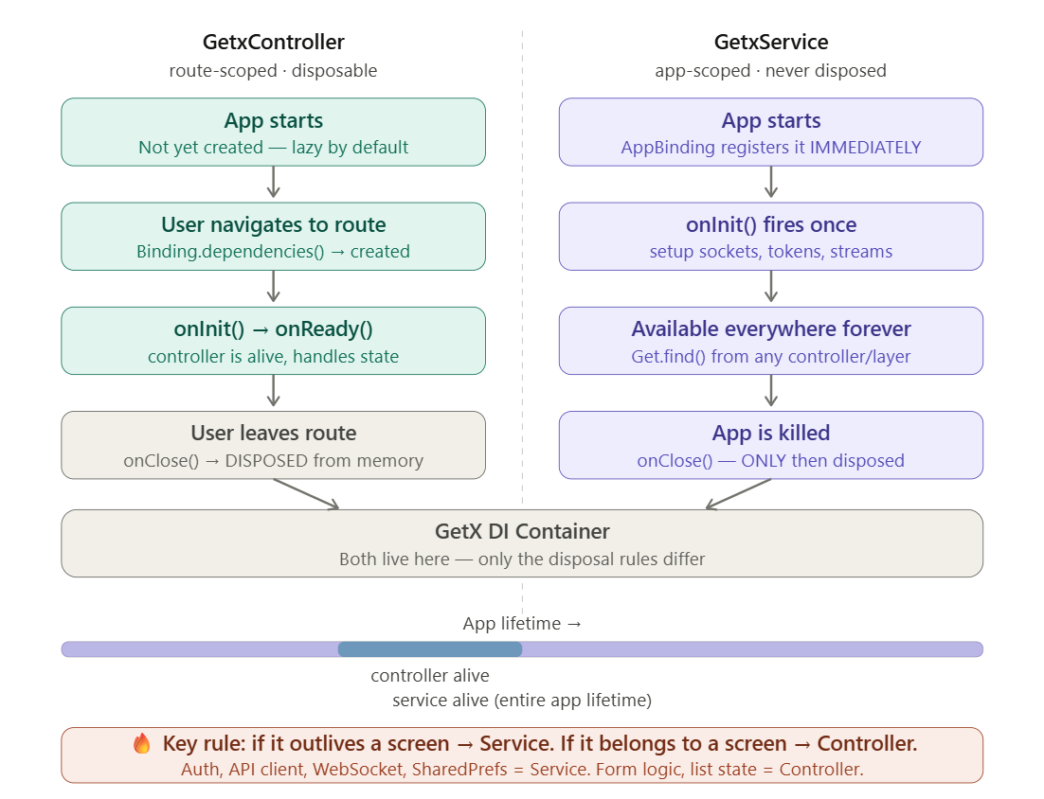

# Both extend GetLifeCycleBase internally, so both get onInit(), onReady(), and onClose() methods. The ONLY difference is that GetxService cannot be disposed by SmartManagement. We have to call Get.reset() or Get.delete<T>(force: true) to remove it, neither happens by accident.

Creating a Service (Using GetxService):
# Simply inherit the GetxService class using extends keyword.
# onInit() method (needs to be overridden) runs one when the app starts and loads stored auth states (like token and user info) from SharedPreferences, Hive etc.
# onClose() method is called when the app is fully killed and cleans up streams, sockets and controllers etc.
// lib/services/auth_service.dart
class AuthService extends GetxService {
// Reactive state that other parts of the app can observe
final isLoggedIn = false.obs;
final currentUser = Rxn<User>(); // Rxn = nullable Rx
// Token stored in memory — loaded from storage on init
String? _token;
String? get token => _token;
@override
void onInit() {
super.onInit();
// This runs ONCE when the app starts and Load stored auth state
_loadPersistedSession();
}
Future<void> _loadPersistedSession() async {
final prefs = Get.find<StorageService>();
_token = prefs.getString('token');
if (_token != null) {
isLoggedIn.value = true;
// Optionally refresh the user profile
await _fetchCurrentUser();
}
}
Future<bool> login(String email, String password) async {
try {
final api = Get.find<ApiService>();
final response = await api.post('/auth/login', {
'email': email,
'password': password,
});
_token = response.data['token'];
currentUser.value = User.fromJson(response.data['user']);
isLoggedIn.value = true;
// Persist or store for next app launch
final prefs = Get.find<StorageService>();
await prefs.setString('token', _token!);
return true;
} catch (e) {
return false;
}
}
Future<void> logout() async {
_token = null;
currentUser.value = null;
isLoggedIn.value = false;
final prefs = Get.find<StorageService>();
await prefs.remove('token');
// Kick user to login and clear the stack
Get.offAllNamed(AppRoutes.login);
}
Future<void> _fetchCurrentUser() async {
// ...
}
@override
void onClose() {
// Only called when the app is fully killed
// Clean up streams, sockets, etc.
super.onClose();
}
}
# Notice isLoggedIn is .obs and in any widget or middleware can Obx() watch on it and react when auth state changes. Our AuthMiddleware from the previous lesson becomes not that important (but good to have)
# API service with GetxService:
class ApiService extends GetxService {
final _dio = Dio(); // or use GetConnect shown later
static const _baseUrl = 'https://api.myapp.com';
@override
void onInit() {
super.onInit();
_dio.options = BaseOptions(
baseUrl: _baseUrl,
connectTimeout: Duration(seconds: 10),
receiveTimeout: Duration(seconds: 10),
);

// Interceptor: attach auth token to every request
_dio.interceptors.add(InterceptorsWrapper(
onRequest: (options, handler) {
final auth = Get.find<AuthService>();
if (auth.token != null) {
options.headers['Authorization'] = 'Bearer ${auth.token}';
}
handler.next(options);
},
onError: (error, handler) {
// 401 = token expired → logout
if (error.response?.statusCode == 401) {
Get.find<AuthService>().logout();
}
handler.next(error);
},
));
}
Future<Response> get(String path) => _dio.get(path);
Future<Response> post(String path, Map<String, dynamic> data) =>
_dio.post(path, data: data);
}
# Storage Service with GetxService, take SharedPreferences as a constructor parameter (prefs) and initialize the _prefs, DI pattern. Which ensures testability. (We can also init() { … return this} pattern too but testability becomes hard here)
class StorageService extends GetxService {
// Dependency Injection using constructor
final SharedPreferences _prefs;
StorageService({ required SharedPreferences prefs})
: _prefs = prefs;
String? getString(String key) => _prefs.getString(key);
Future<bool> setString(String key, String value) =>
_prefs.setString(key, value);
Future<bool> remove(String key) => _prefs.remove(key);
}

Register All Services in AppBinding:
# Go to lib/app/bindings/app_binding.dart. Services are ideal for use with Get.putAsync() since they can be awaited before any route loads.
# Because AppBinding.dependencies() is synchronous but .putAsync() is called inside it, GetX queues the async work and ensures all services are ready before the first frame. No need to await Get.putAsync<…>(…) in main() before runApp()
# Our controllers can safely call Get.find<StorageService>() because by the time any route loads, the Binding has already run.
class AppBinding implements Bindings {
@override
void dependencies() {
// Order matters — register dependencies first
// 1. Storage — no dependencies, SharedPreferences.instance constructor is async
// Add await if StorageService needs to be ready before anything else. SEE BELOW
await Get.putAsync<StorageService>(
() async {
// Or use await StorageService.init() pattern
final prefs = await SharedPreferences.instance;
return StorageService(prefs: prefs);
},
permanent: true,
);
// 2. API — no dependencies
Get.put<ApiService>(ApiService(), permanent: true);
// 3. Auth — depends on Storage + API (both already registered above)
Get.put<AuthService>(AuthService(), permanent: true);
}
}
// main.dart
void main() {
runApp(
GetMaterialApp(
initialBinding: AppBinding(), // services registered before any screen
initialRoute: AppRoutes.splash,
getPages: AppPages.routes,
),
);
}
NOTE: Adding await before Get.putAsync(…) in AppBindings() decreases app startup speed. But if its ok that StorageService is created:
- After all the other synchronous services (like APISerivce, AuthService etc. are created first)
- And the first route or screen (Splash Screen)
# And they don’t depend on the StorageService to be ready before them, then don’t add await in front of Get.putAsync(…). Increasing startup speed

GetConnect (GetX’s built-in HTTP client):
# If we don't want Dio, GetX ships its own HTTP client. Just use extends on GetConnect and with on GetxService. Together they form a permanent HTTP service
# In onInit() method attach base URL and headers for all requests. Global response modifier for handling 401 token expired, auto decoding and data deserialization in models, and clean typed HTTP verb methods
class ApiService extends GetConnect with GetxService {
@override
void onInit() {
super.onInit();
// Base URL for all requests
httpClient.baseUrl = 'https://api.myapp.com';
// Attach auth token to every outgoing request
httpClient.addRequestModifier<dynamic>((request) {
final auth = Get.find<AuthService>();
if (auth.token != null) {
request.headers['Authorization'] = 'Bearer ${auth.token}';
}
return request;
});

// Global response modifier — handle token expiry
httpClient.addResponseModifier((request, response) {
if (response.statusCode == 401) {
Get.find<AuthService>().logout();
}
return response;
});

// Auto-decode all responses into our model
httpClient.defaultDecoder = (data) => data; // replace with YourModel.fromJson
httpClient.maxAuthRetries = 3; // retry auth failures 3 times
}

// Clean typed methods
Future<Response> getUser(int id) => get('/users/$id');
Future<Response> createPost(Map<String, dynamic> body) => post('/posts', body);
}

# GetConnect vs Dio:
 | GetConnect | Dio
Package dependency | None (built into GetX) | Separate package
WebSocket | Built in (socket()) | Plugin needed
Interceptors | addRequestModifier / addResponseModifier | InterceptorsWrapper
When to use | Simple–medium APIs | Complex APIs, need fine control

GetView and GetWidget (Useful widgets):
# GetView<T> replaces StatelessWidget + Get.find() method. We just have to extends it
# GetView<T> is literally just StatelessWidget with a get controller => Get.find<T>() getter baked in.
# GetView<T> auto-injects controller as a getter. We can access it like this controller.title, no Get.find() needed
// Instead of this pattern every time:
class HomeScreen extends StatelessWidget {
final controller = Get.find<HomeController>();
// ...
}
// Use GetView — controller is auto-injected as a getter
class HomeScreen extends GetView<HomeController> {
@override
Widget build(BuildContext context) {
// `controller` is available directly so no Get.find() needed
return Scaffold(
appBar: AppBar(title: Obx(() => Text(controller.title))),
body: Obx(() => ListView.builder(
itemCount: controller.items.length,
itemBuilder: (_, i) => Text(controller.items[i]),
…
}
# GetWidget<T> is for widgets that need their own controller instance per widget (like ListTile’s in a ListView)
# Baked in with get controller => Get.create(), so each list item gets its own controller instance
# controller is unique to THIS widget instance, cached by widget key
// Using Get.create() — each list item gets its own controller instance
class TodoItemWidget extends GetWidget<TodoItemController> {
@override
Widget build(BuildContext context) {
// controller is unique to THIS widget instance — cached by widget key
return CheckboxListTile(
value: controller.isChecked.value,
onChanged: (_) => controller.toggle(),
title: Text(controller.title),
…
}
# The difference, GetWidget caches the controller to the widget's identity (its key). GetView always calls Get.find<T>() which returns the singleton.

ValueBuilder and ObxValue (local ephemeral state):
# Sometimes we need State that belongs to JUST ONE widget not a controller, not a service, just a local toggle. These are the GetX alternatives to StatefulWidget (ValueNotifier<T>()).

ValueBuilder:
# ValueBuilder like setState/ValueNotifier<T> but without StatefulWidget
# initialValue: takes the starting value. And builder: internally gives the value (isObsecure) and ValueChanged callback method (updateFn()) that takes the new toggled value and updates it.
# There are also callback methods like onUpdate: (value) {} that runs every-time value updates and onDispose: method that runs when widget is disposed
// A password field that toggles visibility
// No controller, no StatefulWidget, no boilerplate
ValueBuilder<bool>(
initialValue: false, // obscureText starts as true
builder: (isObscure, updateFn) => TextField(
obscureText: isObscure,
decoration: InputDecoration(
suffixIcon: IconButton(
icon: Icon(isObscure ? Icons.visibility_off : Icons.visibility),
onPressed: () => updateFn(!isObscure), // toggle
…
),
onUpdate: (value) => print('Visibility changed: $value'),
onDispose: () => print('Widget disposed'),
),

ObxValue:
# ObxValue is like ValueBuilder but reactive (.obs). It internally gives us the flag (it takes new value like flag(value)) which can be assigned to onChange: and Rx types are callable
# false.obs is the initial Rx value
// Reactive local state — no controller needed
ObxValue<RxBool>(
(flag) => SwitchListTile(
title: Text('Notifications'),
value: flag.value,
onChanged: flag, // Rx types are callable — this works!
),
false.obs, // the initial Rx value
),
# Use ValueBuilder / ObxValue for truly local, throwaway state: toggle visibility, local tab selection, expand/collapse. Things that don't need to survive beyond this widget. Use a GetxController for anything that needs to be shared or persisted.
NOTE: There’s also Global settings and utility APIs see below. Full architecture picture

Common Mistakes:
# Mistake-1, Using GetxController for auth/network state
// Wrong — controller gets disposed when user leaves a screen
class AuthController extends GetxController { ... }
// Correct — service never gets disposed
class AuthService extends GetxService { ... }
# Mistake-2, Forgetting to await putAsync services before accessing them
// Wrong — StorageService might not be ready yet
void main() {
runApp(MyApp());
Get.put<StorageService>(StorageService()); // async init skipped!
}
// Correct — use initialBinding + putAsync, GetX guarantees order
# Mistake-3, Using GetView<T> when we haven't registered the controller. GetView calls Get.find<T>() in its getter but If nothing registered T, this crashes at runtime
class HomeScreen extends GetView<HomeController> { ... }
// Fix: ensure HomeBinding registers HomeController before HomeScreen loads
# Mistake-4, Mixing GetConnect with GetxService incorrectly
// Wrong — GetConnect is a mixin, use `with`, not `extends`
class ApiService extends GetConnect extends GetxService { } // compile error
// Correct
class ApiService extends GetConnect with GetxService { }
# Mistake-5, Using ValueBuilder for State that needs to survive navigation If the user leaves and returns, ValueBuilder resets to initialValue: . For state that must persist across navigations → use a Controller

Industry Practices & Advanced Usage:
# Pattern-1, In production, services are structured in a lib/data/services/ folder, each in its own file. The AppBinding is the only place they're registered, never Get.put() a service inside a widget.
# Pattern-2, A common pattern is making services expose only reactive getters (.obs fields) and keeping all mutating logic in methods. Controllers that consume services call service methods and observe service state but they never mutate service internals directly.
# Pattern-3, Get.find<AuthService>().isLoggedIn being .obs means our entire app's auth-gated UI can be wired with Obx(() => ...) on that one value so one source of truth, zero duplication.
# Pattern-4, For testing, Get.replace<AuthService>(MockAuthService()) swaps the real service for a mock. Pair with Get.reset() in teardown.
# Pattern-5, Theme switching via Get.changeTheme() is often wired to StorageService to persist the user's choice and restore it in StorageService.onInit(). Zero ThemeProvider boilerplate.

Break

GetX Routing:
# The Full picture:
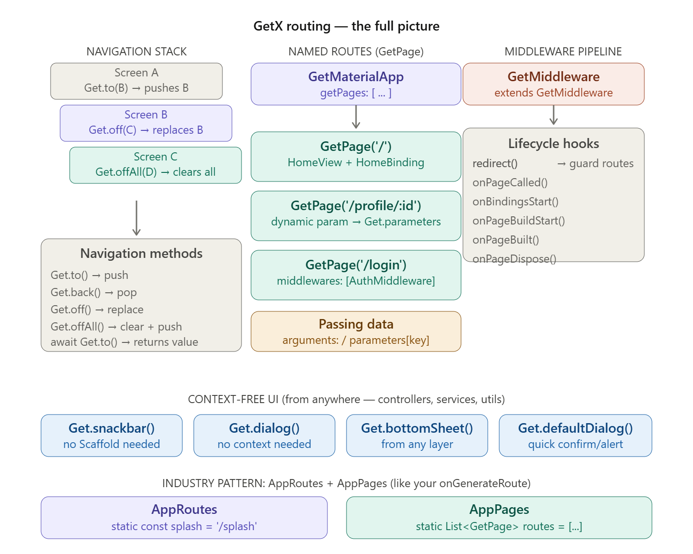

Part-1, Navigation Methods (No Named routes):
# There are four core navigation verbs, burn them in. The mental model, think of the navigation stack as a literal stack of cards. to means put a new card on top. off means swap the top card. offAll means throw all cards away, put one new one.

# Get.to(…) method pushes a new screen and back button still works.
# Get.to() method has arguments: property too to pass data to it
# We can receive that data on the other screen using Get.arguments as Map
Get.to(ProfileScreen());
Get.to(ProfileScreen(), arguments: {'userId': 42}); // pass data
// Receive that data
final args = Get.arguments as Map;
print(args['userId']); // 4

# Get.back() method pops like Navigator.pop(context)
# It also has result: property to pop with a result like returning a value
# But we have to await the result: on the calling screen when navigating to that screen using Get.to()
Get.back();
// Pop WITH a result
Get.back(result: 'deleted');
// Await the result on the calling screen
final result = await Get.to(EditScreen());
if (result == 'deleted') refreshList();

# Get.off() method replaces current screen meaning there’s no back button to previous (like push and replace of navigator). Its perfect for, Login Home (user can’t go back to login)
// Replace current screen
Get.off(HomeScreen());
# Get.offAll() method replaces the entire stack, clears everything and pushes one screen (like push and remove until of navigator). It’s perfect for, after logout back to Splash / Login
// Replace entire stack
Get.offAll(SplashScreen());

NOTE: There’s also Get.until() and Get.offUntil() method in useful utility APIs for advanced navigation

Part-2, Named Routes + GetPage:
# To define routes, use GetMaterialApp (its just a prefix with Getx properties with all of MaterialApp’s property too) and it’s getPages: property that takes a list of GetPage() class instance
# In the GetPage() class we specify:
- The name of the route (named route) using name: property
- The page or screen to build or show using page: () =>
- And the binding for that page to register the controller needed for that screen or page using binding:
- middlewares: takes a list of Middleware’s for route guard
- transition: takes Transition.rightToLeft for per-route animation
# unkownRoute: property of GetMaterialApp takes a GetPage() and shows it if user tries to navigate with a route name that doesn’t exist
GetMaterialApp(
initialRoute: '/',
unknownRoute: GetPage(name: '/404', page: () => NotFoundScreen()),
getPages: [
GetPage(name: '/', page: () => HomeScreen(), binding: HomeBinding()),
GetPage(name: '/login', page: () => LoginScreen(), binding: LoginBinding()),
GetPage(name: '/profile', page: () => ProfileScreen(), binding: ProfileBinding()),
],
)
# Then just navigate using that name: (route name) and using methods like:
- Get.toNamed(…) pushes a new screen on the navigation stack (back button works).
- Get.back() pops screen like Navigator.pop(context)
- Get.off() replaces current screen (like push and replace of navigator, no back button)
- Get.offAll() replaces the entire stack, clears everything and pushes one screen (like push and remove until of navigator).
- Get.offNamedUntil() pops until specified or root screen
// Named navigation
Get.toNamed('/profile');
Get.offNamed('/login'); // replace current
Get.offAllNamed('/home'); // clear stack + push
Get.offNamedUntil(…, …);

Part-3, Passing Data Through Named Routes:
# Two ways to pass Data:
# Way-1, In arguments: property pass any object (String, Map, Model Object)
// Sending
Get.toNamed('/profile', arguments: User(id: 42, name: 'Nazmul'));
// Receiving on ProfileScreen or ProfileController
final user = Get.arguments as User;
print(user.name); // Nazmul

# Way-2, parameters like URL-style-key-value pairs. We can define this in the GetPage() classes name: property. GetX offers advanced dynamic URLs just like on the web.
# But arguments is for rich objects (our model classes) while parameters is for primitive values and deep links (URLs work on web too)
// Define a dynamic segment route
…
GetPage(
name: '/profile/:userId',
page: () => ProfileScreen()
)
// Navigate with a path segment
Get.toNamed('/profile/42');
// Or navigate with query string
Get.toNamed('/profile/42?tab=posts&verified=true');

// Receive on the other screen — everything is a String here
final userId = Get.parameters['userId']; // '42'
final tab = Get.parameters['tab']; // 'posts'
final verified = Get.parameters['verified']; // 'true'

Accessing Previous Route and More (Advanced APIs):
# Get.previousRoute gives the name of the previous route.
If (Get.previousRoute == ‘/home’) return // do something
# Get.rawRoute gives the raw route to access for example, rawRoute.isFirst()
final rawRoute = Get.rawRoute
if (rawRoute.isFirst) return // do something
# Get.routing gives access to Routing API from GetObserver
Get.routing

Part-4, Middleware (GetX equivalent of route guards):
# This is the GetX answer to our onGenerateRoute: guard pattern. First Create a middleware class by inheriting GetMiddleware using extends
# Then override the priority getter method to set priority if there are multiple middleware’s. Lower numbers mean run first
# Then override redirect method which returns RouteSettings? if it returns null then allow through otherwise block and redirect to login
class AuthMiddleware extends GetMiddleware {
@override
int? get priority => 1; // lower number = runs first (if multiple middleware)
@override
RouteSettings? redirect(String? route) {
// This runs BEFORE the route loads
// Return null = allow navigation
// Return RouteSettings = redirect to another route
final authService = Get.find<AuthService>();
if (!authService.isLoggedIn && route != '/login') {
// Block this route and redirect to login
return RouteSettings(name: '/login');
}
return null; // allow through
}
}
# Attach it to any route in GetMaterialApp’s GetPage() classes middlewares: property
…
GetPage(
name: '/profile',
page: () => ProfileScreen(),
binding: ProfileBinding(),
middlewares: [AuthMiddleware()], // runs before screen loads
),
GetPage(
name: '/admin',
page: () => AdminScreen(),
middlewares: [AuthMiddleware(), AdminRoleMiddleware()], // chained
),

# Full middleware lifecycle looks in this order:
class LoggingMiddleware extends GetMiddleware {
// 1. Route is called — redirect here or return null
@override
RouteSettings? redirect(String? route) => null;
// 2. Before bindings are initialized
@override
GetPage? onPageCalled(GetPage? page) {
print('Page called: ${page?.name}');
return page;
}
// 3. Bindings about to start
@override
List<Bindings>? onBindingsStart(List<Bindings>? bindings) => bindings;
// 4. Page widget being built
@override
GetPageBuilder? onPageBuildStart(GetPageBuilder? page) => page;
// 5. Page widget built and ready
@override
Widget onPageBuilt(Widget page) => page;
// 6. Page disposed (user left)
@override
void onPageDispose() {
print('Page disposed');
}
}

Part-5, Our onGenerateRoute: pattern in GetX (Route Guard):
# This is the direct GetX equivalent of our onGenerateRoute: pattern where AppRoutes replaces routeName constants on each screen class, AppPages replaces the switch block. But now we also get bindings, middleware, transitions, and DI for free.
# Define a class like AppRoutes that will hold all of our magic string for route names of each page or screen
// lib/routes/app_routes.dart
// Single source of truth for all route NAME strings
abstract class AppRoutes {
static const splash = '/';
static const signUp = '/sign-up';
static const login = '/login';
static const home = '/home';
static const profile = '/profile/:userId'; // dynamic
static const notFound = '/404';
}
# Then define a class called AppPages that will hold our list of GetPage() class instances
// lib/routes/app_pages.dart
// Single source of truth for all route DEFINITIONS
class AppPages {
static final routes = [
GetPage(
name: AppRoutes.splash,
page: () => SplashScreen(),
// No binding needed — splash is usually simple
),
GetPage(
name: AppRoutes.signUp,
page: () => SignUpScreen(),
binding: SignUpBinding(),
),
GetPage(
name: AppRoutes.login,
page: () => LoginScreen(),
binding: LoginBinding(),
),
GetPage(
name: AppRoutes.home,
page: () => HomeScreen(),
binding: HomeBinding(),
middlewares: [AuthMiddleware()], // guard — redirect to login if not authed
),
GetPage(
name: AppRoutes.profile,
page: () => ProfileScreen(),
binding: ProfileBinding(),
middlewares: [AuthMiddleware()],
transition: Transition.rightToLeft, // per-route animation!
),
];
}
# In main.dart, wire it all up. We also have unknownRoute: property which is shown when no route is found with that name user tried to navigated to, it takes a GetPage()
void main() {
runApp(
GetMaterialApp(
initialRoute: AppRoutes.splash,
unknownRoute: GetPage(
name: AppRoutes.notFound,
page: () => NotFoundScreen(),
),
getPages: AppPages.routes,
initialBinding: AppBinding(),
),
);
}
# Then navigate from anywhere, no context just the string constant
Get.toNamed(AppRoutes.home);
Get.offAllNamed(AppRoutes.login);
Get.toNamed('/profile/42'); // matches AppRoutes.profile = '/profile/:userId'

Common Mistakes:
# Mistake-1, Mixing Get.to() and Get.toNamed() inconsistently, pick one style per project. Named routes (with AppRoutes constants) are always the professional choice and they work on Flutter Web too (actual URL bar changes)
# Mistake-2, Using Get.arguements with named parameters
// Wrong parameters are in Get.parameters, not Get.arguments
Get.toNamed('/profile/42');
final id = Get.arguments; // null!
// Correct
final id = Get.parameters['userId']; // '42'
# Mistake-3, Forgetting Get.offAllNamed after login/logout
// Wrong, user can press Back and return to the login screen
Get.toNamed(AppRoutes.home);
// Correct, clears the auth screens from the stack
Get.offAllNamed(AppRoutes.home);
# Mistake-4, Middleware returning a RouteSettings to the same route
// Infinite redirect loop!
RouteSettings? redirect(String? route) {
if (!isLoggedIn) return RouteSettings(name: '/login');
// If this IS the /login page, you need to check the current route
}
// Correct, always exclude the redirect target itself
RouteSettings? redirect(String? route) {
if (!isLoggedIn && route != AppRoutes.login) {
return RouteSettings(name: AppRoutes.login);
}
return null;
}

Industry Practices & Advanced Usage:
# Practice-1, The AppRoutes + AppPages two-file split is the industry-standard GetX project structure. Almost every large GetX codebase follows this pattern.
# Practice-2, Per-route transitions (transition: Transition.fade, Transition.rightToLeft, Transition.zoom) give each section of the app its own feel without any extra code. There’s also defaultTransition: property in GetMaterialApp
GetMaterialApp(
defaultTransition: Transition.fade,
);
# Practice-3, routingCallback: in GetMaterialApp is used for analytics logging, fire an analytics event on every route change without touching individual screens. Also, if we want Get events trigger actions, we can use routingCallback:
GetMaterialApp(
routingCallback: (routing) {
AnalyticsService.logScreen(routing?.current);
if(routing.current == '/second'){
openAds();
}
},
)
# Practice-4, On Flutter Web, named routes automatically update the browser URL bar and this is a major reason to prefer named routes over anonymous ones.

More Properties of GetMaterialApp:
# See official docs, there’s Git.config() too for setting these
GetMaterialApp(
enableLog: true,
defaultTransition: Transition.fade,
opaqueRoute: Get.isOpaqueRouteDefault,
popGesture: Get.isPopGestureEnable,
transitionDuration: Get.defaultDurationTransition,
defaultGlobalState: Get.defaultGlobalState,
);
Get.config(
enableLog = true,
defaultPopGesture = true,
defaultTransition = Transitions.cupertino
)

Advanced, Using Observers and more:
# If we are not using GetMaterialApp, we can use the manual API to attach Middleware observer suing navigatorObservers:
# Also Get.key gives global navigator key
void main() {
runApp(
MaterialApp(
navigatorKey: Get.key,
onGenerateRoute: Router.generateRoute,
initialRoute: "/",
navigatorKey: Get.key,
navigatorObservers: [
GetObserver(MiddleWare.observer), // HERE !!!
],
),
);
}

Break

GetX Context-Free UI (SnackBars, dialogs, bottomsheets):
# The cherry on top is call these from anywhere like a controller, a service, a background task
# Get.snackBar() shows a snack bar message and it has properties like:
- The message
- The description
- snackPosition: takes a SnackPosition.BOTTOM and used to set the position of the snack bar
- duration: takes a Duration() and sets the duration of displaying the snack bar
- backgroundColor: to set the color of the snack bar
- colorText: to set the color of the text
- icon: takes a Icon() widget and shows it
// Snackbar no Scaffold, no context
Get.snackbar(
'Success',
'Order placed successfully!',
snackPosition: SnackPosition.BOTTOM,
duration: Duration(seconds: 3),
backgroundColor: Colors.green,
colorText: Colors.white,
icon: Icon(Icons.check_circle, color: Colors.white),
);

# Get.dialog<bool>() method shows a dialog and its await able and returns a result. It takes AlerDialog widget (properties of AlerDialog)
# We can also use Get.closeDialog(result: …) instead of Get.back(…)
// Dialog awaitable, returns result
final confirmed = await Get.dialog<bool>(
AlertDialog(
title: Text('Delete item?'),
actions: [
TextButton(onPressed: () => Get.back(result: false), child: Text('Cancel')),
TextButton(onPressed: () => Get.back(result: true), child: Text('Delete')),
],
),
);
if (confirmed == true) deleteItem();

# Get.defaultDialog() method for quick one-liner dialog. Properties:
- title: The title of the dialog
- middleText: the description or question
- onConfirm: the void callback that runs when confirmed
- onCancel: the void callback that runs when cancelled
Get.defaultDialog(
title: 'Warning',
middleText: 'Are you sure?',
onConfirm: () { doSomething(); Get.back(); },
onCancel: () {},
);

# Get.BottomSheet() method shows a bottom sheet
// Bottom sheet, no context
Get.bottomSheet(
Container(
padding: EdgeInsets.all(16),
child: Column(children: [
ListTile(leading: Icon(Icons.share), title: Text('Share')),
ListTile(leading: Icon(Icons.delete), title: Text('Delete')),
]),
),
);

Common Mistake:
# Calling Get.snackbar before GetMaterialApp renders. If we call it in main() before the widget tree is built, it'll crash. Only call context-free UI methods after the app has mounted.

Break

Global Settings (the config knobs we should know):
# enableLog: true logs every route change, DI event in debug console
# defaultTransition: Transition.cupertino sets default transition for ALL routes (overridable per-GetPage())
# transitionDuration: global transition duration
# popGesture: true swipe-to-go-back (iOS style) globally.
# logWriterCallback: pipes GetX logs into our own logger (Crashlytics, etc.)
GetMaterialApp(
enableLog: true,
defaultTransition: Transition.cupertino,
popGesture: true,
transitionDuration: Duration(milliseconds: 300),
logWriterCallback: (text, {bool isError = false}) {
if (isError) FirebaseCrashlytics.instance.log(text);
},
)
# Or set at runtime (e.g. after user toggles debug mode) using Get.config() method
Get.config(
enableLog: true,
defaultPopGesture: true,
defaultTransition: Transition.fade,
);

Useful Utility APIs:
# Useful utility APIs we didn't know GetX had. For Platform detection, no dart:io needed
GetPlatform.isAndroid // true/false
GetPlatform.isIOS
GetPlatform.isWeb
# For responsive helpers, no MediaQuery(context) needed
Get.width // screen width
Get.height // screen height
# For checking overlay state, useful in controllers
Get.isSnackbarOpen
Get.isDialogOpen
Get.isBottomSheetOpen
# For advanced navigation
Get.until((route) => route.isFirst); // pop until root
Get.offUntil(
GetPageRoute(page: () => HomeScreen()),
(route) => route.isFirst,
);
# Theme switching, no ThemeProvider needed
Get.changeTheme(ThemeData.dark());
Get.changeTheme(Get.isDarkMode ? ThemeData.light() : ThemeData.dark());

Break

Encapsulation in GetX:
# Encapsulation like Provider SM doesn’t work in GetX because the getter method returns the actual RxBool object and UI can still modify it
class HomeController extends GetxController {
final RxBool _isLoading = false.obs;
RxBool get isLoading => _isLoading;
}
// UI can change it like this
controller.isLoading.value = true;
# GetX relies heavily on exposing reactive variables (which is perfectly normal)
class HomeController extends GetxController {
final isLoading = false.obs;
…
}
// In UI
Obx(() => controller.isLoading.value
? CircularProgressIndicator()
: Container());
# But if we still want strict encapsulation, there are two patterns for this

Pattern-1:
# Instead of Obx(…) use GetBuilder() (Simple State Manager) but it loses granular rebuild of Rx
class AuthController extends GetxController {
User? _user;
User? get user => _user;
void setUser(User user) {
_user = user;
update();
}
}
# In UI:
GetBuilder<HomeController>(
builder: (controller) {
return Text(controller.user?.name ?? '');
},
);

Pattern-2 (Recommended):
# Encapsulated/Private Rx + Read-only Stream-like access. The getter methods return specific computed values and because username internally reads _user.value, Obx(…) can still track the Rx or dependency. This is actually a very nice pattern
class AuthController extends GetxController {
final Rxn<User> _user = Rxn<User>();
String get username => _user.value?.name ?? '';
bool get isLoggedIn => _user.value != null;
void setUser(User user) {
_user.value = user;
}
}
# In UI, when _user.value changes, Obx(…) rebuilds.
Obx(() => Text(controller.username));

Break

Stream & StreamSubscription in GetX:
# Use a GetXController class for listening to streams in GetX. There are three options to do this:

Option-1, (Most GetX-like) Listen inside the controller:
# Instead of exposing the Stream, subscribe to the StreamSubscription<…> (using .listen() method) in the controller and update an Rx variable (to store the value from Stream).
# Start listening to the Stream when controller is created using onInit() method and cancel() or dispose the StreamSubscription<…> by overriding the onClose() method
class ChatController extends GetxController {
final messages = <Message>[].obs;
StreamSubscription? _subscription;
@override
void onInit() {
super.onInit();

_subscription = repository.messageStream.listen((data) {
messages.assignAll(data);
});
}
@override
void onClose() {
_subscription?.cancel();
super.onClose();
}
}
# In the UI, just watch that reactive RxList<…> using Obx(() {})
Obx(() => ListView(...))

Option-2, Expose the stream directly:
# We can do this if we don't need to transform the data or store additional UI state.
StreamBuilder(
stream: controller.messages,
builder: ...
)

Option-3, Bind a Stream to an Rx variable:
# GetX has bindStream(). This is probably the closest thing to Riverpod's StreamProvider. GetX automatically keeps the Rx variable updated from the Stream
…
final messages = <Message>[].obs;
@override
void onInit() {
super.onInit();

messages.bindStream(repository.messageStream);
}
# Our UI just uses Obx(() {}) or manually .listen() if we need more control

Break

Repository Pattern with GetX:
# If we need the data to survive even after GetxController is destroyed (removed from navigation stack). We could use:
Get.lazyPut<MovieDetailsController>(fenix: true);
Get.put< MovieDetailsController>(permanent: true); //OR
# But then:
- Controller starts becoming a data store
- Memory usage grows
- Harder to maintain
- Breaks separation of concerns
# A controller should not be our apps cache. This is why Repository patter is recommended.

Repository Cache (Recommended):
# We’ll create a GetxService class that will hold our data (in an object, list or map) and call our API service if the movieId is new and KEY is not present in the Map.
# We are storing the MovieDetails object in the map with its movieId as the KEY. So we can easily check using .containsKey() method
# If data is previously fetched from the API return it to the controller or if not call the API and fetch it and then save it in the Map with its movieId as KEY
class MovieRepository extends GetxService {

final ApiService _apiService = Get.find<ApiService>();
final Map<int, MovieDetailsModel> _cache = {};

MovieDetailsModel? checkCache(int movieId){
if(_cache.containsKey(movieId)) {
return _cache[movieId];
}
return null;
}

Future<MovieResult> getMovieDetails(int movieId) async {
final ApiResponse response = await _apiService.getRequest(url: Urls.getMovieById(movieId));
if(response.isSuccess) {
final movieDetails = MovieDetailsModel.fromJson(response.body);
_cache[movieId] = movieDetails;
return MovieResult(
movieDetailsModel: movieDetails,
errorMessage: null,
);
}
return MovieResult(
movieDetailsModel: null,
errorMessage: 'Status Code: ${response.statusCode} Message: ${response.errorMessage}'
);
}
}
# Create a MovieResult model so we can return both the data and error message to the controller and also check if successes or not
class MovieResult {
final MovieDetailsModel? movieDetailsModel;
final String? errorMessage;
MovieResult({this.movieDetailsModel, this.errorMessage});
bool get isSuccess => movieDetailsModel != null;
}
# Register MovieRepository service in AppBindings (assigned to initialBinding:) or specific bindings according to need like if repository needs to survive the whole app register in AppBindings but not the whole app only in HomeScreen as root then put it in HomeBindings
Get.put(MovieRepository(), permanent: true); // In AppBindings
Get.put(MovieRepository()); // or in HomBindings
# Then controller becomes very simple. If data is present in repository cache fetch from there otherwise from the API
class MovieDetailsController extends GetxController{
final MovieRepository movieRepository;
MovieDetailsController({ required this.movieRepository});
final _movieDetails = Rxn< MovieDetailsModel>();
final RxBool isLoading = false.obs;
final errorMessage = RxnString();

Future<bool> fetchMovieDetails(int movieId) async {
final data = movieRepository.checkCache(movieId);
if(data != null) {
movieDetails.value = data;
return true;
}

bool isSuccess = false;
isLoading.value = true;

final MovieResult result = await movieRepository.getMovieDetails(movieId);

if(result.isSuccess) {
isSuccess = true;
errorMessage = null;
movieDetails.value = result.movieDetailsModel;
} else {
errorMessage.value = result.errorMessage ?? 'Showing from controller';
}
isLoading.value = false;
return isSuccess;
}
}
# Then in the Bindings, use Get.find<T>() for Dependency Injection
class MovieDetailsBinding implements Bindings {
@override
void dependencies() {
Get.lazyPut(() {
final repo = Get.find<MovieRepository>();
return MovieDetailsController(repo);
}
}

Control Flow:
# Now, exactly the behavior we wanted:
- User opens Movie #10
- Repository fetches API
- Repository caches it
- User goes back
- Controller destroyed
- User opens Movie #10 again
- New controller created
- Repository instantly returns cached movie
- No API call and no Loading

Industry Pattern
# Most production apps follow this pattern:
UI
↓
Controller/ViewModel
↓
Repository
↓
Remote API
# With caching inside the repository:
Repository
├─ Memory Cache
├─ Local Database (optional)
└─ Remote API
NOTE: For industry projects use repository pattern

Setting Cache Limit in Repo:
# We have to limit the number of data (MovieModel) can be stored in the Map of the Repository. So that it doesn’t take too much space, like user visited 20 movie screens so store all of them (bad practice) store only 3 screens (or recently visited screens) in the cache
# There are two ways to do this:

- Option-1, Simple FIFO (First in First Out) Cache:
# When cache size exceeds 3, remove the oldest cached movie. Example:
Visit Movie 1
Cache = [1]
|
Visit Movie 2
Cache = [1,2]
|
Visit Movie 3
Cache = [1,2,3]
|
Visit Movie 4
Remove 1
Cache = [2,3,4]
# Code:
final Map<int, MovieDetailsModel> _cache = {};
…
// When adding or saving to cache
void cacheMovie(int movieId, MovieDetailsModel movie) {
if (_cache.length >= 3) {
final oldestKey = _cache.keys.first;
_cache.remove(oldestKey);
}
_cache[movieId] = movie;
}

- Option-2, LRU (Least Recently Used) Cache (Recommended):
# This keeps the most recently accessed movies (ordered by recent). Suppose:
Visit 1
Visit 2
Visit 3
Cache = [1,2,3]
# Then user revisits:
Movie 1
Movie 1 should become "recently used".
# Cache becomes:
[2,3,1]
# Now user opens Movie 4, Notice how Movie 1 survived because it was recently used:
Remove 2
Cache = [3,1,4]
# Dart’s LinkedHashMap class preserves this insertion order. Create it using OOP:
import 'dart:collection';
final LinkedHashMap<int, MovieDetailsModel> _cache =
LinkedHashMap();
# Then get movie from cache if available:
MovieDetailsModel? getMovieFromCache(int movieId) {
if (!_cache.containsKey(movieId)) {
return null;
}
final movie = _cache.remove(movieId)!;
_cache[movieId] = movie;
return movie;
}
# And add or save in the cache
void saveMovie(
int movieId,
MovieDetailsModel movie,
) {
_cache.remove(movieId); // not important, just checking
if (_cache.length >= 3) {
_cache.remove(_cache.keys.first);
}
_cache[movieId] = movie;
}

Break

BottomNavigationBar Widget with GetX:
# When using BottomNavigationBar widget + IndexedStack (keeps all screen states alive) and displaying three screens (home, profile and search) there’s no way for route navigation to occur for these screens. So no GetPage() for these screens and no Bindings
# We have to register everything (home controller, profile controller and search controller) these screens need in MainBinding with Get.lazyPut(…), method controller isn’t created immediately but created only when first requested (Get.find())
class MainBinding extends Bindings {
@override
void dependencies() {
Get.lazyPut(() => BottomNavController());
Get.lazyPut<HomeController>(() => HomeController());
Get.lazyPut<SearchController>(() => SearchController());
Get.lazyPut<ProfileController>(() => ProfileController());
}
}
# In UI, when HomeScreen first accesses controller, GetX creates it. This is usually the sweet spot.
class HomeScreen extends GetView<HomeController> {…}

Extra:
# Nested Navigation (Large Apps) use:
MainRoute
├── HomeRoute
├── SearchRoute
└── ProfileRoute
# Each tab has its own navigator and route stack. Then:
HomeBinding
SearchBinding
ProfileBinding
# Works independently. This is used in larger production apps but adds complexity.

Break

The Full Architecture:
lib/
├── main.dart
├── routes/
│ ├── app_routes.dart # AppRoutes constants
│ ├── app_pages.dart # AppPages (GetPage list + bindings + middleware)
│ └── app_binding.dart # AppBinding (permanent services)
├── services/ # GetxService — permanent, app-scoped
│ ├── auth_service.dart
│ ├── api_service.dart
│ └── storage_service.dart
├── modules/
│ └── home/
│ ├── bindings/
│ │ └── home_binding.dart # GetxController registration
│ ├── controllers/
│ │ └── home_controller.dart # GetxController — route-scoped
│ └── views/
│ └── home_view.dart # GetView<HomeController>

