INDEX
- Undoing and Fixing Mistakes…………………………………….…………………2
- git reset……………………………………………………………………………………….2
- git revert……………………………………………………………………………………..3
- git restore (New Command)……………..………………………………………...3
- git stash……………………………………………………………………………………….4
- git reflog………………………………………………………………………………………4
- GitHub Project……………………………………………………………………………..6
- GitHub Security Alerts…………………………………………………………….…14
- Git Security Concept..………………………………………………………………..14
- GitHub Rules………………………………………………………………………….16
- GitHub Stacked PRs (Pull Requests)……………………………………….18
Undoing and Fixing Mistakes:
git reset vs git revert:
# These both “undo” commits, but in different ways. Moves our branch pointer to a previous commit. Can modify history (dangerous if already pushed to remote).
git reset

git reset:
# Completely resets repo to that commit (erases later commits + changes). Use carefully, usually for local cleanup. We can get the commit hash from GitHub repo commits and copy that.
git reset --hard <commit_hash>
# Discard all uncommitted changes
git reset --hard HEAD
# Or, removes the latest commit and its changes. (This is destructive, be sure first)
git reset --hard HEAD~1

# Keeps our changes staged (like “un-committing” but not deleting).
git reset --soft <commit_hash>
# Undo the last commit (but keep changes). Use when the commit message or commit contents need fixing
git reset --soft HEAD~1

git revert:
# git revert. Safest way to undo on shared repos. Creates a new commit that “reverses” the changes from an old commit.
git revert <commit_hash>
git revert HEAD // or this
# Example:
- Commit A pushed to GitHub: add login form
- Commit B pushed to GitHub: add bug 🐛
- git revert B → creates Commit C that undoes B (but keeps A).
# History remains safe & clean.

git restore (new command):
# Introduced in newer Git versions as a replacement for git checkout (when used for files). Undo un-staged changes (reset file to last commit):
git restore file.txt
git restore . // to restore all tracked files
# Undo staged changes (un-add file). Safer than juggling with git checkout + git reset.
git restore --staged file.txt

git stash:
# Temporarily save work without committing (e.g., switching branches quickly). Save changes:
git stash
# List stashes. Used to view stashes. See all stashes stored in the box:
git stash list
# Apply most recent stash:
git stash apply
# Apply & remove:
git stash pop
# Drop a stash:
git stash drop stash@{0}
# Example workflow:
Editing code → need to pull new changes → stash → pull → apply stash back.

git reflog (Recover Deleted Branches & Commits):
# Even if we delete commits or branches, Git usually remembers them in its log. View reflog:
git reflog
# Output example:
a1b2c3d HEAD@{0}: commit: Fix bug
d4e5f6g HEAD@{1}: commit: Add feature
h7i8j9k HEAD@{2}: checkout: moving from main to feature
# Restore branch:
git checkout -b recovered_branch <commit_hash>
Super useful if we accidentally delete a branch or reset too far.

Quick Cheatsheet:
Situation | Command
Undo last commit but keep changes | git reset --soft HEAD~1
Undo last commit & erase changes | git reset --hard HEAD~1
Undo safely (create new commit) | git revert <commit_hash>
Undo unstaged file changes | git restore file.txt
Undo staged changes (un-add) | git restore --staged file.txt
Temporarily save changes | git stash
See all stashes | git stash list
Recover deleted commit | git reflog + git checkout -b newbranch <hash>

Break

GitHub Project:
# GitHub Projects is a flexible, spreadsheet-meets-Kanban task management tool that lives inside GitHub.
# Key insight, unlike Trello or Jira, GitHub Projects doesn't just link to our code but it IS part of our code infrastructure. Issues and PRs from our repos become "cards" in the board automatically.
# Three core things it gives us:
- Board view: visualize tasks as columns (Backlog → In Progress → Done)
- Table view: spreadsheet-style view of all items with custom fields
- Roadmap view: timeline/Gantt-style view for planning sprints
# Mental Model:
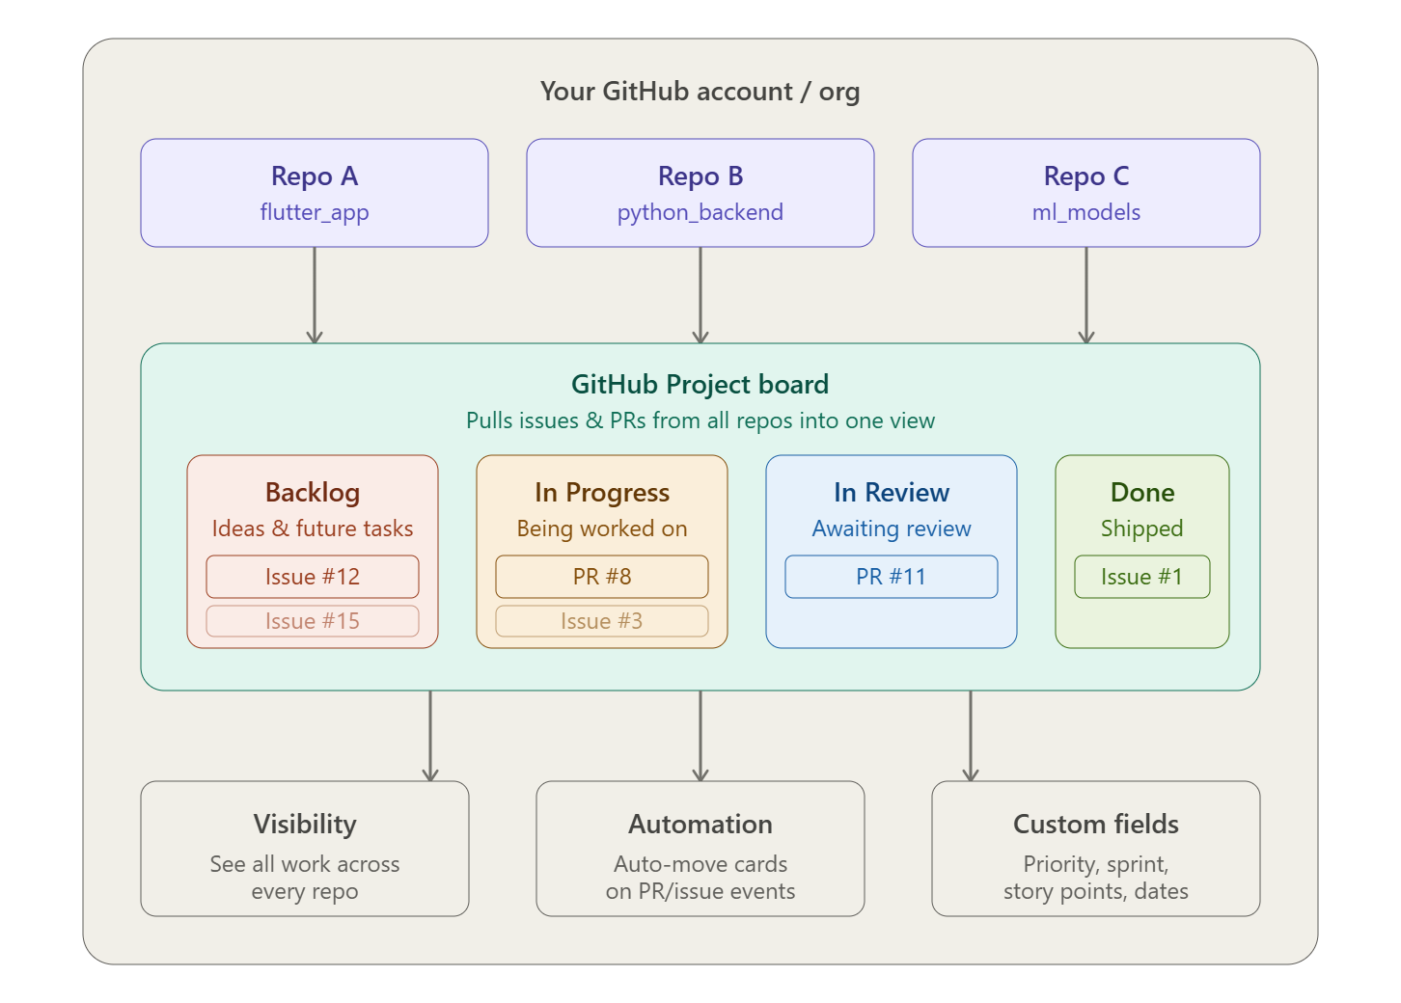

Importance (Why use it):
# Real developers use GitHub Projects because:
- Without it: We have issues scattered across repos, no idea what's being worked on, team members stepping on each other's work, no sprint planning.
- With it: One source of truth. Automated workflows. Linked directly to the actual PRs and commits doing the work.
# The killer feature, when we close a PR, the linked issue can automatically move to "Done" on our board. Zero manual updating.

Usage (Step-by-Step):
Step 1, Create a Project:
# Go to our GitHub profile or organization → click "Projects" tab → "New Project". We'll be asked to choose a template:
- Team backlog → good starting point
- Kanban → classic columns
- Blank → full custom control

Step-2, Add our repos to it:
# Inside our project → Settings → "Linked repositories" → add our repos. This tells GitHub: "pull issues and PRs from these repos into this project."

Step-3, Add issues as items:
# There are two ways:
- Way 1: From the board: click + Add item at the bottom of any column → type # → search for an issue or PR from our linked repo.
- Way 2: From the issue itself: when you create or view an issue, look for the "Projects" section on the right sidebar → click the gear → select our project.

Step-4, Create Custom Fields:
# This is where Projects v2 becomes powerful. First in the Project, create another view (View 2) by clicking on the + icon next to the View 1 and in layout select Table
# Then in Table View scroll all the way right on the header row and click the + icon at the end (in table view) to add:
- Priority → Name it Priority and set field type to Single Select, then add options like:
  - P0 (Critical, must ship now)
  - P1 (High priority, this sprint)
  - P2 (Nice to have, next sprint)
- Sprint → Iteration field (GitHub auto-manages 2-week sprints)
- Story points → Number field
- Due date → Date field
# Finally, click on view settings and save view

Step 5, Set up automation:
# Go to our project → "..." menu → "Workflows" → we'll see built-in automations:
When: Issue closed
Then: Set status to "Done"

When: PR merged
Then: Set status to "Done"

When: Issue opened
Then: Set status to "Backlog"

When: PR opened
Then: Set status to "In Progress"
# These are toggle-on automations like one click to enable. No code needed.

Step-6, Linking issues to PRs (The Real Workflow):
# This is how it works in practice on a real project:
- We create an issue:
Issue #42: Add login screen UI in Flutter
- We create a branch using git command:
git checkout -b feat/login-screen
- We write our code, then open a PR with this in the description:
Closes #42
# That Closes #42 is magic. When the PR merges, GitHub automatically closes issue #42. And if we have automation set up, it moves the card to "Done" on our board.
# The full list of keywords GitHub recognizes; all do the same thing:
close #1
closes #1
closed #1
fix #1
fixes #1
fixed #1
resolve #1
resolves #1
resolved #1
# Don’t do this. It’s wrong and only closes #1 (issue)
Closes #1, #2, #3
# Right way, closes all three
Closes #1
Closes #2
Closes #3

The Flow in our Board:
# Issue #42 starts in Backlog
→ We start working: manually drag to "In Progress" (or automation on PR open)
→ PR opened for review: moves to "In Review"
→ PR merged: automatically → "Done", issue closed

Common Mistakes:
# Mistake-1, Treating it like Trello (manually managing everything). Projects shine when we link issues and PRs. If we're creating "draft notes" instead of real issues, we lose all the automation power.
# Mistake-2, Not using the "Closes #N" keyword in PRs. Most beginners write PRs without linking them to issues. This breaks the automation chain completely.
# Mistake-3, One giant project for everything. Teams with 5+ repos often put ALL work in one board with no filtering. Use views (saved filters) inside our project to show only "Flutter issues" or "this sprint's work."
# Mistake-4, Ignoring the Roadmap view. Solo devs never touch it. But when we start planning features across weeks, the roadmap view (with iteration fields) is how senior devs think about scope.
# Mistake 5, Not setting up workflows. The default project has automation OFF. Most beginners drag cards manually every day like it's 2010. Turn on the built-in workflows on day one.

Industry Practices & Advanced Usage
# In real teams at product companies:
- Sprint planning uses the Iteration field, GitHub auto-creates 2-week iterations and we drag issues into the current sprint
- Priority triage happens weekly and filter by Priority: P0 and make sure those are all "In Progress"
- GitHub Actions + Projects API, advanced teams use the GraphQL API to programmatically move cards, create issues, or generate weekly reports
- Sub-issues (new in 2024) GitHub now supports breaking one issue into sub-tasks directly inside the issue, replacing the old checkbox hack
- Milestones vs Projects, Milestones are for version-based releases (v1.0, v2.0). Projects are for ongoing workflow management. Senior dev’s use both together

Break

Github Security Alerts:
# Go to repo then Security and quality section. Here we can see all of security issues of our codes like code scanning and secret scanning (for detecting leaked API keys)
# GitHub warns us in security and quality section of the repo if the key format matches any known public API key patterns, GitHub cannot know whether it is restricted or dangerous.
# Sometimes it’s totally normal like Firebase config API keys in firebase_options.dart

Managing GitHub Alerts:
# Go to repo and then Security and quality sections. We can:
- leave them
- or mark as “False positive” / “Used in test code”
- Because this is expected behavior for Firebase configs.
# Or we can also select other things as needed

Break

Git Security Concept:
# When someone clones our public repository, they also get the .git file which is tracking the file changes. The .git contains:
- Commit History
- Branches
- Remote URLs
- Git metadata
# It does not contain our GitHub password, OAuth tokens or SSH private keys. So, when they try to git push to that repo, GitHub will ask “who are you & do you have permission”. They will get an error like “Permission Denied”. Unless:
- We added them as collaborator
- Or they have stolen your credentials

Getting Local Repository:
# If we lose our local repository we can just clone it again and Git will recreate the entire .git folder and working directory. Git itself doesn’t know if its us but GitHub authenticates us using:
- HTTPS + Login: GitHub may ask you to sign in
- PAT (Personal Access Token): A token stored in our credential manager
- SSH (Recommended): Git-Hub verifies our SSH key
# Clone through SSH to get lost .git or local repo

Mental Model:
# Imagine:
GitHub Repository
│
├── You clone it
│ └── .git folder created
│
└── Stranger clones it
└── .git folder created
# So, both have .git but when pushing the permission comes from GitHub authentication, not from the .git folder.
Your SSH key → Allowed
Stranger's key → Rejected

GitHub Actions Security:
# If we use GitHub Actions and if someone clones our public repo, they cannot see:
- Repository secrets
- Firebase deployment token stored as secrets
- API keys stored in GitHub secrets
# Those remain on GitHub’s servers and are not included in the clone

Break

GitHub Rules:
# GitHub branch protection rules are Repository settings that prevent direct or forced code pushes (git push --force) to critical branches like main
# Ensuring all code changes are submitted via pull requests (PRs) and reviewed before merging with main. So, no one can edit or update main directly unless added in Bypass List

Setup:
# Go to Repository in GitHub Settings Under Code & Automation Section Rules Rulesets New Ruleset
# Then set the name of the Ruleset. Select Enforcement Status to Active. Add branches in Target Branches (By default main is added) to specify which branches these rules apply
# Then select Branch Rules and hit save.

Bypass List:
# Roles, teams, agents and users who are exempt from this Ruleset is specified here. So, these rules don’t apply to them. We can add:
- Deploy Keys
- Repository Admin (Select)
- Maintain
- Write
- Copilot code review
- Copilot cloud agent

Branch Rules:
- Restrict creations: Prevents creating a branch with the protected name (main). Not Recommended.
- Restrict updates: Nobody can push directly to main unless they're on the bypass list. Recommended only if we always use Pull Requests
- Restrict deletions: Prevents deleting the main branch. Recommended
- Require linear history: Disallows merge commits. Only squash or rebase merges are allowed, keeping history clean.
- Require deployments to succeed: Deployment (e.g., Firebase Hosting) must succeed before merging. Recommended if we use PRs and CI
- Require signed commits: Every commit must have a verified GPG/SSH signature. Skip unless we specifically want signed commits
- Require a pull request: No direct pushes. Every change must go through a Pull Request.
- Require status checks: Ensures automated tests and CI (like flutter analyze, flutter test, flutter build) pass before merging.
- Block force pushes: Prevents git push --force to main. Highly Recommended
- Require code scanning results: Security scanning (e.g., CodeQL) must pass. Enable later if we add CodeQL
- Require code quality results: Blocks merges if code quality checks fail.
- Restrict code coverage: Requires minimum test coverage before merging. Skip until we have a solid test suite
- Automatically request Copilot code review: Copilot reviews every PR automatically. Only if we use GitHub Copilot

Break

GitHub Stacked PR’s (Pull Requests):
# Stacked Pull Requests are two or more Pull Requests in the same repository, where the first (bottom) PR targets the trunk usually main and each subsequent PR targets the branch of the PR below it.
# In one line, a Stack is a chain of PRs where each one builds on the previous one, so we never have to wait for one to merge before starting the next
# Like we opened a PR called "Added Auth" with our current feature/auth branch by comparing it with main and wanting to merge the PR (Added Auth) with main. But we can't open another PR from feature/auth branch unless the previous one has to reviewed and merged, wasting valuable time. This is where Stacked PRs comes in

The Problem:
# Imagine we're building the Local Event Finder app and we have 3 things to do that depend on each other:
- Set up database models (everything depends on this)
- Build the API endpoints (depends on models being done)
- Build the Flutter map screen (depends on API being done)
# Without Stacks, we write all 3 in one giant PR. One PR = one massive diff. Reviewer gives up. Nobody reviews it properly. It goes stale. We merge it hoping for the best.

The Solution:
# With Stacks, 3 small PRs, each reviewable on its own. We don't wait for PR 1 to merge before starting PR 2. We keep building.
# The Key Principle, if code in one layer depends on code in another layer, the dependency must be in the same branch or a lower one.
# Otherwise, create a new branch when we start a different concern like when we switch from backend to frontend work, move from core logic to tests, or when the current branch is already large enough to review.

Mental Model:
# Remember, Foundational changes like shared types and database schema go in lower branches, and code that depends on them like API routes and UI components go in higher branches
main (trunk)
│
└── feat/db-schema → PR #1 ← BOTTOM (targets main)
│
└── feat/api-routes → PR #2 (targets feat/db-schema)
│
└── feat/map-ui → PR #3 ← TOP (targets feat/api-routes)
# Each PR's diff shows ONLY its own changes:
- PR #1 diff: just the db model files
- PR #2 diff: just the API files (not the db stuff again)
- PR #3 diff: just the Flutter UI files (not API or db stuff)
# Reviewer reads 200 lines per PR, not 600 lines all at once.

The Tool or CLI (gh stack) to Manage Stacks:
# The gh stack extension in GitHub CLI handles the local development workflow. We can:
- Create and track branches in the correct dependency order
- Keep branches rebased, push branches
- Create and link pull requests, and navigate between layers.
# The biggest pain with manual stacking is rebasing. If PR #1 changes after review, the branches like feat/api-routes and feat/map-ui above it, all need to be rebased. Rebasing is the trickiest part of working with stacks, and GitHub handles it automatically.
# So, we can trigger a server-side cascading rebase from the Pull Request in GitHub website, or run a local cascading rebase with gh stack extension of the CLI

Installation & Setup:
# Step-1, make sure GitHub CLI is installed and authenticated
gh auth login
# Step-2, install the gh-stack extension
gh extension install github/gh-stack
# Step-3, Optional but create a short alias so we type less like typing gs push works instead of gh stack push
gh stack alias

Core CLI Commands (The Full Workflow):
- Setting up a Stack:
# We’re on main branch. Start a new stack by running the below command. This initializes our Stack with feat/db-schema as the first layer and the Trunk is set to main branch automatically
gh stack init feat/db-schema
# Now write our database models. Stage and commit. Then when we’re ready for the next concern. Just run the below command to add a new layer on top the current branch.
gh stack add feat/api-routes
# Or stage all changes, commit, and add the new branch in one step by combining -A = stage all and -m = commit message flags together
gh stack add -Am "Add event db models" feat/api-routes
# Finally add the third layer the same way:
gh stack add -Am "Add API endpoints" feat/map-ui
# Now check what our local stack looks like using this command
gh stack view
# Output:
feat/map-ui ← top (we are here)
feat/api-routes
feat/db-schema ← bottom
main ← trunk

- Pushing and Creating PRs:
# The below command pushes branches to the remote repo and creates a Pull Request for every branch in the Stack. After creating Pull Requests, gh stack submit automatically creates a stack on GitHub to link the pull requests together.
gh stack submit
# In an interactive terminal, gh stack submit opens a full-screen editor where we can draft the “title” and “description” for each PR, and choose whether the pull request opens ready for review or as a draft. By using these commands:
- Skip the editor and auto-generate titles (as a draft):
gh stack submit --auto
- Skip the editor and open as ready-for-review (not draft):
gh stack submit --auto --open

- Navigating between Layers:
# Without these we'd be doing git checkout <branch-name> and constantly forgetting names. To:
Operation or Instruction | The Command
Move up one layer (away from trunk or main) | gh stack up
Move down one layer (toward trunk) | gh stack down
Jump up 2 layers | gh stack up2
Jump to topmost branch | gh stack top
Jump to bottom branch | gh stack bottom
Jump to main | gh stack trunk
Choose a layer using interactive picker | gh stack switch

- Keeping the Stack in Sync:
# This command is our daily driver:
gh stack sync
# It:
- Fetches the latest changes from origin
- Reconciles the remote stack locally
- Fast-forwards the trunk branch
- Cascades a rebase across all stack branches
- Pushes all branches, syncs Pull Request state from GitHub, and links the Stack's open Pull Requests.
# For syncing and deleting branches for merged PRs automatically pair it with --prune flag
gh stack sync --prune

- When Changes are Requested on PR #1:
# We go down to the bottom, fix it, commit, then run the below command. gh stack rebase does cascading rebase, fixes all branches above automatically and gh stack push pushes all updated branches:
gh stack rebase
gh stack push
# If a rebase conflict occurs, the operation pauses and prints conflicted files. Resolve the conflicts, stage them with git add, then continue with --continue. To undo the entire, rebase, use --abort.
- After resolving conflicts:
gh stack rebase --continue
- If we Changed our mind:
gh stack rebase --abort

Merging With Stacked PRs:
# This is the Stack state before merging:
main ← PR #1 (db-schema) ← PR #2 (api-routes) ← PR #3 (map-ui)
- Option-A, Merge the Entire Stack at Once:
# Merge PR #3 (the top). Everything below (PR #2, PR#1) comes with it. All 3 merge into main. For interactive picks what to merge:
gh stack merge
# For no prompts, squash commits
gh stack merge --yes --squash

- Option-B, Merge only PR #1 (partial merge form bottom):
# Like if we only merge PR #1 then:
Before: main ← PR#1 ← PR#2 ← PR#3
After: main ← PR#2 ← PR#3
↑
PR#2 now targets main directly (auto-retargeted)
# PR #2 and #3 stay open. GitHub automatically re-targets PR #2 to point at main

- Option-C, Merge a Mid-Stack PR#2:
# The hard rule, PRs must always merge from the bottom up. We can never merge PR #2 without PR #1 going first.
Before: main ← PR #1 ← PR #2 ← PR #3
After merge of PR #2:
→ PR #1 and PR #2 merge into main
→ PR #3 stays open, auto-retargets to main

Common Mistakes:
- Mistake-1, Using Stack of Independent Changes:
# Stacks are for dependent changes. If our map UI doesn’t actually use the API code, they shouldn’t be in the same Stack. Independent work = separated PRs, not a Stack

- Mistake-2, Committing to The Wrong Layer:
# If we're on feat/map-ui (top) and we need to fix something in feat/db-schema (bottom). We fix it on the top layer. Now our stack is logically broken because UI layer has db code in it.
# Fix, gh stack down to the right layer, fix it there, then gh stack rebase back up.

- Mistake-3, Not Syncing Before Adding a New Layer:
# We add a new branch while main has moved forward. Our Stack is now behind. Always gh stack sync before adding new work.

- Mistake-4, Manually Rebasing Branches in a Stack:
# Don't git rebase individual branches in a Stack manually. We'll break the chain. That's exactly what gh stack rebase is for, it does the cascading rebase in the right order.

