INDEX
- Post Man Basics……………………………………………………………………………2
- Form Data in Post Man………………………………………………………………….7
- x-www-form-urlencoded in Postman………………………..………………...8
- Set Collection Variables………………………………………………………………..9

Post Man Basics:
# First create an account in post man. Then go to workspaces and create a workspace choose any template api development or api testing.
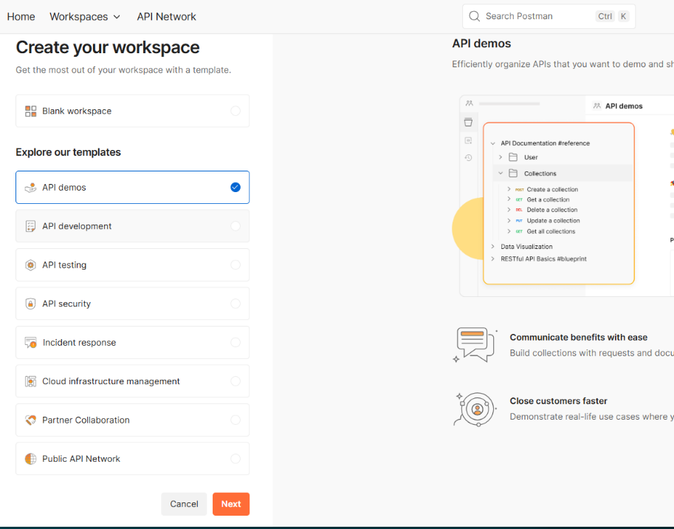

# Then create a blank collection or any preferable template and rename for e.g. Postman learning

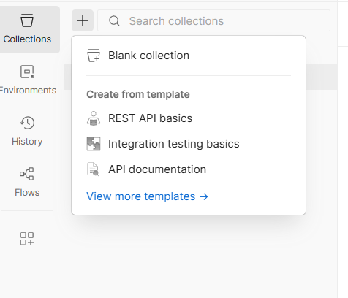

# Then add a request by clicking on the three dots of the collection and rename it.
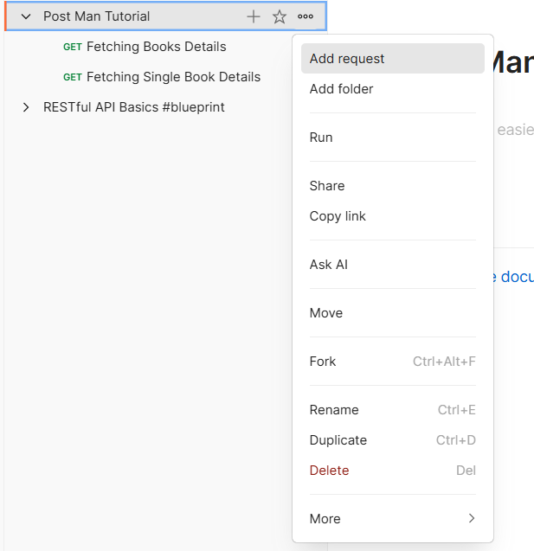

# Now we can just paste the API link and see the response in json or preview.

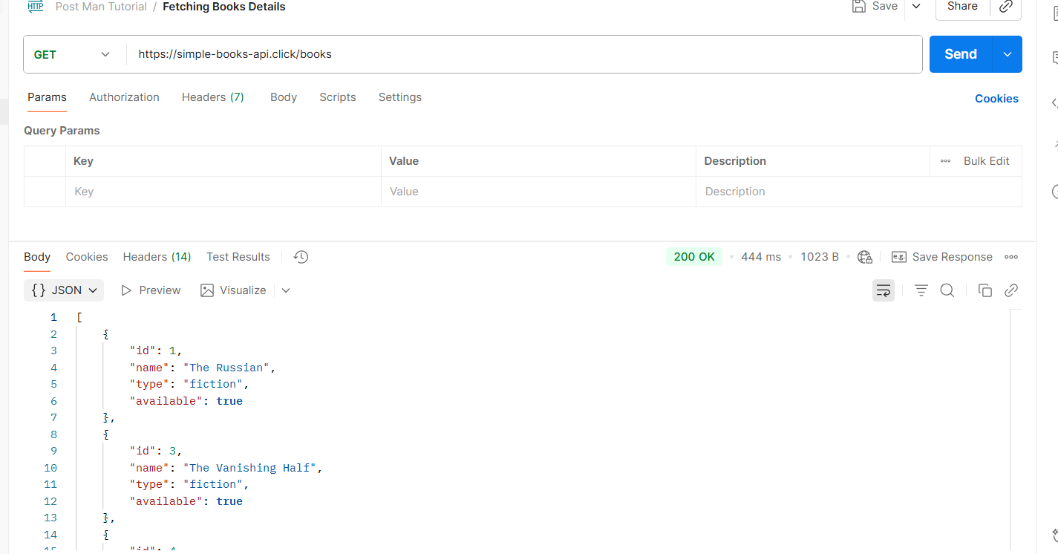
# Now we can also pass queries without writing them in the link or using params. Instead, we can use the postman’s params. We can just edit the key and value and get our query response. Like we set the key to type and value to fiction so that we can get only fiction books. But we must read the documentation to know if our params key is valid or not.
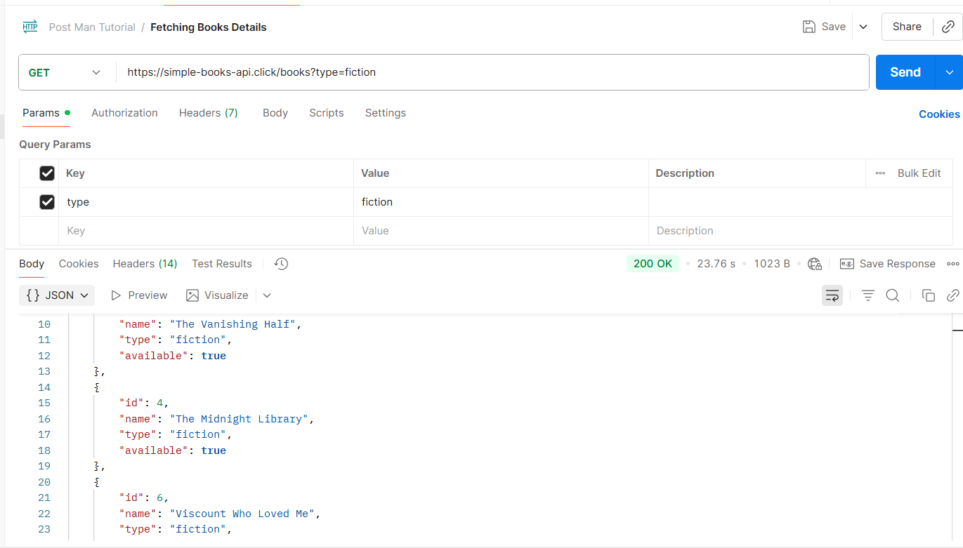

# We can also save our response as by clicking on save responses and also export our collection by clicking on three dots then click on more and export.
# Then we can also add path parameters just typing :bookid after the books/ . Then in the params section we will automatically get our path variables as key-value. We can set the key to bookid and value to 2. To get the book with bookId as 2. We can also directly
access the data by directly writing 2 in link like this books/2
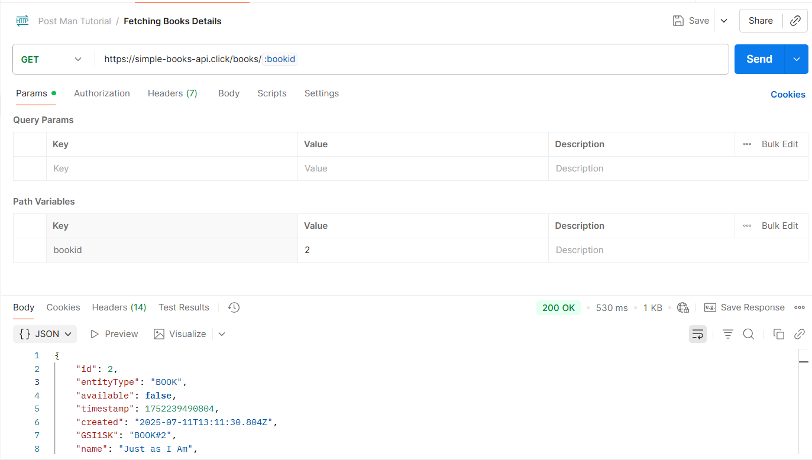

Post Method:
# Add a new request and rename it. Select Post method then in the body section select raw then set Text to json and write the data we want to post as json format.

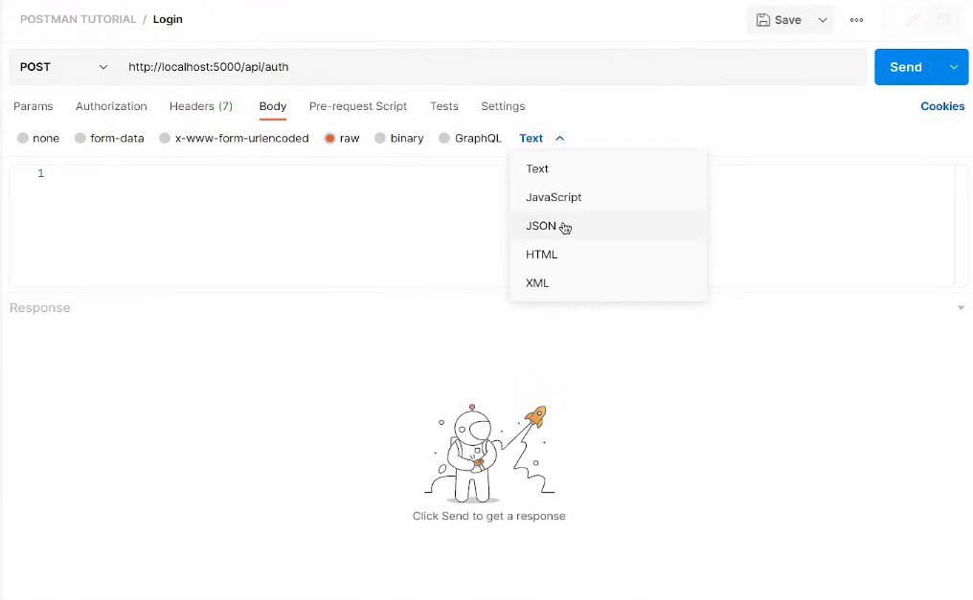

# But make sure the server accepts json format. Then we can also send data in headers. Just go to the Headers section and edit the key-value just like params.

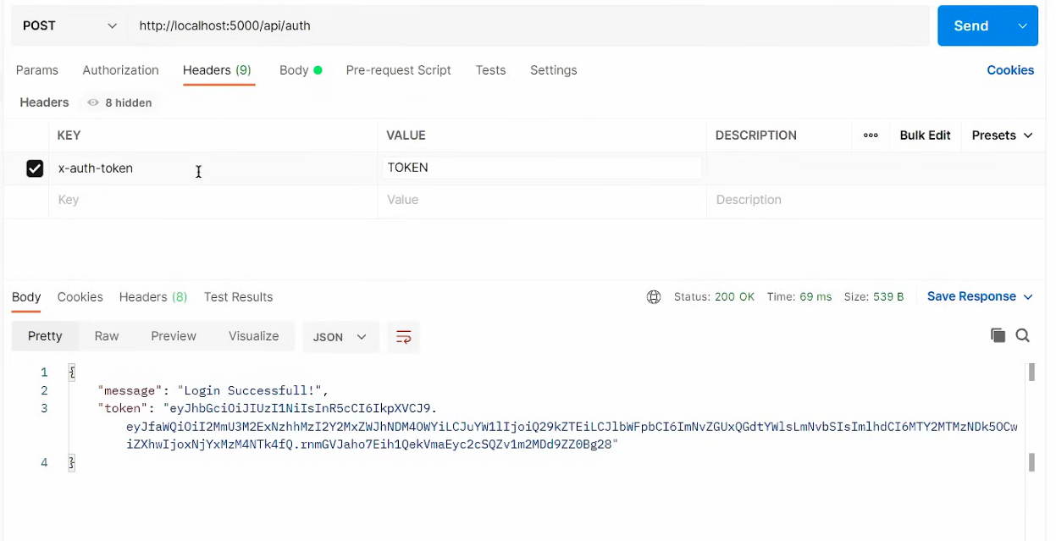

# We can also send images, videos or files in Post method. Just go the body section then select form-data then we edit the key to set our variables name like video. After that in the right side we have a drop-down option to set text to files then in the values click on select files and upload the file.
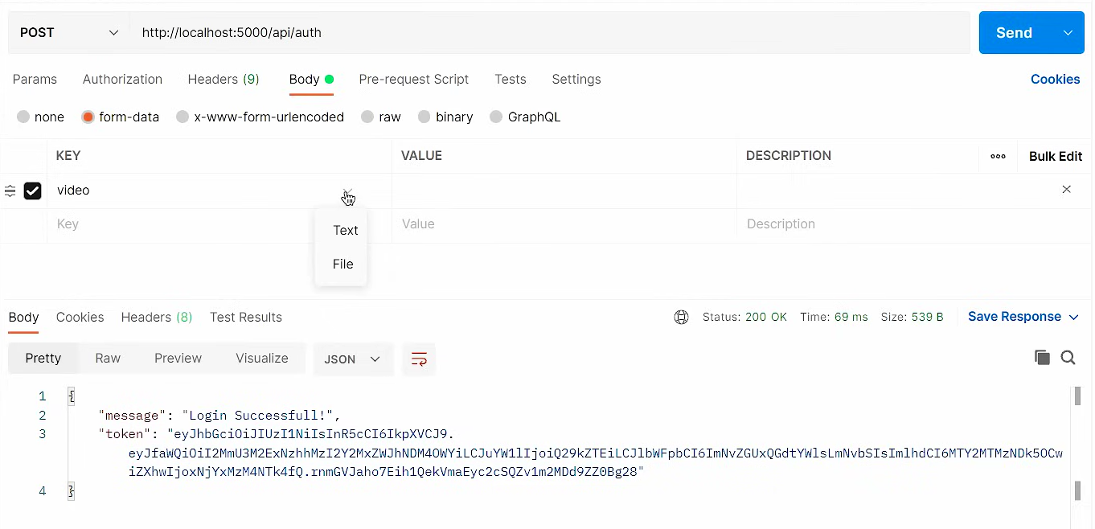

Break

Form Data in Post Man:
# We can send multiple types of data like normal fields as key-value pair and photo files too with it.
# Just go to body and then select form-data. Then simply click on Text and select File. Just like that we can upload files or photos to the API or Backend.
# The server will save the image and give us a URL of the image which will be then show in the fronted. We can also only upload image here
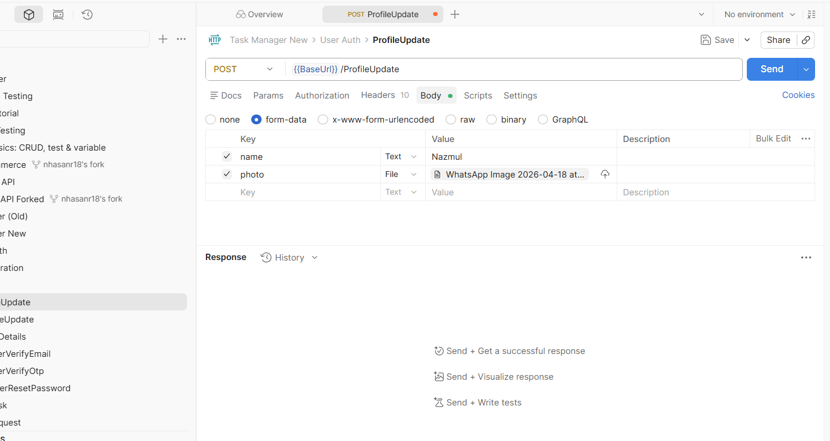

Break

x-www-form-urlencoded in Postman:
# application/x-www-form-urlencoded is a Content-Type header used to send data to a server and is the default method used by HTML forms.
# Useful when we are building a simple website where a standard HTML <form> is submitting data.
# Also needed when integrating with older "legacy" APIs (like some OAuth2 implementations).
# But avoid it if we need to send complex, nested data (like a list of objects). For that, use JSON. Also avoid it if we need to upload a profile picture or a PDF. For that, use form-data.
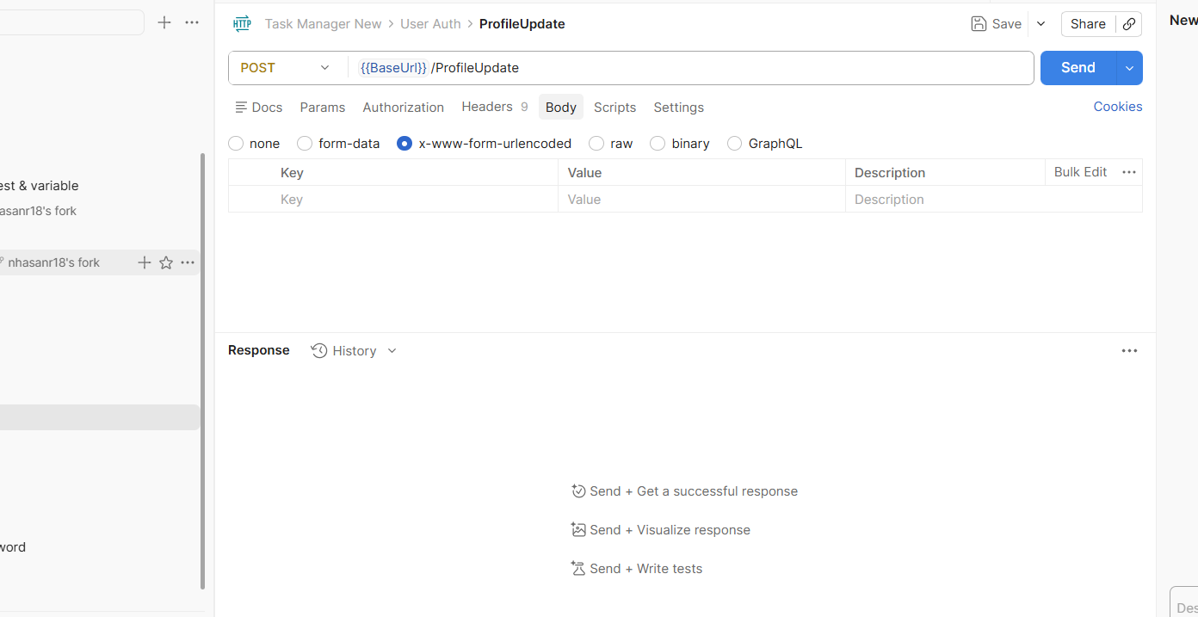

Break

Set Collection Variables:
# Instead of repeating the base URL in every single request file we can make it a variable instead.
# To do that select all in the URL bar and right click and then select Set as variable, then set the variable name and scope (for Collection, Global, Environment or Vault). Usually, the scope is collection so it can be used throughout that testing collection in any request file
# Or go to Collection and then go to Variables section and create a new variable with a value
# Then we can use the variable like this {{BaseURL}}

