INDEX
- Slope………………………………………………………………….2
- Regression………………………………………………………….3
- Linear Regression………………………………………………..4

Slope:
# The equation of a straight line (Slope or Dhal) is written as:
y = mx + c.
# Where:
- y is the dependent variable (Output) or the value we are trying to predict. Its value is determined by x. If x changes, y changes as a result.
- m is the slope (Steepness and Direction). It controls how steep the line is and which direction it leans:
  - If m > 0 → line tilts upward (positive slope)
  - If m < 0 → line tilts downward (negative slope)
  - If m = 0 → line is flat, parallel to the x-axis (no relationship)
- c is the y intercept. The point where the line crosses the y-axis. It shifts the entire line up or down without changing its angle:
  - If c > 0 → line crosses y-axis above the origin
  - If c < 0 → line crosses y-axis below the origin
  - If c = 0 → line passes through the origin (0, 0)

# By changing m and c, we can position and rotate the line anywhere on the graph. The entire goal of Linear Regression is finding the best values of m and c.
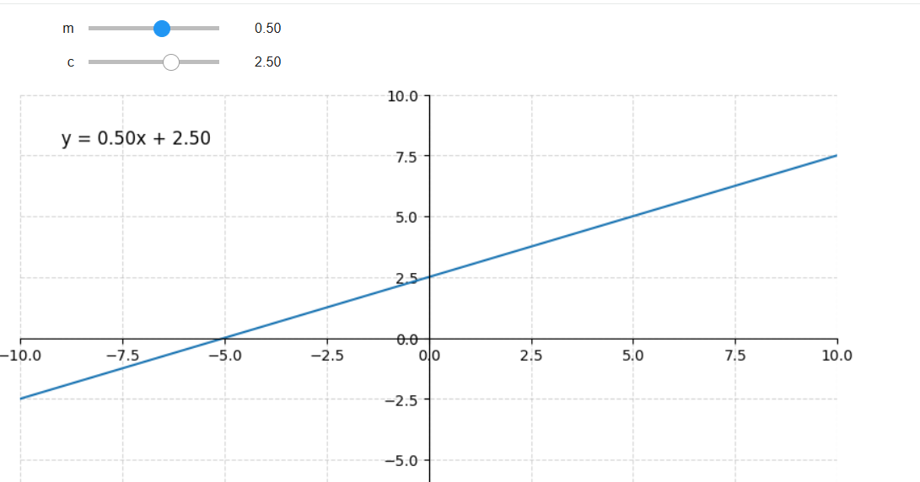

Regression:
# Regression is a statistical method used to model and quantify the relationship between a dependent variable (y) and one or more independent variables (x).
# The word "regression" means returning to a mean or central tendency, the algorithm finds the line that best represents the central trend in the data or goes through the near center of all the data endpoints.
- Simple Linear Regression: one input feature (x) → one output (y)
- Multiple Linear Regression: many input features (x₁, x₂, …) → one output (y)

Linear Regression:
# In Linear Regression, the ML model's job is to find the best values of m (slope) and c (intercept) so that the line fits as closely as possible through all data points.
# Example, predicting exam marks based on study hours.
- x-axis = Study hours (input / feature)
- y-axis = Exam marks (output / target)
# The ML model does not understand labels like "study hours" or "marks". It only works with numbers. So, we give it a mathematical representation:
marks = m × (study_hours) + c
# The model searches for the optimal m and c that produce a line passing as closely as possible through all data points. The closer the line is to every point, the better the model predicts.
# Rule of thumb, a line that passes through or near the center of the data spread (minimizing the overall distance to all points) is a good fit. A line skewed toward only some points is a poor fit.
# Basically, this machine learning algorithm predicts based on, if study hours (x) increases then marks (y) will increase too. And further accuracy achieved by using slope y = mx + c and MSE
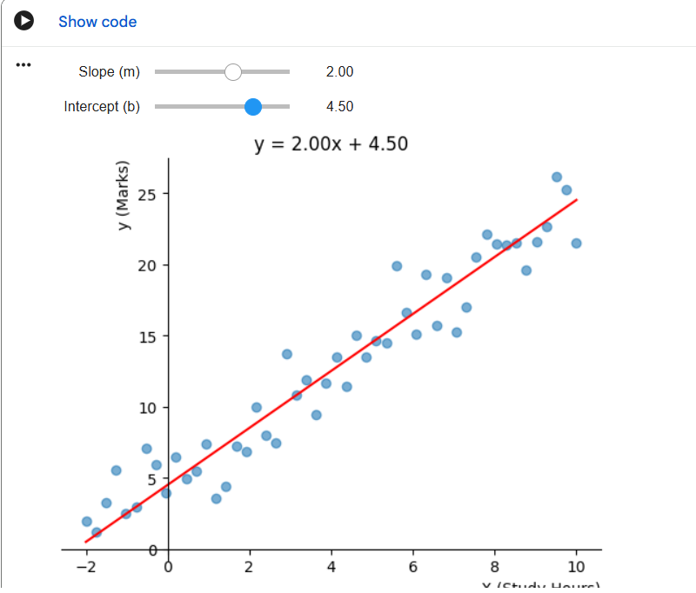

MSE (Mean Squared Error):
# Once a line is drawn, there will always be a small gap between the predicted value (what the line says) and the actual value (the real data point). This gap is called a residual (or error).
# Example:
- Line predicts: marks = 25
- Actual marks: 27 → residual = +2
- Actual marks: 23 → residual = −2
# If we simply add all residuals, the positive and negative errors cancel each other out (e.g., +2 and −2 sum to 0), giving a falsely perfect score even when the line is bad. To avoid this, we square each residual, squaring always produces a positive value.
# The MSE Formula
MSE = (1/n) × Σ (yᵢ − ŷᵢ)²
Where:
- n = total number of data points
- yᵢ = actual value (real data)
- ŷᵢ = predicted value (what the line gives)
- Σ = sum across all data points
# Using our example:
MSE = (1/2) × [(+2)² + (−2)²] = (1/2) × [4 + 4] = 4
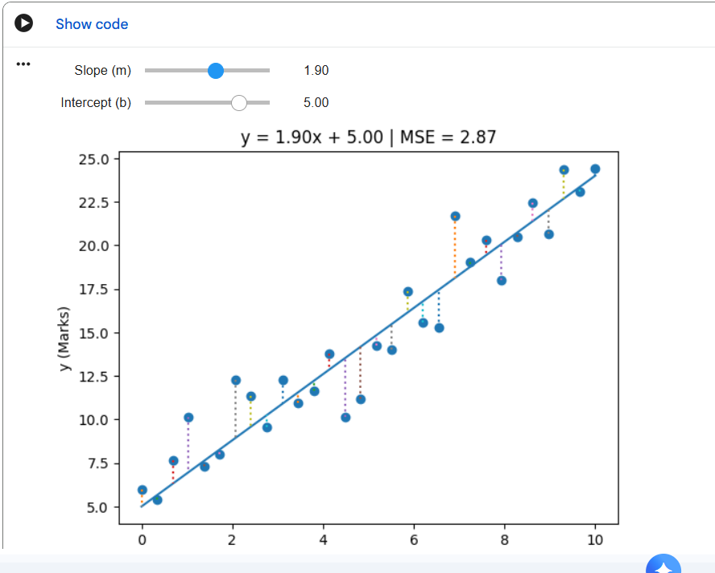

# When we plot MSE against the value of m (or c), we get a U-shaped (upward-opening) parabola. This happens because of how squaring works:
• When x is positive → x² is positive (increases upward)
• When x is zero → x² is zero (the minimum point)
• When x is negative → x² is still positive (increases upward)
# So, the graph curves upward on both sides, forming a U-shape. The lowest point of the U is the minimum MSE and the values of m and c, at that lowest point are the best-fit parameters for our model.
# Important, the model uses an algorithm called Gradient Descent to slide down the U-shaped curve toward the minimum. It repeatedly adjusts m and c in small steps until MSE stops decreasing.

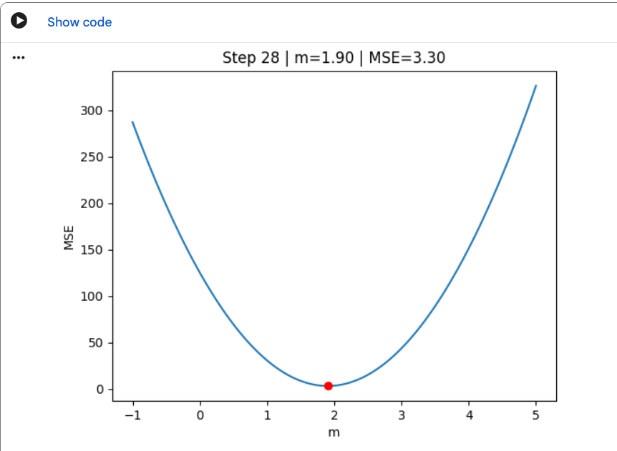
# So, we adjust the value of m or c (intercept) to find lowest MSE
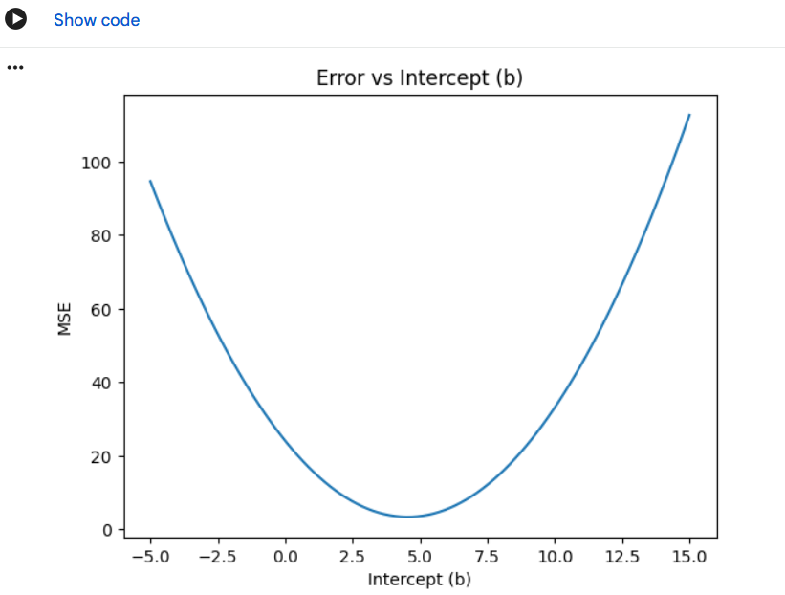

Summary:
# Linear Regression teaches the ML model to find a straight-line y = mx + c that best fits the data.
• y = mx + c is the mathematical model of the relationship
• m and c are adjusted until the line fits the data well
• Residuals are the gaps between predicted and actual values
• MSE measures the average squared error, lower is better
• Gradient Descent finds the m and c that minimize MSE by walking down the U-shaped curve
# Because the relationship is linear (a straight line), the model assumes as study hours increase, marks increase proportionally. Linear Regression captures this trend and uses it to predict new outcomes.

