INDEX

Undoing and Fixing Mistakes:
git reset vs git revert:
# These both “undo” commits, but in different ways. Moves our branch pointer to a previous commit. Can modify history (dangerous if already pushed to remote).
git reset
# Completely resets repo to that commit (erases later commits + changes). Use carefully, usually for local cleanup. We can get the commit hash from github repo commits and copy that.
git reset --hard <commit_hash>
# Keeps our changes staged (like “un-committing” but not deleting).
git reset --soft <commit_hash>
# git revert. Safest way to undo on shared repos. Creates a new commit that “reverses” the changes from an old commit.
git revert <commit_hash>
# Example:
- Commit A: add login form
- Commit B: add bug 🐛
- git revert B → creates Commit C that undoes B (but keeps A).
# History remains safe & clean.

git restore (new command):
# Introduced in newer Git versions as a replacement for git checkout (when used for files). Undo unstaged changes (reset file to last commit):
git restore file.txt
# Undo staged changes (un-add file). Safer than juggling with git checkout + git reset.
git restore --staged file.txt

git stash:
# Temporarily save work without committing (e.g., switching branches quickly). Save changes:
git stash
# List stashes. Used to view stashes. See all stashes stored in the box:
git stash list
# Apply most recent stash:
git stash apply
# Apply & remove:
git stash pop
# Drop a stash:
git stash drop stash@{0}
# Example workflow:
Editing code → need to pull new changes → stash → pull → apply stash back.

Recover Deleted Branches & Commits (git reflog):
# Even if we delete commits or branches, Git usually remembers them in its log. View reflog:
git reflog
# Output example:
a1b2c3d HEAD@{0}: commit: Fix bug
d4e5f6g HEAD@{1}: commit: Add feature
h7i8j9k HEAD@{2}: checkout: moving from main to feature
# Restore branch:
git checkout -b recovered_branch <commit_hash>
Super useful if we accidentally delete a branch or reset too far.

Quick Cheatsheet:
Situation | Command
Undo last commit but keep changes | git reset --soft HEAD~1
Undo last commit & erase changes | git reset --hard HEAD~1
Undo safely (create new commit) | git revert <commit_hash>
Undo unstaged file changes | git restore file.txt
Undo staged changes (un-add) | git restore --staged file.txt
Temporarily save changes | git stash
See all stashes | git stash list
Recover deleted commit | git reflog + git checkout -b newbranch <hash>

GitHub Project:
# GitHub Projects is a flexible, spreadsheet-meets-Kanban task management tool that lives inside GitHub.
# Key insight, unlike Trello or Jira, GitHub Projects doesn't just link to our code but it IS part of our code infrastructure. Issues and PRs from our repos become "cards" in the board automatically.
# Three core things it gives us:
- Board view: visualize tasks as columns (Backlog → In Progress → Done)
- Table view: spreadsheet-style view of all items with custom fields
- Roadmap view: timeline/Gantt-style view for planning sprints
# Mental Model:
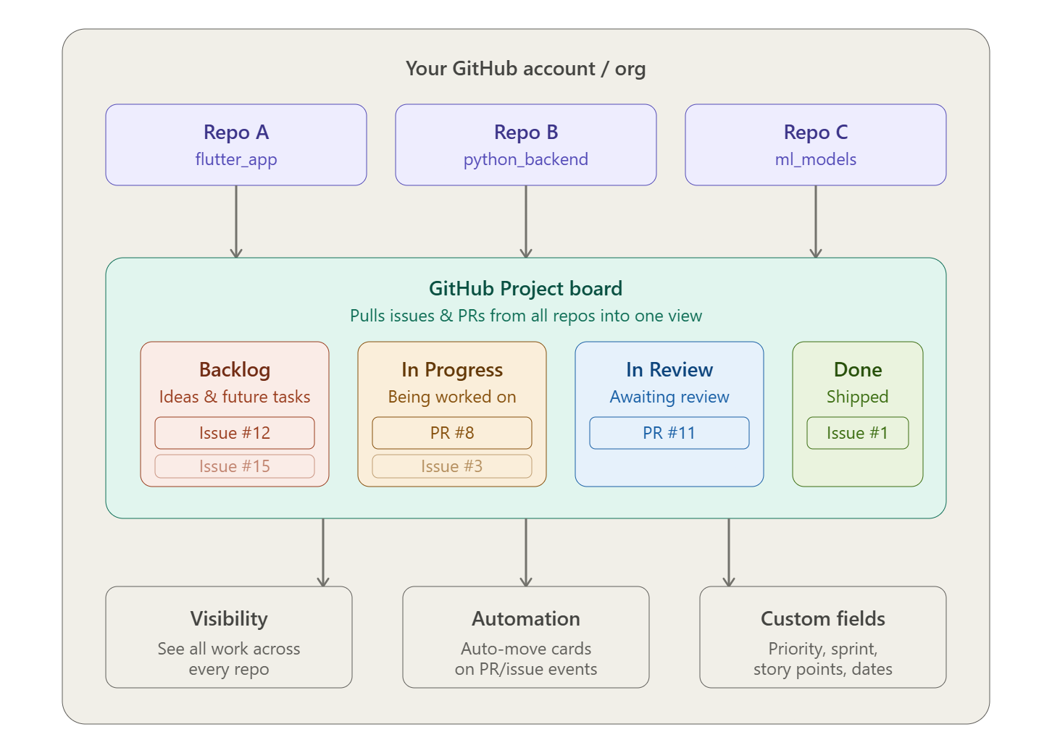

Importance (Why use it):
# Real developers use GitHub Projects because:
- Without it: We have issues scattered across repos, no idea what's being worked on, team members stepping on each other's work, no sprint planning.
- With it: One source of truth. Automated workflows. Linked directly to the actual PRs and commits doing the work.
# The killer feature, when we close a PR, the linked issue can automatically move to "Done" on our board. Zero manual updating.

Usage (Step-by-Step):
Step 1, Create a Project:
# Go to our GitHub profile or organization → click "Projects" tab → "New Project". We'll be asked to choose a template:
- Team backlog → good starting point
- Kanban → classic columns
- Blank → full custom control

Step-2, Add our repos to it:
# Inside our project → Settings → "Linked repositories" → add our repos. This tells GitHub: "pull issues and PRs from these repos into this project."

Step-3, Add issues as items:
# There are two ways:
- Way 1: From the board: click + Add item at the bottom of any column → type # → search for an issue or PR from our linked repo.
- Way 2: From the issue itself: when you create or view an issue, look for the "Projects" section on the right sidebar → click the gear → select our project.

Step-4, Create Custom Fields:
# This is where Projects v2 becomes powerful. First in the Project, create another view (View 2) by clicking on the + icon next to the View 1 and in layout select Table
# Then in Table View scroll all the way right on the header row and click the + icon at the end (in table view) to add:
- Priority → Name it Priority and set field type to Single Select, then add options like:
  - P0 (Critical, must ship now)
  - P1 (High priority, this sprint)
  - P2 (Nice to have, next sprint)
- Sprint → Iteration field (GitHub auto-manages 2-week sprints)
- Story points → Number field
- Due date → Date field
# Finally, click on view settings and save view

Step 5, Set up automation:
# Go to our project → "..." menu → "Workflows" → we'll see built-in automations:
When: Issue closed
Then: Set status to "Done"

When: PR merged
Then: Set status to "Done"

When: Issue opened
Then: Set status to "Backlog"

When: PR opened
Then: Set status to "In Progress"
# These are toggle-on automations like one click to enable. No code needed.

Step-6, Linking issues to PRs (The Real Workflow):
# This is how it works in practice on a real project:
- We create an issue:
Issue #42: Add login screen UI in Flutter
- We create a branch using git command:
git checkout -b feat/login-screen
- We write our code, then open a PR with this in the description:
Closes #42
# That Closes #42 is magic. When the PR merges, GitHub automatically closes issue #42. And if we have automation set up, it moves the card to "Done" on our board.
# The full list of keywords GitHub recognizes; all do the same thing:
close #1
closes #1
closed #1
fix #1
fixes #1
fixed #1
resolve #1
resolves #1
resolved #1
# Don’t do this. It’s wrong and only closes #1 (issue)
Closes #1, #2, #3
# Right way, closes all three
Closes #1
Closes #2
Closes #3

The Flow in our Board:
# Issue #42 starts in Backlog
→ We start working: manually drag to "In Progress" (or automation on PR open)
→ PR opened for review: moves to "In Review"
→ PR merged: automatically → "Done", issue closed

Common Mistakes:
# Mistake-1, Treating it like Trello (manually managing everything). Projects shine when we link issues and PRs. If we're creating "draft notes" instead of real issues, we lose all the automation power.
# Mistake-2, Not using the "Closes #N" keyword in PRs. Most beginners write PRs without linking them to issues. This breaks the automation chain completely.
# Mistake-3, One giant project for everything. Teams with 5+ repos often put ALL work in one board with no filtering. Use views (saved filters) inside our project to show only "Flutter issues" or "this sprint's work."
# Mistake-4, Ignoring the Roadmap view. Solo devs never touch it. But when we start planning features across weeks, the roadmap view (with iteration fields) is how senior devs think about scope.
# Mistake 5, Not setting up workflows. The default project has automation OFF. Most beginners drag cards manually every day like it's 2010. Turn on the built-in workflows on day one.

Industry Practices & Advanced Usage
# In real teams at product companies:
- Sprint planning uses the Iteration field, GitHub auto-creates 2-week iterations and we drag issues into the current sprint
- Priority triage happens weekly and filter by Priority: P0 and make sure those are all "In Progress"
- GitHub Actions + Projects API, advanced teams use the GraphQL API to programmatically move cards, create issues, or generate weekly reports
- Sub-issues (new in 2024) GitHub now supports breaking one issue into sub-tasks directly inside the issue, replacing the old checkbox hack
- Milestones vs Projects, Milestones are for version-based releases (v1.0, v2.0). Projects are for ongoing workflow management. Senior devs use both together

Github Security Alerts:
# Go to repo then Security and quality section. Here we can see all of security issues of our codes like code scanning and secret scanning (for detecting leaked API keys)
# GitHub warns us in security and quality section of the repo if the key format matches any known public API key patterns, GitHub cannot know whether it is restricted or dangerous.
# Sometimes it’s totally normal like Firebase config API keys in firebase_options.dart

Managing GitHub Alerts:
# Go to repo and then Security and quality sections. We can:
- leave them
- or mark as “False positive” / “Used in test code”
- Because this is expected behavior for Firebase configs.
# Or we can also select other things as needed

