Bean Boutique
Website Development Coursework
Tasks 1–4: HTML, CSS, Testing, and Critical Evaluation
Live site: https://beanboutiquecafe.netlify.app/
Source code: https://github.com/nazmuldevs/git-test

Task 1: HTML
The website is built as six interlinked HTML5 pages: Home, Coffee Selection, Brewing Equipment, Events & Workshops, Cart, and Special Offers & Subscriptions. It is deployed and publicly viewable at https://beanboutiquecafe.netlify.app/, and works on both desktop and mobile devices. Each page uses a semantic header, main content sections, and a shared footer, and every page links to the same external style.css file.

Home Page
Header with a sticky navigation bar (hover underline effects), a hero section, an auto-advancing slideshow, informative sections (story, why-us, products, events, social feed, map), a newsletter section, and a footer. A first-visit modal offers 15% off in exchange for an email signup.
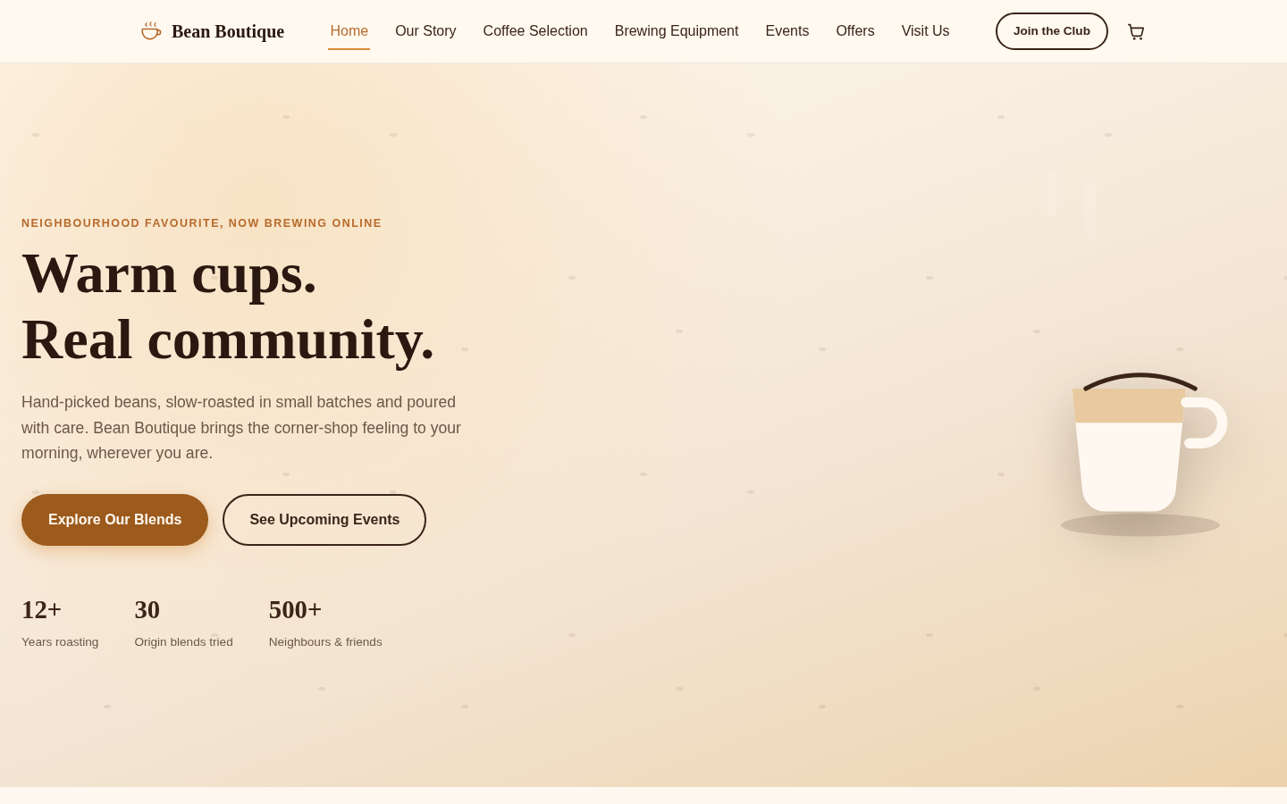
Home page, desktop view (1440×900)

Coffee Selection
A catalogue of ten signature blends and single-origin coffees, each with a description, tasting notes, and recommended brewing methods, plus a live search box and category filters.
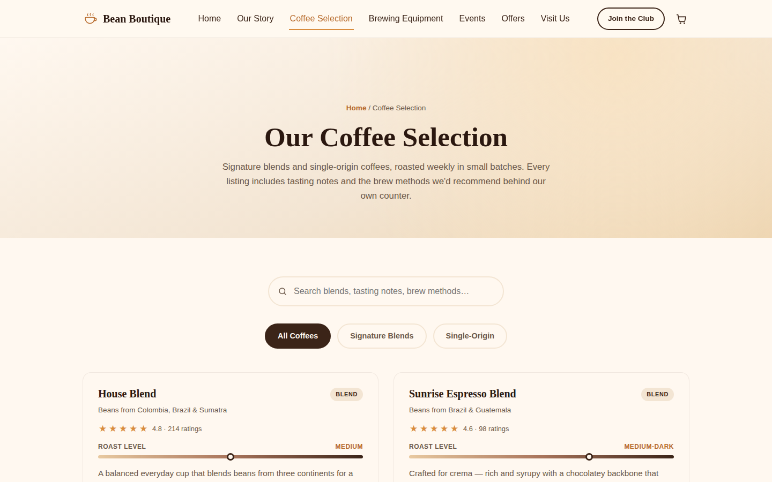
Coffee Selection page, desktop view

Brewing Equipment
Ten pieces of brewing equipment, from espresso machines to French presses, each with a description and usage tips.
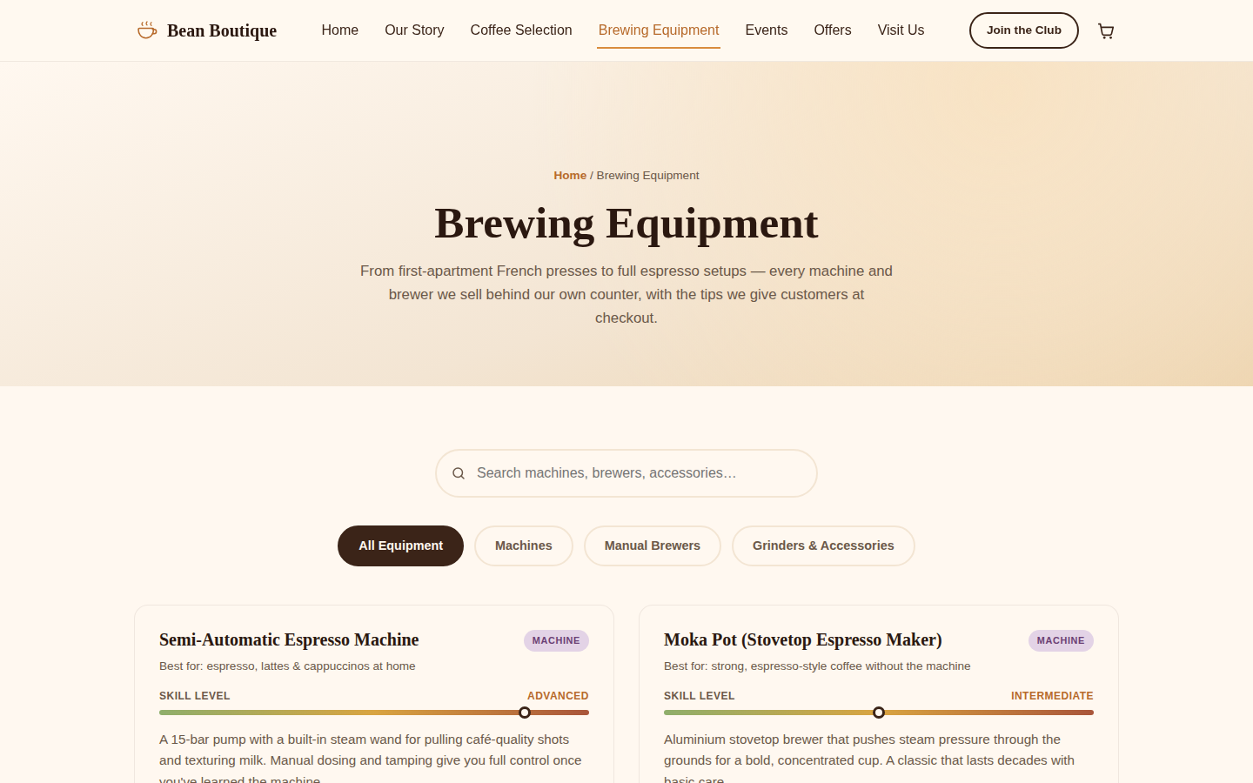
Brewing Equipment page, desktop view

Events & Workshops
Upcoming tastings, workshops, and meet-the-roaster sessions with an online registration form (first name, last name, email, and a submit button that also opens a pre-filled confirmation email).
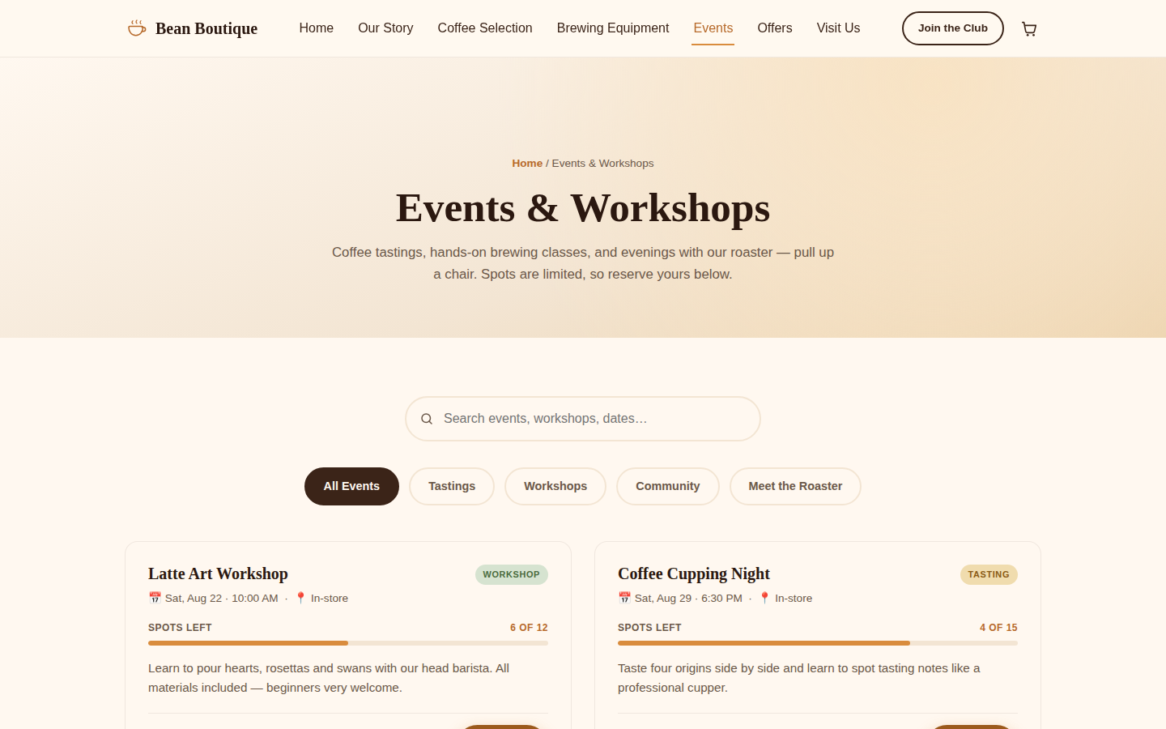
Events & Workshops page, desktop view

Cart
Visitors can add coffee blends and equipment to a shopping cart from three different pages. The cart persists between visits and shows an order summary with a checkout step.
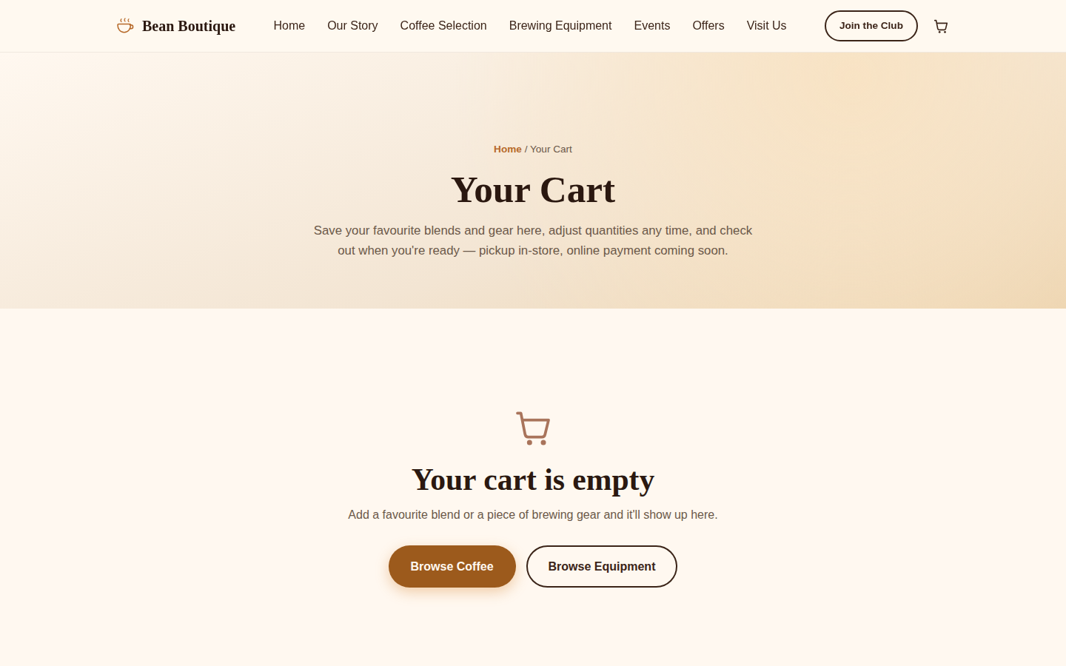
Cart page, desktop view

Special Offers & Subscriptions
Current promotions with copyable discount codes, and a three-tier coffee subscription (Explorer, Regular, Connoisseur) detailing frequency, pricing, and benefits.
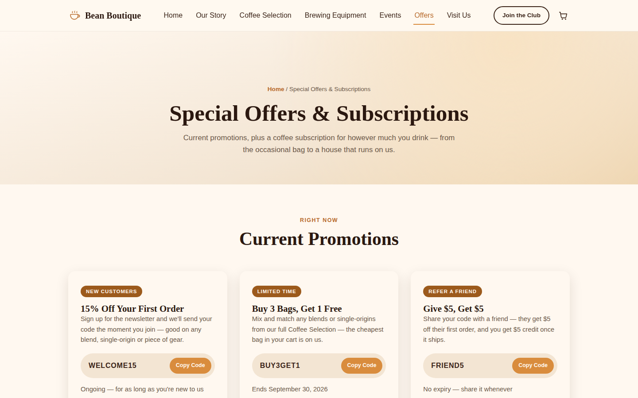
Special Offers & Subscriptions page, desktop view

Responsive Design (Mobile Device)
The layout adapts to mobile viewports: the navigation collapses into a hamburger menu, grids stack into a single column, and all interactive features (cart, search, modals) remain fully usable.
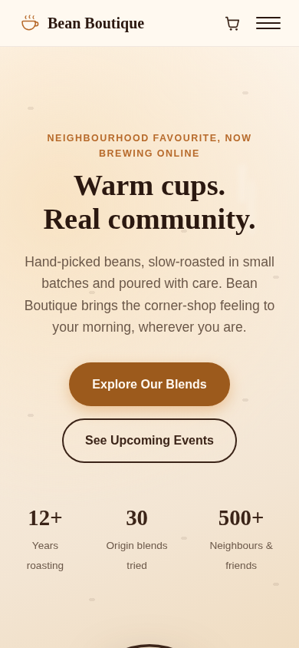
Home page, mobile view (390×844)
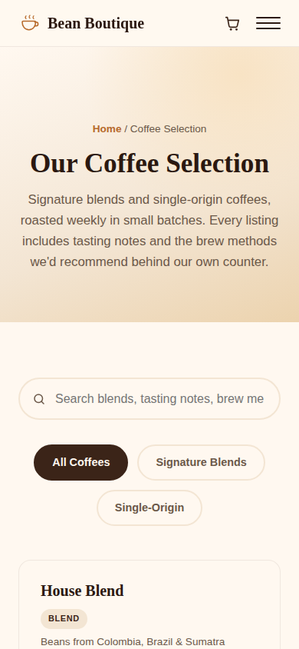
Coffee Selection page, mobile view
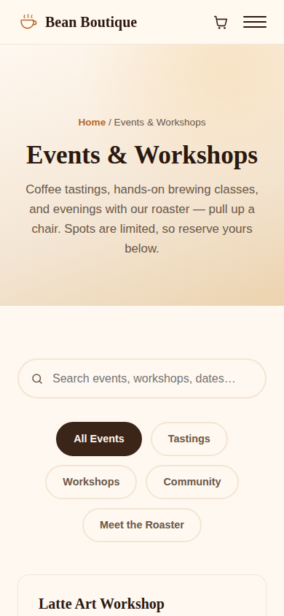
Events & Workshops page, mobile view

Task 2: CSS
Every page links to a single external stylesheet, style.css. No page uses the style attribute or a <style> element; this was confirmed by searching every HTML file for style=" and <style, which returned zero matches. Interactive elements throughout the site use border-radius, box-shadow, and hover transitions, and the Coffee Selection, Brewing Equipment, and Events pages include an animated, on-page text search that filters the catalogue live as the visitor types.

Border-radius, box-shadow and hover effects
Product cards and buttons use rounded corners (border-radius) and soft drop shadows (box-shadow), and lift slightly with a darker background on hover.
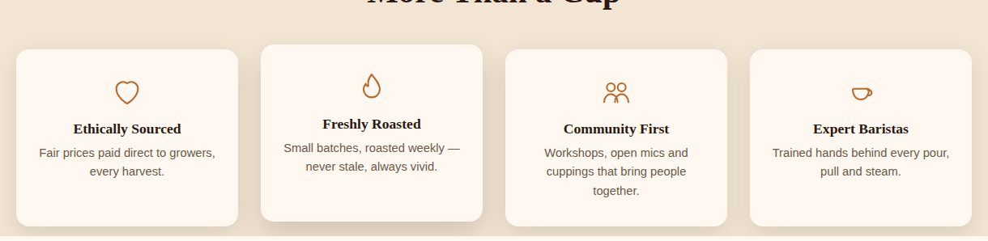
"Why Us" info cards showing border-radius and box-shadow
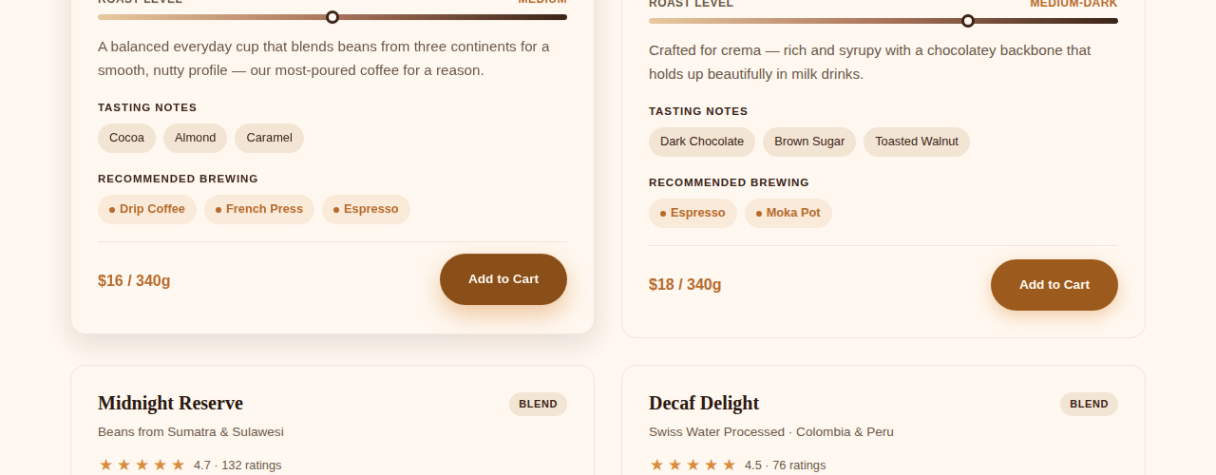
"Add to Cart" button in its hover state (left) compared to the default state (right)

Animated text search
Typing into the search box filters the catalogue live. Matching cards animate into view and non-matching cards fade and collapse out of the grid, with an empty-state message if nothing matches.
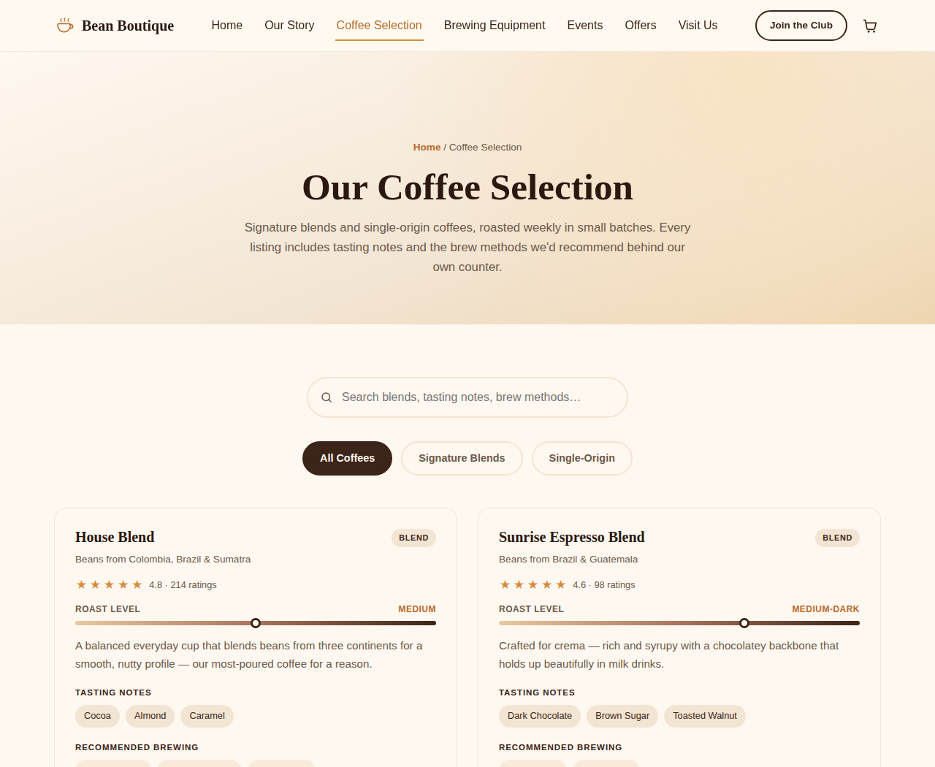
Coffee Selection catalogue before searching
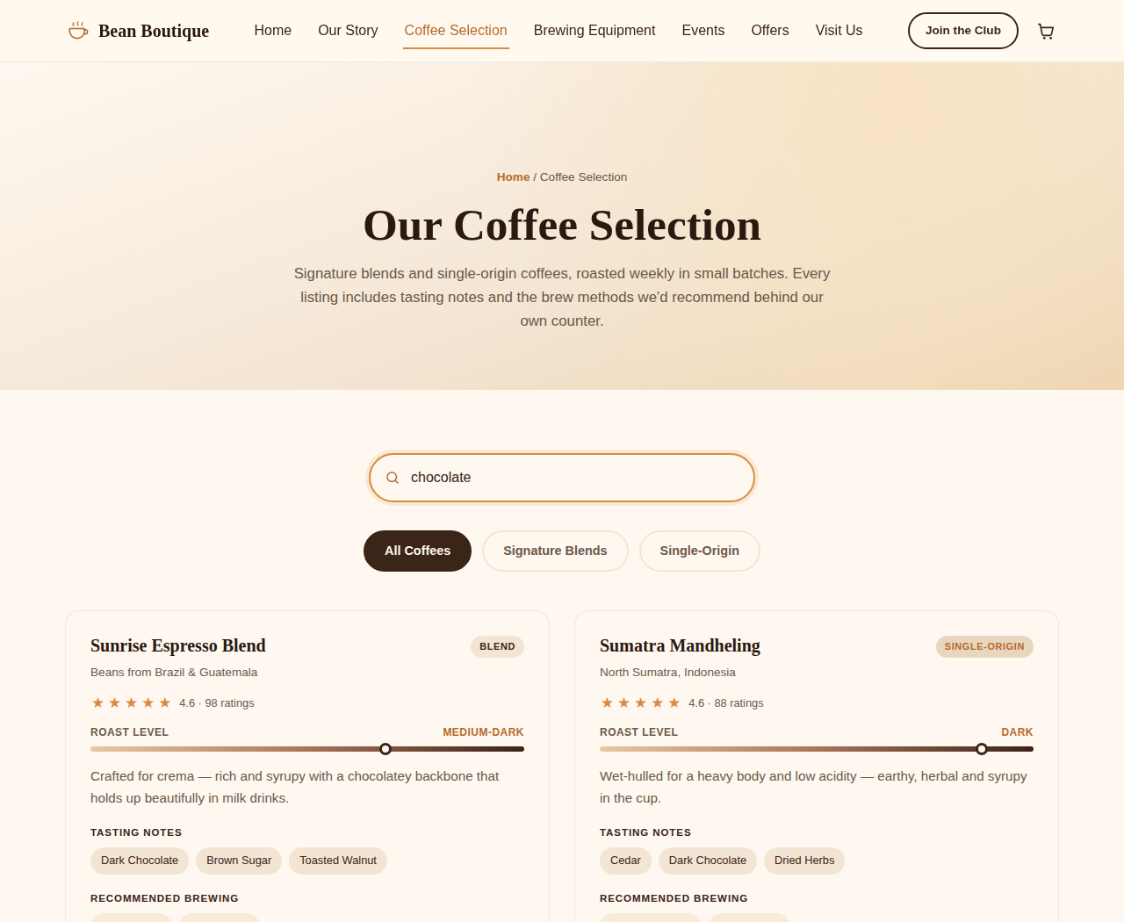
Same page after typing "chocolate" into the search box, showing only matching coffees

Task 3: Testing

W3C HTML Validation
All six HTML files were validated with the W3C Nu Html Checker (the same validation engine used by validator.w3.org).
Document checking completed. No errors found.

W3C CSS Validation
style.css was validated with the W3C CSS Validation Service (jigsaw.w3.org/css-validator), selecting "Show source". Result: valid CSS Level 3 + SVG, 0 errors, 12 informational warnings.
[Insert your W3C CSS Validation Service screenshot here — "Congratulations! No Error Found."]

Test Report (500 words)

Methodology
All six pages (Home, Coffee Selection, Brewing Equipment, Events & Workshops, Cart, Special Offers & Subscriptions) were tested with the W3C Markup Validation Service, the W3C CSS Validation Service, a screen reader, and two browsers, one desktop, one mobile.

HTML & CSS Validation
The W3C Nu Html Checker initially returned three genuine errors: the catalogue pages jumped straight from <h1> to each product’s <h3>, skipping <h2>, and the footer’s <h4> column headings skipped <h3>. Both were fixed, the catalogue pages gained a screen-reader-only <h2> (visually hidden, no layout change), and the footer headings were promoted to <h3>. Re-validation returned zero errors and zero warnings across all six pages (saved as w3c-html-validation-output.txt). The W3C CSS Validation Service confirmed style.css valid under CSS Level 3 + SVG with no errors (12 informational warnings only, none blocking validity, screenshot below).

Screen Reader Testing
Testing with a screen reader confirmed the site is usable non-visually: the corrected heading structure lets a reader jump section-to-section cleanly, every interactive control (nav links, Add to Cart, Register, search boxes, star ratings) announces a clear name and role, the discount and registration modals are announced on open, and form fields read their labels correctly. No blocking issues were found.

Two-Browser & Mobile Testing
Chrome and Firefox (desktop) rendered the site consistently, layout, colours, animations (slideshow, hover states, modal transitions) and interactive JavaScript (cart, search, ratings, registration) all matched. Two minor differences were noted, neither affecting usability: Firefox renders the Georgia headings with marginally tighter letter-spacing than Chrome’s font hinting, and the native <select> dropdown arrows (roast/guest pickers) keep each browser’s own default style rather than a custom one, a deliberate choice to preserve native accessibility behaviour, not a bug.
On mobile (Safari on iOS), the site was fully usable: the hamburger menu, modals, and cart worked correctly, and inputs are set at 16px to avoid iOS Safari’s auto-zoom-on-focus behaviour. One real discrepancy was found: the hero’s min-height: 90vh is calculated against the full viewport height before Safari’s address bar collapses, so on first load the hero sits slightly taller than the visible viewport until the user scrolls once, worth revisiting with 100dvh (dynamic viewport height).

Role of the W3C
The World Wide Web Consortium (W3C) is the standards body that defines and maintains the specifications for HTML and CSS. Its validators check a document against those specifications rather than against how any one browser currently renders it, which is why validation matters even when a page “looks fine”: non-compliant markup can render inconsistently across browsers, assistive technologies, and future browsers never manually tested.

Outstanding Issues & Recommendations
The main outstanding item is real photography, the prototype uses CSS/SVG illustrations rather than licensed photos, which should be sourced before a production launch. The 90vh hero should move to 100dvh. Testing coverage was reasonably thorough for a prototype stage (automated and manual validation, one screen reader, two browsers including mobile), but a production release would benefit from a second screen reader (JAWS) and a wider spread of real devices.

Task 4: Critical Evaluation (750 words)

a) Back-end technology and front-end vs back-end
Front-end code is everything that runs inside the visitor’s own browser. This project is built with HTML, CSS and JavaScript, and all of it counts as front-end. The browser reads these files and draws the page, and any logic, like the cart or the star ratings, runs on the visitor’s machine using localStorage.
Back-end code runs on a server the business controls, not the visitor’s computer. To make Bean Boutique a real working shop, it would need a server (Node.js, PHP or Python), a database (such as MySQL) for products, orders, accounts and bookings, and a payment gateway such as Stripe. It would also need an email service, since the registration form currently just opens a mailto: link instead of sending mail from a server.
The clearest example is the cart. Right now it lives in the browser’s localStorage, so it only exists on one device. A real back-end would save it against a customer account, so it would follow them everywhere and could actually be charged.

b) Evaluating the three plugins
Social feed widget. A grid of sample posts styled like Instagram, built with CSS and emoji rather than a real embed. It shows community engagement, fitting the shop’s “warmth and community” theme. It does not pull in real posts, so a live version should use the real Instagram Graph API instead.
Interactive map. Rather than embedding Google Maps, this is a hand-drawn SVG with a clickable pin showing the shop’s address and hours. A real map needs an API key and sends requests to a third party, which the build environment could not reach. It shows the location well but gives no real directions, so production should use a real map embed.
Cookie and privacy banner. This answers the “security feature to protect customer data” requirement directly. It tells visitors what is stored on their device and lets them choose “Accept All” or “Essential Only”. This fits well because everything the site stores does stay in the browser. Once real payments exist, the banner alone would not be enough. The site would also need HTTPS, a secured server, and PCI DSS compliant payment handling.

c) Version control and GitHub
Version control keeps a history of every change made to a project’s files. Instead of saving files as “final” or “final2”, each change is saved as a “commit” with a message explaining what changed. Old versions are never lost, and mistakes can always be undone.
GitHub hosts this history online. This project was built on its own branch, separate from the main branch, so new features could be tested without risking the working version. Each commit explains what was added, building a clear record of how the site grew into six pages. If Bean Boutique hired more developers, GitHub would let them work on different features at once without overwriting each other’s work.

d) Front-end frameworks and Bootstrap
A front-end framework is a ready-made set of CSS and JavaScript that developers reuse instead of writing everything from scratch. Bootstrap is a well known example, with ready-made buttons, navigation bars and grids. The main advantages are speed, consistency, and code already tested across browsers.
Bootstrap was not used here, partly because the assignment asked for hand-written HTML and CSS, but also because it has a recognisable look that takes effort to override. This site relies on a custom colour palette and hand-drawn illustrations for its own identity, and building by hand gave more control than Bootstrap’s defaults would. For a business that needs a site built fast, Bootstrap is still a sensible choice.

e) Reflection, value and recommendations
The strongest part of this project is that it behaves like a working shop, not static pictures. A visitor can add coffee to a cart from three pages and see it saved, rate a coffee and see it lock in, search the catalogue live while typing, and register for an event with a pre-filled email. That JavaScript and localStorage layer added the most value, turning the design into something a reviewer can use and test.
The clearest next steps are a real back-end and database so orders and accounts persist, real licensed photography in place of the illustrations, a real payment gateway, and real map and social embeds once hosted with normal internet access. These are the right priorities because the site already proves the idea and the user experience work. What is missing is real data and money handling, only possible with a back-end.

