**The Home Page**

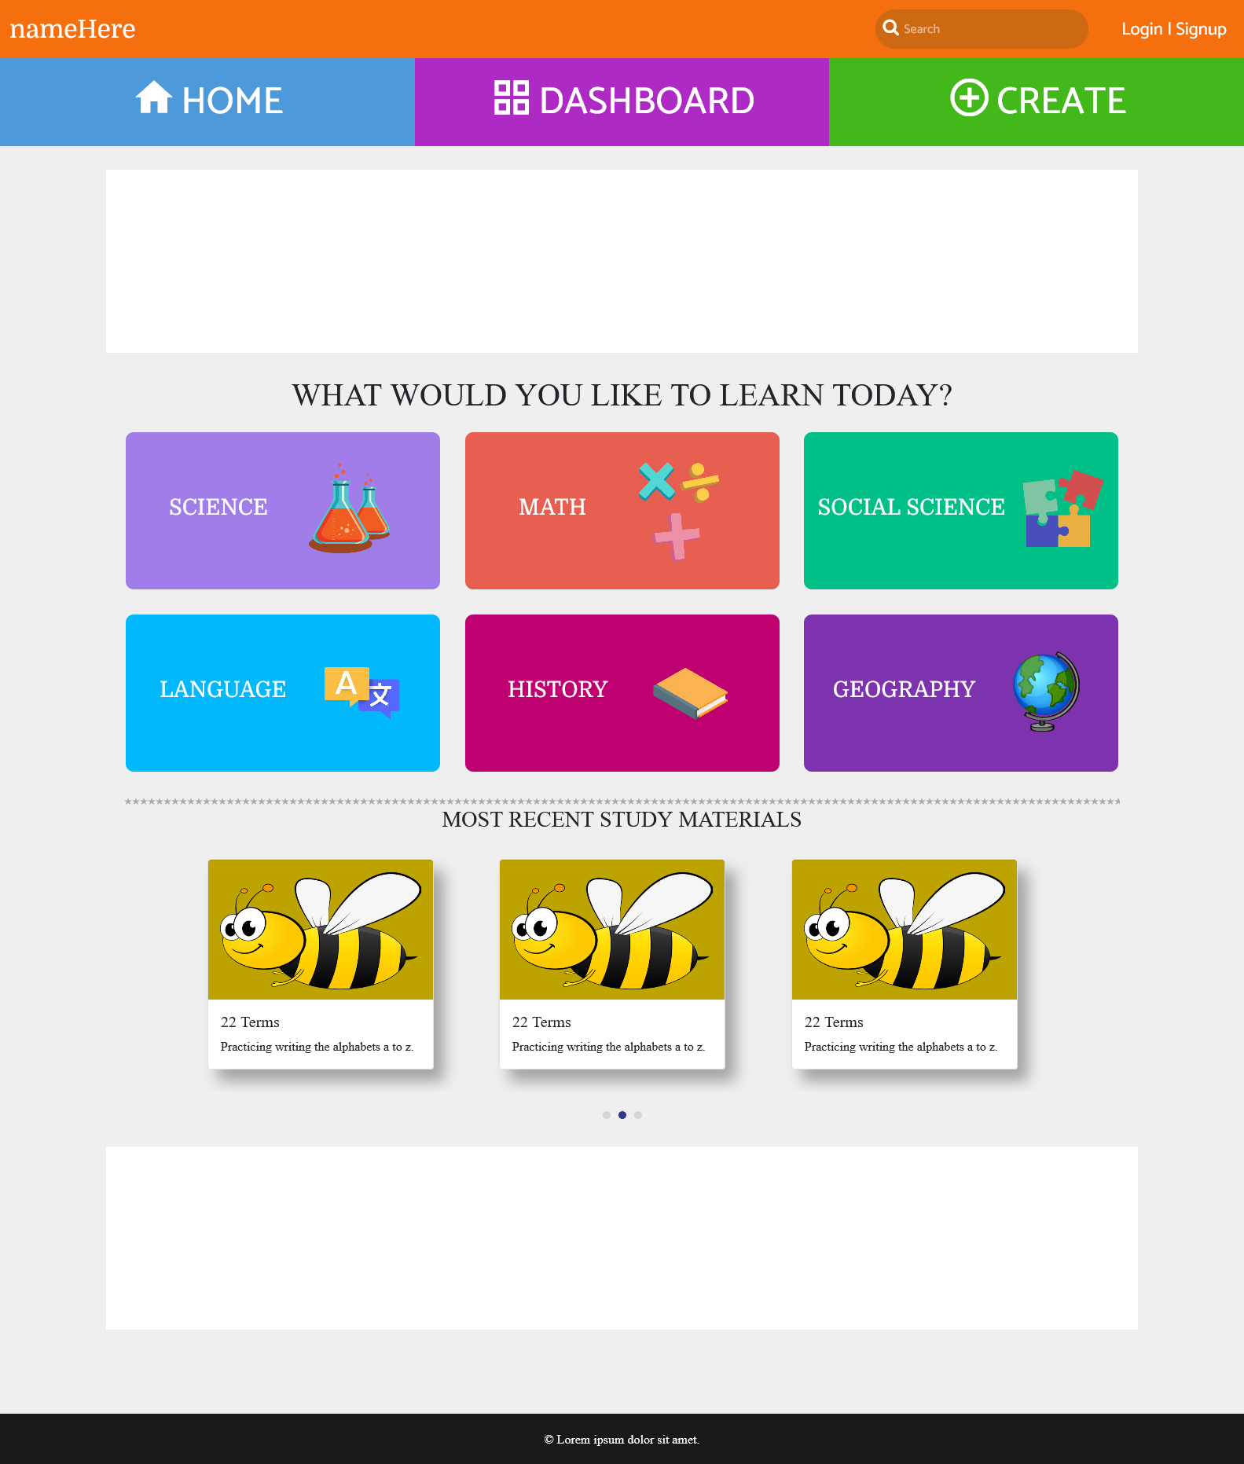Clicking on one of these subjects will lead to another page. For example, when a user clicks on 'SCIENCE', this will lead to science-subject.html page.

The “MOST RECENT CARDS” are dynamically generated by the website by getting from the recently created study materials.

**Subjects Page**

In this page the website should dynamically display all the specific subject **study materials(*)** created by registered users, from latest to oldest. The scrolling of page should be continuous i.e. infinite scrolling.

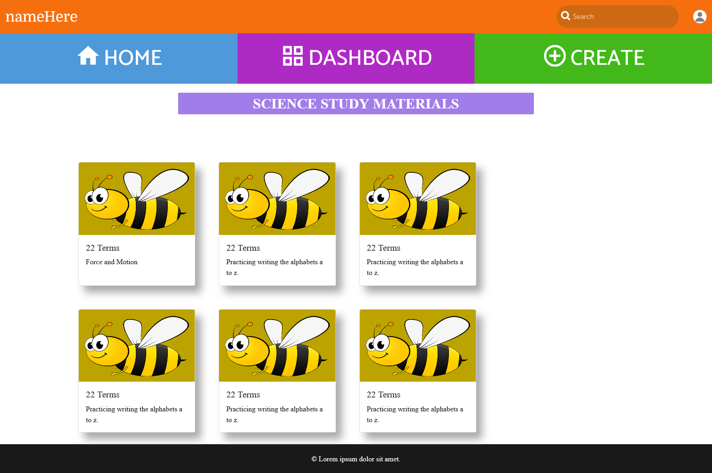

**The Creation page of study materials(*) – For the registered users only\***

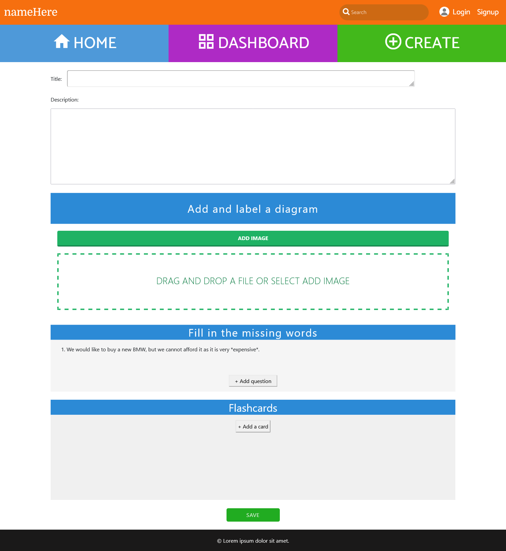

**Title** – The name of the individual study material.

**Description** – Description of the study material.

**Add and label a diagram** – This is the section where a registered user can drag an image.

**Note**: The prototype section for “Add and label a diagram” on this page is not the correct one. The correct one is like on P**icture (c)**

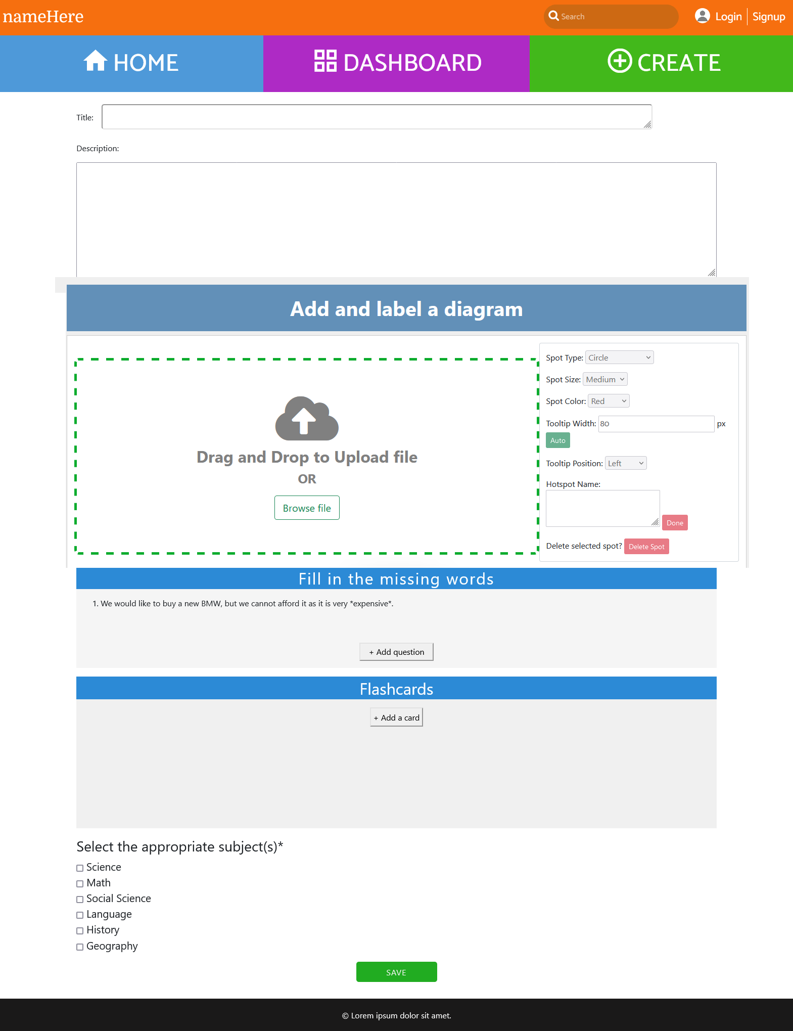

**Picture (c)**

Here a user adds hotspots on the image, see **Picture (a)**. Those hotspots will be use as questions later.

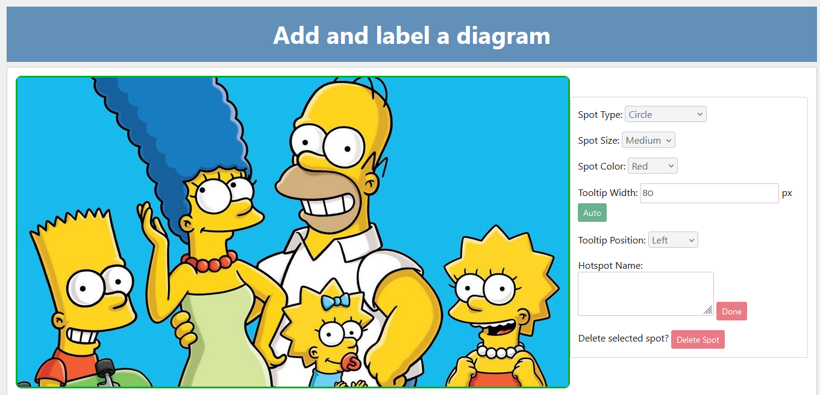

**Picture (a)**

**Example of this – check quiz-page-2.html**

On this page “CREATE”, implement only the first part of this app. i.e. the adding of hotspots. The quiz will have to appear on the other page.

**Fill in the missing words** – This is the activity where a user can enter a sentence. A user can insert asterisks before and after the word, he would like to remove. So the end user can complete later.

In the picture below, “Fill in the missing words”, 1 is the number that cannot be edited, while the rest of the text, example “I would like to buy …” are just placeholder texts, they should disappear as soon as the user start typing.

****Clicking on “Add question” will allow the user to add another sentence. Like the first sentence number 2 should appear

**Flashcards** – When clicking on "+ Add a card", the full page pop up will display like the **Picture (b)**

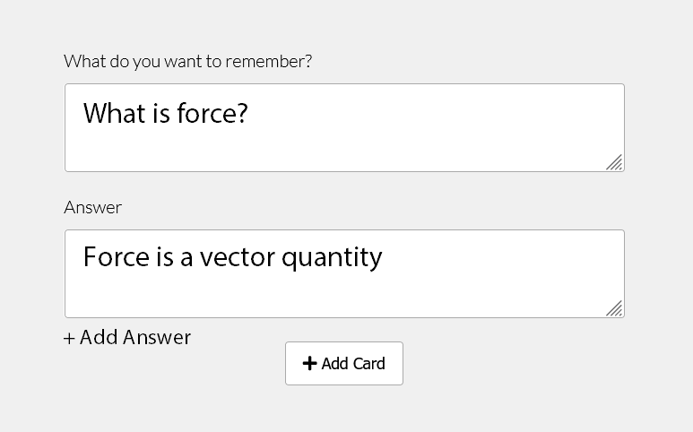

**Picture (b)**

**Example pop up** - <https://codepen.io/rainbowx/pen/mdJQZzx>

IMPORTANT***The flashcards should flip like this https://codepen.io/makecodenotwar/pen/bgdXyX

**Important:**

1. **A user should be able to add up to 4 Answers by clicking on the “+ Add answer”, and can select more than 1 option as correct answer by ticking on the box opposite to each answer.**

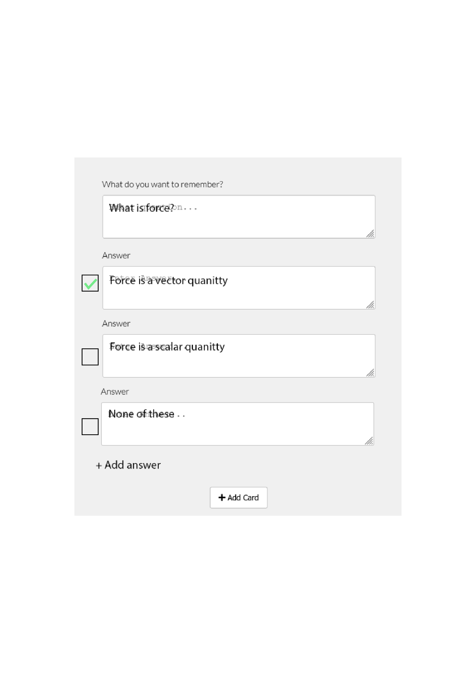

1. **A user should be able to edit the flashcard contents on this page.**

**Note**: Users who are not registered will not see this page when clicking on the ‘CREATE’ button. They will instead see the pop ‘Signup/Sign in”

Now let’s connect between the study materials creation page and what the end users will see.

This is where interactive study materials are automatically created

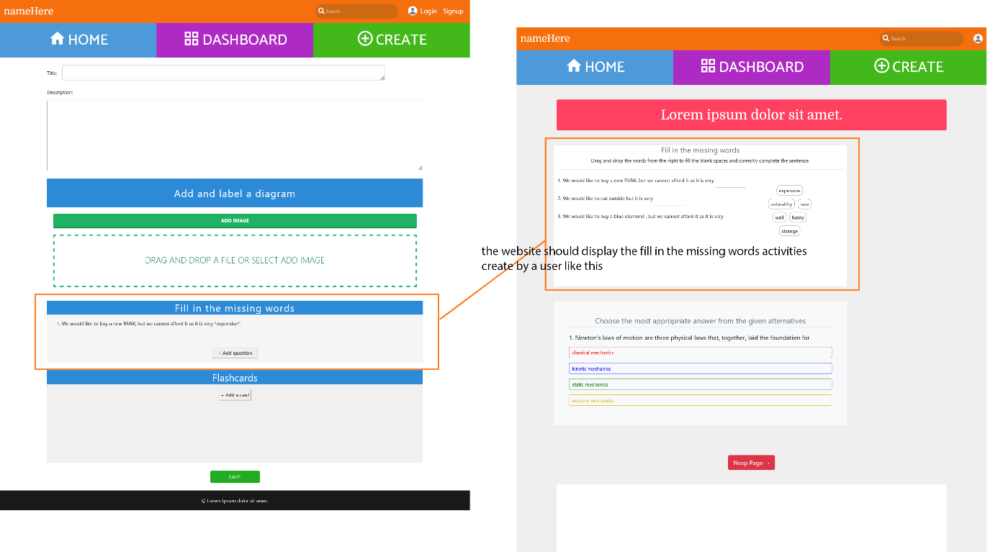

Important:

1. The “Fill in the missing words” activity should not allow user to see the correct answer yet, the “Check answers” should not exist. The html page template I gave is just a prototype.

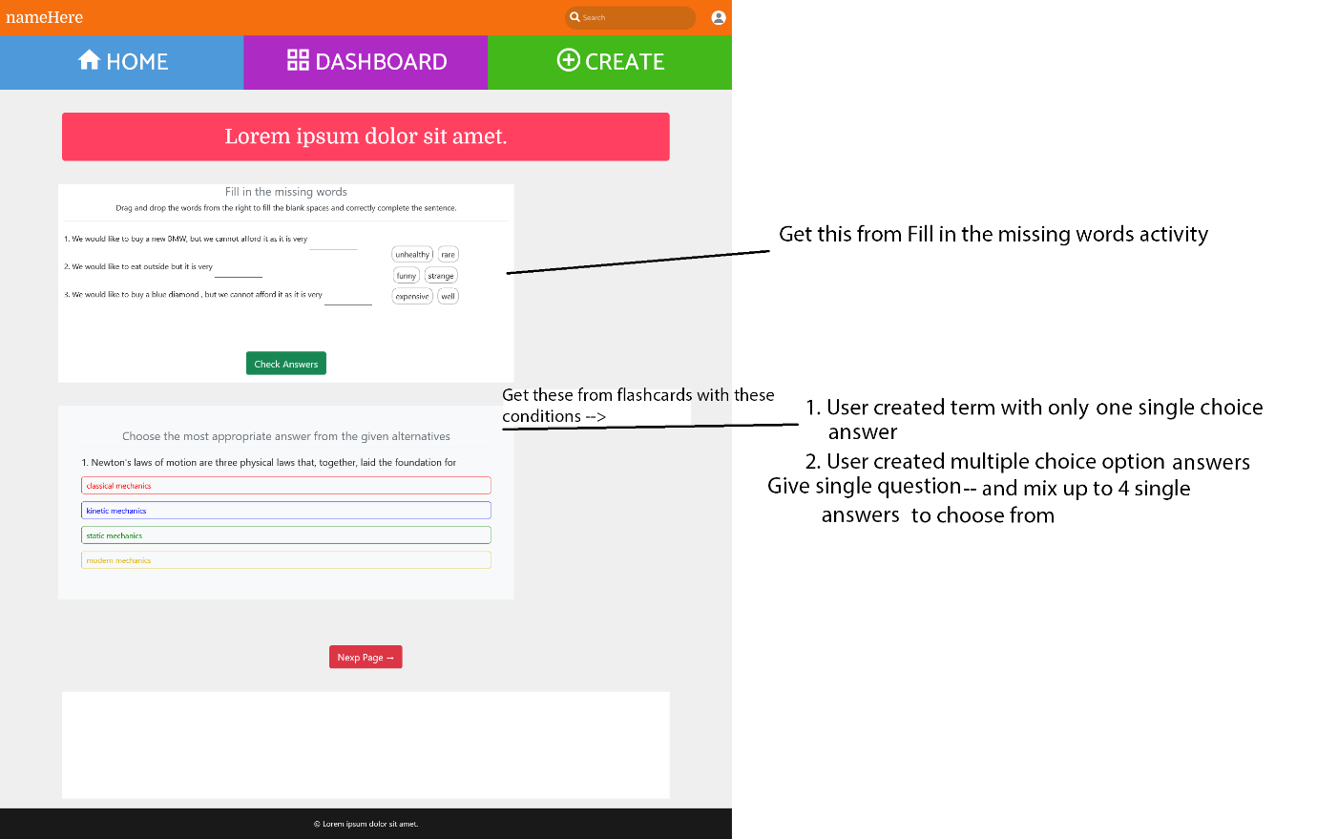

**Important for Multiple choice questions**

1. The website should also automatically generate these multiple choice questions. With these conditions to follow

**Get from**

1. User created term with only one choice answer.



1. User created multiple choice definitions



1. Give single question and mix up to 4 answers from other card to choose from. ***
2. Dynamically generate at least **5 multiple choice questions** (maximum 10) by following the conditions above.

**Hotspot Activity**

This is where the “Add and label a diagram” activity will appear for end users.

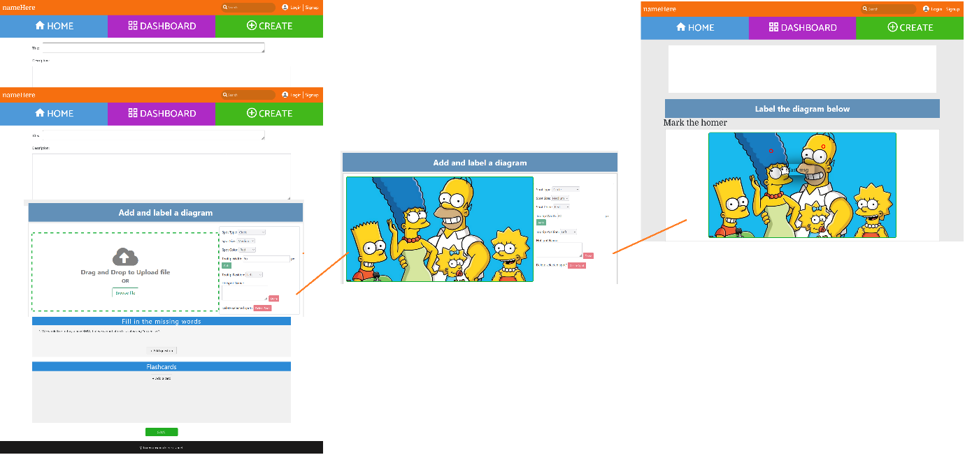

This activity should appear after the “Fill in the missing words” activity and the “Multiple choice” question activity.

**Remaining pages**

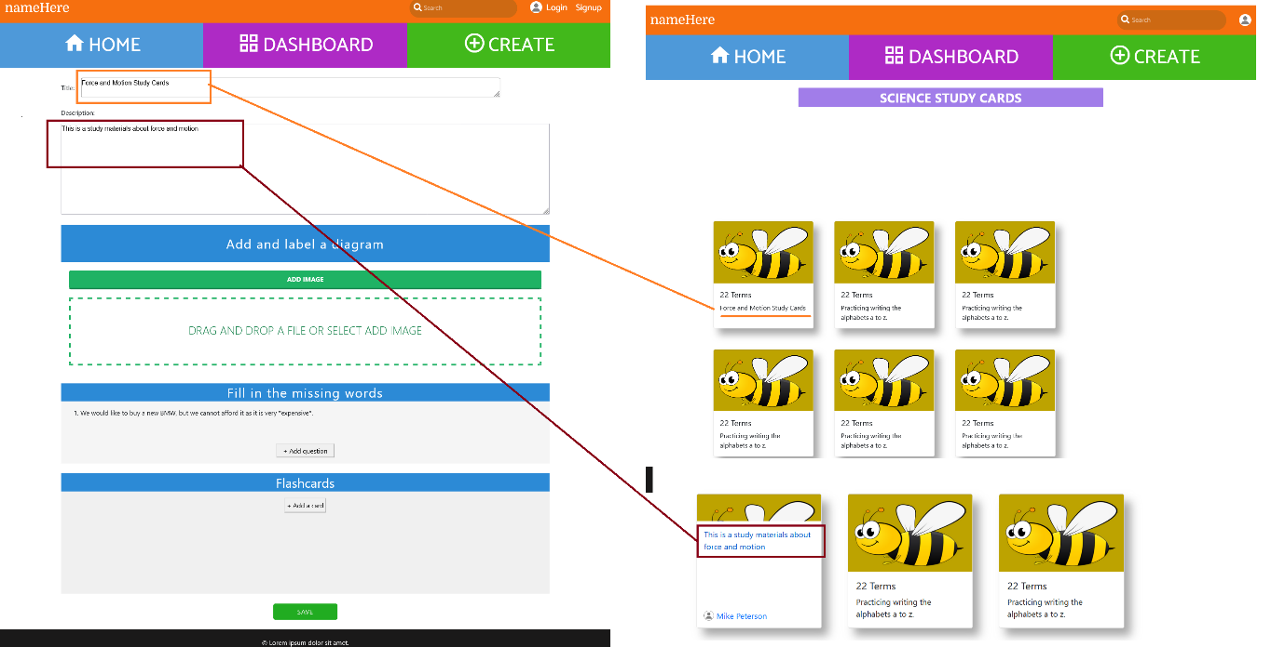

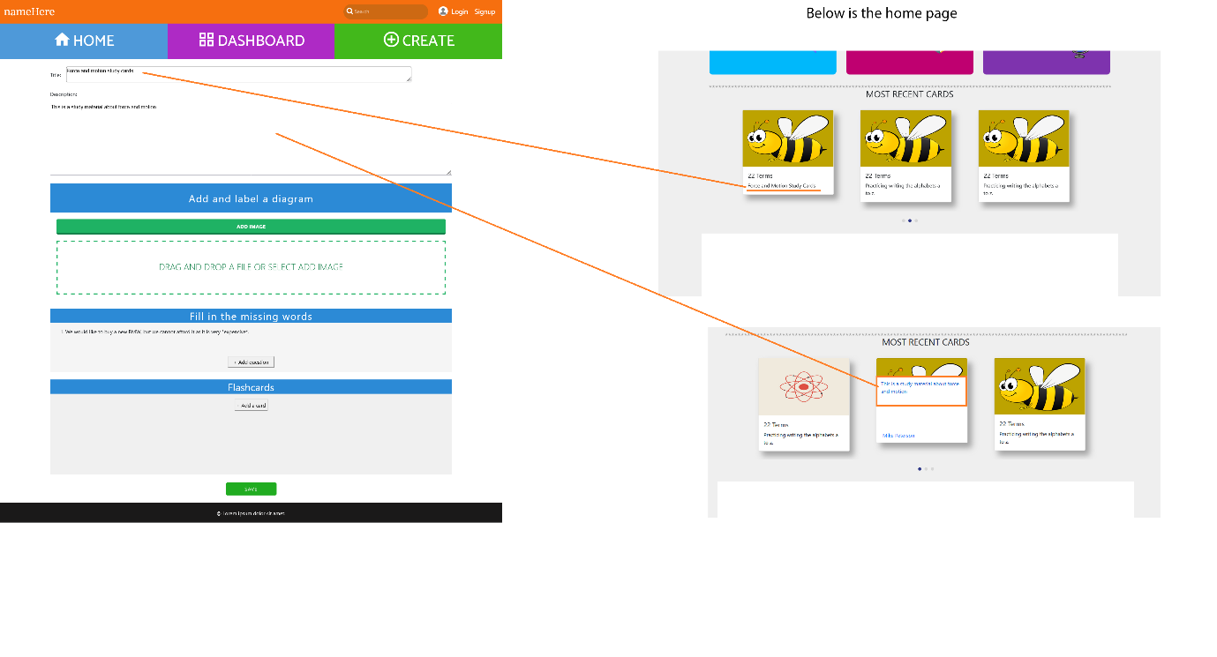

**The page below is for individual study material. Example, go to home page and click on ‘SCIENCE’ category and click on the first study card you will see the page on the right.**

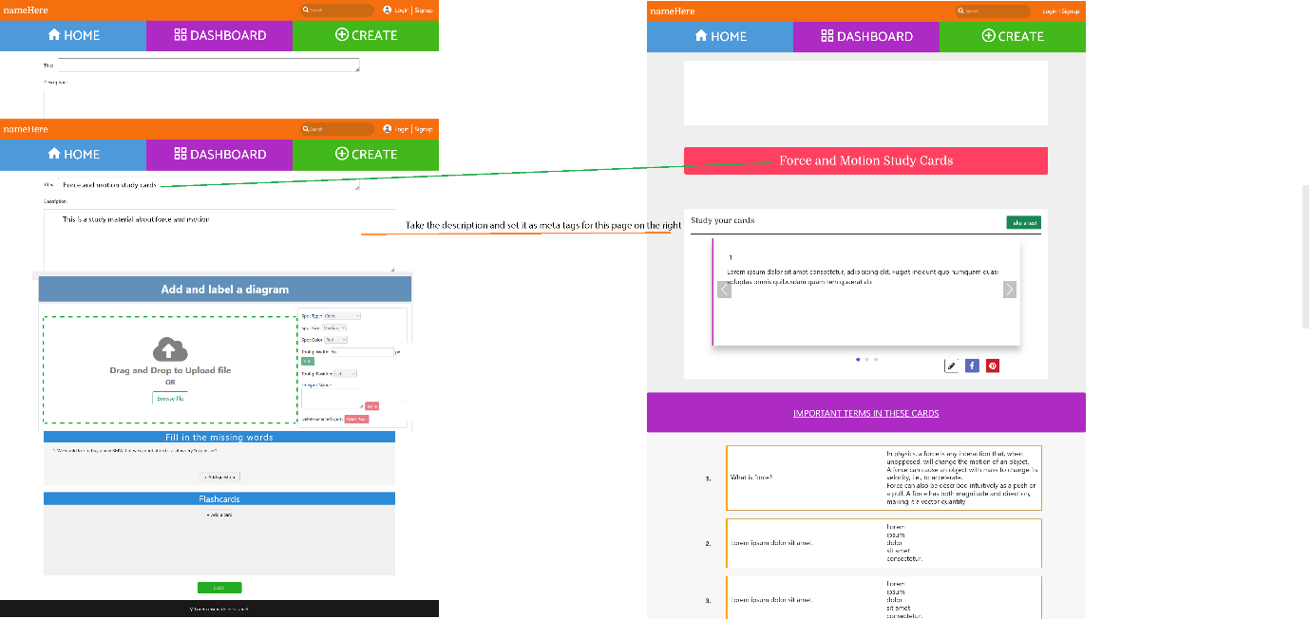

**Important**

The featured image for each individual card are taken from the image uploaded by the user during the creation of the “Add and label a diagram” activity.

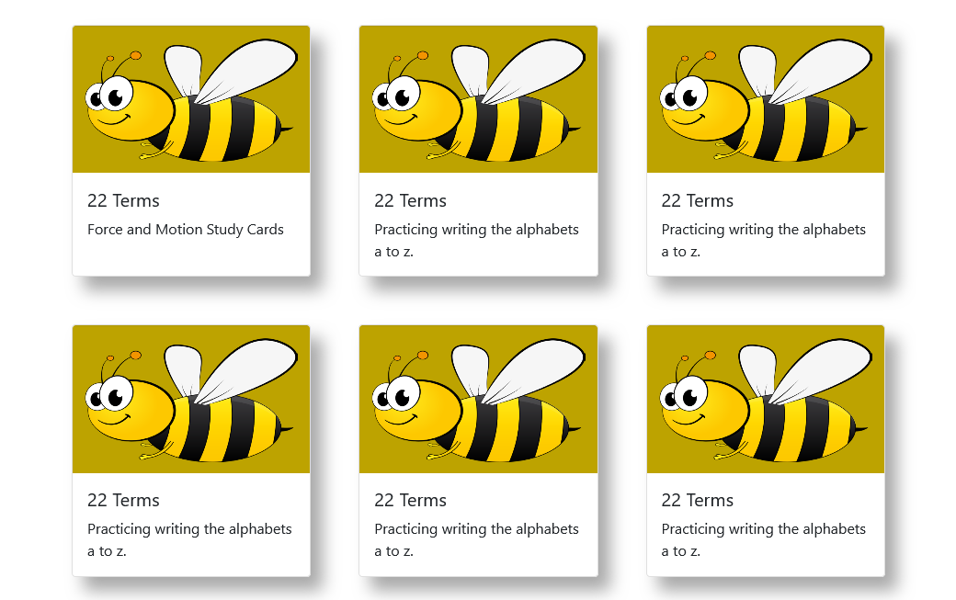

If the user, did not use that activity, a default image will be use. For biology use the default biology image (just a light green background, for physics use the default physics image (just a light blue background) and so on.

**INDIVIDUAL ARTICLE**

++