Progress Motors Imports Limited

225, Tejgaon C/A

Dhaka 1208, Bangladesh

Phone +880 2 9899872

info@pmilbd.com

[www.audi.com.bd](http://www.audi.com.bd)

Audi Dhaka

242 GulshanTejgaon Link Road

Dhaka 1208, Bangladesh

Phone +88 02 8878056

Hotline +88 019 SHOP AUDI

[customer.service@pmilbd.com](mailto:customer.service@pmilbd.com)

Audi Service

429/432 ,Tejgaon Industrial

Area, Dhaka 1208, Bangladesh

Phone +88 02 8891243

Hotline +88 019 CALL AUDI

service@pmilbd.com

**Progress Motors Imports Limited**

Reference: ADQ7VN17AIH

Your message of

Our department

Telephone

Telefax

E-mail

Total pages: 11

Date: 28.01.2017



Dear Sir,

Thank you for your patience.

Please find the attached file for the amended pro forma of the 2017 Audi Q7 2.0 TFSI (252

Bhp) with the revised price.

If you have any further query, please do not hesitate to contact me.

Best Regards,



SheetalTaslim

Sales Executive

Audi Dhaka- PMI Limited

**PRO FORMA OFFER**

**Make: Audi**

**Model:**Q7 2.0TFSI quattro®

**Max Output** (Ps/Rpm): 252 / 5000

**Max Torque**: (Nm/Rpm): 370/1600-4500

**Country of Origin:** European Union

**Year of Manufacture:** 2017

**Model Year:** 2017

**Engine Type:**4-cylinder in-line petrol engine with direct fuel injection, exhaust gas turbocharging

**Transmission:** 8 speed tiptronic

**Seating Capacity:**7 seats configuration

**Exterior Color:**Glacier White, Metallic (2Y2Y)

**Interior Color:**Valcona Leather- Cedar Brown (UU)

**Upholstery:**Valcona Leather- Cedar Brown

**Trim:**Upper inlay, high-gloss black/ lower inlay, Beaufort walnut

**Wheels:** Cast aluminium alloy wheels, 5-V-spoke design, size 8.5 J x 19, with 255/55 R 19 tyres

**Standard Features:**

Moderate hot country

Right-hand drive vehicle

Standard rear axle

Information kit in English

Tropical zones and high-water country

Dynamic suspension

Tyre repair kit

Audi drive select

Reversible load floor

Windshield heat-insulating glass

Heat-insulating glass

Roof spoiler including third brake light

3rd seat row

Head restraints

Front center armrest

Flat tire indicator

Door sill trims with aluminium inlays

Parking aid plus

Cruise control plus

Headlight washers

Driver information system with colour display

Bluetooth interface

Power-assisted closing for the doors

MMI radio plus

Rearview camera

Increased battery capacity

Auto release function

Smoking Package

Ambient lighting

Bumpers in full paint finish

Panoramic glass roof

**Interior Features:**

Electrically adjustable front seats including memory function for the driver's seat

Upper inlay, diamond finish, silver grey/lower inlay, walnut, terra brown

4-way lumbar support for the front seats

Interior mirror with automatic anti-glare action

Dual sun visors

Cricket leather trim

Electric steering wheel adjustment

Leather-covered steering wheel, 4-spoke design with multifunction plus and paddles

Sun blind

Smoking package

Automatic air recirculation

Four-zone deluxe automatic air conditioning

Floor mats at front and rear

Headlining, cloth

Luggage compartment mat

Power assisted Closing for the Doors

Bose sound system with 3D sound

**Exterior Features:**

Contrasting paint finish, dependent on the exterior paint finish, matt black platinum grey

LED headlights

LED rear lights with dynamic indicator

High beam assistant

Separate daytime running lights with low beam assistant and "Coming Home" feature

Automatic headlight-range adjustment dynamic (self-adjusting while driving)

Exterior mirror on the right (large field of view), convex

Exterior mirror housings painted in body colour

Exterior mirrors, electrically adjustable, heated and folding, with memory function

Aluminum look for exterior

Roof rails aluminum

Luggage compartment cover

Luggage compartment lid, electrically opening and closing

Electromechanical power steering

75 -litre fuel tank

Convenience key with sensor-controlled luggage compartment release including Electric storage area cover

**Safety:**

8 airbag system

- 2-stage driver and front seat passenger

- 2 Head airbag system + 2 side airbag

- 2 Rear side airbags

Electronic stabilisation control (ESC)

- Traction control (ASR)

- Electronic Differential Lock (EDL)

- Anti-lock Braking System (ABS)

Tool kit and car jack

Electronic vehicle immobilization device

First aid kit with warning triangle

Reinforced bumpers

ISOFIX child seat mounting all seats and Top Tether anchorage point

**Additional Standard Item for Country Setting, Bangladesh:**

LED Headlights

Cricket Genuine Leather Seats with 7 seats Configuration with Front Electric Seats with Drivers Side Memory

Panoramic Glass Sunroof

BOSE 3D Surround Sound System

19” 5-V Spoke Wheels

4 Zone Deluxe Automatic Air

Convenience Key

Ambient Lighting and Light Package

Tropical Zone and High Water Country

Power Door Closure

Parking aid plus with park display and reverseCamera

**Optional Items Included:**

|  |  |
| --- | --- |
| Adaptive air suspension | BDT 600000 |
| Leather-cov. sports steering wheel, 3-spoke design with multifunction plus and shift paddles | BDT 43000 |
| Dark tinted glass (privacy glass) | BDT 148000 |
| Upper inlay, high-gloss black/ lower inlay, Beaufort walnut | BDT 328000 |
| Valcona leather with Individual contour seats at front with memory function | BDT 1700000 |
| S line exterior package | BDT 580000 |
| **Total** | **BDT 3399000** |
| **Total Optional Items Price after 5% Discount (Rounded up)** | **BDT 3200000** |



**\*Illustrated Models Shown, Actual Vehicle May Differ in Color and Specification Accuracy**



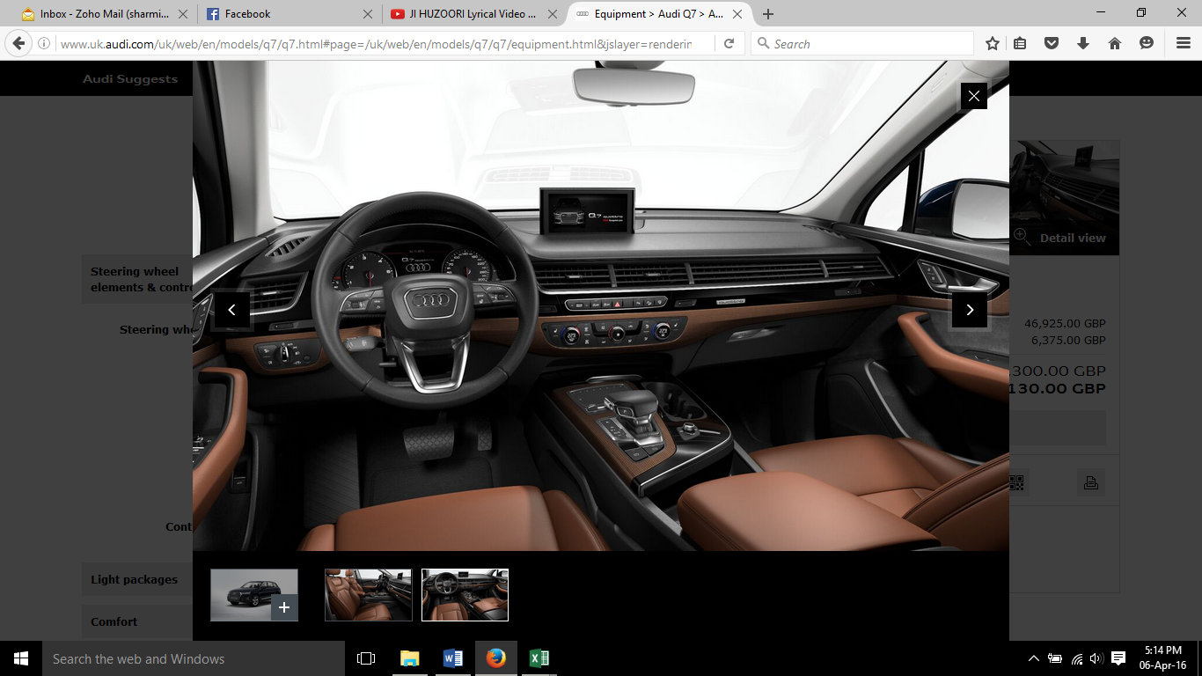

**\*Illustrated Models Shown, Actual Vehicle May Differ in Color and Specification Accuracy**

**PRICE AND SALES TERMS**

**Unit Price (Ex-Showroom): 1, 82, 00 000.00 (One Crore Eighty Two Lacs Only) BDT**

**(This quoted price is exclusive of Registration, Insurance, VAT and Source Tax / AIT etc. of**

**the vehicle)**

**VAT: 1, 25, 000.00 (One Lac Twenty Five Thousand Only) BDT**

**Registration Cost: 85,000.00 (Eighty-Five Thousand Only) BDT**

**Total OTR: 1, 84, 10000.00 (One Crore Eighty Four Lacs Ten Thousand Only) BDT**

**Warranty:** 2 (Two) Years without any Mileage limitation

**Delivery :** May 2017

**Payment:**2500000 (Twenty Five Lacs Only) BDT is to be paid as advance with confirmed work-order and the balance is to be paid before delivery

**Validity of Offer:** 10 (Ten) days from the date of offer (subject to availability - for ready stock)

**After Sales Service:** After sales service will be provided to our valued customers from our completely equipped workshop at 429/432 Tejgaon Industrial Area, Dhaka headed by trained Technician

**Acceptance:**

All sales are subject to and expressly conditioned upon the terms and conditions contained herein, and upon buyer's assent thereto. No variation of these terms and conditions will be binding upon seller unless agreed to in writing and signed by an authorized representative of seller. The seller has the right to change these terms of conditions of sales without prior notice.

**Offer Validity:**

The enclosed offer is valid for 7(seven) banking days from the date of issuance

**Order Specifications:**

The selected options/specifications in the order are binding and cannot be changed as the production process at the factory is initiated as soon as the order is placed within the Audi ordering-system.

**Vehicle Inspection:**

The vehicle inspection carried out by Audi AG at their respective plants shall be final for all purposes. Audi AG reserves the right to change names of options/accessories without prior notice; however, with no financial loss to the customer.

**Cancelling or Changing the Order:**

After the Purchaser has signed the Proforma Offer, the specifications are fixed and may not be changed. If the Purchaser wrongfully cancels the contract or shall fail to take and pay for the goods within 14 days of notification that the goods have been completed for delivery, the Seller shall be at liberty to treat the contract as repudiated by the Purchaser and there upon has the right to retain sufficient funds to cover losses incurred, inclusive of loss of profit, before returning any balance of deposit paid, or in the case that insufficient deposit has been made to cover these costs, the seller shall be entitled to claim for these from the purchaser. If the Seller shall fail to deliver the goods within 90 days of the estimated date of delivery stated in this contract the Purchaser may by notice in writing to the Seller require delivery of the goods within 21 days of receipt of such notice. If the goods shall not be delivered to the Purchaser within the said 21 days, the contract may be cancelled. If the contract be cancelled after the notice has been issued to the Seller, the deposit shall be returned to the Purchaser and the Seller shall be under no further liability.

**Vehicle Specifications:**

If any of the optional equipment/accessory is not in conformity with the vehicle order form, the Purchaser’s sole remedy shall be limited to Seller. Making good any shortage by replacing such equipment/accessory or, if Seller shall choose, by refunding a proportionate part of the price.

**Mode of Payment:**

Advance payment upon receipt of signed Proforma offer and order confirmation. For the price to be valid, payment amount needs to be made on/before the date as mentioned in your Proforma Offer. A cheque will not be treated as payment until it has been cleared. The goods shall remain the property of the Seller until the price has been discharged in full. Any exchange of funds given by the Purchaser in payment shall not be treated as a discharge until the same has been cleared.

**Delivery:**

The Seller will endeavor to secure delivery of the goods by the estimated delivery date (if any) but does not guarantee the time of delivery and shall not be liable for any damages or claims of any kind in respect of delay in delivery (The Seller shall not be obliged to fulfil orders in the sequence in which they are placed). Delivery of the vehicle is estimated (non-binding) between 16-18 weeks after receipt signed Proforma Invoice and clearance of down payment. We will endeavor to adhere to stipulated delivery deadline. In the event of a delay, we will contact you to agree an alternative estimates delivery period. However, delivery deadlines will not be binding unless expressly agreed otherwise. If non-compliance with the delivery date is due to force majeure or to other disturbances beyond our control e.g. war, port’s strikes, workers strike, rail/trucks strikes, vessel/ship delays import or export restrictions, including such disturbances affecting subcontractors, the delivery dates agreed upon shall be extended by the period of time of the disturbance. We will not be liable for any claim for compensation of any description arising out of a delay in delivery. We reserve the right to make deliveries before or after the respective deliver periods.

**Price Fluctuation Clause:**

All prices have been calculated on the basis of the prevalent Government duties, fiscal policies, tariff structures, import policy, freight charges and average Bangladeshi Taka conversion rate with Euro. The Customer hereby agrees to pay the additional charges, if any (more than 5% of current rate), due to the change in the above stated duties and policies or due to Taka devaluation on the date of assessment of duty (by the Customs authorities), when making the final / balance payment. Only in cases of reduction in government duties the customer will be entitled to pay the reduced amount as per the calculations by the Seller. The above does not apply if the vehicle is exempted from duty & taxes (full advance payment in USD/EUR), however the responsibility of customs exemption of the same lies with the customer.

**Customs Clearance:**

The Seller will arrange customs clearance of vehicle if payment is done locally in Bangladeshi Taka, and in case of direct remittance to Audi AG (only valid for Audi Security vehicles) it is optional that clearance assistance from the Seller may be obtained at actual custom clearance cost. For diplomatic sales, or duty free imports the Seller will only assist in vehicle clearance, however any charges occurred during the process of clearing will be borne by the customer.

**Insurance:**

Insurance of the vehicle until our respective dealerships in Bangladesh is seller’s responsibility.

**Force Majeure:**

Neither party shall be liable in damages or have the right to terminate this Agreement for any delay or default in performing hereunder if such delay or default is caused by conditions beyond its control including, but not limited to Acts of God, Government restrictions (including the denial or cancellation of any export or other necessary license), wars, insurrections and/or any other cause beyond the reasonable control of the party whose performance is affected.

**Fuel Quality:**

With the signature below the purchaser agrees to fuel his/her vehicle only with HOBC fuel only. Failure to do so, can possibility void the manufacturer warranty if proven during a possible fault or during a fuel sample analysis.

**Warranty:**

Standard terms of warranty of Audi AG are applicable. 2 (two) years with unlimited mileage

**Special Instruction:**

It is very important for the purchaser to read thoroughly the owner’s manual to better understand their vehicle.

Date: ______________________ Customer Signature: _______________________________