**1. What is client-side and server-side in web development, and what is the main difference between the two?**

Client-side refers to the part of a web application that runs on the user's computer. It is responsible for displaying the web application to the user and handling user input. Client-side development typically uses HTML, CSS, and JavaScript.

Server-side refers to the portion of a web application or software that runs on the server. It encompasses the code, logic, and processes that handle the backend operations and functionality of a web application.

**Client-side vs. server-side development:**

1. **Where code runs:**

One major difference between client-side and server-side development is where code runs. In client-side development, the code runs on the client's or user's device. In server-side development, the code runs through a server.

1. **Scripting**

The way scripts run is another difference between client-side and server-side development. In client-side scripting, scripts simply run on a device. Often, client-side scripts run in a browser. In contrast, server-side scripts run on a web server.

1. **Purpose**

The primary goal of client-side development is to create visual effects and elements for websites, including layouts and user interfaces. Server-side development focuses on the actual content of a webpage, involving tasks like interacting with databases and retrieving information from a web server.

1. **Security**

Client-side and server-side programs also have different levels of security. Client-side programs tend to be less secure, as users are often able to see and interact with them. Server-side programs often have higher levels of security than client-side programs because users can't see or interact with server-side source code.

**2. What is an HTTP request and what are the different types of HTTP requests?**

An HTTP request is a message that is sent from a client to a server. It is used to request a resource, such as a web page, from the server. HTTP requests are made up of a request line, headers, and a message body.

**Different types of HTTP requests:**

GET, POST, PUT, PATCH, and DELETE.

**3. What is JSON and what is it commonly used for in web development?**

JavaScript Object Notation (JSON) is a standard text-based format for representing structured data based on JavaScript object syntax.JSON is a lightweight data-interchange format that is completely language-independent.

**Uses of JSON:**

1. It is used while writing JavaScript based applications that includes browser extensions and websites.
2. It is primarily used to transmit data between a server and web applications.
3. Web services and APIs use JSON format to provide public data.

**4. What is middleware in web development, and give an example of how it can be used.**

Middleware in web development is software that sits between the client and the server. It is used to handle tasks such as authentication, authorization, and routing. Middleware can be used to improve the security, performance, and scalability of web applications.

**some of the benefits of using middleware in web development:**

1. Improved security
2. Improved performance
3. Increased scalability

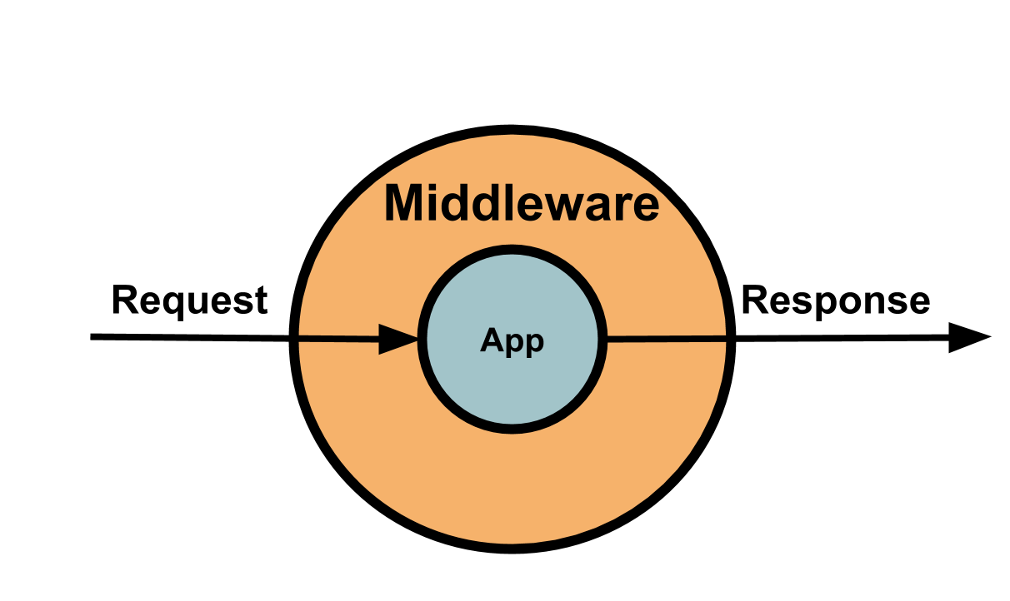

Example: Authentication Middleware

// Middleware functions

const logger = (req, res, next) => {

console.log(`[${new Date().toISOString()}] ${req.method});

next();

};

// Global middleware

app.use(logger);

**5. What is a controller in web development, and what is its role in the MVC architecture?**

In web development, a controller is a part of the Model-View-Controller (MVC) design pattern. The controller is responsible for receiving user input, interacting with the model, and selecting the view for response. The controller is typically implemented as a class that contains methods for handling different types of user input. For example, the controller might have a method for handling a login request, a method for handling a form submission, and a method for handling a click on a link.

When a user interacts with a web application, the controller is responsible for receiving the user input and then taking the appropriate action. For example, if a user submits a form, the controller will interact with the model to retrieve the data from the form and then select the view that will be used to display the data.

The Model-View-Controller (MVC) is an architectural pattern that separates an application into three main logical components: the model, the view, and the controller.

The MVC architecture is a popular choice for web development because it provides a number of benefits. These benefits include:

* Separation of concerns: The MVC architecture separates the different aspects of a web application into three distinct layers: the model, the view, and the controller. This separation of concerns makes the application easier to understand, maintain, and test.
* Reusability: The MVC architecture makes it easy to reuse code. The model, view, and controller can all be reused in different applications. This can save time and development costs.
* Scalability: The MVC architecture is scalable. As an application grows, the MVC architecture can be easily extended to accommodate the increased complexity.

The controller is an important part of the MVC architecture. It is responsible for receiving user input, interacting with the model, and selecting the view to display. The controller is the glue that holds the MVC architecture together.

**ESSAY:**

**Write an essay on the importance of web development in today's digital world, and the impact it has on society and businesses. Discuss how web development has evolved over time, and what the future holds for web developers.**

Web development has become an indispensable part of our increasingly digital world. From personal communication and information access to e-commerce and online services, the web has transformed the way we live, work, and interact. This essay will explore the significance of web development, its impact on society and businesses, the evolution of web development over time, and the promising future it holds for web developers.

**Importance of Web Development:**

1. Accessibility and Information Exchange:

Web development has revolutionized the accessibility and exchange of information. The web serves as a vast repository of knowledge, enabling people worldwide to access information on any subject at any time. It has empowered individuals, bridged the knowledge gap, and facilitated learning and self-improvement.

2. Communication and Collaboration:

Web development has transformed communication, allowing people to connect and collaborate across geographical boundaries. Social media platforms, messaging apps, and video conferencing tools have enabled real-time communication, fostering global connectivity and creating a sense of a global village.

3. Business Growth and Opportunities:

Web development has opened up new avenues for businesses to reach customers, expand their markets, and enhance customer experiences. E-commerce platforms have facilitated online shopping, making it convenient and accessible. Businesses can establish their online presence, market their products and services, and engage with customers on various digital platforms.

4. Automation and Efficiency:

Web development has automated and streamlined various processes, increasing efficiency and productivity. Web-based applications and software have replaced manual tasks, reducing human error, and improving operational efficiency in businesses, healthcare, finance, and other sectors.

5. Innovation and Creativity:

Web development has fostered innovation and creativity, providing a platform for developers, designers, and entrepreneurs to create and showcase their ideas. From interactive websites to web applications and immersive experiences, the web has become a playground for innovation and pushing the boundaries of technology.

Evolution of Web Development:

Web development has evolved significantly since its inception. The transition from static HTML-based websites to dynamic and interactive web applications has been driven by advancements in technologies and standards such as:

1. Client-Side Technologies:

The rise of JavaScript frameworks and libraries like Angular, React, and Vue.js has empowered developers to build responsive and interactive user interfaces. These technologies enable the creation of dynamic web applications that deliver a richer user experience.

2. Server-Side Technologies:

Server-side technologies such as PHP, Python, Ruby on Rails, and Node.js have evolved to provide efficient and scalable server-side processing. These technologies enable developers to handle complex business logic, interact with databases, and deliver data to the client-side.

3. Mobile Optimization:

With the increasing use of mobile devices, web development has focused on responsive design and mobile optimization. Developers strive to create websites and applications that adapt seamlessly to different screen sizes and devices, providing a consistent user experience.

4. APIs and Data Integration:

Web development has embraced the use of APIs (Application Programming Interfaces) to integrate data and functionality from various sources. APIs enable developers to connect different systems, services, and platforms, creating interconnected and data-driven applications.

Future of Web Development:

The future of web development holds immense potential for further innovation and advancement. Here are some key trends and areas of focus for web developers:

1. Progressive Web Applications (PWAs):

PWAs combine the best features of web and mobile applications, providing fast, reliable, and engaging experiences. Web developers will continue to leverage PWAs to deliver app-like experiences, offline capabilities, and seamless integration with native device features.

2. Artificial Intelligence (AI) and Machine Learning (ML):

AI and ML will play a significant role in web development, enabling developers to create intelligent and personalized web experiences. AI-powered chatbots, recommendation engines, and data analysis tools will enhance user interactions and deliver tailored content.

3. Internet of Things (IoT) Integration:

As the IoT ecosystem grows, web developers will need to adapt and develop applications that integrate with IoT devices. Web interfaces will connect with smart devices, sensors, and wearables, creating a seamless user experience across different platforms.

4. Accessibility and Inclusivity:

Web development will focus on ensuring accessibility and inclusivity for all users, regardless of their abilities. Developers will strive to create web experiences that are accessible to individuals with disabilities, providing equal opportunities and enhancing user satisfaction.

**Conclusion:**

Web development has become a transformative force in today's digital world. It has revolutionized communication, access to information, and business operations. As technology advances, web developers will continue to play a crucial role in shaping the digital landscape. The future holds exciting possibilities for web development, with emerging technologies like PWAs, AI, ML, and IoT opening up new frontiers for innovation. Web developers will continue to drive progress, delivering engaging, secure, and accessible experiences that empower individuals and businesses in the digital era.