MD. NAZMUL HASAN SHARIF  Phone: +88 01521408673  Phone: +88 01825690358  Email: nazmulict94@gmail.com | 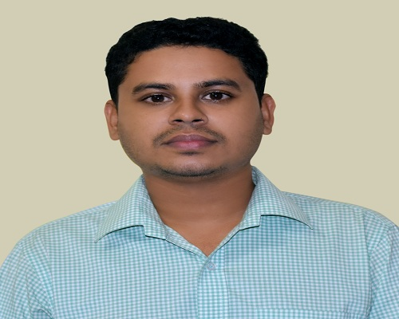

OBJECTIVE
To develop a career in an organization where opportunity to work with talented web application developer, utilize my creativity, innovation, sincerity, hard work and commitment are the cornerstone of my career goal.

EDUCATION
- B.Sc (Engineering) Information and Communication Technology
Comilla University, Comilla
Result: Appeared

- Higher Secondary Certificate, HSC
Birshestha Noor Mohammad Public College, Dhaka
Group: Science Year: 2012
GPA: 5.00 in the scale of 5.00

- Secondary School Certificate, SSC
Chandina Pilot High School, Chandina.
Group: Science Year: 2010
GPA: 5.00 in the scale of 5.00

.
WEB DESIGN AND DEVELOPMENT PROJECTS
- Front end development projects:
    - My Portfilo project: A portfolio project based on html5, CSS3, Javascript, Bootstrap
      - Githublink: https://github.com/nazmulsharif/TechNazmul
    - Vcard project: VCard project based on html5, css3, Javascript, Bootstrap
      - Link: https://nazmulsharif.netlify.com/
      - Git link: https://github.com/nazmulsharif/myvcard
    - Calculator project: simple calculator project made by html, cs, Javascript and Jquery
      - Gitlink:https://github.com/nazmulsharif/simplecalculator
    - CSS template design:
      - Git link:https://github.com/nazmulsharif/Real-state-project
      - Git link:https://github.com/nazmulsharif/Glozzom_template

- Back end development projects:
    - ECommerce Site developement project:
      - Github link:https://github.com/nazmulsharif/Ecommerce
    - Login SignUp project: User can sign up by using name and password and also can login by correct username and password.
      - Gitlink: https://github.com/nazmulsharif/sams
    - Attendance Management System:
      - Githublink:https://github.com/nazmulsharif/attendmngmt

PROBLEM SOLVING SKILLS
- Solved More than 250+ problem in different sites like codeforces (nazmulict), UVA(nazmulict) and URI(nazmul sharif) using C/C++.

- Participate Comilla University Regional Programming Contest in 2017 and placed 15th position.

SKILLS
- Programming Skills : C, C++, Java.
- Web Technologies : HTML,CSS, Javascript, JQuery, Bootstrap, React JS,php
- Database : MySql.

CO-CURRICULAR ACTIVITIES
- Volunteered in “CoU CSE Fiesta 2015”. Always try to be connected with volunteering works.
- Participates intra department Cricket Tournament in 2015.

TRAINING DETAILS
- Training On Web Application Program Development from Sheikh Kamal IT Training and Incubation Center,Comilla.
PERSONAL INFORMATION
Name: Md Nazmul Hasan Sharif
Date of birth: 20-12-1994
Father’s Name: Nazrul Islam
Mother’s Name: Mst. Jharna Akter
Nationality: Bangladeshi
Religion: Muslim
Marital Status: Unmarried
Present Address: Notun Chowdhury Para, Comilla
Permanent Address: Sultanpur, Debidwar, Comilla.

