**Chapter 04**

# Incorporating the Voice of Customer in Product Design with Quality Function Deployment (QFD)

**4.1 Introduction**

Quality can be defined as meeting customer needs and providing superior value. This focus on satisfying the customer's needs places an emphasis on techniques such as Quality Function Deployment to help understand those needs and plan a product to provide superior value. Quality Function Deployment (QFD) is a structured approach to defining customer needs or requirements and translating them into specific plans to produce products to meet those needs. The main advantage of this method is to acquire all the information needed to design a quality product: "Voice of the customers” (VOC) Technical requirements based on customer need Importance of each requirement the “Voice of the Customer” (VOC) is the term to describe stated and unstated customer needs or requirements. The voice of the customer is captured in a variety of ways:

1. Direct discussion or interviews,
2. Surveys,
3. Customer provided specifications,
4. Direct observation,
5. Warranty data analysis,
6. Field reports, etc.

This understanding of the customer needs is then summarized in a product planning matrix or “House of Quality”. We have already done our survey by using a questionnaire to collect customer requirements or what people want to have. Now, the next step is to develop the QFD method to relate all these customers' needs to technical specifications and evaluate the importance of each requirement to maintain a correct focus on true requirements

Tools for QFD

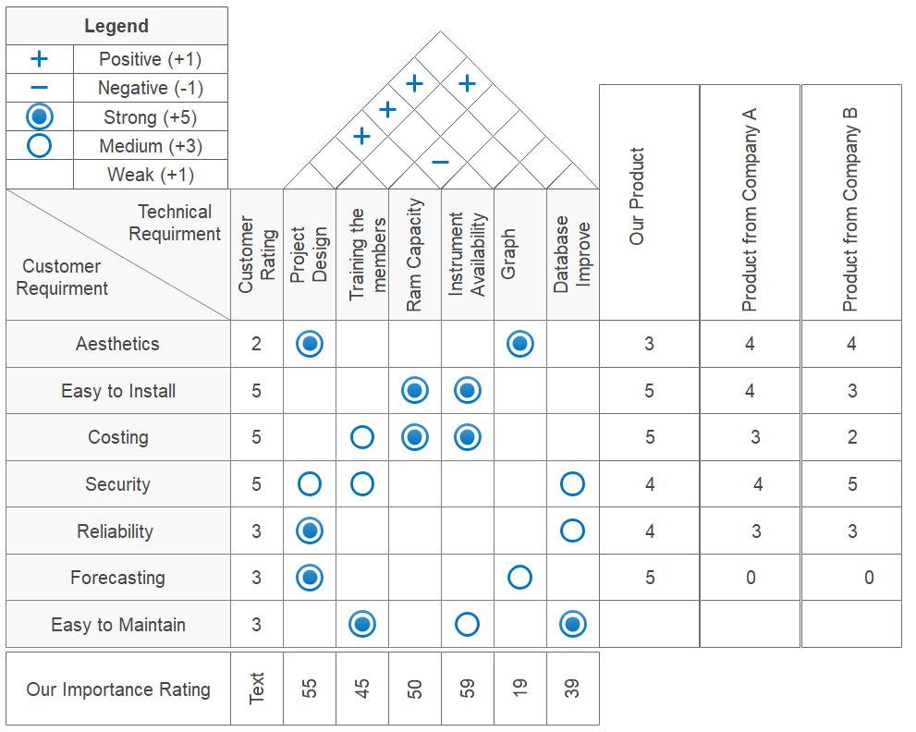

Figure: House of Quality for DSS

The relationship between different Customer and Technical Requirements

1. The relationship between Aesthetic and Project design is high because Project design determine our Aesthetic.
2. he relationship between Aesthetic and Graph is high because Project design determine our Graph.
3. The relationship between Easy to install and Ram Capacity is high because in our Raspberry Pi ram install in not easy.
4. The relationship between Easy to install and Instrument Availability is high because if the Instrument is not avail so mush, we cannot install that properly.
5. The relationship between Costing and Training the Member is medium because it cost extra training process for learning.
6. The relationship between Costing and Ram Capacity is strong because Ram is a costly part.
7. The relationship between Costing and Instrument Availability is high because if the instrument is not available the cost will be so much higher.
8. The relationship between Security and Training the Member is medium because member need to secure the data.
9. The relationship between Security and Project Design is medium according to the Project Design the Security will be determined.
10. The relationship between Security and Database Improvement is medium because we must secure the data in the Database Improvement process.
11. The relationship between Reliability and Database Improvement is medium because we must ensure that the process run properly.
12. The relationship between Reliability and Project Design is medium because we must ensure that the process run properly.
13. The relationship between Forecasting and Project Design is high because Project design determine our Forecasting.
14. The relationship between Forecasting and Graph is medium because it ensures interpretability.
15. The relationship between Easy to Maintain and Project Design is high because Project design determine our Acquaintance system.
16. The relationship between Easy to Maintain and Instrument Availability is medium because Instrument Availability will determine the maintenance cost.
17. The relationship between Easy to Maintain and Training the Member is high because Training the Member will be easy if the maintenance will simple.
18. The relationship between Easy to Maintain and Database Improvement is high because Database Improvement system has the relationship with maintenance.

The relationship between different Technical Requirements

1. The relationship among Easy Product Design with Ram Capacity, Instrument Availability, Graph is positive because Project design determine all of them and their system running process.
2. The relationship between Ram Capacity and Instrument Availability is negative because in Raspberry pi the ram is not easily accessible.
3. The relationship between Training the Member and Database Improvement is positive because the training the upgrade is the working process of the product.

Conclusion

Using Quality Function Deployment (QFD) method we figured out the technical aspect of each customer's requirement. After finishing this method, we become aware of essential requirements, internal capabilities, and constraints. It also enables us to design the product so that everything is in place to achieve the desired outcome –” a satisfied customer”. It not only brings our product closer to the intended target but reduces development cycle time and cost in the process.