Northern University of Business and Technology, Khulna
Department of Computer Science and Engineering

System Design & Software Architecture
Academic Performance Monitoring and AI-Based Recommendation System

Course | CSE 4204 — Mobile Computing Lab
Section | 8A
Team | T07
Submission | Week 04 — System Design Assignment

Team Members

Name | Student ID | Role
Md. NAzmus Shakib | 11220320852 | Team Leader (Database)
Samira Akter Mitu | 11220320858 | AI Integration
Md.Tanvin Sadik Dhrubo | 11220320860 | Frontend
Khan Waziur Rahman | 11220320861 | Backend

Submitted to
Md. Riaz Mahmud
Assistant professor
Department of Computer Science and Engineering
Northern University of Business and Technology, Khulna

Table of Contents

- System Architecture Diagram
- ER Diagram (Database Design)
- Updated Use Case Diagram
- Activity Diagram
- API Design Document
- AI Integration Workflow
- References

1

System Architecture Diagram
React.js · Laravel · MySQL · Gemini API · Analytics Engine

System Architecture Diagram
React.js Frontend • Laravel Backend • MySQL • Gemini API • Analytics Engine

CLIENT / USER INTERACTION LAYER APPLICATION & PROCESSING LAYER DATA & AI SERVICE LAYER

USERS
Student • Faculty • Admin

Use the system, submit input, and view results.

BACKEND
Laravel REST API

- Authentication & validation
  - Business logic
  - API orchestration
  - Connects DB + AI + analytics
    - Sends final response

Read / Write Data

MYSQL DATABASE

Stores persistent system data:
      - Users & roles
      - Academic records
      - Attendance / marks
      - Recommendations
      - Risk alerts & logs

Input / UI Output REST API Request / JSON Response

Analytics Request / Result

FRONTEND
React.js UI

      - Login / Registration
      - Dashboard screens
        - Forms & charts
    - Shows AI suggestions
  - Displays analytics output

ANALYTICS ENGINE

  - Combines stored data + AI output
    - Performance analysis
      - Risk detection
- Recommendation generation
- Report/chart data preparation
AI Prompt / AI Response

Historical / Transactional Data

AI Insight / Generated Output

GEMINI API
External AI Service

- AI guidance
- Natural-language response
- Study / course suggestions
- Text-based analysis support

Security point
Backend should control validation, authorization, and API keys. Frontend should not call Gemini API directly.
Important
Gemini API key stays on Laravel backend / server side only.

2

ER Diagram (Database Design)
Entity-Relationship Diagram showing all tables, keys, and relationships
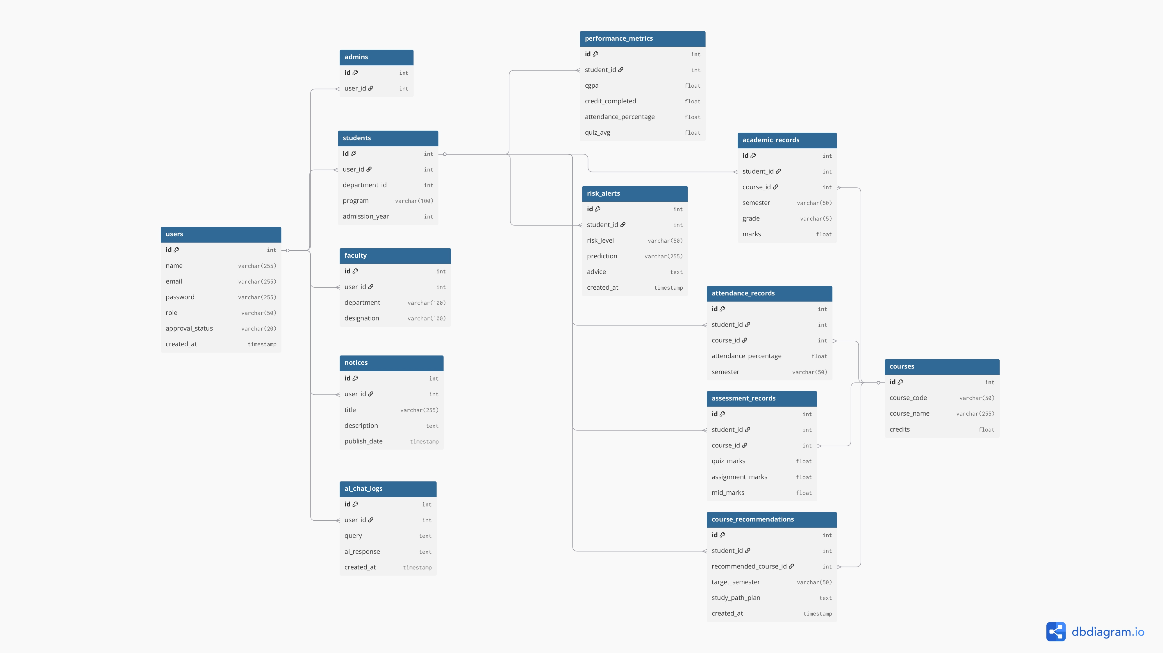
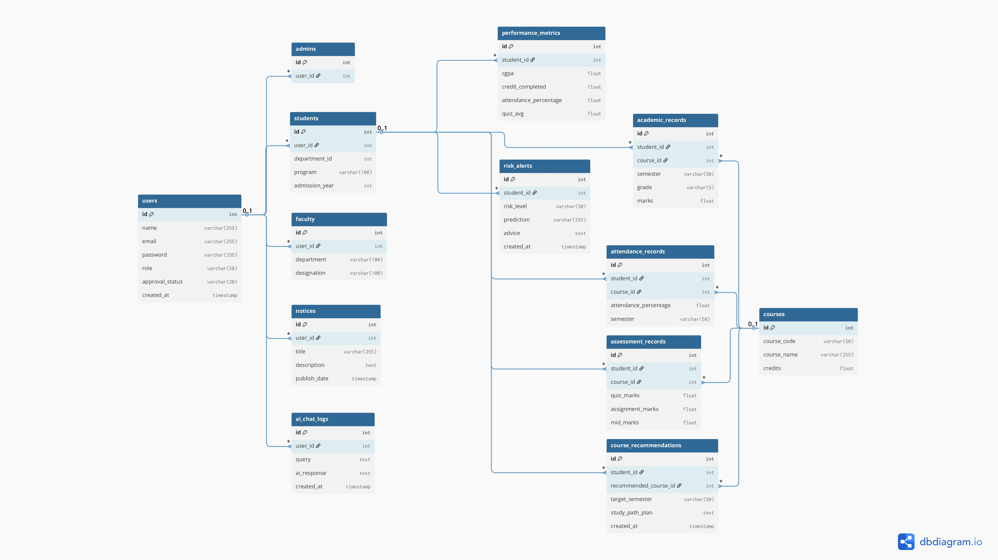

3.Updated Use Case Diagram

The Use Case Diagram illustrates the interactions between system actors (Student, Faculty, Admin) and major system functionalities including AI-related interactions.
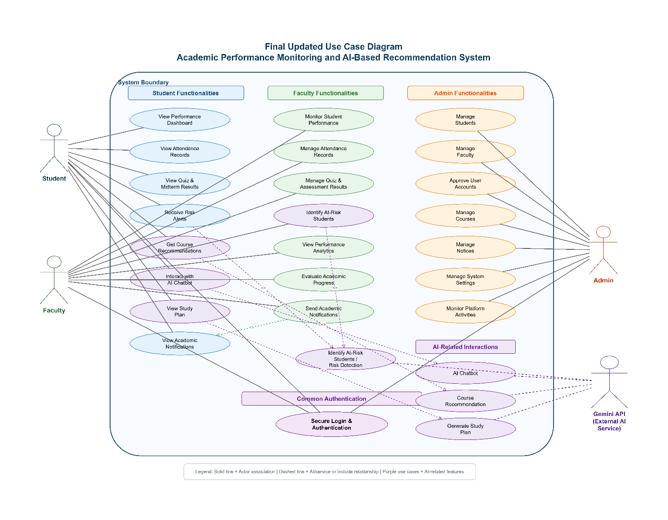

Actors included: Admin • Student / Faculty • Moderator
Major functionalities and AI-related interactions are shown in the diagram above.

4

Activity Diagram
Registration & Approval — Role-Based Flow After Account Activation

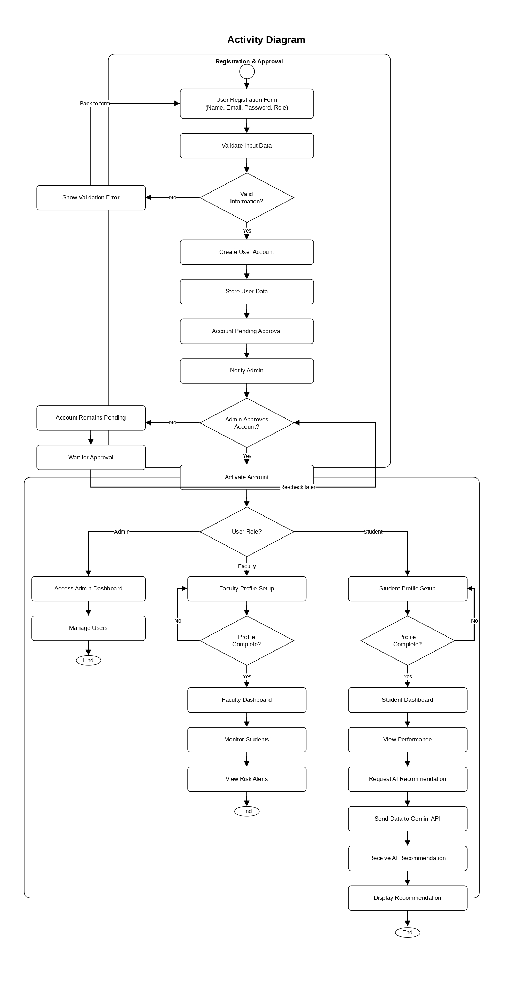

5

API Design Document
Planned API endpoints for Authentication, Student, Faculty, Admin, AI, and Notifications

- API Design Document
Academic Performance Monitoring and AI-Based Recommendation System
This section presents the planned API endpoints for the proposed system. The APIs are organized by user role and system functionality, including authentication, student activities, faculty operations, admin management, Gemini AI integration, and notification services. Each endpoint includes its purpose, required input data, and expected output.

Base URL

API Endpoint Summary

SL | API Name | Method | Endpoint | Category
1 | User Registration | POST | /auth/register | Authentication APIs
2 | User Login | POST | /auth/login | Authentication APIs
3 | User Logout | POST | /auth/logout | Authentication APIs
4 | Get User Profile | GET | /profile | Authentication APIs
5 | View Dashboard | GET | /student/dashboard | Student APIs
6 | View Attendance | GET | /student/attendance | Student APIs
7 | View Academic Results | GET | /student/results | Student APIs
8 | View Risk Alerts | GET | /student/alerts | Student APIs
9 | Monitor Student Performance | GET | /faculty/students/pe rformance | Faculty APIs
10 | Manage Attendance | POST | /faculty/attendance | Faculty APIs
11 | Manage Assessment Results | POST | /faculty/results | Faculty APIs
12 | View At-Risk Students | GET | /faculty/risk-students | Faculty APIs
13 | Manage Students | GET | /admin/students | Admin APIs
14 | Manage Faculty | GET | /admin/faculty | Admin APIs
15 | Approve User Accounts | PUT | /admin/users/appro ve/{id} | Admin APIs
16 | Manage Courses | POST | /admin/courses | Admin APIs
17 | Manage Notices | POST | /admin/notices | Admin APIs
18 | AI Chatbot | POST | /ai/chat | AI APIs - Gemini Integration
19 | Course Recommendation | POST | /ai/recommendation | AI APIs - Gemini Integration
20 | Study Plan Generation | POST | /ai/study-plan | AI APIs - Gemini Integration
21 | Risk Prediction | POST | /ai/risk-prediction | AI APIs - Gemini Integration
22 | Get Notifications | GET | /notifications | Notification APIs
23 | Mark Notification as Read | PUT | /notifications/{id} | Notification APIs

Detailed API Specifications
The following endpoint cards describe each API in a readable format so that the content stays within the page boundary and remains easy to review.

Authentication APIs

1. User Registration | POST /auth/register
Purpose | Register a new Student or Faculty account in the system.
Input Data | Request body:  {  "name": "John Doe",  "email": "john@example.com", "password": "password123", "role": "student"  }
Expected Output | {  "message": "Registration successful. Account pending approval."  }
Access Level | Authentication APIs

2. User Login | POST /auth/login
Purpose | Authenticate Student, Faculty, and Admin users using JWT authentication.
Input Data | Request body:  { "email": "user@example.com", "password": "password123" }
Expected Output | JWT token and user role.  Example: { "token": "jwt_token", "role": "student" }
Access Level | Authentication APIs

3. User Logout | POST /auth/logout
Purpose | Logout an authenticated user from the system.
Input Data | JWT token in authorization header.
Expected Output | Success message.  Example: { "message": "Logged out successfully" }
Access Level | Authentication APIs

4. Get User Profile | GET /profile
Purpose | Retrieve profile information of the authenticated user.
Input Data | JWT token in authorization header.
Expected Output | User profile information.  Example: { "id": 1, "name": "Student Name", "role": "Student" }
Access Level | Authentication APIs

Student APIs

5. View Dashboard | GET /student/dashboard
Purpose | Retrieve the academic performance dashboard of a student.
Input Data | Student ID or authenticated student token.
Expected Output | Attendance percentage, quiz average, and midterm average.  Example: { "attendance": "85%", "quiz_average": "78%", "midterm_average": "82%" }
Access Level | Student APIs

6. View Attendance | GET /student/attendance
Purpose | Retrieve attendance records of a student.
Input Data | Student ID or authenticated student token.
Expected Output | Attendance list with dates and attendance status.
Access Level | Student APIs

7. View Academic Results | | GET /student/results
Purpose | Retrieve quiz, assignment, and midterm examination results.
Input Data | Student ID or authenticated student token.
Expected Output | Result records including quiz marks, assignment marks, and midterm marks.
Access Level | Student APIs

8. View Risk Alerts | GET /student/alerts
Purpose | Retrieve academic risk alerts generated for the student.
Input Data | Student ID or authenticated student token.
Expected Output | Risk alert information.  Example: { "risk_level": "High", "message": "Attendance below threshold" }
Access Level | Student APIs

Faculty APIs

9. Monitor Student Performance | GET /faculty/students/performance
Purpose | Allow faculty members to view student performance statistics.
Input Data | Faculty ID or authenticated faculty token.
Expected Output | List of students with academic performance data.
Access Level | Faculty APIs

10. Manage Attendance | | POST /faculty/attendance
Purpose | Add or update student attendance records.
Input Data | Request body:  { "student_id": 101, "attendance": "Present" }
Expected Output | Success message.  Example: { "message": "Attendance updated" }
Access Level | Faculty APIs

11. Manage Assessment Results | POST /faculty/results
Purpose | Upload quiz, assignment, and exam scores of students.
Input Data | Student ID, course ID, assessment type, and marks.
Expected Output | Success message confirming result submission.
Access Level | Faculty APIs

12. View At-Risk Students | GET /faculty/risk-students
Purpose | Identify students with poor academic performance or low attendance.
Input Data | Faculty ID or authenticated faculty token.
Expected Output | List of at-risk students with risk reasons.
Access Level | Faculty APIs

Admin APIs

13. Manage Students | | GET /admin/students
Purpose | View all student accounts in the system.
Input Data | Admin JWT token.
Expected Output | List of student accounts.
Access Level | Admin APIs

14. Manage Faculty | GET /admin/faculty
Purpose | View all faculty accounts in the system.
Input Data | Admin JWT token.
Expected Output | List of faculty accounts.
Access Level | Admin APIs

15. Approve User Accounts | PUT /admin/users/approve/{id}
Purpose | Approve newly registered user accounts.
Input Data | User ID and admin JWT token.
Expected Output | Success message.  Example: { "message": "User approved successfully" }
Access Level | Admin APIs

16. Manage Courses | POST /admin/courses
Purpose | Create and manage course information.
Input Data | Course name, course code, department, and credit.
Expected Output | Success message confirming course creation or update.
Access Level | Admin APIs

17. Manage Notices | POST /admin/notices
Purpose | Publish university notices for users.
Input Data | Notice title, description, date, and target users.
Expected Output | Success message confirming notice publication.
Access Level | Admin APIs

AI APIs - Gemini Integration

18. AI Chatbot | POST /ai/chat
Purpose | Allow users to ask academic or university-related questions using Gemini API.
Input Data | Request body:  { "question": "What is my exam schedule?" }
Expected Output | AI-generated response.  Example: { "response": "Your next exam is on..." }
Access Level | AI APIs

19. Course Recommendation | POST /ai/recommendation
Purpose | Recommend suitable courses based on student academic performance.
Input Data | Student ID and academic records. Example: { "student_id": 101 }
Expected Output | Recommended course list.  Example: { "recommended_courses": ["Artificial Intelligence", "Machine Learning"] }
Access Level | AI APIs

20. Study Plan Generation | POST /ai/study-plan
Purpose | Generate a personalized study plan for students.
Input Data | Student academic records, weak subjects, attendance, and performance data.
Expected Output | Generated study plan with suggested study schedule and improvement areas.
Access Level | AI APIs

21. Risk Prediction | POST /ai/risk-prediction
Purpose | Predict academic risk based on attendance and performance data.
Input Data | Attendance percentage, quiz marks, assignment marks, and exam results.
Expected Output | Risk level and reason.  Example: { "risk_level": "High", "reason": "Low attendance and poor quiz performance" }
Access Level | AI APIs

Notification APIs

22. Get Notifications | GET /notifications
Purpose | Retrieve user notifications, academic alerts, and system messages.
Input Data | User ID or authenticated user token.
Expected Output | Notification list.
Access Level | Notification APIs

23. Mark Notification as Read | PUT /notifications/{id}
Purpose | Update the status of a notification as read.
Input Data | Notification ID and user token.
Expected Output | Success message confirming notification status update.
Access Level | Notification APIs

Summary
The API design follows a modular structure where each user role has separate endpoints. Authentication APIs handle login and logout; Student APIs provide academic information; Faculty APIs manage attendance and assessment results; Admin APIs control users, courses, and notices; AI APIs integrate Gemini-based intelligent services; and Notification APIs handle alerts and system messages.

6

AI Integration Workflow
Google Gemini API Integration — Chatbot, Recommendation, Risk Prediction, Study Plan

- AI Integration Workflow

AI Integration Workflow Diagram
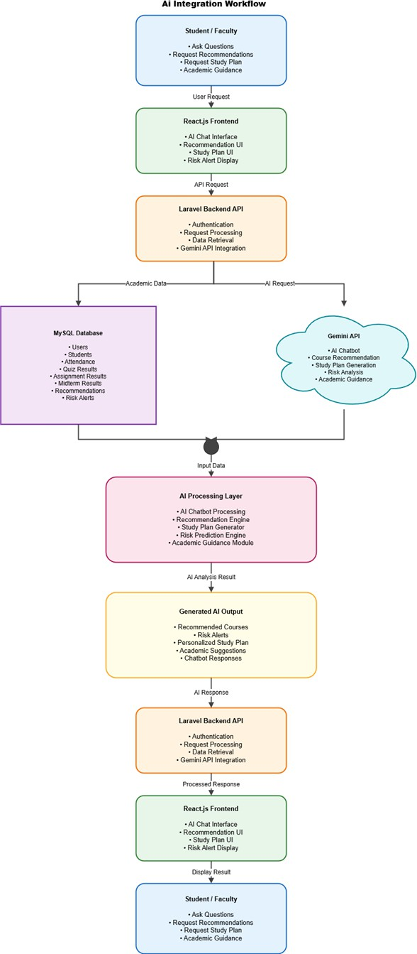
Figure 6.1: AI integration Workflow of AI Smart Campus System

Why AI is Needed

Artificial Intelligence (AI) is a core component of the Academic Performance Monitoring and AI-Based Recommendation System. The purpose of integrating AI is to provide intelligent academic assistance, personalized learning support, and data-driven decision-making for both students and faculty members.
The AI module analyzes academic performance data, attendance records, assessment results, and user queries to generate meaningful recommendations and insights. Through AI integration, the system can automatically identify at-risk students, suggest suitable courses, create personalized study plans, and provide instant academic guidance through an intelligent chatbot.

AI Service Used

AI Model: Google Gemini API

The proposed system utilizes Google Gemini API as its primary Artificial Intelligence service. Gemini is integrated with the Laravel Backend API to process academic queries, analyze student performance data, generate recommendations, predict academic risks, and provide intelligent responses.
The Gemini API enables natural language understanding, academic recommendation generation, risk analysis, and personalized learning assistance within the platform.

Input to the AI System

The AI system receives both academic and user-generated data as input. These inputs are collected from the MySQL Database and user interactions through the React.js Frontend.
Input data include:

    - Student attendance records

    - Quiz scores and assessment results

    - Assignment marks

    - Midterm examination results

    - Academic performance history

    - Course information

    - Student and faculty requests

    - User questions and academic queries

    - Risk-related academic indicators

These inputs are forwarded to the AI service through the Laravel Backend API for further analysis and processing.

AI Processing Functions

The AI Processing Layer performs several intelligent operations to support academic decision-making and student success.
AI Chatbot

The chatbot answers academic and university-related questions submitted by students and faculty members, including:
    - University notices

    - Class schedules

    - Examination information

    - Study-related queries

    - Academic assistance requests Course Recommendation Engine

The recommendation engine analyzes academic records and performance trends to suggest appropriate:
    - Core courses

    - Elective courses

    - Future semester course selections Study Plan Generator
The study plan generator creates personalized learning schedules and improvement strategies based on a student's academic strengths and weaknesses.

Risk Prediction Engine

The risk prediction module evaluates attendance and academic performance data to identify students who may face academic difficulties due to:
    - Low attendance

    - Poor assessment performance

    - Declining academic progress Academic Guidance Module
The guidance module provides personalized recommendations and improvement strategies to help students achieve better academic outcomes.

Output from the AI System

After processing the input data, the AI module generates the following outputs:

    - Personalized course recommendations

    - Academic risk alerts

    - Personalized study plans

    - Academic guidance and suggestions

    - AI chatbot responses

    - Performance improvement recommendations

These outputs are delivered to users through the React.js Frontend interface.

How AI Improves the Project

The integration of Artificial Intelligence transforms the traditional academic management platform into an intelligent academic support system.
The AI module provides several benefits:

    - Personalized learning support for students

    - Early detection of academically at-risk students

    - Intelligent course recommendation services

    - Automated study plan generation

    - Instant academic assistance through chatbot interaction

    - Enhanced academic monitoring and evaluation

    - Improved decision-making support for faculty members

    - Better student engagement and learning outcomes

Through these capabilities, AI significantly improves the effectiveness, efficiency, and overall user experience of the system.

AI Workflow Explanation

Step 1:

A Student or Faculty member submits a question, recommendation request, study plan request, or academic guidance request through the React.js Frontend.
Step 2:

The React.js Frontend sends the request to the Laravel Backend API. Step 3:
The Backend API authenticates the request and retrieves relevant academic information from the MySQL Database.
Step 4:

The Backend forwards the academic data and user query to the Google Gemini API. Step 5:
The Gemini AI service analyzes the provided information and performs recommendation generation, study plan creation, chatbot processing, academic guidance, or risk prediction.
Step 6:

The AI-generated result is sent to the AI Processing Layer, where recommendations, alerts, and intelligent outputs are prepared.
Step 7:

The generated AI output is returned to the Laravel Backend API.

Step 8:

The Backend sends the processed response to the React.js Frontend. Step 9:
The Frontend displays the final result, including recommendations, study plans, risk alerts, academic suggestions, and chatbot responses to the Student or Faculty member.

References

[1] Google AI for Developers, "Gemini API Documentation." [Online]. Available: https://ai.google.dev
[2] Laravel, "Laravel Framework Official Documentation." [Online]. Available: https://laravel.com/docs
[3] React, "React Official Documentation." [Online]. Available: https://react.dev
[4] Oracle Corporation, "MySQL Documentation." [Online]. Available: https://dev.mysql.com/doc
[5] JWT.io, "JSON Web Token (JWT) Introduction and Documentation." [Online]. Available: https://jwt.io
[6] Draw.io, "Diagram Design Tool." [Online]. Available: https://app.diagrams.net
[7] DBDiagram, "Database Design Tool." [Online]. Available: https://dbdiagram.io
[8] I. Sommerville, Software Engineering, 10th ed. Pearson Education, 2016.
[9] R. S. Pressman and B. R. Maxim, Software Engineering: A Practitioner's Approach, 9th ed. McGraw-Hill Education, 2020.

