NORTHERN UNIVERSITY OF BUSINESS AND TECHNOLOGY, KHULNA
Department of Computer Science & Engineering
AI-Smart Campus System
UI/UX Design & Development Planning Document
Academic Performance Monitoring and AI-Based Recommendation System
Course | CSE 4204 — Mobile Computing Lab
Section | 8A
Team | T07
Submission | Week 05 — UI/UX Design & Development Planning
Date | 22 June 2026

Submitted to
Md. Riaz Mahmud
Assistant Professor
Department of Computer Science and Engineering
Northern University of Business and Technology, Khulna

Submitted by — Team T07

Name | Student ID
Md. Nazmus Shakib | 11220320852
Samira Akter Mitu | 11220320858
Md. Tanvin Sadik Dhrubo | 11220320860
Khan Waziur Rahman | 11220320861

1. Team Information
This section presents the official team identification details and the members of Team T07, registered under Section 8A for the course CSE 4204 — Mobile Computing Lab at Northern University of Business and Technology, Khulna.

1.1 Team Identification
University | Northern University of Business and Technology, Khulna
Department | Computer Science & Engineering
Course | CSE 4204 — Mobile Computing Lab
Section | 8A
Team Code | T07
Project Title | AI-Smart Campus System

1.2 Team Members & Responsibilities
Name | Student ID | Main Responsibility
Md. Nazmus Shakib | 11220320852 | Team Leader & Database Management
Samira Akter Mitu | 11220320858 | AI Integration & Documentation Support
Md. Tanvin Sadik Dhrubo | 11220320860 | Frontend Development & UI/UX Design
Khan Waziur Rahman | 11220320861 | Backend Development & API Management

2. Project Information

2.1 Project Overview
AI-Smart Campus System is an academic performance monitoring and AI-based recommendation platform designed to unify attendance tracking, academic analytics, and AI-guided learning support for students, faculty, and administrators. The system brings dashboards, real-time analytics, AI-powered chat assistance, and risk-prediction tools together into a single role-based web platform.

2.2 Purpose
Following completion of the System Design and Software Architecture phase, this document presents the User Interface (UI), User Experience (UX) design, and Development Planning for the AI-Smart Campus System. It serves as the visual and planning blueprint that will guide implementation for the remainder of the semester, helping the team translate system requirements into a concrete, navigable interface before development begins.

2.3 Core User Roles
- Student — views attendance, CGPA trends, course marks, class routine, AI study assistant, and AI-generated course recommendations.
- Faculty — monitors student performance, manages attendance and assessment records, and reviews at-risk student alerts.
- Admin — manages user approvals, oversees system-wide analytics, and publishes campus notices.

2.4 Key Features
- Real-time attendance, marks, and CGPA analytics with trend visualization
- Gemini-powered AI Study Assistant available for academic guidance and exam preparation
- AI-curated course recommendations based on academic performance profile
- Automated risk early-warning system for students with declining attendance or grades
- Role-based secure access for Students, Faculty, and Admin
- Centralized campus notice management with targeted audience delivery

2.5 Project Scope
The platform will be developed as a responsive web application using React.js for the frontend and Laravel REST API for the backend, with MySQL as the relational data store and Google Gemini API powering all AI-driven features — including the chat assistant, course recommendation engine, study plan generation, and student risk prediction.

3. UI / Wireframe Screenshots
The following high-fidelity UI screens were designed in Figma and cover all major user-facing and administrative views of the AI-Smart Campus System, spanning the public landing experience, authentication, and the Student, Faculty, and Admin dashboards.
Screen 01 — Landing Page (Hero)
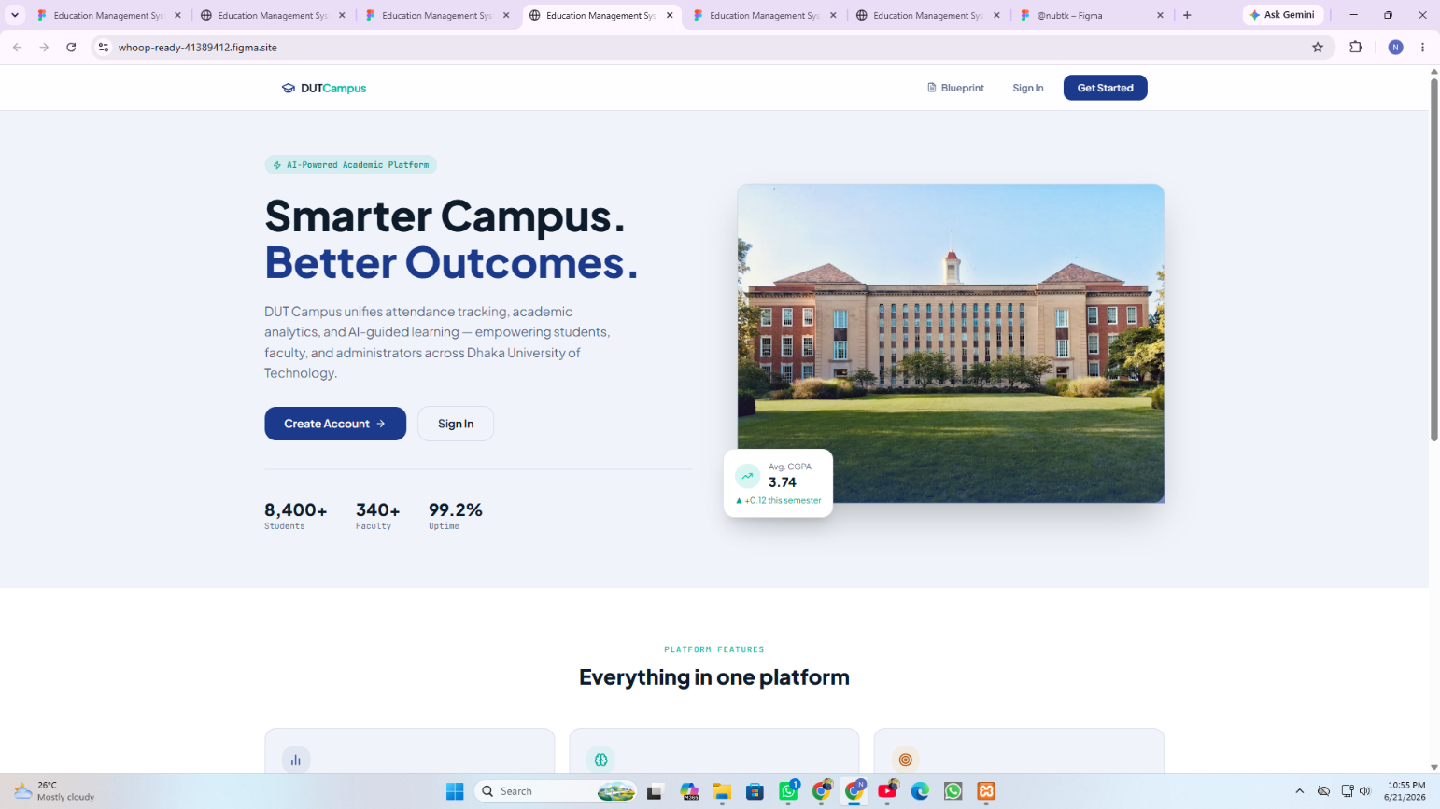
Public homepage introducing DUT Campus as an AI-powered academic platform, with hero messaging, key platform statistics, and primary Create Account / Sign In calls-to-action.

Screen 02 — Landing Page (Features)
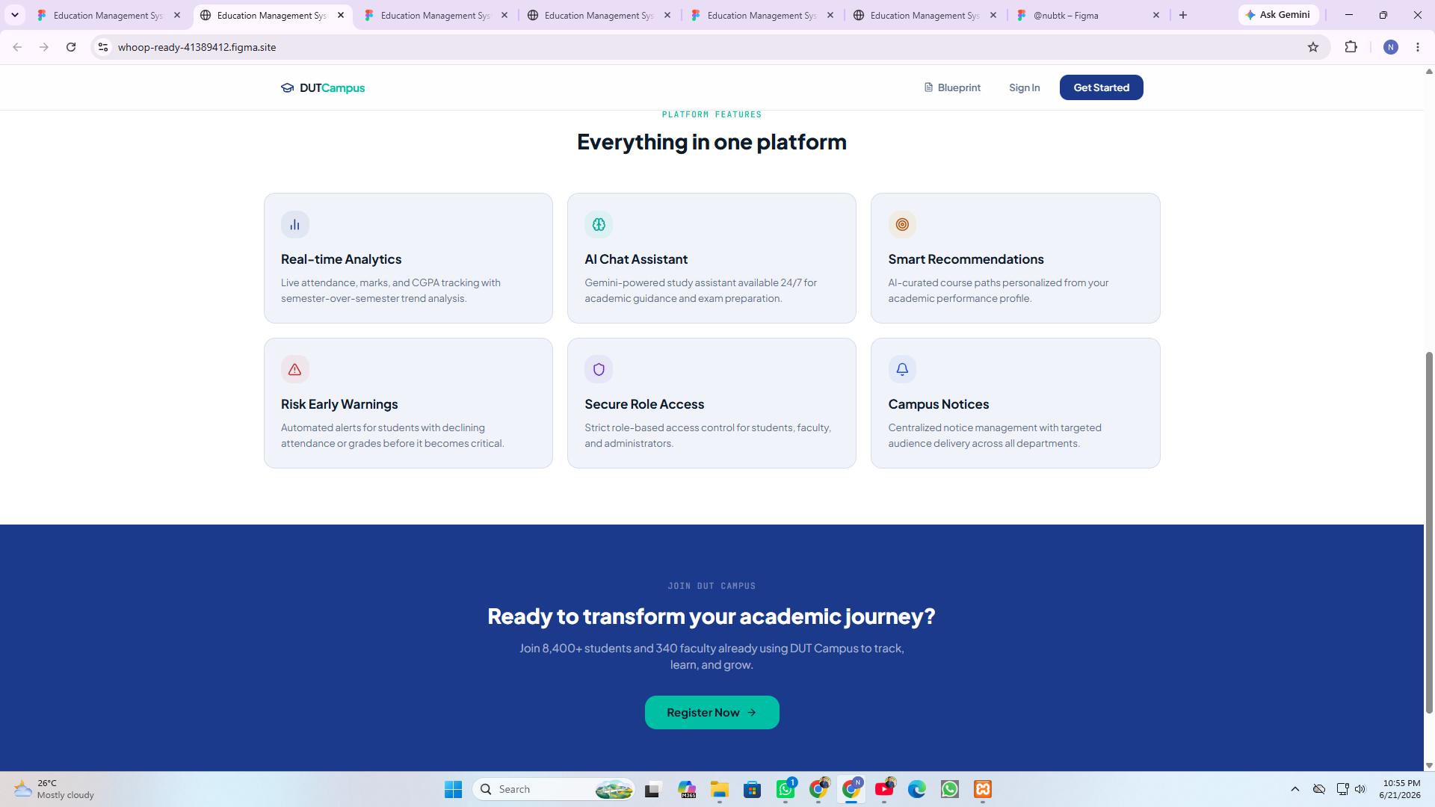
Continuation of the landing page highlighting six core platform features — real-time analytics, AI chat assistant, smart recommendations, risk early warnings, secure role access, and campus notices — followed by a registration call-to-action.
Screen 03 — Sign In
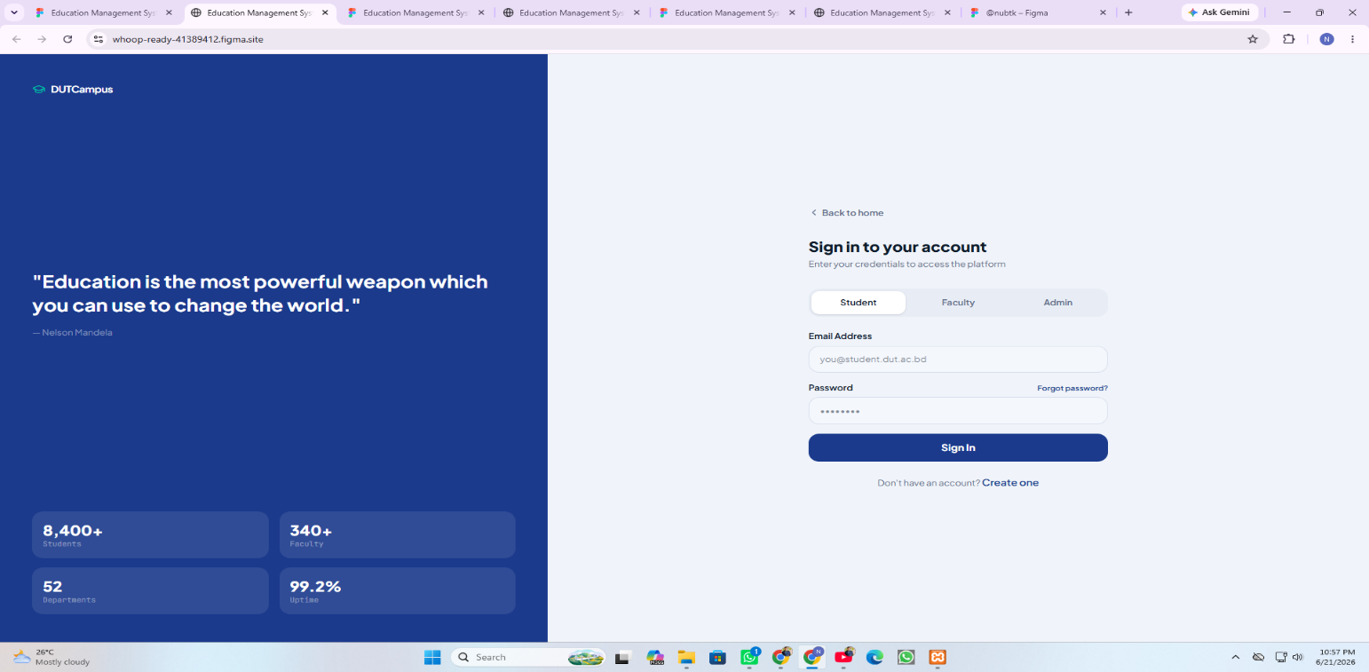
Role-based login screen allowing users to authenticate as Student, Faculty, or Admin via email and password, with a forgot-password link and a path to registration.
Screen 04 — Create Account (Registration)
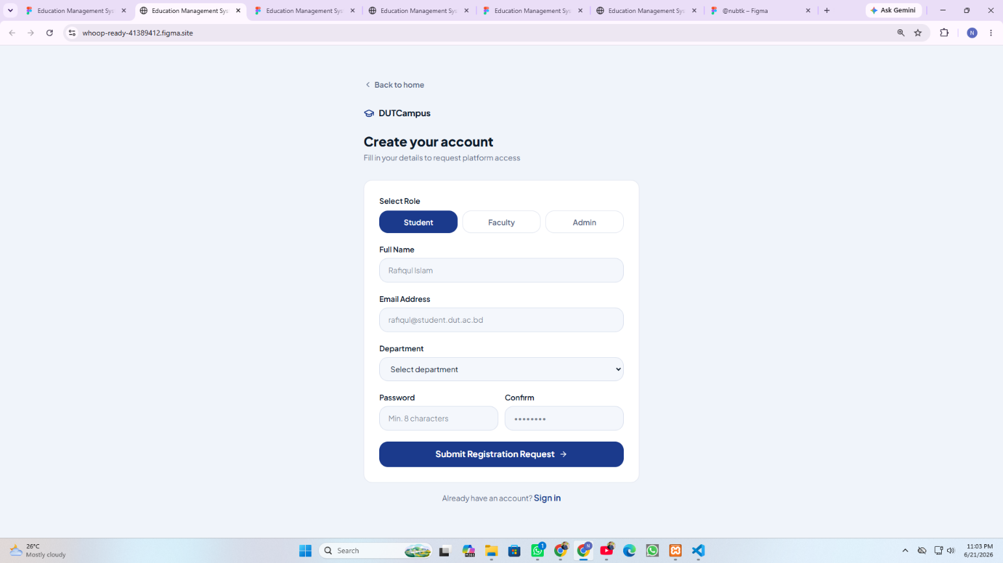
Registration form capturing role selection, full name, university email, department, and password, used to submit a new account request for admin approval.
Screen 05 — Student Dashboard
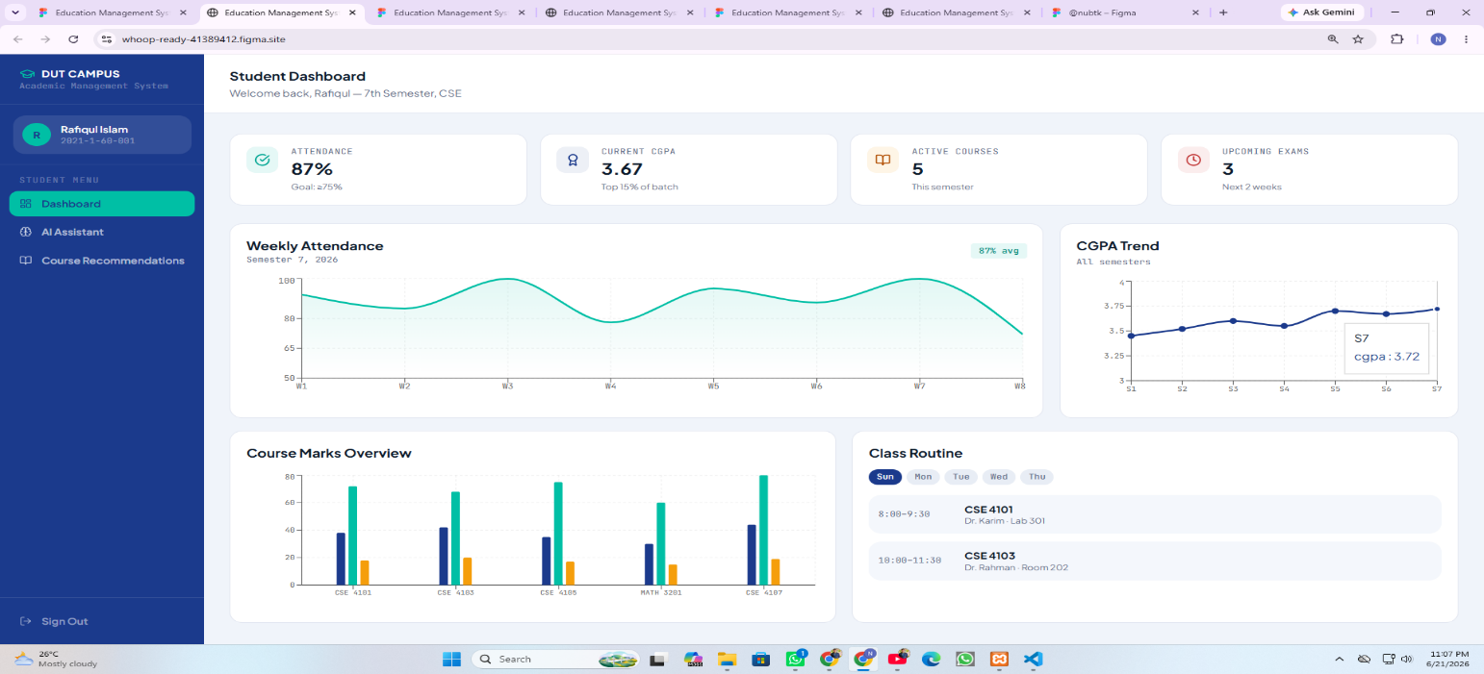
Central student hub displaying attendance percentage, current CGPA, active courses, upcoming exams, weekly attendance trend, CGPA trend across semesters, course marks overview, and class routine.
Screen 06 — AI Study Assistant
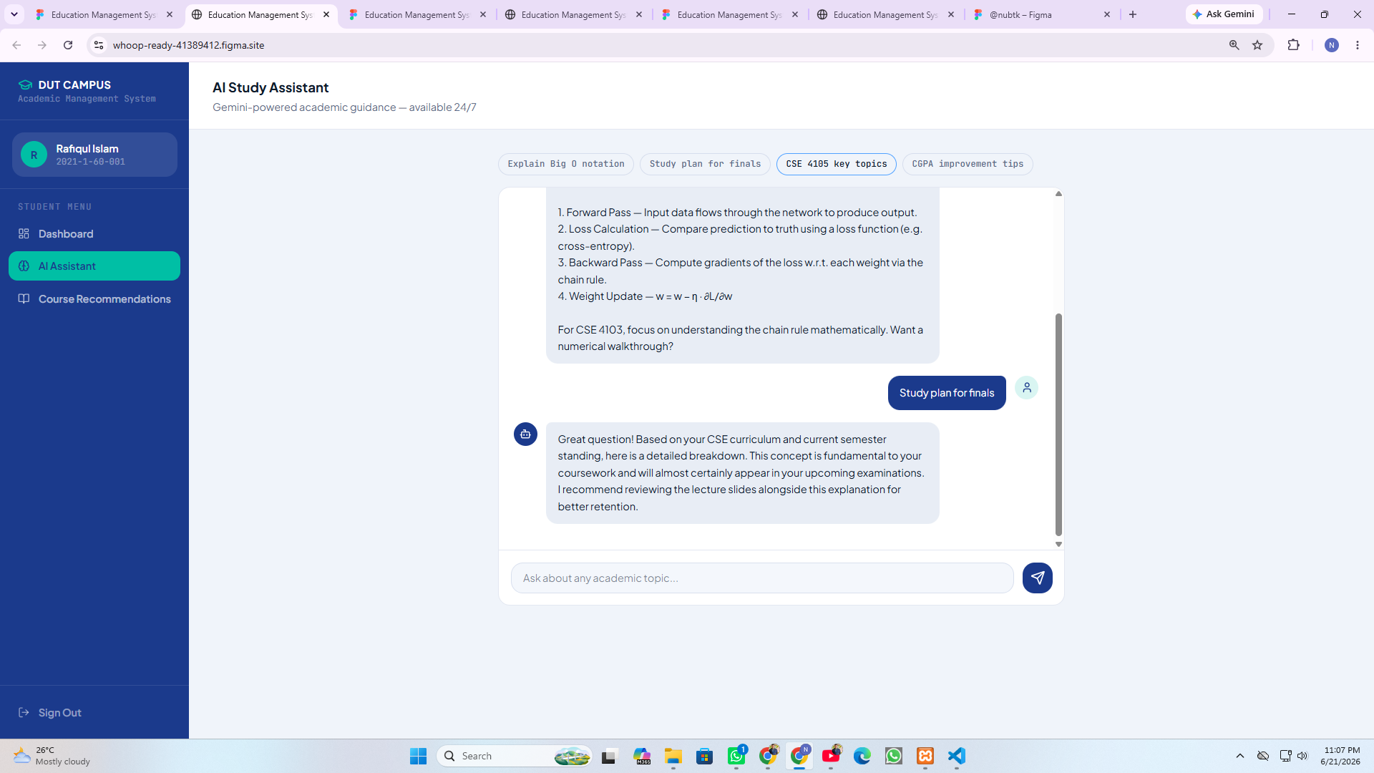
Gemini-powered conversational interface offering 24/7 academic guidance, including quick-access prompts for study plans, key course topics, and CGPA improvement tips.
Screen 07 — Course Recommendations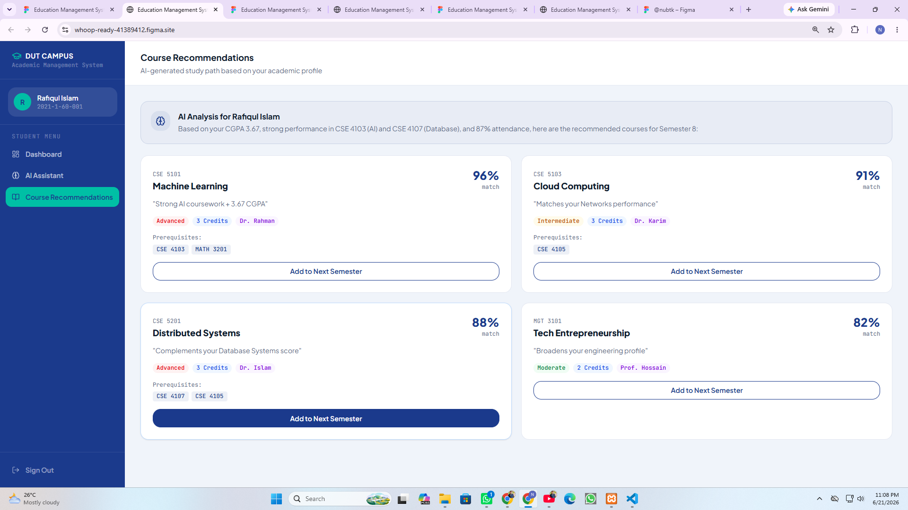AI-generated course suggestions for the upcoming semester based on the student's CGPA, course performance, and attendance, each shown with a match percentage and prerequisites.
Screen 08 — Faculty Dashboard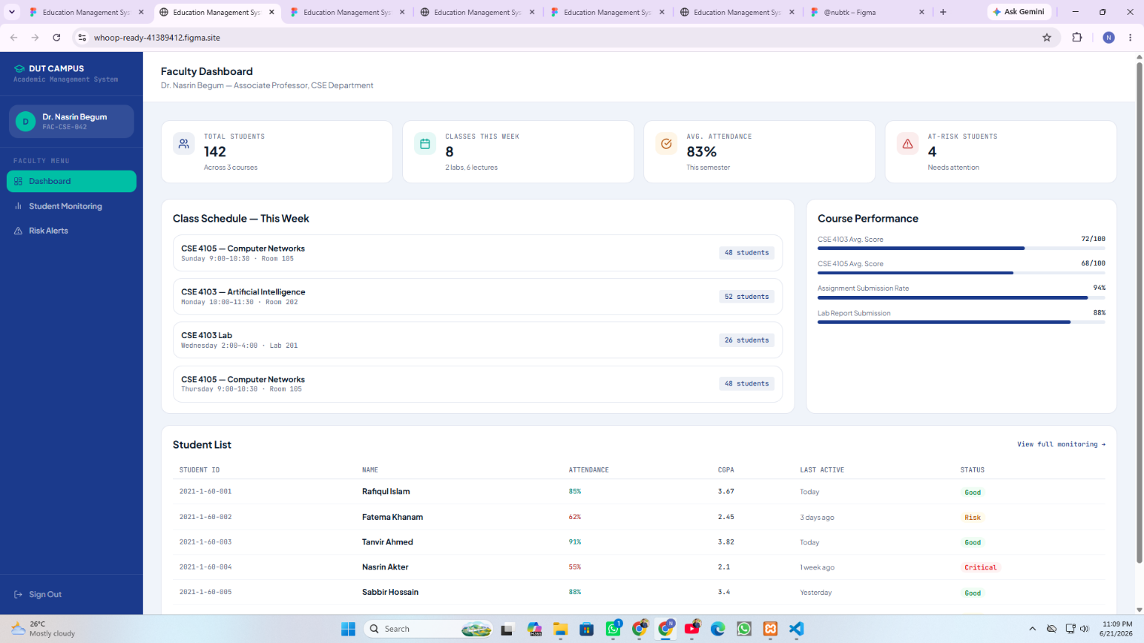
Overview screen for faculty showing total students, weekly class schedule, average attendance, at-risk student count, course performance metrics, and a summarized student list.
Screen 09 — Student Monitoring
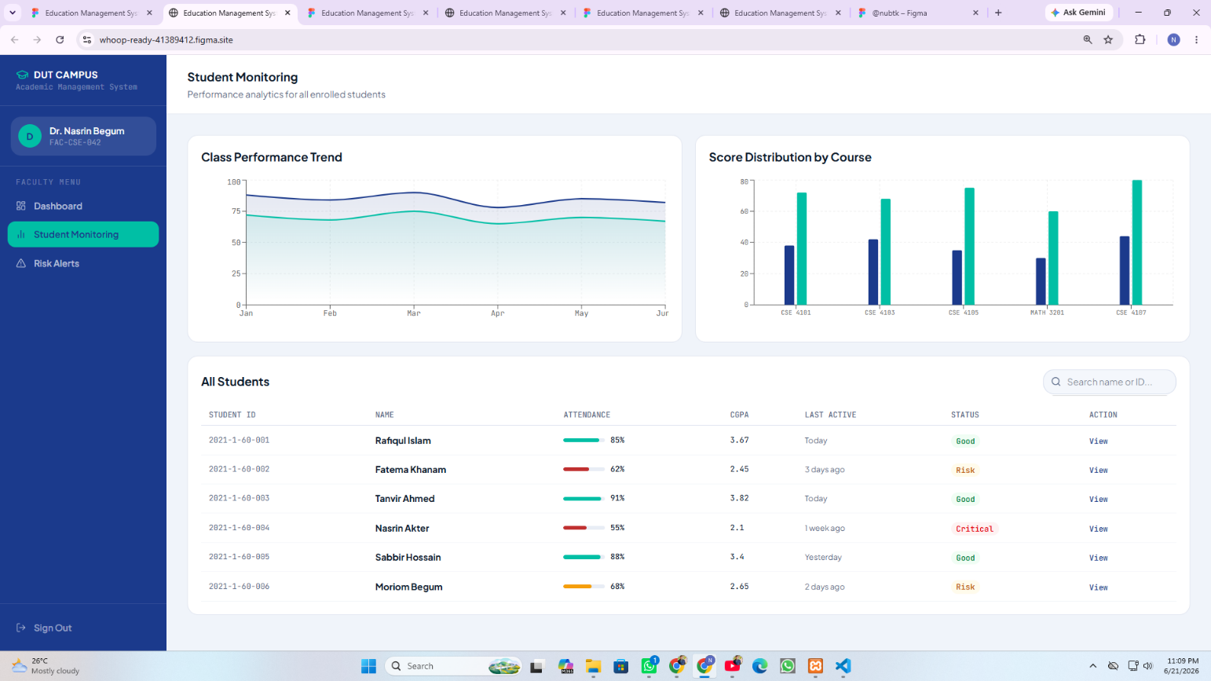
Detailed performance analytics view for faculty, including class performance trend, score distribution by course, and a searchable table of all enrolled students with status indicators.

Screen 10 — Risk Alerts
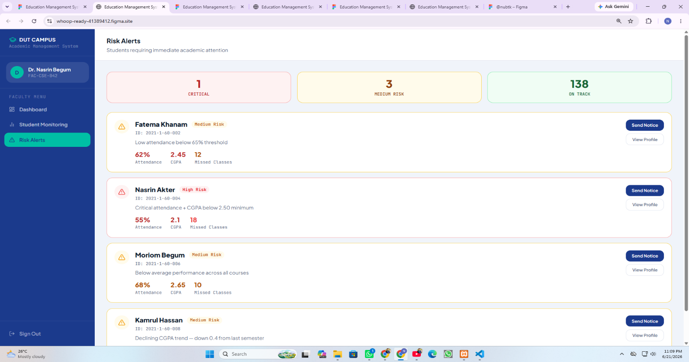
Dedicated risk-management screen listing students flagged as critical or medium risk based on attendance and CGPA thresholds, with options to send notices or view full profiles.
Screen 11 — Admin Dashboard
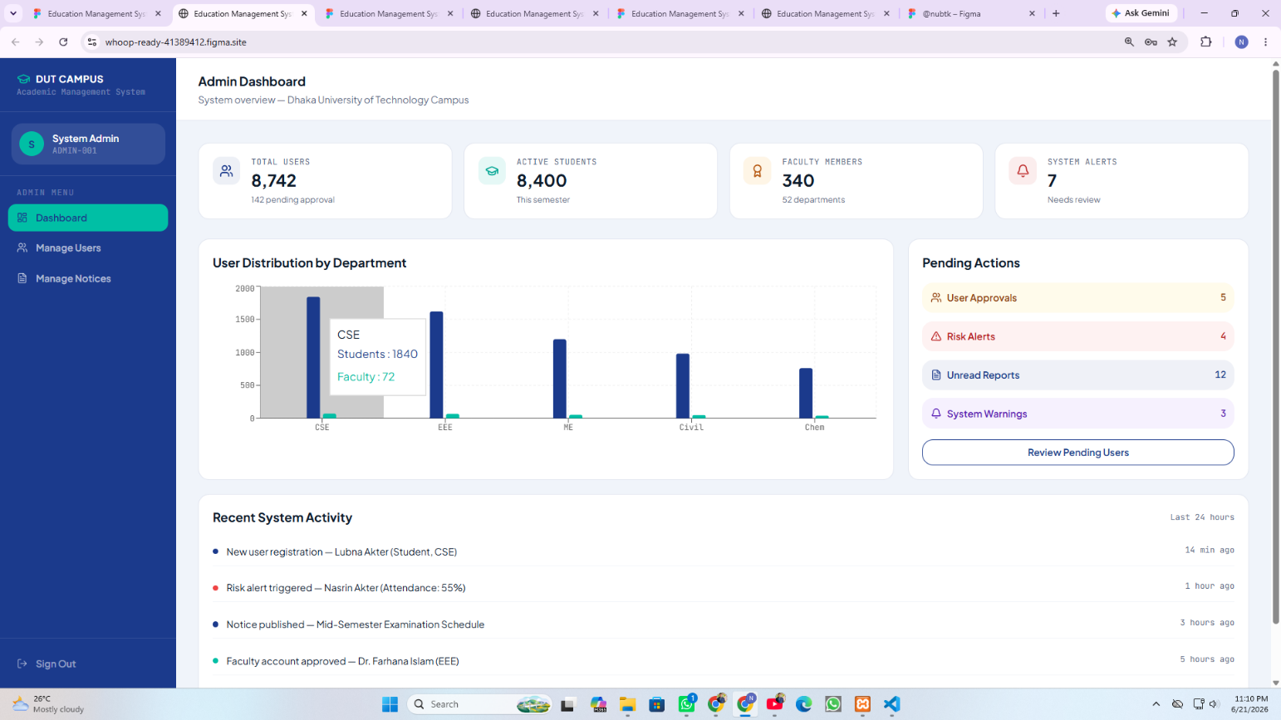
System-wide overview for administrators showing total users, active students, faculty members, system alerts, user distribution by department, pending actions, and recent system activity.
Screen 12 — Manage Users
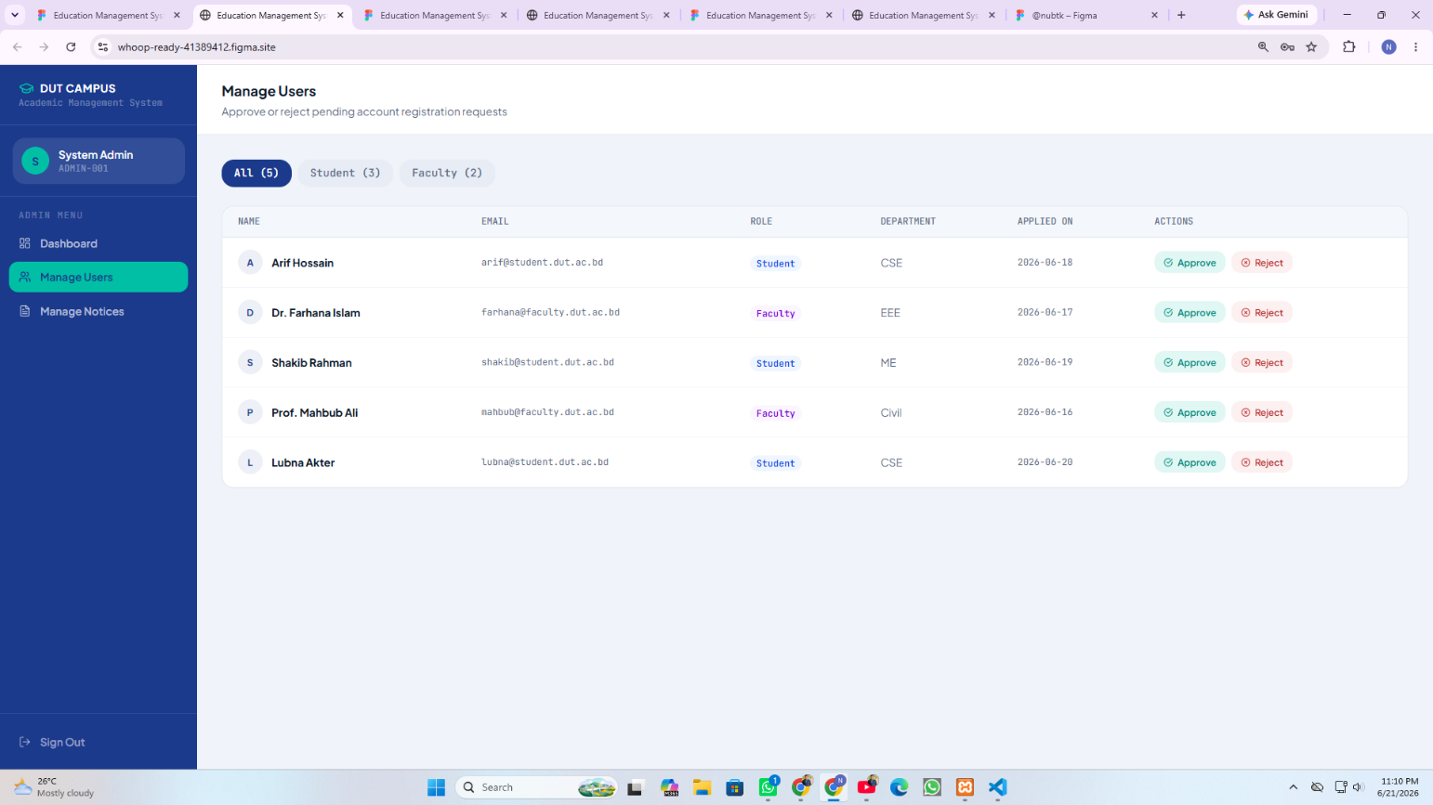
Admin screen for reviewing pending student and faculty registration requests, with approve/reject actions for each applicant.
Screen 13 — Manage Notices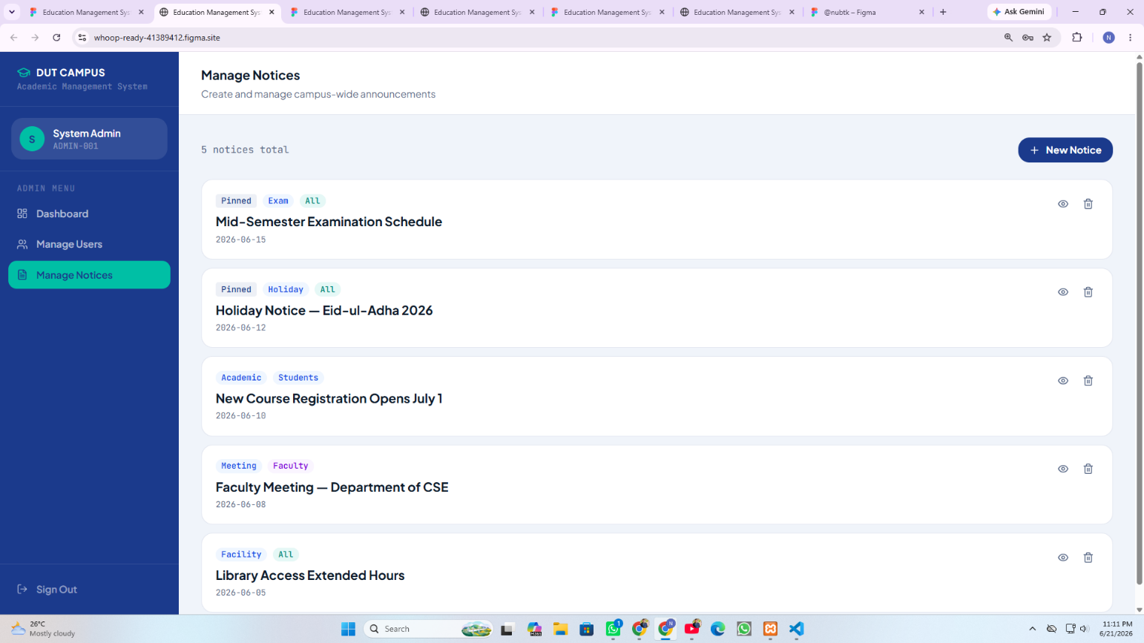
Admin interface for creating and managing campus-wide announcements, with tagging (pinned, category, audience) and view/delete controls for each notice.

4. User Flow Diagram
The diagram below illustrates how users move through the AI-Smart Campus System, covering account registration and role-based authentication, navigation within each role's dashboard, and the AI request/response cycle that powers the chatbot, course recommendation, and study plan generation features.
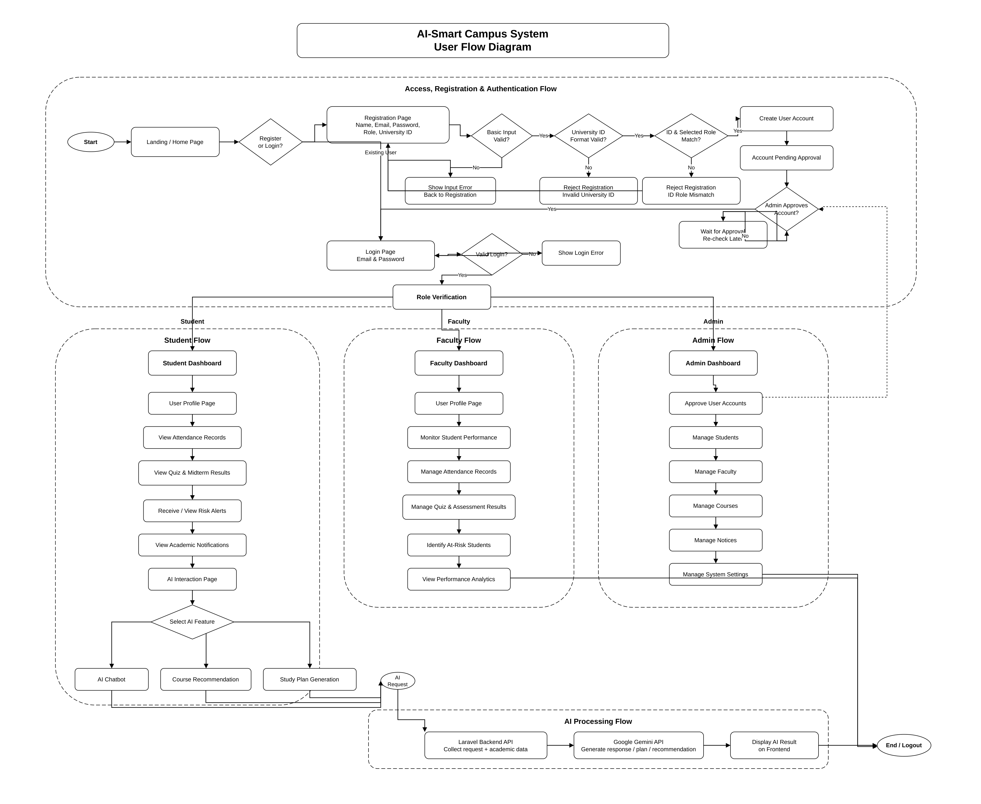

4.1 Flow Summary
- Access, Registration & Authentication Flow — new users register with name, email, password, role, and university ID; the system validates input format and ID-role match before account creation and admin approval. Existing users sign in directly, with role verification routing them to the correct dashboard.
- Student Flow — Dashboard → User Profile → Attendance Records → Quiz & Midterm Results → Risk Alerts → Academic Notifications → AI Interaction Page.
- Faculty Flow — Dashboard → User Profile → Monitor Student Performance → Manage Attendance → Manage Assessment Results → Identify At-Risk Students → View Performance Analytics.
- Admin Flow — Dashboard → Approve User Accounts → Manage Students / Faculty / Courses / Notices → Manage System Settings.
- AI Processing Flow — A user's AI request (chatbot, course recommendation, or study plan generation) is sent to the Laravel backend API, which collects the request and academic data, forwards it to the Google Gemini API for generation, and returns the AI result for display on the frontend.

5. Development Roadmap
The development roadmap describes the planned activities for completing the AI-Smart Campus System within the remaining weeks of the semester. The roadmap follows a logical development sequence starting from project setup and backend foundation, followed by frontend development, core feature implementation, AI integration, testing, documentation, and final submission.
The project will be developed using React.js for the frontend, Laravel REST API for the backend, MySQL for database management, and Google Gemini API for AI-based chatbot, recommendation, study plan generation, and risk-prediction features.

5.1 Development Sequence Flow
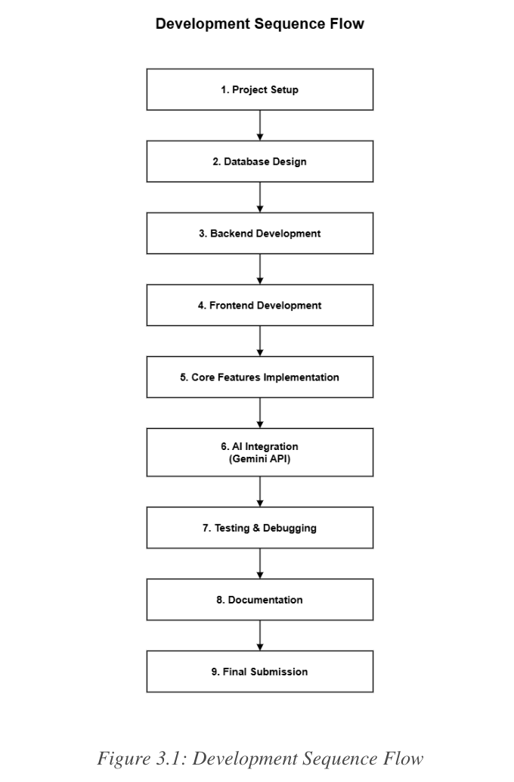

5.2 Weekly Roadmap
Week | Major Module | Major Tasks | Responsible | Expected Outcome
Week 06 | Project Setup & Backend Foundation | Create project structure; configure MySQL database; set up Laravel backend; configure authentication system; create Student, Faculty, and Admin models; prepare role-based access structure. | Backend Developer, Database Manager | Backend environment ready, database connected, and authentication foundation completed.
Week 07 | Frontend UI Development | Develop landing page, login page, registration page; create dashboard UI and navigation components; implement responsive design. | Frontend Developer, UI/UX Designer | Complete user interface structure prepared with responsive layouts.
Week 08 | Core Feature Development | Implement Student, Faculty, and Admin dashboards; build attendance module, quiz result module, and mid-term performance module. | Frontend Developer, Backend Developer | Core system functionalities operational and connected with backend APIs.
Week 09 | AI Integration | Integrate Google Gemini API; develop AI chat assistant and course recommendation module; generate personalized recommendations; build study plan generation and risk prediction logic. | AI Integration Developer, Backend Developer | AI-powered features functional and connected with academic performance data.
Week 10 | Testing & Debugging | Unit, integration, and API testing; authentication and role-based access testing; AI response testing; fix UI issues and resolve bugs. | QA Tester, All Team Members | Stable, tested, and bug-reduced system ready for final improvement.
Week 11 | Finalization & Documentation | Final UI improvements and system optimization; documentation update; GitHub repository cleanup; final presentation preparation; arrange final submission materials. | Documentation Lead, All Team Members | Complete project ready for demonstration and final submission.

5.3 Roadmap Explanation
The roadmap follows a logical sequence: backend and database work are completed first, frontend and core features are developed next, AI integration is added once the data flow is ready, and final testing and documentation are completed before submission.

6. Team Task Distribution
This section describes the responsibility distribution among the team members for the AI-Smart Campus System project. Each member has been assigned specific tasks according to the project requirements, including frontend development, backend development, database management, AI integration, documentation, testing, and GitHub maintenance.

6.1 Individual Responsibilities
Md. Nazmus Shakib (ID: 11220320852)
Team Leader & Database Management
- Coordinate overall project activities and manage team communication.
- Design and maintain the database structure.
- Prepare and review the ER diagram.
- Organize project files and maintain the GitHub repository structure.
- Support documentation and participate in final testing and review.
Samira Akter Mitu (ID: 11220320858)
AI Integration & Documentation Support
- Work on Gemini API integration planning.
- Design AI chatbot workflow.
- Support course recommendation and study plan generation features.
- Prepare AI-related documentation and assist in UI/UX planning.
- Participate in testing AI-based features.
Md. Tanvin Sadik Dhrubo (ID: 11220320860)
Frontend Development & UI/UX Design
- Design and develop the frontend interface using React.js.
- Prepare landing page, login page, registration page, dashboards, user profile page, and AI interaction page.
- Ensure responsive and user-friendly UI design.
- Test frontend navigation and form validation.
Khan Waziur Rahman (ID: 11220320861)
Backend Development & API Management
- Develop backend modules using Laravel.
- Implement authentication and authorization.
- Create REST API endpoints.
- Connect the backend with the MySQL database.
- Support Student, Faculty, and Admin functionalities.
- Test backend APIs and system responses.

6.2 Task Responsibility Summary
Task Area | Assigned Member(s)
Frontend Development | Md. Tanvin Sadik Dhrubo
Backend Development | Khan Waziur Rahman
Database Management | Md. Nazmus Shakib
AI Integration | Samira Akter Mitu
UI/UX Design Support | Md. Tanvin Sadik Dhrubo, Samira Akter Mitu
API Planning and Testing | Khan Waziur Rahman, Md. Nazmus Shakib
Documentation | Md. Nazmus Shakib, Samira Akter Mitu
Testing and Debugging | All Team Members
GitHub Repository Maintenance | Md. Nazmus Shakib
Final Review and Submission | Md. Nazmus Shakib, with support from all team members

6.3 Summary
The team task distribution ensures that every member has a clear and meaningful responsibility in the project. Frontend tasks are assigned to the frontend developer, backend and API tasks are assigned to the backend developer, database and repository management are handled by the team leader, and AI-related features are managed by the AI integration specialist. Testing, debugging, documentation review, and final submission will be completed collaboratively by all team members to ensure the quality and completeness of the project.

7. Final Technology Stack
This section outlines the final technology stack selected for the development and deployment of the AI-Smart Campus System. Each technology has been chosen based on project requirements, team expertise, and compatibility with the AI integration features.

7.1 Technology Stack Overview
Category | Technology | Purpose
Frontend | React.js + Tailwind CSS | Responsive and interactive user interface development
Backend | Laravel | API development, business logic implementation, authentication, and system management
Database | MySQL (XAMPP) | Storage and management of user, academic, attendance, and performance data
AI Integration | Gemini API | AI chatbot, course recommendation, and academic assistance features
Version Control | Git & GitHub | Source code management and team collaboration
Authentication | JWT (JSON Web Token) | Secure user authentication and authorization
Development Environment | Visual Studio Code | Application development and coding
API Testing | Postman | API testing and debugging
Design Tool | Figma | UI/UX design and prototyping

7.2 Technology Usage Overview
Frontend
React.js + Tailwind CSS will be used to develop a responsive and user-friendly interface for Students, Faculty, and Admin users. It will provide dashboards, forms, charts, and navigation components.
Backend
Laravel will handle application logic, API services, user authentication, role management, attendance processing, performance analysis, and communication with the AI module.
Database
MySQL (XAMPP) will store user accounts, attendance records, quiz scores, mid-term results, recommendations, alerts, and system logs.
AI Integration
Gemini API will power the AI Assistant, course recommendation system, academic guidance, study planning support, and student risk prediction features.
Authentication
JWT Authentication will ensure secure login and role-based access control for Students, Faculty, and Admin users.
Version Control
Git and GitHub will be used for source code management, version tracking, team collaboration, and project documentation.

7.3 Deployment Plan
Component | Platform
Frontend | Localhost / Future Cloud Deployment
Backend | Laravel Application Server
Database | MySQL Server
Source Code Repository | GitHub

7.4 Development Tools
- Visual Studio Code
- XAMPP
- Git
- GitHub
- Postman
- Figma
- Google Chrome

8. Link

8.1 Figma Design Link
The complete UI/UX design and interactive prototype of the AI Smart Campus System are available on Figma. The prototype includes all major screens, user workflows, and interface designs.
Figma Design Link:
AI Smart Campus System - Figma Prototype

8.2 GitHub Profile Link
GitHub Profile:
Nazmus Shakib GitHub Profile

8.3 GitHub Repository Link
GitHub Repository:
CSE4204-8A-T07 AI Smart Campus System Repository

