AI Smart Campus System
Backend Project Documentation
━━━━━━━━━━━━━━━━━━━━━━━━━

Course Name | Mobile Computing Lab
Course Code | CSE4204
Submitted To | Md. Riaz Mahmud
Team Number | T07
Department | Computer Science & Engineering
University | Northern University of Business and Technology, Khulna
Submission Date | June 29, 2026

2. Team Information
Team Number: T07
Project Name: AI Smart Campus System
Section: 8A
Course: CSE4204 — Mobile Computing Lab
Instructor: Md. Riaz Mahmud

# | Member Name | Student ID | Role
1 | Md. Nazmus Shakib | 11220320852 | Database (Team Leader)
2 | Samira Akter Mitu | 11220320858 | AI Integration Developer
3 | Md. Tanvin Sadik Dhrubo | 11220320860 | Frontend Developer
4 | Khan Waziur Rahman | 11220320861 | Backend Developer

3. Project Overview

3.1 Objective
The primary objective of this project is to build a centralized, intelligent campus management system that streamlines administrative tasks, student records, and resource management. The system is designed to minimize manual intervention through smart automation and AI-powered recommendations, creating a modern digital campus environment.

3.2 Description
The AI Smart Campus System is a robust backend solution developed using Laravel 12. It provides secure, well-structured RESTful APIs for managing campus operations, including task scheduling, AI-driven academic recommendations, and learning resource distribution. The backend is built following industry-standard practices with token-based authentication, request validation, and modular service architecture.

3.3 User Roles
- Student — Access learning resources, view AI-generated recommendations, and manage personal tasks.
- Faculty — Upload and manage learning materials, assign tasks, and monitor student progress.
- Admin — Full system access including user management, system configuration, and analytics.

4. Backend Technology Stack
The following technologies have been selected to ensure a scalable, maintainable, and secure backend infrastructure for the AI Smart Campus System.

Component | Technology
Backend Framework | Laravel 12
Programming Language | PHP 8.2
Database | MySQL
Authentication | Laravel Sanctum (Token-Based)
API Testing Tool | Postman
Version Control | Git / GitHub

The GitHub repository serves as the central version control hub for all backend source code, enabling collaborative development and continuous tracking of changes across the development lifecycle.

5. Backend Project Setup
The following steps were carried out to initialize and configure the backend development environment for the AI Smart Campus System.
- Laravel 12 project initialized using Composer CLI.
- All required Composer dependencies installed and composer.lock committed to the repository.
- Environment configuration file (.env) set up with MySQL database credentials, app key, and debug settings.
- Laravel Sanctum installed and configured for token-based API authentication.
- API routes defined and organized within routes/api.php following RESTful conventions.
- Database migrations created and executed to generate all required tables.
- Git repository initialized and synchronized with GitHub remote.

6. Database Design Summary
Database Name: campus_management

6.1 Core Tables
- users — Stores all registered users with role designation (student, faculty, admin), hashed passwords, and profile data.
- tasks — Manages tasks assigned to or created by users, with status tracking and foreign key linkage to users.
- recommendations — Stores AI-generated and manually added academic recommendations linked to individual users.
- learning_resources — Contains learning materials uploaded by faculty, categorized and accessible to students.

6.2 Relationships
The database schema follows a normalized design with One-to-Many relationships between the Users table and both the Tasks and Learning Resources tables. Each user can have multiple tasks and access multiple resources, while each task and resource belongs to exactly one user.

6.3 Validation
Strict validation rules have been implemented using Laravel's Form Request classes. All incoming data is validated before processing, ensuring data integrity, preventing injection attacks, and returning structured error responses for invalid inputs.

6.4 Databases Table

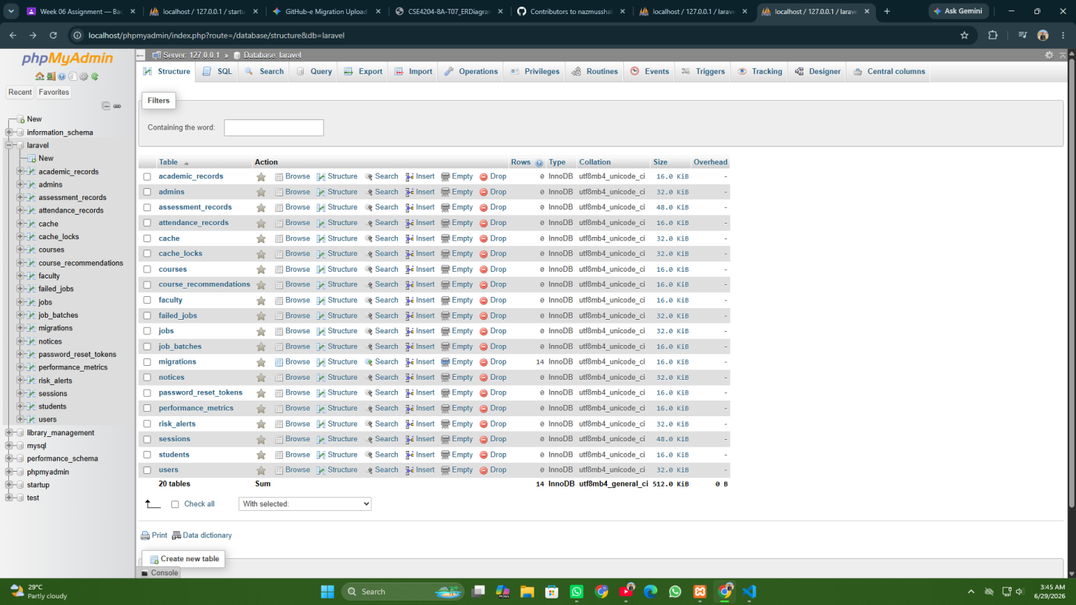

Figure 6.1: Database Tables of the AI Smart Campus System

6.5 User Table

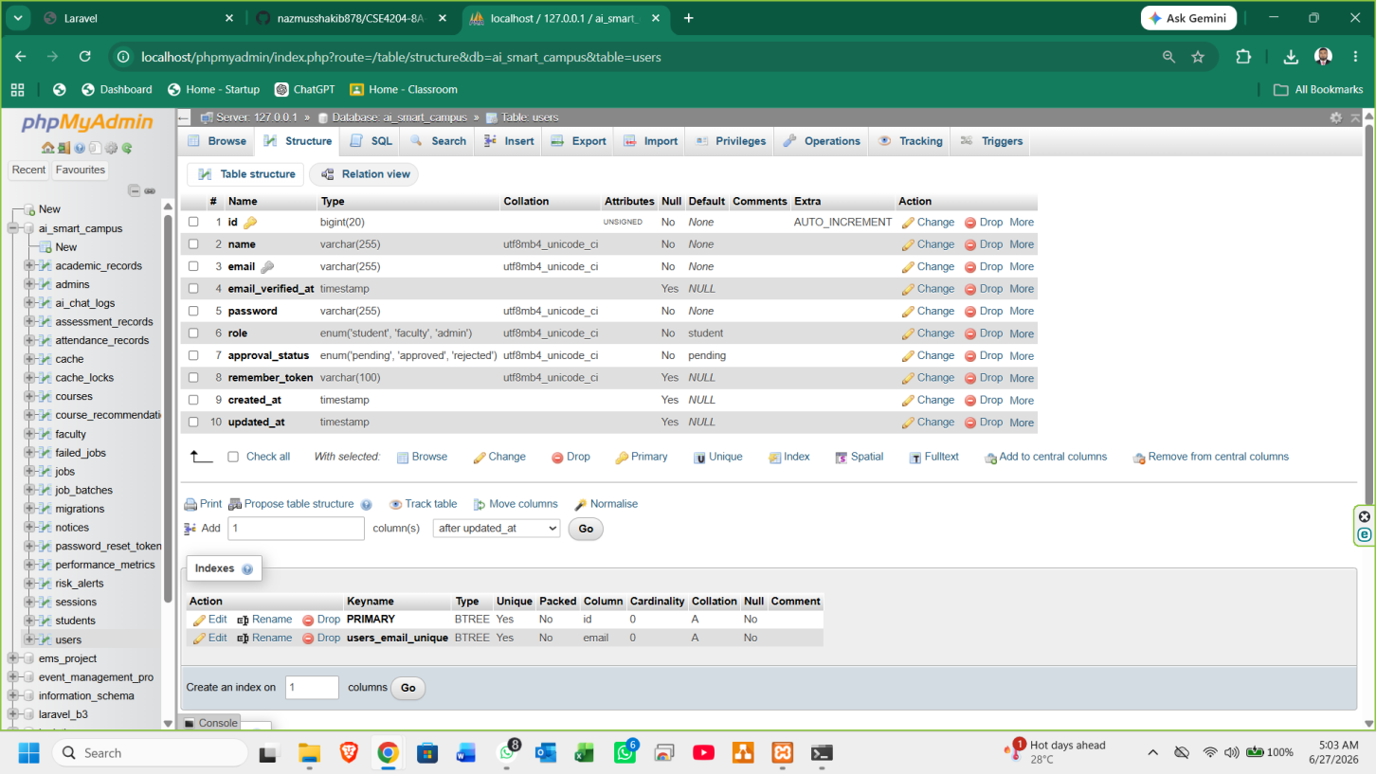

Figure 6.2: Users Table

6.6 Personal Access Tokens Table

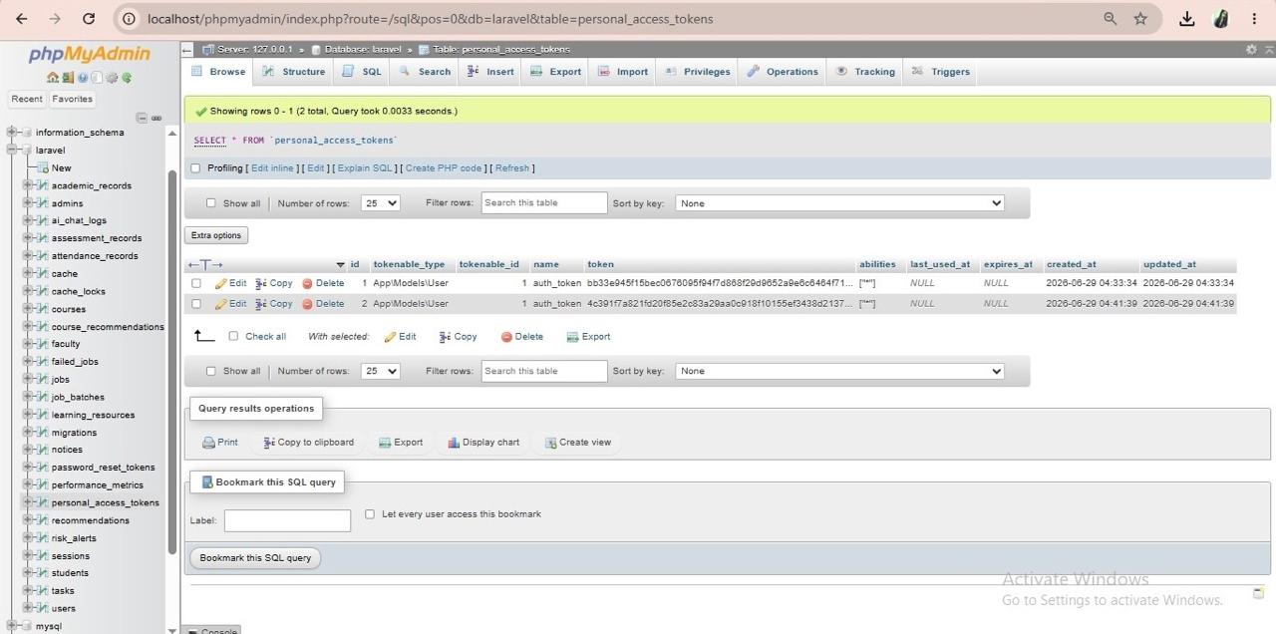

Figure 6.3: Personal Access Tokens Table

6.7 Tasks Table

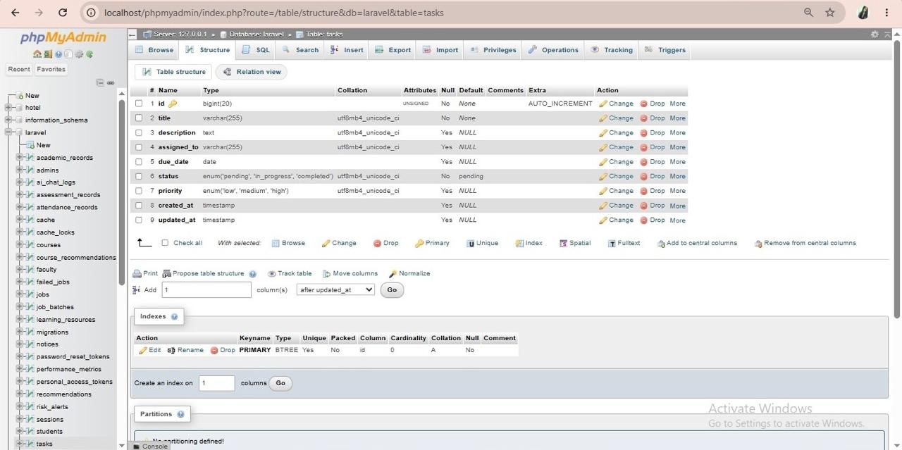

Figure 6.4: Tasks Table

6.8 Recommendations Table

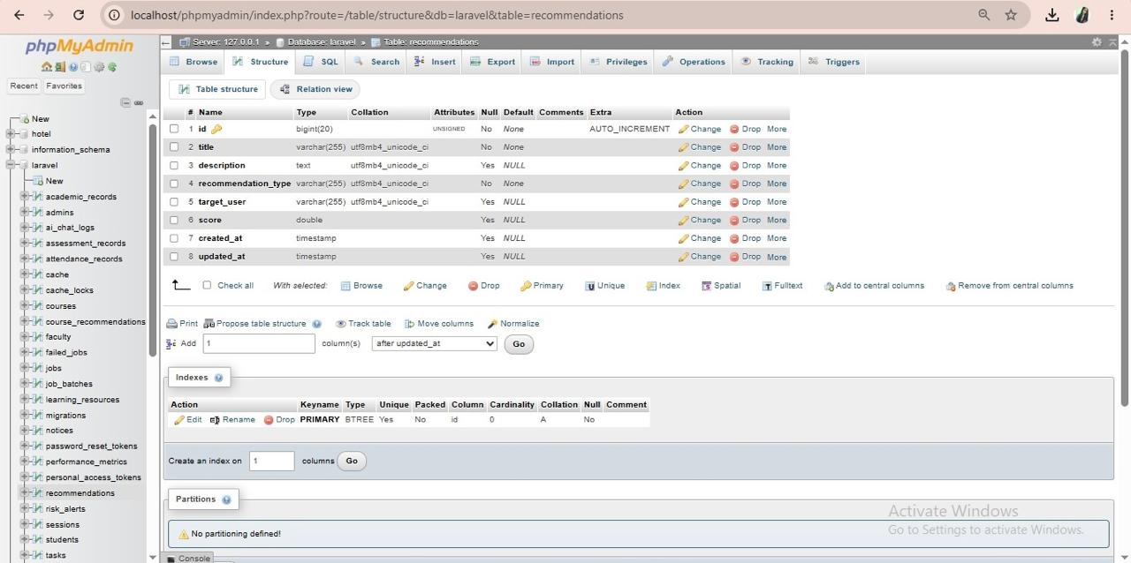

Figure 6.5: Recommendations Table

6.9 Learning Resources Table

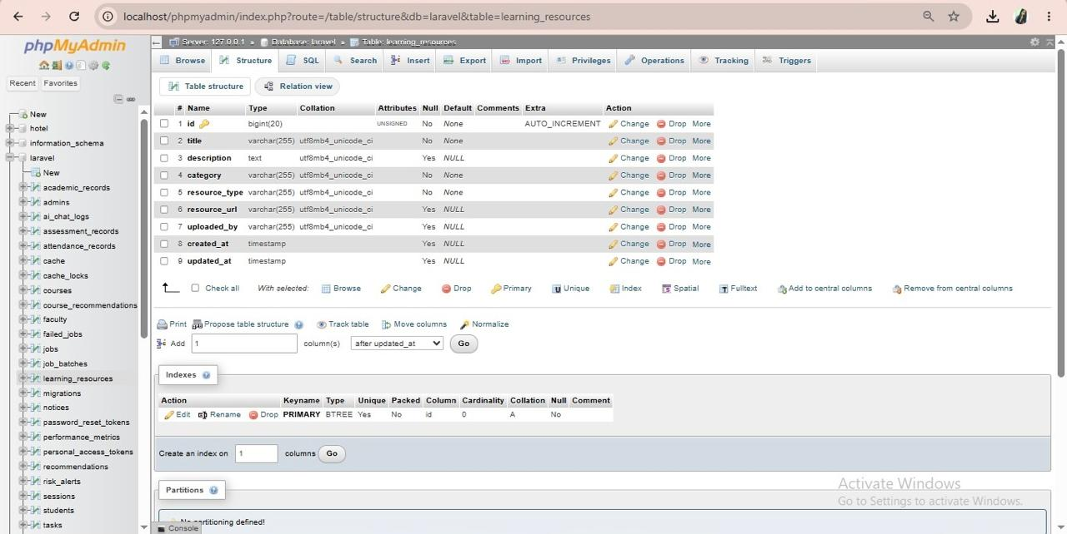

Figure 6.4: Learning Resources Database Table

7. Authentication System
The authentication system has been implemented using Laravel Sanctum, providing a lightweight and secure token-based mechanism suitable for Single Page Applications (SPAs) and mobile clients.
- User Registration — New users can register with validated credentials. Passwords are securely hashed using bcrypt before storage.
- User Login — Authenticated users receive a personal access token upon successful login, which must be included in all subsequent API requests.
- User Logout — Tokens are revoked server-side upon logout, ensuring stateless and secure session termination.
- Token-Based Session Management — All protected routes require a valid Bearer token in the Authorization header, enabling stateless API interactions.
- Role-Based Access Control — Middleware has been implemented to enforce role-specific access, ensuring that students, faculty, and admins can only access their permitted resources.

7.1 Registration API Test

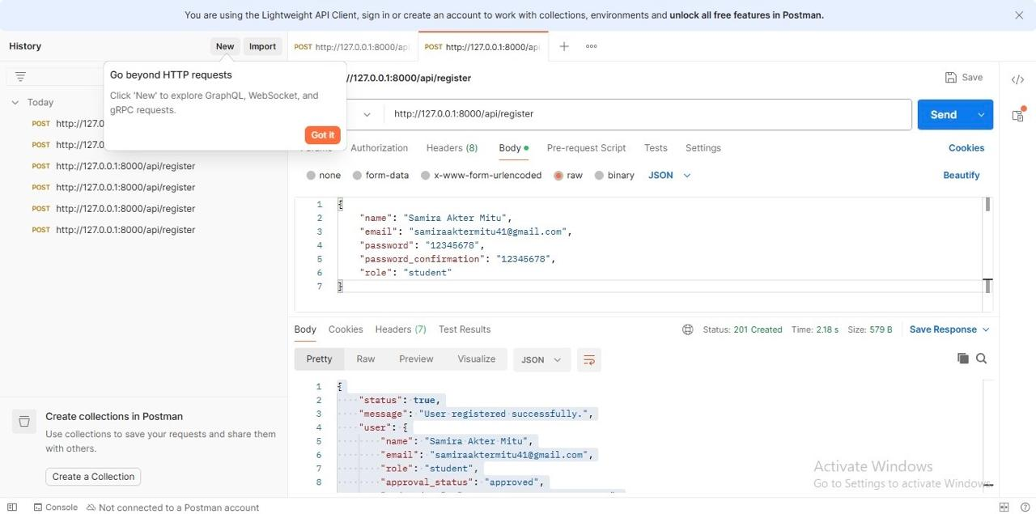

Figure 7.1: Registration API tested successfully using Postman.

7.2 Login API Test

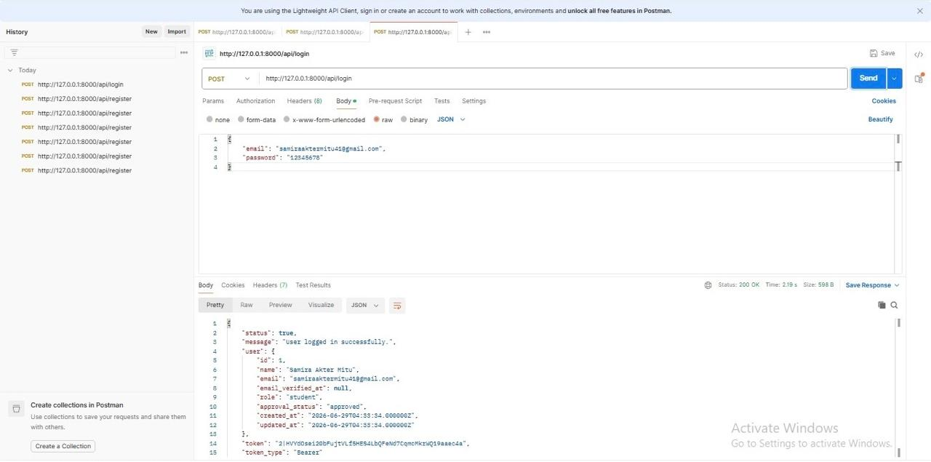

Figure 7.2: Login API tested successfully.

7.3 Profile API Test

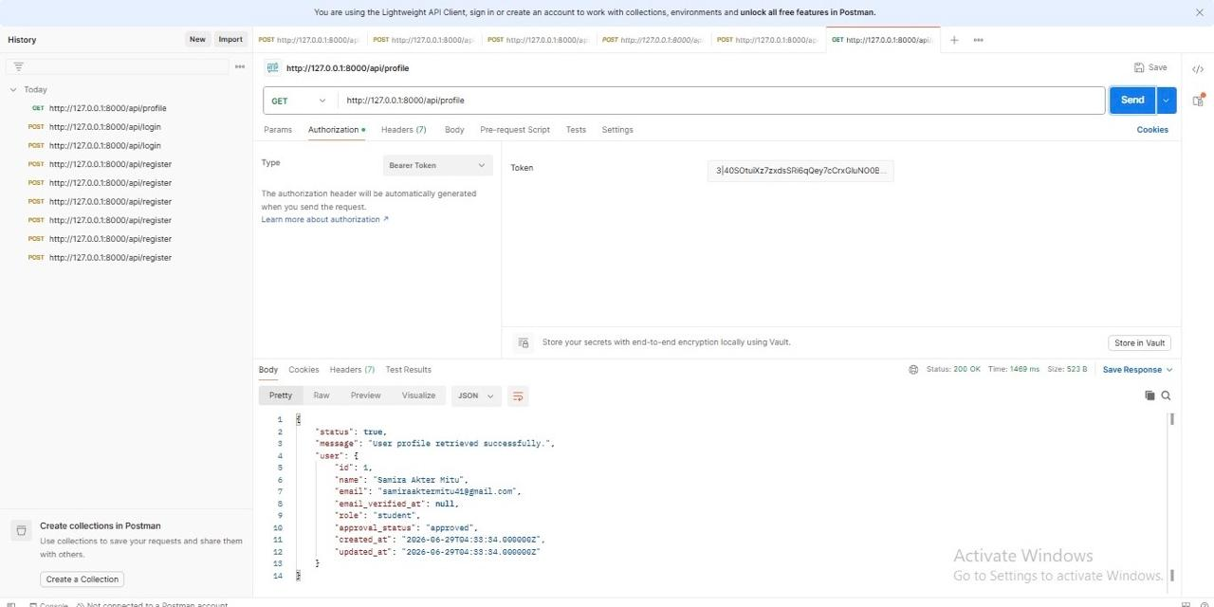

Figure 7.3: Authenticated user profile retrieved successfully.

7.4 Logout API Test

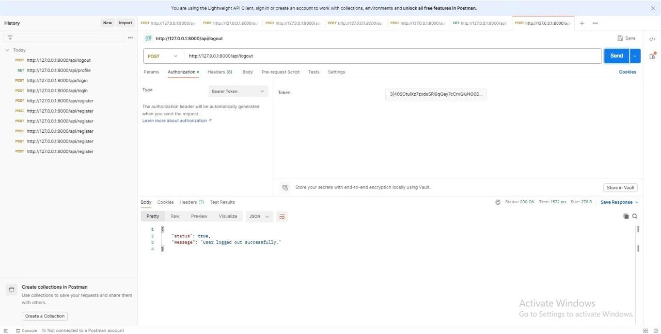

Figure 7.4: User logged out successfully.

7.5 Validation/ Error Handling

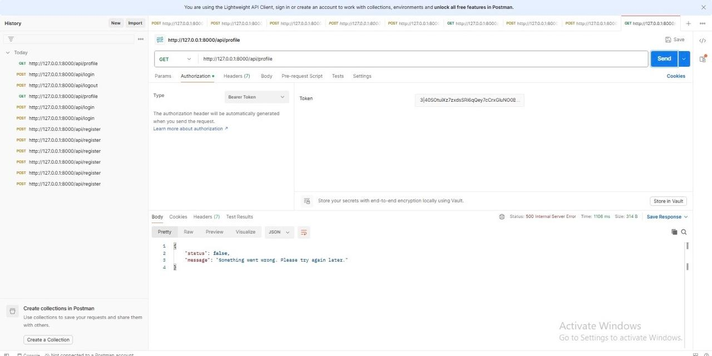

Figure 7.5: Validation error response for invalid input.

8. Implemented APIs
The following RESTful API endpoints have been developed and tested. All routes are prefixed with /api and require appropriate authentication tokens unless specified otherwise.

Method | Endpoint | Description
POST | /api/register | User Registration
POST | /api/login | User Login
POST | /api/logout | User Logout
GET | /api/profile | Fetch User Profile
GET | /api/tasks | Retrieve All Tasks
POST | /api/tasks | Create New Task
GET | /api/recommendations | Fetch AI Recommendations
POST | /api/recommendations | Add New Recommendation
GET | /api/learning-resources | View Learning Materials
POST | /api/learning-resources | Add New Learning Material

All endpoints return JSON responses following a consistent structure with status codes, message fields, and data payloads. Error responses include descriptive messages and validation details where applicable.

9. Current Development Progress
As of the current submission date, the following development milestones have been successfully completed for the AI Smart Campus System backend.
- Backend architecture setup completed — Laravel 12 project structure organized following MVC pattern with service and repository layers.
- Database schema and migrations finalized — All core tables created with proper relationships, indexes, and constraints.
- Authentication system fully functional — Registration, login, logout, and token management tested via Postman.
- Core business logic APIs developed — Task management, recommendations, and learning resource endpoints implemented and operational.
- Error handling and validation implemented — Global exception handler configured; all requests validated through Form Request classes.
- GitHub repository synchronized — All commits pushed with meaningful commit messages; repository is up to date.

10.GitHub Repository
The complete source code and version control history of this backend project are maintained in our GitHub repository for collaboration and project management.
Project Repository (GitHub): CSE4204-8A-T07-AI-Smart-Campus-System Repository

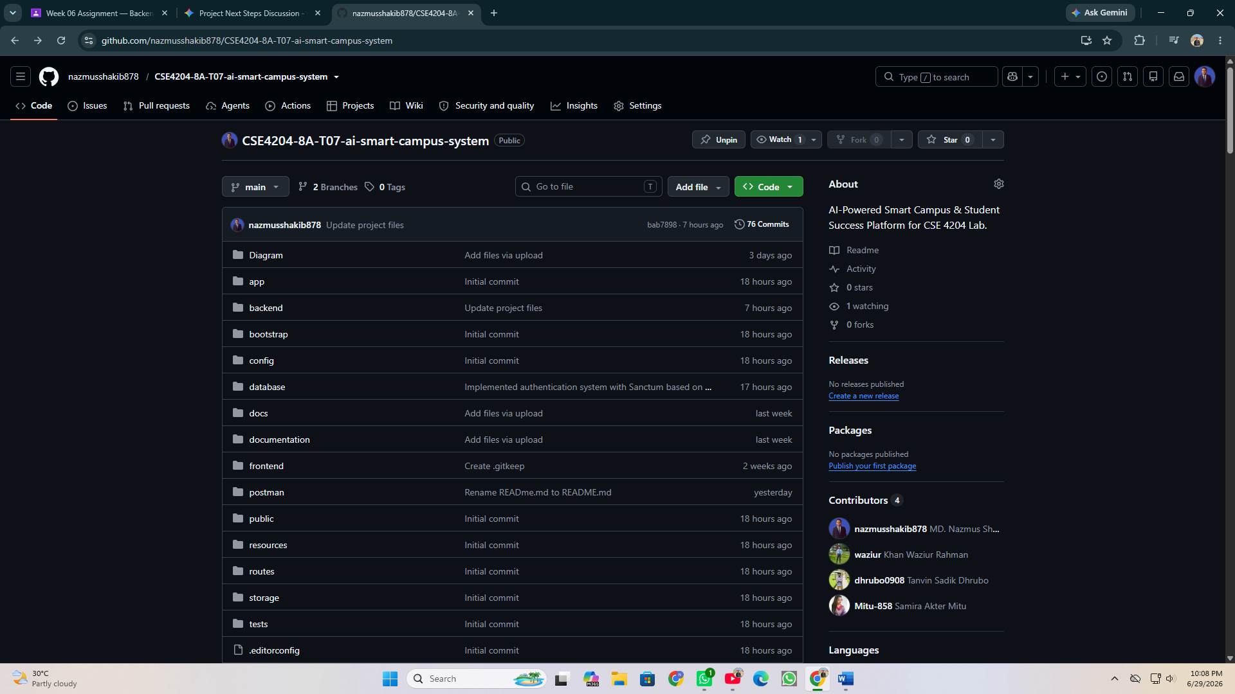

11. Conclusion
The backend infrastructure for the AI Smart Campus System has been successfully designed and implemented using Laravel 12. The system provides a secure, scalable, and efficient foundation for managing campus-related data and operations through well-defined RESTful APIs.
All core authentication flows, database relationships, and API endpoints are fully functional and have been verified through Postman testing. The codebase follows Laravel best practices with strict validation, role-based access control, and modular architecture, ensuring ease of maintenance and future extensibility.
With this backend foundation in place, the project is well-positioned for the subsequent phases of development, including AI integration via the Google Gemini API, advanced analytics, and the deployment of the frontend React.js interface.

— Team T07, CSE4204-8A
Northern University of Business and Technology, Khulna
Submitted: June 29, 2026

