DATABASE DESIGN DOCUMENT
AI-Smart Campus System
Database design for authentication, academic records, smart campus workflows, recommendations, tasks, notices, and risk alerts.
Field | Details
Course | CSE 4204 - Mobile Computing Lab
Team | CSE4204-8A-T07
Technology Stack | Laravel, MySQL, Sanctum API Authentication
Prepared Date | June 29, 2026
Document Type | Functional Database Design Document

Team Members
Role | Name | Student ID
Team Leader | Md. Nazmus Shakib | 11220320852
AI | Samira Akter Mitu | 11220320858
Frontend | Tanvin Sadik Dhrubo | 11220320860
Backend | Khan Waziur Rahman | 11220320861

1. Database Overview
The AI-Smart Campus System database is designed to support a role-based academic platform where students, faculty, and administrators can authenticate, manage campus tasks, publish learning resources, monitor academic performance, and receive intelligent recommendations.
The design uses a relational MySQL structure with primary keys, foreign keys, timestamps, and normalized module-based tables. Laravel Sanctum is used for secure API token authentication.

1.1 Core Modules
- Authentication and user management
- Student, faculty, admin, and course data
- Assessment and attendance tracking
- Performance analysis and risk alerts
- Learning resources and campus tasks
- AI/course recommendations and notices

1.2 Design Goals
- Keep user login data separate from academic records.
- Store assessment, attendance, and risk data in independent tables.
- Use foreign keys where direct entity relationships exist.
- Keep API module tables simple and easy to extend.
- Maintain a structure that can be implemented directly in Laravel migrations.

1.3 Implementation Scope
The current backend includes project-level migrations and API module migrations. This document therefore includes both the conceptual project tables and the implemented API tables used by the Laravel backend. API module tables can later be linked to users, students, and courses as the system expands.

2. Entity Relationship Diagram
High-level ERD showing the main project relationships and implemented Laravel API module tables.
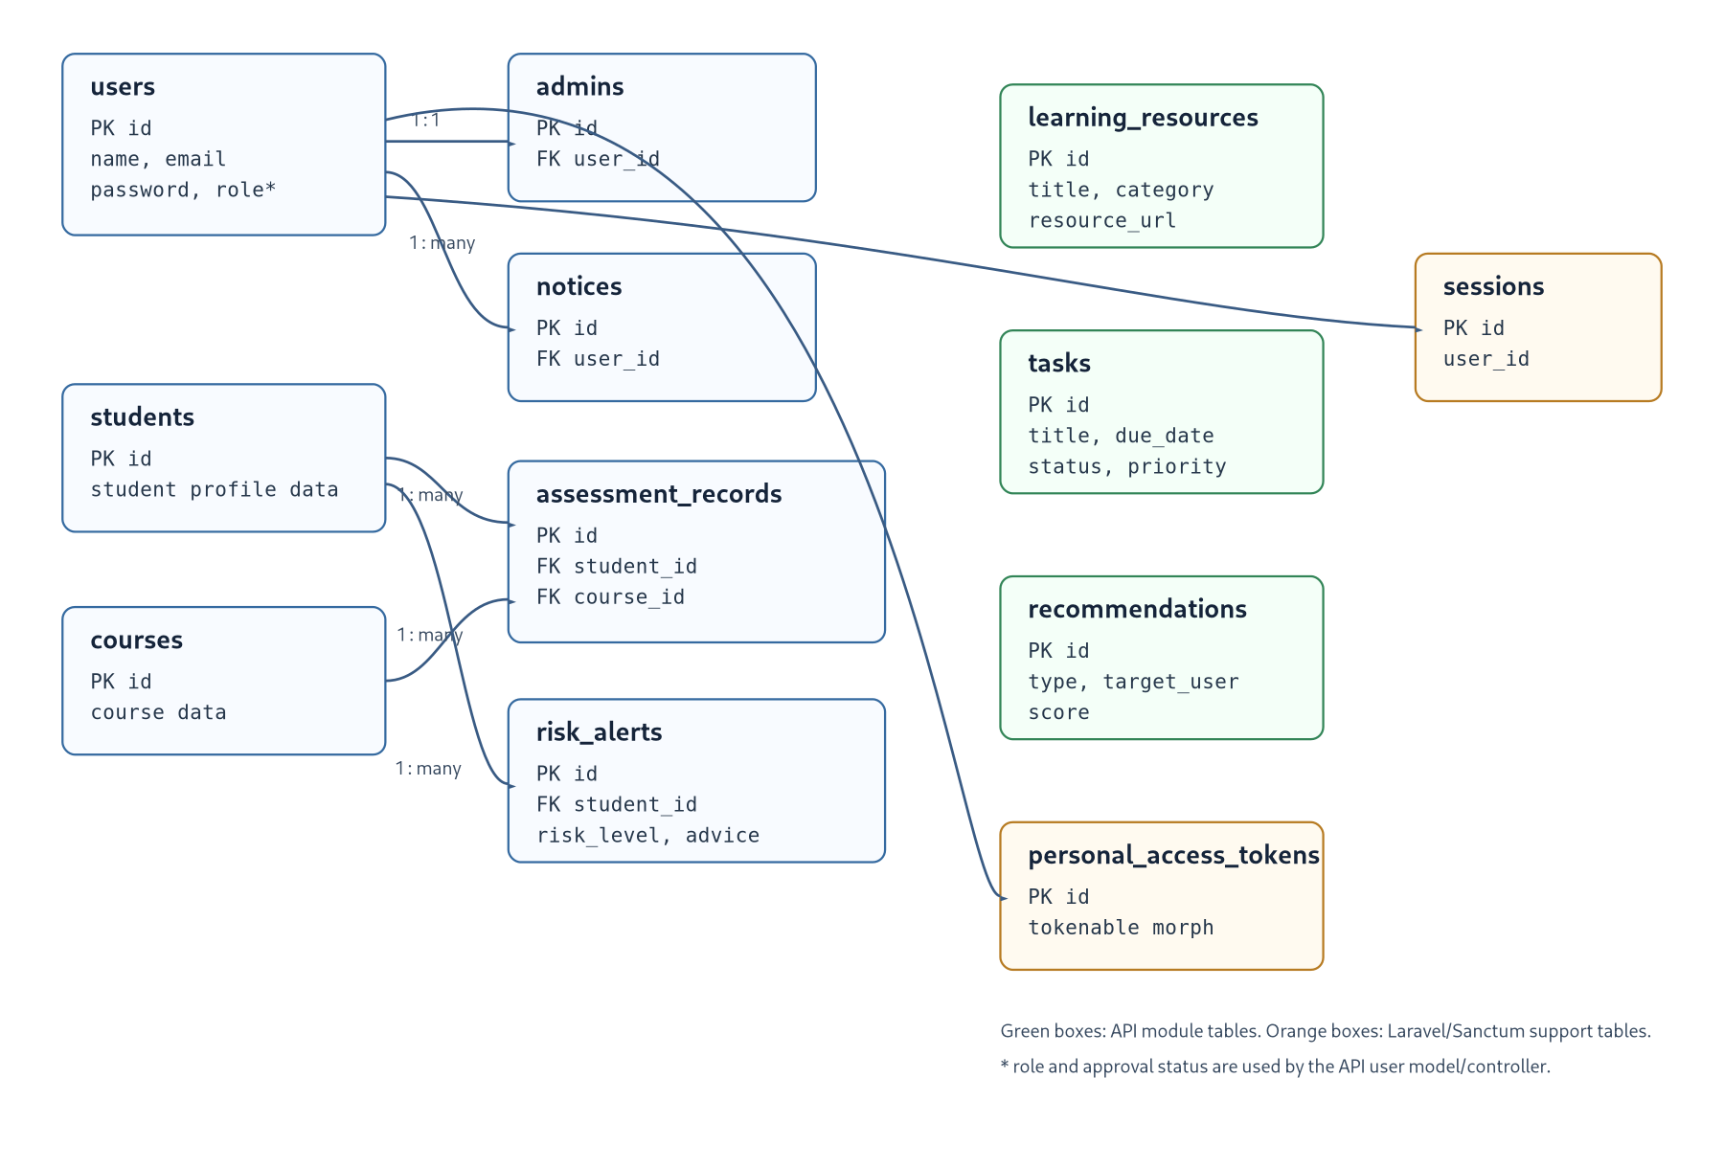

3. Relationship Summary
Relationship | Cardinality | Purpose
users.id to admins.user_id | One user can map to one admin profile. | Connects login identity with admin profile data.
users.id to notices.user_id | One user can publish many notices. | Tracks the author/publisher of campus notices.
students.id to assessment_records.student_id | One student can have many assessment records. | Stores quiz, assignment, and midterm marks per student.
courses.id to assessment_records.course_id | One course can have many assessment records. | Links assessment marks to a specific course.
students.id to risk_alerts.student_id | One student can have many risk alerts. | Stores predicted academic risk and intervention advice.
users to personal_access_tokens | One user can have many API tokens. | Supports Laravel Sanctum authentication.

4. Data Dictionary

4.1 users
Column | Type | Constraint | Description
id | bigint unsigned | Primary key, auto increment | Unique user identifier.
name | varchar | Required | User full name.
email | varchar | Required, unique | User email address used for login.
email_verified_at | timestamp | Nullable | Email verification timestamp.
password | varchar | Required | Hashed password.
remember_token | varchar | Nullable | Laravel remember token.
role | enum/string | Application field | Role values: student, faculty, admin.
approval_status | enum/string | Application field | Account approval state used by the login flow.
created_at, updated_at | timestamp | Nullable | Record audit timestamps.

4.2 admins
Column | Type | Constraint | Description
id | bigint unsigned | Primary key | Unique admin profile identifier.
user_id | bigint unsigned | Foreign key to users, cascade delete | Linked login account.
created_at, updated_at | timestamp | Nullable | Record audit timestamps.

4.3 students
Column | Type | Constraint | Description
id | bigint unsigned | Primary key | Unique student identifier.
created_at, updated_at | timestamp | Nullable | Record audit timestamps.

4.4 faculty
Column | Type | Constraint | Description
id | bigint unsigned | Primary key | Unique faculty identifier.
created_at, updated_at | timestamp | Nullable | Record audit timestamps.

4.5 courses
Column | Type | Constraint | Description
id | bigint unsigned | Primary key | Unique course identifier.
created_at, updated_at | timestamp | Nullable | Record audit timestamps.

4.6 assessment_records
Column | Type | Constraint | Description
id | bigint unsigned | Primary key | Unique assessment record identifier.
student_id | bigint unsigned | Foreign key to students, cascade delete | Student who owns the marks.
course_id | bigint unsigned | Foreign key to courses, cascade delete | Course for the assessment.
quiz_marks | float | Default 0 | Quiz mark total.
assignment_marks | float | Default 0 | Assignment mark total.
mid_marks | float | Default 0 | Midterm mark total.
created_at, updated_at | timestamp | Nullable | Record audit timestamps.

4.7 notices
Column | Type | Constraint | Description
id | bigint unsigned | Primary key | Unique notice identifier.
user_id | bigint unsigned | Nullable foreign key to users, null on delete | User who published the notice.
title | varchar(255) | Required | Notice headline.
description | text | Required | Notice details.
publish_date | timestamp | Nullable | Date/time the notice is published.
created_at, updated_at | timestamp | Nullable | Record audit timestamps.

4.8 risk_alerts
Column | Type | Constraint | Description
id | bigint unsigned | Primary key | Unique risk alert identifier.
student_id | bigint unsigned | Foreign key to students, cascade delete | Student at risk.
risk_level | enum | low, medium, high; default low | Predicted academic risk level.
prediction | varchar(255) | Required | Prediction label or summary.
advice | text | Nullable | Suggested intervention or guidance.
created_at, updated_at | timestamp | Nullable | Record audit timestamps.

4.9 learning_resources
Column | Type | Constraint | Description
id | bigint unsigned | Primary key | Unique learning resource identifier.
title | varchar | Required | Resource title.
description | text | Nullable | Resource summary or details.
category | varchar | Required | Subject or category, for example CSE.
resource_type | varchar | Required | Resource format such as PDF, video, link, note.
resource_url | varchar | Nullable | External or uploaded resource URL.
uploaded_by | varchar | Nullable | Name or identifier of uploader.
created_at, updated_at | timestamp | Nullable | Record audit timestamps.

4.10 tasks
Column | Type | Constraint | Description
id | bigint unsigned | Primary key | Unique campus task identifier.
title | varchar | Required | Task title.
description | text | Nullable | Task details.
assigned_to | varchar | Nullable | Student/faculty/admin assigned to the task.
due_date | date | Nullable | Task deadline.
status | enum | pending, in_progress, completed; default pending | Task workflow state.
priority | enum | low, medium, high; nullable | Task priority level.
created_at, updated_at | timestamp | Nullable | Record audit timestamps.

4.11 recommendations
Column | Type | Constraint | Description
id | bigint unsigned | Primary key | Unique recommendation identifier.
title | varchar | Required | Recommendation title.
description | text | Nullable | Recommendation details.
recommendation_type | varchar | Required | Type such as study_plan, course_advice, risk_support.
target_user | varchar | Nullable | User or student receiving the recommendation.
score | float | Nullable | Confidence score, priority score, or performance score.
created_at, updated_at | timestamp | Nullable | Record audit timestamps.

4.12 Supporting Project Tables
Table | Main Columns | Purpose
academic_records | id, timestamps | Reserved for semester, CGPA, and academic history records.
attendance_records | id, timestamps | Reserved for attendance tracking by student/course/date.
performance_metrics | id, timestamps | Reserved for analytics values used in dashboards and risk prediction.
course_recommendations | id, timestamps | Reserved for AI-generated future course advice.

4.13 Laravel System Tables
Table | Important Columns | Purpose
personal_access_tokens | tokenable_type, tokenable_id, token, abilities, expires_at | Stores Sanctum API tokens.
password_reset_tokens | email, token, created_at | Supports password reset workflow.
sessions | id, user_id, ip_address, user_agent, payload, last_activity | Stores session data when database sessions are enabled.
cache, cache_locks | key, value, expiration | Stores cache and cache lock data.
jobs, job_batches, failed_jobs | Queue payload, status, and failure fields | Supports Laravel queue processing.

5. Normalization Notes
- Each table has a single primary key and stores data for one main entity or workflow.
- Authentication data is kept in users, while academic and workflow data is stored in separate module tables.
- Assessment marks use separate foreign keys for students and courses, avoiding duplicated student/course data.
- Risk alerts are separated from assessment records so multiple predictions can exist for one student over time.
- API module tables are independent at the current implementation stage and can later be connected to users, students, or courses through foreign keys.

6. API Table Mapping
API Resource | Database Table | Supported Actions
Authentication | users, personal_access_tokens | Register, Login, Profile, Logout
Learning Resources | learning_resources | Create, List, Show, Update, Delete
Campus Tasks | tasks | Create, List, Show, Update, Delete
Recommendations | recommendations | Create, List, Show, Update, Delete

7. Implementation Checklist
Requirement | Status in Design | Notes
Primary Keys | Included | Every table uses an id primary key.
Foreign Keys | Included where direct relationships exist | Implemented for users/admins/notices, students/assessment, courses/assessment, and students/risk alerts.
Relationships | Documented | Relationship summary identifies cardinality and purpose.
Validations | Defined at application level | Required, unique, nullable, enum, and default rules are described in the data dictionary.
Scalability | Supported | Module-based tables can be expanded without redesigning the whole schema.

8. Conclusion
This database design provides the relational foundation for the AI-Smart Campus System. It supports authentication, academic monitoring, resource management, campus tasks, notices, AI recommendations, and risk alert workflows. The schema is functional for the current Laravel backend and can be expanded with additional foreign keys and profile fields as project modules become more detailed.

