# Abstract

The document is capturing the Test results for the ATM project.

Table of Contents

1 Use Case : Pin Authentication 1

1.1 Test Case: User providing the correct Account Number and Pin 1

1.2 Test Case: User providing the correct Account Number and wrong pic 1

1.3 Test Case: User providing the correct Account Number and Pin 1

1.4 Test Case: User providing the correct Account Number and wrong pin 1

2 Use Case : Checking the Balance in the user account 2

2.1 Test Case: User providing the correct Account Number and pin 2

3 Use Case : Withdrawal of the amount 2

3.1 Test Case: Money withdrawal where there is sufficient money in the user account and in ATM 2

3.2 Test Case: Checking the higher denomination currency is dispensed 2

3.3 Test Case: User entering invalid amount to be withdrawn 3

3.4 Test Case: Money withdrawal where there is insufficient money in the user account 3

3.5 Test Case: Money withdrawal check for higher currency denomination 4

3.6 Test Case: Money withdrawal where there is insufficient 50notes money in the ATM 4

3.7 Test Case: Money withdrawal checking the overdraft withdrawal 5

3.8 Test Case: Money withdrawal checking the overdraft withdrawal and not sufficient money in the user account 5

3.9 Test Case: Successful money withdrawal for the other user account. 6

3.10 Test Case: Money withdrawal when there is not sufficient money in ATM 6

3.11 Test Case: Money withdrawal when there is not sufficient money in ATM and in user account 7

# Use Case : Authentication

## Test Case: Balance Check: User providing the correct Account Number and Pin

Inputs: Account Number and Pin

Scenario: While checking the balance

Result: The balance is displayed. The Account Number is correct and Pin is correct

## Test Case: Balance Check: User providing the correct Account Number and wrong pin

Inputs: Account Number and Pin

Scenario: While checking the balance

Result: Balance is not displayed.

Message: The pin entered is not correct.

## Test Case: Balance Check: User providing the wrong account Number

Inputs: Account Number and Pin

Scenario: While checking the balance

Result: Balance is not displayed.

Message: The pin entered is not correct.

## Test Case: Withdrawal: User providing the correct Account Number and Pin

Inputs: Account Number and Pin

Scenario: Withdrawal

Result: The amount is withdrawn. The pin is correct.

## Test Case: Withdrawal: User providing the correct Account Number and wrong pin

Inputs: Account Number and Pin

Scenario: Withdrawal

Result: The amount is not withdrawn.

Message: The pin entered is not correct.

# Use Case : Checking the Balance in the user account

## Test Case: User providing the correct Account Number and pin

Inputs: Account Number and Pin

Scenario: Checking the balance

Result: The balance is displayed. The pin is correct.

Message:

The balance is:

Amount Available in the account: 800

Amount that can be withdrawn: 1000

# Use Case : Withdrawal of the amount

## Test Case: Money withdrawal where there is sufficient money in the user account and in ATM

Inputs: Account Number, Pin and amount to be withdrawn = 185

Scenario: Withdrawing the amount

|  |  |
| --- | --- |
| User account Data (123456789) | ATM Data |
| Balance: 800  Overdraft: 200 | Available: 1500  50 Notes: 10  20 Notes: 30  10 Notes: 30  5 Notes: 20 |

Message:

Withdrawn Amount:

50 Notes: 3

20 Notes: 1

10 Notes: 1

5 Notes: 1

Available balance is: 615

Amount that can be withdrawn: 815

## Test Case: Checking the higher denomination currency is dispensed

Inputs: Account Number, Pin and amount to be withdrawn = 185

Scenario: Withdrawing the amount

|  |  |
| --- | --- |
| User account Data (123456789) | ATM Data |
| Balance: 800  Overdraft: 200 | Available: 1500  50 Notes: 10  20 Notes: 30  10 Notes: 30  5 Notes: 20 |

Message:

Withdrawn Amount:

50 Notes: 3

20 Notes: 1

10 Notes: 1

5 Notes: 1

Available balance is: 615

Amount that can be withdrawn: 815

## Test Case: User entering invalid amount to be withdrawn

Inputs: Account Number, Pin and amount to be withdrawn = 111

Scenario: Withdrawing the amount

|  |  |
| --- | --- |
| User account Data (123456789) | ATM Data |
| Balance: 615  Overdraft: 200 | Available: 1335  50 Notes: 7  20 Notes: 29  10 Notes: 29  5 Notes: 19 |

Message:

The amount entered must be in multiples of 5.

P.S : Cannot test this in Junit, since the servlet class is not covered in Junit.

## Test Case: Money withdrawal when there is insufficient money in the user account

Inputs: Account Number, Pin and amount to be withdrawn = 1000

Scenario: Withdrawing the amount

|  |  |
| --- | --- |
| User account Data (123456789) | ATM Data |
| Balance: 615  Overdraft: 200 | Available: 1335  50 Notes: 7  20 Notes: 29  10 Notes: 29  5 Notes: 19 |

Message:

Insufficient money in the user account

## Test Case: Money withdrawal check for higher currency denomination when higher currency is limited

Inputs: Account Number, Pin and amount to be withdrawn = 555

Scenario: Withdrawing the amount

|  |  |
| --- | --- |
| User account Data (123456789) | ATM Data |
| Balance: 615  Overdraft: 200 | Available: 1335  50 Notes: 7  20 Notes: 29  10 Notes: 29  5 Notes: 19 |

Message:

Withdrawn Amount:

50 Notes: 7

20 Notes: 10

10 Notes: 0

5 Notes: 1

Available balance is: 60

Amount that can be withdrawn: 260

## Test Case: Money withdrawal where there is insufficient a specific currency note is zero money in the ATM

Inputs: Account Number, Pin and amount to be withdrawn = 60

Scenario: Withdrawing the amount

|  |  |
| --- | --- |
| User account Data (123456789) | ATM Data |
| Balance: 60  Overdraft: 200 | Available: 780  50 Notes: 0  20 Notes: 19  10 Notes: 29  5 Notes: 18 |

Message:

Withdrawn Amount:

50 Notes: 0

20 Notes: 3

10 Notes: 0

5 Notes: 0

Available balance is: 0

Amount that can be withdrawn: 200

## Test Case: Money withdrawal checking the overdraft withdrawal

Inputs: Account Number, Pin and amount to be withdrawn = 50

Scenario: Withdrawing the amount

|  |  |
| --- | --- |
| User account Data (123456789) | ATM Data |
| Balance: 0  Overdraft: 200 | Available: 720  50 Notes: 0  20 Notes: 16  10 Notes: 29  5 Notes: 18 |

Message:

Withdrawn Amount:

50 Notes: 0

20 Notes: 2

10 Notes: 1

5 Notes: 0

Available balance is: -50

Amount that can be withdrawn: 150

## Test Case: Money withdrawal checking the overdraft withdrawal and not sufficient money in the user account

Inputs: Account Number, Pin and amount to be withdrawn = 250

Scenario: Withdrawing the amount

|  |  |
| --- | --- |
| User account Data (123456789) | ATM Data |
| Balance: -50  Overdraft: 150 | Available: 670  50 Notes: 0  20 Notes: 14  10 Notes: 28  5 Notes: 18 |

Message:

Withdrawn Amount:

Insufficient amount in the user account.

## Test Case: Successful money withdrawal for the other user account.

Inputs: Account Number, Pin and amount to be withdrawn = 200

Scenario: Withdrawing the amount

|  |  |
| --- | --- |
| User account Data (987654321) | ATM Data |
| Balance: 1230  Overdraft: 150 | Available: 670  50 Notes: 0  20 Notes: 14  10 Notes: 28  5 Notes: 18 |

Message:

Withdrawn Amount:

50 Notes: 0

20 Notes: 10

10 Notes: 0

5 Notes: 0

Available balance is: 1030

Amount that can be withdrawn: 1180

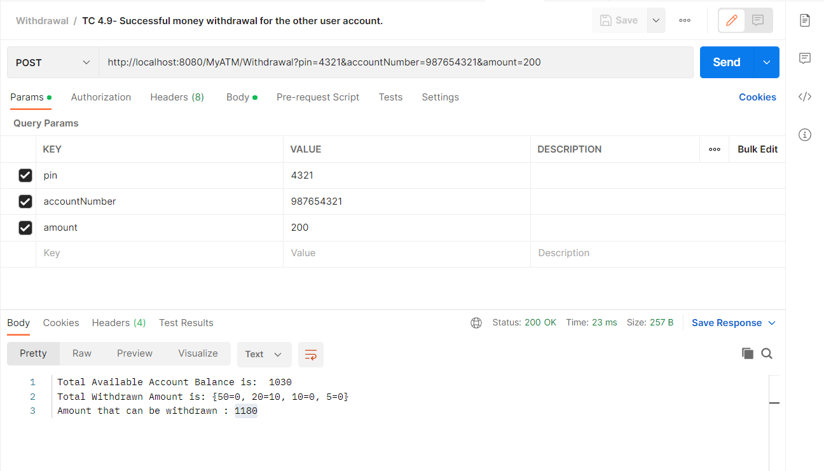

## Test Case: Money withdrawal when there is not sufficient money in ATM

Inputs: Account Number, Pin and amount to be withdrawn = 600

Scenario: Withdrawing the amount

|  |  |
| --- | --- |
| User account Data (987654321) | ATM Data |
| Balance: 0  Overdraft: 150 | Available: 470  50 Notes: 0  20 Notes: 4  10 Notes: 28  5 Notes: 18 |

Message:

Not sufficient money in ATM.

## Test Case: Money withdrawal when there is not sufficient money in ATM and in user account

Inputs: Account Number, Pin and amount to be withdrawn = 600

Scenario: Withdrawing the amount

|  |  |
| --- | --- |
| User account Data (123456789) | ATM Data |
| Balance: 0  Overdraft: 150 | Available: 470  50 Notes: 0  20 Notes: 4  10 Notes: 28  5 Notes: 18 |

Message:

