**Coffee Sales Dashboard Analysis – Astoria**

**Key Observations**

**1. Revenue Trend (Monthly)**

- Consistent growth from Jan ($27,314) to Jun ($55,083). More than 100% increase over 6 months.  
- Biggest jumps between Feb to Mar and Apr to May.  
- Indicates success in marketing, new product launches, or seasonal demand.

**2. Transactions by Hour of Day**

- Peak hours: 9 AM to 11 AM, tapering off after 12 PM.  
- Friday and weekends show lower volume.  
- Morning rush is dominant, likely officegoers or breakfast crowd.

**3. Transactions by Day of Week**

- High activity from Monday to Wednesday.  
- Drops significantly after Thursday.  
- Lowest on weekends (Sat & Sun).  
- Indicates B2B or commuter-heavy customer base (office workers, not weekend cafegoers).

**4. Top Product Categories**

|  |  |
| --- | --- |
| **Category** | **Transactions** |
| Coffee | 20,025 |
| Tea | 16,260 |

**Coffee & tea** are the dominant categories, focus remains beverage driven.

**5. Top Products (by Revenue and Transactions)**

- Barista Espresso has the highest revenue per transaction.  
- Chai tea and hot chocolate surprisingly high — diversity of non-coffee drinkers.

**Insights & Patterns**

**Product Performance**

- Chai Tea, Hot Chocolate, and Barista Espresso are top drivers, consider promotional bundles.  
- Some low-revenue products (Sugar-Free Syrup, Packaged Chocolate) have marginal impact, may need rationalization.

**Day & Hour Demand Gaps**

- Weekends underperform. Could be due to:  
- Lack of family-friendly promotions.  
- Not enough marketing to casual cafegoers.  
- Post-lunch traffic drops. Opportunity for afternoon promos (2–5PM discounts).

**Recommendations for Improvement**

1. Afternoon & Weekend Promotions

Run “Happy Hour” from 2–5 PM and promote weekend specials for families or remote workers.

1. Menu Optimization

Trim underperforming products and focus on high-margin items. Offer customizable bundles.

1. Customer Loyalty Program

Implement points-based rewards, referral bonuses, and birthday discounts.

1. Operational Efficiency

Staff heavily during morning rush. Consider reducing staff or switching to part-timers on weekends. Use sales data for inventory forecasting.

**Coffee Sales Dashboard Analysis – Hell’s Kitchen**

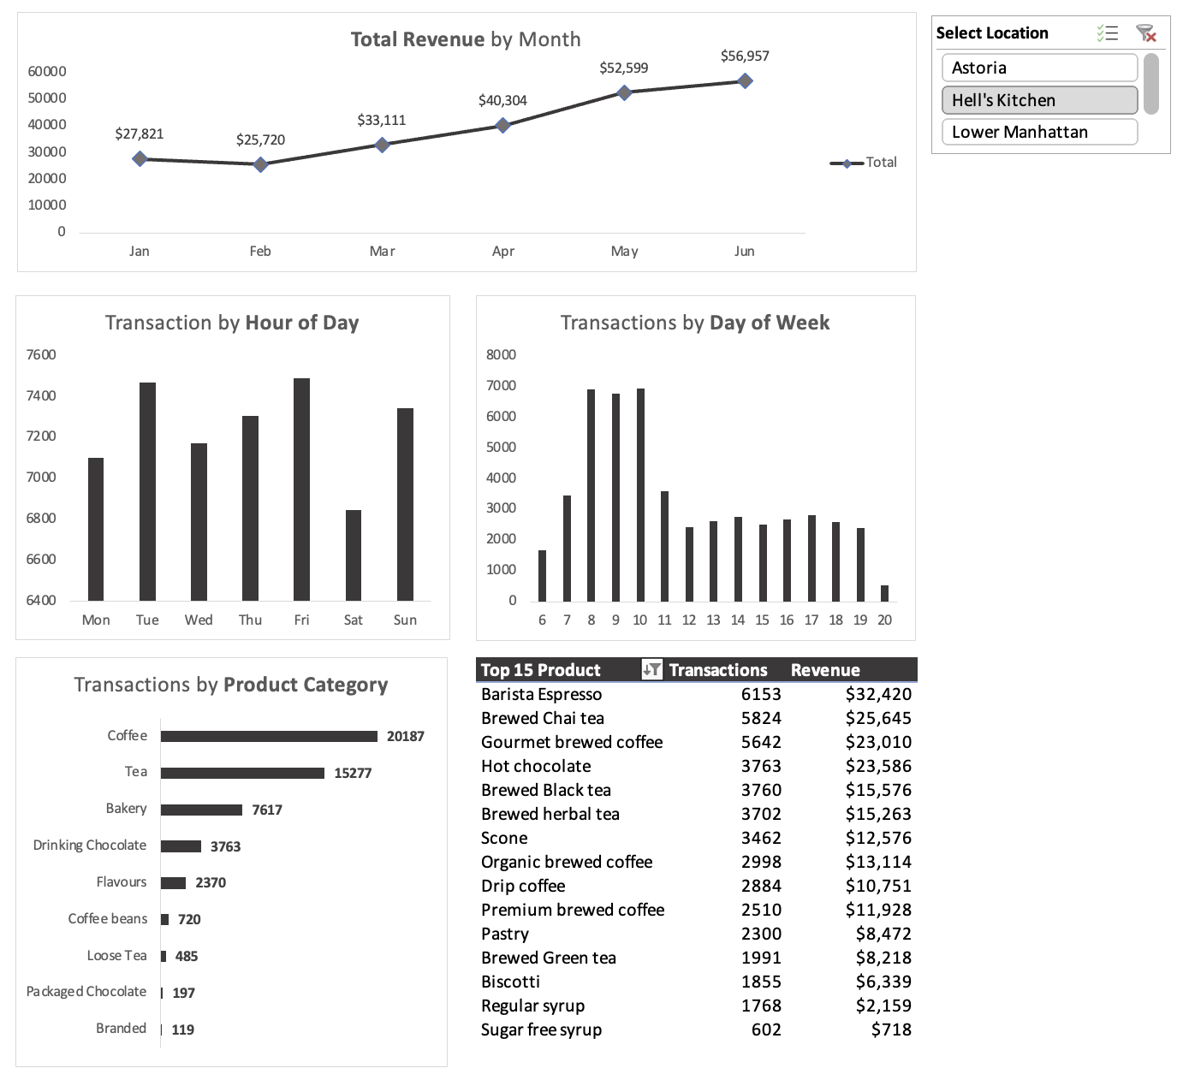

**Key Observations**

**1. Revenue Trend (Monthly)**

- Consistent growth from Jan ($27,821) to Jun ($56,957). More than 100% increase over 6 months.  
- Biggest jumps between Feb to Mar and Apr to May.  
- Indicates strong seasonal demand, effective marketing, or product launches.

**2. Transactions by Hour of Day**

- Peak hours from 9 AM to 11 AM, with noticeable spikes on Monday and Friday.  
- Sunday midday also shows slightly stronger performance compared to other weekend slots.  
- Morning rush is still dominant, but Friday midday spike suggests pre-weekend social or work gatherings.

**3. Transactions by Day of Week**

- Highest transaction counts occur between days 8–10 (likely Mon–Wed).  
- Drop after day 11, with lowest on day 20 (likely Sunday).  
- Weekday dominance indicates reliance on office-worker traffic, with weekends underperforming.

**4. Top Product Categories**

|  |  |
| --- | --- |
| **Category** | **Transactions** |
| Coffee | 20,187 |
| Tea | 15,277 |

Coffee remains the leader, but Tea transactions have slightly decreased compared to the previous dataset.

**5. Top Products (by Revenue and Transactions)**

- Barista Espresso remains the top revenue generator.  
- Brewed Chai Tea and Hot Chocolate continue to perform strongly, showing appeal beyond coffee drinkers.

**Insights & Patterns**

**Product Performance**

- Espresso, Chai Tea, and Hot Chocolate continue to lead.  
- Tea sales have slightly declined. Targeted campaigns could help recover this segment.  
- Low performers like Sugar-Free Syrup and Branded items could be reviewed for removal or rebranding.

**Day & Hour Demand Gaps**

- Weekdays (Mon–Wed) dominate sales.  
- Fridays show a strong midday spike, suggesting potential for targeted promotions.  
- Sundays underperform significantly. Opportunity for brunch or family promotions.

**Recommendations for Improvement**

1. Boost Weekend Traffic

Offer Sunday brunch specials, live events, or discounts for families and remote workers.

1. Capitalize on Friday Midday Spike

Launch 'Friday Lunch Combos' or office delivery discounts targeting the work crowd.

1. Menu Optimization

Reassess low-performing products. Keep focus on espresso-based drinks and seasonal beverages.

1. Revive Tea Sales

Offer tea-focused bundles, loyalty programs, or seasonal tea promotions to recover lost transactions.

1. Operational Adjustments

Increase staffing during high-demand hours (mornings, Friday lunch). Use part-time shifts for slow periods.

**Coffee Sales Dashboard Analysis – Lower Manhattan**

**Key Observations**

**1. Revenue Trend (Monthly)**

- Consistent growth from Jan ($26,543) to Jun ($54,446). Over 100% increase in 6 months.  
- Notable jumps between Feb to Mar and Apr to May.  
- Indicates seasonal demand spikes, effective marketing campaigns, or successful promotions.

**2. Transactions by Hour of Day**

- Monday mornings (around 7–9 AM) are the busiest.  
- Friday mornings and midday also perform relatively well.  
- Suggests a strong commuter and office-worker customer base during early hours.

**3. Transactions by Day of Week**

- Peak transaction counts occur between days 7–9 (likely Mon–Wed).  
- Significant drop after day 11, with the lowest counts on day 20 (likely Sunday).  
- Weekday dominance shows reliance on working crowd, weekends underperform.

**4. Top Product Categories**

|  |  |
| --- | --- |
| Category | Transactions |
| Coffee | 18,204 |
| Tea | 13,912 |

Coffee remains the dominant category, but Tea transactions have declined compared to earlier datasets.

**5. Top Products (by Revenue and Transactions)**

- Barista Espresso is the highest revenue generator.  
- Brewed Chai Tea and Hot Chocolate show strong demand from non-coffee drinkers.

**Insights & Patterns**

**Product Performance**

- Espresso, Chai Tea, and Hot Chocolate remain strong performers.  
- Tea category decline suggests the need for targeted marketing.  
- Low performers like Sugar-Free Syrup and Packaged Chocolate may require repositioning or removal.

**Day & Hour Demand Gaps**

- Strong Monday and weekday morning sales.  
- Weekends, especially Sundays, are weak.  
- Friday midday shows potential for targeted lunch-hour campaigns.

**Recommendations for Improvement**

1. Boost Weekend Sales

Offer weekend-exclusive menu items, brunch specials, or community events to attract non-commuter customers.

1. Leverage Friday Midday

Introduce Friday lunch deals or office delivery promotions for nearby workplaces.

1. Revive Tea Category

Promote tea with pastry bundles, seasonal flavors, and targeted loyalty programs.

1. Menu Optimization

Focus on high-margin espresso drinks and popular non-coffee options; phase out or revamp underperformers.

1. 5. Operational Adjustments

Adjust staffing to meet weekday morning peaks; consider part-time staff for slow weekend hours.