HouseLedger Implementation Guide
  - Shared NestJS backend with Next.js and Flutter
Architecture and delivery blueprint for the House income and expense project
Prepared for Nazrul Islam · 7 November 2026

Recommended foundation
Build one NestJS modular backend and one PostgreSQL database. Use Next.js for the admin web interface and one Flutter application with role-specific navigation. Both clients call the same versioned API. NestJS owns permissions, tenancy changes, bill calculations, payments and audit history. Next.js does not become a second business backend.
Start with a modular monolith: clear feature boundaries inside one codebase. Run the API and background worker as separate processes from the same release. This keeps financial transactions straightforward while allowing requests and scheduled work to scale independently.
Layer | Recommended responsibility
Next.js | Admin presentation, forms, server rendering and API consumption
Flutter | Admin viewing, manager operations and resident self-service
NestJS | Shared authentication, policy, billing and collection rules
PostgreSQL | Authoritative relational data, balances, audit and outbox
Redis and worker | Durable job delivery, scheduled processing and retries
Shared design tokens | Fonts, spacing, colors, dimensions and component states

How to use this guide
Sections 01–10 define scope, security and data. Sections 11–18 describe workflows and API contracts. Sections 19–25 cover client structure, visual consistency, queries and caching. Sections 26–34 cover jobs, security, deployment, testing, delivery and references.
This is an implementation specification, not a completed application. The earlier screen images establish the visual direction; the rules and tokens here resolve implementation details. Capacity figures are proposed test targets, not measured guarantees. Unconfirmed billing policies are explicitly identified before any automatic charging is enabled.

01 Product scope and decisions
The first release manages houses, rooms, manager assignments, residents, tenancies, rent bills, meter readings, electricity bills and separate collections. The word resident is used for the end user throughout. General expense accounting, deposits, online payment gateways and shared-room billing are outside the supplied requirements.
Capability | Admin web | Admin app | Manager app | Resident app
Houses and managers | Manage | View | Assigned scope | No access
Rooms and residents | Manage all | View | Own records only | Own room view
Meter and tariff | Manage all | View | Own scope | View own bill
Record collections | Rent and electric | No | Own scope | No
Collection reports | All | View all | Own scope | Own records
Profile changes | Manage accounts | No domain edits | Own profile | Own profile

Defaults that keep the product simple
- One organization initially, with organization_id on business records so future organizations can be isolated without a data rewrite.
- One active tenancy per room and one active room per resident account. Support multiple managers assigned to a house; each still sees only their own records.
- English and BDT initially. Store the house timezone explicitly; default to Asia/Dhaka. Keep translation keys ready for Bangla.
- One active meter installation per room. A meter can be replaced without deleting its reading history.
- A partial payment is allowed. Overpayment, combining rent and electricity, and client-side paid-status editing are not allowed.

Decisions required before billing goes live
Confirm the due day, move-in and move-out charging policy, mid-month proration, rate-change effective period, meter-replacement settlement, and retention period. For launch simplicity, prefer month-boundary rent changes and room moves. Until an approved mid-month policy exists, route affected bills to admin review rather than calculating an invented charge. SMS recovery and notifications also require an agreed provider.

02 System architecture
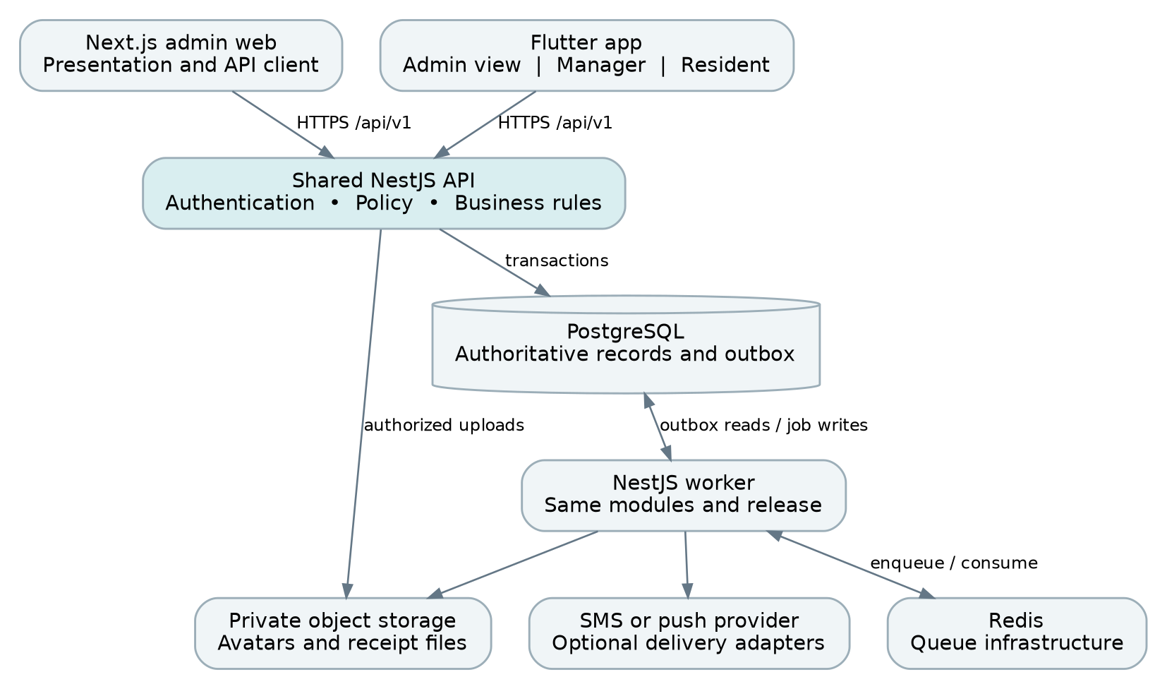
Figure 1 One shared backend serves both clients and a separate worker
The public contract is /api/v1. Route the admin website and API through one TLS reverse proxy where practical. Flutter calls the same API host. The Next.js server may call NestJS for authenticated server rendering, but it must never read PostgreSQL directly or duplicate billing calculations.
PostgreSQL is the source of truth. Redis is infrastructure, not the financial ledger. Private object storage holds uploaded avatars and generated receipt documents. A database outbox connects committed business changes to asynchronous jobs, avoiding the gap between saving a payment and queuing its notification.

Scale in this order
First optimize SQL and remove repeated requests. Then add API replicas and independently adjust worker concurrency. Add a short-lived dashboard cache only after measuring its value. Introduce read replicas for lag-tolerant reports or split services only when actual load and team boundaries justify them. Do not start with Kubernetes, sharding or separate databases for each role.
Technology versions should be compatible stable releases pinned in lockfiles and container images at project kickoff. Treat framework examples in this guide as patterns; verify exact syntax against the selected release. References were checked on 7 November 2026.

03 Repository and module boundaries
Location | Contents
apps/api | NestJS HTTP entry point, controllers and feature modules
apps/worker | NestJS worker entry point using the same domain modules
apps/admin-web | Next.js App Router admin application
apps/mobile | Flutter app with admin, manager and resident feature shells
packages/contracts | Exported OpenAPI document and generated client inputs
packages/design-tokens | Versioned JSON token source, generators and font assets
packages/web-ui | Shared React components used by all admin screens
infra and docs | Deployment definitions, migrations, runbooks and decisions

NestJS module ownership
Module | Owned behavior
Identity and Access | Users, sessions, credential recovery and authorization policy
Properties | Houses, rooms, manager assignments and lifecycle
Residents and Tenancies | Resident profiles, allocation, moves and effective rent terms
Metering | Meters, installations, readings and tariff versions
Billing | Rent bills, electricity bills, previews, adjustments and balances
Collections | Payments, reversals, receipts and idempotency
Reporting | Scoped list and aggregate queries; no business mutations
Platform | Audit, outbox, files, notifications, configuration and health

Controllers validate transport input and invoke a service. Services enforce policy and transactions. Repositories perform scoped database operations. Modules expose explicit services rather than letting every feature write every table. Use one ORM consistently; Prisma is a reasonable default, with parameterized SQL for locks and specialized queries. Do not duplicate model definitions independently in TypeScript and Dart: generate API clients from the contract. [1, 8]

04 Authorization and record ownership
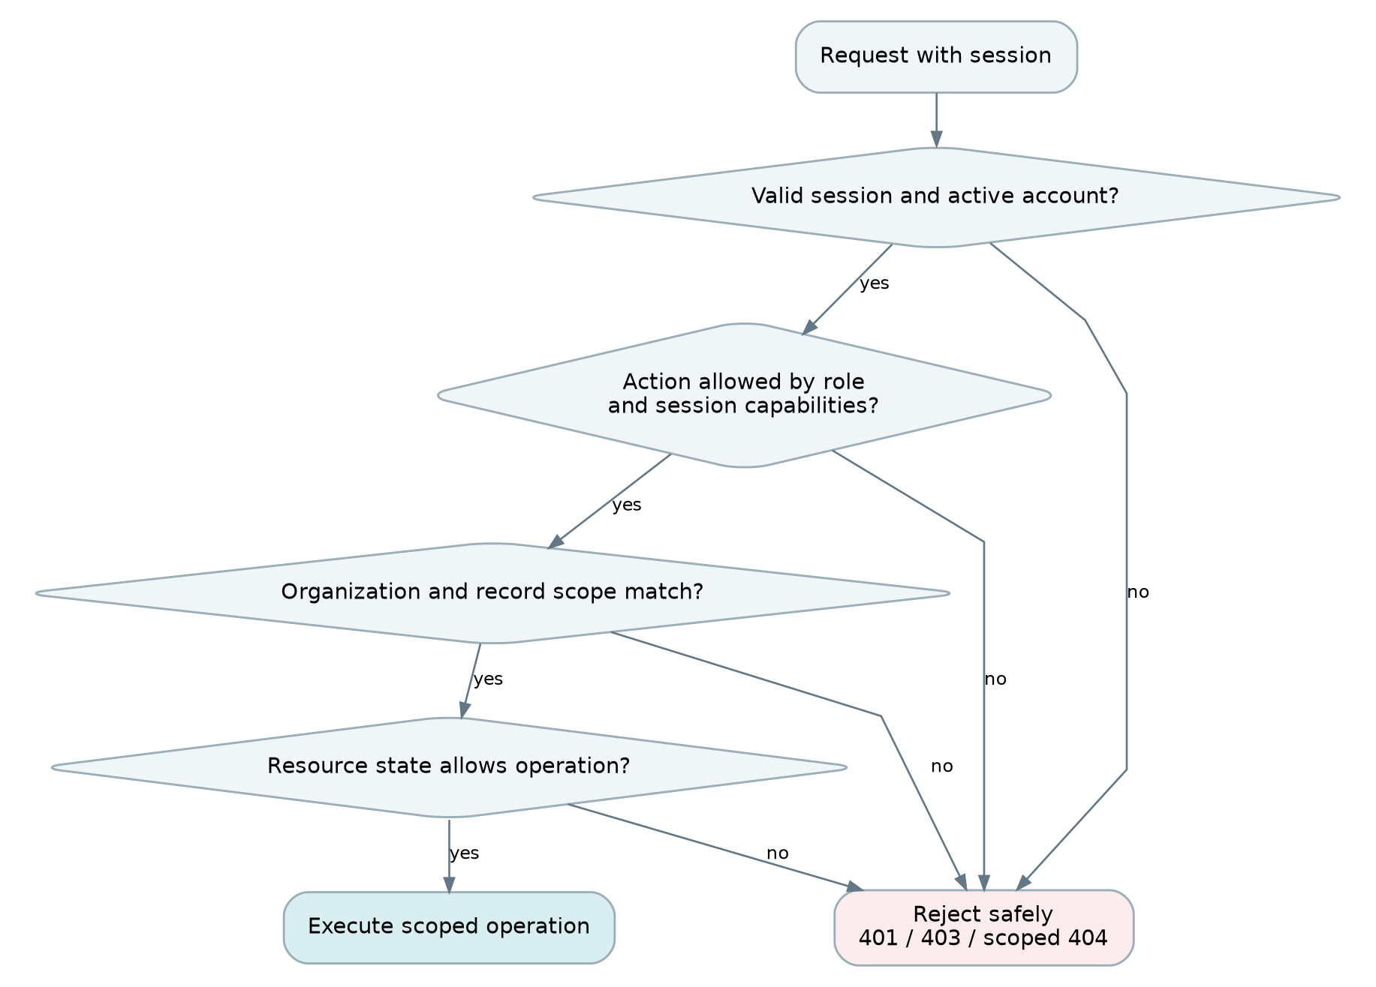
Figure 2 Authorization checks action, scope and resource state
A role check alone is insufficient. A manager operation must match the organization, an active house assignment and the record creator. For a tenancy operation, both the room and resident must be within that manager’s permitted records. Meter access derives from its room; bill access derives from the original tenancy and room. A scheduled job creating a bill must not change who can manage it.
created_by_user_id is immutable audit data. Do not accept it, role, organization_id, paid_amount or permissions from a form. Derive them server-side. Admin-created records remain admin-managed under the user’s strict creator-only rule. Reassigning a house does not transfer its existing records; the admin can manage them while any future ownership-transfer feature is separately agreed.
Apply identical scope to list, detail, totals, search, receipts, exports and mutations. Scope at the database query, not by fetching all rows and filtering in memory. Return a scoped 404 for inaccessible IDs where appropriate. Centralize policy so guards and services cannot drift. [2, 15]

05 Authentication and session capabilities
Session class | Transport | Maximum business access
ADMIN_WEB | Secure HttpOnly host-only cookie | Admin read and write
ADMIN_MOBILE | Bearer access token | Admin read only
MANAGER_MOBILE | Bearer access token | Permitted own-record operations
RESIDENT_MOBILE | Bearer access token | Own records and profile edits

Use separate web and mobile login grants in the same Identity module. The web grant accepts admin accounts only. The mobile grant looks up the account role and issues that role’s fixed capability ceiling; it never accepts a requested role or writable admin scope. Every business mutation checks the stored session class as well as the current user policy. An admin mobile token must receive 403 on all domain writes, including endpoints that happen to use POST for a preview or export.
New accounts receive a single-use, expiring activation link or code to set their password. Store only its hash; never send a reusable password. Recovery uses the same controlled token lifecycle and revokes existing sessions after completion.

Credential and token lifecycle
- Hash passwords using a maintained password-hashing implementation with calibrated Argon2id settings. Rate-limit login and recovery by account and network source; avoid account-enumerating messages.
- Issue a short-lived access token, proposed 10 minutes, and a rotating refresh credential with a defined maximum session lifetime. Store refresh-token hashes and family/revocation data, never plaintext tokens.
- Web uses Secure, HttpOnly, SameSite cookies plus CSRF protection on state changes and origin checks. Mobile keeps access credentials in memory and refresh credentials in platform secure storage.
- Refresh once at a time per client. Detect refresh-token reuse and revoke the affected family. Sign-out, password reset, account deactivation and permission changes invalidate relevant sessions.
- Return effective capabilities from GET /me for navigation. Check current assignment and resource scope for protected data; do not trust a stale JWT role to authorize a write.
A mobile-client header or embedded app secret cannot prove that a request came from a physical phone. The enforceable promise is that mobile sessions cannot gain web-admin privileges. If access must be restricted to managed devices, that is a separate device-attestation requirement. A manager is blocked from the web login grant, but the API is still a network API.

06 Relational data model
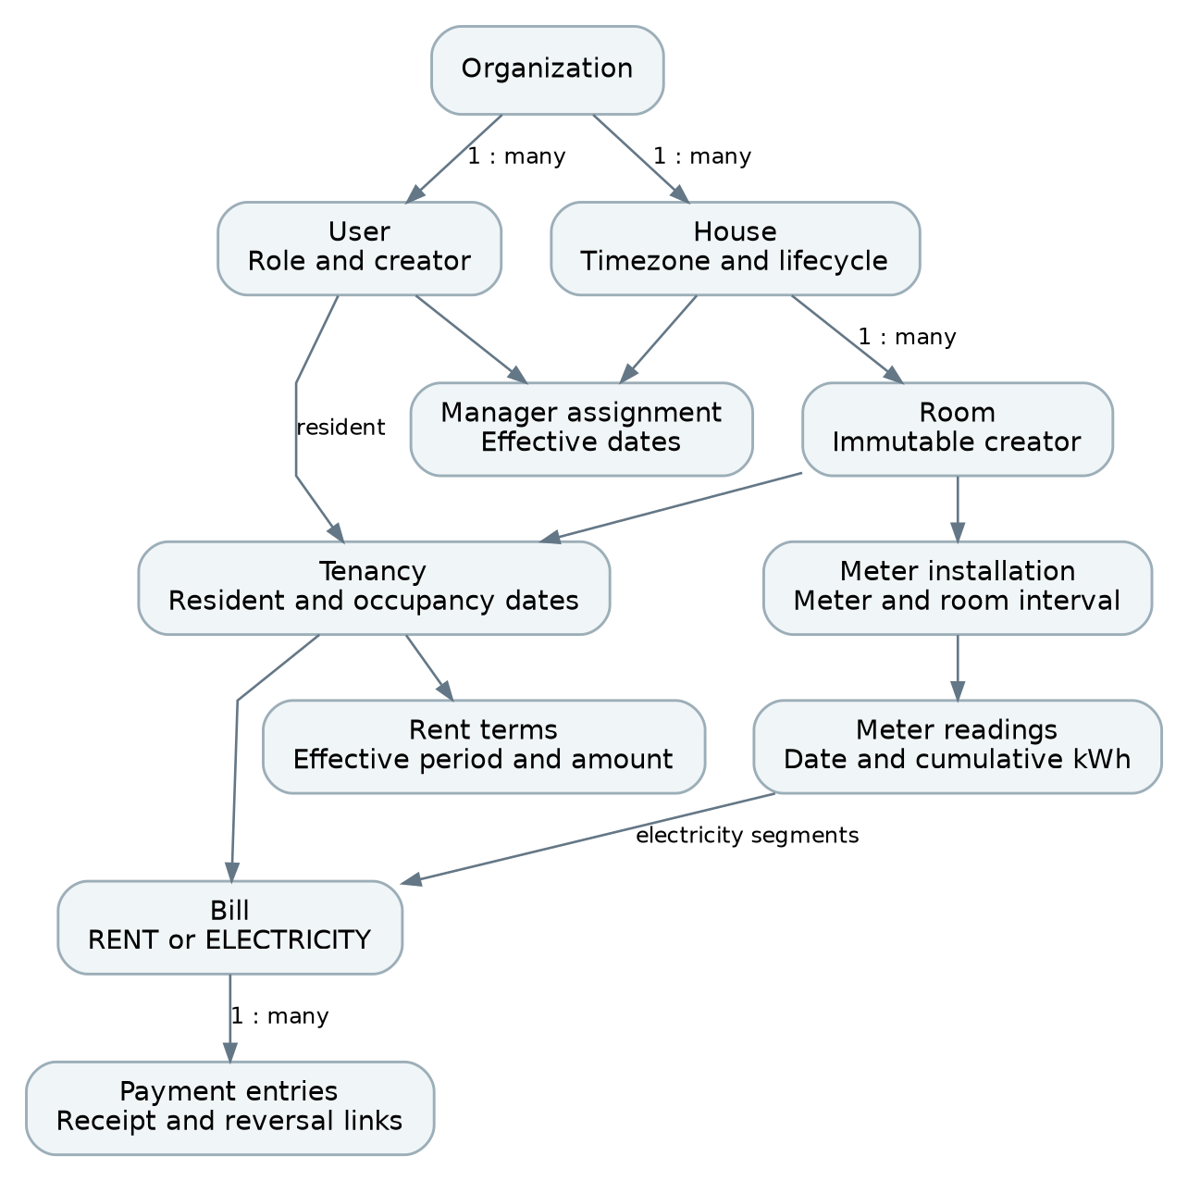
Figure 3 Core entities and their historical relationships
A resident account and a room are different entities. A tenancy records who occupied a room during an interval. Bills belong to that tenancy, so a new resident cannot inherit another person’s private financial history. Rent terms and meter installations have effective dates; changing today’s configuration does not rewrite yesterday’s bill.
The diagram shows principal relationships rather than every column. Every tenant-owned foreign key must preserve organization boundaries. Use composite keys or equivalent database constraints where cross-organization references are possible. Financial rows use restrictive deletion rules. [5]

07 Identity and property schema
Use UUID identifiers, created_at and updated_at timestamps, and organization_id on business tables. Store timestamps as timestamptz in UTC. Store billing months and local effective dates as date values, not timezone-shifted midnight timestamps.
Table | Important fields | Rules
organizations | id, name, currency, default_timezone | One row initially; do not scatter owner constants
users | id, organization_id, role, phone_normalized, password_hash, status, created_by_user_id | Unique normalized phone under the selected login model
sessions | id, user_id, class, refresh_hash, family_id, expires_at, revoked_at | Server-owned class; revoke explicitly
houses | id, organization_id, name, address, timezone, status | ACTIVE or ARCHIVED; hard delete only if unused
house_manager_assignments | house_id, manager_id, valid_from, valid_to | No duplicate overlapping assignment interval
rooms | id, house_id, room_number, created_by_user_id, status, version | Unique house plus room number; occupancy is derived
tenancies | id, room_id, resident_id, start_date, end_date, status, created_by_user_id | No overlapping live or scheduled occupancy
rent_terms | id, tenancy_id, effective_from, effective_to, amount_minor, currency | Non-overlapping effective terms; version bills by snapshot

Identity and lifecycle details
Normalize Bangladesh mobile numbers consistently, including the +880 country code. Decide whether accounts are globally unique or organization-scoped before the login contract is finalized. A user cannot self-change role, creator or organization. A room is Vacant when no relevant tenancy occupies it; do not maintain an unrelated occupied flag that can become inconsistent.
Use half-open intervals: the start date is included and the end date is excluded. A tenancy ending 1 December frees the room for a tenancy starting 1 December. Reject room or resident overlaps in the database, including future scheduled tenancies. Handle a room move as closing one tenancy and opening another in one transaction.

08 Metering and financial schema
Table | Important fields | Rules
meters | id, serial_number, organization_id, status | Unique serial in organization; keep retired meters
meter_installations | id, meter_id, room_id, installed_at, removed_at, baseline_kwh | No overlapping installation for room or meter
meter_readings | id, installation_id, read_at, reading_kwh, source, created_by_user_id | Cumulative decimal; accepted readings are versioned
tariff_versions | id, house_id, scope_owner_id, effective_from, rate_per_kwh, currency | Owner scope limits manager rate changes
bills | id, tenancy_id, house_id, room_id, type, period_start, period_end, revision, amount_minor, paid_minor, lifecycle, version, scope_owner_id, voided_at | RENT or ELECTRICITY; one active bill per business key
bill_segments | bill_id, installation_id, previous_reading_id, current_reading_id, usage_kwh, rate_snapshot | Electricity snapshot; supports meter replacement
payments | id, bill_id, kind, amount_minor, method, received_at, recorded_at, actor_id, receipt_number, reverses_payment_id | Immutable receipt/payment or linked reversal
audit_events and outbox_events | actor, action, resource, minimal payload, event_id, processing metadata | Transactional history and asynchronous handoff
idempotency_records | organization_id, actor_id, route, key, request_hash, result_id, state | Unique scoped key; replay same result

The shared bills table does not combine rent and electricity balances. The type discriminator is mandatory in queries, API routes and reports. Every payment references exactly one bill; the server derives its type. Avoid polymorphic references that allow a payment to point to either of two unrelated tables without a foreign key.
For simple tariffs, a manager’s rate scope is their own rooms within one house. An admin may set the house default. Resolve an explicit permitted override first, otherwise the default. Record the selected tariff ID and rate snapshot. Never let a manager change the default for another manager’s rooms.

09 Database invariants and indexes
Enforce essential invariants in PostgreSQL as well as NestJS. Use migrations for uniqueness, foreign keys, checks and exclusion constraints. Prisma models do not replace database protection; keep specialized constraint SQL in reviewed migrations. [5, 6, 8]
-- Illustrative migration fragments; use actual mapped table names.
CREATE UNIQUE INDEX rooms_house_number_uq
ON rooms (organization_id, house_id, room_number);
CREATE UNIQUE INDEX active_bill_business_key_uq
ON bills (organization_id, tenancy_id, type,
period_start, period_end)
WHERE voided_at IS NULL;
CREATE INDEX bills_manager_period_idx
ON bills (organization_id, scope_owner_id, type,
period_start, created_at DESC, id DESC);
CREATE INDEX payments_bill_time_idx
ON payments (bill_id, recorded_at, id);
CREATE INDEX room_creator_house_idx
ON rooms (organization_id, created_by_user_id, house_id, id);
Include scope_owner_id on bills as the ownership snapshot derived from the original eligible room and tenancy. It is not a writable owner picker. Still join against active manager assignments when serving a manager. Additional indexes should follow actual filters: resident history by tenancy/resident and period; readings by installation and read time; outbox by status and next_attempt_at.

Constraints beyond the sample SQL
- Use btree_gist plus an exclusion constraint on daterange(start_date, end_date, '[)') to prevent overlapping confirmed tenancies for each room and each resident. Filter out cancelled tenancies. Use the same principle for timed meter installations.
- Check amount_minor >= 0, paid_minor >= 0 and paid_minor <= amount_minor. Payment amounts are positive; kind determines payment versus reversal. Prevent multiple reversals of the same payment.
- Restrict all financial foreign-key deletes. Ensure each bill/payment relationship stays inside the organization. Do not rely on a CHECK constraint to validate another table.
- Keep database migrations and query plans under review. Avoid indexing every column; indexes add storage and write cost. Create large new indexes with a suitable online migration strategy.

10 Money dates and state rules
Represent money as integer minor units in PostgreSQL, using bigint. BDT 10,000.00 is 1000000 minor units. Transfer bigint values as JSON strings because JavaScript numbers cannot represent every bigint exactly. Parse with BigInt or a decimal library on the server and suitable exact integer types in Dart. Never calculate charges with binary floating-point.
Store meter readings as numeric(14,3) and tariff rates as numeric(12,4), or adjusted precision based on actual meter requirements. Compute the full decimal usage multiplied by the rate, then round once to the currency’s minor unit using the agreed half-up rule. For multiple installation segments, specify whether rounding occurs per segment; this guide recommends sum exact segment charges, then round the final bill once.
Record | States or interpretation
Bill lifecycle | DRAFT → ISSUED → VOID; payment state is separate
Payment state | UNPAID when paid=0; PARTIAL when 0<paid<amount; PAID when paid=amount
Zero usage bill | ISSUED with amount=0 and ZERO_DUE; never pretend a payment was received
Missing reading | NOT_GENERATED; not a zero bill and not Paid
Payment entry | POSTED; a correction creates a linked REVERSAL entry
Tenancy | SCHEDULED → ACTIVE → ENDED, or CANCELLED before use
House or room | ACTIVE → ARCHIVED when history exists

Time and reporting dimensions
A billing month is a local calendar interval, such as 2026-11-01 through 2026-12-01 exclusive. Store period boundaries, due_date and house timezone explicitly. received_at is when money was received; recorded_at is when the system recorded it. Restrict backdating and retain both timestamps.
Distinguish two reports: collections against November bills, and cash received during November. A late payment for October belongs to October’s bill balance but November’s cash report. Label the filter basis so the admin does not mistake the two. Derive balances from posted payments minus reversals; overdue is a due-date condition, not a replacement for Paid or Partial.

11 House room and tenancy workflows
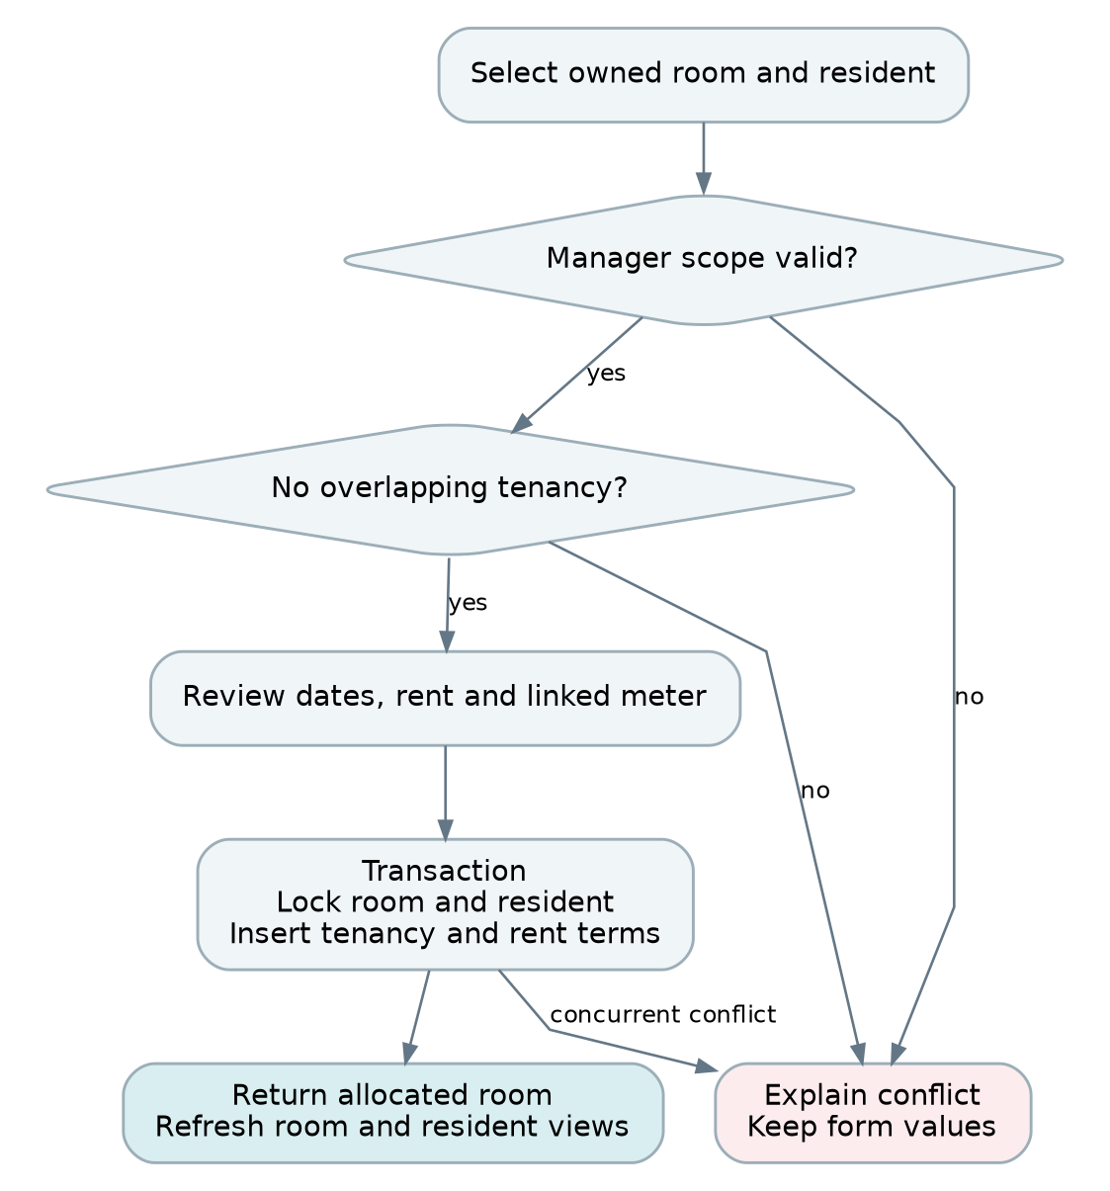
Figure 4 Room allocation validates ownership and concurrent occupancy
Admin house setup: create the house, assign one or more managers, and create any admin-managed records. Manager setup: select an assigned house, add a room, optionally link a meter, then create and allocate a resident. An admin assigning a manager to a house does not grant that manager access to admin-created records. This consequence must be clear in the admin form.
For a move, lock the source room, destination room and resident in a consistent ID order. Recheck permissions and interval conflicts. End the old tenancy at the effective date and create the new one with its own rent terms. For a future move, keep the present tenancy active until its date boundary; do not prematurely show the old room as vacant. Existing bills remain attached to their original tenancy.
Only delete a house or room that has never had dependent tenancy, bill or payment history. Otherwise archive it. Deactivating a manager revokes sessions and assignments but does not destroy records or silently assign them to someone else. The admin continues to handle those records until a separately approved transfer policy exists.

12 Monthly rent generation
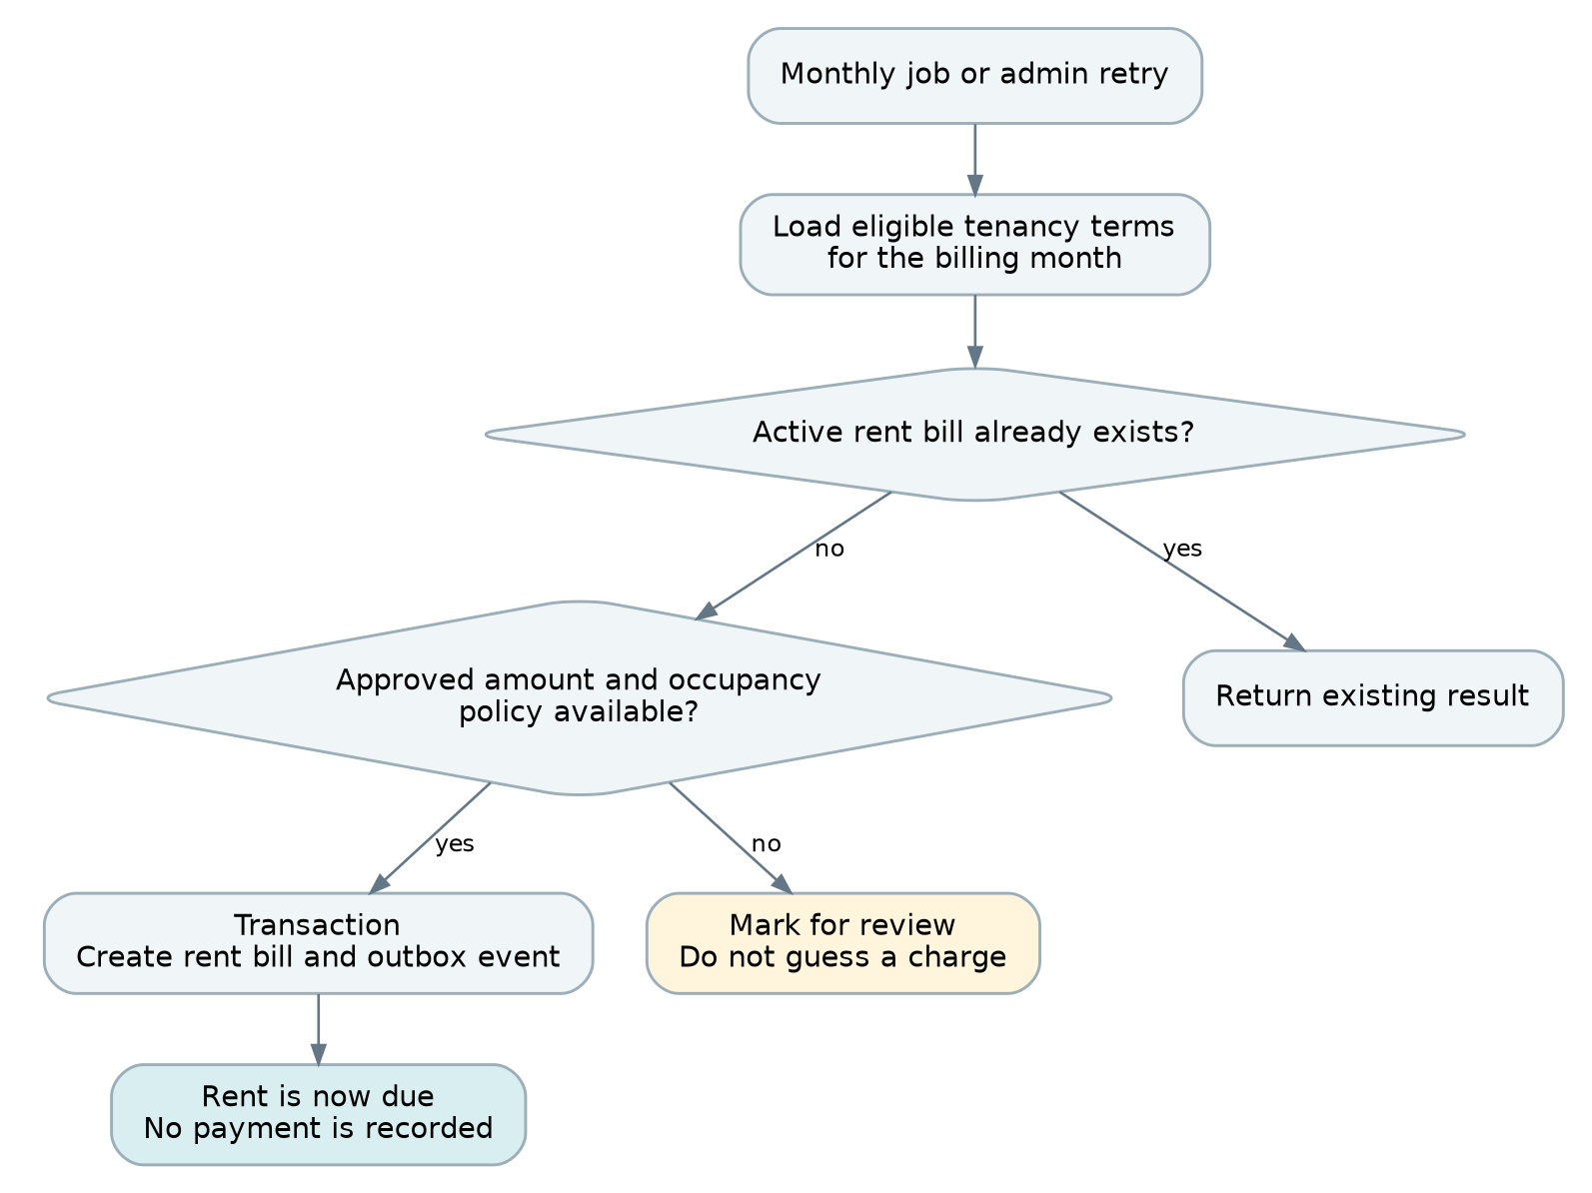
Figure 5 Monthly rent generation is repeatable without duplicate bills
A scheduled job scans eligible tenancies in bounded batches for each house timezone. It selects the rent terms effective for the period, applies the approved occupancy policy, and records the amount, due date and terms snapshot. The job calls the same Billing service as an admin retry. A database business-key constraint makes retries safe; a queue job ID alone is insufficient.
Do not create bills from GET requests, dashboard rendering or app login. A household opening the app ten times must not trigger ten generation attempts. Keep bill creation independent of read paths. A newly created tenancy can explicitly enqueue the relevant month after its creation transaction commits.
For interrupted runs, store job progress and process only missing eligible bills on retry. A tenancy with unclear mid-month terms is flagged for review and excluded from automatic charging. Once a rent bill is issued, later rent edits affect future periods only. A paid bill is corrected through reversal and replacement procedures rather than overwriting its amount.

13 Meter readings and electricity billing
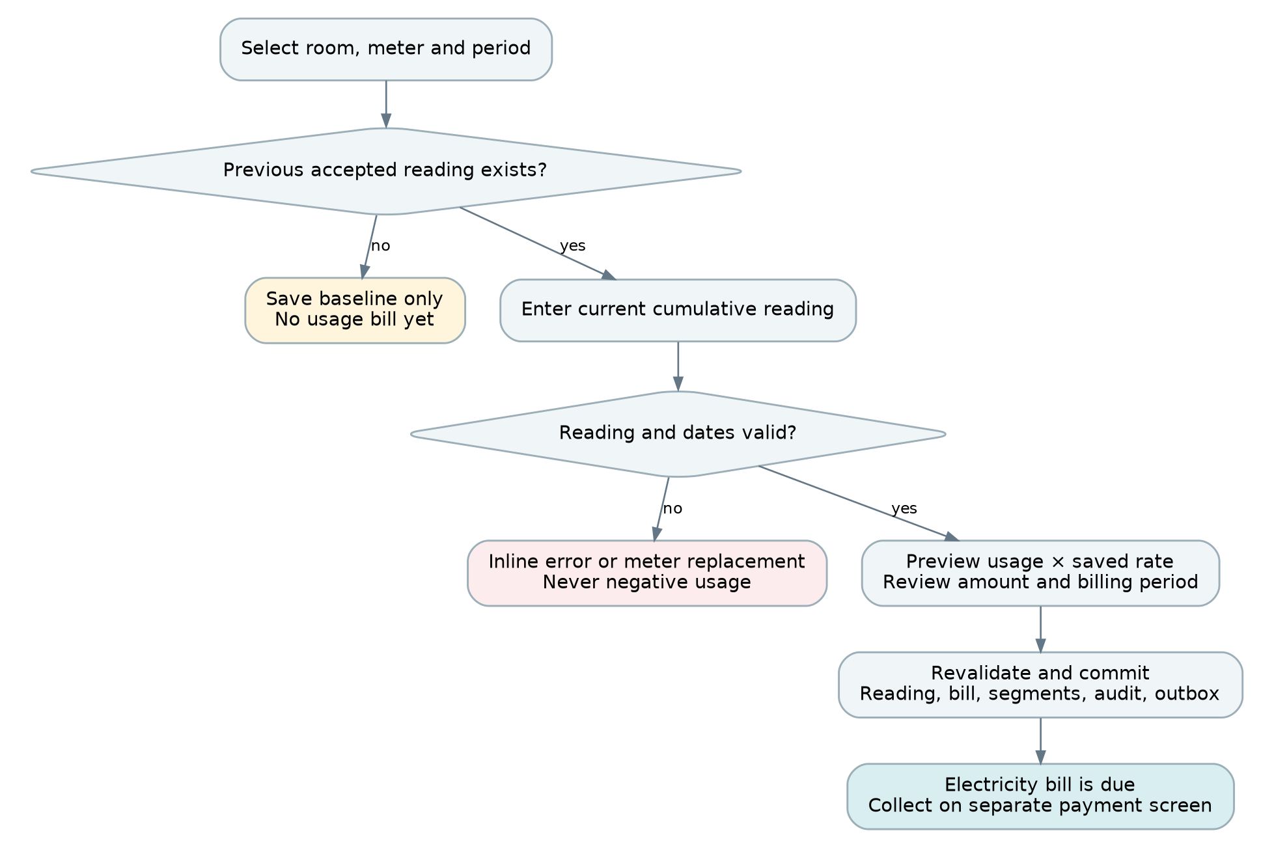
Figure 6 Electricity billing separates baseline entry, calculation and issue
Preview requests send the installation ID, period, reading date and current cumulative reading. The server loads the accepted baseline and permitted tariff. It returns usage, amount and version references. On confirmation, lock the relevant installation/tenancy, reload those references and either commit the same result or return 409 if the preview became stale. Never accept a client-supplied total as the bill amount.
Example: 2,570.000 minus 2,450.000 is 120.000 kWh. At BDT 10.0000 per kWh, the bill is BDT 1,200.00. The first reading is only a baseline. Reject lower readings, out-of-order dates, duplicate periods and overlapping usage intervals. Zero usage is valid; missing readings are not zero usage.
A meter replacement closes the old installation with a final reading and starts the new installation with its baseline. When a billing period crosses replacement, calculate separate installation segments and sum their charges. For a room move, take a boundary reading; otherwise require reviewed allocation instead of charging the next resident for the previous resident’s usage. Mid-period tariff changes require a boundary policy; prefer next-period changes initially.

14 Payment collection flow
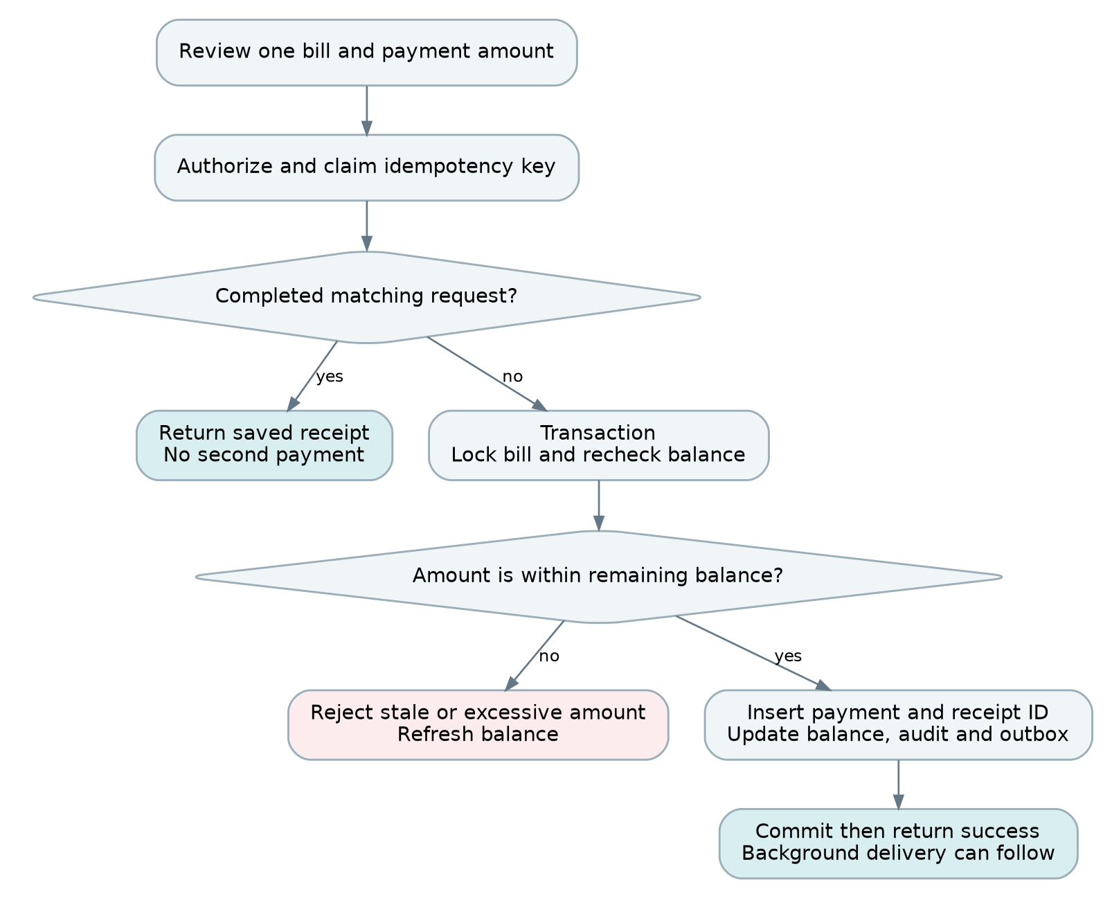
Figure 7 A payment is recorded once against one selected bill
Rent and electricity use separate screens and route families, but share one transactional collection service internally. The server checks that the selected bill type matches the route. Every submission carries an idempotency key generated once when the user confirms the operation. The same key survives timeouts and retries; a new intentional payment receives a new key.
The review screen identifies the resident, room, bill month, previous collections, remaining balance, received amount, method and date. The app shows success only after the commit response or a verified idempotent replay. If a request times out, show “Checking payment status” and recover the original result before permitting a replacement submission.
The canonical response returns the receipt ID and updated bill balance immediately. Receipt PDF generation or SMS delivery can happen later. A failed notification does not invalidate a saved payment and must never prompt the manager to collect the same amount again.

15 Payment transaction and corrections
The following is transaction pseudocode, not copy-and-paste ORM code. All database writes use one transaction and connection. PostgreSQL row locks serialize competing changes to the same bill; keep transactions short and retry only transient conflicts with a bounded backoff. [4, 8]
authorize(actor, session, billId, requiredType)
begin transaction
claim unique key (organization, actor, route, idempotencyKey)
if key exists with different request hash: fail 409
if completed key exists: authorize again; return saved result
bill = SELECT scoped bill FOR UPDATE
recheck current role, assignment, bill type and lifecycle
remaining = bill.amount_minor - bill.paid_minor
assert 0 < received_minor <= remaining
INSERT immutable payment with unique receipt_number
UPDATE bill SET paid_minor = paid_minor + received_minor,
version = version + 1
INSERT audit event and outbox event
store completed result ID against idempotency key
commit
return receipt and canonical balance
A concurrent request with the same key must wait for or retrieve the first committed result; do not let it insert a second payment. A different payload using an existing key is a conflict. If the transaction rolls back, no payment or completed idempotency result remains. The payment and its request key retain a durable unique association, so cleanup of response metadata cannot permit a late duplicate.

Corrections and reversals
Do not edit or delete posted payments. An admin web session creates a reasoned full reversal referencing the original payment, under the same bill lock. Subtract the reversed amount from paid_minor, create a unique reversal receipt/audit event, and return the reopened balance. The original receipt remains visible as reversed. A manager requests correction rather than silently changing history.
To correct an issued bill, first resolve any payments through the approved reversal/refund procedure, then void the old bill and issue a linked replacement revision. A reversal records an accounting correction; it does not itself prove that cash was refunded. Preserve old readings and rate snapshots. Reject corrections that would make balances negative or obscure received money.

16 Core API contract
Use REST JSON under /api/v1 with OpenAPI generated from NestJS DTOs. Generate a TypeScript client and Dart client from the same checked-in specification. Controllers can be role-specific when response shape differs, but all call the same services. Use request validation with whitelisted fields and rejection of unexpected properties. [1, 3]
Method and route | Purpose | Allowed scope
POST /auth/web/login | Create admin web session | Admin credentials only
POST /auth/mobile/login | Create fixed-capability mobile session | Recognized account role
POST /auth/refresh and /auth/logout | Rotate or revoke session | Current session family
GET /me | Identity and effective capabilities | Authenticated user
PATCH /me/profile | Name, photo and verified contact changes | Manager/resident own profile
GET /houses and /houses/:id | House list and detail | Admin all; manager assigned
POST /houses; PATCH /houses/:id | Create or edit house | Admin web
POST /houses/:id/archive | Preserve a house with history | Admin web
DELETE /houses/:id | Delete unused empty house | Admin web, strict preconditions
POST /managers; PATCH /managers/:id | Create, edit or deactivate manager | Admin web
POST /houses/:id/assignments | Assign manager with effective dates | Admin web
GET /rooms; POST /rooms | Scoped rooms and creation | Admin web or manager scope
PATCH /rooms/:id; DELETE /rooms/:id | Edit or delete unused room | Admin web or creator scope
GET /residents; POST /residents | List and create residents | Admin web or creator scope
POST /tenancies and /tenancies/:id/move | Allocate or move resident | Admin web or permitted scope
POST /tenancies/:id/end | End tenancy with final checks | Admin web or permitted scope

GET on resident records returns only needed fields; password hashes and session credentials are never serialized. DELETE is conditional, not a cascade through financial history. The admin app uses the same GET resources but its session cannot execute the mutation routes.

17 Billing reporting and metering APIs
Method and route | Purpose | Important rule
POST /rooms/:id/meter-installations | Link meter and establish baseline | Owned room; serial and interval checks
POST /meter-installations/:id/replace | Close old meter and link new meter | Atomic boundary readings
GET /tariffs; POST /tariffs | View or version unit rates | Admin or manager-owned scope
GET /rent/bills | Rent bill list | Type fixed to RENT
POST /rent/bill-runs | Generate or retry a month | Admin web; scheduled service also supported
GET /electricity/bills | Electricity bill list | Type fixed to ELECTRICITY
POST /electricity/previews | Server-calculated reading preview | No persistent bill yet
POST /electricity/bills | Revalidate reading and issue bill | Idempotent; lock installation
POST /rent/bills/:id/payments | Record rent collection | Route type must match bill
POST /electricity/bills/:id/payments | Record electricity collection | No meter or amount-total override
POST /payments/:id/reversal | Reverse an incorrect collection | Admin web with reason
GET /receipts/:id | Read receipt metadata or authorized file | Same scope as underlying bill
GET /collections | Collected payments | Explicit type and date basis
GET /balances | Remaining bills | Explicit type; balance greater than zero
GET /dashboard | Bounded summary for selected month | Policy-scoped aggregates
GET /me/bills and /me/receipts | Resident bill and receipt history | Never accepts another resident ID

For list routes use limit=25 by default, maximum 100, a stable cursor and whitelisted filters. Common filters are houseId, period, type and status; the server intersects them with the caller’s scope. Never treat a supplied houseId as authorization. Cursor ordering must include a unique tie-breaker such as created_at and id.
Use bounded GET reports for admin mobile. Future export jobs require explicit authorization, size limits and private downloads.

Supporting API operations
These routes complete account setup, record editing and historical configuration. They use the same authentication, scope, validation and concurrency rules as the main catalogue. Domain writes remain unavailable to admin mobile sessions.
Method and route | Purpose and access rule
POST /auth/activate | Redeem a single-use activation token and set password; no role input
POST /auth/recovery/request and /auth/recovery/complete | Rate-limited recovery request and token redemption; revoke old sessions
GET /managers and /managers/:id | Admin account list and detail; both admin clients may view
PATCH /houses/:houseId/assignments/:id | Admin web ends an assignment with an effective date; retain history
GET /residents/:id; PATCH /residents/:id | Scoped detail and profile/status editing by admin web or creator-manager
POST /tenancies/:id/rent-terms | Create effective-dated rent terms; admin web or permitted manager; never rewrite issued bills
GET /meter-installations/:id/readings | Scoped reading history, including baseline and final reading
GET /bills/:id | Authorized bill detail and segments; resident only for own tenancy
POST /bills/:id/void and /bills/:id/replacements | Admin web corrections with reason, payment checks and linked revision
POST /files/avatar-upload; PATCH /me/profile | Obtain a constrained upload, then attach validated file; manager/resident own profile

A resident status change cannot silently end a tenancy or erase bills. End or transfer occupancy explicitly before deactivating an occupied account, and retain the original financial history. Duplicate phone checks may reveal only that the identifier is unavailable, not another manager’s resident details.
Document every route in OpenAPI with its request and response DTOs, capabilities, error codes, examples and idempotency behavior. Add detail and filter parameters to this catalogue as contracts are finalized; reject unknown writable properties. Generate both clients and check contract changes in CI.

18 Payloads errors and concurrency
Money and decimal quantities are strings in the API. Display formatting belongs in the clients; authoritative calculations belong in NestJS. A successful write returns enough canonical data to update the affected screen without a second detail fetch.
POST /api/v1/rent/bills/{billId}/payments
Idempotency-Key: 8ea75ec8-48b4-4f74-902c-7e8659ff018a
{
"amountMinor": "600000",
"method": "CASH",
"receivedAt": "2026-11-07T09:30:00Z"
}
201 Created
{
"data": {
"receiptId": "receipt_uuid",
"billType": "RENT", "currency": "BDT",
"receivedMinor": "600000", "paidMinor": "1000000",
"remainingMinor": "0", "paymentStatus": "PAID",
"billVersion": 4
},
"meta": { "requestId": "request_uuid" }
}
Status | Meaning | Client behavior
400 or 422 | Invalid fields or business validation | Show mapped field errors; preserve input
401 | Expired or invalid session | Attempt one coordinated refresh, then sign in
403 or scoped 404 | Capability or ownership denied | Hide inaccessible content; do not retry
409 | Stale version, duplicate mismatch or occupancy conflict | Refresh canonical state and explain conflict
429 | Rate limit reached | Respect Retry-After; prevent a retry loop
5xx or timeout | Unknown or unavailable outcome | Reads may retry; writes reuse the same key

An error envelope includes code, message, fieldErrors and requestId without stack traces. Edits carry an expected version or If-Match value to prevent lost updates. Reject unknown enum values clearly; generated mobile clients must handle newly added response enum values safely. Add fields compatibly within v1, deprecate before removal, and retain API support for still-supported app versions.

19 Next.js admin implementation
Use the App Router with feature folders for houses, managers, residents, rent, electricity and reports. Build one AdminShell, PageHeader and navigation configuration. Server Components provide the authenticated shell and initial reads; Client Components handle forms, filters, dialogs and interactive tables. NestJS remains the authoritative service behind every HTTP call. [9]

Data and rendering pattern
- Create a server-only API wrapper that forwards only the necessary credential and request headers to a fixed internal NestJS URL. Do not expose backend tokens or arbitrary upstream URLs to client components.
- For user-specific SSR requests, explicitly use cache: no-store and private response policy. Do not depend on changing framework cache defaults. Cache static fonts, icons and public assets separately. [10]
- Use TanStack Query for interactive client data. Include organization, session scope, filters and page/cursor in keys. Hydrate an initial query once or fetch it on the client; do not issue duplicate SSR and mount requests.
- After a successful mutation, apply the returned canonical object and invalidate only related lists and dashboard summaries. Await necessary refreshes before presenting an up-to-date balance. Clear all user-scoped cache on sign-out. [18]
- Keep URL search parameters for month, house and status so filters survive refresh and can be shared within permitted access. Debounce text search and cancel superseded requests.

Forms and routes
Use React Hook Form with schema-based client validation for user feedback; NestJS validates again. Use the shared AppField, AppSelect, MoneyField and AppButton components exclusively. Reuse the same create/edit form with explicit initial values and mode, rather than copying markup. Keep confirmation dialogs separate from destructive execution.
A server-rendered authorization redirect improves UX, but it is not a security boundary. Every request still passes NestJS policy. Do not place sensitive data in static route output. Never write directly to the database from a Next.js Server Action. If a thin route handler is unavoidable for transport, it forwards to NestJS and contains no billing logic.

Responsive layout
Use a 240 logical-pixel desktop sidebar, a flexible content column and a maximum content width near 1440 pixels. Collapse navigation on narrow screens. Use two form columns only when each retains a practical width; use one column on mobile widths. Dense data tables may scroll horizontally inside their own container, while the page itself must not clip.

20 Flutter app implementation
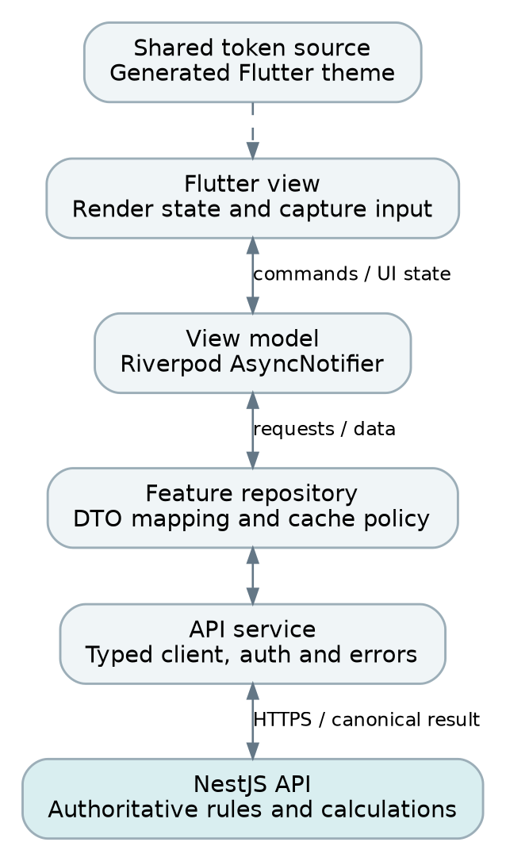
Figure 8 Flutter keeps presentation separate from API and repository concerns
Use one Flutter codebase with separate admin, manager and resident route shells. Follow feature-based MVVM: a view renders state, a view model handles commands, a repository manages feature data, and an API service handles transport. Riverpod AsyncNotifier is a suitable implementation choice; financial business rules remain on the backend. [11, 17]
Suggested feature folders are auth, admin_overview, properties, residents, rent, electricity, collections and profile. Shared core folders contain routing, API client, secure storage, errors, theme and reusable widgets. Do not construct network clients or issue API calls inside build(). Use provider families keyed by scope and filters, with deliberate disposal.
Use a typed Dart client with a single auth interceptor, coordinated refresh, timeouts and structured error mapping. Persist a pending payment idempotency key securely until its outcome is resolved. Financial saves require a confirmed online response; do not queue offline payments in the first release. A small read cache may display last-known data with a visible timestamp.
Navigation is derived from GET /me capabilities. Deep links pass the same route checks; unauthorized screens never flash previous-user data. Clear providers and cached personal data on account switch. Use lazy lists, stable item keys, targeted rebuilds and restrained shadows. Test on a representative lower-end Android device, not only an emulator.

21 Shared visual tokens and font system
Use one versioned JSON token file as the visual source of truth. Generate CSS variables and TypeScript constants for Next.js, and Dart constants plus ThemeExtension values for Flutter. A CI check regenerates these outputs and fails on uncommitted drift. Equivalent tokens are shared; React and Flutter component code is not.
Token family | Canonical value or rule
Font family | Inter, bundled locally in both clients; 400, 500, 600 and 700 weights
Fallback | System sans serif; bundle a licensed Bangla font before Bangla launch
Canvas and surface | #EEF2F5 canvas; #F7F9FA surface; white for dense readable regions
Text | #132238 primary; #4C5D6F secondary; labels never rely on placeholder color
Primary action | #167D8D fill with white text; test every state contrast
Status | Paid: green with label; Partial: amber with label; Unpaid: red with label
Spacing scale | 4, 8, 12, 16, 24, 32, 48 logical units
Radius scale | 8 small; 12 inputs and buttons; 16 cards and dialogs
Control height | 48 minimum for standard fields and primary buttons
Borders | 1 unit visible border; stronger focus ring independent of shadows
Shadows | Soft raised surface only; subtle inset field; no multi-layer heavy blur

Font delivery and measurement
For Next.js, load local Inter assets through next/font/local and expose one CSS family variable at the root. For Flutter, declare bundled font assets and weights in pubspec.yaml, then set one ThemeData font family and TextTheme. Keep the selected font files and license in source control. Both platforms support local font integration. [12, 13, 16]
Use the same semantic sizes and weights across platforms. CSS pixels and Flutter logical pixels are comparable design units, not a promise of identical rasterization on every device. Alignment, hierarchy and spacing should match while honoring accessibility scaling. Do not disable text scaling just to reproduce an image.
Create a component showcase before business pages: headings, paragraphs, forms, buttons, cards, status badges, tables and every state. This becomes the visual acceptance reference, replacing ad hoc per-page CSS or widget styling.

22 Typography components and symmetry
Text role | Size and line height | Weight | Usage
Page title | 28 / 36 | 700 | Web and mobile main title; wrap naturally
Section title | 20 / 28 | 600 | Card and section headings
Body | 16 / 24 | 400 | Descriptions, form values and main content
Field label | 14 / 20 | 600 | Always visible above the input
Button label | 16 / 24 | 600 | Same baseline and padding everywhere
Secondary text | 14 / 20 | 400 | Help, timestamps and supporting text
Key amount | 28 / 36 | 700 | Rent, collected and remaining summaries

Component | Layout contract
AppField | 48 minimum height, 16 horizontal inset, 12 radius; label gap 8; help/error below
AppButton | 48 minimum height, 20 horizontal padding, 12 radius; 20 icon and 8 icon gap
IconButton | 48 by 48 touch area; accessible name; 20–24 icon; no unlabeled financial action
AppCard | 16 radius, 24 web padding / 16 mobile padding; shared heading and amount slots
FormRow | 16 column gap; 24 vertical row gap; equal widths when fields are equivalent
StatusBadge | Label plus color; 12–14 text; consistent horizontal inset and rounded shape
Dialog | One title, explanation, content and action row; primary action placement consistent
Table or list row | Tabular numerals for amounts; trailing amount/status aligned; stable action column

Use minimum heights rather than fixed heights so long labels, validation errors and large text do not clip. Pair equal-role summary cards with equal structure, but let them grow for translations. Place labels, input edges and action buttons on a shared grid. Avoid local font-size, radius and padding overrides outside the design-system layer.
Build default, hover, focus, pressed, disabled, loading, error and read-only states centrally. Read-only fields should look like information, not disabled unfinished forms. Neumorphism must not reduce readability: target at least 4.5:1 for normal text and 3:1 for large text, with visible boundaries and keyboard focus. [14]

23 Screen behavior and validation
Area | Required behavior
Admin overview | Separate rent and electricity cards; month and house filters; explicit totals basis
House and room management | Reuse create/edit forms; show assigned managers and creator information
Manager home | Only own records; direct Collected and Remaining shortcuts; separate bill actions
Meter entry | Room and linked meter visible; previous reading read-only; server preview before issue
Collection forms | One bill type only; balance visible; review before save; receipt after commit
Resident home | Own current rent and electricity separately; no payment-recording controls
Resident history | Rent defaults to fully paid months; electricity has separate history and detail
Admin mobile | Persistent view-only cue; no edit, tariff, bill-generation or collection controls

Validation that is consistent on every client
Maintain stable field names and error codes in OpenAPI. Clients may validate required fields and formats immediately, but server errors are authoritative. Keep typed values after failures and focus the first error. Normalize phone numbers and room identifiers before uniqueness checks. Date pickers use the house timezone and show the exact billing month.
Room allocation requires an available room, permitted resident, start date and approved rent. Meter entry requires a linked installation, baseline, acceptable date and non-decreasing reading. Collection requires a positive exact amount within the remaining balance. Contact edits re-verify the login phone before replacing it. A profile request cannot edit room, meter, rent, role or payment data.

Loading empty error and success states
- Loading: retain layout with a modest skeleton; keep one clear progress indicator for submission.
- Empty: say No rooms yet, No bills generated or No payments recorded, rather than displaying misleading zero totals.
- Error: explain the next action and preserve inputs. For a stale balance or room conflict, refresh the affected record.
- Success: show a concise confirmation and canonical result. Use an enduring receipt for payments, not just a disappearing toast.
- Offline: show when data was last refreshed; disable financial writes. Retry uncertain payments using the original request key.
Use the same confirmation wording and action order on web and Flutter. Keep the main button within comfortable reach on mobile, above the keyboard and safe area. Avoid nested scrolling inside ordinary forms or cards; use a single page scroll.

24 Query design and performance budgets
Design read endpoints around a complete screen rather than one API call per card. Select only required columns. Use joins, relation loading or batched queries instead of a per-room loop that fetches resident, meter and bill separately. Query count should remain approximately constant as the page grows from 10 to 100 rows.
Read path | Initial business query target | Approach
Dashboard | 3–5 | One aggregate for bills; property counts and attention rows separately
Room list | 1–3 | Page rooms with current tenancy and meter in bounded joins
Bill list | 1–2 | Indexed filtered page; optional separate count only if needed
Resident current month | 2–4 | Scoped tenancy plus bills; recent payments in one batch
Receipt detail | 1–2 | Payment joined to its bill and tenancy
Collection history | 1–2 | Cursor page; no repeated payment queries per row

These are engineering budgets, not claims about a running system. Account separately for session validation and scope checks, normally another 1–2 database operations depending on the implementation. Record actual counts, plans, rows examined, payload size and p95 latency in integration tests.
-- Manager summary: intersect ownership and active house assignment.
SELECT b.type,
SUM(b.amount_minor) AS billed_minor,
SUM(b.paid_minor) AS collected_minor,
SUM(b.amount_minor - b.paid_minor) AS remaining_minor
FROM bills b
WHERE b.organization_id = $1 AND b.scope_owner_id = $2
AND b.period_start >= $3 AND b.period_start < $4
AND b.lifecycle = 'ISSUED' AND b.voided_at IS NULL
AND EXISTS (
SELECT 1 FROM house_manager_assignments a
WHERE a.house_id = b.house_id AND a.manager_id = $2
AND a.valid_from <= $5
AND (a.valid_to IS NULL OR a.valid_to > $5)
)
GROUP BY b.type;
The admin uses a separate authorized query without the manager restriction. Do not join raw payment rows into a bill summary and then sum bill amounts: multiple payments would duplicate the billed total. Use the transactionally maintained bill balance or pre-aggregate payments. Inspect EXPLAIN ANALYZE on realistic data before changing indexes. Paginate first; lazy rendering alone does not reduce database work. [6]

25 Caching and consistency
The simplest safe first release uses indexed PostgreSQL reads for financial balances and a small client memory cache. Do not add a server cache to every endpoint. Caching is useful only when the correct authorization scope, freshness policy and invalidation behavior are explicit.
Data | Initial policy | Invalidation or restriction
Static fonts and icons | Long-lived content-hashed CDN cache | New asset hash on release
User-scoped web HTML | Private; no shared persistent cache | Never serve one user’s page to another
Bills and balances | Read from primary; client memory allowed | Update from mutation response and refetch affected queries
House selectors | Short client cache, e.g. 60 seconds | Invalidate on property or assignment changes
Dashboard summary | Direct SQL initially; optional 15–30 second cache later | Key by organization, actor scope, filters and access version
Receipts | Immutable metadata after authorization | Private signed file links with short expiry
Authorization decisions | Current session and assignment checks | Revoke on changes; never cache indefinitely

Post write consistency
The write transaction updates bill balances, payment entries, audit and outbox together. Return the updated balance from that commit. Client caches replace the changed record and invalidate the related ledger and dashboard. Do not read a potentially lagging replica immediately after a payment. If a summary cache is introduced, invalidate after commit and use the database for the immediate confirmation view.
Any optional summary response includes generatedAt and dataAsOf. Reauthorize before serving cached content. Manager assignment changes invalidate that manager’s scope version and cached lists. A cache miss falls back to the database with bounded concurrency; use short jittered expiries and request coalescing to prevent a stampede.

Reconciliation
Run a scheduled reconciliation that sums immutable payments minus reversals and compares the result to bills.paid_minor. A mismatch raises an alert and creates a repair task; it does not silently fabricate a payment. Dashboard projections must be rebuildable from authoritative records. Keep cache and queue Redis instances separate when eviction policies or durability requirements differ; separate logical databases alone do not isolate memory eviction.

26 Jobs and transactional outbox
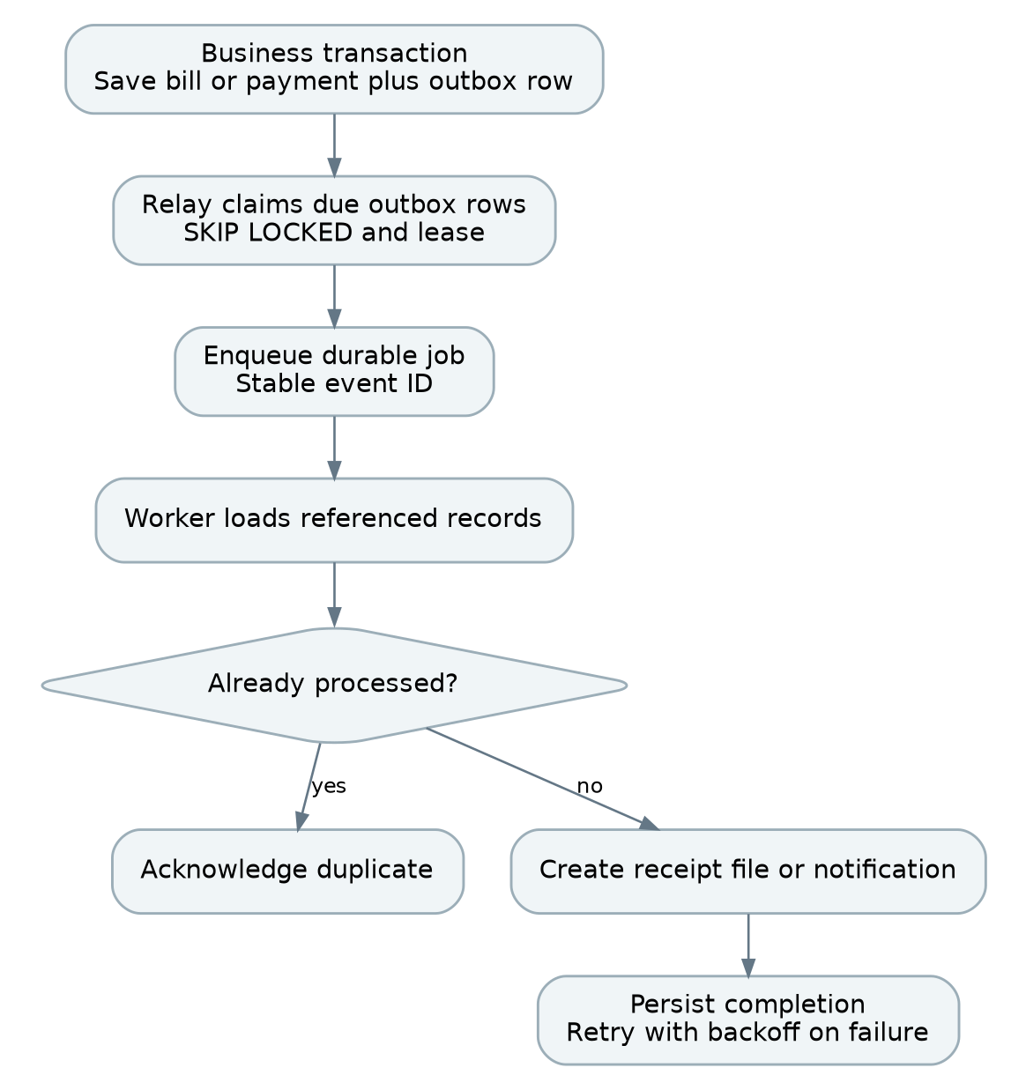
Figure 9 Committed changes reach background workers through a durable outbox
Use the NestJS BullMQ integration with Redis for background jobs. Run workers separately from API processes, using the same domain services. Appropriate jobs include monthly rent generation, receipt rendering, notification delivery, reconciliation and cleanup. API requests must not wait for SMS, email or large document generation. [7]
Save the outbox event in the same PostgreSQL transaction as the business change. A relay claims due events in small batches using SKIP LOCKED and a recoverable lease, then enqueues jobs with a stable event ID. Mark delivery after enqueue succeeds. If the relay crashes between enqueue and marking, it may enqueue again; consumers must tolerate this.
This is at-least-once delivery, not a blanket exactly-once guarantee. Use a processed-event record or unique business key for database effects, and provider idempotency support for external effects where available. Without provider support, a crash after sending but before marking may duplicate a notification. Keep that limitation separate from payment correctness, which is protected by database transactions and keys.
Limit worker concurrency, apply exponential retry with jitter, and move exhausted jobs to a visible failed queue with operator replay. Give jobs bounded payloads containing IDs rather than full personal records. Run one logical scheduler or use a lock and unique run keys so replicas cannot issue duplicate monthly bills.

27 Security files and observability

Application security
- Validate every request and authorize every resource. Test ID substitution across managers, residents and organizations. Deny by default and keep guard order explicit. [2, 3, 15]
- Use TLS everywhere, a restricted CORS policy, CSRF protection for cookie authentication and security headers for the web app. Keep database and Redis off the public network.
- Keep secrets in environment-backed secret storage. Never place database URLs, signing keys or SMS credentials in NEXT_PUBLIC variables, the Flutter binary or source control.
- Rate-limit authentication, password recovery, expensive reports and write endpoints. Set body-size limits and query limits. Use parameterized SQL and whitelist sort/filter columns.
- Require a reason for destructive or financial corrections. Consider stronger admin authentication at launch; do not expand manager permissions to compensate for missing admin workflows.

Private files
Store files in private object storage under generated object keys. Validate content type, file signature and size; strip image metadata and re-encode avatars. Do not accept arbitrary remote URLs for server fetching. Save file metadata and owner scope in PostgreSQL. Authorize downloads before issuing short-lived signed links. A receipt URL must not be a public permanent guessable path.

Operational visibility
Signal | Actionable information
Request logs | Request ID, route template, status, duration and actor ID; no credentials
Database | Query time, slow plans, lock waits, pool saturation and failed transactions
Queues | Oldest job age, retry count, failures and outbox backlog
Financial integrity | Duplicate attempts blocked, reversal activity and reconciliation mismatches
Product failures | Failed sign-ins, bill review exceptions, stale-version conflicts and save failures

Propagate a correlation ID from API to worker and external delivery logs. Do not log passwords, tokens, full phone numbers or complete sensitive request bodies. Audit events contain the minimum facts needed to explain who changed what and why. Agree retention, account deletion and financial-history policies before launch; these are product and jurisdiction decisions, not assumptions made by the UI.

28 Deployment and scaling architecture
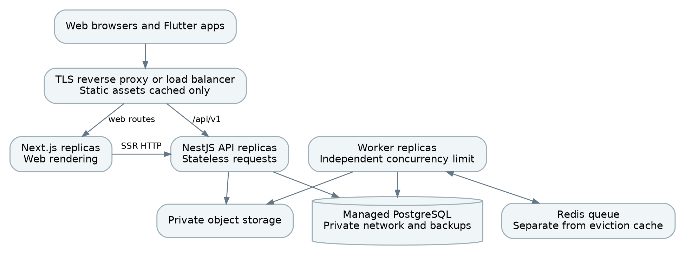
Figure 10 API and worker processes scale independently behind private services
A practical initial deployment has a TLS reverse proxy, a Next.js service, a NestJS API service and one worker service. Use managed PostgreSQL where available, Redis for queues and private object storage. They may initially share a compute host if the budget requires it, but use separate processes, limits and restart policies. This is one logical backend even when API and worker have multiple replicas.
Stage | Recommended change | Trigger
Initial | One API, one worker, one web service | Small measured load; simple operational ownership
Availability | Two API replicas and redundant edge | Uptime requirement justifies removal of single points
Throughput | Scale API and worker separately | Measured CPU, queue age or latency pressure
Database reads | Optimize plans, then consider read replica | Reporting load dominates; lag is acceptable
Large history | Archive or partition selectively | Measured table size and maintenance justify complexity

Keep the API stateless across requests. Store sessions and durable operation state centrally, not in process memory or local disk. A load balancer must not need sticky sessions for correctness. Use readiness checks for dependencies required to serve requests and liveness checks for process health; an SMS outage should degrade notification delivery rather than restart every API replica.
Budget connection pools across all replicas. Example: two API replicas × 10 connections plus one worker × 5 is 25 application connections before migrations and monitoring. The total must remain below the database limit with a reserve. More API replicas without a pool budget can make the system slower. Set worker concurrency independently to avoid starving interactive requests.

29 Delivery migrations and recovery

Continuous integration
- Validate formatting, static types, generated design tokens and OpenAPI compatibility. Run unit tests and database integration tests against real PostgreSQL.
- Run web component and flow tests, Flutter widget/golden tests, and the critical role and payment scenarios. Build Next.js, NestJS API/worker and Flutter from pinned dependencies.
- Scan dependencies and images, check migrations and produce versioned release artifacts. Store the exact schema and API contract used by the mobile release.
- Deploy to staging with representative anonymized data. Execute smoke tests, financial reconciliation and performance checks before production promotion.

Safe production release
Use expand-and-contract migrations: add compatible columns or structures first, deploy code that works with both versions, backfill in bounded batches, then remove old structures in a later release. Run migrations once under a release lock, not from every API replica. Avoid long blocking table rewrites during peak use. Feature flags can gate new billing behavior while old app versions remain supported.
Deploy backward-compatible backend changes before the clients that need them. Drain API requests and worker jobs during shutdown. Roll back code only while the schema remains compatible; prefer a forward migration for financial-data repair. A mobile app store release may take longer than a web release, so never require simultaneous deployment of every client.

Backup and recovery
Use automated encrypted database backups with point-in-time recovery when available and versioned/private file storage. A proposed starting target is RPO 15 minutes and RTO 4 hours, subject to the chosen hosting plan and a successful restore drill. These are targets, not guaranteed capabilities. Keep backups in a separate failure domain and test restoration to an isolated environment.
A recovery drill verifies users, tenancies, bills, payment totals, receipt links, permissions and outbox behavior. Reconciliation must pass before reopening financial writes. Queue restoration must not replay money creation: payment idempotency and database uniqueness remain authoritative. Document who restores, who verifies balances and who approves reopening.

Environment separation
Use separate development, staging and production credentials, databases, storage buckets and notification destinations. Seed demo data only outside production. Keep local start commands and required environment variables documented, but never include real secrets in the repository or guide.

30 Test strategy and acceptance targets
Test area | Minimum meaningful scenarios
Authorization | Manager A cannot read/write B’s room; resident cannot fetch another receipt; admin mobile POST is denied
Assignment lifecycle | Revoked assignment removes access immediately; house reassignment does not transfer creator-owned records
Occupancy | Concurrent allocations cannot both succeed; future overlaps fail; move preserves historical bills
Metering | Baseline only; lower reading rejected; zero usage valid; replacement segments and stale preview handled
Money | Decimal rounding; partial collection; overpayment blocked; payment reversal restores balance
Idempotency | Same key and payload replay same receipt; changed payload conflicts; timeout retry creates one payment
Concurrency | Two collectors compete for same balance; only valid total commits; transient lock retries are bounded
Jobs | Duplicate monthly job creates one bill; relay crash/retry does not duplicate financial effects
Frontend | Keyboard and screen reader use; narrow width; large text; identical component tokens; no clipped errors
Recovery | Restore backup, reconcile balances and replay pending outbox safely

Proposed performance test profile
Seed a non-production profile of 100 houses, 10,000 rooms, 24 months of history and roughly 480,000 bills if both bill types exist every month. Include partial payments and inactive tenancies. Start a representative load test at 50 requests per second, mostly reads, with a small share of collection writes. Increase until the actual bottleneck appears; this is a benchmark scenario, not a capacity promise.
Initial targets: p95 common API reads below 300 ms and p95 collection commits below 700 ms under the agreed profile, measured at the server and excluding device/network delay. Query counts remain within the budgets in section 24, with no N+1 growth. Define error-rate, queue-age and resource thresholds in staging, then record the measured baseline.
Use Playwright for web journeys, Flutter widget/integration and golden tests for mobile, and NestJS integration tests with PostgreSQL for business rules. Financial concurrency must be tested against the real database, not only mocked repositories. Test fonts, 200 percent text scaling, mobile safe areas and status labels visually.

31 Implementation sequence
Phase | Deliverable | Exit condition
1 Foundation | Repository, environments, PostgreSQL, NestJS skeleton, API versioning, health and logging | Clean build and migration on a fresh environment
2 Identity and policy | Role/session model, ownership filters, login/recovery and audit foundation | Cross-role and cross-owner denial tests pass
3 Design system | Tokens, bundled fonts, web components and Flutter themes/showcase | Approved typography, fields, buttons and responsive states
4 Property workflows | House, manager, room, resident and tenancy CRUD/move/archive | Occupancy constraints and strict manager scope verified
5 Rent vertical slice | Rent generation, bill lists, collection, receipt and reversal | One complete end-to-end rent journey passes all money tests
6 Electricity vertical slice | Meters, baseline, readings, tariff snapshots and separate collection | Usage, replacement and duplicate-period cases pass
7 All role surfaces | Admin web, read-only admin app, manager app and resident history/profile | Each role completes its approved tasks with no extra access
8 Reliability and launch | Outbox, jobs, reporting, load checks, deployment and restore drill | Release checklist and reconciliation pass

Deliver vertical slices: implement the backend endpoint, generated contract, web or Flutter screen, tests and observability together. Do not finish every screen before validating the financial model. Build the component showcase early so subsequent pages compose approved controls instead of inventing new styling.

Suggested team responsibilities
A backend owner maintains schema, rules, contracts and jobs. A web owner maintains the admin interface and shared React components. A Flutter owner maintains mobile routing, state and themes. A product/design reviewer approves flows and token changes; QA verifies role isolation and financial edge cases. These are responsibilities, not a requirement to hire five separate people.
Do not commit to a calendar estimate before staffing, existing code, deployment environment, integrations and billing-policy decisions are known. Estimate phases after the first rent vertical slice exposes the actual implementation effort.

32 Release decisions and completion criteria

Product decisions to record
Decision | Recommended initial direction
Creator-only access | Keep strict as requested; admin-created records stay admin-managed
Rent schedule | Confirm due day and month-boundary changes; review mid-month cases
Electricity tariff | Flat rate per kWh; new-period changes; preserve billed snapshots
Room occupancy | One resident account and one active tenancy per room initially
Corrections | Admin web reversal with reason; retain original receipt and audit trail
Resident rent history | Fully paid prior months; current partial receipts visible in current detail
Authentication recovery | Confirm SMS provider and verification flow before enabling
Retention and availability | Agree retention, backup targets and operational ownership

Definition of done for every feature
- The server checks role, session capability, organization, record ownership and current resource state.
- The API is documented, versioned and compatible with supported mobile clients; generated clients compile.
- The page uses shared fonts, tokens and components, including validation, loading, empty and error states.
- Queries are bounded and indexed, pagination works, and measured behavior avoids repeated per-row fetches.
- Money operations are transactional, idempotent and audited; receipt and balance results reconcile.
- Critical integration and UI tests pass; logs identify failures without exposing secrets or unnecessary personal data.
- Migration, rollback/forward-repair and operational notes exist for changes affecting stored data.

Launch gate
Release only after all four role surfaces pass acceptance: admin web can manage the required entities; admin mobile cannot mutate business records; managers can operate only their own permitted records; residents see only their own history and can edit only their profile. Rent and electricity totals remain separate from screen to API to database report. Complete a restore drill and a real-device usability review before accepting production collections.
The architecture is intentionally extensible through modules and contracts. Add features such as online payments or general expenses later as explicit domains with their own rules; do not weaken the existing ledger or permission model to fit them informally.

33 Technical references for backend and data
Official documentation checked on 7 November 2026. Bracketed references support framework capabilities and technical primitives; project-specific policies, schema choices and performance targets are recommendations developed for this application. Pin exact framework versions at implementation kickoff.
[1] NestJS OpenAPI introduction
https://docs.nestjs.com/openapi/introduction
[2] NestJS authorization
https://docs.nestjs.com/security/authorization
[3] NestJS request validation
https://docs.nestjs.com/techniques/validation
[4] PostgreSQL explicit locking
https://www.postgresql.org/docs/current/explicit-locking.html
[5] PostgreSQL constraints
https://www.postgresql.org/docs/current/ddl-constraints.html
[6] PostgreSQL multicolumn indexes
https://www.postgresql.org/docs/current/indexes-multicolumn.html
[7] NestJS queues and BullMQ integration
https://docs.nestjs.com/techniques/queues
[8] Prisma transaction guidance
https://www.prisma.io/docs/orm/fundamentals/transactions
Use these references to verify the exact API and migration syntax for the versions selected by the development team. The transaction algorithm and SQL fragments in this guide are intentionally implementation-focused examples, not a replacement for complete schema migrations or tests.

34 Technical references for clients and design
[9] Next.js data security and external HTTP APIs
https://nextjs.org/docs/app/guides/data-security
[10] Next.js fetch caching controls
https://nextjs.org/docs/app/api-reference/functions/fetch
[11] Flutter application architecture
https://docs.flutter.dev/app-architecture/guide
[12] Next.js font optimization
https://nextjs.org/docs/app/getting-started/fonts
[13] Flutter themes and custom fonts
https://docs.flutter.dev/cookbook/design/themes
[13a] Flutter custom font assets
https://docs.flutter.dev/cookbook/design/fonts
[14] W3C minimum text contrast guidance
https://www.w3.org/WAI/WCAG22/Understanding/contrast-minimum.html
[15] OWASP authorization guidance
https://cheatsheetseries.owasp.org/cheatsheets/Authorization_Cheat_Sheet.html
[16] Inter font family and distribution
https://rsms.me/inter/
[17] Riverpod providers
https://riverpod.dev/docs/concepts2/providers
[18] TanStack Query invalidation after mutations
https://tanstack.com/query/latest/docs/framework/react/guides/invalidations-from-mutations

