PM CIRCLE
Software Requirements
Specification
AI-powered professional community, learning, examinations and career platform
Laravel 13 + Inertia 3 + React 19 + TypeScript
Technical baseline and product requirements | 29 October 2026

Document property | Value
Project | PM Circle by ITQAN
Document ID | PMC-SRS-001
Version / status | 1.0 / Proposed baseline for approval
Audience | Product owner, designers, Laravel/React developers, QA, DevOps, security
Delivery | Single Laravel modular monolith with Inertia React frontend
Primary markets | Bangladesh first; internationalization-ready architecture

This SRS describes the intended system and engineering acceptance requirements. Decisions labeled "to confirm" require product-owner approval before implementation.

Document control and reading guide
Revision | Date | Description | Status
1.0 | 29 Oct 2026 | Initial end-to-end SRS based on approved stack and supplied product screens | Proposed

How to interpret requirement statements
“Shall” indicates a testable requirement. “Should” denotes recommended behavior. Priority labels mean P0 = mandatory baseline for the relevant production launch, P1 = next planned delivery increment, and P2 = advanced roadmap. This document separates product requirements from technical implementation recommendations and open decisions.

Contents
1. Vision, scope and assumptions
2. Stakeholders, roles and access model
3. Screen inventory and user journeys
4. Functional software requirements
5. Core business rules and entitlements
6. Non-functional and security requirements
7. System architecture and technology stack
8. AI subsystem design and control flows
9. Database model and ER diagrams
10. Application project structure
11. Interface, event and integration specifications
12. Deployment, operations and observability
13. Test plan and acceptance criteria
14. Phased implementation and delivery plan
15. Risks, open decisions and definitions
Appendix A. Sample data contracts and sources

Status of reference material
The supplied visual designs cover public discovery, registration steps, membership selection, pricing comparison, member posts and nested discussions, daily scenario assessment, and a community-focused homepage. These screens define product direction, not a complete authorization or billing contract. Missing details are made explicit as requirements and decisions.

1. Vision, scope and assumptions

1.1 Product vision
PM Circle is a professional community for project managers and adjacent disciplines. Members build a public or restricted career identity, share practical experience, learn through lessons and examinations, practice realistic situations, earn platform achievements, and use transparent AI assistance for learning and career development.

1.2 Business objectives
- Launch a trusted professional community with discoverable public content and a low-friction free membership.
- Convert engaged learners to recurring Plus and Pro plans through lessons, exam practice, simulations and career AI tools.
- Improve member outcomes through practical scenario discussion, structured feedback and verifiable progress records.
- Support sustainable platform operations through moderation, measurable AI cost controls and a clear admin workflow.

1.3 In scope
- Responsive public website, authenticated member experience and administrative console.
- Registration/onboarding, professional profiles, following, feed, posting, comments, reactions, bookmarks and reports.
- Courses, lessons, question banks, timed examinations, scenarios, AI feedback, achievements and progress dashboard.
- Subscription catalog, plan access control, transaction history and AI credit allowances.
- Resume upload/review, AI interview practice, job discovery, profiles and recruiter capabilities by release phase.
- Daily AI editorial generation with human review, logging, scheduling and controlled publishing.

1.4 Out of scope for initial MVP
- Native iOS/Android application, direct LinkedIn data synchronization, peer-to-peer money transfers, automatic external professional certification issuance, live video classrooms and a full applicant tracking suite.
- Unsupervised AI posting on behalf of human members, fabricated engagement, and scraping restricted third-party profile data.

1.5 Assumptions and constraints
Area | Assumption / constraint
Application | Single platform and user directory, not a multi-tenant SaaS product at launch.
Architecture | One Laravel 13 repository with Inertia React UI; no Next.js service or independent frontend API gateway needed.
Data hosting | PostgreSQL and Redis available in chosen hosting environment.
Payment | Bangladesh-first BDT plans; recurring-billing capabilities must be verified for each approved merchant/provider.
Pricing | Screens show Free BDT 0, Plus BDT 399/month, Pro BDT 699/month; these are proposed, not signed-off commercial terms.
Visuals | Public/community pages are predominantly blue; onboarding references also use green. Final brand tokens require confirmation.
Compliance | Applicable privacy, payment and records requirements must be reviewed by project counsel prior to launch.

2. Stakeholders, roles and access model

2.1 Stakeholders and actors
Actor | Main objectives
Visitor | Browse public content, scenarios, pricing and public profiles; register or sign in.
Member - Free | Create profile, participate in community, use samples, access public jobs.
Member - Plus | Consume complete standard learning content, practice exams, standard scenarios and allocated AI feedback.
Member - Pro | Use advanced simulations, AI resume and interview tools, expanded feedback allowance.
Recruiter | Publish available jobs and access candidate features where explicit candidate consent and plan rules allow.
Moderator | Review reports, abusive content, AI-assisted drafts, appeals and editorial queue.
Content author | Maintain courses, question banks, accepted solutions and assessment rubrics.
Finance / Support | Review purchases, refunds, subscription status, disputes and support cases within permission scope.
Super administrator | Manage settings, access roles, integration configuration and audited overrides.

2.2 RBAC and authorization
Roles are independent from membership plans. A recruiter may also hold Free or Pro membership; a moderator can be a paid member without mixing moderation permissions with subscription entitlements. Every protected action is checked server-side by policies and entitlement services.
Capability | Visitor | Member | Content / Mod | Admin
Browse public feed / pages | Yes | Yes | Yes | Yes
Post, comment, save | No | Yes | If member | Yes
Take gated exams | No | Plan gated | Plan gated | Override audited
Publish learning content | No | No | Scoped author | Yes
Approve AI editorial posts | No | No | Scoped mod | Yes
View another user private resume | No | No | No | Consent + scoped
Manage subscription pricing | No | No | No | Finance/Admin
Moderate/restrict users | No | No | Scoped mod | Yes

3. Screen inventory and key user journeys

3.1 Screen map from reference designs
Area | Primary screens / UI components
Public website | Homepage, scenario preview, community feed, member post, pricing comparison, jobs teaser, member discovery, privacy/terms.
Registration | Step 1 account details, Step 2 professional profile, Step 3 plan selection; email verification and checkout return states.
Community | Feed, category filters, post detail, threaded replies, reporting, author card, saved posts, follow actions.
Learning | Lesson catalog, learning path, lesson detail, scenario detail, written response, AI feedback, progress page.
Exam | Exam catalog, instructions, timed attempt, review-before-submit, result and explanation, attempt history.
Career | Profile editor, LinkedIn export import review, resume library, resume review, jobs, applications, AI interview coach.
Billing | Pricing, checkout, payment status, receipts, current plan, change/cancel renewal, AI usage summary.
Administration | Dashboards, content/editorial, questions and exams, abuse reports, members, billing, AI prompts, analytics.

3.2 Registration and onboarding journey
- Visitor enters full name, email address and password; accepts required legal documents with recorded versions.
- System validates unique email and password policy; sends verification link and enforces rate limits.
- Member optionally sets role, experience, certifications and uploads a resume for a reviewed import.
- Member selects Free / Plus / Pro and an allowed billing duration; server shows exact total and renewal policy.
- For a paid plan, payment must be confirmed server-side before paid entitlements become active; Free activation requires no payment.
- Member arrives at their dashboard, with onboarding completion shown and optional profile-completion prompts.

3.3 Discussion and AI scenario journey
- Reader opens a public scenario with context, constraints, focus topics and rubric explanation.
- Authenticated member submits their reasoning as a response and can choose to request AI feedback if eligible.
- An async AI assessment validates the rubric, assigns structured feedback and records AI credit usage.
- Member sees annotated strengths, missing considerations and suggested next steps; human discussions remain separate from AI scoring.
- Member may reply to peers, share the scenario, save it, and continue through recommended practice.

3.4 Exam and achievement journey
- Member selects a permitted practice examination and reads the rules, duration and attempt limitations.
- Laravel creates a server-timestamped attempt; the React interface displays a synchronized countdown.
- Autosave records answers without exposing answer keys; finish and expiry follow server-enforced rules.
- Objective questions are marked deterministically; written responses are evaluated only under the stated grading policy.
- Results, lesson recommendations and eligible achievements are issued once using idempotent events.

4. Functional software requirements
All IDs are stable traceability keys. P0 = mandatory baseline, P1 = next delivery increment, P2 = advanced roadmap. Phase 1 can operate as a limited Free beta; paid general availability depends on Phase 2 payment controls. Every item must have a named owner and corresponding automated or manual acceptance test before sign-off.

4.1 Authentication and onboarding
ID | Requirement (shall) | Priority / Release
AUTH-01 | The system shall register users with unique, case-normalized email addresses and hashed passwords. | P0
AUTH-02 | The system shall require recorded acceptance of current Terms and Privacy Policy versions. | P0
AUTH-03 | The system shall verify email ownership before enabling posting, examination or payment-sensitive activity. | P0
AUTH-04 | The system shall support login, logout, password reset, session invalidation and rate-limited authentication. | P0
AUTH-05 | The system shall present three recoverable onboarding steps: account, profile, and plan. | P0
AUTH-06 | The system shall retain partial onboarding progress and allow completion after a safe sign-in. | P0
AUTH-07 | The system shall support optional role, experience, certificate and resume upload in onboarding. | P0
AUTH-08 | The system shall validate resume type, file size and malware-scan status before processing. | P0
AUTH-09 | The system shall require reviewed confirmation before applying imported profile information. | P1
AUTH-10 | The system should support multi-factor authentication for privileged accounts. | P1

4.2 Profile, network and privacy
ID | Requirement (shall) | Priority / Release
PROF-01 | Members shall edit headline, role, summary, location, skills, employment and certifications. | P0
PROF-02 | Members shall upload and replace a profile photo within configured limits. | P0
PROF-03 | Profiles shall support public, members-only and private visibility for configured fields. | P0
PROF-04 | Members shall follow and unfollow other members with duplicate and self-follow prevention. | P0
PROF-05 | Public profile pages shall provide canonical URLs and configurable search visibility. | P0
PROF-06 | Members shall share profile URLs and export an accessible profile or portfolio view. | P1
PROF-07 | Members shall link an external LinkedIn URL without claiming automatic profile sync. | P0
PROF-08 | Members shall be able to block another member and limit their interactions. | P1
PROF-09 | The system shall honor privacy settings when showing profile viewers, resumes or contact details. | P1
PROF-10 | Imported profile updates shall show a field-by-field review and explicit confirmation. | P1

4.3 Community feed, discussion and moderation
ID | Requirement (shall) | Priority / Release
SOC-01 | Members shall create, edit and delete their own text posts, with optional permitted media. | P0
SOC-02 | Posts shall support topics/tags, visibility, scheduled publication for editors, and draft status. | P0
SOC-03 | The system shall display a paginated feed ordered by a defined launch policy. | P0
SOC-04 | Members shall react to a post using Like or Love; one active reaction per member per post. | P0
SOC-05 | Members shall comment and reply in threads with stable parent references. | P0
SOC-06 | Members shall edit/delete their own comments subject to retention and moderation policies. | P0
SOC-07 | Members shall save/unsave posts and retrieve a personal saved-post list. | P0
SOC-08 | The system shall provide safe share links and accurate share metadata for public posts. | P0
SOC-09 | Post detail shall display author information, time, discussion, reply counts and related posts. | P0
SOC-10 | Anonymous visitors shall be able to read allowed public posts but not publish reactions. | P0
SOC-11 | The system shall provide report reasons and protected reporting workflows. | P0
SOC-12 | Moderators shall hide/restore content, warn users and record reasoned audit entries. | P0
SOC-13 | Feed and comment actions shall enforce abuse throttling and anti-spam controls. | P0
SOC-14 | Feed ranking and personalization may be introduced behind a feature flag. | P2

4.4 Daily scenarios and AI editorials
ID | Requirement (shall) | Priority / Release
SCN-01 | Editors shall create scenarios with situation, known facts, focus, difficulty and rubric. | P0
SCN-02 | Scenario pages shall display expected time and answer guidance before submission. | P0
SCN-03 | Members shall submit written reasoning and view community responses as permitted. | P0
SCN-04 | The system shall support AI-generated daily scenario drafts on a defined schedule. | P0
SCN-05 | Generated editorial content shall be held for review unless auto-publish is specifically enabled. | P0
SCN-06 | Published AI-created posts shall visibly identify their AI origin. | P0
SCN-07 | Admins shall configure prompts, topics, schedule, maximum daily posts and source policy. | P1
SCN-08 | Failed generation/publishing shall not create duplicate posts or leak incomplete drafts. | P0

4.5 Courses, lessons and learning paths
ID | Requirement (shall) | Priority / Release
LRN-01 | Authors shall create, version, publish, archive and reorder courses and lessons. | P1
LRN-02 | Courses shall declare category, prerequisites, access tier and learning objectives. | P1
LRN-03 | Lessons shall support text, media, downloadable permitted resources and checkpoints. | P1
LRN-04 | The system shall record enrollment, completion and last-position progress for each member. | P1
LRN-05 | Access to gated lessons shall be verified on each server-side content request. | P1
LRN-06 | The catalog shall provide samples to Free members and entitled content to paid plans. | P1
LRN-07 | Members shall track a course, path and history across sessions. | P1
LRN-08 | Editorial content changes shall not corrupt previously recorded member progress. | P1

4.6 Question banks, practice exams and simulations
ID | Requirement (shall) | Priority / Release
EXAM-01 | Authors shall manage question banks, choices, explanations, tags and approved answer keys. | P1
EXAM-02 | Exams shall define duration, allowed attempts, pass threshold, randomization and release rules. | P1
EXAM-03 | Every attempt shall have a server-owned start time, expiration and immutable exam version. | P1
EXAM-04 | The frontend shall autosave answers with retry-safe identifiers and visible save status. | P1
EXAM-05 | The system shall score objective answers deterministically using the approved answer key. | P1
EXAM-06 | The system shall prevent duplicate final submission using database constraints/idempotency. | P1
EXAM-07 | Expiry behavior shall follow an admin-defined policy: auto-submit or expire ungraded. | P1
EXAM-08 | Answer keys and protected rubrics shall never be sent to the browser during an active exam. | P1
EXAM-09 | Members shall see score, outcome, explanations and improvement areas under release rules. | P1
EXAM-10 | Exam results shall retain provenance: exam version, question version and grading method. | P1
EXAM-11 | Advanced simulations shall support decision points and multiple graded stages. | P2
EXAM-12 | Written answer AI feedback shall be guidance and not silently override objective marks. | P1
EXAM-13 | Authors shall review and override disputed subjective scores with an audit trail. | P1

4.7 Achievements and progress
ID | Requirement (shall) | Priority / Release
ACH-01 | The system shall define achievements with immutable rule keys and versioned criteria. | P1
ACH-02 | The system shall award an achievement only once per eligible rule/version/member tuple. | P1
ACH-03 | Every award shall keep evidence, timestamp and source event for audit. | P1
ACH-04 | Members shall see earned badges, course completion and examination history in their profile. | P1
ACH-05 | The system shall distinguish PM Circle badges from external professional certifications. | P1
ACH-06 | Achievements may support leaderboards only with opt-in visibility controls. | P2

4.8 AI assistant, feedback and safety
ID | Requirement (shall) | Priority / Release
AI-01 | All model requests shall pass through one server-side AI gateway and never expose provider keys. | P0
AI-02 | The AI gateway shall verify membership entitlements, feature caps and remaining credits. | P0
AI-03 | The system shall reserve, settle or release AI credits atomically for each request. | P1
AI-04 | AI requests shall be idempotent across browser/network retries. | P0
AI-05 | AI outputs for scoring/resume review shall be validated against versioned structured schemas. | P1
AI-06 | The system shall store prompt template version, model version, usage and request status. | P0
AI-07 | AI scenario feedback shall identify strengths, gaps, assumptions and next actions. | P1
AI-08 | The interface shall clearly label AI content, scores and limitations. | P0
AI-09 | AI inputs and outputs shall pass applicable safety checks and abuse policies. | P0
AI-10 | Knowledge retrieval shall use approved content with permission-aware retrieval. | P1
AI-11 | The system shall never treat uploaded documents as instructions with system privileges. | P0
AI-12 | An administrative kill switch shall disable affected AI features without disabling community. | P0
AI-13 | The system shall define behavior for provider failure, credit refund and user-facing retry. | P0
AI-14 | AI-generated comments shall not impersonate named real members or fabricate engagement. | P0
AI-15 | The system shall measure cost and latency per AI feature without exposing sensitive inputs. | P1

4.9 Resume, interview, jobs and recruiters
ID | Requirement (shall) | Priority / Release
CAR-01 | Members shall upload, manage, export and delete resumes with private default visibility. | P1
CAR-02 | Resume review shall parse document text only after clear user consent. | P1
CAR-03 | AI resume feedback shall provide structured suggestions and avoid unsupported facts. | P1
CAR-04 | Members shall download an edited, reviewable resume export. | P2
CAR-05 | The AI interview tool shall present role-specific questions and feedback with consent. | P2
CAR-06 | Employers/recruiters shall create, edit and close job listings under moderation. | P1
CAR-07 | Members shall search, save and apply to available jobs where application flow is enabled. | P1
CAR-08 | Recruiters shall view candidate material only under explicit granular access rules. | P2
CAR-09 | Members shall revoke recruiter access, and revocation shall invalidate future fetches. | P2
CAR-10 | The system shall not infer or display protected characteristics in candidate recommendations. | P1

4.10 Subscription, payments and AI credits
ID | Requirement (shall) | Priority / Release
BILL-01 | The system shall store plans, terms, prices, currency and plan benefits independently. | P0
BILL-02 | The current price and amount due shall be calculated server-side at checkout. | P0
BILL-03 | The system shall support Free, Plus and Pro entitlements without tying authorization to UI. | P0
BILL-04 | Plus shall support 1/3/6/12-month terms if enabled in approved price catalog. | P0
BILL-05 | Each checkout shall create an immutable order/payment reference before gateway redirect. | P0
BILL-06 | Paid access shall activate only after verified payment confirmation/webhook. | P0
BILL-07 | Gateway webhooks shall validate authenticity, amount, currency, reference and replay safety. | P0
BILL-08 | The system shall support cancel-at-end-of-term without prematurely revoking paid access. | P0
BILL-09 | The system shall support renewal, expiration, upgrade and downgrade state transitions. | P1
BILL-10 | An AI allowance shall be granted once per eligible subscription cycle. | P1
BILL-11 | AI usage shall be tracked in an immutable debit/refund ledger. | P1
BILL-12 | Members shall see receipts, billing history, plan renewal date and current AI balance. | P0
BILL-13 | Admins shall perform scoped refunds and entitlement corrections with audit logs. | P1
BILL-14 | Billing failures shall not result in duplicate charges or duplicate plan grants. | P0

4.11 Notifications, discovery and administration
ID | Requirement (shall) | Priority / Release
OPS-01 | The system shall send email and in-app notifications for important account events. | P0
OPS-02 | Members shall control optional notification categories and delivery frequency. | P1
OPS-03 | In-app notification counts shall synchronize using Reverb or safe polling fallback. | P1
OPS-04 | The system shall provide keyword/topic search across public posts and profiles. | P0
OPS-05 | Content visibility filters shall be applied consistently to all search results. | P0
OPS-06 | Filament admin shall manage member status, roles, reports and content. | P0
OPS-07 | Content authors shall manage courses, questions, exams and scenario rubrics. | P1
OPS-08 | Admins shall view subscription health, AI spend, moderation and learning analytics. | P1
OPS-09 | A scheduled job shall generate daily AI editorial drafts without duplicate execution. | P0
OPS-10 | All high-risk admin actions shall create tamper-evident audit records. | P0
OPS-11 | The system shall offer export/delete request workflows for personal data. | P1

5. Business rules and subscription entitlements

5.1 Proposed plan catalog
Entitlement | Free | Plus | Pro
Membership cost | BDT 0 | BDT 399/month base | BDT 699/month proposed
Community and profile | Yes | Yes | Yes
Public discussions, reactions | Yes | Yes | Yes
Learning & practice | Samples | Full standard | Full standard + advanced
Scenario feedback | Not included by default | 50 credits/month proposed | 150 credits/month proposed
Advanced simulations | No | No | Yes
AI resume + interview | No | No | Yes
Profile view totals | No | Yes | Yes
Recent viewer identities | No | No | Consent-gated Pro

Proposed Plus terms from the design: 1 month = BDT 399; 3 months = BDT 1,050 (350/month); 6 months = BDT 1,800 (300/month); 12 months = BDT 3,000 (250/month). Pro term options, renewal behavior and tax treatment require explicit approval. All prices are stored as integer minor units with a price-version record.

5.2 Subscription state model
State | Rule / allowed transition
pending_payment | No paid entitlements. Move to active only after verified paid event.
active | Entitlements valid until term_end; renewal may be enabled separately.
cancel_at_term_end | Active until paid-through date, then expired unless new verified term.
past_due | Follow approved grace policy; never silently claim a successful charge.
expired | Paid entitlements removed; Free entitlements remain.
refunded / revoked | Financial adjustment and entitlement correction require audited policy.

5.3 Other binding business rules
ID | Policy
BR-01 | Server-side plan and role rules take precedence over hidden buttons, props or frontend route guards.
BR-02 | Every financial write uses provider event ID and internal idempotency key; never grant access twice.
BR-03 | The effective plan is derived from active entitlements and time period, not a mutable plan label alone.
BR-04 | AI credit grant cadence and rollover/expiry policy are explicit configuration; default proposed: no rollover.
BR-05 | AI credits cannot go below zero; failed provider requests release reserved credits.
BR-06 | A post may be AI-authored only under an explicitly identified AI editorial account/type.
BR-07 | Private user content, resumes and paid lesson material cannot enter public search or AI retrieval.
BR-08 | Daily scenario AI scores must identify rubric version and explain that they are educational.
BR-09 | Experience badges are platform achievements, never presented as official PMP certification.
BR-10 | Published exam attempts preserve the question/rubric versions used for grading.
BR-11 | Profile import is a snapshot with user review; LinkedIn API sync is not part of baseline.
BR-12 | Visibility and consent apply to recruiters, AI analysis, metrics and notifications.

6. Non-functional and security requirements
The following are proposed measurable targets for staging and production sign-off. They should be adjusted after performance testing against an agreed load profile.
ID | Area | Target / verification
NFR-01 | Availability | Target >=99.5% monthly uptime excluding announced maintenance during initial production period.
NFR-02 | Page speed | p75 LCP <=2.5 seconds on key public mobile pages under agreed device/network profile.
NFR-03 | API latency | p95 <=500 ms for common authenticated non-AI read/write endpoints under agreed load.
NFR-04 | AI latency | Typical asynchronous AI review should provide an immediate job receipt; display progress and timeout policy.
NFR-05 | Scale | Stateless Laravel web nodes and separately scalable Horizon workers, measured under stress tests.
NFR-06 | Security | HTTPS only, secure cookies, CSRF protection, output escaping, CSP and audited dependencies.
NFR-07 | Access control | Server policy tests cover own/other user, hidden content, role boundaries and tier restrictions.
NFR-08 | Rate limits | Configurable per-route login, posting, comment, AI generation and application throttles.
NFR-09 | Data integrity | Foreign keys, check constraints, transactions and unique/idempotent event processing.
NFR-10 | Privacy | Explicit resume/AI consent, private storage, data-access logs and retention policy.
NFR-11 | Accessibility | Target WCAG 2.2 AA for key registration, feed, exams, billing and admin workflows.
NFR-12 | Responsive | Usable from 360px mobile width through desktop; no horizontal content clipping.
NFR-13 | Observability | Correlated request/job IDs, structured logs, alerting on payment/AI failures and latency.
NFR-14 | Backups | Encrypted daily database backups and tested restore procedure; RPO <=24h / RTO <=8h initially.
NFR-15 | Reliability | At-least-once queue execution with idempotent side effects; dead-letter/retry policies.
NFR-16 | Search | Only authorized public/members-only data appears; stale index removal handled after privacy change.
NFR-17 | Testing | Automated feature/API tests, frontend component tests and critical end-to-end flows on CI.
NFR-18 | Maintainability | Strict TypeScript, PHP static analysis, clear domain boundaries, migrations and documented contracts.
NFR-19 | Internationalization | Store all timestamps UTC; display in member timezone; initial UI English, currency BDT.
NFR-20 | Cost controls | AI budget thresholds, per-user usage limits, queue concurrency and alerting.

6.1 Sensitive data handling
- Separate public profiles from private resume files, payment metadata and personal AI prompts. Never publish uploaded document text by default.
- Use server-issued short-lived signed URLs for private files; malware-scan and validate file types before making them available.
- Apply least-privilege database and object-storage credentials; never expose provider secrets in React props, logs or public assets.
- Retain the minimum necessary AI request data, make retention configurable, and support account deletion/export requirements.
- Define age eligibility, consent language and data-processing jurisdiction before the first live registration.

7. System architecture and technology stack

7.1 External system context
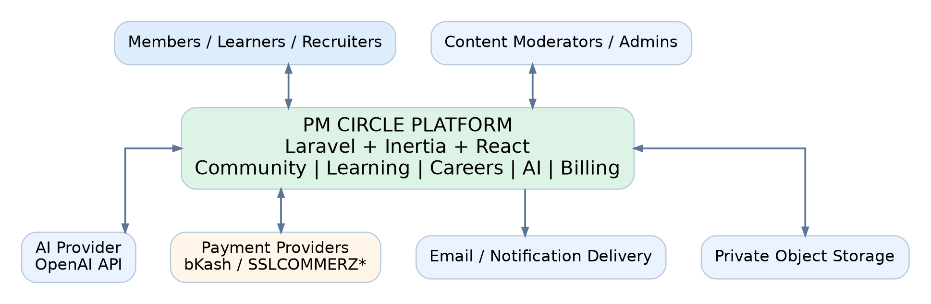
Figure 1. System context and primary external integrations.

7.2 Logical software architecture
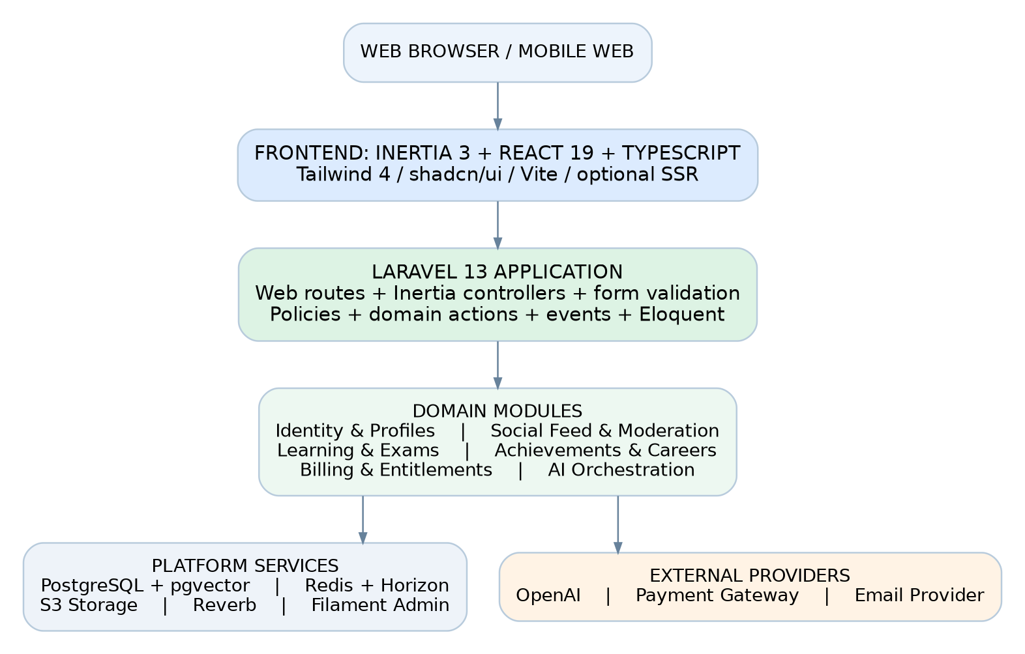
Figure 2. Modular monolith: Inertia React UI, Laravel domain modules, and shared platform services.
All first-party browser page navigation is handled by Laravel routes returning Inertia pages. React renders the pages, invokes Laravel routes through Inertia form/navigation helpers, and subscribes to selected realtime updates. JSON APIs are retained for async widgets, webhook entry points or future mobile integrations, rather than duplicating every page as a REST endpoint.

7.3 Approved technology baseline
Layer | Standard | Responsibilities / notes
Runtime | PHP 8.4+ compatible with Laravel 13 | Select supported production PHP release after confirming Laravel + package compatibility.
Application | Laravel 13 | Routing, validation, domain services, policies, Eloquent, scheduling.
Frontend | Inertia 3 + React 19 + TypeScript | Single repository, typed React page props; optional SSR for public SEO pages.
Styling | Tailwind CSS 4 + shadcn/ui | Shared design tokens; responsive accessible components.
Build | Vite + Node LTS | Asset building; optional Inertia SSR server in production.
Data | PostgreSQL + pgvector | Transactions, integrity, text/vector retrieval.
Cache/queue | Redis + Laravel Horizon | Caching, queues, job retries, usage counters.
Realtime | Laravel Reverb + Echo | Notifications and selected live interactions.
Admin | Filament (compatible release) | Policy-scoped administration and editorial workflows.
AI | OpenAI Responses API via Laravel AI Gateway | Structured generation, feedback, tool use and retrieval where permitted.
Media | Private S3-compatible storage | Resumes, uploads, thumbnails and secured exports.
Payments | Adapter-based gateway integration | BDT providers subject to merchant capabilities; verified signed webhooks.
Quality | Pest / PHPUnit, Vitest, Playwright | Backend, component and critical flow coverage.

7.4 Module boundaries and ownership
Domain module | Owns | May consume
Identity | User identity, verified credentials, roles, profile privacy | Notification delivery and audit service
Community | Posts, comments, reactions, follows, reports | Identity public projection, moderation policies, AI editorial events
Learning | Courses, lessons, enrollments, exams, attempts | Entitlements, achievement awards, approved AI scoring
Achievements | Rule registry, awards, evidence | Domain-completion events; no direct controller writes
Career | Resumes, review requests, jobs, applications | Private media, AI gateway, privacy/consent
Billing | Plan catalog, checkout, subscriptions, payments, entitlements | Gateway adapter, event handlers; never trusts frontend prices
AI | Templates, request logs, model invocations, credits, moderation | Provider adapter, retrieval index, content/rubric versions
Administration | Moderation cases, editorial queue, settings, audit logs | Scoped domain management actions

7.5 Request paths and processing boundaries
- Synchronous page navigation: browser -> Laravel route + auth/policy -> controller/action -> query -> Inertia props -> React page.
- Synchronous mutation: React form -> Laravel CSRF/session -> Form Request + policy -> transactional action -> redirect/Inertia success or validation error.
- Asynchronous AI/media: request -> durable job record -> Redis queue -> worker -> provider/storage -> database result -> notification/realtime update.
- Payment confirmation: provider -> signed callback/webhook endpoint -> verify and deduplicate -> transaction -> update subscription -> emit entitlement change.
- Search and recommendation: permission-filtered PostgreSQL query with optional pgvector embedding retrieval; never bypass visibility checks.

7.6 Core design decisions
Decision | Rationale
Single Laravel codebase | Fewer deployments, shared policies and transactions, less duplication across public, admin and member experiences.
Modular monolith | Allows future service extraction when operationally justified without premature distributed complexity.
PostgreSQL first | Relational integrity and vector capability in one system; add dedicated search only if measured need.
Async by default for AI | Protects web response time and allows retries, back-pressure, quotas and provider failures.
SSR only where it matters | Enable for public indexable pages after testing deployment and caching; authenticated areas may stay client-hydrated.
Filament admin | Accelerates CRUD and operational workflows, but custom dashboards and permissions remain first-party.

8. AI subsystem design and control flows

8.1 AI use-case catalog
AI capability | Input | Output / quality control | Release
Editorial post generation | Approved topic, source guidance, style and frequency | Draft post + safety flags + provenance; moderator approval | P0
Daily project scenario | Topic, complexity, learning objective, rubric seed | Draft scenario and answer guidance for editorial review | P0
Community answer assistance | Member-typed question and selected visible context | Suggested response, edit-before-post; never posts as member automatically | P1
Scenario reasoning assessment | Member response + versioned scenario rubric | JSON feedback, explanation, educational score, caveats | P1
Resume review | Consented extracted resume + optional job description | Structured review and suggested improvements; no fabricated credentials | P1
Interview coach | Role/job target, practice responses | Questions, summaries and coaching feedback | P2
Recommendations | Opt-in skills, activity and learning history | Suggested lessons, scenarios, jobs; explain why relevant | P2
Moderation assistance | Reported post/context | Classification recommendation for moderator; not automatic final appeal decision | P1

8.2 AI job lifecycle
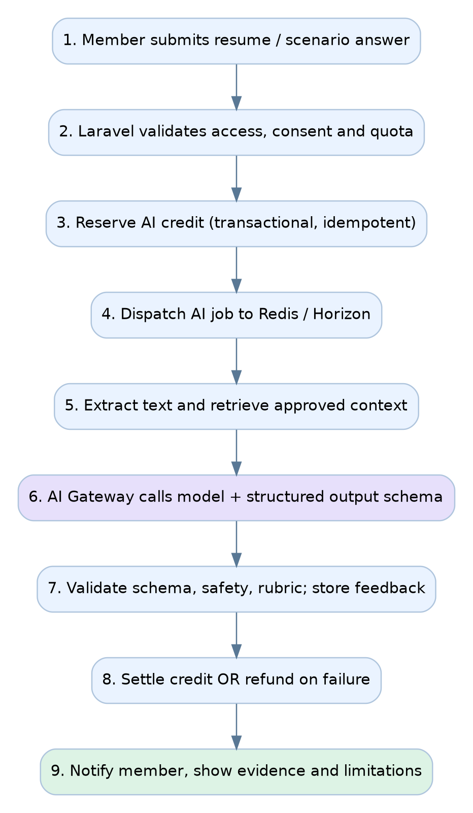
Figure 3. Queue-driven AI feedback lifecycle with credit reservation, schema validation, and settlement.
An AI request receives a stable idempotency key and job identifier. The gateway must preserve the member plan at request time, versioned rubric/template, model metadata, consent state, cost measurements and final response state. When output fails validation, do not silently assign a score; retry under bounded policy or move to error/review.

8.3 Recommended Laravel AI services
Service / action | Required behavior
AiGateway | One entry point to model providers, with feature-to-model routing and safe defaults.
AiPromptRegistry | Versioned templates and system/developer instructions stored securely.
AiEntitlementService | Checks role, plan, daily limits, feature availability and quota.
ReserveAiCredits / SettleAiCredits | Transactional reservation, debit/release and deduplicated ledger writes.
DocumentExtractionService | Reads permitted PDF/DOCX text; isolates untrusted content.
KnowledgeRetrievalService | Retrieves only approved, member-accessible learning material.
StructuredFeedbackValidator | Validates JSON schema, rubric requirements and confidence disclaimers.
AiModerationService | Flags disallowed input/output for safe handling or human review.
AiCostObserver | Tracks tokens, model usage, failures, spend caps and alert thresholds.
EditorialDraftPublisher | Generates a draft and publishes only after policy-required approval.

8.4 AI generation versus scoring rules
- Deterministic assessments such as multiple-choice marking must never rely on a generative model for correctness.
- AI may provide advisory rubric feedback on written answers with a rubric version, reason codes, appropriate uncertainty, and a re-review channel.
- A candidate resume score, if shown, must be transparent and contextual; it must not be presented as a validated hiring prediction.
- AI output must be escaped/sanitized before display and checked before public publishing.
- User-uploaded PDF text, external web snippets, and retrieved content are treated as untrusted data, not privileged instructions.

8.5 Prompt and model governance
Control | Implementation rule
Provider abstraction | Adapters support provider substitution; client code never references model IDs directly.
Prompt versions | Store prompt key/version, evaluation rubric version and release notes per operation.
Output schema | Use a versioned JSON schema with explicit outcome, rationale, checklist and warnings.
Test suite | Maintain representative scenarios, unsafe inputs, low-quality resumes and adversarial document tests.
Budget policy | Hard per-request and per-member limits; separate model choices by risk/cost.
Retention | Store minimal operational metadata by default; full content only under approved retention/consent policy.
Human oversight | Editors approve public AI posts initially; moderators can suppress content and halt a feature.

9. Data architecture and entity-relationship design

9.1 Data modeling principles
Use UUIDv7 or bigint primary keys consistently (final choice before first migration); all entity tables include created_at/updated_at and necessary published/deleted timestamps. Foreign keys must have explicit delete behavior. Prefer constrained statuses, immutable economic records and history tables for stateful processes. Store money as integer minor units and all instants in UTC.

9.2 ER diagram: Identity and community
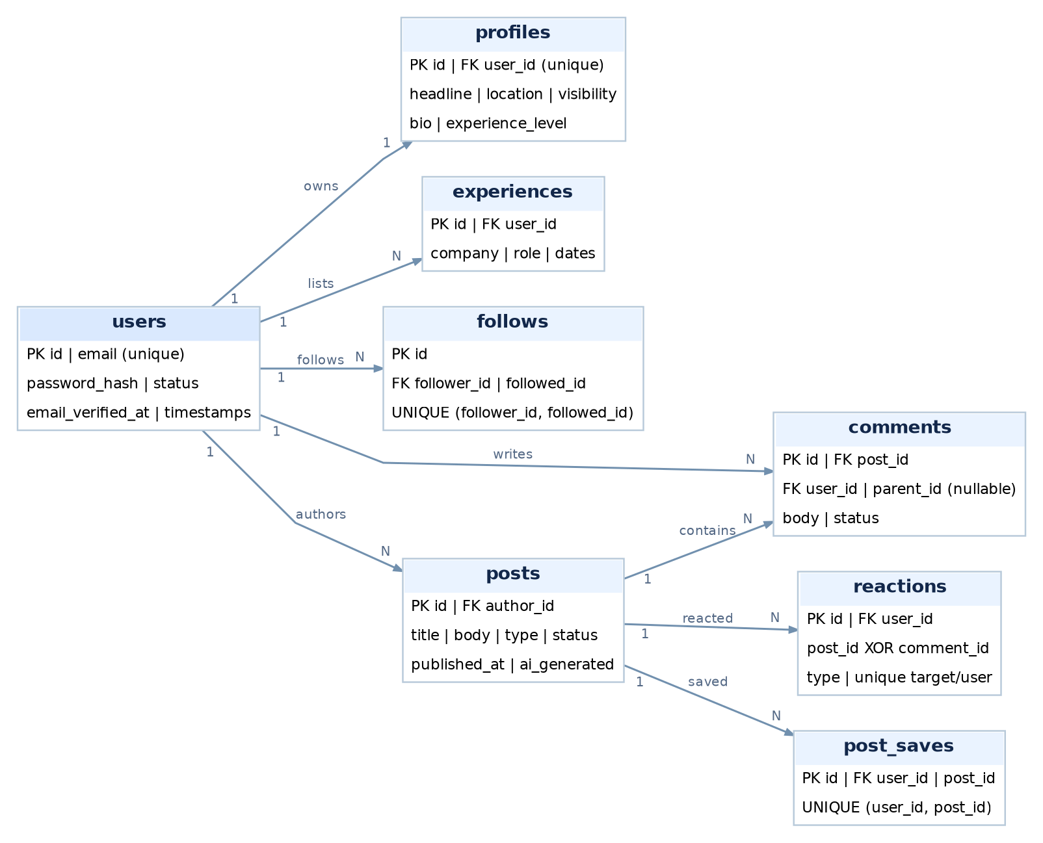
Figure 4. Key identity/social relationships. FK direction and multiplicities are complemented by the detailed constraints below.
Important detail: profiles.user_id is unique (1:1), while follows has two foreign keys to users (follower_id, followed_id). Nested replies reference comments.parent_id. Reactions are modeled with a mutually exclusive target column or may be separated into post_reactions and comment_reactions for stronger FK integrity.

9.3 ER diagram: Learning, exams and achievements
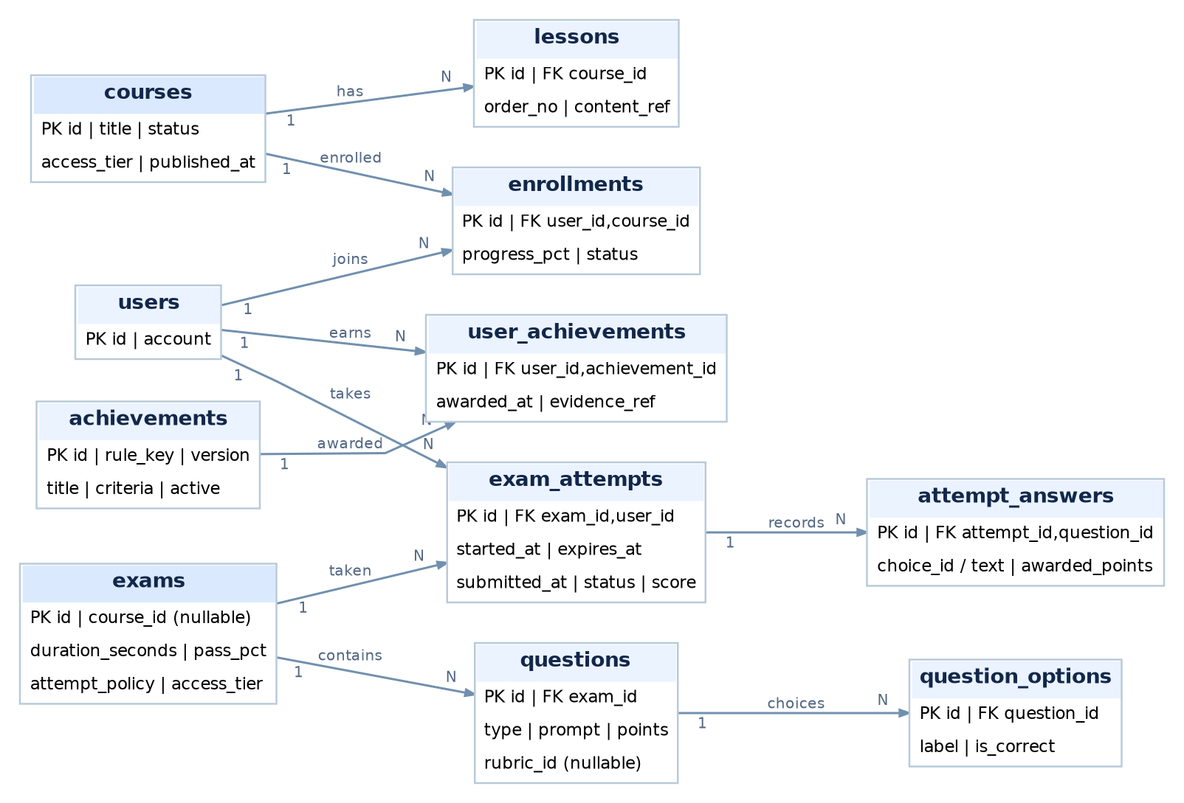
Figure 5. Learning and examinations, showing enrollments, question/attempt records and achievement awards.
Lessons relate to courses; attempts relate to the exact exam version. The question_options, attempt_answers and achievement evidence tables preserve auditability. Optional scenario responses reuse rubric-based AI feedback without becoming official exam grades.

9.4 ER diagram: Billing, AI and careers
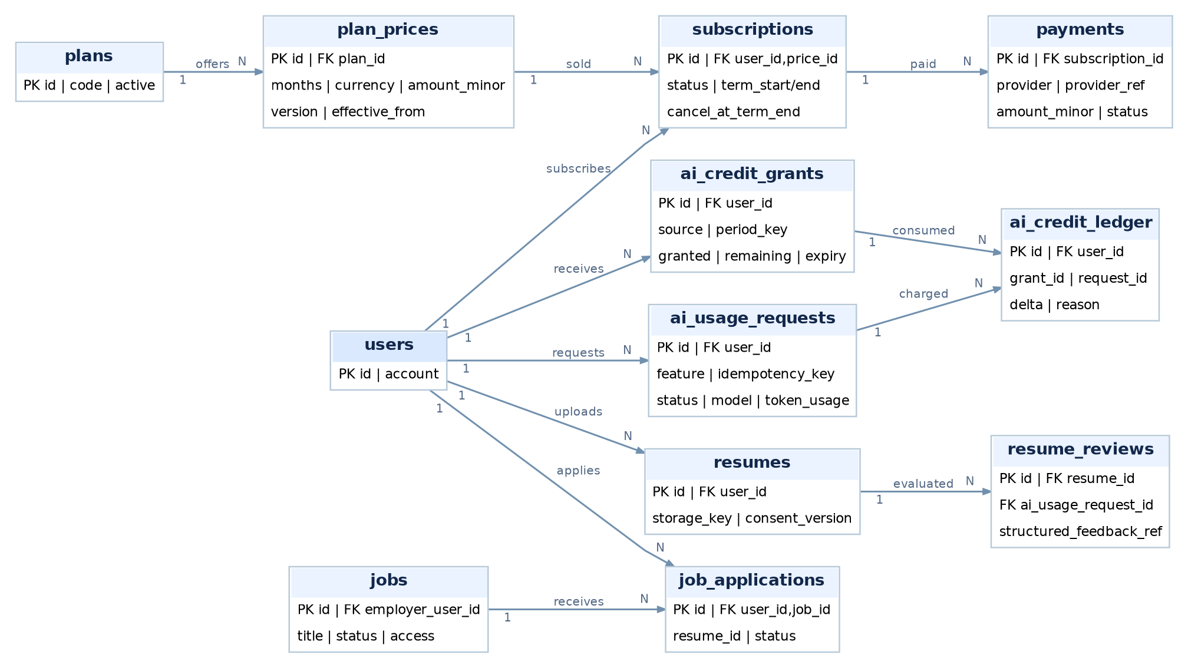
Figure 6. Membership prices, subscriptions, AI usage ledger and career documents.
These diagrams are logical summaries rather than exhaustive migration specifications. The entity catalog and integrity constraints below are normative for implementation; all optional/self-referential foreign keys are described explicitly.

9.5 Core entity catalog
Entity group | Tables / core fields | Critical keys and constraints
Accounts | users (id, email, password, status); profiles (user_id, headline, privacy) | UNIQUE normalized email; UNIQUE profiles.user_id; verified state required for writes.
Professional identity | experiences, skills, user_skills, certifications, profile_imports | Unique ordered link IDs; profile import review state and source hash.
Connections | follows, blocks | UNIQUE (follower_id, followed_id); checks forbid self-follow/self-block.
Social | posts, post_media, comments, reactions, post_saves, post_tags, tags | Author/post FKs, comment.parent_id self-FK, uniqueness for reaction and save.
Moderation | reports, moderation_cases, moderation_actions, user_sanctions | Reason, actor_id, subject_id, timestamps, evidence and appeal linkage.
Learning | courses, lessons, lesson_resources, enrollments, lesson_progress | Unique (user_id, course_id); unique lesson order per course/version.
Exams | exams, exam_versions, questions, question_options, exam_attempts, attempt_answers | Attempt state/version; UNIQUE attempt+question; no answer key on active browser response.
Scenarios | scenarios, scenario_rubrics, scenario_responses, feedback_reviews | Versioned scenario/rubric, author FK and visibility controls.
Badges | achievements, achievement_rules, user_achievements | UNIQUE (user_id, achievement_id, rule_version), recorded evidence.
Commercial | plans, plan_prices, subscriptions, payment_intents, payments, gateway_events | Unique external refs; immutable amount/currency; bounded periods.
Entitlements | entitlement_grants, ai_credit_grants, ai_credit_ledger | Atomic grant/settlement and balanced nonnegative grant remainder.
AI operations | ai_usage_requests, ai_prompt_versions, ai_outputs, ai_feedback | UNIQUE (user_id, idempotency_key), model/prompt/rubric versions.
Career | resumes, resume_reviews, jobs, job_applications, recruiter_access_grants | Private file keys and consent; unique active applications if policy requires.
Operations | notifications, notification_preferences, audit_logs, outbox_events | Queue-safe event IDs, lifecycle and immutable privileged audit entries.

9.6 Referential integrity and index requirements
- Index post author_id + published_at, post status + published_at, comments.post_id + created_at, and user feed visibility join paths.
- Index exam_attempts(user_id, exam_id, started_at), attempt_answers(attempt_id, question_id), and unique current award tuples.
- Make gateway_events(provider, provider_event_id) unique; make payments provider reference unique when the provider guarantees uniqueness.
- Use unique constraints and transactional locks for subscription cycle grants and AI credit reservation/settlement.
- Use partial/compound indexes for active subscriptions, public posts and visible job listings; measure with EXPLAIN ANALYZE.
- For semantic retrieval, store source_id, embedding model/version, ACL metadata and embedding; use pgvector HNSW only after relevance/recall tests.
- Prefer soft-delete for social content where moderation/audit requires it; privacy erasure may require anonymization/hard deletion under policy.

9.7 Data lifecycle and retention
Data type | Recommended operational treatment
Accounts and profile | Export/delete request workflow; delete public projection and queue index cleanup.
Resume files | Private by default, consent-limited AI processing, delete originals/derivatives on approved request.
Posts/comments | Soft-delete plus moderation audit; retain only required legal/evidence data.
Exam records | Preserve grading/version provenance for defined retention duration.
Payments | Retain immutable provider/financial records for regulatory and accounting requirements.
AI logs | Minimize payload retention; track request IDs, feature, model, cost and safety status.
Provider webhooks | Persist event ID, verification and processing status to support reconciliation.
Backups | Encrypted retention and tested recovery, with deletion schedule aligned to legal requirements.

10. Full proposed Laravel project structure
The directory tree below is a recommended implementation layout, not a claim about an existing repository. Build on the official Laravel React starter kit; preserve its standard files and conventions while adding module-oriented business code. App/Domain modules own business operations; controllers remain thin and React components never enforce authoritative access checks.

10.1 Repository and Laravel application tree
pm-circle/
app/
Domain/
Identity/{Actions,DTOs,Enums,Queries,Services}/
Profiles/{Actions,DTOs,Queries,Services}/
Community/{Actions,DTOs,Events,Listeners,Queries,Services}/
Moderation/{Actions,Enums,Events,Services}/
Learning/{Actions,DTOs,Events,Queries,Services}/
Examinations/{Actions,DTOs,Enums,Events,Services}/
Achievements/{Actions,Events,Listeners,Rules}/
Career/{Actions,DTOs,Events,Services}/
Billing/{Actions,DTOs,Enums,Events,Gateways,Services}/
AI/{Actions,Adapters,DTOs,Enums,Prompts,Services,Validators}/
Notifications/{Actions,Events,Services}/
Search/{Actions,Queries,Services}/
Http/
Controllers/{Auth,Profile,Community,Learning,Exam,
Scenario,Career,Billing,AI,Notification}/
Controllers/Api/V1/{AI,Exam,Upload,Feed}/
Controllers/Webhooks/{PaymentWebhookController.php}/
Middleware/{EnsureOnboarded,EnsureEntitled,VerifyApiClient}/
Requests/{Auth,Community,Learning,Exam,Career,Billing}/
Resources/{MemberResource,PostResource,ExamResultResource}/
Models/{User,Profile,Post,Comment,Exam,Attempt,Subscription,...}/
Policies/{PostPolicy,ProfilePolicy,ExamPolicy,ResumePolicy,...}/
Jobs/{AI,Media,Payments,Notifications,Search}/
Events/{PostPublished,ExamSubmitted,AchievementAwarded,...}/
Listeners/{UpdateFeeds,IssueAchievement,SendReceipt,...}/
Notifications/{NewReply,AIResultReady,PaymentConfirmed,...}/
Filament/
Resources/{Users,Posts,Reports,Courses,Exams,Plans,...}/
Pages/{EditorialQueue,AIUsage,RevenueOverview}/
Widgets/{ModerationStats,PaymentHealth,AISpend}/
Console/Commands/{GenerateDailyScenario,ReconcilePayments,...}/
Providers/{AppServiceProvider,EventServiceProvider,...}/
bootstrap/{app.php,providers.php}/
config/{app,auth,cache,database,filesystems,queue,reverb,...}.php
database/
migrations/{000_users,010_community,020_learning,030_billing,...}/
factories/{UserFactory,PostFactory,ExamFactory,...}/
seeders/{RoleSeeder,PlanSeeder,DemoContentSeeder}/
routes/{web.php,api.php,console.php,channels.php}/
resources/
css/{app.css,tokens.css}/
views/{app.blade.php}/
js/ [see detailed frontend structure below]
storage/app/private/{resumes,imports,exports}/
tests/{Feature,Unit,Architecture}/
scripts/{deploy,backup,seed-demo}/
docs/{architecture,api,adr,runbooks,prompt-schemas}/
.github/workflows/{ci.yml,deploy-staging.yml,deploy-prod.yml}/
composer.json | package.json | vite.config.ts | tsconfig.json
phpunit.xml | pint.json | .env.example | README.md

10.2 Inertia / React page and component layout
resources/js/
app.tsx | ssr.tsx | bootstrap.ts
pages/
public/{Home.tsx,Pricing.tsx,About.tsx,Privacy.tsx}/
auth/{Login.tsx,RegisterStep1.tsx,RegisterStep2.tsx,
RegisterStep3.tsx,VerifyEmail.tsx,ForgotPassword.tsx}/
community/{Feed.tsx,PostShow.tsx,SavedPosts.tsx,
CreatePost.tsx,MemberDirectory.tsx}/
profiles/{Show.tsx,Edit.tsx,Achievements.tsx,ImportReview.tsx}/
scenarios/{Index.tsx,Show.tsx,MyFeedback.tsx}/
learning/{Catalog.tsx,CourseShow.tsx,LessonShow.tsx,
MyLearning.tsx}/
exams/{Index.tsx,Instructions.tsx,Attempt.tsx,Result.tsx,
History.tsx}/
career/{Jobs.tsx,JobShow.tsx,MyApplications.tsx,
Resumes.tsx,ResumeReview.tsx,InterviewPractice.tsx}/
billing/{Plans.tsx,Checkout.tsx,Result.tsx,Subscription.tsx}/
account/{Dashboard.tsx,Notifications.tsx,Settings.tsx}/
layouts/{PublicLayout.tsx,MemberLayout.tsx,AuthLayout.tsx}/
components/
ui/{Button,Input,Select,Dialog,Toast,...}.tsx
navigation/{Header,MobileNav,Sidebar,Breadcrumb}.tsx
community/{PostCard,Composer,Reactions,CommentThread}.tsx
learning/{LessonCard,ProgressBar,QuestionRenderer}.tsx
exams/{ExamTimer,QuestionNavigation,SubmissionReview}.tsx
ai/{AiFeedback,UsageMeter,ResultDisclosure}.tsx
billing/{PlanCard,DurationSelector,PaymentSummary}.tsx
profile/{ProfileHeader,ExperienceList,AchievementGrid}.tsx
hooks/{useExamTimer,useAutosave,useDebouncedSearch,useEcho}.ts
lib/{routeHelpers,formatMoney,formatDate,validation,permissions}.ts
types/{auth,community,learning,exam,billing,ai,career}.ts
tests/{components,pages,accessibility}/

10.3 Coding conventions and dependency rules
- PHP domain actions are named for use cases (SubmitExamAttempt, PublishPost, GrantAiAllowance), rather than generic service objects with many unrelated operations.
- Controllers validate input, call policies/actions and return Inertia pages or small JSON contracts; Eloquent queries live in dedicated query classes where complex.
- React pages receive only an authorized minimal data projection; sensitive model properties are never serialized by default.
- Use application events plus an outbox pattern for business-critical cross-module notifications and payment-related side effects.
- Store UI tokens centrally: color, typography, spacing, radii, card/border styles, validation messages and loading states.
- Write an Architecture Decision Record (ADR) for changes to schema key type, exam policies, payments, AI scoring and data retention.

11. Interface, event and integration specifications

11.1 Internal URL and interface inventory
Laravel web routes render Inertia pages; REST-like JSON endpoints are reserved for independent async interactions, integrations and possible future mobile clients. Exact names can change, but access rules and contracts must not.
Route / action | Method | Access and behavior
/ | GET | Public homepage; SEO metadata and curated content.
/join/step/{n} | GET/POST | Guest/partial onboarding; steps 1-3 with CSRF.
/pricing | GET | Public pricing plan comparison; server-priced durations.
/community | GET | Public/member feed with cursor paging and visibility.
/posts/{slug} | GET | Public/member post with comments and author sidebar.
/posts | POST | Verified member creates moderated/validated post.
/posts/{id}/reactions | POST/DELETE | Verified member changes unique reaction.
/posts/{id}/comments | POST | Verified member creates a comment or parent reply.
/scenarios/{slug} | GET | Scenario content and permissible responses.
/scenarios/{id}/responses | POST | Verified member submits a written response.
/learning/{course} | GET | Public preview/entitled course detail.
/exams/{id}/attempts | POST | Entitled user starts a server-timed attempt.
/exams/attempts/{id}/answers | PUT | Autosave answer, concurrency/idempotency validated.
/exams/attempts/{id}/submit | POST | Locks and scores attempt under exam policy.
/billing/checkout | POST | Price/version checked server-side; payment intent created.
/billing/return | GET | Displays return state; not sufficient to grant paid access.
/webhooks/payments/{provider} | POST | Provider-signed callback only; reconciled idempotently.
/ai/requests | POST | Protected async AI job creation, credit reservation.
/ai/requests/{id} | GET | Owner-only result/progress with safe response.
/career/resumes | POST | Private upload, owner only; scanner and consent.
/jobs/{slug}/apply | POST | Authorized application with own resume reference.
/account/settings | GET/PATCH | Authenticated member profile/notification/privacy changes.

11.2 Structured AI feedback contract (illustrative)
{
"request_id": "uuid",
"feature": "scenario_feedback",
"schema_version": "1.0",
"rubric_version": "SCN-CHG-001:v3",
"score": {"value": 8, "maximum": 10, "advisory": true},
"strengths": ["Impact assessed before commitment"],
"considerations": ["Identify formal approval authority"],
"next_steps": ["Record and present trade-offs"],
"disclaimer": "Educational AI feedback; review critically."
}

Use separate versioned contracts for resume review, interview practice and moderation. Do not accept arbitrary model-generated database field names, executable instructions or HTML as trusted data.

11.3 Domain events and async jobs
Event / job | Producer | Consumer / guaranteed effect
UserRegistered | Identity | Verification notification and onboarding analytics; deduplicated.
PostPublished | Community | Feed/search indexing and follower notification rules.
PostReported | Moderation | Create case and alert permitted reviewer.
DailyScenarioDraftDue | Scheduler | Create one draft per date/topic key, never duplicate.
ExamAttemptSubmitted | Exams | Objective scoring job and immutable scoring record.
ExamResultPublished | Exams | Update progress, check achievement eligibility once.
AchievementAwarded | Achievements | User notification and achievement history.
PaymentVerified | Billing adapter | Activate period only after amount/currency/reference verification.
SubscriptionCycleStarted | Billing | Grant configured monthly/term AI allowance once.
AiRequestQueued | AI gateway | Run provider request, validate, persist result and settle credits.
AiRequestFailed | AI gateway | Refund reserved allowance and notify user.
ResumeUploaded | Career | Scan, extract only if consented, set private processing state.
ProfileVisibilityChanged | Profiles | Invalidate caches and remove stale public/search projections.

11.4 Integration constraints
External system | Boundary and trust requirements
OpenAI API | Server-only secrets; request limits; separate sandbox/staging key; structured output validation.
Payment gateway | Approved merchant account, signed callbacks, transaction verification and reconciliation job.
Email service | Transactional templates, throttling, bounce handling, unsubscribe for optional campaigns.
S3-compatible storage | Private default ACL, signed URLs, antivirus processing and lifecycle deletion.
Optional LinkedIn profile | Accept user-entered link or user-supplied PDF/export only; no unsanctioned data extraction.
Observability tool | Error data redaction, minimal PII and controlled access to traces.

12. Deployment, operations and observability

12.1 Target deployment topology
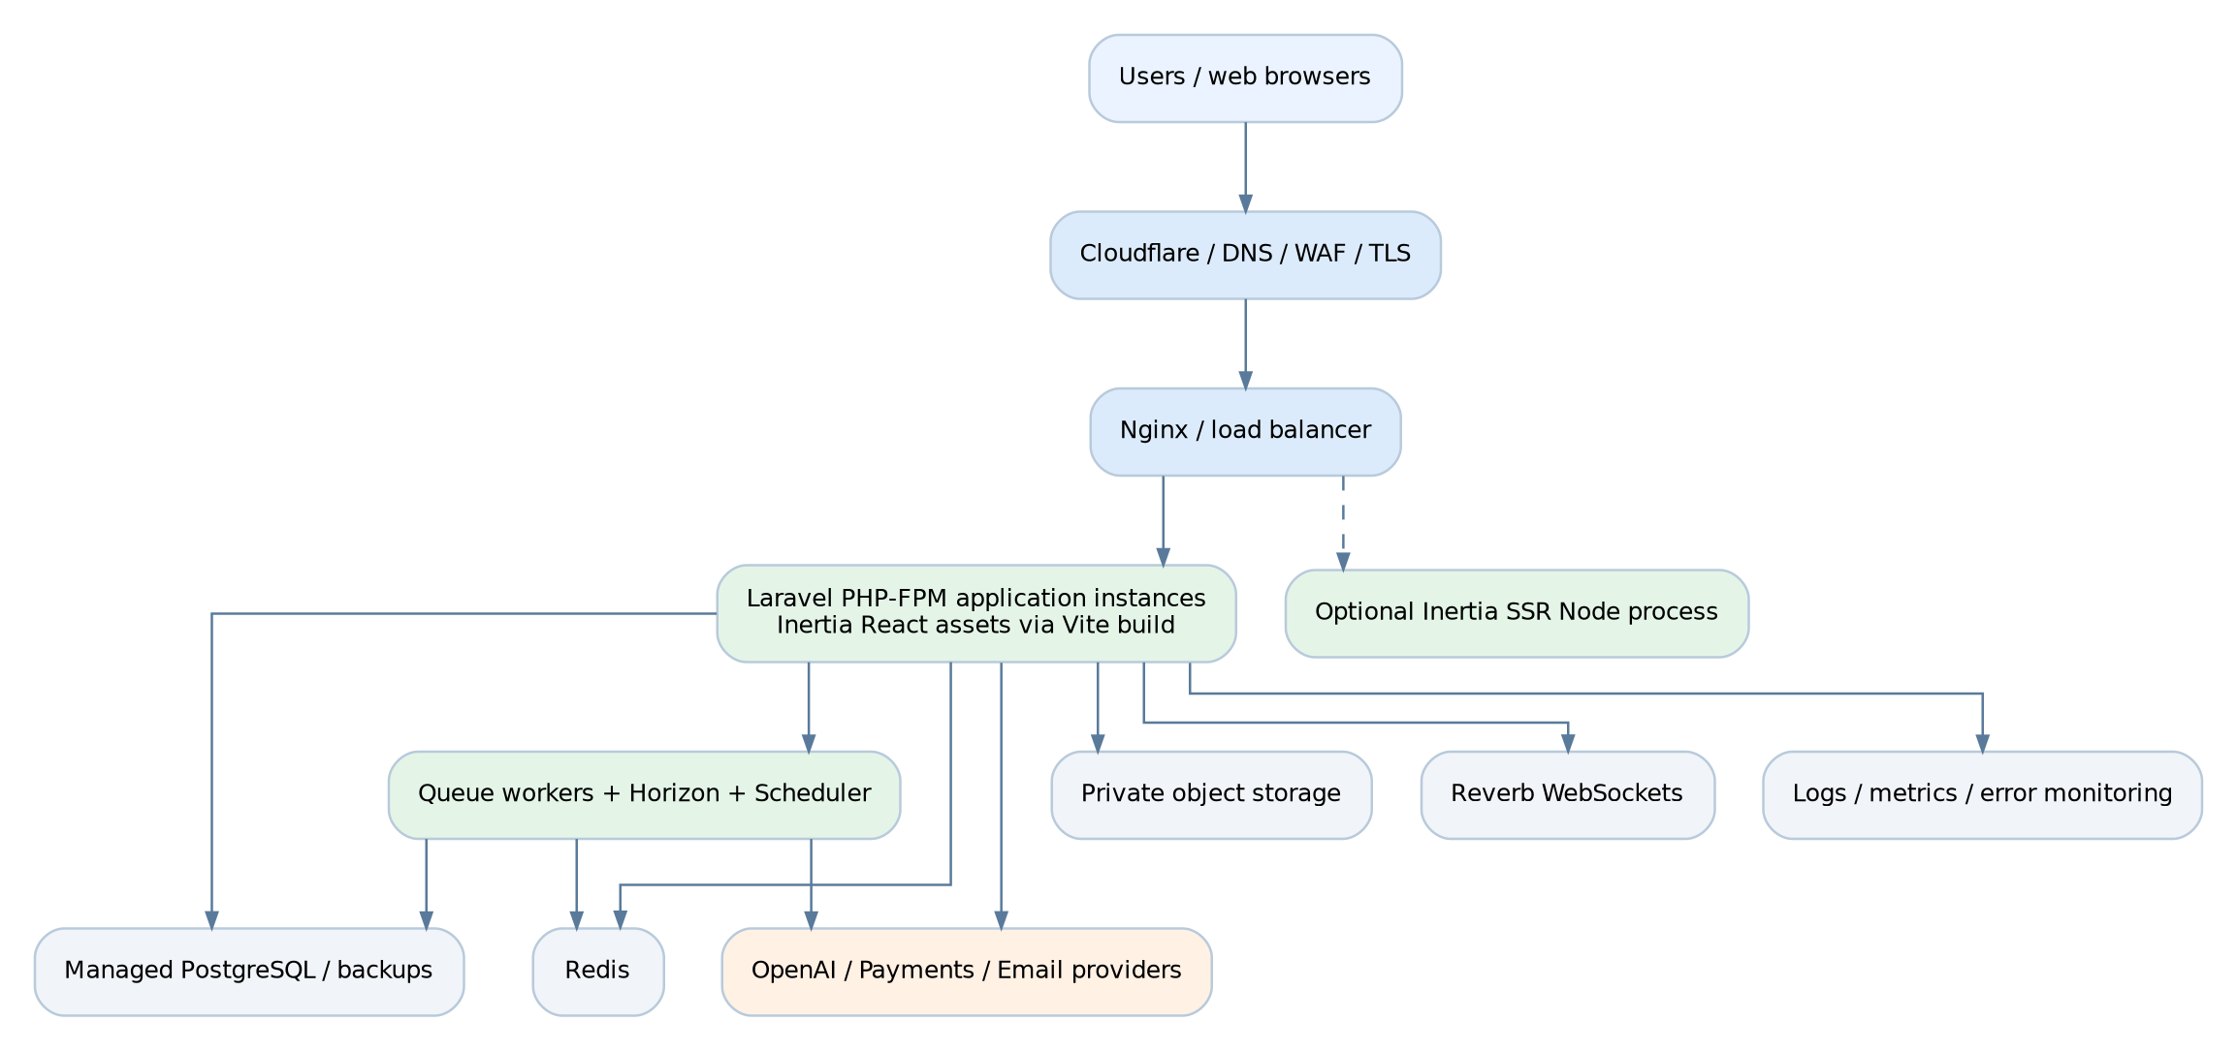
Figure 7. Recommended deployable topology; start with one web node and separate workers if load permits.

12.2 Environments and release processes
Environment | Responsibilities
Local | Laravel + Vite dev, PostgreSQL, Redis, fake payment and AI provider adapters; seeded data.
CI | Composer/Node dependency locking, PHP lint/static analysis, TS checks, unit/feature/E2E tests.
Staging | Production-like services with sanitized data, provider test credentials, full critical-flow validation.
Production | Secrets manager/environment, TLS/WAF, workers and scheduling, backups, incident alerts.
Deployment | Build assets, run backward-compatible migrations, restart workers/SSR, run health checks, rollback app safely.

12.3 Queues, scheduling and realtime operations
Queue / schedule | Priority and execution policy
payments | Highest reliability; retry on transient errors only, idempotent verification, alerts.
notifications | Fast user-facing email and in-app notifications; batch where appropriate.
ai-high | Paid interactive AI results; concurrency/cost caps.
ai-editorial | Daily scenario/post generation; review workflow and schedule lock.
media | Resume extraction, antivirus status and image processing.
search | Async index refresh and deletion; visibility-aware.
realtime | WebSocket broadcast events only, lightweight jobs.
scheduler | One authoritative scheduler instance or distributed lock for daily tasks/renewals.

12.4 Health monitoring and incidents
- Health endpoints verify Laravel readiness, database access, Redis queue availability and storage connectivity without leaking secrets.
- Alert on payment webhook failures, stale subscription renewals, unprocessed AI jobs, large moderation backlogs and database disk usage.
- Use request_id, event_id and job_id consistently to trace a user action across HTTP, queue, AI provider and database changes.
- Maintain runbooks for payment reconciliation, AI provider outage, Redis recovery, failed deployment, backup restore and privacy incident.
- Run periodic restore tests, provider-integration smoke tests and permission regression tests before major releases.

13. Testing, acceptance and traceability

13.1 Quality assurance strategy
Test level | Scope and tooling
Unit | Business rules: payment state, credit settlement, achievement eligibility, exam scoring; Pest/PHPUnit.
Feature / integration | Policies, requests, transactional actions, webhooks, queues and external adapter contracts.
React components | Forms, state transitions, accessibility, timers and field errors; Vitest/Testing Library.
End-to-end | Registration, paid activation, posting, exams, AI results and resume privacy; Playwright.
Security | Authorization matrix, injection/XSS, CSRF, file scanning, rate limits, prompt-injection fixtures.
Load / resilience | Feed pagination, exam submission spikes, queue backlog, gateway retry and model timeout simulations.
Accessibility | Keyboard-only workflows, focus order, labels, status announcements and screen-reader behavior.
Operational | Backup restore, deploy/rollback, alert routing, timeout/retry and recovery exercises.

13.2 Release acceptance scenarios
Acceptance ID | Given / when / then result | Mapped requirements
AT-01 | Given a visitor, when registering and verifying email, then account enables permitted member actions. | AUTH-01..04
AT-02 | Given interrupted onboarding, when returning, then saved progress is restored without duplicate user. | AUTH-05..07
AT-03 | Given a member, when posting/replying/reacting, then exactly one intended mutation occurs. | SOC-01..09
AT-04 | Given unauthorized viewer, when requesting private resume, then access is denied and audited as applicable. | PROF-03, CAR-01
AT-05 | Given a scenario, when submitting an answer, then feedback references current rubric and has correct disclosure. | SCN-03, AI-05..08
AT-06 | Given a submitted exam, when request is retried, then one scored result exists with immutable version. | EXAM-03..10
AT-07 | Given an earned badge event replay, then only one award exists. | ACH-01..03
AT-08 | Given fraudulent/duplicate webhook, then no entitlement or payment duplication occurs. | BILL-05..07,14
AT-09 | Given cancellation, then access stays until paid term_end, after which Free remains. | BILL-08..09
AT-10 | Given exhausted credits, AI request is rejected before provider cost is incurred. | AI-02..04, BILL-11
AT-11 | Given AI provider failure, pending credits are released and a clear error is displayed. | AI-12..13
AT-12 | Given public AI content, it carries AI disclosure and editorial approval record. | SCN-04..08
AT-13 | Given blocked user/private post, search and recommendation must omit forbidden content. | PROF-08..10, OPS-05
AT-14 | Given unsupported payment return URL without webhook confirmation, paid entitlements remain inactive. | BILL-06..07

13.3 Definition of done
- Every P0 requirement has an owner, linked acceptance test and documented business rule.
- All financial/credit/exam finalization flows pass replay, concurrency and rollback tests.
- Critical screens pass responsive and keyboard tests, without unreadable text or clipped mobile UI.
- Production logging/alerting and backups are functional and a recovery test has been completed.
- AI features pass structured-output, safety, quota and prompt-injection test cases.
- Product owner approves branding, billing, privacy, access policy and exact P0 scope.

14. Recommended phased delivery
Phases 0-1 may be released as a limited Free beta. The paid general-availability release must wait for the Phase 2 billing, exam and AI-credit controls and their acceptance tests.
Phase | Functional outcomes | Exit criteria
Phase 0 - Foundation | Design system, authentication, shared permissions, infra/CI, schema baseline, moderation/admin skeleton. | Staging deployment, roles/policies, core layouts, database migrations and monitoring work.
Phase 1 - Community MVP | Public website, onboarding, profiles, posts, feed, threaded replies, follow/save, daily AI editorial drafts. | AT-01..04 and AT-12; moderation workflow and acceptable performance.
Phase 2 - Learning & Revenue | Lessons, question banks, exam engine, scenarios and AI feedback, achievements, payment/credits. | AT-05..11, AT-14; payment reconciliation and exam integrity signed off.
Phase 3 - Career AI & Scale | Resume review, jobs/recruiters, advanced simulations, interview practice, recommendations. | Privacy-consent testing, fairness review and load-tested operations.

A phase is a release grouping, not an estimated duration or contractual delivery commitment. Final sprint sizing depends on team capacity, design approval and provider integration availability.

15. Risks, decisions and glossary

15.1 Key risks and mitigations
Risk | Impact | Mitigation
Unverified recurring payment capability | Broken subscription renewal | Validate merchant/provider contract and sandbox before billing design freeze.
AI cost growth / abuse | Budget exposure | Per-feature caps, credit reservation, throttling, queues, alerts and admin kill switch.
Weak exam integrity | Unreliable outcomes | Server timers, immutable exam version, deterministic scoring, unique submissions.
Resume/privacy leakage | Sensitive personal data exposure | Consent, private storage, ACL tests, signed URLs, retention/deletion flow.
Premature microservices | Maintenance overhead | Modular monolith with clean domain contracts and outbox events.
SEO on Inertia pages | Reduced organic discovery | SSR or prerender targeted public pages, canonical URLs and performance audits.
Moderation workload | Low trust / unsafe content | Report queues, moderation tools, editorial review and escalation SLAs.
Unclear badges vs certification | Consumer confusion | Explicit PM Circle label, rubric and limitation on all awards.

15.2 Decisions requiring product-owner approval
Decision ID | Question / decision required | Proposed default
DEC-01 | Final visual brand: blue/green/accent use, typography, UI tokens. | Blue primary, green success/registration accents.
DEC-02 | Are Plus/Pro price points and 1/3/6/12-month terms commercially approved? | Keep proposed prices configurable; confirm before checkout.
DEC-03 | Does Pro support prepaid durations beyond one month? | Monthly only until approved.
DEC-04 | Are AI allowances 50/150 per month, and do unused credits expire? | 50 / 150; no rollover, monthly grant.
DEC-05 | Should AI daily posts auto-publish? | Draft + human approval initially.
DEC-06 | Which payment merchant supports verified recurring debit? | Integration by adapter; initial manual renewal if needed.
DEC-07 | What are exam retake rules, expiry action and passing threshold? | Per exam configuration; no global fixed values.
DEC-08 | What personal data retention and user deletion periods are required? | Define with counsel before production.
DEC-09 | Who can see profile-view identities and recruiter resume details? | Consent gated; Pro viewer data and recruiter P2.
DEC-10 | Which parts are MVP versus later roadmap? | Phase 1 community; Phase 2 learning/revenue; Phase 3 career AI.
DEC-11 | Is Bangla localization required at launch? | English UI, internationalization-ready.
DEC-12 | When should SSR be enabled for public discovery pages? | Enable after deployment validation for indexable routes.

15.3 Glossary
Term | Meaning
SRS | Software Requirements Specification: testable behavioral and quality requirements.
Inertia | Server-driven bridge between Laravel routes/controllers and React pages in one application.
RBAC | Role-based access control; distinct from paid plan entitlement.
Entitlement | Effective access right arising from membership, role or explicit grant.
RAG | Retrieval-augmented generation using approved source material.
SSR | Server-side rendering of page output to improve initial content and SEO where configured.
Webhook | Provider-to-platform callback, authenticated and deduplicated.
Idempotency | Repeated requests/events produce one intended business effect.
Rubric | Versioned grading criteria for examination or scenario feedback.
pgvector | PostgreSQL extension for storing and searching vector embeddings.

Appendix A. Implementation examples and primary references

A.1 Suggested named Laravel modules and responsibilities
- Community example: PostController -> StorePostRequest -> PostPolicy -> CreatePost action -> PostPublished event -> feed/search listeners.
- Exam example: SubmitAttemptController -> AttemptOwnershipPolicy -> SubmitExamAttempt -> database lock/unique constraint -> AttemptSubmitted event -> ScoreAttempt worker.
- Billing example: PaymentWebhookController -> ProviderSignatureVerifier -> RecordGatewayEvent -> VerifyPayment -> ActivateSubscription -> EntitlementChanged event.
- AI example: RequestScenarioFeedbackController -> AiEntitlementService -> ReserveAiCredits -> QueueAiEvaluation -> OpenAI adapter -> ValidateStructuredOutput -> SettleAiCredits.

A.2 Suggested operational configuration keys
APP_NAME="PM Circle"
APP_ENV=production
APP_URL=https://example.org
DB_CONNECTION=pgsql
QUEUE_CONNECTION=redis
CACHE_STORE=redis
BROADCAST_CONNECTION=reverb
FILESYSTEM_DISK=private_s3
AI_PROVIDER=openai
AI_DEFAULT_FEATURES_ENABLED=true
AI_MAX_DAILY_EDITS_PER_USER=<configured>
PAYMENTS_DEFAULT_CURRENCY=BDT
PAYMENTS_WEBHOOK_VERIFICATION_ENABLED=true
FEATURE_PUBLIC_SSR=true

Values shown above are illustrative names and are not guaranteed native Laravel environment variables. Store actual sensitive values in secured deployment secrets, never in source control.

A.3 Source and product references
Laravel 13 frontend / Inertia: https://laravel.com/docs/13.x/frontend
Laravel 13 starter kits: https://laravel.com/docs/13.x/starter-kits
Laravel official React starter kit: https://github.com/laravel/react-starter-kit
OpenAI Responses API: https://developers.openai.com/api/reference/responses/overview
OpenAI File Search guide: https://developers.openai.com/api/docs/guides/tools-file-search
pgvector project: https://github.com/pgvector/pgvector
Project inputs: PM Circle supplied product reference images, registration and pricing samples, discussions/scenario screens.

A.4 Requirements baseline sign-off
Product owner: _______________________ Technical lead: _______________________
QA lead: ____________________________ Privacy/security: _____________________
End of proposed PM Circle Software Requirements Specification.

