**ISSUE 1**

**LOGIN PAGE WILL REFRESH AFTER CLICKING ON LOGIN USING VALID USER CREDENTIALS**

We are still facing the login issue on SIT TT3 IES. Unable to login with admin.

**Admin used** : hsricc, hsrietprv. **Browsers** : IE, Chrome

Kindly let us know if we have to try with any particular admin username.

TT3 IES URL : <http://10.64.33.12:9080/SELoginAccess.jsp?fromIndex=true>

**RCA:**

Due to discrepancy with Time Travel dates between App Servers and DB.

**FIX:**

Make sure both app and DB are running at the same date and time.

**ISSUE 2**

Unable to create a PA account in Citizen Portal. After entering all the details and clicking on Create button, below screen is displayed.

**URL:** <http://10.64.65.85:9082/HIXWebI3/DisplayHomePage>

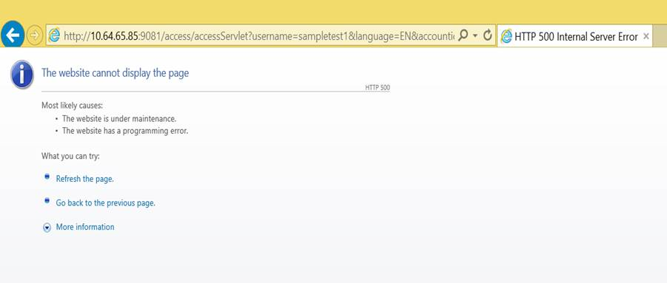

**RCA**

Odbj.jar path is set wrongly. Corrected the path and bounced SSP

Issue resolved.

Unable to access **Pre-SIT CCAP Portal TAM ON** environment. Exception page displayed. Tried after deleting cookies, OOPS page displayed directly. PFB screens.

Can you please look into the issue.

URL accessed : <https://10.64.65.48:454/CCAPWeb>

**ISSUE 3**

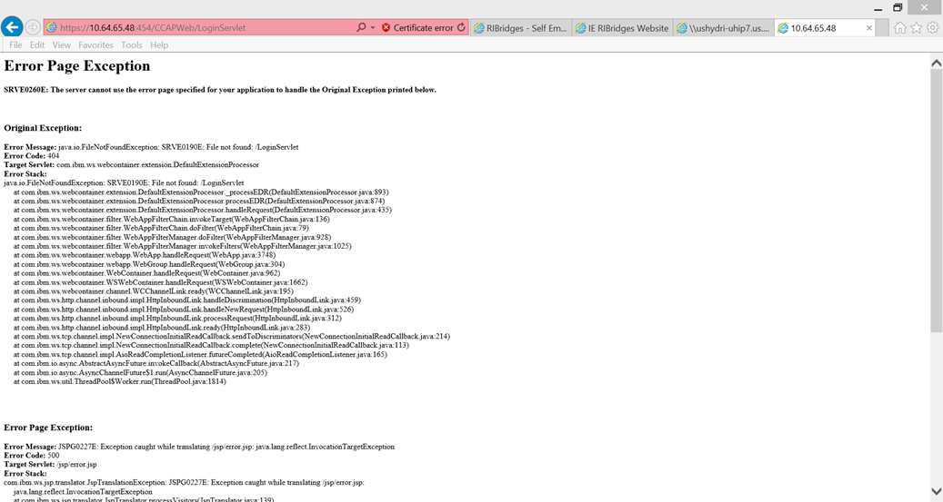

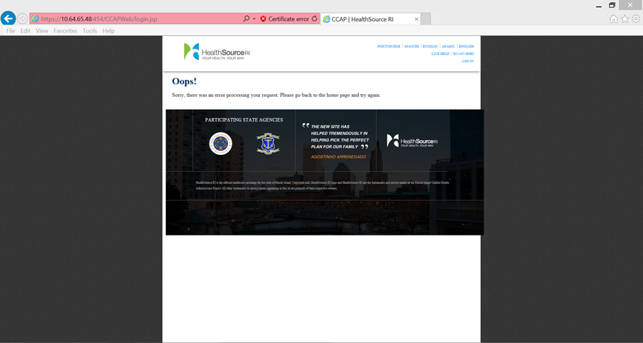

**RCA**

Occurred due to “No space available”(HDD). Cleared space and bounced the server.

Issue resolved

**ISSUE 4**

Unable to create an application is SITTT2.  The below error is being displayed after Household address screen in AR flow. UAT defect retest is being blocked by this.

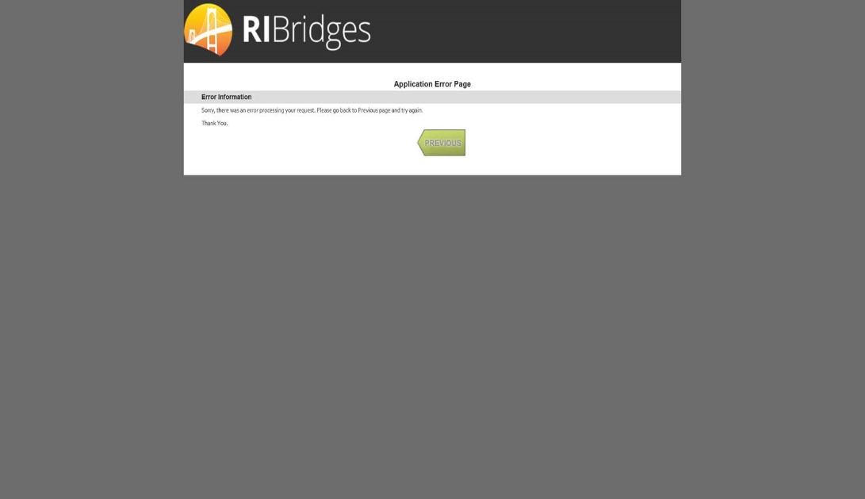

LOG -   
CNTR0020E: EJB threw an unexpected (non-declared) exception during invocation of method "initializeAddr" on bean "BeanId(IESHSRISITTT2#AR.jar#ApplicationControllerSessionEJBBean, null)". Exception data: java.lang.NoClassDefFoundError: us.ri.eohhs.uhip.ies.framework.mci.MCIService (initialization failure)

**RCA**

Not able to hit MCI though IES app while creating account.

Bounced IES App server and it resolved the issue – intermittent issue only on TT environments.

**ISSUE 5**

As part of the security patches, one of the applied patches was around the OPA components and underlying Apache application platform. After the patch was applied, the end points were verified to be up based on a simple component ping. The application was then handed over for smoke testing as part of which it was uncovered that anonymous eligibility was not working.

**RCA**

**Root Cause**: When OPA services were started after the patch upgrade, one of the deployed code files for rules got corrupt. This corruption was likely caused by a service not shutting down properly within the OPA COTS tool even though operator issued the shutdown commands before the upgrade activities were done

**Fix**: We re-deployed from backup, restarted services and re-validated all rules, not just the one that got corrupt, using SOAP UI to emulate application behavior. Anonymous eligibility was further validated by using the application as well. To avoid this in future, for any patch upgrades we will add a step to re-deploy rules after upgrade is complete. Additionally, a ticket will be raised to Oracle for OPA around the issue of inconsistent behavior in shutting down of the COTS service and receive Oracle's recommended procedures for handling shut down and start up further.

**ISSUE 6**

We are facing below issue in 6.0 SIT TAM Environment.

2016-07-12 06:53:11 INFO  ApplicationESignAction:[WebContainer : 4]->incomermc->y7rxCzSAcLT0xygJdzyjPfc-> : Exception received while processSSPRMC Record javax.net.ssl.SSLHandshakeException: com.ibm.jsse2.util.j: PKIX path building failed: java.security.cert.CertPathBuilderException: unable to find valid certification path to requested target

While trying to call SSP from HIX end, We see above exception, due which SSP call is not successful from HIX side. URL is being invoked from Java code.

<https://10.64.65.49:444/access/acces>

sServlet?username=incomermc&language=EN&trackId=4089&PAGE_ACTION=PrintApplication&VALID_GET=Y&MODULE_CD=RMC&nextPageId=ARFAS

2016-07-12 06:53:11 INFO  BaseAction:[WebContainer : 4]->incomermc->y7rxCzSAcLT0xygJdzyjPfc-> : getActiveUserName incomermc

2016-07-12 06:53:11 INFO  BaseAction:[WebContainer : 4]->incomermc->y7rxCzSAcLT0xygJdzyjPfc-> : getActiveUserName incomermc

2016-07-12 06:53:11 INFO  ApplicationESignAction:[WebContainer : 4]->incomermc->y7rxCzSAcLT0xygJdzyjPfc-> : Inside processSSPRMCRecord method

2016-07-12 06:53:11 INFO  ApplicationESignAction:[WebContainer : 4]->incomermc->y7rxCzSAcLT0xygJdzyjPfc-> : rmcPDFUrl is <https://10.64.65.49:444/access/acces>

sServlet?username=incomermc&language=EN&trackId=4089&PAGE_ACTION=PrintApplication&VALID_GET=Y&MODULE_CD=RMC&nextPageId=ARFAS

2016-07-12 06:53:11 INFO  ApplicationESignAction:[WebContainer : 4]->incomermc->y7rxCzSAcLT0xygJdzyjPfc-> : Inside sendGET method

2016-07-12 06:53:11 INFO  ApplicationESignAction:[WebContainer : 4]->incomermc->y7rxCzSAcLT0xygJdzyjPfc-> : Exception received while processSSPRMC Record javax.net.ssl.SSLHandshakeException: com.ibm.jsse2.util.j: PKIX path building failed: java.security.cert.CertPathBuilderException: unable to find valid certification path to requested target

2016-07-12 06:53:11 INFO  ApplicationESignAction:[WebContainer : 4]->incomermc->y7rxCzSAcLT0xygJdzyjPfc-> : Inside processSSPRMCRecord method

2016-07-12 06:53:11 INFO  BaseAction:[WebContainer : 4]->incomermc->y7rxCzSAcLT0xygJdzyjPfc-> : getActiveUserName incomermc

2016-07-12 06:53:11 INFO  RMCDataHandlerServiceImpl:[WebContainer : 4]->incomermc->y7rxCzSAcLT0xygJdzyjPfc-> : -- Inside  publishRMCData Service method--

2016-07-12 06:53:11 INFO  RMCDataHandlerServiceImpl:[WebContainer : 4]->incomermc->y7rxCzSAcLT0xygJdzyjPfc-> : RMCTrackID : 4089

2016-07-12 06:53:11 INFO  RMCDataHandlerServiceImpl:[WebContainer : 4]->incomermc->y7rxCzSAcLT0xygJdzyjPfc-> : SSP Account ID : 186118599

**RCA**

ROOT CAUSE:

We found that SSL handshake is missing with TAM server on SIT Regular environment for HIX application. Please find the server logs and URLs below.

Please have a look into it.

HIX - <https://10.64.65.49:444/HIXWebI3/DisplayHomePage.action>

IES -  <https://10.64.65.49:449/toIES/SELoginAccess.jsp?fromIndex=true>

[7/12/16 9:10:10:979 EDT] 000000ca WSX509TrustMa E   CWPKI0022E: SSL HANDSHAKE FAILURE:  A signer with SubjectDN "CN=ENT-TST-UHATAM3.UHIP.RI.GOV, O=Policy Director, C=US" was sent from target host:port "10.64.65.49:444".  The signer may need to be added to local trust store "/opt/IBM/WebSphere/AppServer/profiles/AppSrv01/config/cells/ENT-TST-UHAPP08Cell01/trust.p12" located in SSL configuration alias "NodeDefaultSSLSettings" loaded from SSL configuration file "security.xml".  The extended error message from the SSL handshake exception is: "PKIX path building failed: java.security.cert.CertPathBuilderException: unable to find valid certification path to requested target".

[7/12/16 9:10:10:979 EDT] 000000ca SystemOut     O

[7/12/16 9:10:10:979 EDT] 000000ca SystemOut     O CWPKI0022E: SSL HANDSHAKE FAILURE:  A signer with SubjectDN "CN=ENT-TST-UHATAM3.UHIP.RI.GOV, O=Policy Director, C=US" was sent from target host:port "10.64.65.49:444".  The signer may need to be added to local trust store "/opt/IBM/WebSphere/AppServer/profiles/AppSrv01/config/cells/ENT-TST-UHAPP08Cell01/trust.p12" located in SSL configuration alias "NodeDefaultSSLSettings" loaded from SSL configuration file "security.xml".  The extended error message from the SSL handshake exception is: "PKIX path building failed: java.security.cert.CertPathBuilderException: unable to find valid certification path to requested target".

[7/12/16 9:10:10:980 EDT] 000000ca SystemOut     O

[7/12/16 9:10:10:980 EDT] 000000ca SystemOut     O

[7/12/16 9:10:10:980 EDT] 000000ca SystemOut     O CWPKI0428I: The signer might need to be added to the local trust store. You can use the Retrieve from port option in the administrative console to retrieve the certificate and resolve the problem. If you determine that the request is trusted, complete the following steps: 1. Log into the administrative console.  2. Expand Security and click SSL certificate and key management. Under Configuration settings, click Manage endpoint security configurations. 3. Select the appropriate outbound configuration to get to the (cell):ENT-TST-UHAPP08Cell01 management scope. 4. Under Related Items, click Key stores and certificates and click the CellDefaultTrustStore key store. 5. Under Additional Properties, click Signer certificates and  Retrieve From Port.  6. In the Host field, enter 10.64.65.49 in the host name field, enter 444 in the Port field, and 10.64.65.49_cert in the Alias field. 7. Click Retrieve Signer Information.  8. Verify that the certificate information is for a certificate that you can trust. 9. Click Apply and Save.

FIX:

In log (“The signer may need to be added to local trust store”) means you need to add the ROOT CA for the webseal certificate in your appserver

Add the certificate public_webseal_test.cer to the trust store. (Sent by security team)

Steps:

Go to Admin Console:

1,

Security

SSL certificate and key management

Key stores and certificates

NodeDefaultTrustStore

Signer certificates

Add

Give the require details and save

2,

Security

SSL certificate and key management

Key stores and certificates

CellDefaultTrustStore

Signer certificates

Add

Give the require details and save

Bounce the servers on that IP.

**ISSUE 7**

A,

Issue: (Log) (Regarding defect# [UHIP-127040](http://10.64.65.24:9080/jira/browse/UHIP-127040))

[7/18/16 16:18:39:046 EDT] 000000b6 SystemOut     O EWS | 7/18/16 4:18 PM | Executing Engine: /Mount_HPExstream/data/HP_Exstream_Engine_8_0_322_Linux_64_DB/Tar/Engine -CONTROLFILE=/Mount_HPExstream/data/HPExstream/Work/Eligibility16055.00019c87131b04db5988bf25a2d37b84b/control.opt

[7/18/16 16:18:39:046 EDT] 000000b6 SystemOut     O EWS | 7/18/16 4:18 PM | Working Directory: /Mount_HPExstream/data/HPExstream/Work/Eligibility16055.00019c87131b04db5988bf25a2d37b84b

[7/18/16 16:18:39:151 EDT] 000000b6 SystemOut     O EWS | 7/18/16 4:18 PM | engine run status:  127

[7/18/16 16:18:39:151 EDT] 0000275a SystemOut     O EWS | 7/18/16 4:18 PM | ERR: /Mount_HPExstream/data/HP_Exstream_Engine_8_0_322_Linux_64_DB/Tar/Engine: error while loading shared libraries: libicudata.so.42: cannot open shared object file: No such file or directory

[7/18/16 16:18:39:152 EDT] 000000b6 EndpointMetho I   Engine execution error.  Return code:  127

                                 com.hpexstream.services.ews.exception.EngineServiceException: Engine execution error.  Return code:  127

        at com.hpexstream.services.ews.engine.Engine.Compose(Engine.java:232)

**RCA**

HP Exstream WAS server should have a mount point on HP Exstream server. It is missing.

**FIX:**

Mount HPExstream on WebSphere server.

B,

Still the issue persists. Please copy libicudata.so.42 and libicuuc.so.42 files from HP Exstream server to /lib64 folder in EWS WAS server as well.

        linux-vdso.so.1 =>  (0x00007fff179ab000)

        libicudata.so.42 => not found

        libicuuc.so.42 => not found

        libdl.so.2 => /lib64/libdl.so.2 (0x0000003385200000)

        libstdc++.so.6 => /usr/lib64/libstdc++.so.6 (0x0000003398800000)

        libpthread.so.0 => /lib64/libpthread.so.0 (0x0000003385600000)

        libm.so.6 => /lib64/libm.so.6 (0x0000003385a00000)

        libgcc_s.so.1 => /lib64/libgcc_s.so.1 (0x0000003394000000)

        libc.so.6 => /lib64/libc.so.6 (0x0000003384e00000)

        /lib64/ld-linux-x86-64.so.2 (0x0000003384a00000)

FIX:  
We have already copied the files.

As of now we have given full permissions to the missing files.

Please validate now

**ISSUE 8**

**Issue: (env - pilot)**

We ran one of the SHOP CO-SHP-GN-01 notice batch as of 18-July-2016 in PILOT environment . Please find the exception below:

18 Jul 2016 14:46:43,981 DEBUG [us.ri.eohhs.uhip.hix.common.dao.impl.ExceptionHandlingDaoImpl.persistException(ExceptionHandlingDaoImpl.java:63)] - Persisting exception details : us.ri.eohhs.uhip.hix.common.dto.ExceptionDto@5d91dd1d[jobId=CO-SHP-GN-01,asOfDate=18-JUL-16,programName=us.ri.eohhs.uhip.hix.correspondence.batch.AnnualEmployerElectionPeriodGenerationBatch,exceptionCd=Fatl,exceptionSummary=Error in generating COR-SHP-01 notice : 48487446,exceptionDetail=2016-07-18_14:46:43:981 - javax.xml.ws.WebServiceException: The following WSDL exception occurred: WSDLException: faultCode=WSDL4JWrapper : : java.lang.NullPointerException

at org.apache.axis2.jaxws.ExceptionFactory.createWebServiceException(ExceptionFactory.java:173)

at org.apache.axis2.jaxws.ExceptionFactory.makeWebServiceException(ExceptionFactory.java:70)

at org.apache.axis2.jaxws.description.impl.ServiceDescriptionImpl.setupWsdlDefinition(ServiceDescriptionImpl.java:1202)

at org.apache.axis2.jaxws.description.impl.ServiceDescriptionImpl.<init>(ServiceDescriptionImpl.java:249)

at org.apache.axis2.jaxws.description.impl.ServiceDescriptionImpl.<init>(ServiceDescriptionImpl.java:172)

at org.apache.axis2.jaxws.description.impl.DescriptionFactoryImpl.createServiceDescription(DescriptionFactoryImpl.java:143)

at org.apache.axis2.jaxws.description.impl.DescriptionFactoryImpl.createServiceDescription(DescriptionFactoryImpl.java:79)

at org.apache.axis2.jaxws.description.DescriptionFactory.createServiceDescription(DescriptionFactory.java:78)

**RCA:**

These are our findings for this issue:

Generally this issue occurs either when the ImageNow server is down or HpExstream Engine is down.

It was confirmed that HPExstream Engine is working fine and they are able to view notices.

As far as ImageNow server is concerned it is still under build stage.

We need to check with Caitlin and Team on the status.

**FIX:**

We need to check with Caitlin and Team on the status.

**ISSUE 9**

**Issue:** Batch failed due to below issue on IES

INFO  20-07 07:24:29,211 - loadAndRegisterCustomDAOs: Registered DAO Instance: [us.ri.eohhs.uhip.ies.common.dao.custom.ElPersonIncomeAndDeductionDAO@2e739136](mailto:us.ri.eohhs.uhip.ies.common.dao.custom.ElPersonIncomeAndDeductionDAO@2e739136) against table: EL_PERSON_INCOME_AND_DEDUCTION

INFO  20-07 07:24:29,252 - ~~~~Auto renewal Batch - init method called ~~~~

INFO  20-07 07:24:29,478 - ~~~~Receive Autorenewal Batch Information - preProcess method Info called ~~~~ jobID = EL-AUTO-MU

INFO  20-07 07:24:29,478 - ~~~~Receive Autorenewal Batch Information - preProcess method Info called ~~~~ ended ~~~~ asOfDate = 07/20/2016

FATAL 20-07 07:24:29,798 - Object not found.

ERROR 20-07 07:24:29,805 - us.ri.eohhs.uhip.ies.framework.exception.GenericBatchException: ERROR in start Error in starting the Job:Error in inserting RunControl Error while inserting run Controller. null

        at us.ri.eohhs.uhip.ies.framework.batch.util.FwAbstractBatch.startJob(FwAbstractBatch.java:208)

        at us.ri.eohhs.uhip.ies.framework.batch.util.FwAbstractBatch.start(FwAbstractBatch.java:138)

       at us.ri.eohhs.uhip.ies.common.bo.SFAbstractBatch.begin(SFAbstractBatch.java:108)

        at us.ri.eohhs.uhip.ies.ed.batch.enrollment.jobs.AutoRenewalBatch.init(AutoRenewalBatch.java:220)

        at us.ri.eohhs.uhip.ies.ed.batch.enrollment.jobs.AutoRenewalBatch.main(AutoRenewalBatch.java:54)

FATAL 20-07 07:24:29,807 - Unable to find property file: /admin.properties. Make certain that it is in the CLASSPATH.

FATAL 20-07 07:24:29,807 - Unable to retrieve properties from admin.properties

ERROR 20-07 07:24:29,833 - us.ri.eohhs.uhip.ies.framework.exception.GenericBatchException: Error in stopping Job. Couldn't abort the Job: Error in updating run control record to AB : Error while updating run Controller. 0

        at us.ri.eohhs.uhip.ies.framework.batch.controller.GenericBatchController.stop(GenericBatchController.java:932)

        at us.ri.eohhs.uhip.ies.common.bo.SFAbstractBatch.abnormalExit(SFAbstractBatch.java:425)

        at us.ri.eohhs.uhip.ies.common.bo.SFAbstractBatch.begin(SFAbstractBatch.java:110)

        at us.ri.eohhs.uhip.ies.ed.batch.enrollment.jobs.AutoRenewalBatch.init(AutoRenewalBatch.java:220)

        at us.ri.eohhs.uhip.ies.ed.batch.enrollment.jobs.AutoRenewalBatch.main(AutoRenewalBatch.java:54)

**RCA:**

There was no date in FW parameters.

**FIX:**

DB team has updated the date in FW parameter table. Hence solved the issue

**ISSUE 10**

**Issue:**

We are getting below exception while connecting to SMTP server on 443 server

**Exception in thread "main" java.lang.RuntimeException: javax.mail.MessagingException: Could not connect to SMTP host: ent-mail-uhml02.uhip.ri.gov, port: 443, response: -1**

We tried using telnet to check if TLS is enabled and found out that TLS is not available on the server.

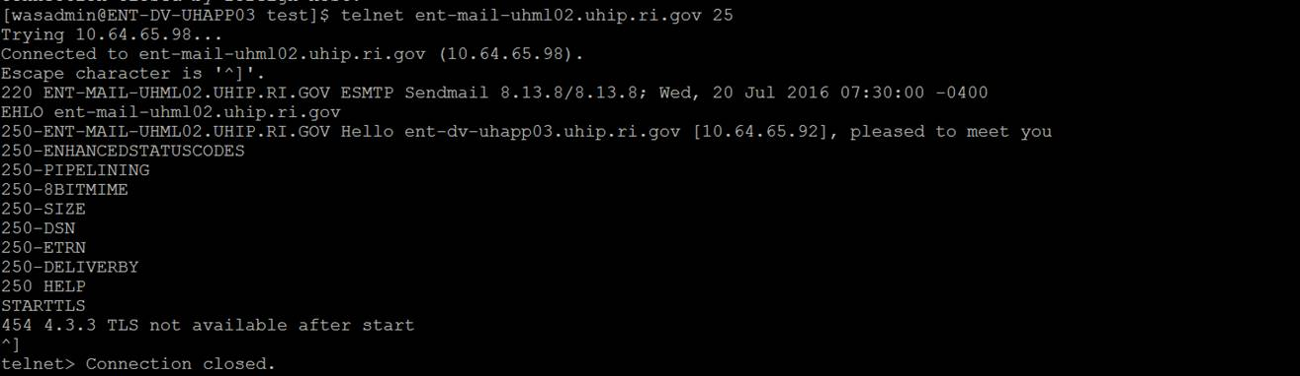

Once the TLS configurations are completed we have to register SMTP server certificate as trusted server in WebSphere location and in JAVA HOME ( so that it is accessible by batch jobs).

Initially we can register the certificates in 6.0 HIX server (<http://10.64.65.92:9087/HIXWebI3/DisplayHomePage.action>) and also in JAVA HOME for testing .

**RCA:**

Two way Authentication is not done.

**FIX:**

Need to add certificate to get the connection between 2 servers.

**ISSUE 11**

**Issue:** (App didn’t come up after deployment)

[7/26/16 7:41:59:656 EDT] 00000001 ContainerHelp E WSVR0501E: Error creating component com.ibm.ws.runtime.component.CompositionUnitMgrImpl@40c90eb7

com.ibm.ws.exception.RuntimeWarning: Error while processing references for EJB-in-WAR: java.lang.NoClassDefFoundError: us.ri.eohhs.uhip.ies.common.collection.custom.VCoRequestRecipientsCollection

at com.ibm.ws.runtime.component.ata(EJBContainerImpl.java:734)

at com.ibm.ws.runtime.component.MetaDataMgrImpl.createNestedModuleMetaData(MetaDataMgrImpl.java:564)

at com.ibm.ws.runtime.component.DeployedModuleImpl.start(DeployedModuleImpl.java:633)

at com.ibm.ws.runtime.component.DeployedApplicationImpl.start(DepEJBContainerImpl.createNestedModuleMetaData(EJBContainerImpl.java:3454)

at com.ibm.ws.runtime.component.EJBContainerImpl.createNestedModuleMetaDloyedApplicationImpl.java:968)

at com.ibm.ws.runtime.component.ApnUnitMgrImpl.java:116)

at com.ibm.ws.runtime.component.CompositionUnitMgrImpl$CUInitializer.run(CompositionUnitMgrImpl.java:994)

at com.ibm.wsspi.runtime.component.WsComponentImpl$_AsynchInitializer.run(WsComponentImpl.java:496)

at com.ibm.ws.util.ThreadPool$Worker.run(ThreadPool.java:1815)

Caused by: java.lang.NoClassDefFoundError: us.ri.eohhs.uhip.ies.common.collection.custom.VCoRequestRecipientsCollection

at java.lang.Class.getDeclaredMethodsImpl(Native Method)

at java.lang.Class.getDeclaredMethods(Class.java:748)

at com.ibm.ws.metadata.ejb.InterceptorMetaDataFactory.createInterceptorProxyMap(InterceptorMetaDataFactory.java:1767)

at com.ibm.ws.metadata.ejb.InterceptorMetaDataFactory.processBeanInterceptors(InterceptorMetaDataFactory.java:1475)

at com.ibm.ws.metadata.ejb.InterceptorMetaDataFactory.createInterceptorMetaData(InterceptorMetaDataFactory.java:389)

at com.ibm.ws.metadata.ejb.EJBMDOrchestrator.initializeInterceptorMD(EJBMDOrchestrator.java:7363)

at com.ibm.ws.metadata.ejb.EJBMDOrchestrator.finishBMDInitForReferenceContext(EJBMDOrchestrator.java:8951)

at com.ibm.ws.ejbcontainer.runtime.AbstractEJBRuntime.finishBMDInitForRefplicationMgrImpl.startApplication(ApplicationMgrImpl.java:772)

at com.ibm.ws.runtime.component.ApplicationMgrImpl.start(ApplicationMgrImpl.java:2175)

at com.ibm.ws.runtime.component.CompositionUnitMgrImpl.start(CompositionUnitMgrImpl.java:445)

at com.ibm.ws.runtime.component.CompositionUnitImpl.start(CompositionUnitImpl.java:123)

at com.ibm.ws.runtime.component.CompositionUnitMgrImpl.start(CompositionUnitMgrImpl.java:388)

at com.ibm.ws.runtime.component.CompositionUnitMgrImpl.access$500(CompositioerenceContext(AbstractEJBRuntime.java:2601)

at com.ibm.ws.runtime.component.EJBContainerImpl.createNestedModuleMetaData(EJBContainerImpl.java:3447)

... 13 more

**RCA:**

Deployment didn’t happened properly.

**FIX:**

Re deployed HIX code and it solved the issue

**ISSUE 12**

**Issue:** (gettin missing URL on the apache url check)

Jul 28, 2016 3:31:16 AM org.apache.catalina.core.StandardContext loadOnStartup

SEVERE: Servlet /determinations-server threw load() exception

java.lang.ClassNotFoundException: us.ri.eohhs.uhip.ies.business.rules.cache.BusinessRulesCacheServlet

at org.apache.catalina.loader.WebappClassLoader.loadClass(WebappClassLoader.java:1713)

at org.apache.catalina.loader.WebappClassLoader.loadClass(WebappClassLoader.java:1558)

at org.apache.catalina.core.DefaultInstanceManager.loadClass(DefaultInstanceManager.java:527)

at org.apache.catalina.core.DefaultInstanceManager.loadClassMaybePrivileged(DefaultInstanceManager.java:509)

at org.apache.catalina.core.DefaultInstanceManager.newInstance(DefaultInstanceManager.java:137)

at org.apache.catalina.core.StandardWrapper.loadServlet(StandardWrapper.java:1144)

at org.apache.catalina.core.StandardWrapper.load(StandardWrapper.java:1088)

at org.apache.catalina.core.StandardContext.loadOnStartup(StandardContext.java:5033)

at org.apache.catalina.core.StandardContext.startInternal(StandardContext.java:5317)

at org.apache.catalina.util.LifecycleBase.start(LifecycleBase.java:150)

at org.apache.catalina.core.ContainerBase.addChildInternal(ContainerBase.java:901)

at org.apache.catalina.core.ContainerBase.addChild(ContainerBase.java:877)

at org.apache.catalina.core.StandardHost.addChild(StandardHost.java:633)

at org.apache.catalina.startup.HostConfig.deployDirectory(HostConfig.java:1114)

at org.apache.catalina.startup.HostConfig$DeployDirectory.run(HostConfig.java:1673)

at java.util.concurrent.Executors$RunnableAdapter.call(Executors.java:441)

at java.util.concurrent.FutureTask$Sync.innerRun(FutureTask.java:303)

at java.util.concurrent.FutureTask.run(FutureTask.java:138)

at java.util.concurrent.ThreadPoolExecutor$Worker.runTask(ThreadPoolExecutor.java:886)

at java.util.concurrent.ThreadPoolExecutor$Worker.run(ThreadPoolExecutor.java:908)

at java.lang.Thread.run(Thread.java:662)

**RCA:**

Happens after deployment when some of the URL’s didn’t get loaded

**FIX:**

Multiple restarts will solve the issue.

**ISSUE 13**

**Issue:** Application is not coming up after date change activity

[7/29/16 2:34:09:833 EDT] 00000064 webapp E com.ibm.ws.webcontainer.webapp.WebApp commonInitializationFinally SRVE0266E: Error occured while initializing servlets: {0}

javax.servlet.ServletException: SRVE0207E: Uncaught initialization exception created by servlet

at com.ibm.ws.webcontainer.servlet.ServletWrapper.init(ServletWrapper.java:398)

at com.ibm.ws.webcontainer.servlet.ServletWrapperImpl.init(ServletWrapperImpl.java:168)

at com.ibm.ws.webcontainer.servlet.ServletWrapper.loadOnStartupCheck(ServletWrapper.java:1351)

at com.ibm.ws.webcontainer.webapp.WebApp.doLoadOnStartupActions(WebApp.java:604)

at com.ibm.ws.webcontainer.webapp.WebApp.commonInitializationFinally(WebApp.java:574)

at com.ibm.ws.webcontainer.webapp.WebAppImpl.initialize(WebAppImpl.java:425)

at com.ibm.ws.webcontainer.webapp.WebGroupImpl.addWebApplication(WebGroupImpl.java:88)

at com.ibm.ws.webcontainer.VirtualHostImpl.addWebApplication(VirtualHostImpl.java:169)

at com.ibm.ws.webcontainer.WSWebContainer.addWebApp(WSWebContainer.java:749)

at com.ibm.ws.webcontainer.WSWebContainer.addWebApplication(WSWebContainer.java:634)

at com.ibm.ws.webcontainer.component.WebContainerImpl.install(WebContainerImpl.java:426)

at com.ibm.ws.webcontainer.component.WebContainerImpl.start(WebContainerImpl.java:718)

at com.ibm.ws.runtime.component.ApplicationMgrImpl.start(ApplicationMgrImpl.java:1173)

at com.ibm.ws.runtime.component.DeployedApplicationImpl.fireDeployedObjectStart(DeployedApplicationImpl.java:1370)

at com.ibm.ws.runtime.component.DeployedModuleImpl.start(DeployedModuleImpl.java:639)

at com.ibm.ws.runtime.component.DeployedApplicationImpl.start(DeployedApplicationImpl.java:968)

at com.ibm.ws.runtime.component.ApplicationMgrImpl.startApplication(ApplicationMgrImpl.java:772)

at com.ibm.ws.runtime.component.ApplicationMgrImpl.start(ApplicationMgrImpl.java:2175)

at com.ibm.ws.runtime.component.CompositionUnitMgrImpl.start(CompositionUnitMgrImpl.java:445)

at com.ibm.ws.runtime.component.CompositionUnitImpl.start(CompositionUnitImpl.java:123)

at com.ibm.ws.runtime.component.CompositionUnitMgrImpl.start(CompositionUnitMgrImpl.java:388)

at com.ibm.ws.runtime.component.CompositionUnitMgrImpl.access$500(CompositionUnitMgrImpl.java:116)

at com.ibm.ws.runtime.component.CompositionUnitMgrImpl$CUInitializer.run(CompositionUnitMgrImpl.java:994)

at com.ibm.wsspi.runtime.component.WsComponentImpl$_AsynchInitializer.run(WsComponentImpl.java:349)

at com.ibm.ws.util.ThreadPool$Worker.run(ThreadPool.java:1814)

Caused by: org.springframework.beans.factory.CannotLoadBeanClassException: Cannot find class [us.ri.eohhs.uhip.hix.web.interceptor.HixExceptionInterceptor] for bean with name 'exceptionInterceptor' defined in class path resource [appContext/applicationContext-web.xml]; nested exception is java.lang.ClassNotFoundException: us.ri.eohhs.uhip.hix.web.interceptor.HixExceptionInterceptor

at org.springframework.beans.factory.support.AbstractBeanFactory.resolveBeanClass(AbstractBeanFactory.java:1266)

at org.springframework.beans.factory.support.AbstractAutowireCapableBeanFactory.predictBeanType(AbstractAutowireCapableBeanFactory.java:581)

at org.springframework.beans.factory.support.AbstractBeanFactory.isFactoryBean(AbstractBeanFactory.java:1335)

at org.springframework.beans.factory.support.AbstractBeanFactory.isFactoryBean(AbstractBeanFactory.java:901)

at org.springframework.beans.factory.support.DefaultListableBeanFactory.preInstantiateSingletons(DefaultListableBeanFactory.java:607)

at org.springframework.context.support.AbstractApplicationContext.finishBeanFactoryInitialization(AbstractApplicationContext.java:932)

at org.springframework.context.support.AbstractApplicationContext.refresh(AbstractApplicationContext.java:479)

at org.springframework.web.context.ContextLoader.configureAndRefreshWebApplicationContext(ContextLoader.java:389)

at org.springframework.web.context.ContextLoader.initWebApplicationContext(ContextLoader.java:294)

at org.springframework.web.context.ContextLoaderListener.contextInitialized(ContextLoaderListener.java:112)

at com.ibm.ws.webcontainer.webapp.WebApp.notifyServletContextCreated(WebApp.java:1676)

at com.ibm.ws.webcontainer.webapp.WebAppImpl.initialize(WebAppImpl.java:414)

... 19 more

Caused by: java.lang.ClassNotFoundException: us.ri.eohhs.uhip.hix.web.interceptor.HixExceptionInterceptor

at java.net.URLClassLoader.findClass(URLClassLoader.java:432)

at com.ibm.ws.bootstrap.ExtClassLoader.findClass(ExtClassLoader.java:204)

at java.lang.ClassLoader.loadClassHelper(ClassLoader.java:701)

at java.lang.ClassLoader.loadClass(ClassLoader.java:680)

at com.ibm.ws.bootstrap.ExtClassLoader.loadClass(ExtClassLoader.java:119)

at java.lang.ClassLoader.loadClass(ClassLoader.java:663)

at com.ibm.ws.classloader.ProtectionClassLoader.loadClass(ProtectionClassLoader.java:62)

at com.ibm.ws.classloader.ProtectionClassLoader.loadClass(ProtectionClassLoader.java:58)

at com.ibm.ws.classloader.CompoundClassLoader.loadClass(CompoundClassLoader.java:584)

at java.lang.ClassLoader.loadClass(ClassLoader.java:663)

at com.ibm.ws.classloader.CompoundClassLoader.loadClass(CompoundClassLoader.java:584)

at java.lang.ClassLoader.loadClass(ClassLoader.java:663)

at org.springframework.util.ClassUtils.forName(ClassUtils.java:260)

at org.springframework.beans.factory.support.AbstractBeanDefinition.resolveBeanClass(AbstractBeanDefinition.java:416)

at org.springframework.beans.factory.support.AbstractBeanFactory.doResolveBeanClass(AbstractBeanFactory.java:1287)

at org.springframework.beans.factory.support.AbstractBeanFactory.resolveBeanClass(AbstractBeanFactory.java:1258)

... 30 more

**RCA:**

This is happening only on TT environments after the date change activity.

**FIX:**

Redeploying the application will solve the issue

**ISSUE 14**

**Issue:** In Create case start application page upon clicking on NEXT app is failing.

I could see below exceptions in Application logs(datacollection.log). Seems the data base connection in mule server went for a toss. Restarted mule to reestablish the connections. Please check now and let us know if you still see the issues.

*Caused by: us.ri.eohhs.uhip.ies.framework.exception.ApplicationException: us.ri.eohhs.uhip.datasynchronization.service.DataSynchronizationException_Exception: Unable to get sequence value for CASE_NUMBER_SEQ*

*at us.ri.eohhs.uhip.ies.ejb.business.services.ar.ApplicationControllerSessionEJBBean.saveApp(ApplicationControllerSessionEJBBean.java:1448)*

*at us.ri.eohhs.uhip.ies.ejb.business.services.ar.ApplicationControllerSessionEJBBean.initializeAppType(ApplicationControllerSessionEJBBean.java:2929)*

*... 50 more*

*Caused by: us.ri.eohhs.uhip.datasynchronization.service.DataSynchronizationException_Exception: Unable to get sequence value for CASE_NUMBER_SEQ*

*at sun.reflect.NativeConstructorAccessorImpl.newInstance0(Native Method)*

*at sun.reflect.NativeConstructorAccessorImpl.newInstance(NativeConstructorAccessorImpl.java:56)*

**Could see below in Mule Datasync logs:**

*Caused by: org.springframework.transaction.TransactionSystemException: Could not commit JDBC transaction; nested exception is java.sql.SQLRecoverableException: Io exception: Broken pipe*

*at org.springframework.jdbc.datasource.DataSourceTransactionManager.doCommit(DataSourceTransactionManager.java:271)*

*at org.springframework.transaction.support.AbstractPlatformTransactionManager.processCommit(AbstractPlatformTransactionManager.java:755)*

*Caused by: java.sql.SQLRecoverableException: Io exception: Broken pipe*

*at oracle.jdbc.driver.SQLStateMapping.newSQLException(SQLStateMapping.java:101)*

*at oracle.jdbc.driver.DatabaseError.newSQLException(DatabaseError.java:112)*

*at oracle.jdbc.driver.DatabaseError.throwSqlException(DatabaseError.java:173)*

**RCA:**

Seems the data base connection in mule server went for a toss. Restarted mule to reestablish the connections

**FIX:**

Only Mule restart required.

**ISSUE 15**

**Issue:**

All Applications logs are not getting generated. Only few are getting generated for IES Application.

**RCA:**

Logging. Properties is not having extra spaces when compared to other environments.

**FIX:**

Copied the logging.properties from the other environment and updated the log paths and bounced the server.  
Issues is resolved now and all logs are getting generated.

**ISSUE 16**

**Issue:**

Not able to view the PDF but the PDF is getting generated under HPExtreme folder structure.

**RCA:**

Disk space is full.

**FIX:**

Cleared all the junk files and unwanted EAR’s from /opt/IBM/.

Now they are able to view the PDF through application pages. Issue is resolved.

**ISSUE 17**

Issue:

In trunk dev HIX, getting below time-out error while accessing IES tables from the application,

2016-08-24 07:27:57 ALL   exception:[Web Container : 2]->Tstsenca->1TmEWyS-zwuqYQ9ynsQu2R6-> : us.ri.eohhs.uhip.ies.framework.exception.GenericRunTimeException: An error (DB Specific Information: 0 Connection not available, Timed out waiting for 180002) has occurred in the Data Layer, while retrieving the data SQL:

**RCA:**

Below exception occurs when all the connections in connection pool are exhausted. We have max connections value as 150 in connection pool. Seems like some malfunctioning code is not returning the connections properly to the pool.

**FIX:**

Restarting the HIX dev trunk server now. Will let you know once done.

**ISSUE 18**

Issue:

I am getting below error while running any batch job in PRE-SIT.

../../CLASSPATH/HSRIIESSharedLib/*:../../CLASSPATH/HSRIAppLib/*:../../CLASSPATH/HSRIIESSharedLib/CRConfig.xml:../../BI/mappings:../../CLASSPATH/HSRIIESInternalLib/*:../../CLASSPATH/HSRIProperties:../../BI/mappings:../../CLASSPATH/HSRIProperties/mappings

Exception in thread "main" java.lang.NoClassDefFoundError: com/deloitte/common/interfaces/Converter

Caused by: java.lang.ClassNotFoundException: com.deloitte.common.interfaces.Converter

        at java.net.URLClassLoader$1.run(URLClassLoader.java:202)

        at java.security.AccessController.doPrivileged(Native Method)

        at java.net.URLClassLoader.findClass(URLClassLoader.java:190)

        at java.lang.ClassLoader.loadClass(ClassLoader.java:306)

        at sun.misc.Launcher$AppClassLoader.loadClass(Launcher.java:301)

        at java.lang.ClassLoader.loadClass(ClassLoader.java:247)

Could not find the main class: us.ri.eohhs.uhip.ies.bi.batch.util.BiProcessDailyEBTHistory.  Program will exit.

Job execution FAILURE!

**RCA:**

Permissions changed for CLASSPATH folder.

**FIX:**

Given 711 permissions for below location:

/home/opconbatch/hsri-ies-batch/Branch3/CLASSPATH/