Nikunj Bhalotia
nb25877@essex.ac.uk
Abstract
Security Assessment and Audit Plan for Altoro Mutual, aligned with OWASP standards to identify, evaluate, and mitigate application vulnerabilities.
Altoro Mutual
Vulnerability Audit and Assesment Plan

Table of Contents
1.0 Document Control 2
1.1 Identity 2
1.2 History 2
1.3 Distribution List 2
1.4 Principal Contact 2
1.5 Document Purpose 2
2.0 Overview 3
2.1 Introduction 3
2.2 Vulnerability Mapping and Threat Modelling 3
2.3 Compliance and Risk Frameworks 3
2.4 Risk Rating Methodology 4
2.5 Tools Selection and Business Impact 6
3.0 Deliverabels 7
3.1 Scope 7
3.1.1 In-Scope 7
3.1.2 Out-of-Scope 7
3.2 Tests To Be Performed 7
3.2.1 Broken Access Control 7
3.2.2 Cryptographic Failures 7
3.2.3 Injection 7
3.2.4 Insecure Design 8
3.2.5 Security Misconfiguration 8
3.2.6 Vulnerable and Outdated Components 8
3.2.7 Identification and Authentication Failures 9
3.2.8 Software and Data Integrity Failures 9
3.2.9 Security Logging and Monitoring Failures 9
3.2.10 Server-Side Request Forgery (SSRF) 9
3.3 Report 10
4.0 Assessment Plan & Timeline 11
4.1 Project Phases and Timeline 11
4.2 Limitations and Assumptions 12
5.0 References 13

Document Control

Identity
File Information
Issue Type | Draft
Issue Date | 18th August 2025
Current Version | 1.0
File Name | Altoro Mutual Website Vulnerability Assessment Plan V1.0.docx

History
Version | Author | Date | Revision Notes
D 0.1 | Nikunj Bhalotia | 15th August 2025 | Document Installation
D 0.2 | Nikunj Bhalotia | 17th August 2025 | Revision One
P 1.0 | Nikunj Bhalotia | 18th August 2025 | Final Version

Distribution List
Name | Role | Company | Email Address
John Doe | Chief Information Security Officer | Altoro Mutual | John.doe@demo.testfire.net
Jane Doe | Head of Development | Altoro Mutual | Jane.doe@demo.testfire.net

Principal Contact
Name | Role | Company | Email Address
Nikunj Bhalotia | Principal Consultant | Nikunj Bhalotia Inc | nikunj@nikunjb.com

Document Purpose
The purpose of this document is to present a Vulnerability Audit and Assessment plan to the Altoro Mutual Security team, which shall cover the Methodology used for the assessment and define a baseline for the scans that shall be performed during the assessment stage.

Overview

Introduction
Nikunj Bhalotia Inc. would like to thank Altoro Mutial for the opportunity to conduct a vulnerability audit and assessment on its Online Banking website (demo.testfire.net). As a leading Bank managing approximately $20 billion in assets and serving over 6.6 million customers, Altoro Mutual operates in a domain where 78% of financial institutions have faced ransomware attacks in the past year alone(Bridewell, 2024). This assessment will allow Altoro Mutual to secure its customers’ trust and safeguard its business and public reputation.

Vulnerability Mapping and Threat Modelling
For the current assessment, we will cover the security risks mentioned in the OWASP Top 10 awareness document. The awareness document covers the most critical web application security risks, which serve as a practical checklist for immediate vulnerability assessment.
The OWASP Top 10 (2021) risks covered are(OWASP top 10, 2021) (Euriun, n.d.):
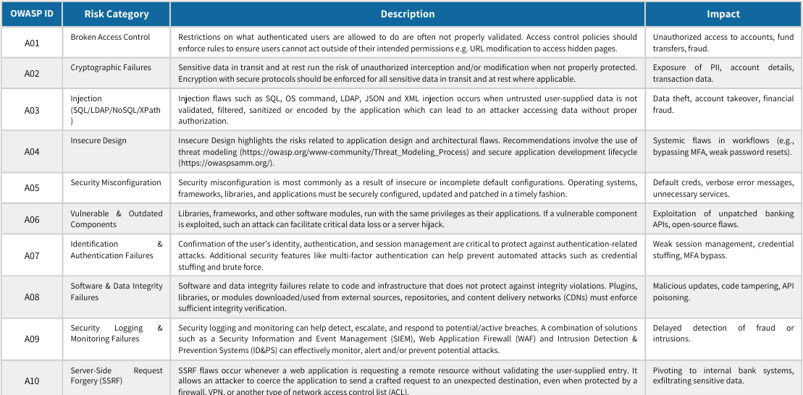

Compliance and Risk Frameworks
As a financial industry company, Altoro Mutual is expected to comply with the Payment Card Industry Data Security Standard (PCI-DSS) to ensure the secure handling of payments and card data. Given the presence of European customers, it is also expected to follow the General Data Protection Regulation (GDPR) compliance framework. Finally, as a U.S.-based financial institution, Altoro Mutual falls under the scope of the Federal Financial Institutions Examination Council (FFIEC) and should comply with the FFIEC IT Handbook guidelines.

Risk Rating Methodology
Our approach will focus not only on identifying vulnerabilities but also on estimating the associated risks to the business. Early in the project life cycle, we will perform threat modelling to detect security concerns within the architecture and design. As we progress, we will review the application code and conduct penetration testing to uncover potential security issues. By systematically evaluating the severity of all identified risks, we will enable informed decision-making regarding risk mitigation strategies. Implementing a consistent risk rating system will streamline prioritisation, reduce time spent on debates, and ensure that attention is focused on addressing significant risks rather than being distracted by minor or less understood issues.

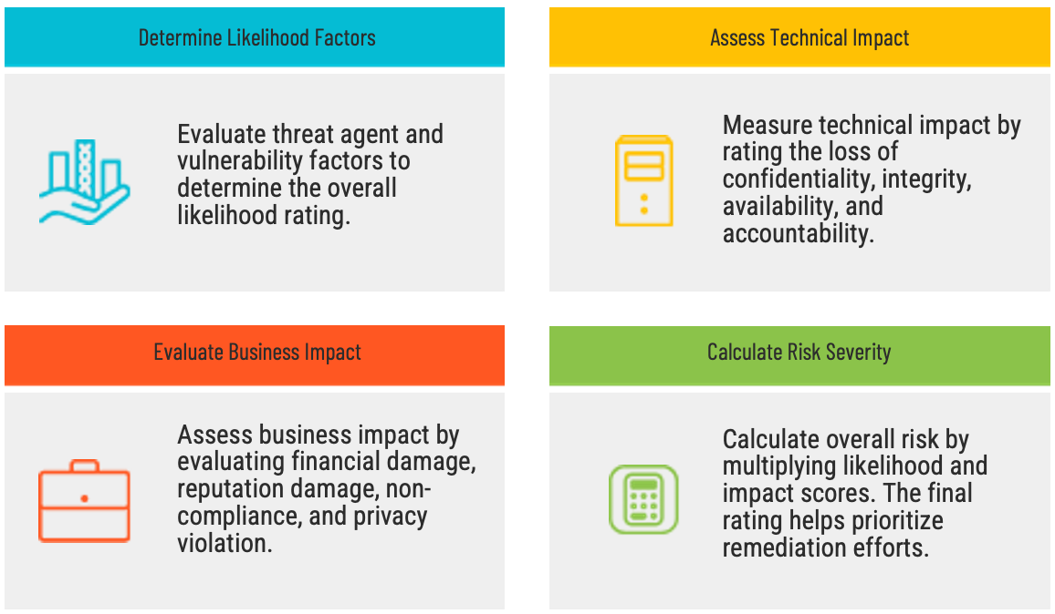

The severity/risk levels are determined by considering both probability (ease of operation) and impact. To determine the final severity rating of the risk, an informal method will be used according to the OWASP Risk Rating Methodology (OWASP, n.d.)

The diagram below details the risk matrix used for the pen test:
Impact | High | Medium | High | Critical
Impact | Medium | Low | Medium | High
Impact | Low | Note | Low | Medium
 |  | Low | Medium | High
 |  | Probability

Vulnerabilities with severity "critical" and "high" should be closed first. The "medium" level vulnerabilities are difficult to operate, but they can cause damage if not properly managed.
Vulnerability levels of "low" and "note" can provide an attacker with information about a system to use when attacking through other vectors.

Tools Selection and Business Impact
This assessment will employ a targeted set of recognised security tools to identify vulnerabilities across application and infrastructure layers. OWASP ZAP will be used to detect common web application risks. (OWASP Foundation, n.d.). Metasploit will perform controlled exploitation to validate identified weaknesses (Rapid7, n.d.), and testssl.sh will be applied to evaluate TLS/SSL configurations for cryptographic security (Testssl.sh, n.d.).
The table below lists the tools and methods that will be used during the assessment and audit, along with the use case for each tool and the potential environmental impact. Depending on the effect, each tool shall be used to minimise the impact on production.
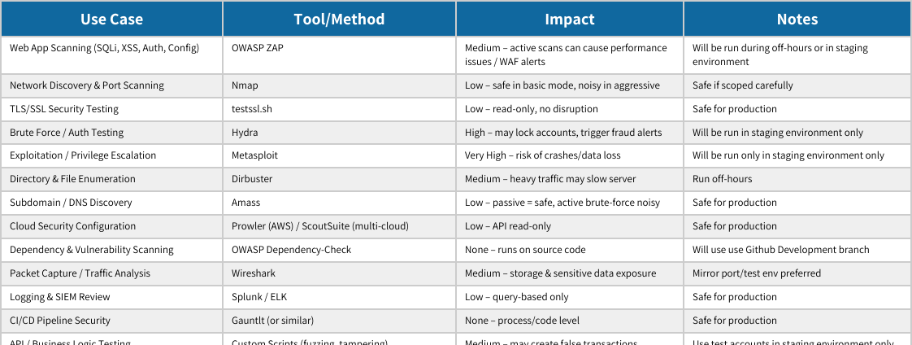

Deliverabels

Scope

In-Scope
- Public-facing website (https://demo.testfire.net)
- API endpoints
- Source code review
- Server and application configuration review
- Compliance alignment

Out-of-Scope
- Internal employee devices and network infrastructure
- Third party integrated services not owned by Altoro Mutual
- Social Engineering Activities

Tests To Be Performed
The following tests are structured according to the OWASP Web Application Security Testing Guide (WSTG), which defines a black-box, comprehensive methodology for evaluating web applications through active analysis of security controls. (OWASP Web Application Security Testing, n.d.)

Broken Access Control
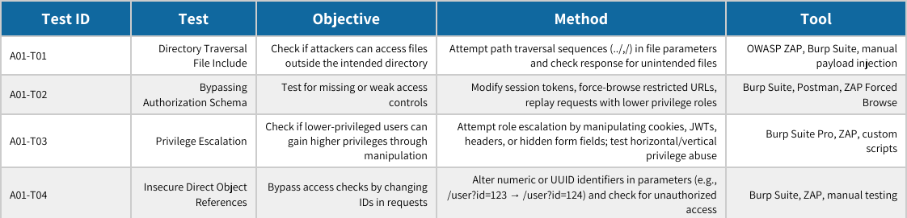

Cryptographic Failures
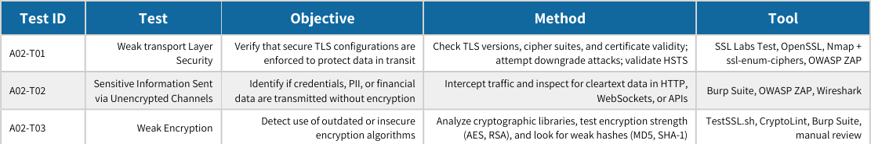

Injection
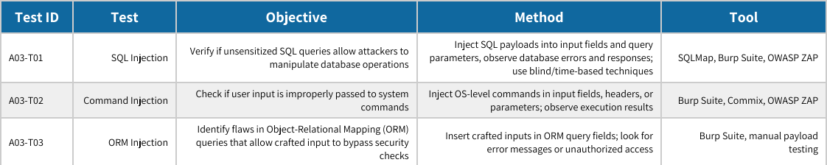

Insecure Design
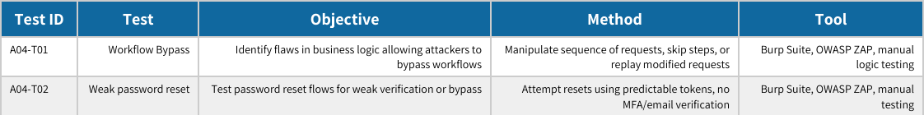

Security Misconfiguration
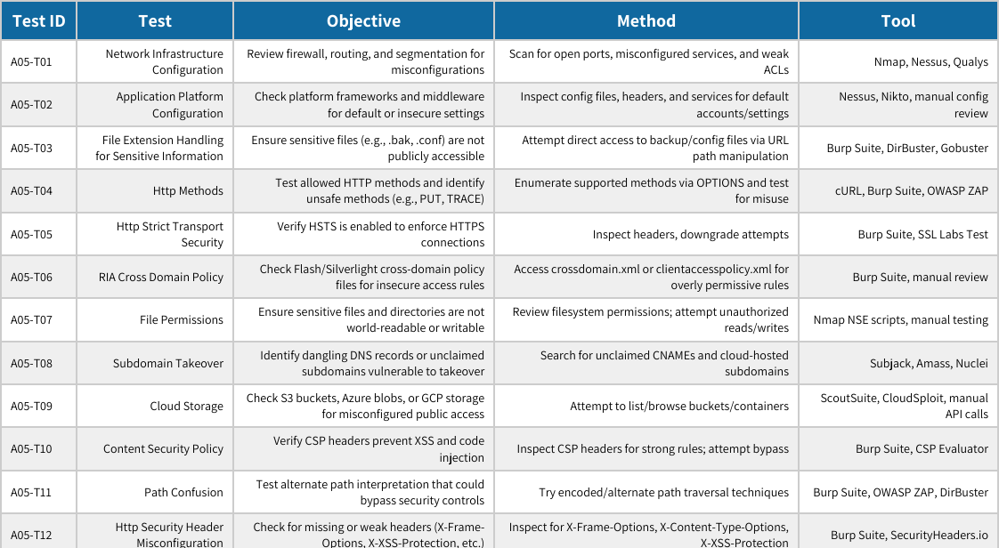

Vulnerable and Outdated Components
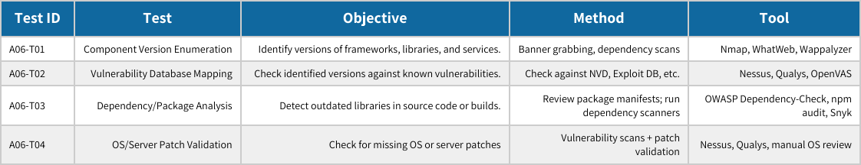

Identification and Authentication Failures
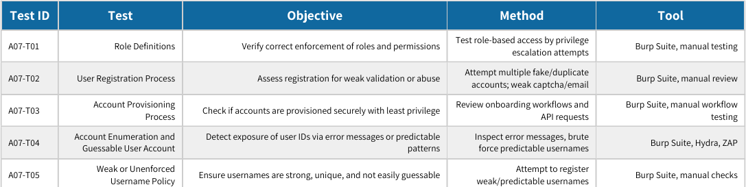

Software and Data Integrity Failures
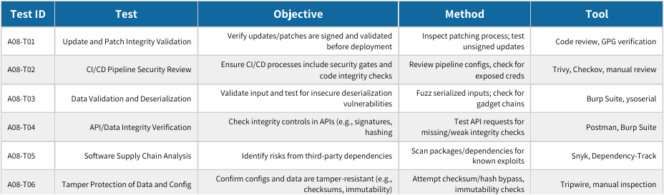

Security Logging and Monitoring Failures
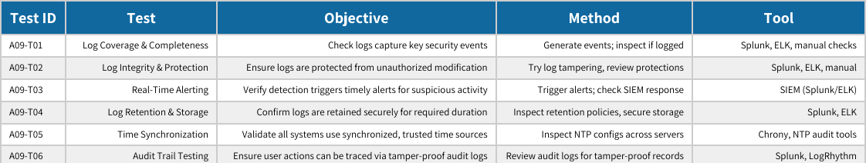

Server-Side Request Forgery (SSRF)
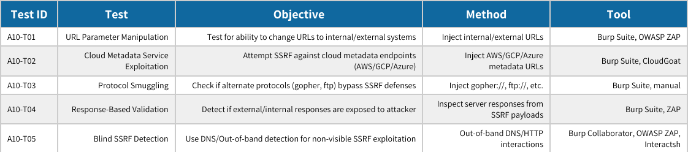

Report
The final reports will consist of the following deliverables(EC-Council, 2022)
- Executive Summary – A high-level overview of key findings, business risks, and recommendations for leadership.
- Detailed Vulnerability Findings and Remediation Roadmap – Comprehensive documentation of discovered vulnerabilities with technical details and prioritised remediation steps.
- Compliance and Risk Framework Mapping – Alignment of vulnerabilities and controls with PCI-DSS, GDPR, and FFIEC requirements to demonstrate regulatory impact.

Assessment Plan & Timeline

Project Phases and Timeline
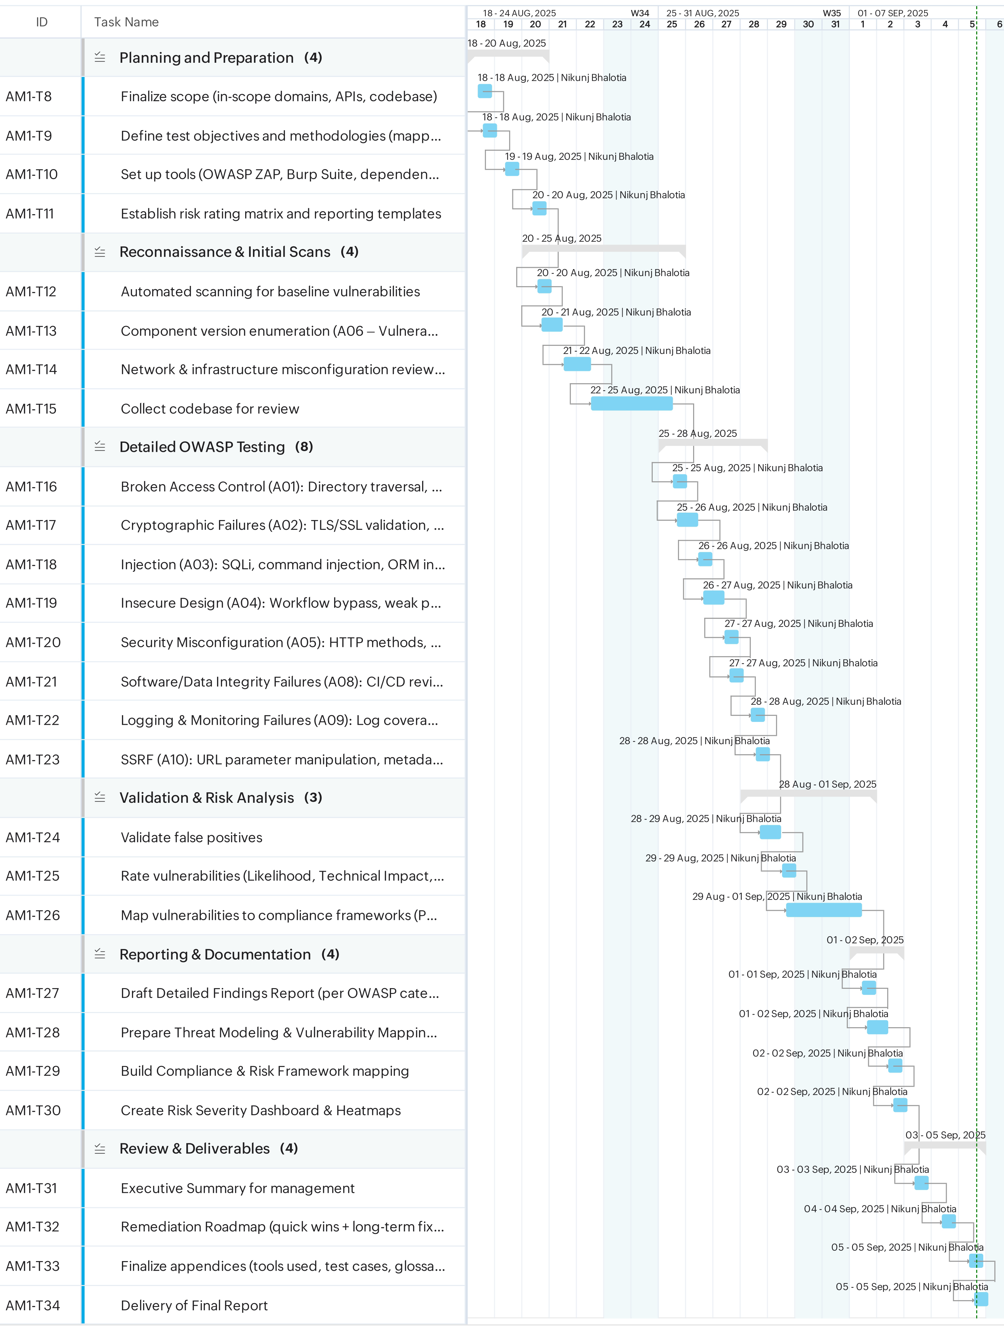

Limitations and Assumptions
The following assumptions and constraints apply to the Altoro Mutual Website Vulnerability Assessment and Audit Plan. They define the conditions under which the engagement will be conducted:
- The assessment scope is limited to Altoro Mutual’s public-facing website (https://demo.testfire.net) and associated staging/test environments, not internal infrastructure or third-party services.
- Access to source code, staging environment, documentation of development processes, and demo/test accounts (including admin credentials where required) will be provided by Altoro Mutual.
- Social engineering and denial-of-service testing are explicitly excluded from the scope.
- Any testing that may cause potential business disruption will be performed in a controlled/staging environment to avoid production impact.
- Testing will be conducted only within the defined 3-week engagement period, and vulnerabilities outside this timeframe may not be detected.
- Automated tools may generate false positives and may not identify complex business logic flaws; manual validation will be performed to test business logic.

References

- Bridewell (2024) US Critical National Infrastructure (CNI) Research Report 2024: Cyber Security in Financial Services. Bridewell Consulting. Available at: https://144806018.fs1.hubspotusercontent-eu1.net/hubfs/144806018/Reports/US_CNI_Research_Report_2024_Cyber_Security_in_Financial_Services.pdf (Accessed: 13 August 2025).
- OWASP Foundation (2021) OWASP Top 10: 2021. Available at: https://owasp.org/Top10/ (Accessed: 14 August 2025).
- Euriun Technologies (n.d.) OWASP Top 10 (2021) Threat Levels & Scenarios. Available at: https://www.euriun.com/owasp/ (Accessed: 18 August 2025).
- OWASP Foundation (n.d.) OWASP Risk Rating Methodology. Available at: https://owasp.org/www-community/OWASP_Risk_Rating_Methodology (Accessed: 16 August 2025).
- OWASP Foundation (n.d.) WSTG Section 4.0: Introduction and Objectives – Web Application Security Testing. Available at: https://owasp.org/www-project-web-security-testing-guide/latest/4-Web_Application_Security_Testing/ (Accessed: 16 August 2025)
- EC-Council (2022) How To Write a Vulnerability Assessment Report. Available at: https://www.eccouncil.org/cybersecurity-exchange/ethical-hacking/how-to-write-vulnerability-assessment-report/ (Accessed: 16 August 2025)
- OWASP Foundation (n.d.) OWASP Zed Attack Proxy (ZAP). Available at: https://www.zaproxy.org/ (Accessed: 17 August 2025).
- Rapid7 (n.d.) Metasploit Penetration Testing Framework. Available at: https://www.metasploit.com/ (Accessed: 17 August 2025).
- Testssl.sh (n.d.) Testing TLS/SSL Encryption. Available at: https://testssl.sh/ (Accessed: 17 August 2025).

