Nikunj Bhalotia, Kyle Au, Bilge Baykurt

This report assesses the risks of the current and proposed digital operating models to recommend the most sustainable path for Pampered Pets.

Pampered Pets
Risk Identification Report

Table of Contents
1.0 Document Control 2
1.1 Identity 2
1.2 History 2
1.3 Distribution List 2
1.4 Principal Contact 2
1.5 Document Purpose 2
2.0 Introduction 3
3.0 Risk Analysis of Maintaining the Status Quo 3
3.1 Assessment Methodology 3
3.2 Risk and Threat Modelling Framework 3
3.3 Risk Assessment 4
4.0 Risk Analysis of Digital Transformation 5
4.1 Assessment Methodology 5
4.2 Digital Transformation Vision and Roadmap 5
4.3 Technical Risk Assessment 7
4.4 Business Risk Assessment 7
5.0 Conclusion and strategic Recommendations 8
6.0 References 9

Document Control

Identity
File Information
Issue Type | Published
Issue Date | 4th September 2025
Current Version | 0.1
File Name | Pampered Pets Risk Identification Report 1.0.docx

History
Version | Author | Date | Revision Notes
D 0.1 | Nikunj Bhalotia, Kyle Au, Bilge Baykurt | 7th November 2025 | Document Installation
D 0.2 | Nikunj Bhalotia, Kyle Au, Bilge Baykurt | 28th November 2025 | Second Draft
P 1.0 | Nikunj Bhalotia, Kyle Au, Bilge Baykurt | 1st December 2025 | Document Published

Distribution List
Name | Role | Company | Email Address
Alice | Owner | Pampered Pets
Cathy | Shop Manager | Pampered Pets
Andrea | Store Assistant | Pampered Pets
Harry | Warehouse Manager | Pampered Pets
Orla O’dour | Share Holder | Pampered Pets

Principal Contact
Name | Role | Company | Email Address
Alice | Owner | Pampered Pets

Document Purpose
This report assesses the risks of the current and proposed digital operating models to recommend the most sustainable path for Pampered Pets.

Introduction
Pampered Pets is at a critical stage in its development. Although well-known locally for high-quality, locally sourced pet foods, the business still relies heavily on face-to-face sales and basic digital tools. With new investment from Orla O’Dour, the company must decide whether to maintain its traditional operating model or adopt digital solutions. This decision is important because each option presents distinct operational, financial, and strategic risks that will influence the long-term sustainability of the business.

Risk Analysis of Maintaining the Status Quo

Assessment Methodology
To assess the current business, we have used ISO 31000 because it offers a broad organisational view suitable for SMEs with low digital maturity (ISO, 2018). Unlike technical cyber-focused models, ISO 31000 allows Pampered Pets to evaluate strategic, operational, financial, compliance, and reputational risks that stem from manual processes, limited staffing, and a single-site operating model (ISO, 2018). It is especially suitable because the current environment is not digitally complex; most risks relate to operational inefficiency, supplier dependency, service reliability, and market pressures rather than data-centric security failures. ISO 31000 also supports semi-quantitative scoring, which is recommended for SMEs without historical incident data but still needing structured prioritisation (Aven, 2016).

Risk and Threat Modelling Framework
The grid below summarises the risk modelling method used to calculate the risk ratings based on the Likelihood of an event occurring and the impact on the business.
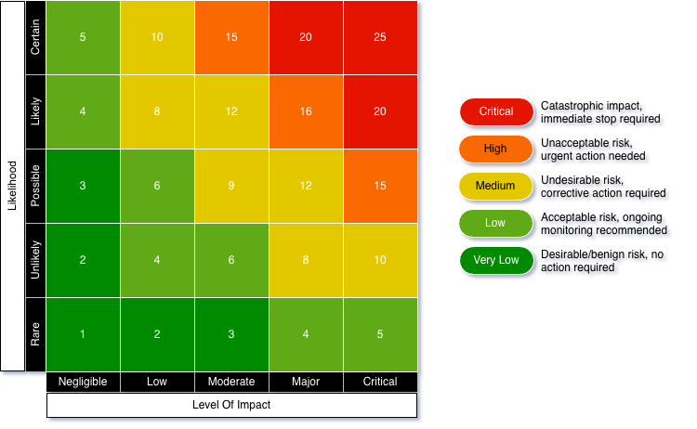
Likelihood: 1 = Very Low, 5 = Very High
Impact: 1 = Negligible, 5 = Critical operational/financial/regulatory consequences
Risk Score: Risk = Likelihood x Impact
Risk Thresholds: 1-3 = Very Low, 4-7 = Low, 5-14 = Medium, 15-19 = High, 20-25 = Critical

Risk Assessment
A threat modelling exercise was undertaken to identify and evaluate key operational, technical, strategic, compliance, and reputational threats affecting the current business environment.
The following risk matrix highlights the most critical business risks:
ID | Name | Category | Inherent RIsk  (LxI) | Key Mitigation Controls | Residual Risk  (LxI)
R-01 | Warehouse PC Failure | Operational | 4x4=16  (High) | Replace legacy PC, cloud-based inventory, automated backups | 2x3=6  (Low)
R-02 | Data Loss | Technical | 4x4=16  (High) | Cloud storage, daily backups, versioning | 2x3=6  (Low)
R-03 | Competitive Disadvantage | Strategic | 4x4=16  (High) | Basic website, online visibility, benchmarking competitors | 2x3=6  (Low)
R-04 | Manual Inefficiency | Operational | 4x4=16  (High) | SOPs, digitised processes, staff training | 2x3=6  (Low)
R-05 | Malware/Ransomware | Technical | 3x5=15  (High) | MFA, endpoint protection, OS patching, staff awareness | 2x3=6  (Low)
R-06 | Wi-Fi Intrusion | Technical | 3x4=12  (Medium) | Wi-Fi segmentation, strong passwords, WPA3 | 2x3=6  (Low)
R-07 | Email Compromise | Technical | 3x4=12  (Medium) | MFA, anti-phishing filters, secure email | 2x3=6  (Low)
R-08 | Supply Chain dependency | Operational | 3x4=12  (Medium) | Secondary suppliers, inventory buffers | 2x3=6  (Low)
R-09 | Market Share Erosion | Strategic | 3x4=12  (Medium) | Basic digital presence, customer engagement | 2x3=6  (Low)
R-10 | Business Continuity Failure | Operational | 2x5=10  (Medium) | Cloud systems, offline procedures, backup connectivity | 2x3=6  (Low)
R-11 | Compliance Risk | Compliance | 2x4=8  (Medium) | GDPR basics, secure data handling, retention policies | 2x2=4  (Low)
R-12 | Reputational harm | Reputational | 2x4=8  (Medium) | Service quality controls, customer feedback loop | 2x2=4  (Low)

The heatmap below shows how risks will move toward acceptable thresholds if the suggested mitigation controls are applied.
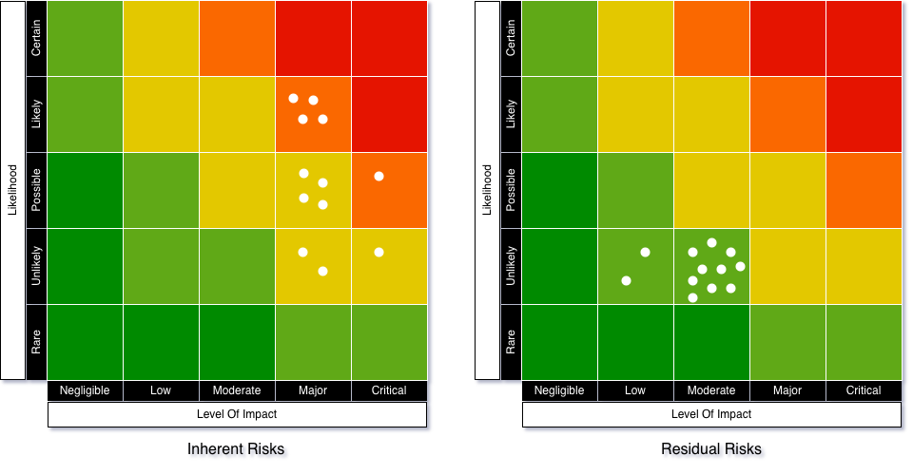

Risk Analysis of Digital Transformation

Assessment Methodology
ISO 31000 is used to assess the broader organisational risks associated with digital transformation, including strategic, operational, financial, compliance, and reputational impacts. To evaluate the technical risks introduced by new digital systems, NIST SP 800-30 is incorporated because it provides a structured method for identifying threat sources, vulnerabilities, likelihood, and impact.
NIST is particularly advantageous in the TO-BE environment because digitalisation introduces data-centric threats, requiring evaluation of Confidentiality, Integrity, and Availability (CIA). This complements ISO 31000 by ensuring that technology-enabled risks, such as data breaches, configuration errors, and online fraud, are assessed with appropriate technical depth while still feeding into the wider business risk picture.

Digital Transformation Vision and Roadmap
We propose a carefully structured 3-phase implementation approach to ensure a controlled transition.
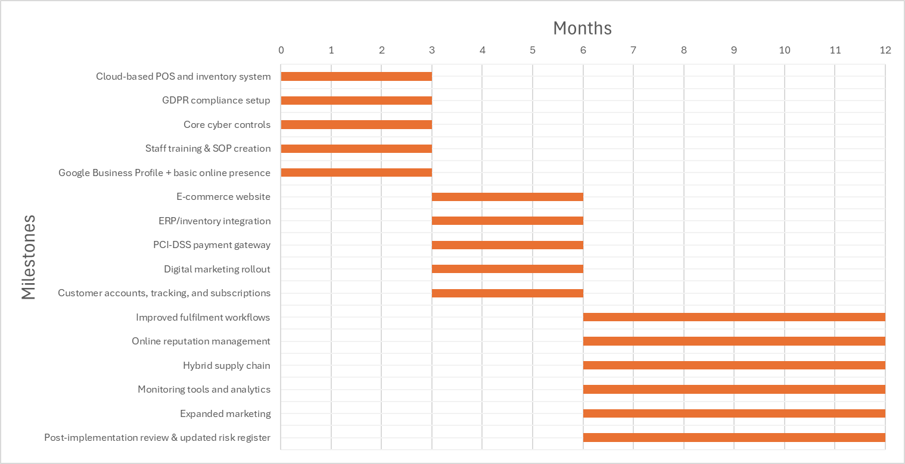

Phase 1- Digital Foundations
The initial 3-month phase should focus on establishing foundational digital capabilities to achieve operational stability and regulatory compliance before going live with online sales.
- Cloud-based POS and inventory system
- GDPR compliance setup
- Core cyber controls (MFA, EPP, segmentation, backups)
- Staff training & SOP creation
- Google Business Profile + basic online presence

Phase 2 – Digital Service Launch
The second 3-month phase focuses on introducing customer-facing digital capabilities that directly support new revenue streams.
- E-commerce website
- ERP/inventory integration
- PCI-DSS payment gateway
- Digital marketing rollout
- Customer accounts, tracking, and subscriptions

Phase 3 – Optimization and Expansion
The final 6-month phase focuses on optimisation, scaling operations, and strengthening supply chain resilience.
- Improved fulfilment workflows
- Online reputation management
- Hybrid supply chain (local + selected international)
- Monitoring tools and analytics
- Expanded marketing (ads, loyalty, referrals)
- Post-implementation review & updated risk register
Digitalisation changes the risk profile from operational inefficiencies to data-centric and service availability risks, requiring a combined ISO 31000 and NIST assessment.

Technical Risk Assessment
The following risk matrix highlights the most critical technical risks:
ID | Technical Risk | CIA Impact | Likelihood | Impact | Score
T-01 | Data Breach for Customer Accounts | C, I | 3 | 5 | 15 (High)
T-02 | Credential Theft, Account takeover | C, I, A | 3 | 5 | 15 (High)
T-03 | Cloud Misconfiguration | C, I, A | 3 | 4 | 12 (Medium)
T-04 | Payment Fraud/ PCI-DSS Exposure | C | 2 | 5 | 10 (Medium)
T-05 | DDoS attack on website | A | 3 | 4 | 12 (Medium)
T-06 | API Integration failure (ERP-Website) | I, A | 2 | 4 | 8 (Medium)
T-07 | Malware/ website defacement | I, A | 2 | 4 | 8 (Medium)

Digitalisation significantly increases exposure to high-impact cyber events. CIA analysis shows Confidentiality and Availability become critical due to customer data, online payments, and public web interfaces.

Business Risk Assessment
The following risk matrix highlights the most critical business risks:
ID | Business Risk | Category | Inherent Risk (L x I) | Key Mitigation Controls | Residual Risk (L x I)
B-01 | Online Services Outage | Operational | 3x4=12 (Medium) | Uptime Monitoring and alerting, High Availability setup, DDoS protection | 2x3=6  (Low)
B-02 | Negative Online Reputation | Reputational | 3x4=12 (Medium) | Fast complaint resolution workflow, Implement a customer response policy | 2x3=6  (Low)
B-03 | Poor order fulfillment capacity | Operational | 3x4=12 (Medium) | Maintain minimum stock thresholds, implement sales predictions and trends | 2x3=6  (Low)
B-04 | Regulatory Non-compliance (GDPR /PCI) | Compliance | 2x5=10 (Medium) | Use PCI-DSS compliant gateway, apply GDPR ready privacy and retention policy, conduct periodic compliance reviews | 2x3=6  (Low)
B-05 | International Supply Chain delays | Operational | 3x4=12 (Medium) | Maintain buffer stock for critical items, adopt a multi-supplier strategy | 2x3=6  (Low)
B-06 | Increased cost of digital operations | Financial | 2x4=8  (Medium) | Implement elastic scaling, automate routine processes to reduce labor cost | 2x2=4  (Low)
B-07 | Reliance on third party platforms | Strategic | 2x4=8  (Medium) |  | 2x3=6  (Low)
B-08 | Digital Skills Gap | Operational | 4x4=16  (High) | Structured training, develop SOPs and knowledge base, vendor onboarding | 3x3=9  (Medium)
B-09 | International sourcing quality risk | Reputational | 4x5=20  (Critical) | Hybrid sourcing (local food, imported accessories) | 2x3=6  (Low)
B-10 | Cybersecurity breach (data theft, ransomware) | Operational | 3x5=15  (High) | PCI DSS-compliant PSP, TLS, MFA, network segmentation, Cyber Essentials | 2x3=6  (Low)
B-11 | Business continuity outage | Operational | 3x4=12  (Medium) | Backup ISP, cloud SLAs, offline POS | 2x3=6  (Low)

The heatmap below shows how risks will move toward acceptable thresholds if the suggested mitigation controls are applied.

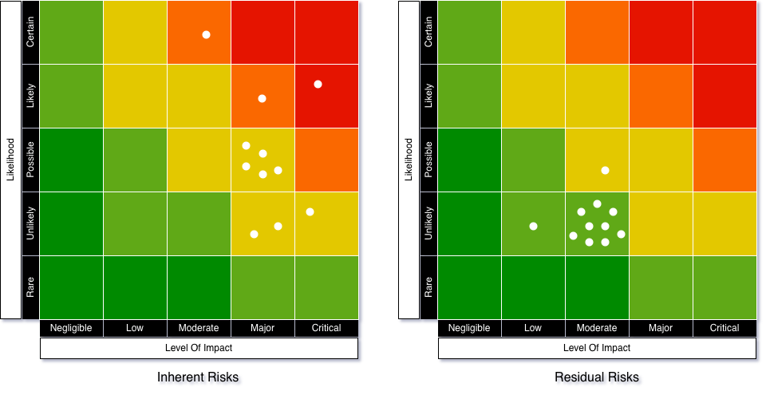

Conclusion and strategic Recommendations
The risk assessment shows that maintaining the current model exposes Pampered Pets to significant long-term threats, including an internally projected 33% customer attrition aligned with online purchasing trends (IBISWorld, 2024). The UK pet care market’s strong projected growth, from USD 8.55bn in 2024 to USD 13.75bn by 2033, combined with 58% of owners preferring online shopping (IMARC Group, 2024; ONS, 2024), indicates that an e-commerce presence could realistically support up to 50% business growth.
While international sourcing offers 24% cost reductions (Boston Consulting Group, 2025), it compromises the core 'locally sourced' brand value (UK Pet Food, 2024). Thus, phased digital transformation is recommended to manage risks while enabling growth (ISO, 2018; NIST, 2012).

References

Aven, T. (2016) ‘Risk assessment and risk management: Review of recent advances on their foundation’, European Journal of Operational Research, 253(1), pp. 1–13.
Boston Consulting Group (2025) Ways to make supply chains more cost-efficient. Available at: https://www.bcg.com/publications/2025/supply-chain-efficiency (Accessed: 29 November 2025).
IBISWorld (2024) Online Pet Food and Pet Supply Retailing in the UK. Available at: https://www.ibisworld.com/united-kingdom/industry/online-pet-food-pet-supply-retailing/14525/ (Accessed: 29 November 2025).
IMARC Group (2024) UK Pet Care Market Report. Available at: https://www.imarcgroup.com/uk-pet-care-market (Accessed: 29 November 2025).
ISO (2018) ISO 31000:2018 Risk management — Guidelines. Geneva: International Organization for Standardization.
NIST (2012) NIST SP 800-30 Rev.1: Guide for Conducting Risk Assessments. Gaithersburg: National Institute of Standards and Technology.
ONS (2024) Retail sales, Great Britain: Digital statistics. Office for National Statistics. Available at: https://www.ons.gov.uk (Accessed: 29 November 2025).
UK Pet Food (2024) Pet Data 2024: Market Overview. Available at: https://www.ukpetfood.org/resource/pet-data-2024.html (Accessed: 29 November 2025).

