INC000098188704 (P2) - We have multiple Dmaap jobs abort (Conn Issue – MFT Team / AT Servers)
5 de dezembro de 2025
10:44

Date: 03-Feb-2026
Requester: Suryawanshi, Sanket
Description:
- We have multiple jobs are aborting with the following error:
[INFO ] 01:24:07 dmaap.j_ff_e_dataextractfiledelimited_0_35.J_FF_E_DataExtractFileDelimited- JL_CTR_LogProcessExecution_DMaaP_1_tLo\
gRow_2 - Printed row count: 1.
[ERROR] 01:24:07 dmaap.j_ff_e_dataextractfiledelimited_0_35.J_FF_E_DataExtractFileDelimited- tDie_1 - The die message: Cannot conne\
ct to the SFTP server10.59.2.4
[FATAL] 01:24:07 dmaap.j_ff_e_dataextractfiledelimited_0_35.J_FF_E_DataExtractFileDelimited- tDie_1 null
routines.system.TDieException: null
at dmaap.j_ff_e_dataextractfiledelimited_0_35.J_FF_E_DataExtractFileDelimited.tDie_1Process(J_FF_E_DataExtractFileDelimited.java:1\
8906) [j_ff_e_dataextractfiledelimited_0_35.jar:?]
at dmaap.j_ff_e_dataextractfiledelimited_0_35.J_FF_E_DataExtractFileDelimited.tFTPConnection_2_error(J_FF_E_DataExtractFileDelimit\
P2 JUSTIFICATION MEC IMPACTED

Initial Diagnosis:
- Connect issue for SFTP server to 10.59.2.4
- Requested feed names that were impacted (SFHIER informed by AO – Commissions source – Although others were aborted but not related to this INC)

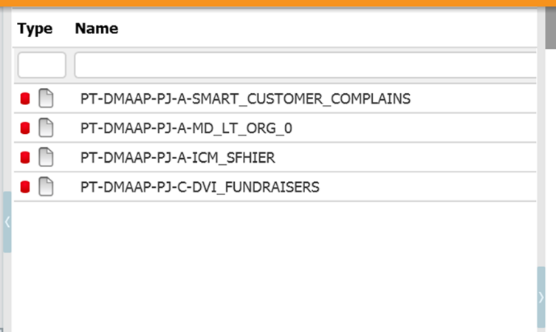

Actions Taken:
- Checked CTR_DMAAP_FILE_PRCS (DMAAP Table) if files were processed for current DS_PARAM_VALUE – NOT OK
- Checked in INPUT FOLDER (MTD_DMAAP_FEED_CONF DMAAP Table) if files were sent by Source Team – NOT OK
- Checked the content of flag FL_ABORT_NO_SRC_FILES = 'Y' (MTD_DMAAP_FEED_CONF) to justify the error as per the files were not in the folder – OK
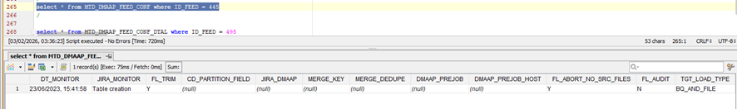

- Tested connection for AT Server in pt1098yr – NOT OK (Partially)
sftp -oPort=2216 at_talend@10.59.2.4
unable to connect AT due to which DWBI Jobs are aborting

sftp -oPort=15722 at_talend@213.30.99.17
able to connect AT

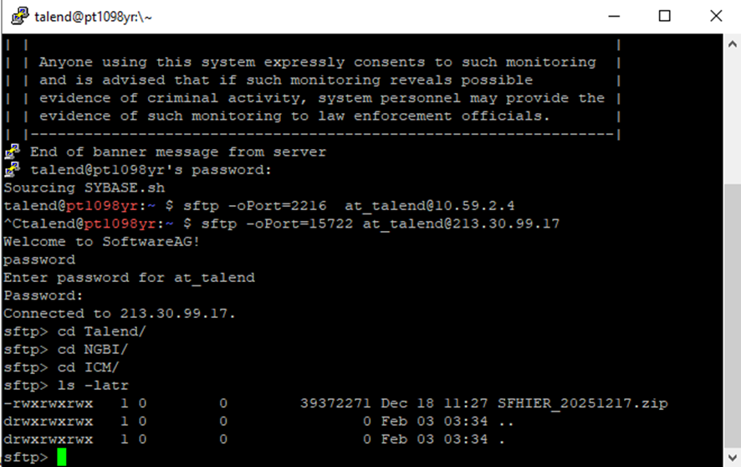

- Assigned INC to AO to check with Source Team (in this case Commission) about the missing files, and also with the Integration Team to check the connectivity issue to Active Transfer server.

Resolution:
- After Commission Team re-sent the files, the MFT / AT server was not transferring them to be processed by Talend according to this flow:
Source - PT1099YR (Talend - 46.190.234.199 ) / PT1098YR >> 10.59.2.4 (MFT ) >> Destination - 213.30.99.17 ( AT server )
- First contact for this P2 was on 02am before AM assigning back to AO. Second contact was on 07am to join (again) a MIEM call, where Frederico Araújo informed about configuration needed to reach out to MFT Server (reference INC000093736970 – a comment from Alberto Faria with this configuration and indicating it is a VIP Server that need to be whitelisted). Around 07:30 am, the MFT Team was contacted (“VG CFS Enablers Operations OPS-APPL ENT” - AbdElRahman Emam - Service Name” VF-CFS-TRANSFER PROD”) that didn't identified any anomalies on their end, however, AbdElRahman Emam decided to restart both AT Servers. After this action, Commission team resent the files that were transferred and processed by DMaaP (Talend), and file was generated to be processed by Raw2Raw and then, by Nucleus / VOIS.

Related Links:
- INC000093736970 P2 05-MAY-2025 (Old reference with MFT Servers Configuration)
- INC000098188808 (P2) with the 1st occurrence on 03-Feb-26 (not handled by AM) that raised a new INC P2 (this corresponding page)

