INC000099266256 (P2) - Multiple job abort due to TALEND MJ_DMaaP_Main_** job connection issue
7 de maio de 2026
14:26

Date: 07-05-2026
Requester: AO
Description:
We have multiple job abort and long running jobs in yesterday and today's date.

As Dmaap jobs are picking Talend MJ_Dmaap_Main** jobs.

The jobs are failing as we connection to the TALEND MAIN job they are picking the same talend jobs and after doing TP to PE we rerun the job still job is failing.

DST team is already aware of the issue as yesterday few MAIN jobs were there but today max Are impacted due to which controlm is impacted.

Diagnosis:

Error on control m DMAAP jobs: ORA-20000: No main jobs available ORA-06512

- We analyzed the script and found that the query used to validate whether there are Main jobs available is the following:

talenduser@pt402adr: /var/SP/data1/dmaap/runFeed

Talend BD, schema DMAAP

with param as (
--select '$(hostname)' host
--select 'pt402adr' host
--select 'pt413adr' host
--select 'pt1082yr' host
select 'full' host
from dual
)
, ready as (
select e.id
, e.label
, replace(e.label,e.generatedjobname||'_') jobno
--, s.host
--, e.executio_execution_e_id, e.context, e.applycontexttochildren, e.uselatestversion, e.jobversion, e.artifactversion
from executiontask e
--inner join executionserver s on (e.executio_execution_e_id = s.id)
where e.generatedprojectname = 'DMAAP'
and e.generatedjobname = 'MJ_DMaaP_Main'
and e.processingstate = 0
and replace(e.label,e.generatedjobname||'_') <= 80
order by e.label
)
, assigned as (
select distinct f.ds_run_main_id
--, f.ds_run_main_name
--, f.dt_run_main
from mtd_dmaap_feed_conf f
where f.dt_run_main between sysdate - (2/24/60) and sysdate
)
, in_execution as (
select b.ds_run_main_id
from CTR_DMAAP_FILE_PRCS a, MTD_DMAAP_FEED_CONF b
where a.id_load = b.DS_RUN_LOAD_ID
and a.DT_END is null
and b.DT_RUN_MAIN >= sysdate-1
and cd_status <> 'PE'
)
, ready_and_not_assigned as (
select r.id
, r.label
, row_number() over (order by r.label asc) rn
from ready r
inner join param p on ( (substr(p.host,1,8) = 'pt402adr' and r.jobno between '01' and '39') /*EdgeNode1*/
or (substr(p.host,1,8) = 'pt413adr' and r.jobno between '40' and '80') /*EdgeNode2*/
or (substr(p.host,1,8) = 'pt1082yr') /*Dev*/
or (substr(p.host,1,8) = 'full')) /*Balance all Mains*/
left outer join assigned a on (r.id = a.ds_run_main_id)
left outer join in_execution b on (r.id = b.ds_run_main_id)
where a.ds_run_main_id is null
and b.ds_run_main_id is null
)
select id
, label
from ready_and_not_assigned
where rn = 1
--order by rn

- We saw that there were several jobs running since the previous day with the in_execution query. Many of them were GS_ORG and LT_ORG jobs, so we tested killing one of the Control-M jobs.

select id_load, dt_run_main, ds_file_name, DT_LAST_UPD_FEED, DS_RUN_MAIN_NAME, DS_RUN_MAIN_ID, DS_FILE_NAME, CD_SOURCE_NAME, id_source ,CD_BUSINESS_AREA
from CTR_DMAAP_FILE_PRCS a, MTD_DMAAP_FEED_CONF b
where a.id_load = b.DS_RUN_LOAD_ID
and a.DT_END is null
and b.DT_RUN_MAIN >= sysdate-1
and cd_status <> 'PE'

- We validated which id_load it was and performed an update on the CTR_DMAAP_FILE_PRCS table to make the Main available:

update CTR_DMAAP_FILE_PRCS
set CD_STATUS='PE'
where id_load = 1443777

- With that Main freed up (always validating with the query), we tried running the Control-M job again and confirmed through the log that it picked up the Main we had released.

However, we noticed that in TAC the Main was not starting, it remained in a "Ready to Run" state, which raised suspicion that the issue might be related to the connection to TAC.

So we went to look in RunFeed.sh to see where it connects to TAC:

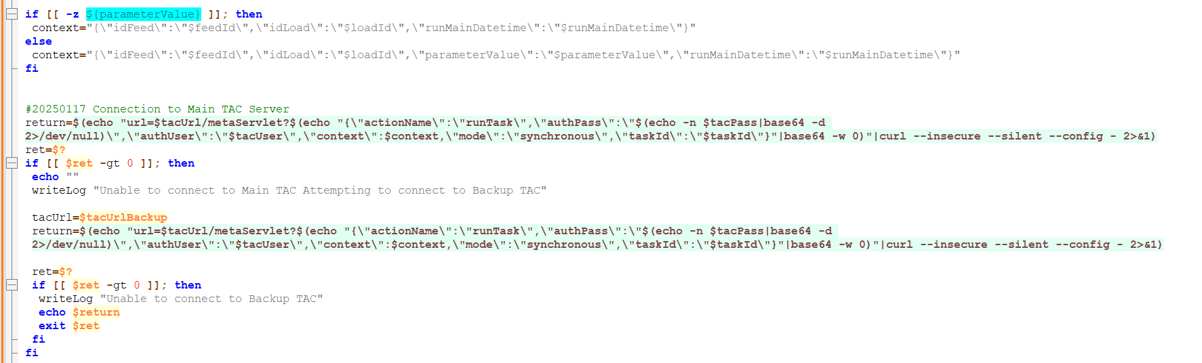

- Credentials are retrieved by Secret:

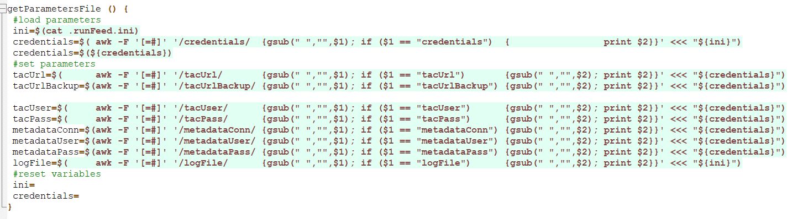

- So it's necessery to go to GCP Secret Management and select the run-feed-credentials secret to view the TAC conection parameters necessary to simulate the TAC conection.
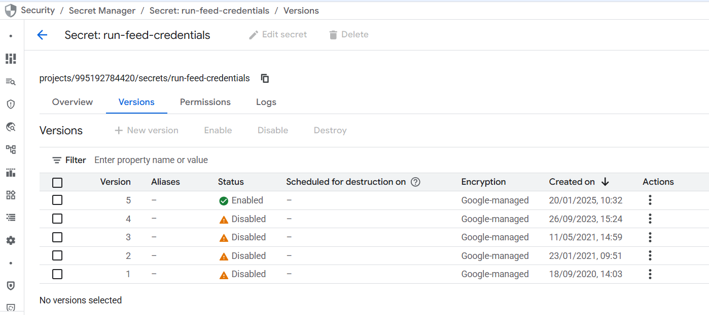

- Then we simulated the connection to TAC by replacing all the variables and realized that the issue lies with the username/password.

We also tried logging into TAC using the username and password, and it failed as well. The password returned by the secret is in Base64, so we used a converter to get the actual password and be able to test it in TAC.

https://www.base64decode.org/pt/

$ echo "url=https://pt1096yr.pt.sedc.internal.vodafone.com:8443/org.talend.administrator/metaServlet?$(echo "{\"actionName\":\"runTask\",\"authPass\":\"$(echo -n I<password decoded>I=|base64 -d 2>/dev/null)\",\"authUser\":\"analytics2@vodafone.pt\",\"context\":{\"idFeed\":\"1907\",\"idLoad\":\"1444257\",\"parameterValue\":\"20260506\",\"runMainDatetime\":\"20260507100503\"},\"mode\":\"synchronous\",\"taskId\":\"13672\"}"|base64 -w 0)"|curl --insecure --silent --config - 2>&1

Result: { “error”:”Username or password is wrong”,”returnCode”:3}

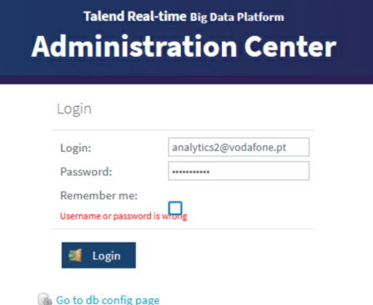

Resolution:

We sent an email outlining our analysis and realized that the previous day Manuel Andrade had made changes to the user analytics2@vodafone.com without anticipating this impact.
After he corrected it, we tested the connection to TAC again and it was successfully established.

