INC000099274091 - (FAILED) [GCP] - New SR
11 de maio de 2026
09:32

Se o ficheiro Dmaap na vf-pt-datahub-prd-mgmt.vfpt_dh_mgmt_dmaap_metadata_s.dmaap_feed_ctrl carregou mais que um ficheiro (neste caso mais que um ficheiro cops da mesma feed) a contagem irá falhar sempre.

Exemplo:

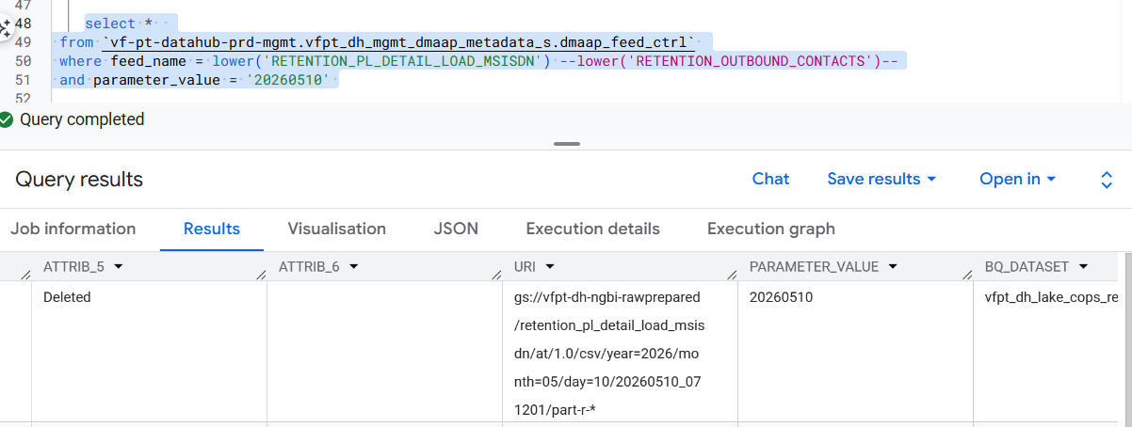

Este que agora está a Deleted (ficheiro gerado na exec do DMaap) carregou 2 ficheiros (COPS_RETENTION_PL_DETAIL_LOAD_20260509000000_MSISDN.csv e COPS_RETENTION_PL_DETAIL_LOAD_20260510000000_MSISDN.csv)

Logo o Numero de Linhas é a soma de ambos os ficheiros (vamos assumir que tem 100 linhas cada 1) aqui a contagem seria de 200 Nr_lines, mas quando faz o validate row count é por ficheiro, logo iria dar 200 vs 100 que dará mismatch no numero de linhas.
Para resolver isto, temos de processar outra vez:

1º Passo:
--update CTR_DMAAP_FILE_DELIM --CTR_DMAAP_FILE_PRCS
set CD_STATUS = 'PE'
where 1 = 1
-- and id_feed = 2888
-- and DS_PARAMETER_VALUE = 20260507
--and id_load = 1448412

--UPDATE
--select * from
`vf-pt-datahub-prd-mgmt.vfpt_dh_mgmt_dmaap_metadata_s.dmaap_feed_ctrl`
set ATTRIB_5 = 'Deleted'
where feed_name = lower('RETENTION_PL_DETAIL_LOAD_MSISDN')
and parameter_value = '20260510'

2º Passo: (reprocessar)

Na 402 ir para a diretoria da feed que queremos reprocessar:
/BDE/cops/archive/feeds/COPS_RETENTION_OUTBOUND_CONTACTS

Depois logar na At:

sftp -oPort=15722 at_talend@213.30.99.17
Pass: at_talendmwp

Fazer a copia dos ficheiros:

put COPS_RETENTION_PL_DETAIL_LOAD_20260510000000_MSISDN.csv /Talend/DMaaP/Inbox

Executar o runFeed:

runFeed.sh -f 2341 -d 20260511

Queries de Validação:

Algumas queries que também podem ser uteis estão no GCP com o nome: INC000099274091 - (FAILED) [GCP] - New SR COPS

MISSING FILES: (por dia)

WITH expected_files_single AS (
SELECT
REPLACE(file_name, '*', CONCAT('%20260511%')) AS expected_file_pattern,
file_name AS original_pattern
FROM `vf-pt-datahub-prd-mgmt.vfpt_dh_mgmt_dmaap_metadata_s.bde_rd_da_cops_feeds`
WHERE ds_area = 'RETENTION'
AND fl_dual_date = 'N'
),

existing_files_single AS (
SELECT
v.TF_ORIGINAL_FILE_NAME AS actual_file_name
FROM `vf-pt-datahub.vfpt_dh_lake_cops_others_s.audit_files_dmaap_processing_v` v
JOIN `vf-pt-datahub.vfpt_dh_lake_cops_others_s.cops_logs_files` l
ON v.TF_ORIGINAL_FILE_NAME = l.file_name
WHERE l.status = 'SUCCESS'
),

missing_files_single AS (
SELECT ef.original_pattern AS expected_file
FROM expected_files_single ef
LEFT JOIN existing_files_single e
ON e.actual_file_name LIKE ef.expected_file_pattern
WHERE e.actual_file_name IS NULL
),

-- 2. Two dates pattern
expected_files_dual AS (
SELECT
REPLACE(file_name, '*', CONCAT('_%_20260511%')) AS like_pattern,
file_name AS original_pattern
FROM `vf-pt-datahub-prd-mgmt.vfpt_dh_mgmt_dmaap_metadata_s.bde_rd_da_cops_feeds`
WHERE fl_dual_date = 'Y'
),

onprem_files_dual AS (
SELECT
l.file_name AS original_file_name
FROM `vf-pt-datahub-prd-mgmt.vfpt_dh_mgmt_dmaap_metadata_s.bde_cops_bau_files` l
JOIN expected_files_dual p
ON l.file_name LIKE p.like_pattern

),

processed_files_dual AS (
SELECT
tf_original_file_name
FROM `vf-pt-datahub.vfpt_dh_lake_cops_others_s.audit_files_dmaap_processing_v`
),

missing_files_dual AS (
SELECT f.original_file_name AS expected_file
FROM onprem_files_dual f
LEFT JOIN processed_files_dual p
ON f.original_file_name = p.tf_original_file_name
WHERE p.tf_original_file_name IS NULL
),

-- 3. Patterns Union
all_missing AS (
SELECT * FROM missing_files_single
UNION ALL
SELECT * FROM missing_files_dual
),

-- 4. Final status
final_status AS (
SELECT
CASE
WHEN COUNT(*) = 0 THEN 'OK'
ELSE 'MISSING FILES: ' || STRING_AGG(expected_file, ', ')
END AS status
FROM all_missing
)

SELECT status FROM final_status;

ROW_VALIDATION: (por dia)

WITH expected_files AS (
SELECT
REPLACE(file_name, '*', '%20260509%') AS expected_file_pattern
FROM vf-pt-datahub-prd-mgmt.vfpt_dh_mgmt_dmaap_metadata_s.bde_rd_da_cops_feeds
WHERE ds_area = 'RETENTION'
),
log_counts AS (
SELECT
file_name AS filename,
SUM(row_count) AS log_row_count
FROM `vf-pt-datahub.vfpt_dh_lake_cops_others_s.cops_logs_files`
WHERE EXISTS (
SELECT 1 FROM expected_files ef WHERE file_name LIKE ef.expected_file_pattern
)
AND status = 'SUCCESS'
GROUP BY file_name
),
file_counts AS (
SELECT
tf_original_file_name AS filename,
SUM(nr_lines_append) AS file_nr_lines_sent,
SUM(nr_lines_original_file) AS file_nr_lines_original,
SUM(record_count_gcp) AS file_nr_lines_bq
FROM `vf-pt-datahub.vfpt_dh_lake_cops_others_s.audit_files_dmaap_processing_v`
WHERE EXISTS (
SELECT 1 FROM expected_files ef WHERE tf_original_file_name LIKE ef.expected_file_pattern
)
GROUP BY tf_original_file_name
),
join_counts AS (
SELECT
l.filename,
l.log_row_count,
f.file_nr_lines_sent,
f.file_nr_lines_original,
f.file_nr_lines_bq,
CASE
WHEN (l.log_row_count != f.file_nr_lines_sent
OR l.log_row_count != f.file_nr_lines_original
OR l.log_row_count != f.file_nr_lines_bq)
THEN 'NOK'
ELSE 'OK'
END AS file_status
FROM log_counts l
INNER JOIN file_counts f
ON l.filename = f.filename
),
final_status AS (
SELECT
CASE
WHEN COUNT(CASE WHEN file_status = 'NOK' THEN 1 END) > 0
THEN 'NOK: ' || STRING_AGG(CASE WHEN file_status = 'NOK' THEN filename END, ', ')
ELSE 'OK'
END AS status
FROM join_counts
)
SELECT status FROM final_status;

