INC000097067129 - The field DISCONNECT_PARTY is always 0 in table `vf-pt-datahub.vfpt_dh_lake_kenan_s.dm_no
DO NOT DELETE - THIS IS A TEMPLATE
Date: 28-10-2025
Requester: Lopes, Sérgio Santos

Description:
- [Enter description of the issue]

Initial Diagnosis:
- [Notes from initial analysis]

Actions Taken:
-
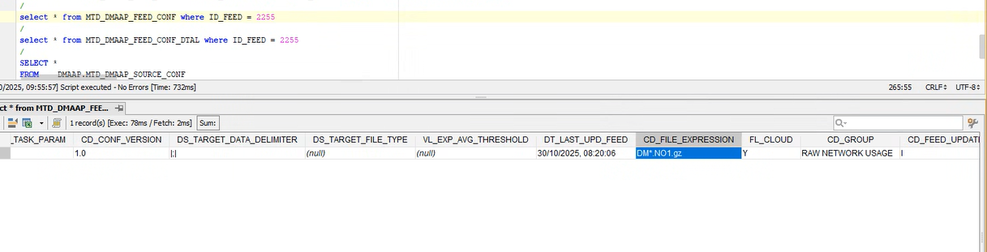
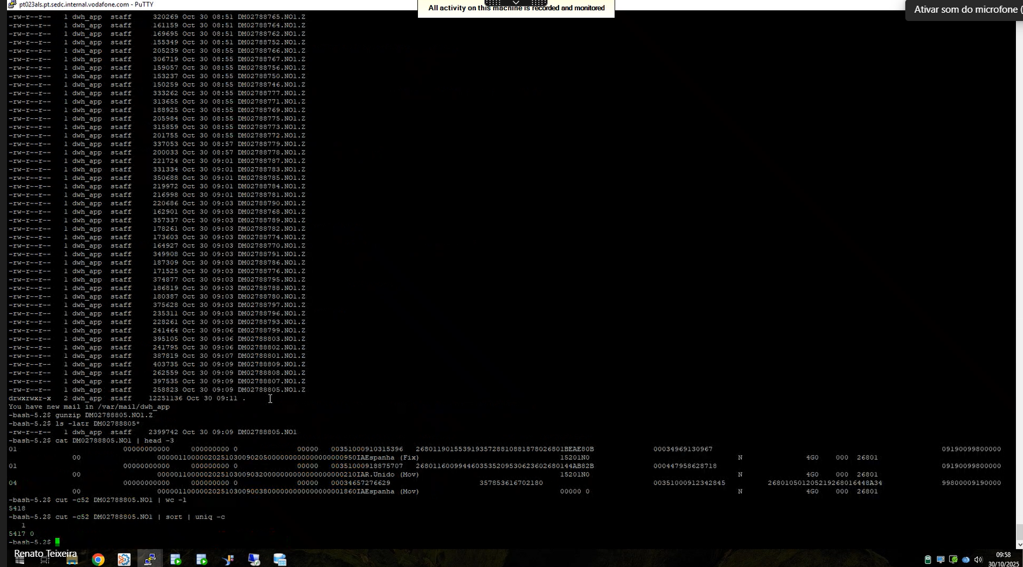

Não tem delimitador e vai por caracter

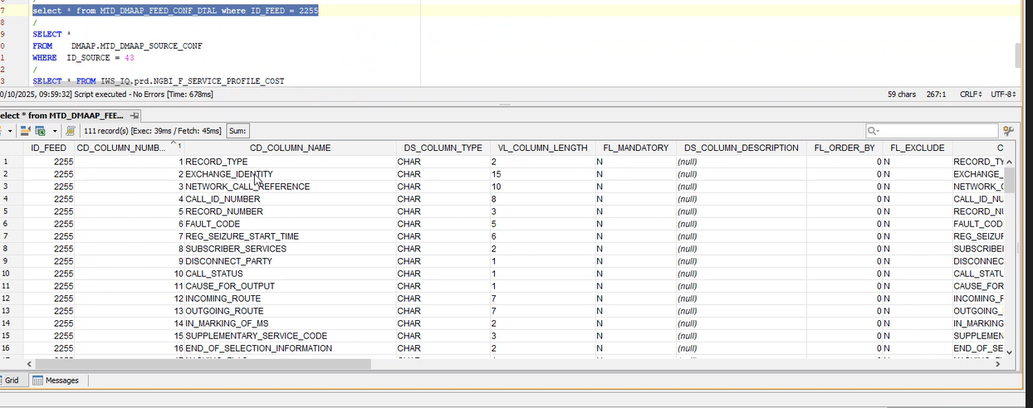

A coluna 9 aparece na posição 52
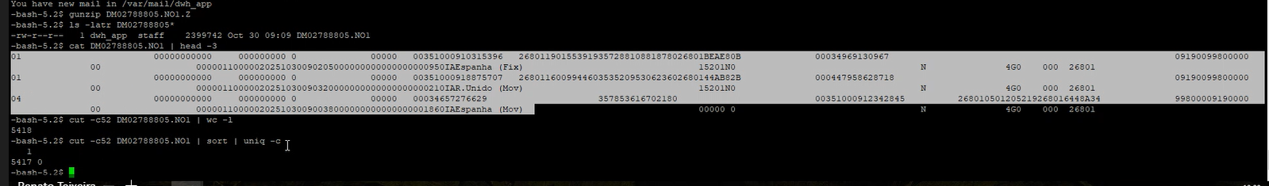

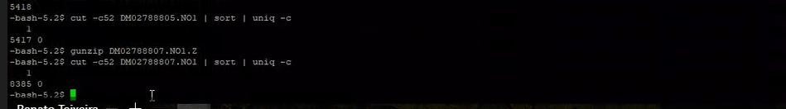

Resolution:
-
Hi AO,

This is a feed that extract directly from the received source file. The file mask is DM*.NO1.gz.

You can check that on DMAAP DB.

1 | select * from MTD_DMAAP_FEED_CONF where ID_FEED = 2255

If you check the file you can see that they dont have a file delimiter, the columns are build by the nr of caracters.

You can check the column build with this query:

1 | select * from MTD_DMAAP_FEED_CONF_DTAL where ID_FEED = 2255

1 RECORD_TYPE CHAR 2
2 EXCHANGE_IDENTITY CHAR 15
3 NETWORK_CALL_REFERENCE CHAR 10
4 CALL_ID_NUMBER CHAR 8
5 RECORD_NUMBER CHAR 3
6 FAULT_CODE CHAR 5
7 REG_SEIZURE_START_TIME CHAR 6
8 SUBSCRIBER_SERVICES CHAR 2
9 DISCONNECT_PARTY CHAR 1
10 CALL_STATUS CHAR 1

If you count the nr of caracters to grab the position of column nr 9 you will see that this column is on position 52.

Now go the file backup folder and grab 2 example files on PT023ALS:

1  2  3  4  5  6 | -bash-5.2$ cut -c52 DM02788805.NO1 | sort | uniq -c  1  5417 0  -bash-5.2$ cut -c52 DM02788807.NO1 | sort | uniq -c  1  8385 0

You can see that the value is always 0.

If the requester its complaining about this you need to engage with the source system to clarify why and if its normal to always get this column with 0.

Related Links:
- Remedy Ticket
- Documentation

18 de dezembro de 2025
10:12

