INC000097245442 - ngbi_extr_preactive_services - Drop in Subscribers
18 de dezembro de 2025
10:05

DO NOT DELETE - THIS IS A TEMPLATE
Date: 12-11-2025
Requester: VG Appl-NGDI DATA OPS-APPL ENT

Description: Business has highlighted an issue where there’s a drop in subscribers count since past few days. Upon analysis we found that the issue is within the feed ‘ngbi_extr_preactive_services’ where there is a drop from 5th Nov onwards. Please refer the below
query:

Initial Diagnosis:
- [Notes from initial analysis]

Actions Taken:
-
select id_type,
date(ACTIVATION_DATE),
count(*)
from `vf-pt-datahub.vfpt_dh_lake_eis_s.ngbi_extr_preactive_services`
where ACTIVATION_DATE >='2025-10-01'
and tf_extract_date = 20251111
and id_type = 'Fibra'
group by id_type,2

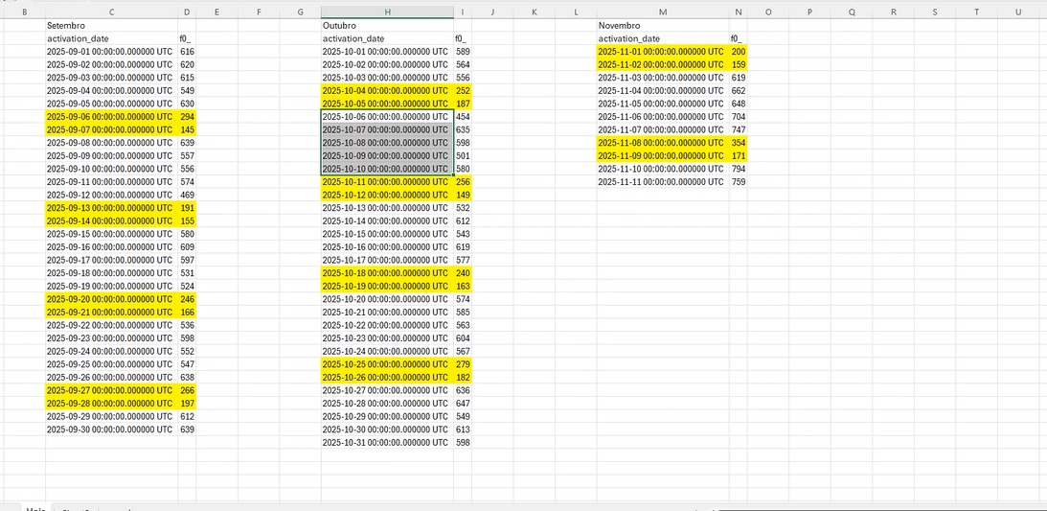

1  2  3  4  5  6  7  8  9  10  11 | select TRUNC(ACTIVATION_DATE) as activation_date, count(*)  from EXTR_PREACTIVE_SERVICES  where TRUNC(ACTIVATION_DATE) >= TO_DATE('2025-10-01','YYYY-MM-DD')  group by TRUNC(ACTIVATION_DATE)  /  select TRUNC(ACTIVATION_DATE) as activation_date, count(*)  from NGBI_EXTR_PREACTIVE_SERVICES  where id_type in ('Fibra', 'ADSL')  and TRUNC(ACTIVATION_DATE) >= TO_DATE('2025-10-01','YYYY-MM-DD')  and TF_EXTRACT_DATE = 20251111  group by TRUNC(ACTIVATION_DATE)

Resolution:
-
Hi AO,

Please engage with VOIS Nucleus team.

In our RAW we are coherent with the expected counts.

1  2  3  4  5  6  7  8 | select id_type,  date(ACTIVATION_DATE),  count(*)  from `vf-pt-datahub.vfpt_dh_lake_eis_s.ngbi_extr_preactive_services`  where ACTIVATION_DATE >='2025-10-01'  and TF_EXTRACT_DATE = 20251111  and id_type = 'Fibra'  group by id_type,2

id_type f0_ f1_
Fibra 2025-11-11 759
Fibra 2025-11-10 794
Fibra 2025-11-09 171
Fibra 2025-11-08 354
Fibra 2025-11-07 747
Fibra 2025-11-06 704
Fibra 2025-11-05 648
Fibra 2025-11-04 662
Fibra 2025-11-03 619
Fibra 2025-11-02 159
Fibra 2025-11-01 200
Fibra 2025-10-31 598
Fibra 2025-10-30 613
Fibra 2025-10-29 549
Fibra 2025-10-28 647
Fibra 2025-10-27 636
Fibra 2025-10-26 182
Fibra 2025-10-25 279
Fibra 2025-10-24 567
Fibra 2025-10-23 604
Fibra 2025-10-22 563
Fibra 2025-10-21 585
Fibra 2025-10-20 574
Fibra 2025-10-19 163
Fibra 2025-10-18 240
Fibra 2025-10-17 577
Fibra 2025-10-16 619
Fibra 2025-10-15 543
Fibra 2025-10-14 612
Fibra 2025-10-13 532
Fibra 2025-10-12 149
Fibra 2025-10-11 256
Fibra 2025-10-10 580
Fibra 2025-10-09 501
Fibra 2025-10-08 598
Fibra 2025-10-07 635
Fibra 2025-10-06 454
Fibra 2025-10-05 187
Fibra 2025-10-04 252
Fibra 2025-10-03 556
Fibra 2025-10-02 564
Fibra 2025-10-01 589

So this is not an issue on ngbi_extr_preactive_services feed.

Please engage with VOIS Nucleus team.

Related Links:
- Remedy Ticket
- Documentation

