INC000097373402 - Talend Job J_DD_RETENTION_CCIL - DQ26
5 de dezembro de 2025
10:28
Date: 20251124
Requester: Talend Alert
Description:
- Talend Job J_DD_RETENTION_CCIL Abort

Initial Diagnosis:
- Numeric Overflow error in the process.

Actions Taken:
- Step 1
Check Error
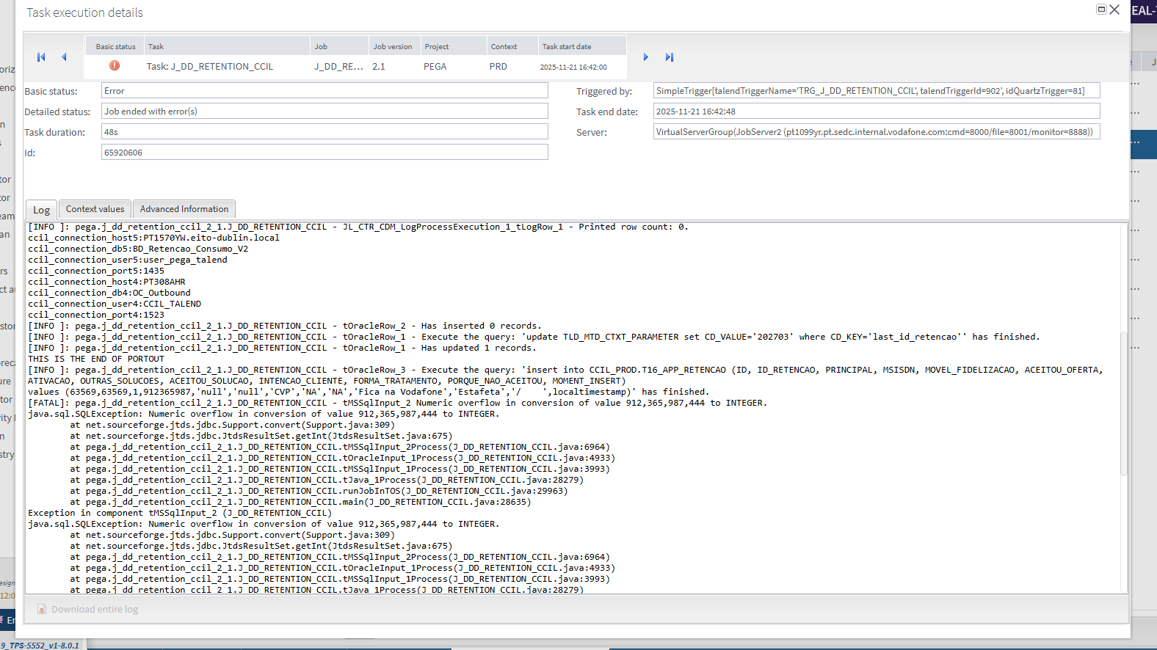

- Step 2
Check Connections
ccil_connection_host4 PT308AHR
ccil_connection_db4 CCPRDSRV
ccil_connection_port4 1523
ccil_connection_user4 CCIL_TALEND
ccil_connection_pass4 1671bbe59daa483491e51ba553c6de42 --> qazwsx_321

ccil_connection_host5 PT1570YW.eito-dublin.local
ccil_connection_db5 BD_Retencao_Consumo_V2
ccil_connection_port5 1435
ccil_connection_user5 user_pega_talend
ccil_connection_pass5 47bd313aae643d672357cc0f04369861b58975c91127da52d61f8376969ab7fb --> user_pega_talend_Pass

Resolution:

Enviado o ticket para o AO com a seguinte nota:

Hi AO,

From our analysis the issue is on the v_PEGA view from the database BD_Retencao_Consumo_V2 . There is an MSISDN that is too long when it tries to insert into the CCIL bd on the table CCIL_PROD.T16_APP_RETENCAO.

ID ID_RETENCAO PRINCIPAL MSISDN
63570 63570 2 912365987444
63573 63573 2 912365987444

Please check with the responsable team if this value is correct .

DB connections from retention DB

ccil_connection_host PT308AHR
ccil_connection_db CCPRDSRV
ccil_connection_port 1523
ccil_connection_user CCIL_TALEND

If you don’t know who to contact, please reach out to the SMs.

We also checked that the last run was on 24/11/2025 at 02:06:08, and after that the job was paused. Why is it paused?
This job has been failing since the run on 21/11/2025 at 16:42:08

Related Links:
- Remedy Ticket
- Documentation

