INC000097490715 - DQ26 - MJ_Samples and J_KK_ET_CVPEvent is failing daily
5 de dezembro de 2025
10:44

Date: 03-12-2025
Requester: AO
Description:
DQ26 - MJ_Samples and J_KK_ET_CVPEvent is failing daily.

Initial Diagnosis:
- Jobs J_KK_ET_CVPEvent and MJ_Samples are failing daily with Connection error which inturn generates DQ26 Alert.

Actions Taken:
- Validate Connections on the error component
-
J_KK_ET_CVPEvent
Abort entre
02/12/2025, 18:53:40
02/12/2025, 18:00:20

1º abort
[FATAL]: pega.j_kk_et_cvpevent_1_8.J_KK_ET_CVPEvent - tOracleInput_1 No more data to read from socket
2º abort
[FATAL]: pega.j_kk_et_cvpevent_1_8.J_KK_ET_CVPEvent - tOracleConnection_1 ORA-01033: ORACLE initialization or shutdown in progress
java.sql.SQLRecoverableException: ORA-01033: ORACLE initialization or shutdown in progress
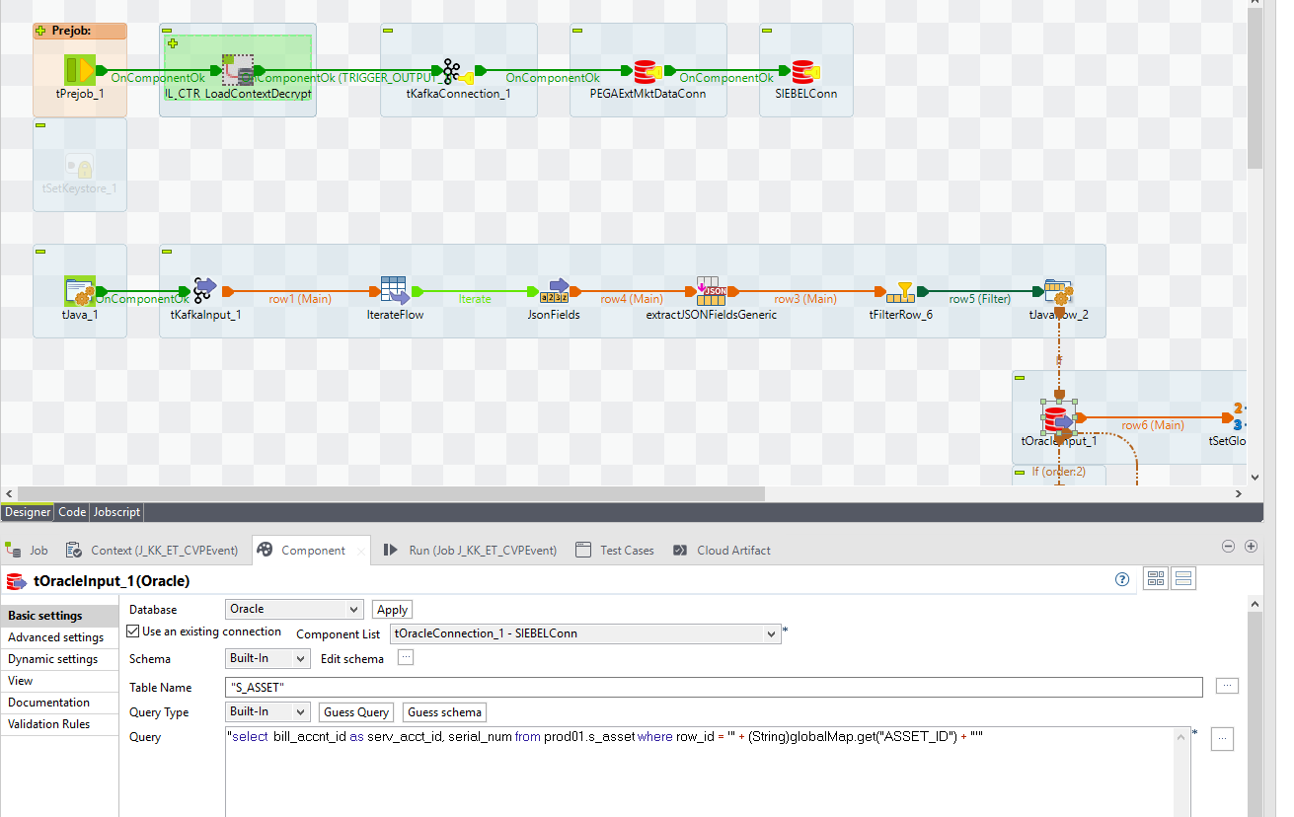


MJ Samples

[FATAL] 03:03:08 samples.j_dd_t_mediation_0_1.J_DD_T_Mediation- tDBConnection_1 IO Error: The Network Adapter could not establish the connection
java.sql.SQLRecoverableException: IO Error: The Network Adapter could not establish the connection

J_DD_T_Mediation- tDBConnection_1

MediationDB_Server pt00147do-scan.sne3001.it1vcn019232o1.oraclevcn.com
MediationDB_Service ptprd.ptmedprd.3rba.paas.oracle.com
MediationDB_Port 1521
MediationDB_Schema mzdwh
MediationDB_Login mzdwh
MediationDB_Password 117d2898986ee1e4764f275444a0a095

Resolution:

Conclusões
J_KK_ET_CVPEvent - aborta após as 18h na conexão á BD BD do Siebel está em Baixo
MJ_Samples - aborta ocasionalemte na ligação á BD da mediação, necessário perceber o que se passa com a BD as 03:00 para por vezes a mesma estar em baixo.

An exception was added to the DQ26 Alert to prevent generating alerts between 17:00 and 00:10, which is the time when the database is down.

Related Links:
- Remedy Ticket
- Documentation

