INC000097621696 - CONTROL-M: JOBFAILURE error occured for PT-DMAAP-PJ-A-MEDALLIA_SURVEY_RESPONSE (Control-M source: GCP)
10 December 2025
11:58

Date: 20251210
Requester: Agent, Monitoring
Description:
- CONTROL-M: JOBFAILURE error occured for PT-DMAAP-PJ-A-MEDALLIA_SURVEY_RESPONSE

Initial Diagnosis:
- Files were moved to Quarantine Folder by Talend Sanity Checks process

Actions Taken:
- Check the DMAAP Quarantine table to confirm if feed MEDALLIA_SURVEY_RESPONSE (ID_FEED = 2698) is in quarantine and its cause
SELECT * from CTR_DMAAP_FILE_QRT
WHERE ID_FEED = 2698
ORDER BY dt_created desc;
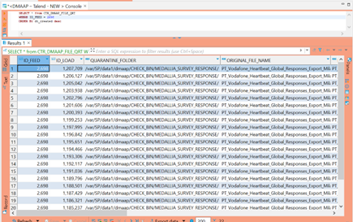

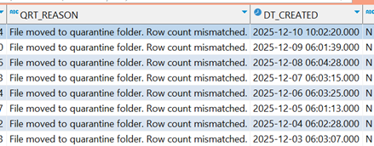

- Check the quarantine folder in pt402adr
cd /var/SP/data1/dmaap/CHECK_BIN/MEDALLIA_SURVEY_RESPONSE

- Evaluate filename and format for feed MEDALLIA_SURVEY_RESPONSE
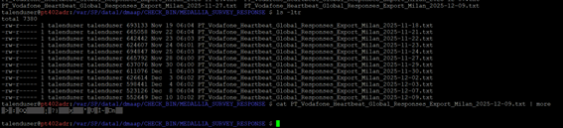

Resolution:
- After AM confirmed the file sent to be processed were not in ASCII format (they were in binary since several previous days), AO was guided to engage with Source Team to re-send them in the correct format to be re-processed by AO in DMAAP.

Related Links:
- Remedy Ticket
- Documentation created by AM (Frederico Araújo) and attached to INC000097621696 with information about queries and folders required to this analysis.

