INC000097725730 - GS_ORG Feed Issue : files are not clearing from input after feed generated
18 December 2025
15:11
Date: 18-12-2025
Requester: Agent, Monitoring
Description:
- GS_ORG Feed Issue : files are not clearing from input after feed generated

Initial Diagnosis:
- GS_ORG old files already successfully processed by DMAAP and Nucleus GCP, however they were kept in the input folder (pt023als).

Actions Taken:
- Checked time files arrived in the input folder.
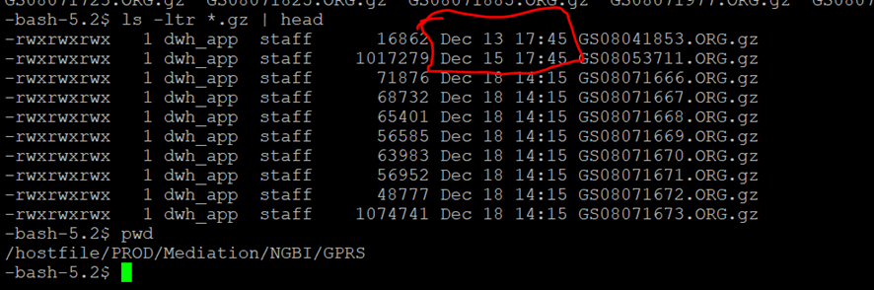

- Verified the execution date of DMAAP process by running this query:
SELECT delim.id_load, delim.id_feed, delim.DS_ORIGINAL_FILE_NAME, cdfp.DT_END
FROM CTR_DMAAP_FILE_PRCS cdfp
INNER JOIN CTR_DMAAP_FILE_DELIM delim
ON delim.ID_LOAD = cdfp.ID_LOAD
WHERE delim.id_load IN (1213431, 1211281)
AND delim.DS_ORIGINAL_FILE_NAME IN ('GS08041853.ORG.gz' ,'GS08053711.ORG.gz' );

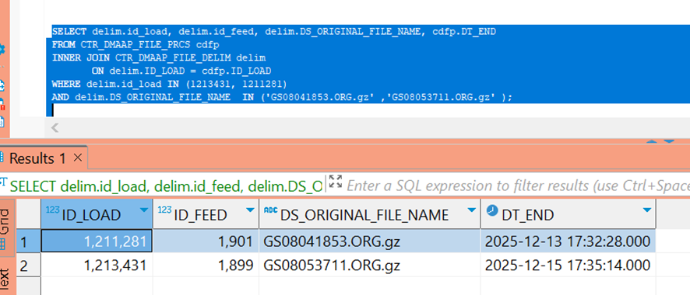

Resolution:
- Based on the DT_END / “data end” field in the DMAAP tables (which indicates when files were processed and uploaded to Nucleus GCP), the files in the INPUT folder were moved after the processing window.
- A manual move can be performed, since the DMAAP process deletes jobs once they are completed, and this occurred before DT_END.
- Files with a later date will be handled in the next executions. And, if any files were already processed, DMAAP will keep them in the folder and will not reprocess them.

Related Links:
- Remedy Ticket
- Documentation

