INC000097736857 – Kafka Monitoring Dashboard - GCP_DQ8 Kafka Abort
19 December 2025
11:44
Date: 19-Dec-2025
Requester: Portal, PCS-GW
Description:
- GCP_DQ8 Kafka Abort

Initial Diagnosis:
- Kafka Table for feed S_INDUST_anonymized in Nucleus dataset has been created with a specific column as partitioned, not the usual _partitiontime implicit field.

Actions Taken:
- Run query below to check the cause.
SELECT *
FROM `vf-pt-datahub-prd-mgmt.vfpt_dh_mgmt_dmaap_metadata_s.kfk_control_scheduler_exec`
order by ID_SCHEDULER_EXEC desc LIMIT 1000;
-> NOTES = "DEBUG: OFF - MSG: Query error: Unrecognized name: _partitiontime at [vf-pt-datahub-prd-mgmt.vfpt_dh_mgmt_dmaap_metadata_s.prc_upd_kfk_control_last_updt:1:126] - ORIGINATED BY: select DATETIME(MAX(DMAAP_BIQUERY_LOAD_TS)) from `vf-pt-datahub.vfpt_dh_lake_siebel_s.siebel_S_INDUST_anonymized` where date(_partitiontime) = '2025-12-18'..."

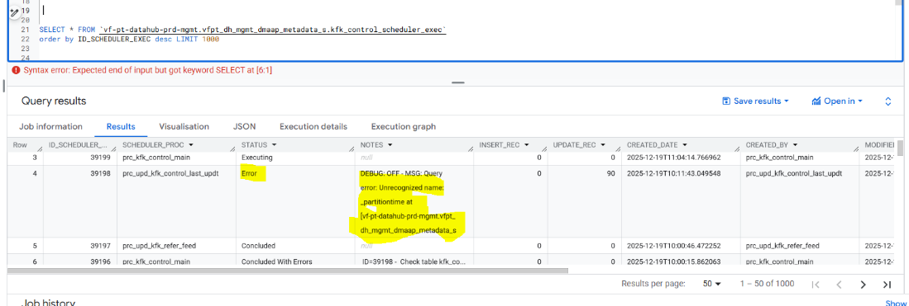

- Compare the table in error to another one without error:
SELECT *
FROM `vf-pt-datahub.vfpt_dh_lake_siebel_s.INFORMATION_SCHEMA.TABLES`
WHERE table_name in ( 'siebel_S_ASSET_X_anonymized', 'siebel_S_INDUST_anonymized');

In the DDL, see the difference when creating the table:
S_ASSET_X: PARTITION BY DATE(_PARTITIONTIME)
S_INDUST: PARTITION BY DATE(DMAAP_BIQUERY_LOAD_TS)

- Changed the procedure prc_upd_kfk_control_last_updt:
-- INC000097736857 - Table `vf-pt-datahub.vfpt_dh_lake_siebel_s.siebel_S_INDUST_anonymized` out of old pattern
-- SET V_COMP_STMT_PARTITION = " where date(_partitiontime) = '" || V_PARTITION_ID || "'";
BEGIN
-- Try to use the actual loading field
SET V_COMP_STMT_PARTITION = " where date(" || V_LOADING_FIELD_NAME || ") = '" || V_PARTITION_ID || "'";
EXCEPTION WHEN ERROR THEN
-- Fallback to _partitiontime in case of any error
SET V_COMP_STMT_PARTITION = " where date(_partitiontime) = '" || V_PARTITION_ID || "'";
END;

Resolution:
- After analyzed the cause and the related procedure, the new scenario will consider the specific column as partition when informed.

Related Links:
- Remedy Ticket
- Documentation

