INC000097771779 - DQ26 - MJ_SIM_DataLoad in error
23 de dezembro de 2025
14:36

DO NOT DELETE - THIS IS A TEMPLATE
Date: 23-12-2025
Requester: AO
Description:
- DWBI : DQ26 - MJ_SIM_DataLoad in error

Initial Diagnosis:
-
[ERROR]: itsim.j_dd_simspexec_1_0.J_DD_SIMspExec - tDie_1 - The die message: NOK - SP call timed out
[FATAL]: itsim.j_dd_simspexec_1_0.J_DD_SIMspExec - tDie_1 - Exiting the VM.
NOK - SP call timed out

Actions Taken:

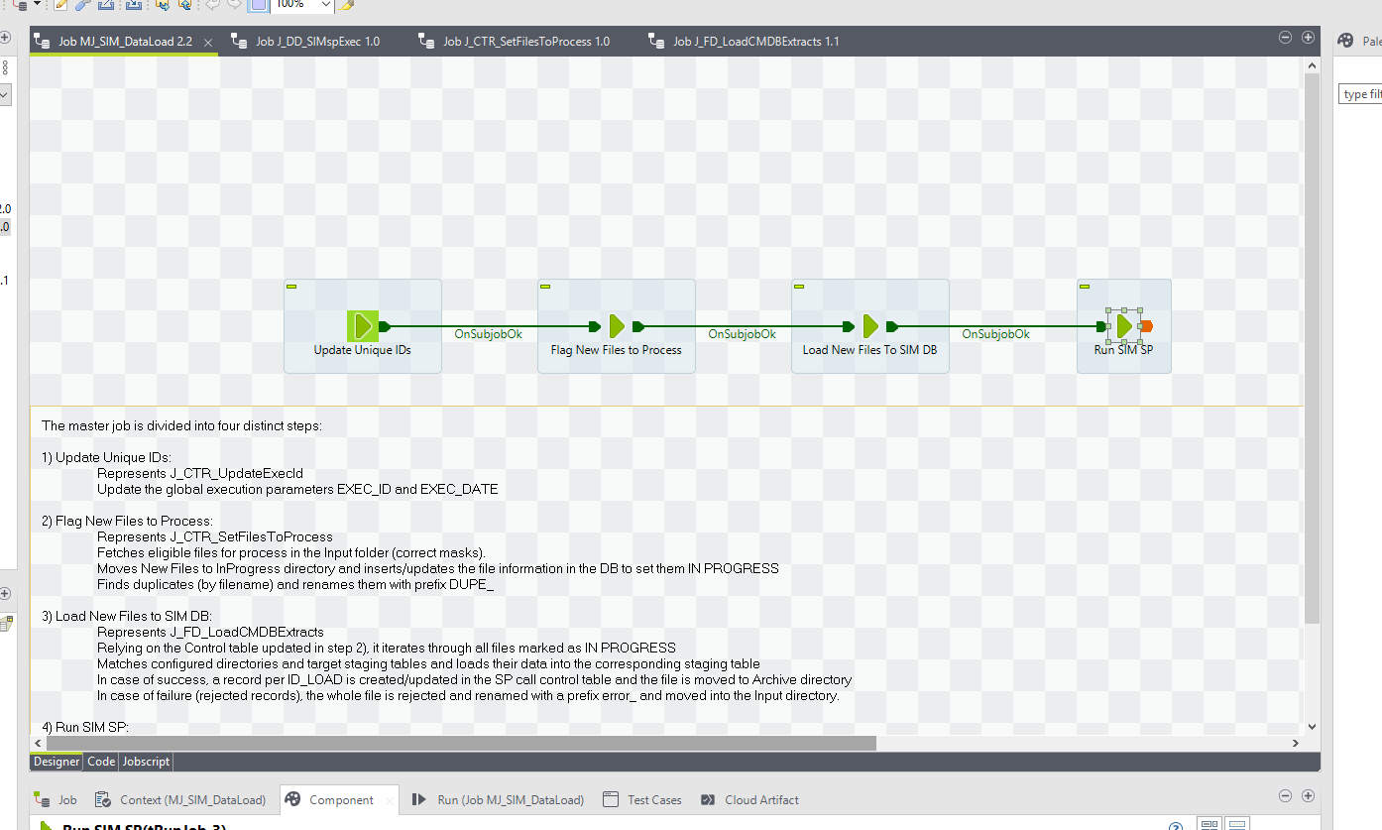
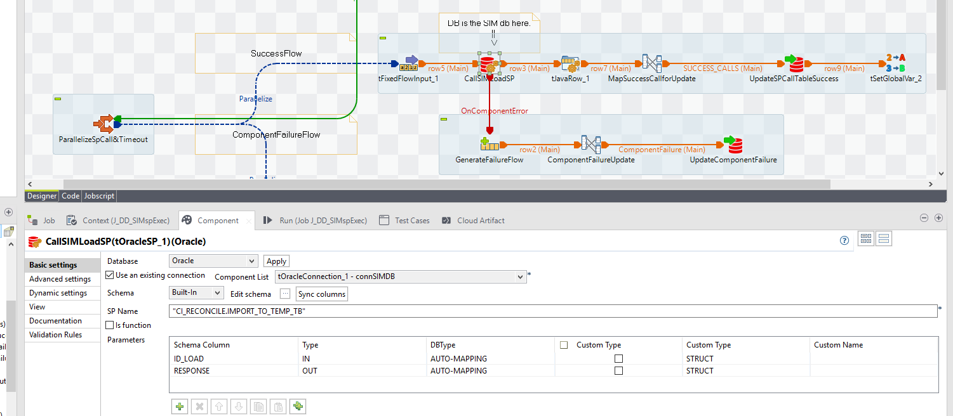
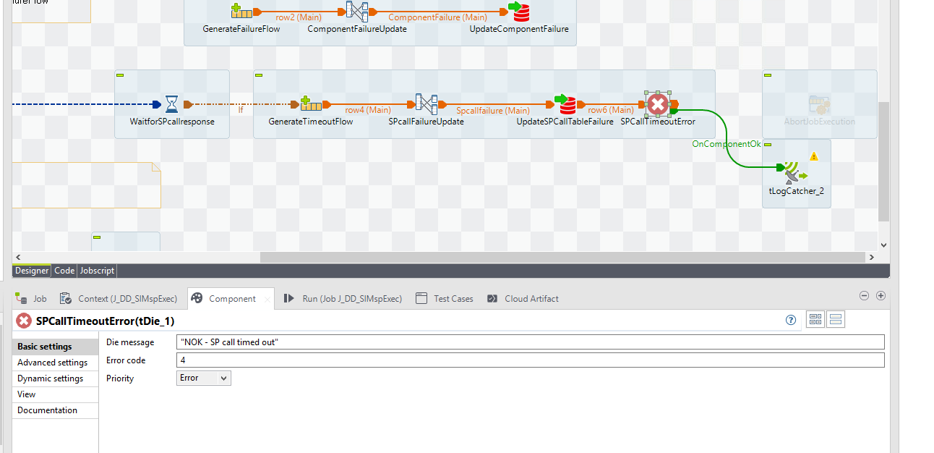

"CI_RECONCILE.IMPORT_TO_TEMP_TB"

1  2  3  4  5  6  7  8 | SELECT max( import_id) FROM import1368_data WHERE import_id = 383 -- 2853  SELECT max( import_id) FROM import1485_data WHERE import_id = 387 -- 1037  SELECT max( import_id) FROM import1618_data WHERE import_id = 387 -- 3191  SELECT count (*) FROM import1368_data WHERE import_id = 383 -- 2853  SELECT count (*) FROM import1485_data WHERE import_id = 387 -- 1037  SELECT count (*) FROM import1618_data WHERE import_id = 387 -- 3191

Resolution:
-
create table SIM_SP_CALLS_bck_20251223 as
select *
from SIM_SP_CALLS

update SIM_SP_CALLS
set CD_SP_CALL_STATUS = 'OK - IMPORT COMPLETE - STATUS MANUAL UPDATE'
where id_load in (387 ,386,385)



Os ficheiros foram recebidos do lado do ITSIM

We made a manual execution to try to avoid the abort, check on the next execution if it run with success.

Related Links:
- Remedy Ticket
- Documentation

