INC000097806679 We have talend job J_DD_E_ODS_Load_AuxCOPS and MJ_CDM_ALTERN_VARIABLES_NEW aborts
29 de dezembro de 2025
16:30
Date:27-12-2025
Requester: AO
Description:
-We have talend job J_DD_E_ODS_Load_AuxCOPS and MJ_CDM_ALTERN_VARIABLES_NEW aborts

Initial Diagnosis:
-
We have talend job J_DD_E_ODS_Load_AuxCOPS and MJ_CDM_ALTERN_VARIABLES_NEW aborts with below erroe:

MJ_CDM_ALTERN_VARIABLES_NEW
[FATAL] 18:38:45 bde.j_df_cdm_altern_variables_pt1_1_0.J_DF_CDM_ALTERN_VARIABLES_PT1- tOracleConnection_1 ORA-01017: invalid username/password; logon denied

J_DD_E_ODS_Load_AuxCOPS
[FATAL] 20:00:14 bde.j_dd_e_ods_load_auxcops_1_1.J_DD_E_ODS_Load_AuxCOPS- tOracleConnection_1 ORA-01017: invalid username/password; logon denied

Actions Taken:

https://confluence.sp.vodafone.com/spaces/VDE1/pages/685435615/Extract+pre-processing
https://confluence.sp.vodafone.com/spaces/VDE1/pages/685435603/CDM+-+sources+on-prem

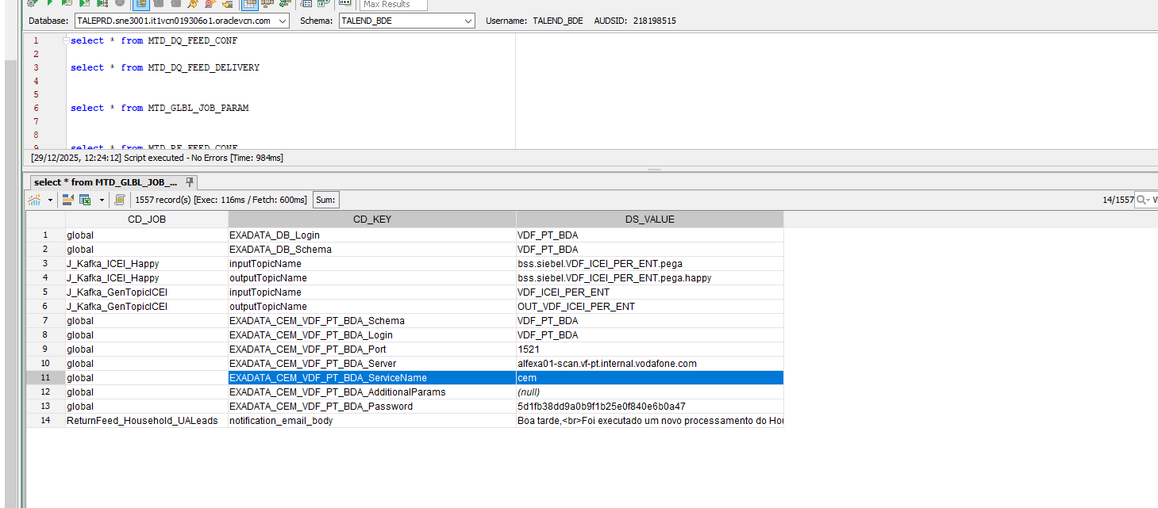

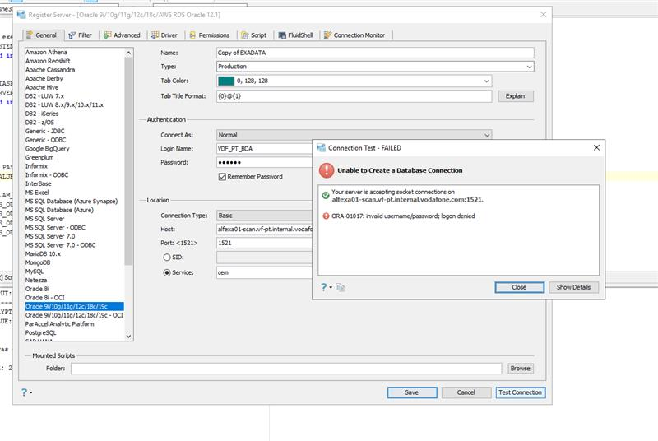
Steps 2
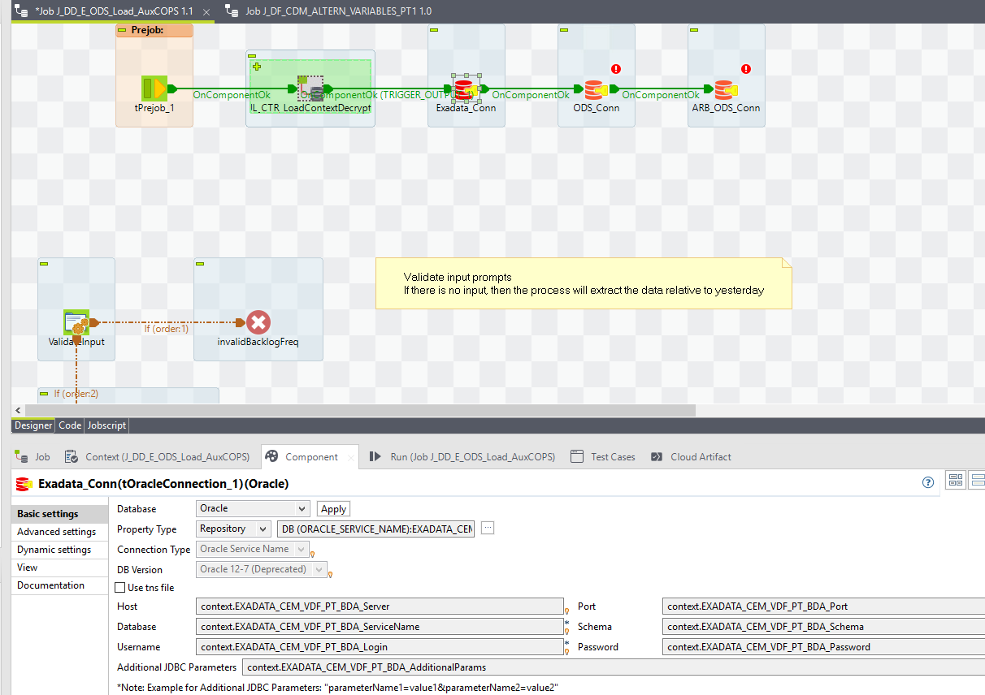
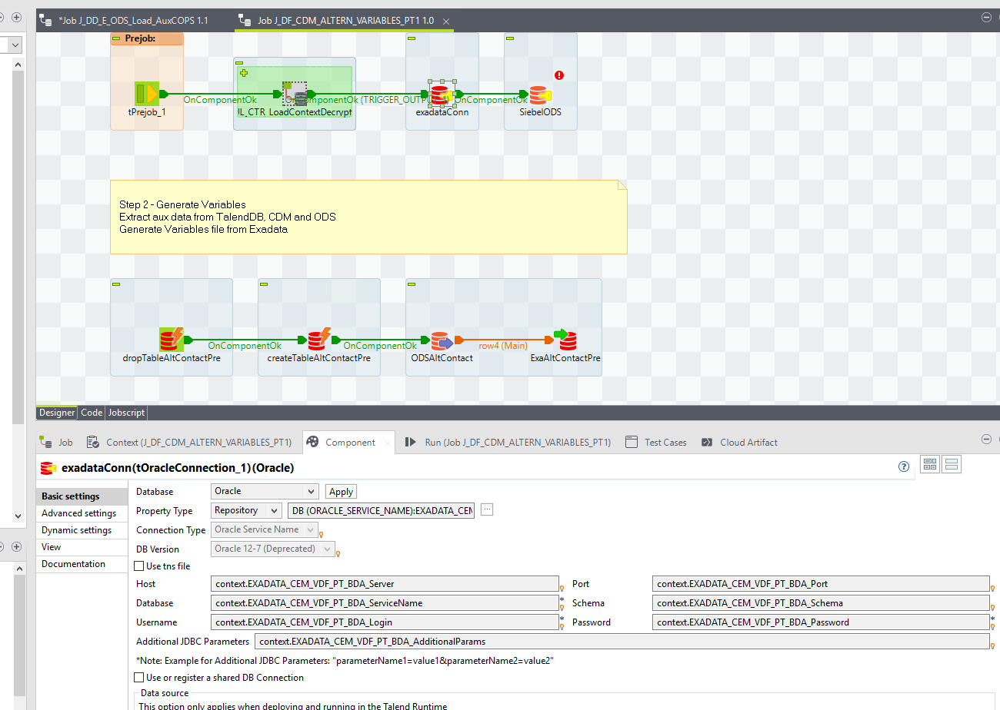

Resolution:

Hi,
The Talend jobs J_DD_E_ODS_Load_AuxCOPS and MJ_CDM_ALTERN_VARIABLES_NEW use a connection to the Exata DB (please check the project documentation), and the password has been changed.
You need to verify the new password and update the encrypted password parameter in the Talend database used by these two projects.
Login: VDF_PT_BDA
Port: 1521
BDA Server: alfexa01-scan.vf-pt.internal.vodafone.com
Service Name: cem

Related Links:
- Remedy Ticket
- Documentation

