NC000097876092 | URGENT | SAFT files with incorrect information
13 de janeiro de 2026
17:18

Date: 05-01-2026
Requester: Anabela Silva
Description:
- I would like to inform you that the SAFT files from our stores, sent today and referring to the month of December, are incorrect, containing sales and returns information (credit and debit) at zero, as shown in the printout below:

Initial Diagnosis:
- Valores credito e debito a zero
Foram recebidos 2 ficheiros de SAFT, um deles ( a correção) chegou após a execução do job do Talend .

Actions Taken:
- Validação dos ficheiros reportados

Resolution:
Como recebemos uma segunda versão do ficheiro de SAFT fora de horas, testou-se processar para as lojas da queixa do user ,quando correu validamos e os valores estavam corrigidos. Após falar com o utilizador corrigimos para as restantes lokas.

Temos um procedimento de recuperação, seguimos alguns dos passos desse procedimento.

1  2  3  4  5  6  7  8  9  10  11  12  13  14  15  16  17  18  19 | select * from RD_LOJAS  where id in (163,17076,2070)  -- 163 LVI JCA-Via Catarina  -- 17076 LVI Cepcom- Retail Park Coina-Barreiro  --2070 LVD LV CC Aveiro Glicínias  truncate table RD_LOJAS  insert into RD_LOJAS select * from RD_LOJAS_full_20260106 where id not in (163,17076,2070)  create table RD_LOJAS_full_20260106 as  select *  from RD_LOJAS  TABLESPACE TAC_631 NOCOMPRESS PCTFREE 10 INITRANS 1 MAXTRANS 255  insert into RD_LOJAS_full_20260106  select *  from RD_LOJAS

1  2 3 | /var/SP/prd_share/SAFT_PerStore/input  /var/SP/prd_share/SAFT_PerStore/archive/20260106

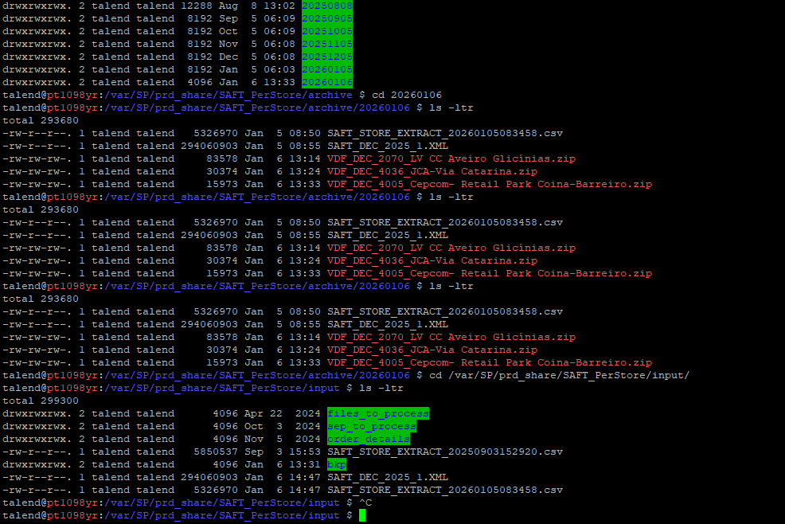

Nota Adicional: Em 18-Mar-2026, recebemos o INC000098652561 que apresentava o mesmo erro. Segue a RCA e nota enviada (para atualizar o SOP):

Hi SD, Please assign to @DWBI AO OPS-PT Team.
Hello Team,
We noticed that multiple CSV/XML files (all monthly files) were copied into the input folder and reprocessed in a single execution. This caused the total values to be incorrect.
To resolve the issue, we placed one CSV file and one XML file in the input folder (Jan'2025 and Store 2210 - LV CC MAR Shopping Algarve) and reprocessed them. The results are now correct.
Please update the SOP to reflect that only one CSV–XML pair should be processed per manual execution.
Note: We got the files from the folder: /var/SP/prd_share/SAFT_PerStore/archive/20250808
Thanks.

Related Links:
- INC000098565331
- INC000098652561
- Documentation

