INC000098015851 - DQ16 : COPS FEEDS are in LANDING state 20260117
5 de dezembro de 2025
10:44

Date: 19-Jan-2026
Requester: Portal, PCS-GW
Description:
- Hello AM team, as the below DAGS are not triggred after 16th Jan, FEEDS are in landing state from 17th Jan. can you please check and assist why these DAGS are not triggred.
dmaapBDE-bau_da_cops_siebel-prd
dmaapBDE-bau_hdm-prd
dmaapBDE-bau_cops_reclamacoes-prd
dmaapBDE-bau_da_cops_tobi-prd

FEEDS list:
cpe
oportunities
cops_tobi_sms_agent
cops_operations
cops_tipifications
cops_os
cops_activities
cops_reclamacoes
cops_reclamacoes_juridic_process

Initial Diagnosis:
- Due to the HPE Credentials Maintenance held on 16-Jan by AO / VOIS Team, some DAGs were not triggered and the associated feeds haven't delivered files to Nucleus since 16-Jan.

Actions Taken:
1. Manually triggered all DAGs listed above (except HDM DAG for BAU feed CPE) to eliminate the backlog of old files.
2. FUP to ensure files moved to the archived folder
3. Checked the corresponding triggering DAG for the DAGs listed above.
3.1. dmaapBDE-bau_da_cops_siebel-prd is triggered by bde_bau_cops_trigger_siebel (**), according to the code of the "trigger" DAG.
3.2. No reference found in the Confluence Page for dmaapBDE-bau_hdm-prd dag (***).
3.3. dmaapBDE-bau_cops_reclamacoes-prd is triggered by bde_bau_cops_trigger_reclamacoes (***), according to the code of the "trigger" DAG.
3.4. dmaapBDE-bau_da_cops_tobi-prd is triggered by bde_bau_da_cops_trigger_tobi (*).
(*) Present in Confluence page https://confluence.sp.vodafone.com/spaces/VDE1/pages/632280526/COPs+-+Daily+Process
(**) Not documented in the same Confluence Page the "trigger" DAG -> Please engage with BDE to document this process or provide a reference to the corresponding documentation.
(***) Neither the "trigger" nor the "triggered" DAGs are documented in the same Confluence page -> Please engage with BDE to document this process or provide a reference to the corresponding documentation.
4. Marked DAG State as Success and manually triggered both trigger and triggered DAGs related to old executions (16-Jan) to restore execution control in Airflow.

5. All old files dated 16 to 19-Jan were successfully processed and archived.

Next Steps - To be performed by AO Team:
1. Engage with BDE to identify the DAG that triggers the "dmaapBDE-bau_hdm-prd" dag, then manually trigger the identified DAG.
2. FUP (to AO): Ensure upcoming DAG runs complete without manual intervention.
3. Engage with BDE to check the missing documentation identified in item #3.

Resolution:
- Listed in the previous topic
- Some screenshots related to actions performed by Frederico (AM).

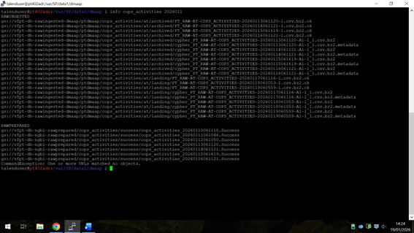
Files stuck for one of the feeds impacted

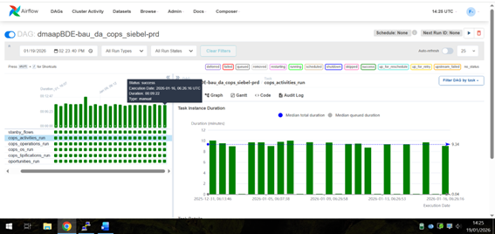
One of the DAGs that should be triggered and it was stuck since 16-Jan

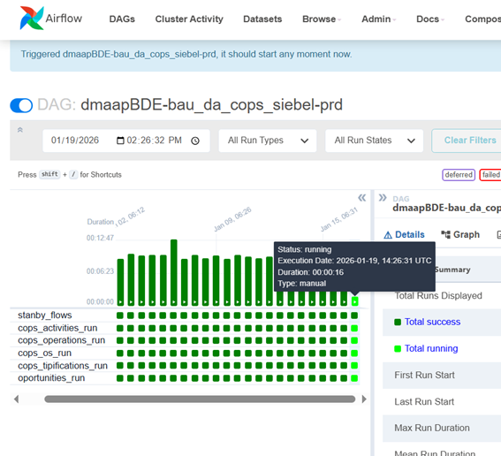
Manually triggered

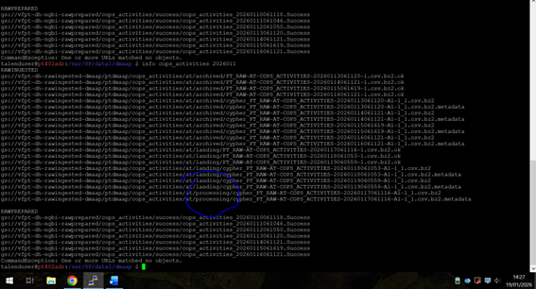
Files started processing as expected

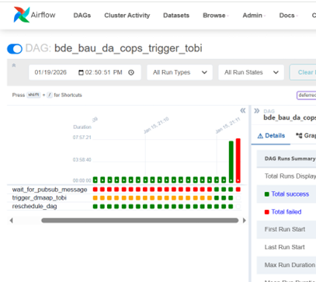
One of DAGs that should trigger other(s) on 16-Jan

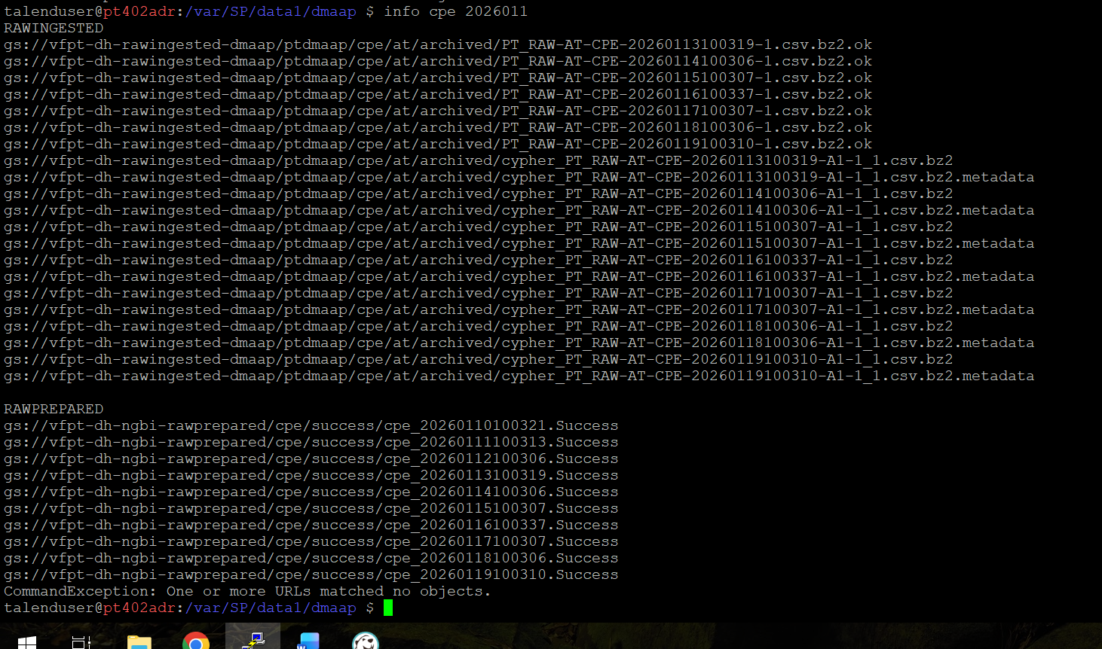
One of the feeds with all old files processed and move to archived folder

Related Links:
https://confluence.sp.vodafone.com/spaces/VDE1/pages/632280526/COPs+-+Daily+Process

